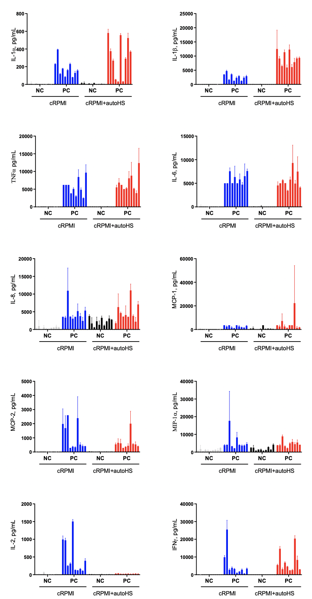
Supplement
Supplementary Figure 1. PBMC from 10 healthy donors were isolated from fresh, heparinized whole blood. The cells were cultured either in complete RPMI (cRPMI ) containing 10% heat-inactivated FBS, L-glutamine and pen/strep or in cRPMI supplemented with 10% autologous fresh human serum (autoHS) obtained from the same donors. Negative control (NC) was PBS; positive control (PC) was 20 ng/mL of E.coli K12 LPS. The incubation continues for 24 hours, after which the supernatants were analyzed by ELISA for the presence of cytokines. Each bar shows mean response and standard deviation (N=3).
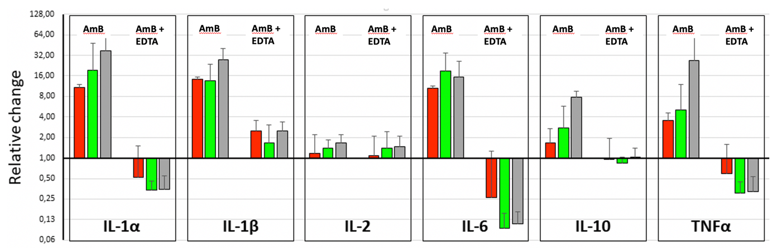
Supplementary Figure 2. Relative changes of IL-1α, β, IL-2, IL-6, IL-10 and TNFα levels in PBMC culture supernatants after 18 hours incubation with AmBisome alone (AmB) or together with 20 mM EDTA (AmB + EDTA). Similar measurements as shown in Fig. 4, using 3 donor PBMCs (red, gree and gray) that were different from the donors shown in Fig 4. The y axis shows the changes related to baseline (0 min), thus values below 1 (IL-1α, IL-6, TNFα) may imply inhibited spontaneous release of the cytokine. Values are mean +/- SD.

