***Supporting Information for***

**A Solid-State Fluorescence Switch Based on Triphenylethene Functionalized Dithienylethene with Aggregation-Induced Emission**

Haining Zhang1, Xiaoxiao Hu1, Huijuan Zhu1, Limin Shen1, Congmin Liu1, Xiaoman Zhang1, Xinyu Gao1, Lingmei Li1, Yan-Ping Zhu2* and Ziyong Li1*

*1 Luoyang Key Laboratory of Organic Functional Molecules, College of Food and Drug, Luoyang Normal University, Luoyang, 471934,* *P. R. China*

*2 School of Pharmacy, Key Laboratory of Molecular Pharmacology and Drug Evaluation, Ministry of Education, Collaborative Innovation Center of Advanced Drug Delivery System and Biotech Drugs in Universities of Shandong,* *Yantai University, Shandong, Yantai, 264005, P. R. China.*

Corresponding author E-mail: [liziyong@mails.ccnu.edu.cn](mailto:liziyong@mails.ccnu.edu.cn); [chemzyp@foxmail.com](mailto:chemzyp@foxmail.com)



**FIGURE S1.** Fatigue resistance of **1** upon alternating irradiation with 254 nm UV light and visible light at >402 nm over six cycles in DMSO (2.0 × 10-5 mol/L).



**FIGURE S2.** Fatigue resistance of **2** upon alternating irradiation with 254 nm UV light and visible light at >402 nm over six cycles in DMSO (2.0 × 10-5 mol/L).



**FIGURE S3.** Fatigue resistance of **3** upon alternating irradiation with 254 nm UV light and visible light at >402 nm over six cycles in DMSO (2.0 × 10-5 mol/L).

**Appendix: NMR and Mass spectra**

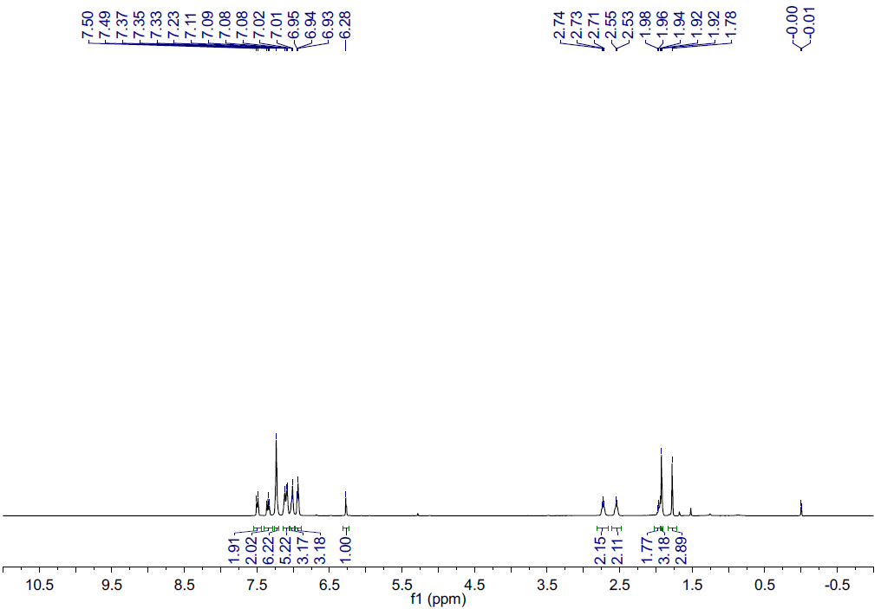

**FIGURE S4**.400 MHz1H NMR spectrum of dithienylethene **1** in CDCl3 at room temperature.

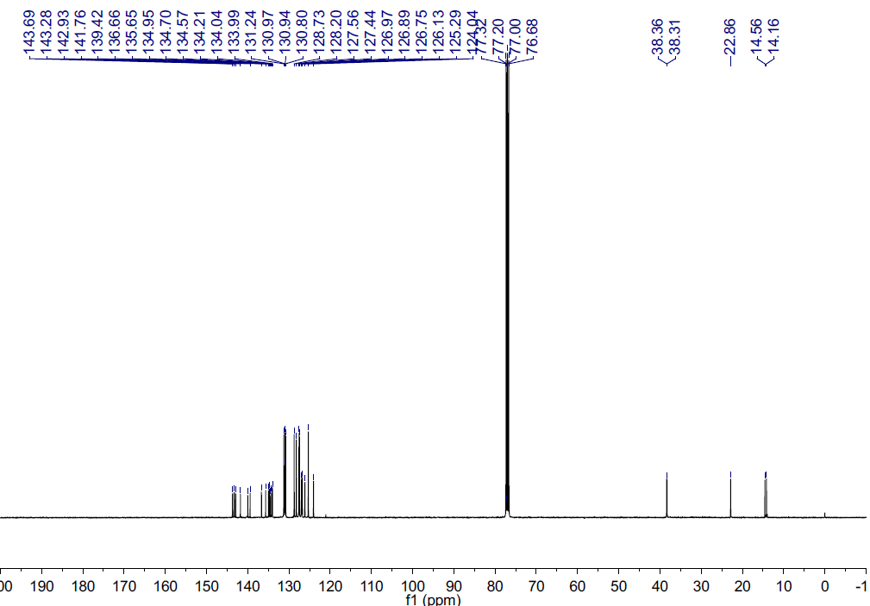

**FIGURE S5**. 100 MHz13C NMR spectrum of dithienylethene **1** in CDCl3 at room temperature.

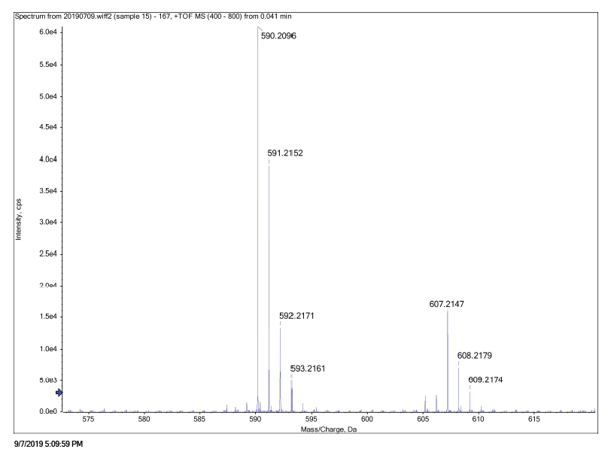

**FIGURE S6**.HRMS of dithienylethene **1** at room temperature.

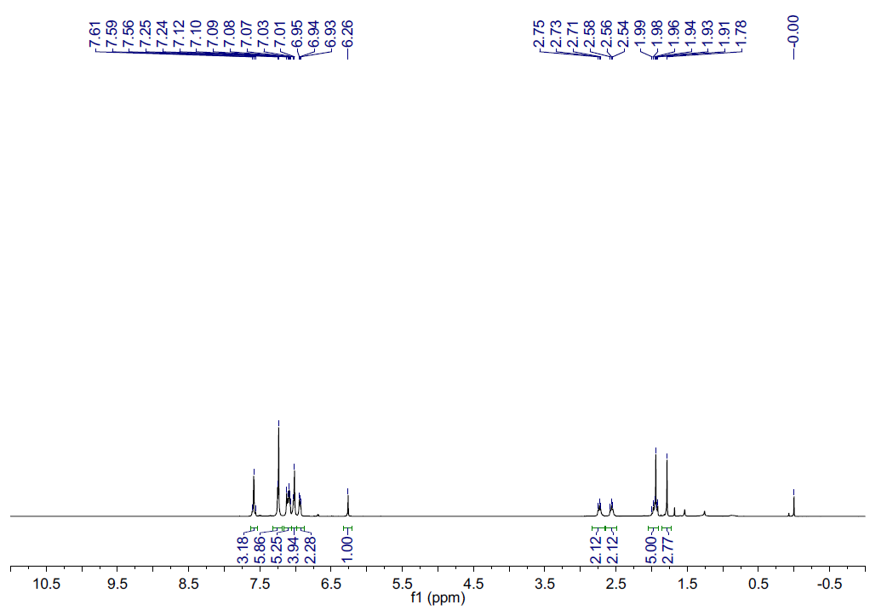

**FIGURE S7**.400 MHz1H NMR spectrum of dithienylethene **2** in CDCl3 at room temperature.

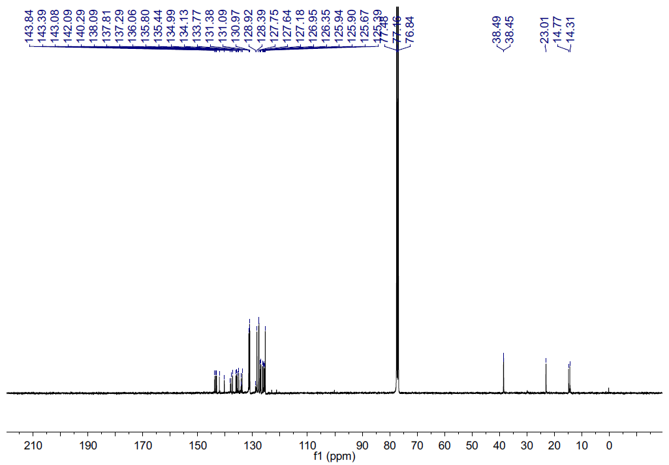

**FIGURE S8**.100 MHz13C NMR spectrum of dithienylethene **2** in CDCl3 at room temperature.

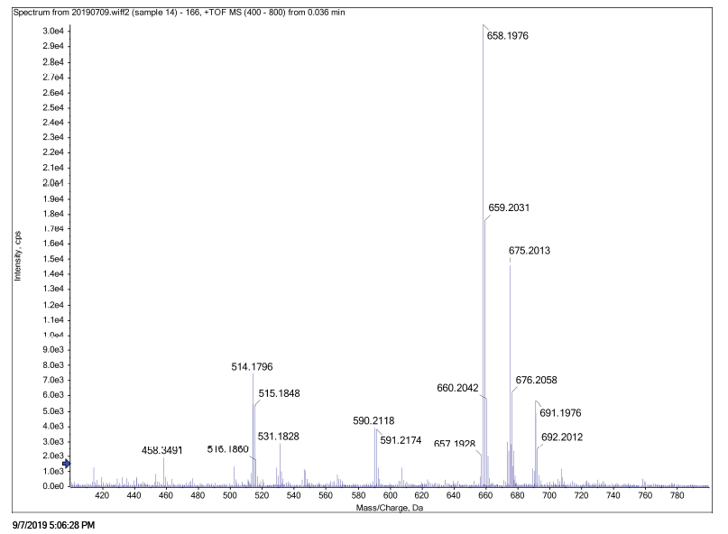

**FIGURE S9**.HRMS of dithienylethene **2** at room temperature.

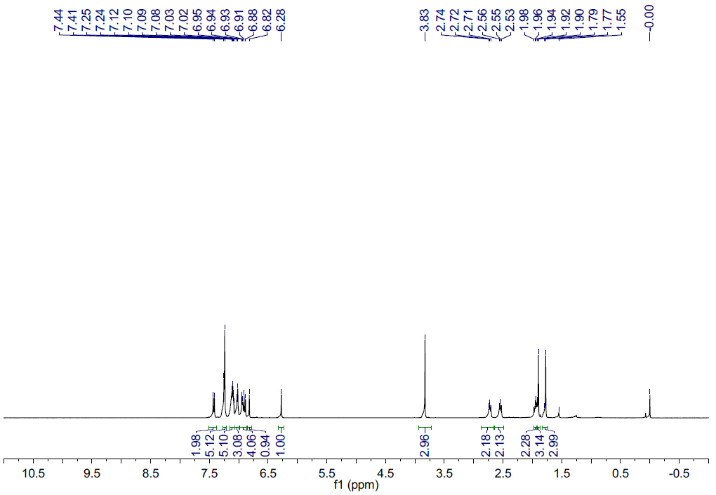

**FIGURE S10**.400 MHz1H NMR spectrum of dithienylethene **3** in CDCl3 at room temperature.

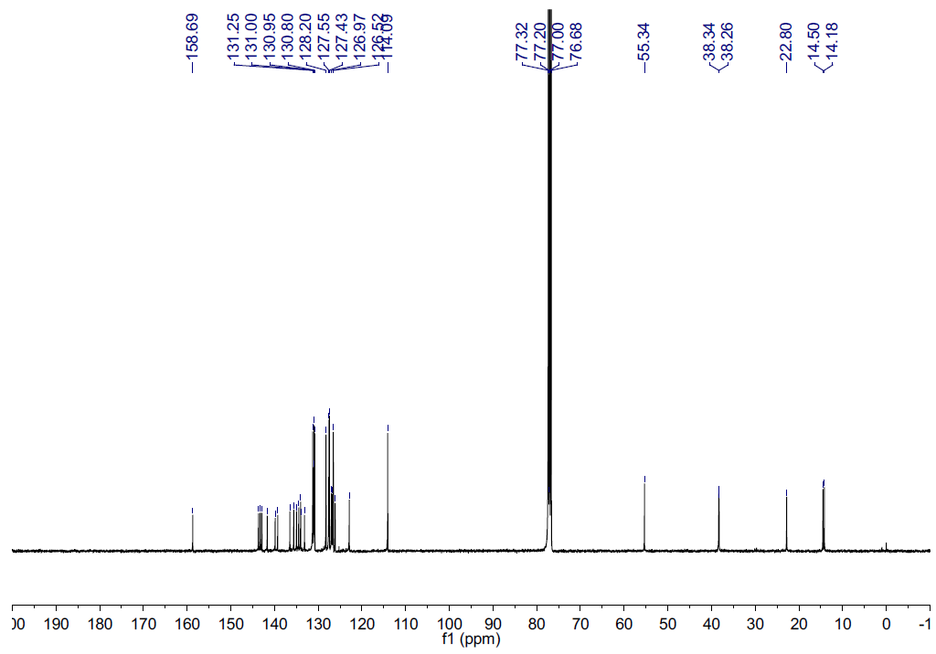

**FIGURE S11**.100 MHz13C NMR spectrum of dithienylethene **3** in CDCl3 at room temperature.

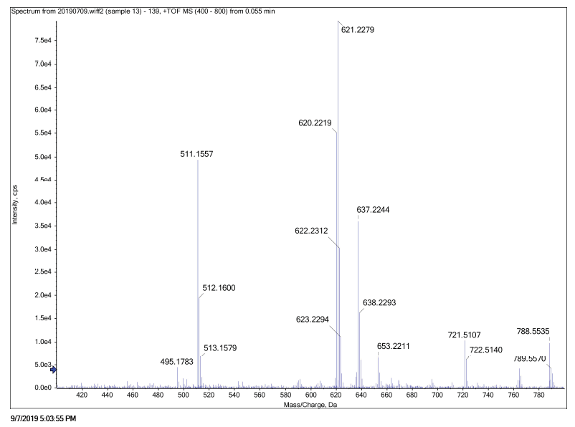

**FIGURE S12**.HRMS of dithienylethene **3** at room temperature.