Monocytic-Myeloid Derived Suppressor Cells of HIV-Infected Individuals with Viral Suppression Exhibit Suppressed Innate Immunity to Mycobacterium tuberculosis
Priyanka Namdev ¹, Shiv Patel ², Brandi Sparling ^{1#}, Ankita Garg*
¹ Departments of Infectious Diseases, College of Veterinary Medicine, University of Georgia, Athens, GA, USA
² Franklin College of Arts and Sciences, University of Georgia, Athens, GA, USA
#Present Address: Western University of Health Sciences, Pomona, USA

*Address correspondence to: Ankita Garg, PhD,
Department of Infectious Diseases
College of Veterinary Medicine
University of Georgia,
Athens, GA, 30606
USA
Phone: 706-542-4541
Fax: 706-542-5771
E-mail: agarg@uga.edu

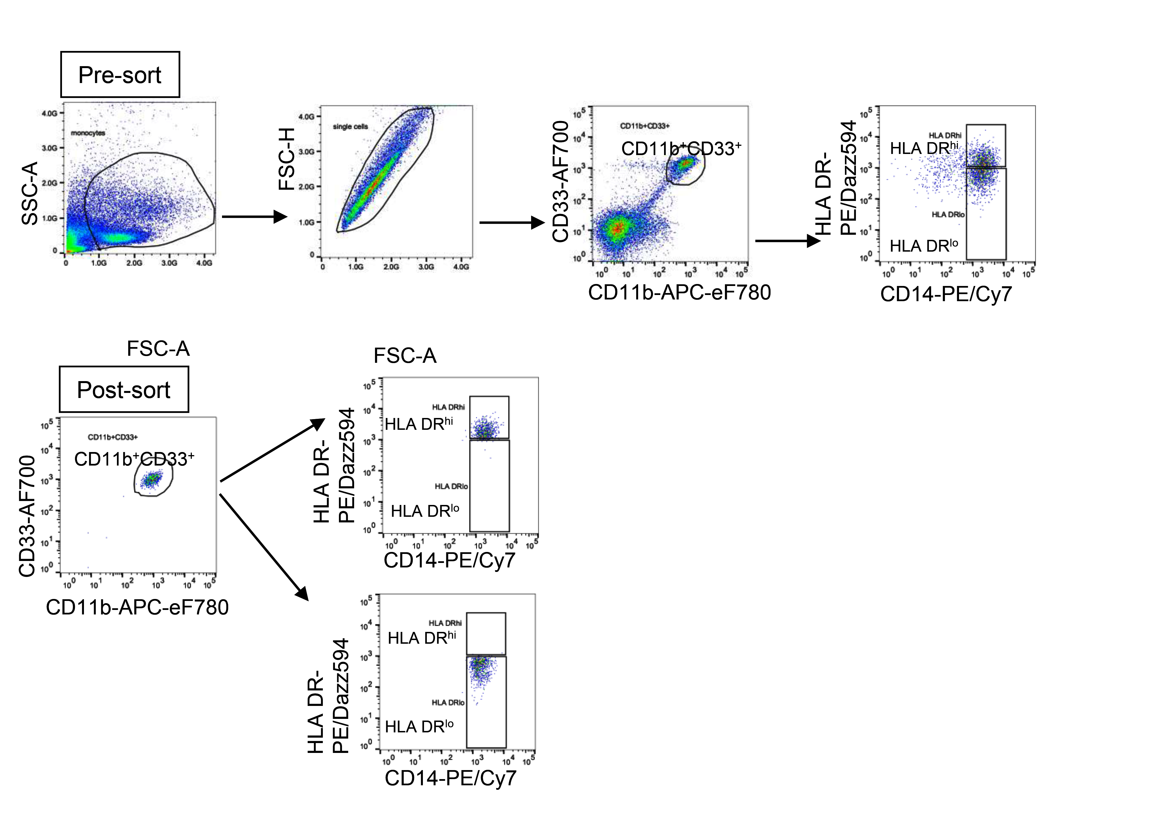
Supplementary Figure 1

Purity of sorted CD11b⁺CD33⁺CD14⁺HLA DR^{+/hi} (HLA DR^{hi}) and CD11b⁺CD33⁺CD14⁺HLA DR^{-/lo} (MDSC) isolated from peripheral blood mononuclear cells of HIV-infected individuals on combined anti-retroviral therapy and virologic suppression (HIV MDSC) or healthy controls (HIV (-) MDSC).

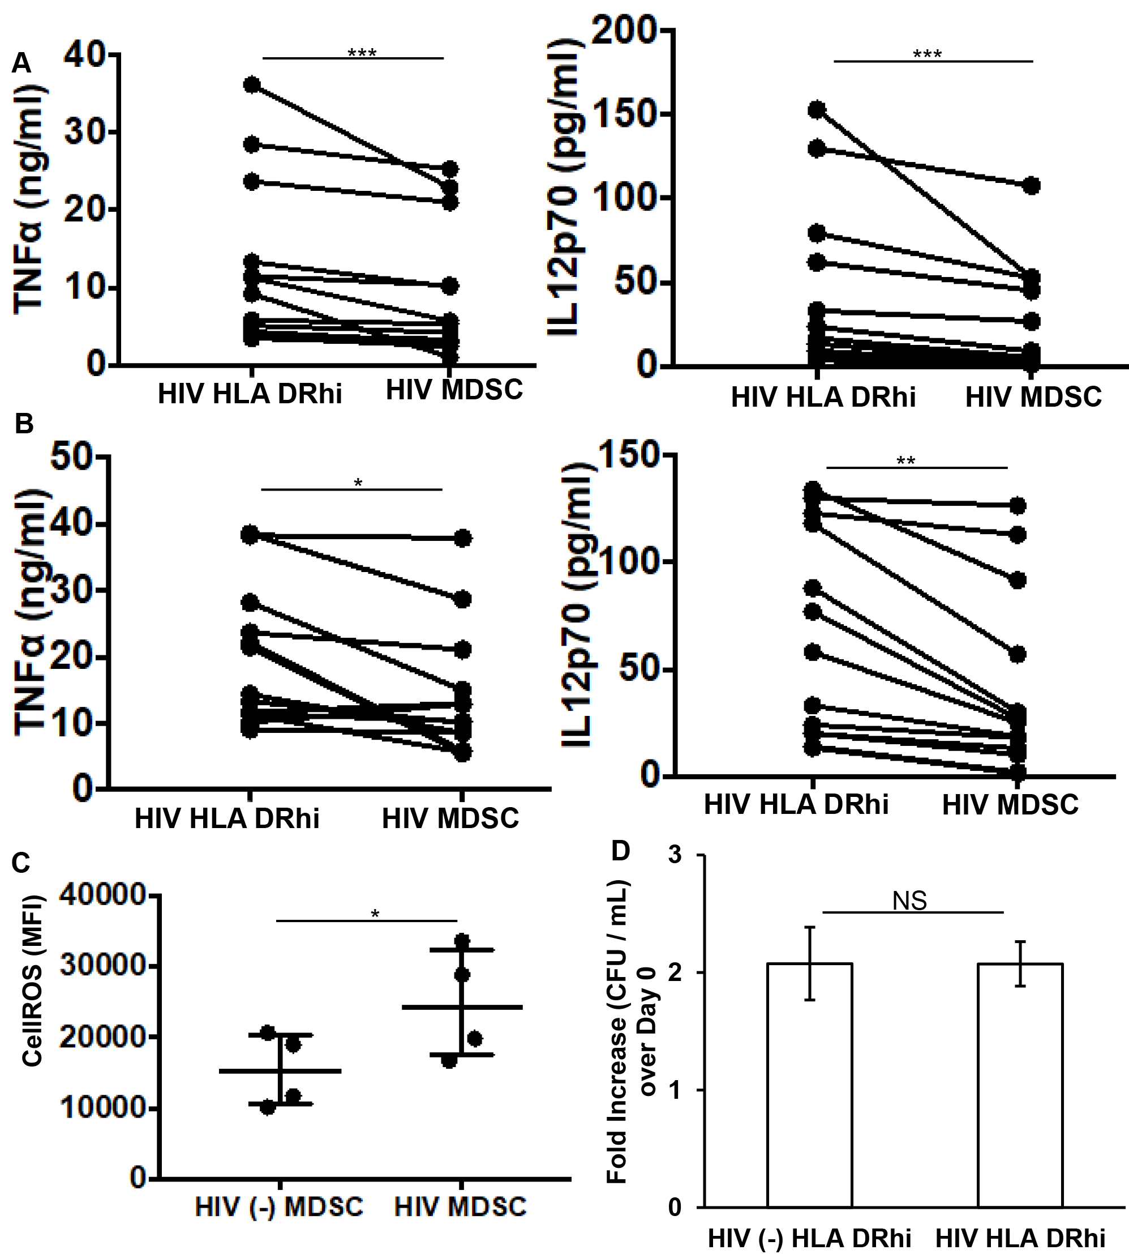
Supplementary Figure 2

(A-B) HIV MDSC as compared to HLA DR^{hi} cells produce low levels of TNFα and IL-12p70 in response to M tuberculosis: CD11b⁺CD33⁺CD14⁺HLA DR^{+/hi} (HIV HLA DR^{hi}) and CD11b⁺CD33⁺CD14⁺HLA DR^{-/lo} (HIV MDSC) were (A) infected with M tuberculosis Erdman or (B) cultured with M tuberculosis whole cell lysate for 24 hours. The quantities of IL-12p70 and TNFα was measured in the culture supernatant. (C) Increased expression of ROS in HIV MDSC: MDSC from healthy (HIV (-) MDSC) and HIV-infected individuals (HIV MDSC) were first stained with CellROX deep read reagent and subsequently with aqua fluorescent LIVE/DEAD stain. The expression of basal level of ROS (CellROS) was determined by flow cytometry (MFI: Mean Fluorescence Intensity). (D) Comparable replication of intracellular M tuberculosis in HIV (-) and HIV HLA DR^{hi} cells: CD11b⁺CD33⁺CD14⁺HLA DR^{+/hi} cells isolated from healthy (HIV (-) HLA DR^{hi}) and HIV-infected (HIV HLA DR^{hi}) individuals were infected with M tuberculosis at MOI of 1:5 for 3-hrs, washed with PBS to remove extracellular bacteria, M tuberculosis growth (colony forming units (CFU) / ml) was determined in the cellular lysates at day-0 and day-5 post-infection. The fold increase in intracellular bacterial replication was measured as CFU/ml at Day-0 / CFU/ml at Day-5. For (A), (B) and (C), each dot represents an individual donor; for (C) each dot representing an individual donor include observations from 25th to 75th percentile; the horizontal line represents the median value; for (D) histograms shown are for N=4 donors in each group. All histograms show mean values +/- SEM. *p<0.05, **p<0.005, ***p<0.0005, NS: Non-Significant.

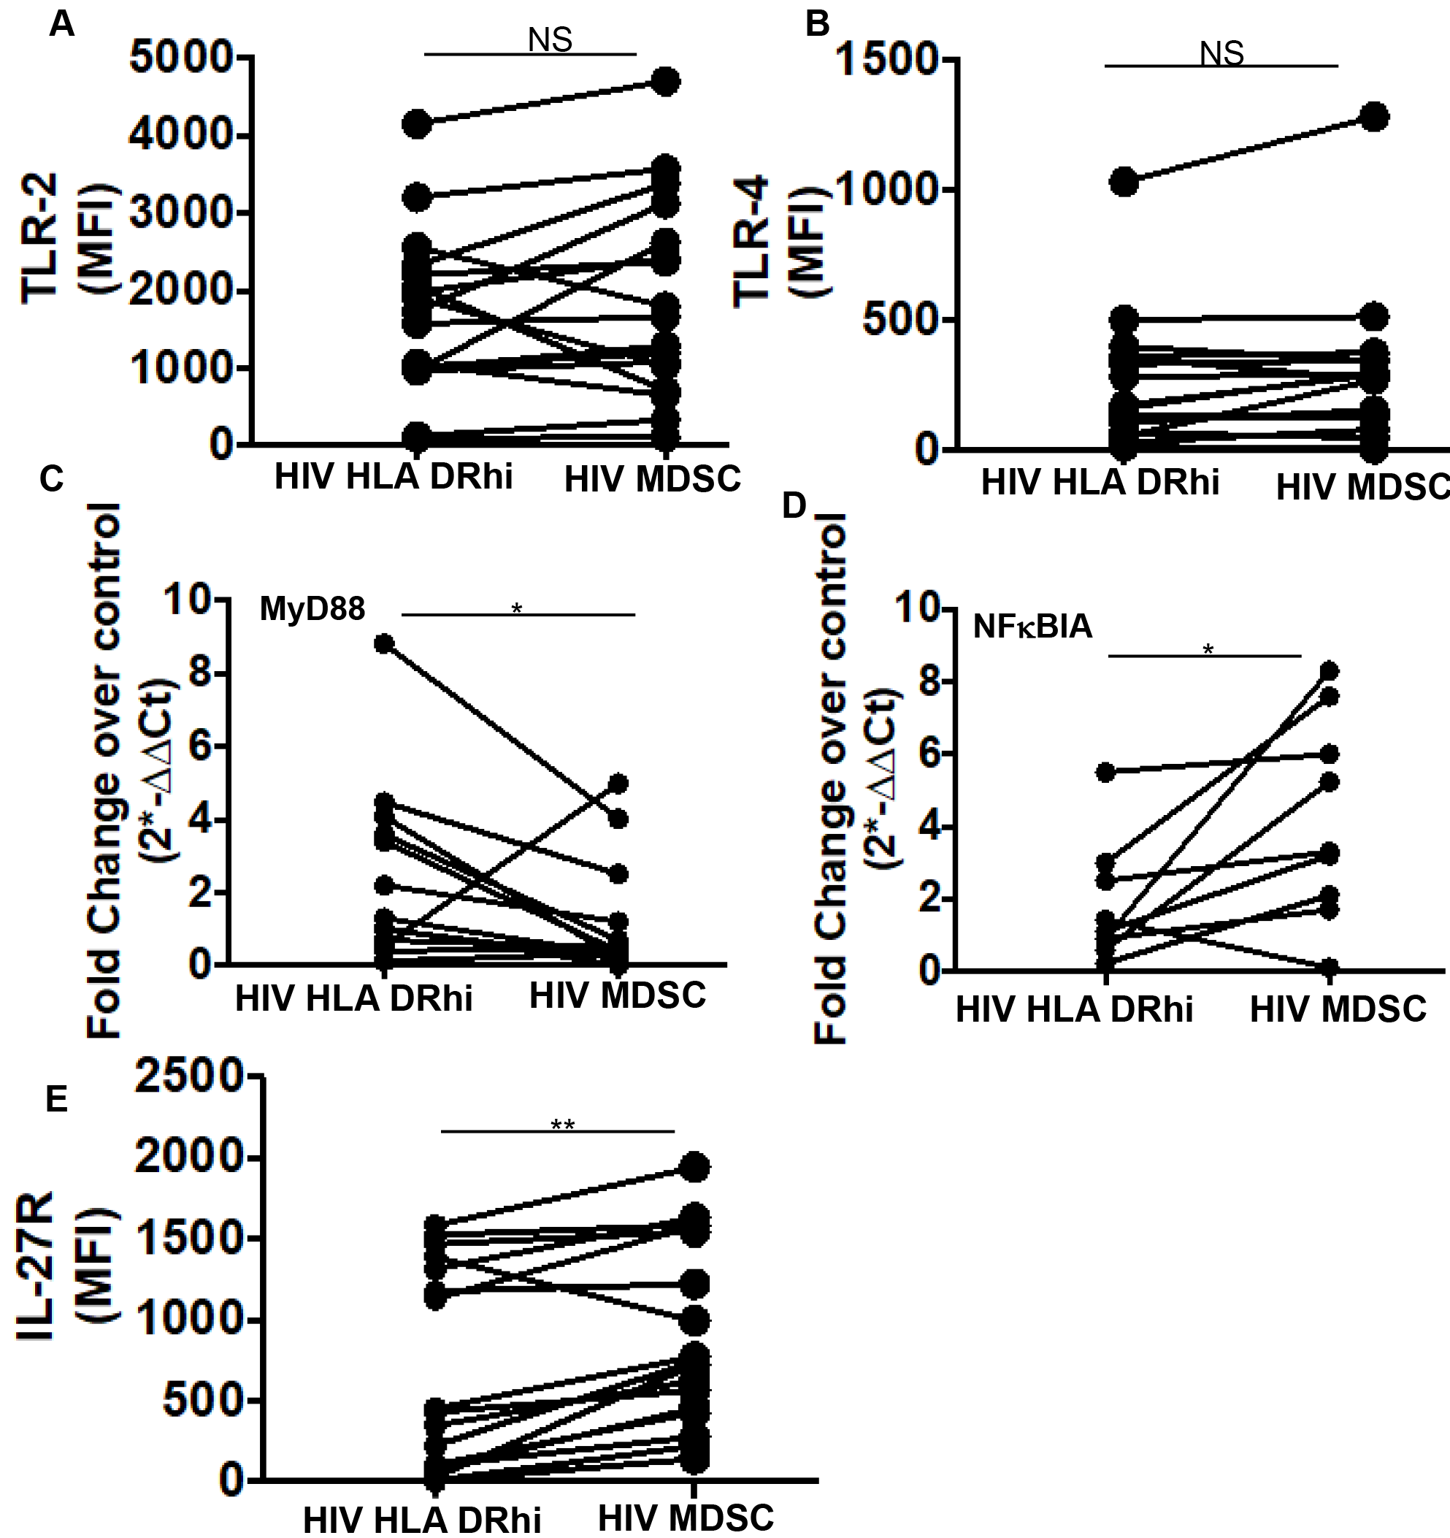
Supplementary Figure 3

(A-D) HIV MDSC as compared to HLA DR^{hi} cells exhibit truncated TLR signaling in response to M tuberculosis: CD11b⁺CD33⁺CD14⁺HLA DR^{+/hi} (HIV HLA DR^{hi}) and CD11b⁺CD33⁺CD14⁺HLA DR^{-/lo} (HIV MDSC) were stained with anti-TLR2 and anti-TLR4 antibodies. The expression of TLR-2 (A) and TLR-4 (B) was determined by flow cytometry and Mean Fluorescence Intensity (MFI) calculated, and (C-D) cultured without or with M tuberculosis WCL for 24 hours, expression of housekeeping gene 18S RNA and MyD88 (C) and NFκBIA (D) and was determined using TaqMan Gene expression assay, and ∆∆C_{T}= ∆C_{T,WCL}-∆C_{T,control.} The fold change was calculated as 2 ^{- (∆∆C}_{T}⁾. (E) HIV MDSC as compared to HLA DR^{hi} cells express higher level of IL-27R: CD11b⁺CD33⁺CD14⁺HLA DR^{+/hi} (HIV HLA DR^{hi}) and CD11b⁺CD33⁺CD14⁺HLA DR^{-/lo} (HIV MDSC) were stained with anti-IL-27R antibody. The expression of IL-27R was determined by flow cytometry and Mean Fluorescence Intensity (MFI) calculated. For all figures, each dot represents an individual donor *p<0.05, **p<0.005, NS: Non-Significant.
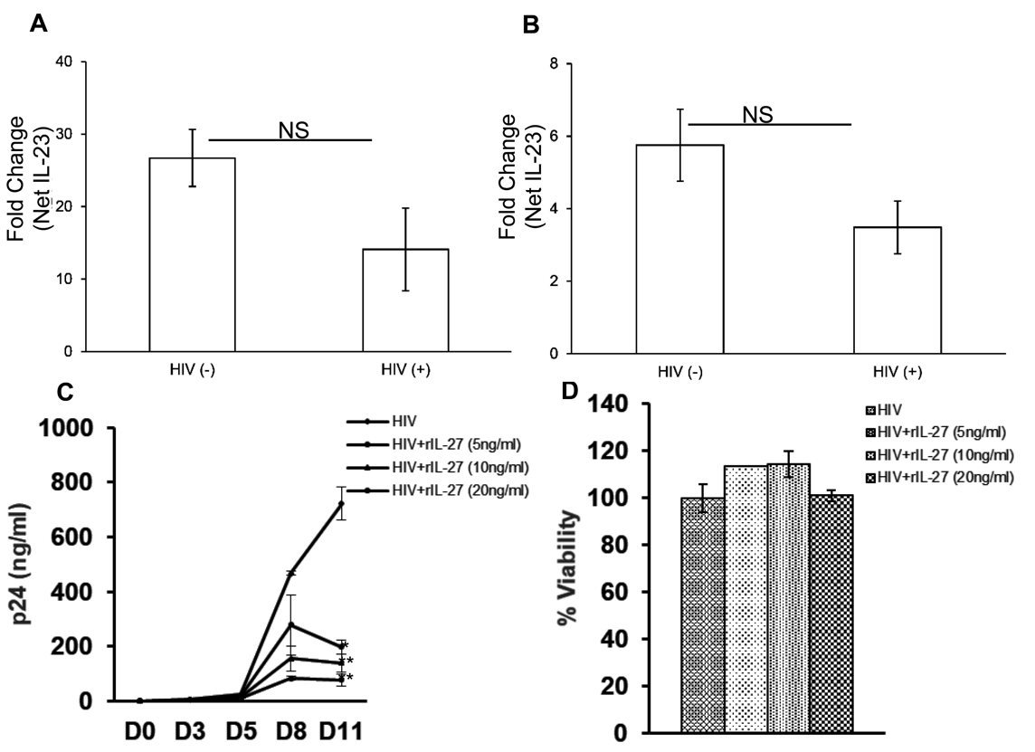
Supplementary Figure 4

(A-B) HIV MDSC express low levels of IL-23 in response to M tuberculosis: CD11b⁺CD33⁺CD14⁺HLA DR^{-/lo} (MDSC) from HIV-infected individuals on combined anti-retroviral therapy and virologic suppression were and HIV (-) healthy controls were (A) infected with M tuberculosis Erdman or (B) cultured with M tuberculosis whole cell lysate for 24-48 hours. The quantities of IL-23 was measured by Luminex multiplex cytokine assay. (C-D) IL-27 inhibits HIV replication: PHA stimulated PBMCs of HIV (-) donors were infected with infectious HIV_{BaL} (MOI 0.01) in presence of IL-2 with or without rIL-27 (5, 10 and 20 ng/ml). Culture supernatants were collected at indicated time post-infection. (C) Amount of p24 as an indicator of HIV replication was quantitated by ELISA. (D) Cytotoxicity of PBMCs at day 11 post-infection was determined by LDH release assay. Cells from each donor were infected in triplicates. For A and B, each dot represents an individual donor; for C and D, mean values +/- SEM are shown from 3 donors. *p<0.05, NS: Not Significant

