Fast and accurate classification of meta-genomics long reads with deSAMBA
Gaoyang Li^{1, +}, Yongzhuang Liu^{1, +}, Deying Li^{, 2}, Bo Liu¹, Junyi Li^{1, 3}, Yang Hu^{1, *} and Yadong Wang^{1,4 *}
¹Center for Bioinformatics, School of Computer Science and Technology, Harbin Institute of Technology, Harbin, Heilongjiang 150001, China
2 Department of Internal Medicine, General Hospital of Heilongjiang Province Land Reclamation Bureau, Harbin, China
³ School of Computer Science and Technology, Harbin Institute of Technology (Shenzhen), Shenzhen, Guangdong 518055, China
⁴ School of Life Science and Technology, Harbin Institute of Technology, Harbin, China
*To whom correspondence should be addressed.
⁺The authors should be regarded as Joint First Authors.
Contact: gaoyangli@hit.edu.cn, yongzhuang.liu@hit.edu.cn, bo.liu@hit.edu.cn, lijunyi@hit.edu.cn, huyang@hit.edu.cn and ydwang@hit.edu.cn

Table of Contents
Supplementary Table 1. Real sequencing pseudo-metagenomics datasets 3
Supplementary Table 2. The numbers and proportions of bases in GIS20 mock metagenome data being classified to ground truth by various approaches 8
Supplementary Fig 1. The results of the various approaches on the pseudo metagenomics datasets 10
Supplementary Fig 2. The results of the various approaches on the 6 ONT datasets with strain-level labels 11
Supplementary Fig 3. The speed of deSAMBA with various numbers of CPU threads 12
Supplementary Fig 4. The sensitivities and accuracies on the pseudo metagenomics datasets 13
Supplementary Fig 5. The sensitivity of BLASTN on 7 WR-datasets with low sensitivity 14
Supplementary Notes 15
1. Implementation of benchmark 15
2.1 Reference sequences used for benchmark 15
2.2 Pseudo-metagenomics datasets and ground truth 15
2.3 Command lines used for read classification 16
2. References 17

- Real sequencing pseudo-metagenomics datasets
# | SRA accessionª | Sequencing  Platform^{b} | # of Reads^{c} | # of  Bases (Mbp)^{d} | Organism^{e} | Taxonomy  ID^{f} | Genus  ID^{g} | With  Reference^{h}
1 | DRR129651 | ONT | 116592 | 744.10 | Vibrio litoralis DSM 17657 | 1123493 | 662 | no
2 | DRR129656 | ONT | 38252 | 464.56 | Vibrio aphrogenes | 1891186 | 662 | no
3 | DRR129658 | ONT | 125964 | 910.34 | Vibrio algivorus | 1667024 | 662 | no
4 | DRR129662 | ONT | 132936 | 801.39 | Vibrio rumoiensis | 76258 | 662 | no
5 | DRR131199 | ONT | 44741 | 364.29 | Arthrobacter sp. MN05-02 | 1571833 | 1663 | no
6 | DRR154113 | ONT | 270603 | 1838.80 | Streptococcus agalactiae | 1311 | 1301 | yes
7 | DRR154115 | ONT | 46024 | 195.03 | Streptococcus pneumoniae | 1313 | 1301 | yes
8 | DRR164908 | ONT | 33965 | 233.14 | Leptotrichia trevisanii | 109328 | 32067 | no
9 | DRR164910 | ONT | 62626 | 273.77 | Leptotrichia wadei | 157687 | 32067 | no
10 | DRR164912 | ONT | 145853 | 598.02 | Leptotrichia goodfellowii | 157692 | 32067 | no
11 | DRR164915 | ONT | 26286 | 126.45 | Leptotrichia trevisanii | 109328 | 32067 | no
12 | ERR1358778 | ONT | 33642 | 285.16 | Escherichia coli | 562 | 561 | yes
13 | ERR1418239 | ONT | 2547 | 10.57 | Escherichia coli K-12 | 83333 | 561 | yes
14 | ERR1769944 | ONT | 10102 | 166.54 | GlucoNObacter oxydans 621H | 290633 | 441 | yes
15 | ERR2109178 | ONT | 7908 | 114.92 | Enterococcus faecium | 1352 | 1350 | yes
16 | ERR2195906 | ONT | 10039 | 27.90 | Citrobacter koseri | 545 | 544 | yes
17 | ERR2259087 | ONT | 1533 | 25.10 | Neisseria meningitidis | 487 | 482 | yes
18 | ERR2278795 | ONT | 104 | 0.68 | Streptomyces cinnamoneus | 53446 | 1883 | no
19 | ERR2722109 | ONT | 288320 | 1919.33 | Campylobacter jejuni subsp. Jejuni | 32022 | 194 | yes
20 | ERR2724040 | ONT | 69052 | 166.18 | Mycobacterium tuberculosis | 1773 | 1763 | yes
21 | ERR776852 | ONT | 2312 | 18.77 | Acinetobacter sp. ADP1 | 62977 | 469 | no
22 | ERR977574 | ONT | 7202 | 48.23 | Bacteroides fragilis | 817 | 816 | yes
23 | SRR3191595 | ONT | 29682 | 170.98 | Agrobacterium tumefaciens | 358 | 357 | yes
24 | SRR4046732 | ONT | 4346 | 22.20 | Xanthomonas citri pv. malvacearum | 86040 | 338 | yes
25 | SRR5117441 | ONT | 27892 | 217.97 | Yersinia pestis | 632 | 629 | yes
26 | SRR5344353 | ONT | 2680 | 14.84 | Akkermansia muciniphila | 239935 | 239934 | yes
27 | SRR5344354 | ONT | 21368 | 50.89 | LachNOclostridium sp. An76 | 1965654 | 1506553 | no
28 | SRR5344355 | ONT | 17954 | 44.43 | Anaerotignum lactatifermentans | 160404 | 2039240 | no
29 | SRR5344357 | ONT | 5455 | 34.66 | Bacteroides sp. An51A | 1965640 | 816 | no
30 | SRR5344358 | ONT | 15973 | 56.64 | Flavonifractor sp. An10 | 1965537 | 946234 | no
31 | SRR5429682 | ONT | 9174 | 68.80 | Klebsiella pneumoniae subsp. Pneumoniae | 72407 | 570 | yes
32 | SRR5457530 | ONT | 6139 | 36.21 | Clostridioides difficile | 1496 | 1870884 | yes
33 | SRR5514549 | ONT | 12219 | 72.91 | Achromobacter denitrificans | 32002 | 222 | yes
34 | SRR5629775 | ONT | 68851 | 808.43 | Klebsiella oxytoca | 571 | 570 | yes
35 | SRR5629779 | ONT | 6948 | 89.05 | Serratia marcescens | 615 | 613 | yes
36 | SRR5665595 | ONT | 61681 | 836.52 | Klebsiella pneumoniae | 573 | 570 | yes
37 | SRR5891470 | ONT | 19378 | 237.24 | Acinetobacter baumannii | 470 | 469 | yes
38 | SRR5997379 | ONT | 9345 | 33.01 | Mesoplasma chauliocola | 216427 | 46239 | yes
39 | SRR6082028 | ONT | 23223 | 228.70 | Mesoplasma lactucae ATCC 49193 | 81460 | 46239 | yes
40 | SRR6129218 | ONT | 93588 | 783.29 | Mesoplasma florum | 2151 | 46239 | yes
41 | SRR6224382 | ONT | 21302 | 177.54 | Mesoplasma entomophilum | 2149 | 46239 | yes
42 | SRR6312194 | ONT | 23297 | 49.53 | Paenibacillus pasadenensis | 217090 | 44249 | no
43 | SRR6327830 | ONT | 25654 | 155.58 | Legionella sainthelensi | 28087 | 445 | yes
44 | SRR6364637 | ONT | 133722 | 363.43 | Mesoplasma syrphidae | 225999 | 46239 | yes
45 | SRR6471048 | ONT | 20039 | 383.52 | Mycoplasma hominis | 2098 | 2093 | yes
46 | SRR6475285 | ONT | 45031 | 644.93 | Streptomyces lunaelactis | 1535768 | 1883 | no
47 | SRR6780924 | ONT | 33201 | 165.87 | Fusobacterium periodonticum | 860 | 848 | yes
48 | SRR6830111 | ONT | 17411 | 105.82 | Fusobacterium nucleatum subsp. nucleatum | 76856 | 848 | yes
49 | SRR6917534 | ONT | 18610 | 121.69 | Streptococcus pyogenes | 1314 | 1301 | yes
50 | SRR7119552 | ONT | 55045 | 332.69 | Acinetobacter NOsocomialis | 106654 | 469 | yes
51 | SRR7119560 | ONT | 42530 | 308.59 | Acinetobacter pittii | 48296 | 469 | yes
52 | SRR7467298 | ONT | 265157 | 2370.25 | AmiNObacter sp. MSH1 | 374606 | 31988 | no
53 | SRR7467447 | ONT | 445670 | 2554.30 | Streptomyces sp. | 1931 | 1883 | no
54 | SRR7532470 | ONT | 58457 | 664.97 | Clostridium botulinum | 1491 | 1485 | yes
55 | SRR7739756 | ONT | 70760 | 685.10 | Staphylococcus aureus | 1280 | 1279 | yes
56 | SRR7908033 | ONT | 46226 | 1292.88 | Bordetella pertussis | 520 | 517 | yes
57 | SRR7957428 | ONT | 364969 | 968.02 | CapNOcytophaga canimorsus | 28188 | 1016 | yes
58 | SRR7989235 | ONT | 108976 | 839.33 | Borrelia miyamotoi | 47466 | 138 | yes
59 | SRR8030961 | ONT | 25668 | 171.13 | Microbacterium foliorum | 104336 | 33882 | no
60 | SRR8069226 | ONT | 275794 | 2176.62 | Thalassotalea euphylliae | 1655234 | 1518149 | no
61 | SRR8081954 | ONT | 9451 | 76.11 | SiNOrhizobium meliloti | 382 | 28105 | yes
62 | SRR8112132 | ONT | 201287 | 2248.28 | Achromobacter sp. B7 | 2282475 | 222 | no
63 | SRR8113455 | ONT | 2,174,450 | 11400.00 | Thermoanaerobacter ethaNOlicus JW 200 | 509192 | 1754 | no
64 | SRR8115246 | ONT | 2,404,454 | 6100.00 | Pantoea agglomerans | 549 | 53335 | yes
65 | SRR8185373 | ONT | 39767 | 545.95 | Rhodococcus sp. P1Y | 1302308 | 1827 | no
66 | SRR8278838 | ONT | 110157 | 268.48 | Helicobacter pylori | 210 | 209 | yes
67 | SRR8306005 | ONT | 75727 | 857.01 | Wolbachia endosymbiont of Drosophila ananassae | 307502 | 953 | no
68 | SRR8335319 | ONT | 84212 | 1092.09 | Vibrio campbellii DS40M4 | 1088888 | 662 | yes
69 | SRR8362629 | ONT | 168429 | 767.51 | Mannheimia varigena | 85404 | 75984 | no
70 | SRR8428672 | ONT | 159650 | 1122.23 | Ochrobactrum intermedium | 94625 | 528 | no
71 | SRR8457080 | ONT | 8417 | 43.56 | Neisseria goNOrrhoeae | 485 | 482 | yes
72 | SRR8467877 | ONT | 525599 | 2633.69 | Caldicellulosiruptor changbaiensis | 1222016 | 44000 | no
73 | SRR8480439 | ONT | 69399 | 918.04 | Brevundimonas diminuta | 293 | 41275 | no
74 | SRR8480530 | ONT | 234432 | 2365.95 | Bacillus subtilis subsp. spizizenii ATCC 6633 | 96241 | 1386 | yes
75 | SRR8494918 | ONT | 100105 | 1099.82 | Citrobacter gillenii | 67828 | 544 | no
76 | SRR8536147 | ONT | 1,000,846 | 8300.00 | Halomonas olivaria | 390919 | 2745 | no
77 | SRR8538950 | ONT | 64431 | 173.74 | Staphylococcus pseudintermedius | 283734 | 1279 | yes
78 | SRR8549412 | ONT | 74931 | 429.56 | Halomonas sulfidaeris | 115553 | 2745 | no
79 | SRR8550983 | ONT | 81829 | 749.91 | Psychrobacter sp. KH172YL61 | 2517899 | 497 | no
80 | SRR8554089 | ONT | 76024 | 510.07 | Halomonas axialensis | 115555 | 2745 | no
81 | SRR8560598 | ONT | 11084 | 165.31 | Sphingomonas paucimobilis | 13689 | 13687 | no
82 | SRR8664470 | ONT | 543832 | 4410.84 | Klebsiella sp. PO552 | 1972757 | 570 | no
83 | SRR8697008 | ONT | 19085 | 303.34 | Brevundimonas naejangsanensis | 588932 | 41275 | yes
84 | SRR8749593 | ONT | 13605 | 25.91 | Burkholderia pseudomallei | 28450 | 32008 | yes
85 | SRR8767485 | ONT | 2029 | 28.51 | Enterobacter hormaechei | 158836 | 547 | no
86 | SRR8767486 | ONT | 6602 | 100.54 | Citrobacter freundii | 546 | 544 | yes
87 | ERR1140956 | PacBio | 64922 | 823.64 | Staphylococcus aureus | 1280 | 1279 | yes
88 | ERR1354168 | PacBio | 100569 | 1257.47 | Streptococcus sobrinus | 1310 | 1301 | no
89 | ERR1543212 | PacBio | 83955 | 1111.02 | Acinetobacter junii | 40215 | 469 | yes
90 | ERR1599942 | PacBio | 11808 | 87.44 | Campylobacter upsaliensis | 28080 | 194 | no
91 | ERR1802424 | PacBio | 88061 | 914.95 | Actinomyces slackii | 52774 | 1654 | no
92 | ERR1805700 | PacBio | 65521 | 747.50 | Mycoplasma hyorhinis | 2100 | 2093 | yes
93 | ERR1857497 | PacBio | 35380 | 396.41 | Bartonella grahamii | 33045 | 773 | no
94 | ERR1883080 | PacBio | 115549 | 1013.75 | Helicobacter mustelae | 217 | 209 | no
95 | ERR1940980 | PacBio | 82137 | 950.67 | Helicobacter pullorum | 35818 | 209 | no
96 | ERR1940990 | PacBio | 95528 | 912.78 | Clostridium paraputrificum | 29363 | 1485 | no
97 | ERR2125654 | PacBio | 84110 | 859.20 | Kocuria rosea | 1275 | 57493 | no
98 | ERR2125846 | PacBio | 86844 | 1282.82 | Achromobacter xylosoxidans | 85698 | 222 | yes
99 | ERR2146854 | PacBio | 110931 | 1257.07 | Citrobacter youngae | 133448 | 544 | no
100 | ERR2146855 | PacBio | 89496 | 827.10 | Actinobacillus equuli | 718 | 713 | no
101 | ERR2225503 | PacBio | 46696 | 551.10 | Helicobacter fennelliae | 215 | 209 | no
102 | ERR2237784 | PacBio | 16373 | 123.42 | Campylobacter ureolyticus | 827 | 194 | no
103 | ERR2237840 | PacBio | 115641 | 1343.08 | Helicobacter cinaedi | 213 | 209 | no
104 | ERR2246641 | PacBio | 82270 | 782.65 | Actinomyces howellii | 52771 | 1654 | no
105 | ERR2246671 | PacBio | 119321 | 1355.07 | Shigella boydii | 621 | 620 | no
106 | ERR2432878 | PacBio | 56894 | 561.80 | Acinetobacter calcoaceticus | 471 | 469 | yes
107 | ERR2532027 | PacBio | 79831 | 870.43 | Neisseria gonorrhoeae | 485 | 482 | yes
108 | ERR2532043 | PacBio | 71229 | 518.42 | Listeria innocua | 1642 | 1637 | no
109 | ERR2532096 | PacBio | 33466 | 299.86 | Clostridium tertium | 1559 | 1485 | no
110 | ERR2532135 | PacBio | 121764 | 1175.98 | Vibrio furnissii | 29494 | 662 | no
111 | ERR2532412 | PacBio | 84519 | 862.70 | Actinobacillus pleuropneumoniae | 715 | 713 | no
112 | ERR2543055 | PacBio | 126847 | 1260.59 | Shewanella putrefaciens | 24 | 22 | no
113 | ERR2749075 | PacBio | 102245 | 980.09 | Mycobacteroides abscessus | 36809 | 1763 | yes
114 | ERR772459 | PacBio | 81190 | 894.16 | Citrobacter koseri | 545 | 544 | yes
115 | ERR772462 | PacBio | 139046 | 922.92 | Actinobacillus ureae | 723 | 713 | no
116 | ERR841690 | PacBio | 81618 | 1040.88 | Neisseria lactamica | 486 | 482 | yes
117 | ERR910531 | PacBio | 152267 | 1110.66 | Streptococcus sanguinis | 1305 | 1301 | no
118 | SRR2163073 | PacBio | 126276 | 1203.68 | Bacillus licheniformis | 1402 | 1386 | yes
119 | SRR2560502 | PacBio | 57657 | 140.32 | Bacteroides vulgatus | 821 | 816 | no
120 | SRR2925022 | PacBio | 117636 | 822.15 | Clostridium botulinum | 1491 | 1485 | yes
121 | SRR4176232 | PacBio | 177858 | 704.60 | Carnobacterium iners | 1073423 | 2747 | no
122 | SRR4180946 | PacBio | 136430 | 608.67 | Pseudarthrobacter chlorophenolicus | 85085 | 1742993 | no
123 | SRR4181438 | PacBio | 29049 | 131.32 | Rhodococcus percolatus | 45461 | 1827 | no
124 | SRR4181588 | PacBio | 236611 | 802.53 | Amycolatopsis niigatensis | 369932 | 1813 | no
125 | SRR4236930 | PacBio | 111645 | 474.70 | Achromobacter sp. MFA1 R4 | 1881016 | 222 | no
126 | SRR4237132 | PacBio | 231416 | 869.52 | Terriglobus roseus | 392734 | 392733 | no
127 | SRR4244870 | PacBio | 118334 | 493.82 | Bradyrhizobium erythrophlei | 1437360 | 374 | no
128 | SRR5165186 | PacBio | 43375 | 88.08 | Mesorhizobium loti | 381 | 68287 | no
129 | SRR5165459 | PacBio | 167285 | 630.72 | Mesorhizobium australicum | 536018 | 68287 | no
130 | SRR5320243 | PacBio | 44474 | 146.97 | Mycoplasma hyopneumoniae | 2099 | 2093 | yes
131 | SRR5829900 | PacBio | 145413 | 619.16 | Clostridium beijerinckii | 1520 | 1485 | yes
132 | SRR6256365 | PacBio | 104731 | 462.71 | Caldicellulosiruptor bescii | 31899 | 44000 | no
133 | SRR7072821 | PacBio | 160498 | 640.46 | Halanaerobium congolense | 54121 | 2330 | no
134 | SRR7135411 | PacBio | 69488 | 378.16 | Acidovorax citrulli | 80869 | 12916 | yes
135 | SRR7637788 | PacBio | 105804 | 401.74 | Helicobacter saguini | 1548018 | 209 | no
136 | SRR7967879 | PacBio | 92278 | 1108.33 | Borreliella burgdorferi | 139 | 64895 | yes
137 | SRR8175749 | PacBio | 65808 | 1006.98 | Acinetobacter haemolyticus | 29430 | 469 | yes
138 | SRR8270580 | PacBio | 254965 | 597.83 | Xanthomonas vasicola | 56459 | 338 | no
139 | SRR8281303 | PacBio | 119161 | 844.92 | Deinococcus wulumuqiensis | 980427 | 1298 | no
140 | SRR8292561 | PacBio | 93819 | 1382.05 | Salmonella enterica | 28901 | 590 | yes
141 | SRR8293937 | PacBio | 215678 | 1066.08 | Streptococcus agalactiae | 1311 | 1301 | yes
142 | SRR8436601 | PacBio | 31434 | 66.13 | Escherichia coli | 562 | 561 | yes
143 | SRR8476224 | PacBio | 65455 | 416.61 | Bacillus coagulans | 1398 | 1386 | yes
144 | SRR8494910 | PacBio | 145862 | 1239.14 | Citrobacter braakii | 57706 | 544 | yes
145 | SRR8691672 | PacBio | 48351 | 441.98 | Acinetobacter baumannii | 470 | 469 | yes

a) The SRA accession number of the dataset;
b) The type of sequencing platform produces the dataset (ONT or PacBio);
c) The number of reads in the dataset;
d) The total number of bases in the dataset, counted by million base-pairs (Mbp);
e) The organism of the sample of the dataset, i.e., the ground truth genome the dataset being from;
f) The taxonomy ID of the organism of the dataset;
g) The genus ID of the organism of the dataset;
h) Whether the ground truth genome sequence is in the reference.

- The numbers and proportions of bases in GIS20 mock metagenome data being classified to ground truth by various approaches
# | Species |  | Expected  Number | deSAMBA  (s = 64) | deSAMBA  (s = 100) | Minimap2 | Centrifuge | MetaMaps | Kaiju
1 | Pseudomonas putida | #Base | 707875994 * | 649935867 | 632206298 | 636651282 | 637265139 | 554082522 | 616737687
 |  | #Proportion | 30.00% | 33.88% | 34.10% | 33.86% | 30.54% | 33.63% | 29.01%
2 | Klebsiella pneumoniae | #Base | 471917329 | 414631856 | 405186764 | 407790936 | 392899870 | 360699720 | 307235418
 |  | #Proportion | 20.00% | 21.61% | 21.86% | 21.69% | 18.83% | 21.89% | 14.45%
3 | Acinetobacter baumannii | #Base | 353937997 | 275003070 | 268734026 | 269816013 | 266099707 | 237087355 | 250599732
 |  | #Proportion | 15.00% | 14.33% | 14.50% | 14.35% | 12.75% | 14.39% | 11.79%
4 | Staphylococcus epidermidis | #Base | 235958665 | 134713818 | 130686868 | 131034672 | 128889716 | 109135345 | 116607313
 |  | #Proportion | 10.00% | 7.02% | 7.05% | 6.97% | 6.18% | 6.62% | 5.49%
5 | Enterococcus faecium | #Base | 165171065 | 149642289 | 146482755 | 146791137 | 142619804 | 128217266 | 131869161
 |  | #Proportion | 7.00% | 7.80% | 7.90% | 7.81% | 6.83% | 7.78% | 6.20%
6 | Salmonella enterica | #Base | 117979332 | 118809737 | 116244384 | 116892301 | 110718105 | 104690255 | 84166214
 |  | #Proportion | 5.00% | 6.19% | 6.27% | 6.22% | 5.31% | 6.35% | 3.96%
7 | Neisseria subflava | #Base | 70787599 | 27560799 | 22433127 | 25419687 | 25043719 | 30041423 | 28685625
 |  | #Proportion | 3.00% | 1.44% | 1.21% | 1.35% | 1.20% | 1.82% | 1.35%
8 | Capnocytophaga ochracea | #Base | 70787599 | 51655150 | 49977669 | 50210350 | 47582411 | 44378401 | 42395142
 |  | #Proportion | 3.00% | 2.69% | 2.70% | 2.67% | 2.28% | 2.69% | 1.99%
9 | Lactobacillus reuteri | #Base | 35393800 | 26769371 | 25436570 | 25880118 | 26540805 | 22839983 | 24726039
 |  | #Proportion | 1.50% | 1.40% | 1.37% | 1.38% | 1.27% | 1.39% | 1.16%
10 | Bifidobacterium longum ** | #Base | 35393800 | 21216422 | 20542070 | 20659268 | 19813448 | 17673266 | 17966641
 |  | #Proportion | 1.50% | 1.11% | 1.11% | 1.10% | 0.95% | 1.07% | 0.85%
11 | Finegoldia magna | #Base | 11797933 | 8346920 | 8033284 | 8098295 | 7314086 | 6542420 | 6094047
 |  | #Proportion | 0.50% | 0.44% | 0.43% | 0.43% | 0.35% | 0.40% | 0.29%
12 | Enterobacter cloacae | #Base | 11797933 | 7903827 | 7749626 | 6337493 | 8178528 | 5308735 | 27375818
 |  | #Proportion | 0.50% | 0.41% | 0.42% | 0.34% | 0.39% | 0.32% | 1.29%
13 | Bifidobacterium adolescentis ** | #Base | 5898967 | 1903008 | 1815155 | 1827416 | 1837073 | 1491033 | 1777403
 |  | #Proportion | 0.25% | 0.10% | 0.10% | 0.10% | 0.09% | 0.09% | 0.08%
14 | Streptococcus parasanguinis | #Base | 5898967 | 3517483 | 3383509 | 3440288 | 4888071 | 3189656 | 6422237
 |  | #Proportion | 0.25% | 0.18% | 0.18% | 0.18% | 0.23% | 0.19% | 0.30%
15 | Fusobacterium nucleatum | #Base | 5898967 | 2717536 | 2532533 | 2551595 | 3149608 | 2196184 | 3027116
 |  | #Proportion | 0.25% | 0.14% | 0.14% | 0.14% | 0.15% | 0.13% | 0.14%
16 | Prevotella oris | #Base | 2359587 | 624475 | 238978 | 434560 | 773701 | 1392180 | 2027005
 |  | #Proportion | 0.10% | 0.03% | 0.01% | 0.02% | 0.04% | 0.08% | 0.10%
17 | Helicobacter cinaedi | #Base | 2359587 | 1659273 | 1627792 | 2383058 | 2501730 | 1500918 | 2308706
 |  | #Proportion | 0.10% | 0.09% | 0.09% | 0.13% | 0.12% | 0.09% | 0.11%
18 | Parascardovia denticolens | #Base | 2359587 | 571254 | 524676 | 537499 | 513790 | 456371 | 464343
 |  | #Proportion | 0.10% | 0.03% | 0.03% | 0.03% | 0.02% | 0.03% | 0.02%

Description：
* ：All results are based on GENUS level taxonomy.
** ：Bifidobacterium longum and Bifidobacterium adolescentis and are from same GENUS, so their results are based on species level taxonomy.

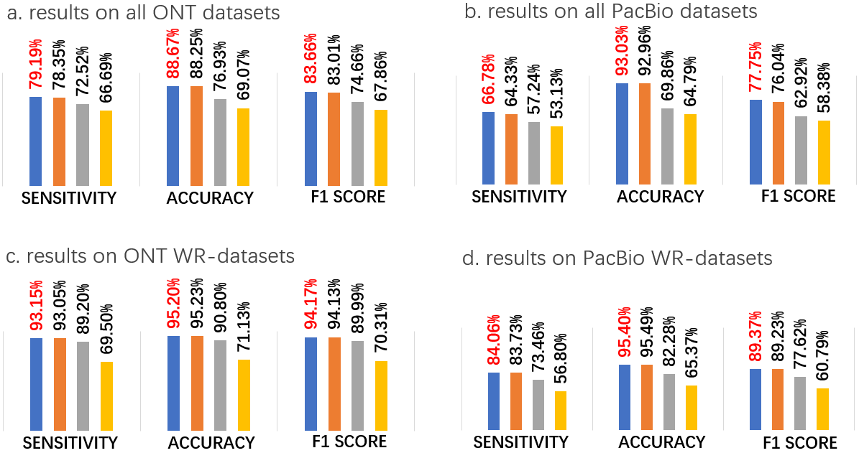

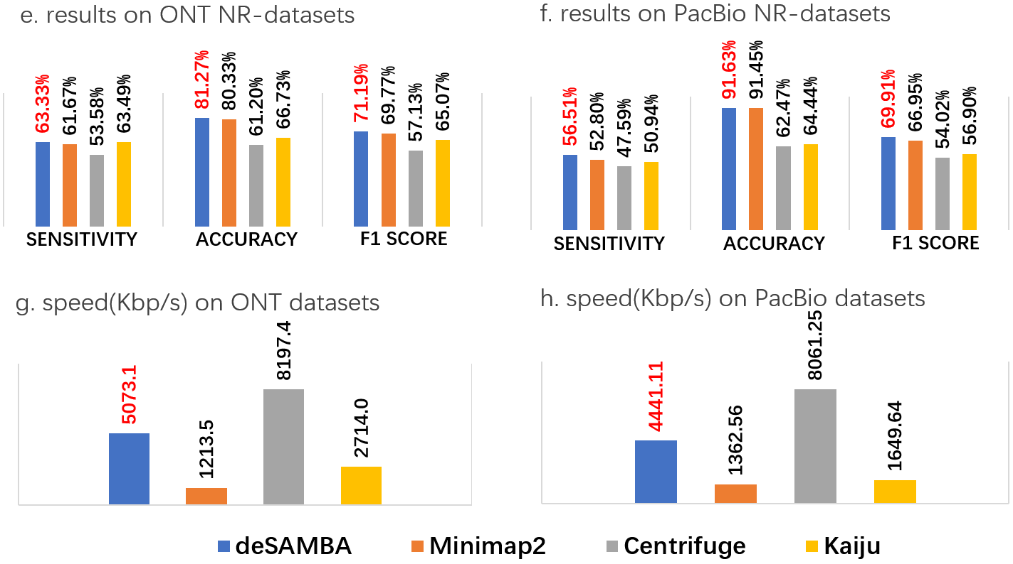

- The results of the various approaches on the pseudo metagenomics datasets
The subfigures a-f respectively indicate the average sensitivity, accuracy, F1-score on all the 86 ONT (a) and 59 PacBio (b) datasets, the WR-datasets produced by ONT (c) and PacBio (d) platforms, the NR-datasets produced by ONT (e) and PacBio (f) platforms. The speed of the various approaches on all the 86 ONT and 59 PacBio datasets are respectively shown in subfigures g and h (assessed with 8 CPU threads).

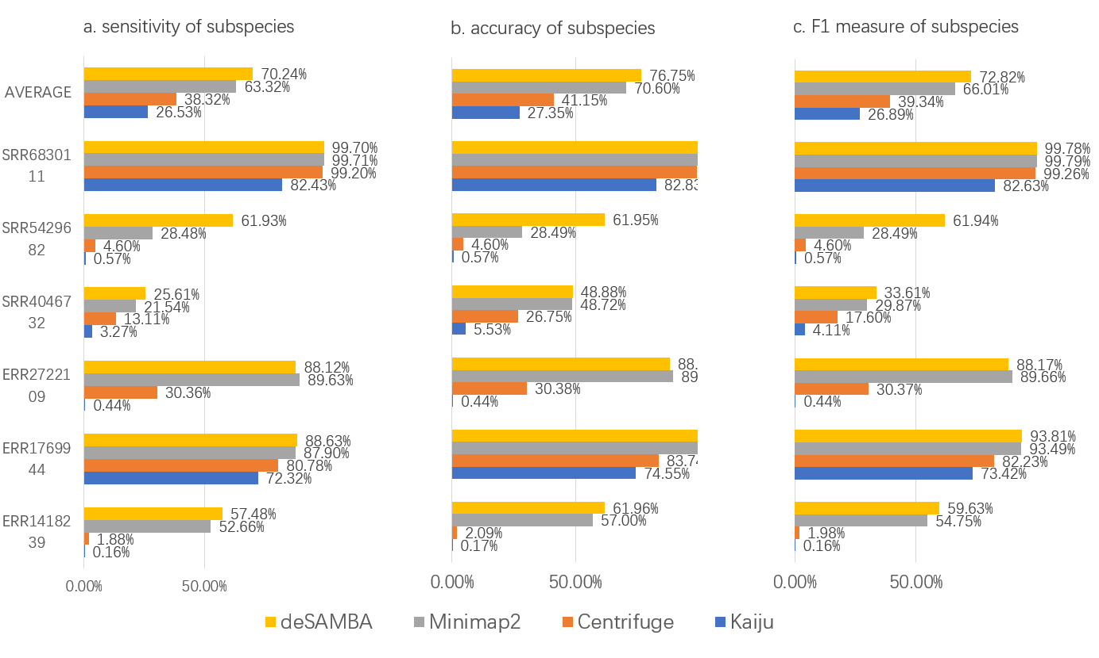
- The results of the various approaches on the 6 ONT datasets with strain-level labels
The sensitivity (a), accuracy (b) and F1-score (c) of the four approaches on the 6 ONT datasets with strain-level labels. The averaged statistics (marked as “AVERAGE”) and the statistics on the 6 datasets (SRA Accessions: ERR1418239, ERR1769944, ERR2722109, SRR4046732, SRR5429682 and SRR6830111, corresponding to lines 13, 14, 19, 24, 31, 48 of Supplementary Table 1) are respectively shown in the bar plots.

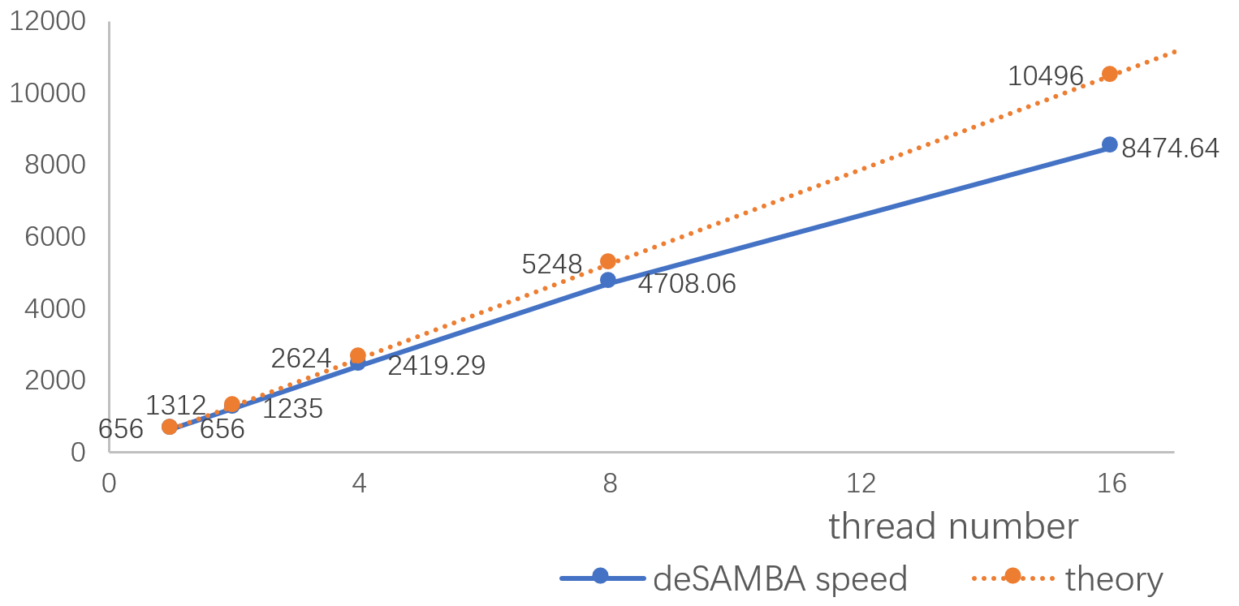
- The speed of deSAMBA with various numbers of CPU threads
The figure shows the speed of deSAMBA with 1, 2, 4, 8 and 16 CPU threads (blue line and dots). The orange dashed line and dots indicate the speedup in theory with the same numbers of threads.

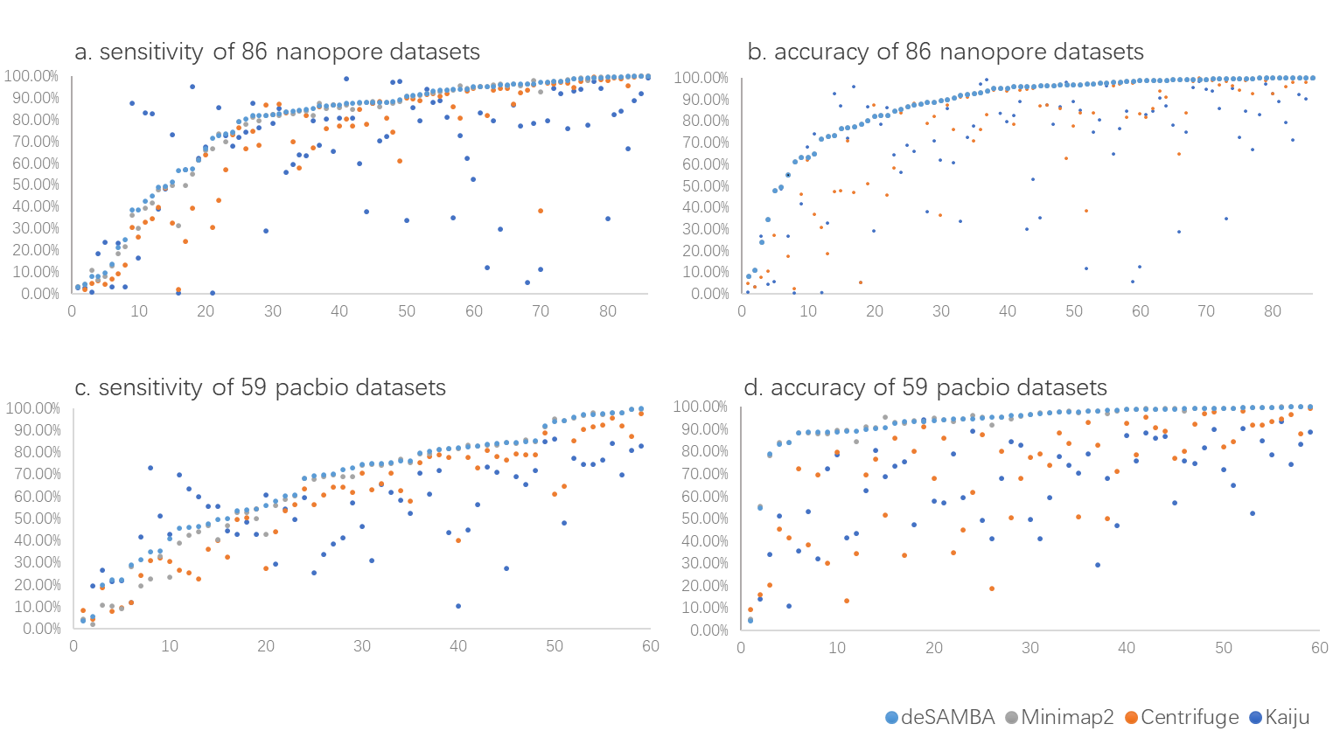
- The sensitivities and accuracies on the pseudo metagenomics datasets
The sensitivities (subfigures a and c) and accuracies (subfigures b and d) of various approaches are shown by various colored dots (light blue, gray, orange and blue dots for the results of deSAMBA, Minimap2, Centrifuge and Kaiju, respectively).

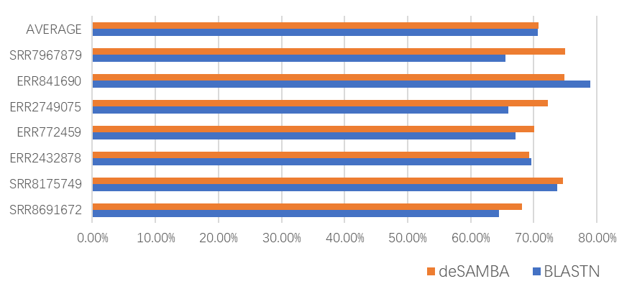
- The sensitivity of BLASTN on 7 WR-datasets with low sensitivity
There are 7 WR-datasets (accession numbers: SRR7967879, ERR841690, ERR2749075, ERR772459, ERR2432878, SRR8175749 and SRR8691672) which deSAMBA had <80% sensitivities (indicated by orange bars in the figure). BLSATN was used to directly align the reads of these datasets to their ground truth genomes, respectively. The blue bars indicate the sensitivities of BLASTN on these datasets. The sensitivity of BLASTN for a given dataset is defined by the proportion of the reads having alignment outputs.

Supplementary Notes

Implementation of benchmark
All the benchmarks were carried out on a server with 4 Intel E7-4820 CPUs (32 cores) and 1 TB RAM running Ubuntu Linux OS. All the benchmarked classification tools were run in 8 CPU threads. Some detailed information about employed reference sequences, the real sequencing datasets and the command lines used for read classification is as following.

2.1 Reference sequences used for benchmark
We downloaded all reference sequences from NCBI RefSeq database. A genome sequence from RefSeq database was employed only if it is marked as a “complete genome”. There are totally 8621 bacterial, 251 archaea and 7412 viral genomes being used. The RefSeq ID and Taxonomy ID are described in “reference describe.txt”. For kaiju, the reference index was built using NCBI protein database, due to its specifically designed read classification approach.
Downloading “assembly_summary” files:
ftp://ftp.ncbi.nlm.nih.gov/genomes/refseq/bacteria/assembly_summary.txt
ftp://ftp.ncbi.nlm.nih.gov/genomes/refseq/viral/assembly_summary.txt
ftp://ftp.ncbi.nlm.nih.gov/genomes/refseq/archaea/assembly_summary.txt
Download “fna” file using “ftp_path” item of each assembly accession line. For example:
ftp://ftp.ncbi.nlm.nih.gov/genomes/all/GCF/000/189/935/GCF_000189935.1_ASM18993v2/GCF_000189935.1_ASM18993v2_genomic.fna.gz
All reference sequences were downloaded using an in-house script:
https://github.com/hitbc/deSAMBA-meta/blob/master/download
We used this script to download the reference sequences via the following commandlines:
bash ./download -P 10 -o $DOWNLOAD -d bacteria refseq
bash ./download -P 10 -o $DOWNLOAD -d viral refseq
bash ./download -P 10 -o $DOWNLOAD -d archaea refseq
All reference files were combined before the construction to the index:
find $DOWNLOAD/ -name "*.fna" | xargs -n 1 cat > ref.fa

2.2 Pseudo-metagenomics datasets and ground truth
We downloaded the 145 real sequencing pseudo-metagenomics datasets from NCBI Sequence Read Archive (SRA). The datasets are from various bacteria, viral or archaea genomes. It is also worthnoting that for all the datasets, only the reads longer than 1000 bp were used for the benchmark.
The ground truth of a dataset was got from NCBI SRA database, and the true organism of a dataset is shown in the “Organism” label:
https://trace.ncbi.nlm.nih.gov/Traces/sra/?run= [ SRA accession]
The taxonomy and genus labels of a dataset are got from NCBI taxonomy database:
https://www.ncbi.nlm.nih.gov/Taxonomy/Browser/wwwtax.cgi

2.3 Command lines used for read classification
1) Benchmark for deSAMBA (version 1.0)
Building index:
bash ./build-index ref.fa INDEX_DIR
Read classification:
deSAMBA classify -t 8 -s 62 INDEX_DIR read.fastq > classify.sam
2) Benchmark for minimap2[1] (version 2.16 r922):
Building index for PACBIO data:
minimap2 -x map-pb -d ref_pb.mmi ref.fa
Building index for NANOPORE data:
minimap2 -x map-ont -d ref_np.mmi ref.fa
Read classification for PACBIO data:
minimap2 -a ref_pb.mmi read.fastq -t 8 > classify.sam
Read classification for NANOPORE data:
minimap2 -a ref_np.mmi read.fastq -t 8 > classify.sam
3) Benchmark for Centrifuge[2] (version 1.0.4)
Building index:
centrifuge-build -p 16 --conversion-table ref.map --taxonomy-tree nodes.dmp --name-table names.dmp ref.fa INDEX_DIR
Read classification:
centrifuge-class INDEX_DIR --out-fmt sam -t -p 8 -U read.fastq > classify.cen
4) Benchmark for KAIJU[3] (version 1.6.3)
Building index:
kaiju-makedb -s refseq
Read classification in MEM mode:
kaiju -t node.dmp -f kaiju_db_refseq.fmi -v -a mem -i read.fastq -z 8 > classify.kai

References
1. Li H. Minimap2: pairwise alignment for nucleotide sequences, Bioinformatics 2018;34:3094-3100.
2. Kim D, Song L, Breitwieser FP et al. Centrifuge: rapid and sensitive classification of metagenomic sequences, Genome Research 2016;26:1721-1729.
3. Menzel P, Ng KL, Krogh A. Fast and sensitive taxonomic classification for metagenomics with Kaiju, Nat Commun 2016;7:11257.

