Supplementary Material
- Quantum mechanical predictions of the antioxidant capability of moracin C isomers

Angela Parise^{1,2}, Bruna Clara De Simone¹, Tiziana Marino¹, Marirosa Toscano¹, Nino Russo^{1*}
1 Dipartimento di Chimica e Tecnologie Chimiche, Università della Calabria, 87036 Rende, Italy
2 Université Paris-Saclay, CNRS, Institut de Chimie Physique UMR8000, Orsay, France
* Correspondence:
Nino Russo
nrusso@unical.it
Supplementary Data

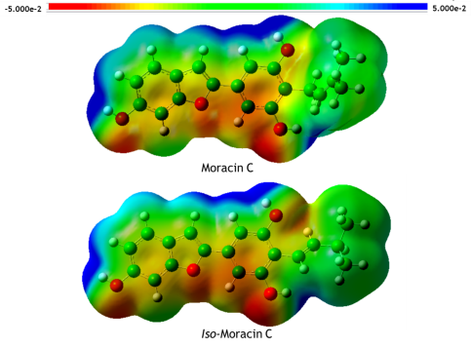
Figure S1. Molecular electrostatic potential (MEP) for moracin C and iso-moracin C structures optimized in water at M05-2X/6-311++G(d,p) level of theory.

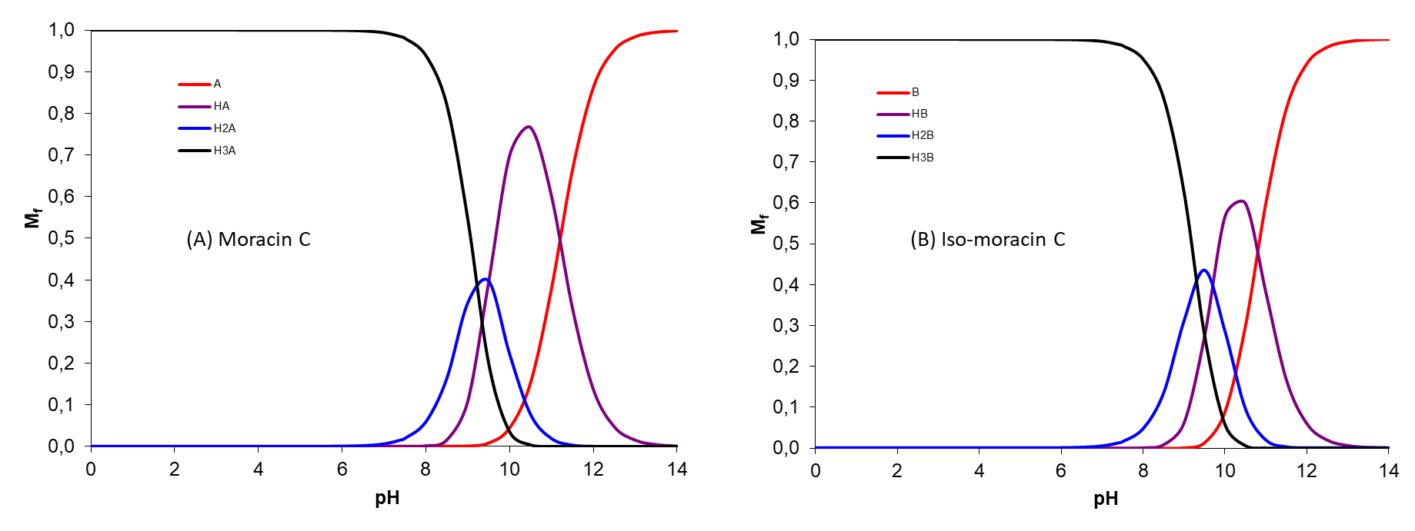
Figure S2. Molar fractions (M f) of the different acid–base species of moracin C and iso-moracin C at physiological pH.

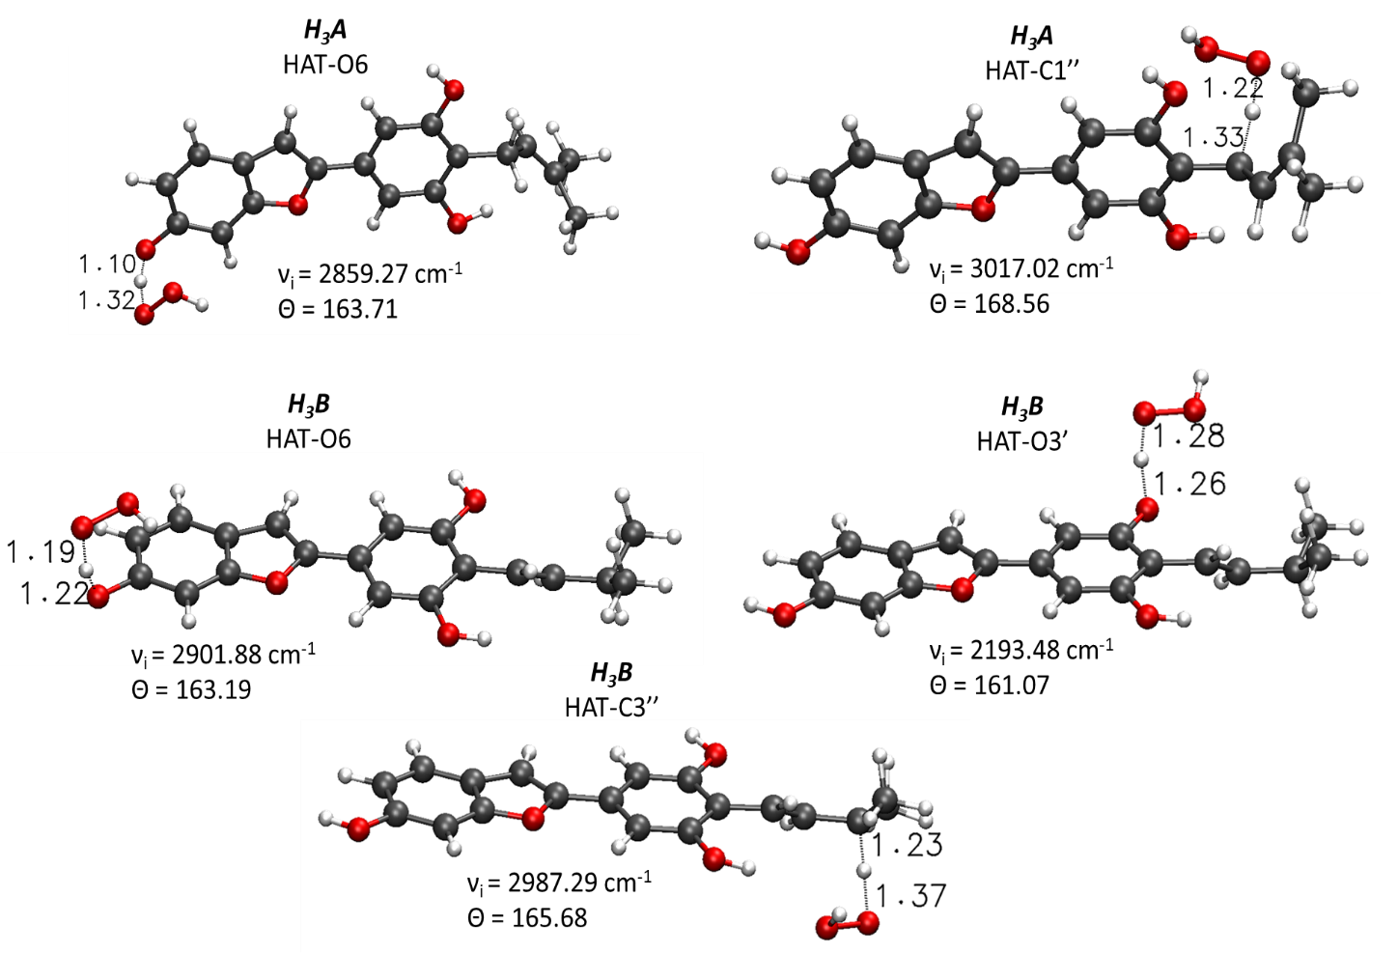
Figure S3. Main geometrical parameters for the optimized TSs structures in lipidic environment for the HAT mechanism of neutral moracin C and iso-moracin C. Bond lengths are in Å, angles in degrees and imaginary frequencies in cm-1.

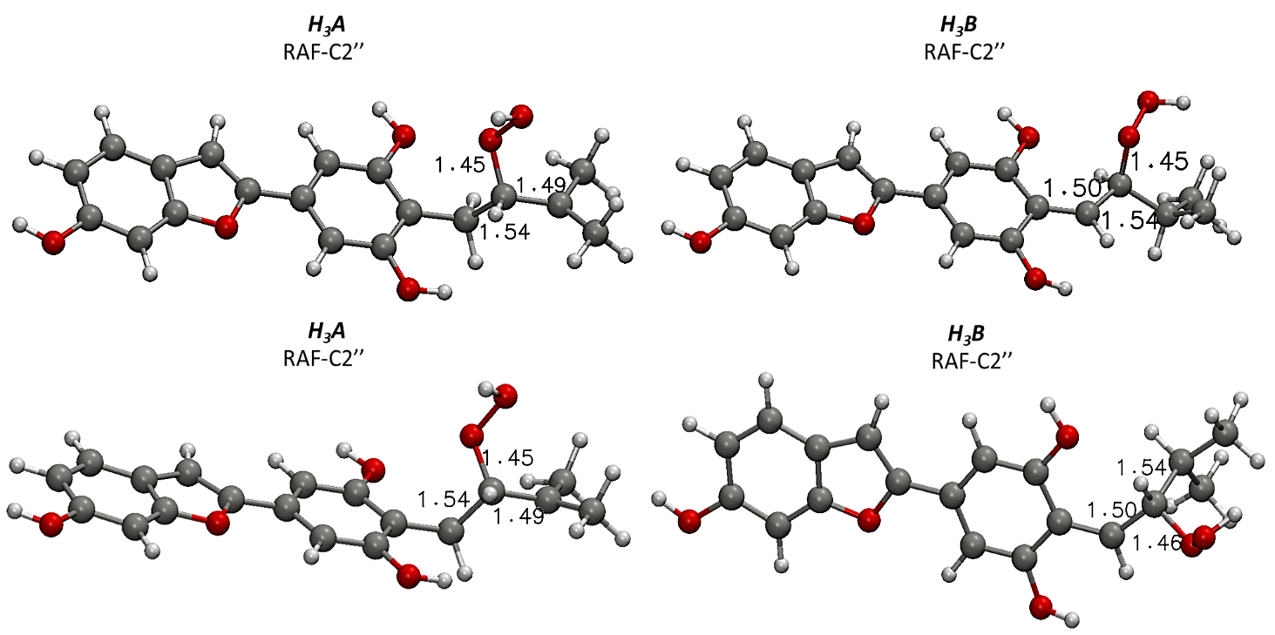
Figure S4.. Main geometrical parameters for the optimized structures in water (on top) and lipidic (down) solvent, concerning the RAF mechanism, for the OOH-moracin C and OOH-iso-moracin C. Bond lengths are in Å.

Table S1. NBO charge values in |e| for the optimized geometries of moracin C and iso-moracin C.
NBO | Moracin C | Iso-moracin C
O (6) | -0.761 | -0.761
H (6) | 0.552 | 0.552
O (3’) | -0.758 | -0.754
H (3’) | 0.556 | 0.554
O (5’) | -0.756 | -0.756
H (5’) | 0.556 | 0.552
C (4’) | -0.152 | -0.193
C (1’’) | -0.533 | -0.301
C (2’’) | -0.266 | -0.170
C (3’’) | -0.029 | -0.339
C (4’’) | -0.743 | -0.704
H1 (C4’’) | 0.261 | 0.244
H2 (C4’’) | 0.255 | 0.251
H3 (C4’’) | 0.260 | 0.252
C (5’’) | -0.733 | -0.719
H1 (C5’’) | 0.257 | 0.246
H2 (C5’’) | 0.257 | 0.251
H3 (C5’’) | 0.255 | 0.256

Table S2. CC bond lengths and atomic spin density values for the OOH addition to the C2” atom of Moracin C and Iso-Moracin C in water (A) and PE (B) environments
 | Water |  |  |  | PE
 | H₃A RAF-C2'' |  | H₃B RAF-C2'' |  | H₃A RAF-C2'' |  | H₃B RAF-C2''
Atom | d (Å) | Spin density | d (Å) | Spin density | d (Å) | Spin density | d (Å) | Spin density
1 | - | 3.60 10⁻⁰⁵ | - | 1.81 10 ⁻⁰³ | - | 3.60 10 ⁻⁰⁵ | - | 4.31 10 ⁻⁰³
8 | 1.361 | 2.34 10⁻⁰⁴ | 1.369 | 1.24 10 ⁻⁰² | 1.371 | 2.34 10 ⁻⁰⁴ | 1.369 | 2.83 10 ⁻⁰²
7 | 1.395 | -1.64 10 ⁻⁰⁴ | 1.384 | -8.52 10 ⁻⁰³ | 1.394 | -1.64 10 ⁻⁰⁴ | 1.381 | -2.00 10 ⁻⁰²
6 | 1.394 | 1.99 10 ⁻⁰⁴ | 1.392 | 1.40 10 ⁻⁰² | 1.394 | 1.99 10 ⁻⁰⁴ | 1.390 | 3.30 10 ⁻⁰²
5 | 1.410 | -6.50 10 ⁻⁰⁵ | 1.411 | -5.02 10 ⁻⁰³ | 1.409 | -6.50 10 ⁻⁰⁵ | 1.411 | -1.22 10 ⁻⁰²
4 | 1.391 | 2.95 10 ⁻⁰⁴ | 1.392 | 1.49 10 ⁻⁰² | 1.382 | 2.95 10 ⁻⁰⁴ | 1.393 | 3.64 10 ⁻⁰²
9 | 1.460 | -2.01 10 ⁻⁰⁴ | 1.460 | -1.63 10 ⁻⁰² | 1.403 | -2.01 10 ⁻⁰⁴ | 1.403 | -3.70 10 ⁻⁰²
3 | 1.441 | 1.22 10 ⁻⁰³ | 1.443 | 5.25 10 ⁻⁰² | 1.441 | 1.22 10 ⁻⁰³ | 1.440 | 1.25 10 ⁻⁰¹
2 | 1.351 | -5.32 10 ⁻⁰⁴ | 1.357 | -4.26 10 ⁻⁰² | 1.357 | -5.32 10 ⁻⁰⁴ | 1.361 | -9.33 10 ⁻⁰²
1' | 1.459 | 3.23 10 ⁻⁰³ | 1.453 | 1.17 10 ⁻⁰¹ | 1.462 | 3.23 10 ⁻⁰³ | 1.451 | 2.46 10 ⁻⁰¹
2' | 1.403 | 2.45 10 ⁻⁰³ | 1.401 | -7.92 10 ⁻⁰² | 1.403 | 2.45 10 ⁻⁰³ | 1.411 | -1.45 10 ⁻⁰¹
3' | 1.392 | -1.35 10 ⁻⁰³ | 1.382 | 1.26 10 ⁻⁰¹ | 1.381 | -1.35 10 ⁻⁰³ | 1.384 | 2.60 10 ⁻⁰¹
4' | 1.404 | -2.13 10 ⁻⁰² | 1.441 | -1.03 10 ⁻⁰¹ | 1.402 | -2.13 10 ⁻⁰² | 1.439 | -2.75 10 ⁻⁰¹
1'' | 1.508 | 1.33 10 ⁻⁰² | 1.400 | 8.85 10 ⁻⁰¹ | 1.503 | 1.33 10 ⁻⁰² | 1.403 | 7.44 10 ⁻⁰¹
2'' | 1.543 | -1.59 10 ⁻⁰² | 1.504 | -3.79 10 ⁻⁰² | 1.544 | -1.59 10 ⁻⁰² | 1.499 | -8.85 10 ⁻⁰²
3'' | 1.513 | 9.26 10 ⁻⁰¹ | 1.541 | 3.04 10 ⁻⁰³ | 1.491 | 9.26 10 ⁻⁰¹ | 1.542 | 2.64 10 ⁻⁰²
4'' | 1.491 | 3.23 10 ⁻⁰² | 1.530 | 1.51 10 ⁻⁰³ | 1.490 | 3.23 10 ⁻⁰² | 1.531 | -2.67 10 ⁻⁰³

