**Supporting Information**

**Coronarin K and L: Two Novel Labdane Diterpenes from Roscoea purpurea: An Ayurvedic Crude Drug**

Venugopal Singamaneni1, Bashir Lone1, Jasvinder Singh2,3, Pankaj Kumar4, Sumeet Gairola2,4, Shashank Singh2,3, Prasoon Gupta1,2,*

*1Natural Product Chemistry Division, Indian Institute of Integrative Medicine, Canal Road, Jammu-180001, India*

*2Academy of Scientific & Innovative Research (*AcSIR*), CSIR, New Delhi-110025, India*

*3Cancer Pharmacology Division, Indian Institute of Integrative Medicine, Canal Road, Jammu-180001, India*

*4Plant Science Division, Indian Institute of Integrative Medicine, Canal Road, Jammu-180001, India*

------------

* To whom corresponding should be addressed.

Dr. Prasoon Gupta Ph.D.

Principal Scientist

Indian Institute of Integrative Medicine

Canal Road, Jammu-180001

Office: +91(191) - 2585006-13 Ext-485

Fax: 0191-2569333

Mail: [guptap@iiim.ac.in](mailto:guptap@iiim.ac.in)

**Supporting Information**

**Figure S1.** 1H NMR (400 MHz, CDCl3) spectrum of compound **1**

**Figure S2.** 13C NMR (100 MHz, CDCl3) spectrum of compound **1**

**Figure S3.** 13C NMR (DEPT) (100 MHz, CDCl3) spectrum of compound **1**

**Figure S4.** HMBC spectrum of compound **1**

**Figure S5.** HSQC spectrum of compound **1**

**Figure S6.** COSY spectrum of compound **1**

**Figure S7**.ESI-MS Spectrumof compound **1**

**Figure S8.** 1H NMR (400 MHz, CDCl3) spectrum of compound **2**

**Figure S9.** 13C NMR (100 MHz, CDCl3) spectrum of compound **2**

**Figure S10.** 13C NMR (DEPT) (100 MHz, CDCl3) spectrum of compound **2**

**Figure S11.** HMBC spectrum of compound **2**

**Figure S12.** HSQC spectrum of compound **2**

**Figure S13.** COSY spectrum of compound **2**

**Figure S14**.ESI-MS Spectrumof compound **2**



**Figure S1.** 1H NMR (400 MHz, CDCl3) spectrum of compound **1**



**Figure S2.** 13C NMR (100 MHz, CDCl3) spectrum of compound **1**

**Figure S3.** 13C NMR (DEPT) (100 MHz, CDCl3) spectrum of compound **1**



**Figure S4.** HMBC spectrum of compound **1**



**Figure S5.** HSQC spectrum of compound **1**



**Figure S6.** COSY spectrum of compound **1**

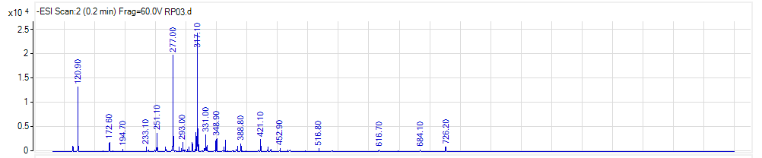

**Figure S7**.ESI-MS Spectrumof compound **1**

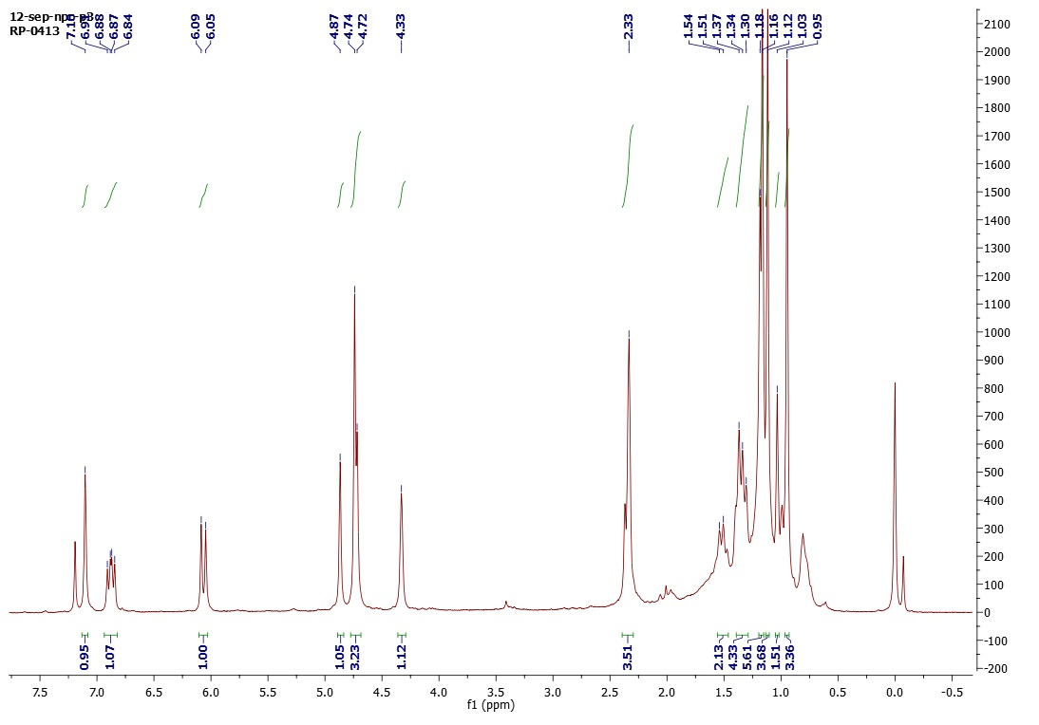

**Figure S8.** 1H NMR (400 MHz, CDCl3) spectrum of compound **2**



**Figure S9.** 13C NMR (100 MHz, CDCl3) spectrum of compound **2**



**Figure S10.** 13C NMR (DEPT) (100 MHz, CDCl3) spectrum of compound **2**

**Figure S11.** HMBC spectrum of compound **2**

**Figure S12.** HSQC spectrum of compound **2**



**Figure S13.** COSY spectrum of compound **2**

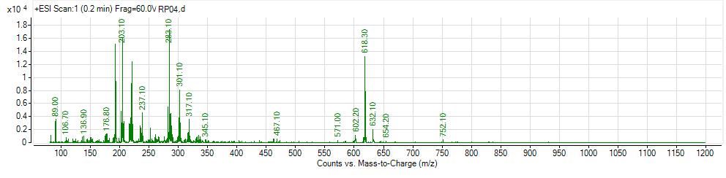

**Figure S14**.ESI-MS Spectrumof compound **2**