Supplementary Material

Supplementary Figures and Tables

Supplementary Figures
Supplementary Figure 1A. Melting curve analysis showing specificity of primers used on RT-qPCR reactions. A - Analysis of each identified sugarcane Mitchell clade A gene and reference gene ScGAPDH. All ScAT1 to ScAT9 and ScGAPDH genes from sugarcane were analyzed in young internode, while ScAT10 and ScAT5 genes were analyzed in immature leaf tissues. Plots show Derivative Reporter (Rn) versus Temperature (°C), for each primer pair. Colored peaks represent samples and curves in beige represent negative control.

Supplementary Figure 1B. Melting curve analysis showing specificity of primers used on RT-qPCR reactions. B - Melting curve analysis of sugarcane transgene ScAT10 and maize endogenous ZmAT10 and reference genes ZmLUG and ZmMEP in RT-qPCR analysis of transgenic maize lines (Ubi:ScAT10). Plots show Derivative Reporter (Rn) versus Temperature (°C), for each primer pair. Colored peaks represent samples and curves in beige represent negative control.

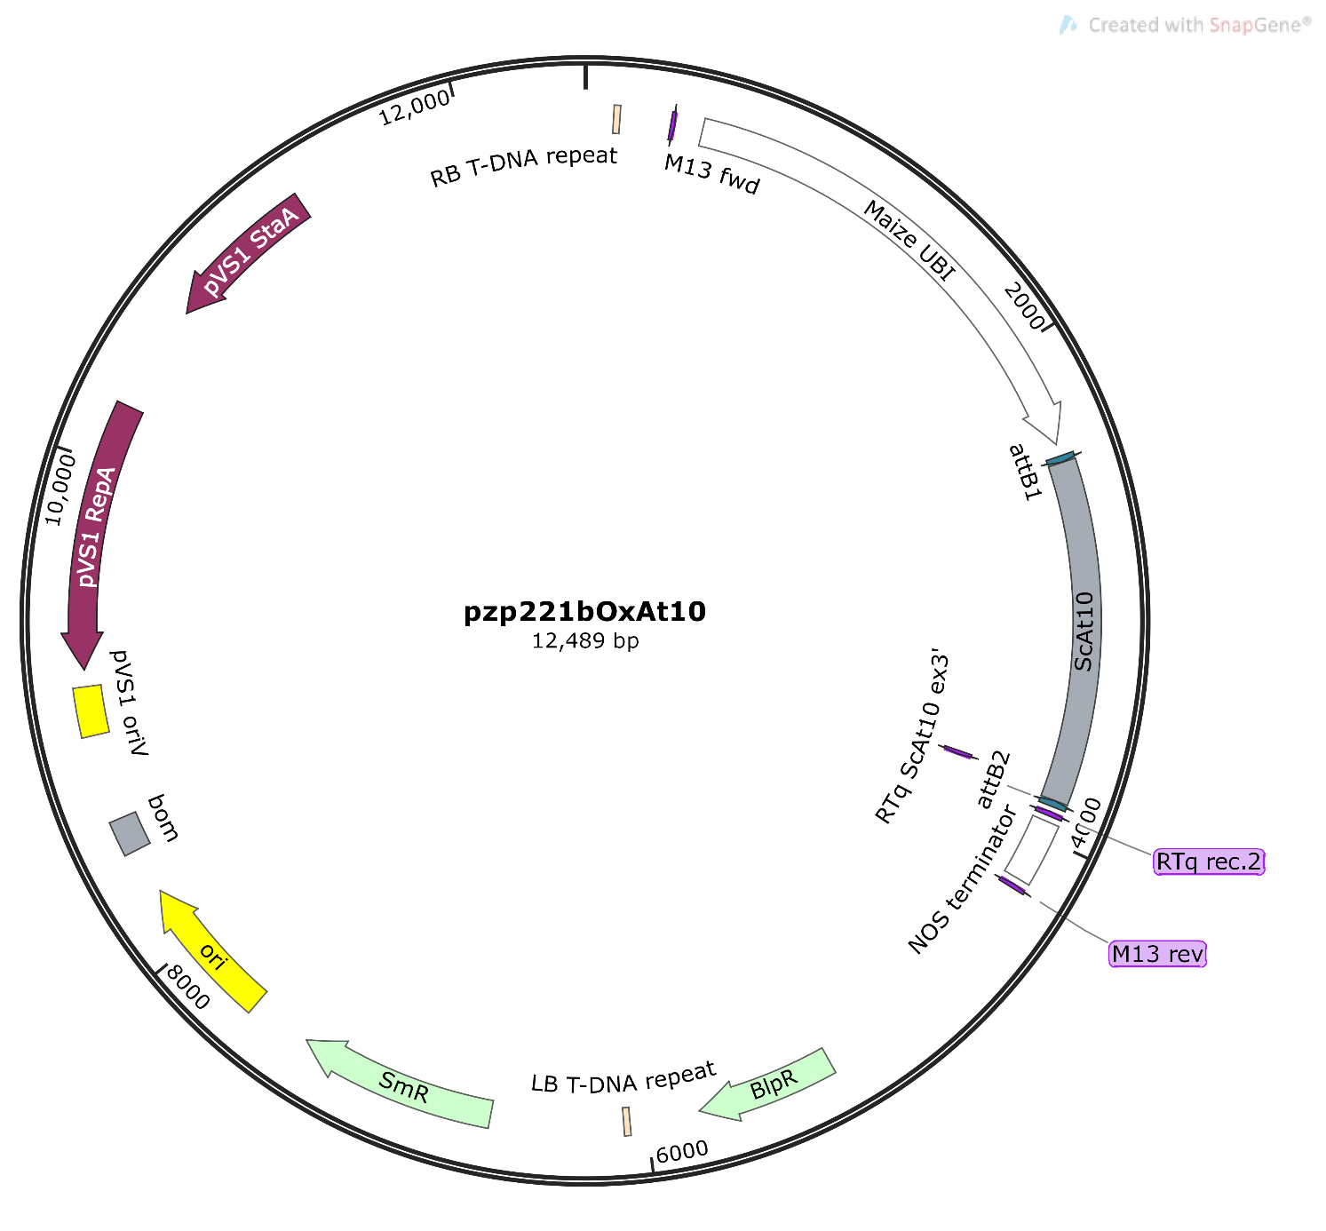
Supplementary Figure 2. Pzp221b:Ox:ScAT10 (ScAT10 overexpression) construction map. pCS1 StaA/ RepA, stability, and replication protein from Pseudomonas plasmid pVS1. Bom, basis of mobility region of pBR322. RB T-DNA, Right border repeat from T-DNA. Maize UBI, maize ubiquitin 1 promoter. attb1/attb2, Gateway® recombination sites. ScAT10, sugarcane AT10 cDNA. RTq rec2/RTq ScAT10 ex3`, primers used in RT-qPCR analysis for expression levels determination. NOS terminator, nopaline synthase transcription terminator. BlpR, Bialaphos resistance gene. LB T-DNA, Left border repeat from T-DNA. SmR, Spectinomycin and Streptomycin resistance gene (aadA). Number represent the length in base pairs.

Supplementary Figure 3. Growth of maize transgenic and control lines. A - Plants after 1-month growth, cultivated in 11.5 L pots, in the greenhouse (16 h light, 8 h dark regime). B - Adult plants after 2-month growth.

Supplementary Figure 4. Alignment of endogenous maize ZmAT10 gene and the ScAT10 cDNA region used to design primers Ox:ScAT10genF/R to genotype transgenic lines, showing primer specificity. A - Alignment showing Ox:ScAT10genF primer binding region. B - Alignment showing Ox:ScAT10genR primer binding region. The highlight in orange represents a break in the primer sequence, showing that the primer does not anneal in the genomic intron region (in brackets).

Supplementary Figure 5. Expression profile of sugarcane Mitchell clade A genes. Heatmap data of normalized reads for distinct EST libraries from SUCEST. Each library corresponds to a distinct tissue: SB1 Stalk bark upper; ST1 First apical internode; ST3 Fourth apical internode; LR1-2 Leaf-roll; LV1 Etiolated leaves; RT 1-2-3 Root; RZ1-2 Shoot root trans-zone; RZ3 Shoot-root trans-zone; FL1 Inflorescence at beginning; FL3 Base of developing inflorescence; FL4 Developed inflorescence; FL5 Developed inflorescence; AM1 Apical meristem (mature); AM2 Apical meristem (immature); LB1-2 Lateral bud; CL6 Cauli-temperature stress; SD1-2 Developing seeds.

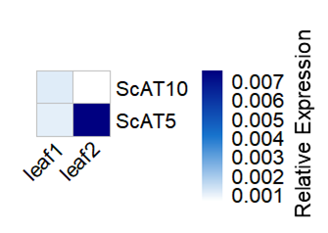
Supplementary Figure 6. RT-qPCR relative expression levels of ScAT10 and ScAT5 in immature leaf tissues of sugarcane hybrid H321. Values are relative expression normalized with reference gene GAPDH (2^-ΔCt).

Supplementary Figure 7. Multiple sequence alignment of AT10 sequences from sugarcane and other grasses. Bd, Os, Sb, Sc, Sv, and Zm is abbreviation from Brachypodium, rice, sorghum, sugarcane, Setaria, and maize. The region containing PFAM transferase domain of AT10 sequences is indicated by brackets.

Supplementary Figure 8. In silico expression profile of AT10 ortholog genes in maize, rice, and Brachypodium. (A) Micro-array expression data of OsAT10 in distinct tissues from rice (Jain et al., 2007). (B) Micro-array expression data of BdAT10 in distinct tissues from Brachypodium (Winter et al., 2007; Sibout et al., 2017). T- Plants cultivated in growth chamber in Toulouse, France. V- Plants grown in green house in Versailles, France. (C) RNA-seq expression data of ZmAT10 in distinct tissues from maize B73 (Hoopes et al., 2019). Analysis obtained from Bar Utoronto eFP Browser tool (http://bar.utoronto.ca).

Supplementary Figure 9. PCR genotyping of transgenic maize lines. Ubi:ScAT10 lines are positive for the presence of the ScAT10 insert, whereas escape-2 and escape-3 are negative (empty vectors). MM - Molecular weight marker, 100 bp. Electrophoresis was performed using a 3% agarose gel stained with ethidium bromide.

Supplementary Figure 10. Digestibility of cell walls from transgenic Ubi:ScAT10 and control lines treated with cellulase and xylanase mix. Values represent average percent of cell wall sugar conversion after 48 h hydrolysis. Red boxes represent the distribution of values for transgenic lines (Ubi:ScAT10-2,-6,-11, and -14, n=4 plants). Blue boxes represent the distribution of values for control lines (empty vector escape-2 and escape-3, and wild-type (WT) B73, n=3 plants). Each box delimits values within the first and third quartile range. The horizontal black lines in the boxes represent median values. Whiskers represent the data range. Means of transgenic lines were not significantly different from mean of controls (empty and B73) at p<0.05 (Welch’s t-test).

Supplementary Tables

Supplementary Table 1. DNA primers for cloning, genotyping, and RT-qPCR analyses.

Name | Sequence | Purpose
ScAT1 F | TTCCCTCCGTTGTGTACCTG | RT-qPCR sugarcane
ScAT1 R | TTCCCACTGTGGAATGGAAT
ScAT2 F | GCCAAGTTCGCGTAGATCAT | RT-qPCR sugarcane
ScAT2 R | CGTTTGCATCCAACAATGTC
ScAT3 F | GCATCATGACCATGTGCGTC | RT-qPCR sugarcane
ScAT3 R | CCAAACTTGCACCTGGATGC
ScAT5 F | CAGTGTGTGGAGGAGAAGCA | RT-qPCR sugarcane
ScAT5 R | CCAATGAGGCTACTGGTCAA
ScAT6 F | CAGGTCGGTCTGTGTTGGAA | RT-qPCR sugarcane
ScAT6 R | AACCCCACCCATCAGTTAGC
ScAT7 F | CAGGGGCCAGGCTCATCA | RT-qPCR sugarcane
ScAT7 R | ACCCATGAACAAACGGGAGG
ScAT8 F | GCCTTCCACAAGGACATGAT | RT-qPCR sugarcane
ScAT8 R | TCATGGGATACAGCAACGAA
ScAT9 F | GCGTCACCAAGGAGCACT | RT-qPCR sugarcane
ScAT9 R | CAGTTTCCCCGTTTCATCAT
ScAT10 F | GAGGACCTCGTCTGATACGATA | RT-qPCR sugarcane
ScAT10 R | TCAGCACACTCACACGTAGG
ScGAPDH F | TTGGTTTCCACTGACTTCGTT | RT-qPCR sugarcane  reference gene
ScGAPDH R | CTGTAGCCCCACTCGTTGT | GAPDH (SCCCCL3001G02.g)
AttB1-OxShAT10 F | GGGGACAAGTTTgtacaaaaaagcaggctTT  ATGGGCATCTTCACGG | Amplify AttbScAT10 product for gateway cloning
AttB2-OxShAT10 R | GGGGACCACTTTGTACAAGaaagctgggtAT  CAGACGAGGTCC
Ox:ScAT10gen F | TGACCACCAAGCAGAAGTCC | Genotyping Ox:ScAT10 (Ubi:ScAT10 lines)
Ox:ScAT10gen R | CGTGACCTGTATCATGGCGA
RTq ScAT10 ex3'.2 | AGCTGCGTCACCAAGGAG | RT-qPCR analysis of ScAT10
RTq rec.2 | CTAGTAACGGCCGCCAGTG | expression
RTq_LUG_F | CAGGGAAGGTTGCCTCAGTA | RT-qPCR reference gene
RTq_LUG_R | GCGTCATGTGGTCATTTTTG | LEUNIG (GRMZM2G425377)
RTq_MEP_F | CCATCTGTCTGGGTCAGGAT | RT-qPCR reference gene
RTq_MEP_R | TTTGATGCTCCAGGCTTACC | Membrane  protein PB1A10.07c
 |  | (GRMZM2G018103)

Supplementary Table 2A. Product size of each RT-qPCR amplicon and average primer pair efficiency as estimated by LinReg PCR for primers used in RT-qPCR expression analysis of Mitchell clade A genes in sugarcane samples.

Name | Product size | Efficiency
ScAT1 | 148 bp | 1.88
ScAT2 | 140 bp | 1.85
ScAT3 | 143 bp | 1.92
ScAT5 | 141 bp | 1.83
ScAT6 | 127 bp | 1.92
ScAT7 | 124 bp | 1.90
ScAT8 | 118 bp | 1.79
ScAT9 | 109 bp | 1.92
ScAT10 | 105 bp | 1.86
ScGAPDH | 122 bp | 1.91

Supplementary Table 2B. Product size of each RT-qPCR amplicon and average primer pair efficiency as estimated by LinReg PCR for primers used in RT-qPCR expression analysis of Ubi:ScAT10 in maize transgenic and control lines.

Name | Product size | Efficiency
RTq ScAT10 ex3'.2/ RTq rec.2 | 128 | 1.68
RTqZmLUG | 110 | 1.90
RTq ZmMEP | 129 | 1.74
RTq ZmCUL | 125 | 1.80

Supplementary Table 3A. Sugarcane sequences from genomic sources identified in the Mitchell Clade A and alignment information with sorghum ortholog.
Name | Sorghum | Sugarcane genomic | Source | Identity* |  | Cover  ** | Length sugarcane (aa) | Length sorghum(aa)
AT1 | Sobic.003G219800 | deg7180000190712_g2410ª | SP8032-80 | 97 | 100 |  | 429 | 426
AT2 | Sobic.003G219700 | scf7180000349327_g7029ª | SP8032-80 | 95 | 99 |  | 425 | 428
 |  | scf7180000356993_g1930 | SP8032-80 | 98 | 37 |  | 162
 |  | scf7180000354309_g6422 | SP8032-80 | 99 | 37 |  | 162
AT3 | Sobic.009G034300 | Sh09_p003100ª | R570 STP | 92 | 99 |  | 427 | 436
 |  | singlet_100000184749_g762 | SP8032-80 | 89 | 59 |  | 152
 |  | Sh_202B14_p000080 | R570 BAC | 90 | 55 |  | 236
 |  | Sh_202B14_p000070 | R570 BAC | 93 | 69 |  | 294
AT5 | Sobic.008G068300 | scf7180000355999_g504ª | SP8032-80 | 94 | 64 |  | 287 | 440
AT6 | Sobic.003G043600 | Sh03_p003210ª | R570 STP | 95 | 100 |  | 436 | 444
 |  | Sh_219N24_p000050 | R570 BAC | 90 | 34 |  | 202
AT7 | Sobic.009G065600 | Not found | - | - | - |  | - | 441
AT8 | Sobic.010G180100 | Sh10_p012420ª | R570 | 94 | 100 |  | 441 | 438
 |  | Sh_217G03_p000010 | R570 BAC | 91 | 36 |  | 189
 |  | Sh_224K09_p000080 | R570 BAC | 93 | 100 |  | 441
AT9 | Sobic.003G037800 | deg7180000278811_g7338ª | SP8032-80 | 98 | 100 |  | 417 | 417
 |  | scf7180000354540_g6769 | SP8032-80 | 98 | 63 |  | 265
 |  | deg7180000229535_g7252 | SP8032-80 | 98 | 63 |  | 265
AT10 | Sobic.010G179900 | scf7180000358018_g3307ª | SP8032-80 | 92 | 100 |  | 453 | 446

References for each sugarcane sequence source: SP803280 - Riano-Pachón and Matiello, 2017, R570 - Garsmeur et al., 2018. Alignment performed using BLASTp with sorghum as query and sugarcane as subject. * Identity is the percentage of identities in the aligned region by BLASTp. ** Cover is the percent of sorghum sequence covered by the alignment. ª indicates code containing sequence used for ML tree in Fig. 1A.

Supplementary Table 3B. Sugarcane sequences from transcriptomic sources identified in the Mitchell Clade A and alignment information with sorghum ortholog.
Name | sorghum | Sugarcane genomic | Source | Identity* | Cover  ** | Length sugarcane (aa) | Length sorghum  (aa)
AT1 | Sobic.003G219800 | comp192319_c0_seq1 | leaf | 97 | 100 | 429 | 426
 |  | Locus824.1_Confidence_1.000_Length_1566 | internode | 97 | 100 | 429
 |  | SCJFRZ1005C03.g | SUCEST | 97 | 100 | 429
AT2 | Sobic.003G219700 | comp196893_c0_seq1 | leaf | 96 | 99 | 424 | 428
 |  | Locus3452.1_Confidence_1.000_Length_1064 | internode | 95 | 67 | 291
 |  | Locus18879.1_Confidence_1.000_Length_637 | internode | 99 | 33 | 145
 |  | SCQSLB1052F09.g | SUCEST | 95 | 99 | 425
AT3 | Sobic.009G034300 | SCJFRT2054E01.g | SUCEST | 93 | 96 | 414 | 436
 |  | SCQSLB1052F12.g | SUCEST | 87 | 65 | 212
 |  | comp193913_c2_seq1 | leaf | 95 | 70 | 304
 |  | comp193913_c3_seq1 | leaf | 86 | 41 | 135
 |  | Locus323.15_Confidence_0.243_Length_1901 | internode | 92 | 99 | 432
AT5 | Sobic.008G068300 | Locus5470.1_Confidence_1.000_Length_1343 | internode | 94 | 85 | 373 | 440
 |  | SCJLRT1018B04.b | SUCEST | 89 | 32 | 142
 |  | SCJLRT1018B04.g | SUCEST | 90 | 43 | 192
AT6 | Sobic.003G043600 | SCJFRT1010E08.g | SUCEST | 99 | 51 | 250 | 444
 |  | SCEZRZ3052G06.g | SUCEST | 84 | 36 | 162
AT7 | Sobic.009G065600 | comp105233_c0_seq1 | leaf | 97 | 21 | 131 | 441
 |  | Locus9463.10_Confidence_0.585_Length_1498 | internode | 88 | 91 | 395
 |  | SCJLLR1033F12.gª | SUCEST | 91 | 100 | 438
 |  | SCCCRT2C07A08.g | SUCEST | 95 | 29 | 134
AT8 | Sobic.010G180100 | comp203803_c0_seq1 | leaf | 66 | 80 | 308 | 438
 |  | Locus6993.4_Confidence_0.826_Length_1710 | internode | 94 | 66 | 308
 |  | SCEZRZ3094D10.g | SUCEST | 93 | 62 | 478
AT9 | Sobic.003G037800 | comp186435_c0_seq1 | leaf | 98 | 100 | 417 | 417
 |  | Locus3963.2_Confidence_1.000_Length_1583 | internode | 98 | 100 | 417
 |  | SCEQLR1007G01.g | SUCEST | 98 | 100 | 417
AT10 | Sobic.010G179900 | Locus7917.2_Confidence_1.000_Length_1272 | internode | 95 | 86 | 383 | 446
 |  | SCJFFL1C04C08.b | SUCEST | 96 | 51 | 199
References for each sugarcane sequence source: SUCEST - Vettore et al., 2003 (3); Vicentini et al., 2012 (4), leaf - Cardoso-Silva et al., 2014 (6), internode - Vicentini et al., 2015 (5). Alignment performed using BLASTp with sorghum as query and sugarcane as subject. * Identity is the percentage of identities in the aligned region by BLASTp. ** Cover is the percent of sorghum sequence covered by the alignment. ª indicates code containing sequence used for ML tree in Fig. 1A.

Supplementary Table 4A. Identity matrix for AT10 full-length amino acid sequences from Brachypodium, rice, maize, sorghum, sugarcane, and Setaria.
 | Brachypodium | Rice | Maize | Sorghum | Sugarcane | Setaria
Brachypodium | ID | 77.0% | 72.8% | 77.9% | 79.4% | 77.1%
Rice | 77.0% | ID | 74.2% | 81.0% | 80.5% | 79.2%
Maize | 72.8% | 74.2% | ID | 85.4% | 86.1% | 79.9%
Sorghum | 77.9% | 81.0% | 85.4% | ID | 92.9% | 85.9%
Sugarcane | 79.4% | 80.5% | 86.1% | 92.9% | ID | 87.3%
Setaria | 77.1% | 79.2% | 79.9% | 85.9% | 87.3% | ID

Amino acid sequences from Brachypodium (Bradi13g36990), rice (LOC_Os06g39390), maize (GRMZM2G107027), sorghum (Sobic.010G179900), sugarcane (scf7180000358018_g3307), and Setaria (Sevir.4G238000). Alignment was performed using ClustalW and the identity matrix was created using BioEdit®.

Supplementary Table 4B. Identity matrix for AT10 transferase domain region amino acid sequences from Brachypodium, rice, maize, sorghum, sugarcane, and Setaria.

 | Brachypodium | Rice | Maize | Sorghum | Sugarcane | Setaria
Brachypodium | ID | 78.2% | 79.0% | 81.2% | 81.1% | 80.8%
Rice | 78.2% | ID | 79.3% | 83.0% | 82.5% | 82.8%
Maize | 79.0% | 79.3% | ID | 91.0% | 91.0% | 86.9%
Sorghum | 81.2% | 83.0% | 91.0% | ID | 94.7% | 89.2%
Sugarcane | 81.1% | 82.5% | 91.0% | 94.7% | ID | 90.0%
Setaria | 80.8% | 82.8% | 86.9% | 89.2% | 90.0% | ID
Aminoacid sequences from Brachypodium (Bradi13g36990), Rice (LOC_Os06g39390), Maize (GRMZM2G107027), Sorghum (Sobic.010G179900), Sugarcane (scf7180000358018_g3307) and Setaria (Sevir.4G238000). Alignment was performed using ClustalW and the identity matrix was created using BioEdit®.

Supplementary Table 5. p-Coumaric acid (pCA), ferulic acid (FA) and ratio of pCA/FA content released by mild alkaline treatment, from culms of transgenic lines Ubi:ScAT10 and control lines(empty vector escape-2 and escape-3, and wild-type B73).

Lines | pCA | FA | pCA/FA
Ubi:ScAT10-2 | 29.0 ± 2.5 | 1.8 ± 0.2 *** | 15.9 ± 0.1 ***
Ubi:ScAT10-4 | 32.9 ± 2.3 ** | 3.1 ± 0.1 * | 10.6 ± 0.3 **
Ubi:ScAT10-6 | 29.3 ± 1.6 | 2.0 ± 0.2 *** | 15.1 ± 0.6 ***
Ubi:ScAT10-7 | 29.8 ± 0.5 | 3.7 ± 0.2 | 8.1 ± 0.2
Ubi:ScAT10-11 | 40.6 ± 1.0 *** | 1.5 ± 0.1 *** | 27.7 ± 0.7 ***
Ubi:ScAT10-13 | 21.2 ± 0.4 | 3.1 ± 0.1 * | 6.9 ± 0.1
Ubi:ScAT10-14 | 29.5 ± 1.3 | 0.7 ± 0.1 *** | 43.2 ± 2.2 ***
Ubi:ScAT10-15 | 20.8 ± 1.5 | 2.7 ± 0.2 ** | 7.7 ± 0.1
escape-2 | 27.8 ± 0.4 | 3.3 ± 0.3 | 8.6 ± 0.5
escape-3 | 18.6 ± 0.0 | 6.6 ± 0.2 | 2.8 ± 0.1
B73-1 | 20.3 ± 0.2 | 6.8 ± 0.0 | 3.0 ± 0.0
B73-2 | 26.0 ± 2.3 | 7.1 ± 0.5 | 3.6 ± 0.1
B73-3 | 21.3 ± 0.1 | 6.3 ± 0.0 | 3.4 ± 0.0
B73-4 | 25.9 ± 2.4 | 6.3 ± 1.0 | 4.1 ± 0.3
Values are g/Kg cell wall and represent means ± SEM (n=2 technical replicates). For each Ubi:ScAT10 line, values followed by *, **, *** were significantly different from the mean of control lines at p <0.05, p<0.01 and p<0.001, respectively (ANOVA followed by post-hoc Dunnet’s test against the mean values of B73 and empty vector lines).

Supplementary Table 6. p-Coumaric acid linked to arabinose (pCA-Ara) and ferulic acid linked to arabinose (FA) content released by mild acidolysis, from culms of transgenic lines Ubi:ScAT10 and control lines(empty vector escape-2 and escape-3, and wild-type B73).

Lines | pCA-Ara | FA-Ara
Ubi:ScAT10-2 | 2.3 ± 0.1 *** | 1.4 ± 0.1 ***
Ubi:ScAT10-6 | 5.1 ± 0.2 *** | 1.2 ± 0.0 ***
Ubi:ScAT10-11 | 4.9 ± 0.1 *** | 0.9 ± 0.0 ***
Ubi:ScAT10-14 | 4.9 ± 0.1 *** | 0.4 ± 0.0 ***
escape-2 | 0.1 ± 0.0 | 2.8 ± 0.2
escape-3 | 0.0 ± 0.0 | 4.7 ± 0.1
B73 | 0.0 ± 0.0 | 3.6 ± 0.1
Values are g/Kg cell wall and represent means ± SEM (n=3 technical replicates). For each Ubi:ScAT10 line, values followed by *** were significantly different from the mean of control lines at p<0.001 (ANOVA followed by post-hoc Dunnet’s test against the mean values of B73 and empty vector lines).

Supplementary Table 7. Non-acylated S, G, and H units, S-pCA and G-pCA amounts in lignin from culms of transgenic lines Ubi:ScAT10 and control lines(empty vector escape-2 and escape-3, and wild-type B73), as determined by DFRC.

Lines | S-pCA | S | G | G-pCA | H
Ubi:ScAT10-2 | 15.6 ± 1.1 | 5.0 ± 0.1 | 10.3 ± 0.0 | 0.3 ± 0.0 | 0.4 ± 0.0
Ubi:ScAT10-6 | 14.2 ± 0.8 | 5.1 ± 0.1 | 9.9 ± 0.2 | 0.3 ± 0.0 | 0.3 ± 0.0
Ubi:ScAT10-11 | 13.6 ± 0.5 | 5.2 ± 0.1 | 11.6 ± 0.0 | 0.4 ± 0.0 | 0.3 ± 0.0
Ubi:ScAT10-14 | 12.1 ± 0.4 | 4.3 ± 0.0 | 9.5 ± 0.0 | 0.3 ± 0.0 | 0.3 ± 0.0
escape-2 | 18.0 ± 0.2 | 5.5 ± 0.2 | 10.2 ± 0.2 | 0.4 ± 0.1 | 0.3 ± 0.0
escape-3 | 12.9 ± 0.1 | 4.7 ± 0.0 | 7.7 ± 0.2 | 0.2 ± 0.0 | 0.2 ± 0.0
B73 | 16.6 ± 1.6 | 7.2 ± 0.1 | 12.6 ± 0.1 | 0.3 ± 0.0 | 0.5 ± 0.0
Values are g/Kg cell wall and represent means ± SEM (n=2 technical replicates). Values for each Ubi:ScAT10 line were not significantly different from the mean of control lines at p<0.05 (ANOVA followed by post-hoc Dunnett’s test against the mean values of B73 and empty vector lines).

Supplementary Table 8. Glucose, Xylose and Arabinose content from culms of transgenic lines Ubi:ScAT10 and control lines (empty vector escape-2 and escape-3, and wild-type B73).

Lines | Glucose | Xylose | Arabinose
Ubi:ScAT10-2 | 443.9 ± 2.6 | 207.8 ± 5.9 | 28.6 ± 6.6
Ubi:ScAT10-6 | 488.2 ± 8.0 | 251.4 ± 5.6 | 29.1 ± 0.8
Ubi:ScAT10-11 | 439.2 ± 51.7 | 225.0 ± 29.0 | 23.0 ± 0.6
Ubi:ScAT10-14 | 505.4 ± 3.6 | 224.6 ± 0.6 | 21.8 ± 0.1
escape-2 | 470.2 ± 12.6 | 237.5 ± 0.6 | 38.0 ± 0.9
escape-3 | 387.8 ± 73.2 | 204.0 ± 28.5 | 31.9 ± 1.5
B73 | 476.2 ± 14.4 | 211.4 ± 13.6 | 25.2 ± 0.6
Values are g/Kg cell wall and represent means ± SEM (n=2 technical replicates). Values for each Ubi:ScAT10 line were not significantly different from the mean of control lines at p<0.05 (ANOVA followed by post-hoc Dunnett’s test against the mean values of B73 and empty vector lines).

Supplementary Table 9. Cell wall sugar conversion after 48h hydrolysis from transgenic Ubi:ScAT10 and control lines (empty vector escape-2 and escape-3, and wild-type B73) treated with cellulase and xylanase mix.

Lines | % conversion
Ubi:ScAT10-2 | 18.5 ± 4.8
Ubi:ScAT10-6 | 27.4 ± 5.6
Ubi:ScAT10-11 | 15.2 ± 4.1
Ubi:ScAT10-14 | 21.2 ± 2.4
escape-2 | 31.0 ± 2.8
escape-3 | 24.0 ± 3.4
B73 | 20.5 ± 3.4
Values represent means ± SEM (n=2 technical replicates). Values for each line were not significantly different from the mean of controls at p<0.05 (ANOVA followed by post-hoc Dunnett’s test against the mean values of B73 and empty vector lines).

