Supplementary Material

Drought Deteriorates the N Stoichiometry of Biomass Production in European Beech Saplings Under Global Change
Julia Köhler^{1*}, Nan Yang^{2†}, Rodica Pena^{2†}, Andrea Polle^{2,3}, Ina C. Meier^{1†}
¹Plant Ecology, Albrecht-von-Haller Institute for Plant Sciences, University of Goettingen, Göttingen, Germany
²Forest Botany and Tree Physiology, University of Goettingen, Göttingen, Germany
³Laboratory for Radio-Isotopes, University of Goettingen, Göttingen, Germany

* Correspondence:
Julia Köhler
julia.koehler@biologie.uni-goettingen.de

†Present Address:
Nan Yang, College of Biology and the Environment, Nanjing Forestry University, Nanjing, China.
Rodica Pena, Department of Sustainable Land Management, School of Agriculture, Policy and Development, University of Reading, Reading, United Kingdom.
Ina C. Meier, Functional Forest Ecology, Department of Biology, University of Hamburg, Hamburg, Germany

Supplementary Tables
Supplementary Table S1. Study design of the full-factorial experiment with two temperature, three soil moisture, two N supply and three P supply levels (n = 36 treatments in total; after Köhler et al., 2018). A gradient from current environmental conditions to the expected future global change conditions (elevated temperature and N deposition and reduced soil moisture and P availability) was simulated. Temperature: T1, ambient; T2, elevated. Soil moisture: M1, drought; M2, moderately moist; M3, well-watered. N supply: N1, ambient; N2, elevated. P supply: P1, low; P2, moderate; P3, high.

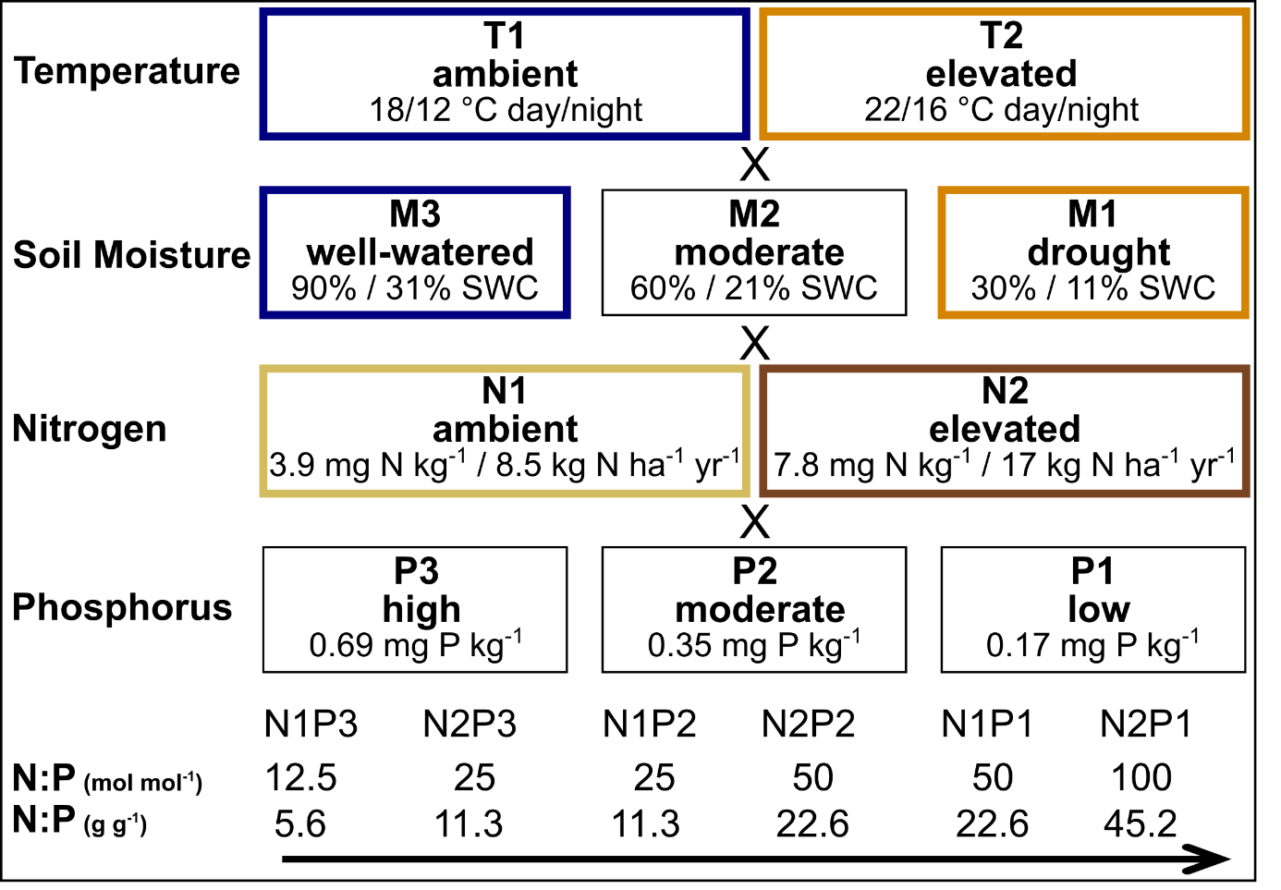

Supplementary Table S2. Means and SE of photosynthetic capacity (A_{max}), total C assimilation, and ectomycorrhizal fungal (ECMF) colonization rate of European beech saplings grown at increasing soil N:P ratios and ambient (ambient temperature and soil moisture, AmbT+AmbM; treatment T1M3) or climate change conditions (elevated temperature and reduced soil moisture, ElevT+RedM; treatment T2M1) in climate chambers. Four-factorial ANOVAs and post-hoc multiple comparisons according to Tukey were calculated using a dataset limited to temperature and soil moisture treatments only. Significant differences between soil N:P treatments are indicated by different lower-case letters (n = eight replicates per treatment for ECMF colonization; n = five replicates per treatment for A_{max} and total C assimilation). N supply: N1, ambient; N2, elevated. P supply: P1, low; P2, moderate; P3, high. n/d = no data.

Treatment |  |  | A_{max}  (µmol CO₂ m⁻² s⁻¹) |  | Total C assimilation  (µmol C h⁻¹) |  | ECMF colonization rate  (%)
AmbT+AmbM | N1P3 |  | 3.2 (0.3) ^{ab} |  | 60.4 (8.9) ^{bc} |  | 80.6 (10.7) ^{ab}
 | N2P3 |  | 4.3 (0.4) ^{b} |  | 100.5 (9.4) ^{c} |  | 69.1 (8.1) ^{ab}
 | N1P2 |  | n/d |  | n/d |  | 72.6 (14.0) ^{ab}
 | N2P2 |  | n/d |  | n/d |  | 83.6 (7.5) ^{b}
 | N1P1 |  | 1.8 (0.3) ª |  | 54.9 (11.4) ^{bc} |  | 71.3 (4.2) ^{ab}
 | N2P1 |  | 2.2 (0.2) ª |  | 53.3 (9.2) ^{bc} |  | 80.4 (7.3) ^{ab}
ElevT+RedM | N1P3 |  | 2.1 (0.3) ª |  | 13.2 (6.5) ^{ab} |  | 30.5 (9.2) ª
 | N2P3 |  | 2.0 (0.3) ª |  | 5.7 (0.2) ª |  | 40.9 (20.2) ^{ab}
 | N1P2 |  | n/d |  | n/d |  | 57.7 (10.7) ^{ab}
 | N2P2 |  | n/d |  | n/d |  | 47.1 (11.0) ^{ab}
 | N1P1 |  | 2.5 (0.5) ^{ab} |  | 28.2 (10.4) ^{ab} |  | 47.4 (24.1) ^{ab}
 | N2P1 |  | 1.9 (0.6) ª |  | 1.6 (0.1) ª |  | 22.5 (16.5) ^{ab}

Supplementary Table S3. Means and SE of total, leaf, coarse root, and fine root biomass of European beech saplings grown at increasing soil N:P ratios and ambient (ambient temperature and soil moisture, AmbT+AmbM; treatment T1M3) or climate change conditions (elevated temperature and reduced soil moisture, ElevT+RedM; treatment T2M1) in climate chambers. Four-factorial ANOVAs and post-hoc multiple comparisons according to Tukey were calculated using a dataset limited to temperature and soil moisture treatments only. Significant differences between soil N:P treatments are indicated by different lower-case letters (n = eight replicates per treatment). N supply: N1, ambient; N2, elevated. P supply: P1, low; P2, moderate; P3, high.

 |  |  | Biomass (g)
Treatment |  |  | Total |  | Leaves |  | Coarse roots |  | Fine roots
AmbT+AmbM | N1P3 |  | 7.6 (1.1) ^{cd} |  | 0.9 (0.2) ^{bcd} |  | 2.7 (0.4) ^{b} |  | 2.3 (0.4) ^{ab}
 | N2P3 |  | 8.7 (0.7) ^{d} |  | 1.0 (0.1) ^{cd} |  | 2.8 (0.3) ^{b} |  | 2.6 (0.3) ^{b}
 | N1P2 |  | 7.8 (1.1) ^{cd} |  | 1.0 (0.2) ^{cd} |  | 2.7 (0.4) ^{b} |  | 2.2 (0.3) ^{ab}
 | N2P2 |  | 8.3 (0.8) ^{d} |  | 1.0 (0.1) ^{cd} |  | 2.8 (0.2) ^{b} |  | 2.5 (0.4) ^{ab}
 | N1P1 |  | 8.5 (0.7) ^{d} |  | 1.2 (0.1) ^{d} |  | 2.9 (0.2) ^{b} |  | 2.2 (0.3) ^{ab}
 | N2P1 |  | 6.5 (0.5) ^{bcd} |  | 0.9 (0.1) ^{bcd} |  | 2.2 (0.3) ^{b} |  | 1.8 (0.2) ^{ab}
ElevT+RedM | N1P3 |  | 3.4 (0.3) ª |  | 0.4 (0.1) ^{ab} |  | 0.8 (0.1) ª |  | 1.3 (0.1) ª
 | N2P3 |  | 3.9 (0.3) ^{ab} |  | 0.5 (0.1) ^{abc} |  | 0.8 (0.1) ª |  | 1.4 (0.2) ^{ab}
 | N1P2 |  | 3.8 (0.5) ^{ab} |  | 0.5 (0.1) ^{abc} |  | 1.1 (0.2) ª |  | 1.4 (0.2) ^{ab}
 | N2P2 |  | 3.6 (0.3) ª |  | 0.3 (0.1) ª |  | 1.1 (0.1) ª |  | 1.3 (0.1) ª
 | N1P1 |  | 3.9 (0.4) ^{ab} |  | 0.5 (0.1) ^{abc} |  | 1.1 (0.1) ª |  | 1.3 (0.2) ª
 | N2P1 |  | 4.4 (0.6) ^{abc} |  | 0.4 (0.2) ^{ab} |  | 1.1 (0.1) ª |  | 1.5 (0.3) ^{ab}

Supplementary Table S4. Means and SE of N uptake efficiency (NUptakeE), photosynthetic N use efficiency (PNUE), and N use efficiency (NUE) of European beech saplings grown at increasing soil N:P ratios and ambient temperature and reduced soil moisture (AmbT+RedM; treatment T1M1) or elevated temperature and ambient soil moisture (ElevT+AmbM; treatment T2M3) in climate chambers. Four-factorial ANOVAs and post-hoc multiple comparisons according to Tukey were calculated using a dataset limited to temperature and soil moisture treatments only. Significant differences between soil N:P treatments are indicated by different lower-case letters (n = eight replicates per treatment). N supply: N1, ambient; N2, elevated. P supply: P1, low; P2, moderate; P3, high. n/d = no data.

Treatment |  |  | NUptakeE  (g N_{DW} g⁻¹ N_{added}) |  | PNUE  (µmol CO₂ g⁻¹ N s⁻¹) |  | NUE  (g DW g⁻¹ N_{DW})
AmbT+RedM | N1P3 |  | 8.2 (0.7) ^{cde} |  | 4.4 (1.0) ª |  | 57.8 (4.0) ª
 | N2P3 |  | 4.2 (0.2) ^{ab} |  | 3.1 (0.4) ª |  | 47.2 (2.0) ª
 | N1P2 |  | 7.7 (1.0) ^{bcd} |  | n/d |  | 56.8 (8.8) ª
 | N2P2 |  | 4.0 (0.3) ^{ab} |  | n/d |  | 66.3 (3.6) ^{abc}
 | N1P1 |  | 9.1 (0.6) ^{cde} |  | 3.5 (0.2) ª |  | 62.0 (4.8) ^{ab}
 | N2P1 |  | 4.1 (0.3) ª |  | 3.8 (0.7) ª |  | 69.1 (5.1) ^{abc}
ElevT+AmbM | N1P3 |  | 10.3 (1.1) ^{de} |  | 8.4 (1.1) ª |  | 100.9 (8.9) ^{cd}
 | N2P3 |  | 5.7 (0.6) ^{abc} |  | 7.5 (0.5) ª |  | 94.7 (10.6) ^{bcd}
 | N1P2 |  | 11.8 (1.2) ^{de} |  | n/d |  | 119.1 (9.3) ^{d}
 | N2P2 |  | 5.9 (0.4) ^{abc} |  | n/d |  | 106.3 (8.4) ^{cd}
 | N1P1 |  | 12.5 (1.1) ^{e} |  | 5.9 (1.7) ª |  | 104.2 (11.5) ^{cd}
 | N2P1 |  | 4.5 (0.8) ^{ab} |  | 5.1 (1.0) ª |  | 81.8 (6.8) ^{abcd}

Supplementary Table S5. Means and SE of N uptake efficiency (NUptakeE), photosynthetic N use efficiency (PNUE), and N use efficiency (NUE) of European beech saplings with increasing temperature, soil moisture, P availability, and N availability in climate chambers. n/d = no data.

Effect | Levels | NUptakeE  (g N_{DW} g⁻¹ N_{added}) | PNUE  (µmol CO₂ g⁻¹ N s⁻¹) | NUE  (g DW g⁻¹ N_{DW})
Temperature | T1 | 6.8 (0.3) | 4.3 (0.3) | 87.7 (2.5)
 | T2 | 7.6 (0.3) | 5.2 (0.6) | 79.2 (2.8)
Moisture | M1 | 6.2 (0.3) | 3.4 (0.3) | 53.0 (1.8)
 | M2 | 7.7 (0.4) | n/d | 93.5 (2.7)
 | M3 | 7.7 (0.4) | 5.4 (0.4) | 101.9 (2.6)
P availability | P1 | 7.1 (0.4) | 3.8 (0.3) | 77.5 (2.9)
 | P2 | 7.1 (0.3) | n/d | 90.9 (3.4)
 | P3 | 7.4 (0.3) | 5.5 (0.4) | 82.0 (3.3)
N availability | N1 | 9.5 (0.3) | 4.5 (0.4) | 85.1 (2.9)
 | N2 | 4.9 (0.1) | 4.6 (0.4) | 81.9 (2.4)

Supplementary Table S6. Means and SE of foliar, coarse root, and fine root N:P ratios of European beech saplings grown at increasing soil N:P ratios and ambient (ambient temperature and soil moisture, AmbT+AmbM; treatment T1M3) or climate change conditions (elevated temperature and reduced soil moisture, ElevT+RedM; treatment T2M1) in climate chambers. Four-factorial ANOVAs and post-hoc multiple comparisons according to Tukey were calculated using a dataset limited to temperature and soil moisture treatments only. Significant differences between soil N:P treatments are indicated by different lower-case letters (n = eight replicates per treatment). N supply: N1, ambient; N2, elevated. P supply: P1, low; P2, moderate; P3, high.

 |  |  | N:P ratio (g g⁻¹)
Treatment |  |  | Leaves |  | Coarse roots |  | Fine roots
AmbT+AmbM | N1P3 |  | 8.2 (1.3) ^{ab} |  | 4.8 (0.6) ^{ab} |  | 6.3 (0.2) ª
 | N2P3 |  | 6.0 (0.5) ª |  | 3.9 (0.5) ª |  | 6.1 (0.3) ª
 | N1P2 |  | 11.6 (0.7) ^{bcd} |  | 4.9 (0.6) ^{ab} |  | 8.1 (0.3) ^{ab}
 | N2P2 |  | 11.0 (1.2) ^{bc} |  | 6.1 (1.2) ^{ab} |  | 8.5 (0.7) ^{ab}
 | N1P1 |  | 30.7 (1.4) ^{f} |  | 70.0 (40.4) ^{def} |  | 18.1 (3.6) ^{cd}
 | N2P1 |  | 29.5 (2.6) ^{ef} |  | 29.2 (6.9) ^{def} |  | 19.9 (2.7) ^{d}
ElevT+RedM | N1P3 |  | 20.8 (2.9) ^{ef} |  | 10.0 (2.3) ^{abc} |  | 10.3 (1.1) ^{b}
 | N2P3 |  | 19.1 (1.1) ^{def} |  | 11.0 (2.1) ^{bcd} |  | 9.6 (1.1) ^{ab}
 | N1P2 |  | 17.4 (1.2) ^{cde} |  | 9.6 (1.5) ^{abc} |  | 10.4 (0.5) ^{b}
 | N2P2 |  | 18.9 (0.8) ^{def} |  | 18.0 (4.5) ^{cde} |  | 11.8 (0.9) ^{bc}
 | N1P1 |  | 32.1 (5.2) ^{ef} |  | 41.8 (6.7) ^{f} |  | 20.4 (1.8) ^{d}
 | N2P1 |  | 31.5 (2.0) ^{f} |  | 36.8 (4.6) ^{ef} |  | 21.3 (0.9) ^{d}

Supplementary Table S7. Pearson’s correlations between the ectomycorrhizal fungal (ECMF) community and plant biomass, assimilation, nutrient concentrations, and nutrient ratios of European beech saplings grown at increasing soil N:P ratios and climate change. Given are the correlation coefficients R and the probabilities of error P (*P < 0.05, **P < 0.01, ***P < 0.001; n = 36 treatments). Significant correlations are indicated by bold letters.

 | ECMF  colonization rate | ECMF  species richness | ECMF  α diversity
Leaf biomass | 0.39* | 0.27 | 0.36*
Total C assimilation | 0.23 | 0.22 | 0.31
C _{leaves} | -0.30 | -0.52** | -0.44**
N _{leaves} | -0.42* | -0.39* | -0.37*
P _{leaves} | 0.01 | 0.16 | 0.06
C:N _{leaves} | 0.40* | 0.36* | 0.36*
N:P _{leaves} | -0.12 | -0.20 | -0.15
Coarse root biomass | 0.42* | 0.37* | 0.44**
C _{coarse roots} | 0.51** | 0.34* | 0.07
N _{coarse roots} | -0.51** | -0.43** | -0.37*
P _{coarse roots} | -0.17 | -0.13 | -0.17
C:N _{coarse roots} | 0.49** | 0.38* | 0.31
N:P _{coarse roots} | -0.05 | -0.04 | 0.00
Fine root biomass | 0.40* | 0.44** | 0.49**
C _{fine roots} | 0.26 | 0.37* | 0.28
N _{fine roots} | -0.44** | -0.34* | -0.35*
P _{fine roots} | -0.12 | -0.03 | -0.04
C:N _{fine roots} | 0.48** | 0.32 | 0.30
N:P _{fine roots} | -0.08 | -0.11 | -0.09

Supplementary Figures
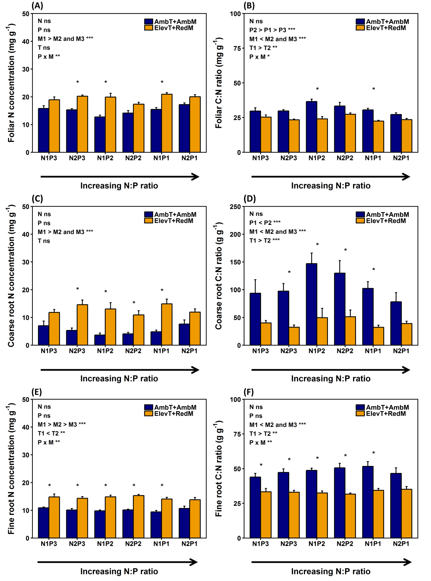

Supplementary Figure S1. Means and SE of foliar, coarse root, and fine root (A, C, E) N concentration and (B, D, F) C:N ratios of European beech saplings grown at increasing soil N:P ratios and ambient (blue bars; ambient temperature and soil moisture, AmbT+AmbM) or climate change conditions (orange bars; elevated temperature and reduced soil moisture, ElevT+RedM) in climate chambers. The associated tables show the results of four-factorial ANOVAs and post-hoc multiple comparisons according to Tukey across all experimental treatments (*P < 0.05, **P < 0.01, ***P < 0.001; ns, not significant; n = eight replicates per treatment). Asterisks show significant differences between ambient and climate change conditions (*P < 0.05). N supply: N1, ambient; N2, elevated. P supply: P1, low; P2, moderate; P3, high. Temperature: T1, ambient; T2, elevated. Soil moisture: M1, drought; M2, moderately moist; M3, well-watered.
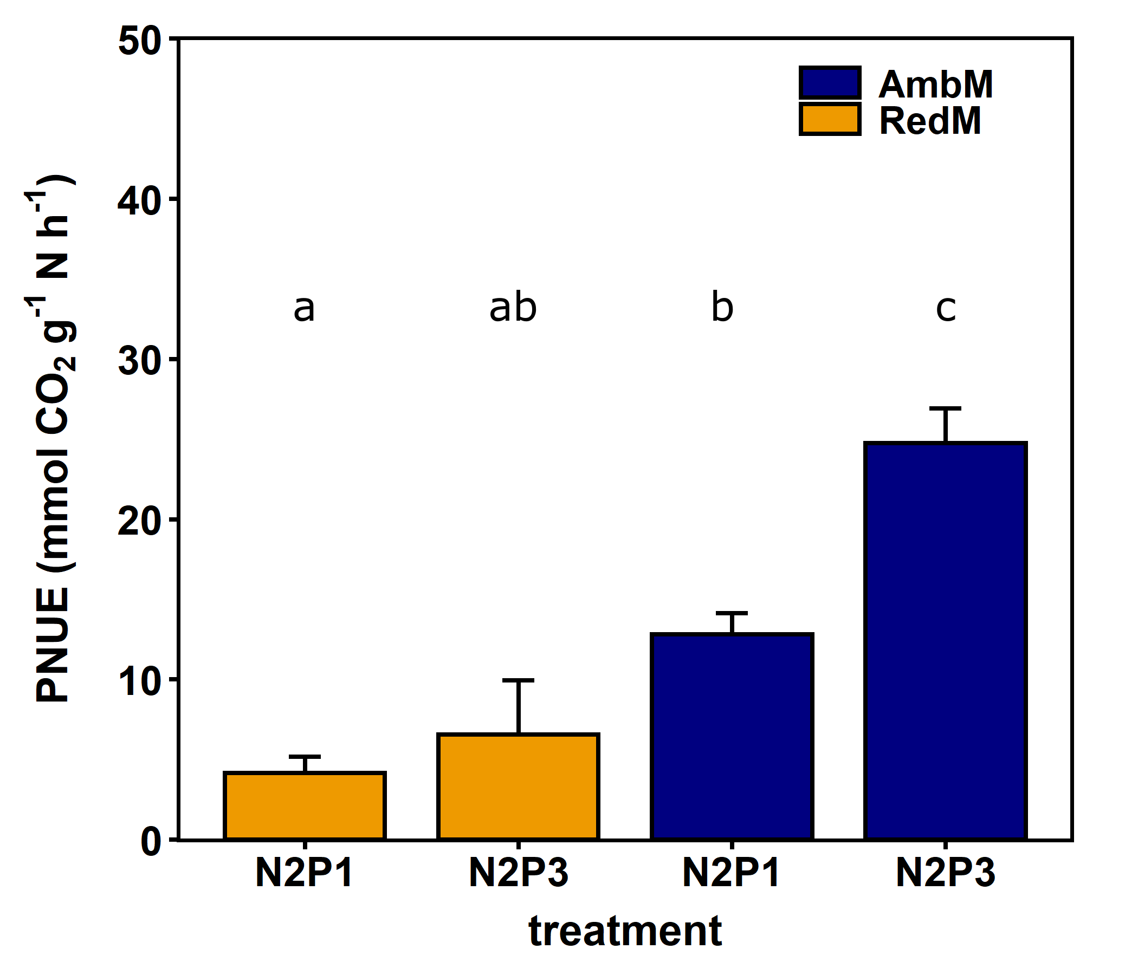

Supplementary Figure S2. Response of photosynthetic N use efficiency (PNUE; means and SE) of European beech saplings to factorial addition of phosphorus and soil moisture (n = 16 replicates per treatment). The response represents super-additive independent co-limitation (as defined by Harpole et al. 2011), with a dominating effect exerted by soil drought and a subordinate effect by P deficiency. Significant differences between soil N:P treatments are indicated by different lower-case letters. N supply: N1, ambient; N2, elevated. P supply: P1, low; P3, high. Soil moisture: RedM, drought (orange bars; treatment M1); AmbM, ambient, well-watered (blue bars; treatment M3).

