Supplementary Figure 1: Relative abundance of 16S rRNA reads of the Lily Pond Biofilm (LPB) sample at the phylum level.

Supplementary Figure 2: comparison of RNA purity (A260/280; A260/230) for five RNAzol-based extraction groups before and after post-isolation purification step.

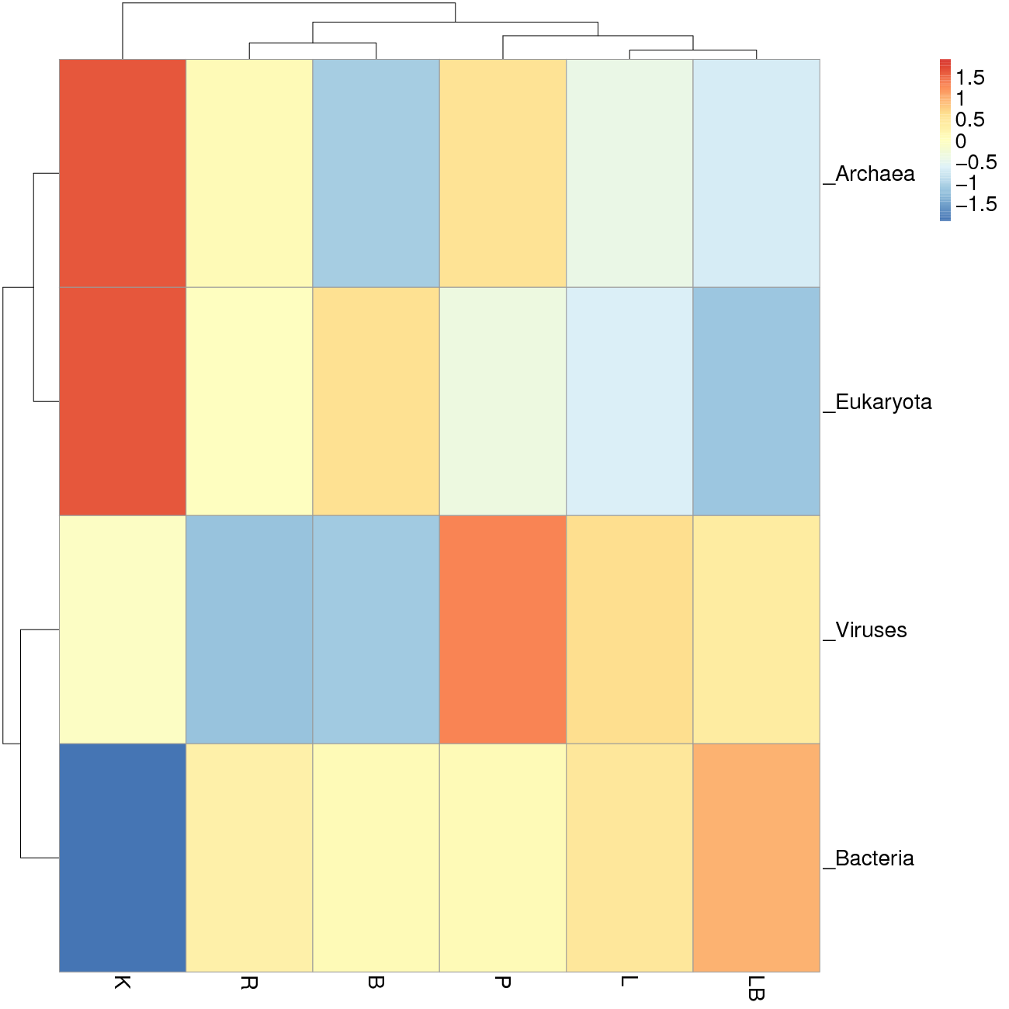

Supplementary Figure 3: Kingdom-level species annotation derived from taxonomically annotated reads of the six RNA extraction groups. The color code denotes a) For highest value of relative abundance <red> , b) For lowest value of relative abundance <blue>. Abbreviations of extraction groups denote, K: Column-based kit isolation; R: RNAzol only group; B: Bead-beating group; L: Lysozyme group; P: Cell disruption bomb; LB: Lysozyme + bead-beating group.

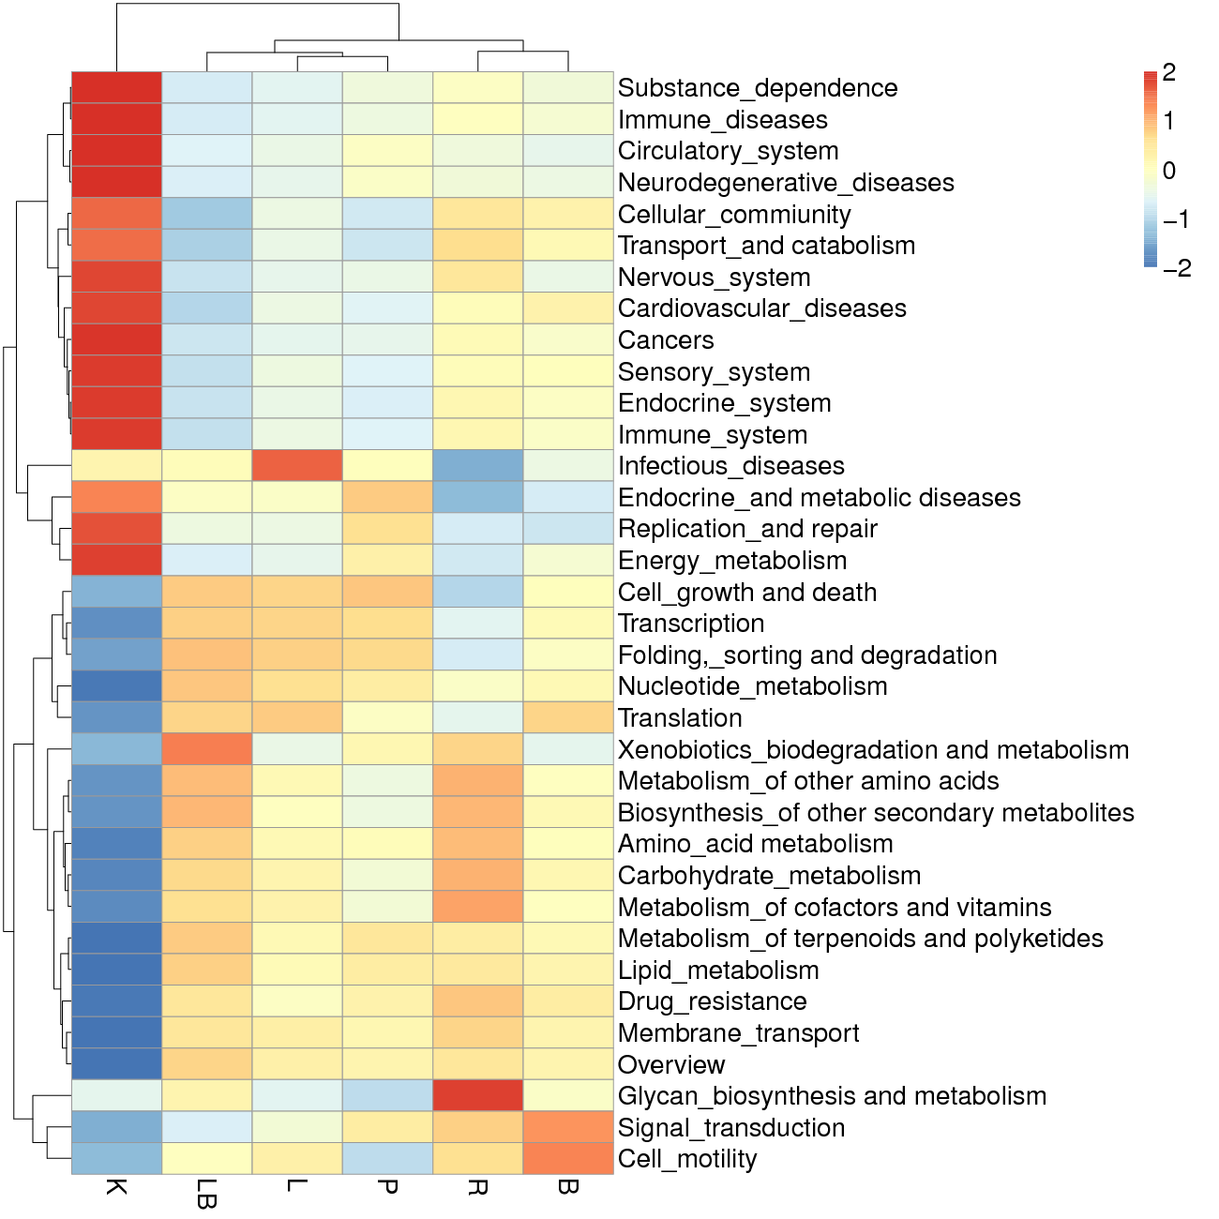
Supplementary Figure 4: KEGG pathways derived from functionally annotated genes following six RNA extraction groups based on KEGG database level 2 - 43 sub-pathway database. The color code denotes a. For highest value of relative abundance <red> , b) For lowest value of relative abundance <blue>. Abbreviations of extraction groups denote, K: Column-based kit isolation; R: RNAzol only group; B: Bead-beating group; L: Lysozyme group; P: Cell disruption bomb; LB: Lysozyme + bead-beating group.

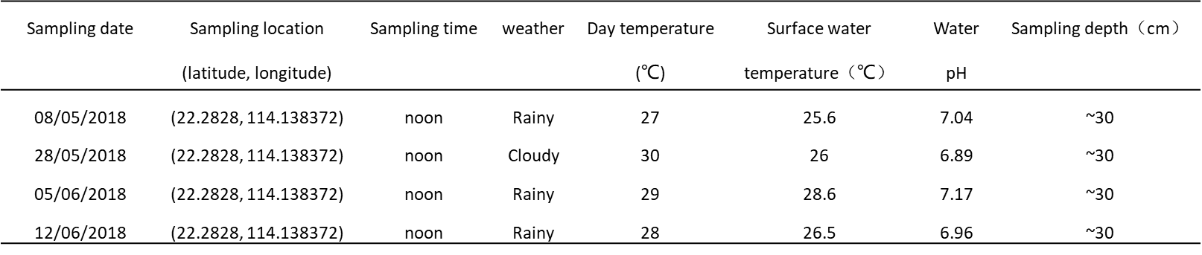Supplementary Table 1: Lily pond sampling metadata.

Supplementary Table 2: Preprocessing of 16s rRNA gene sequencing data and QC statistics.

