Supporting Information

Engineering Tunneling Selector to Achieve High Nonlinearity for 1S1R Integration

Supporting information 1
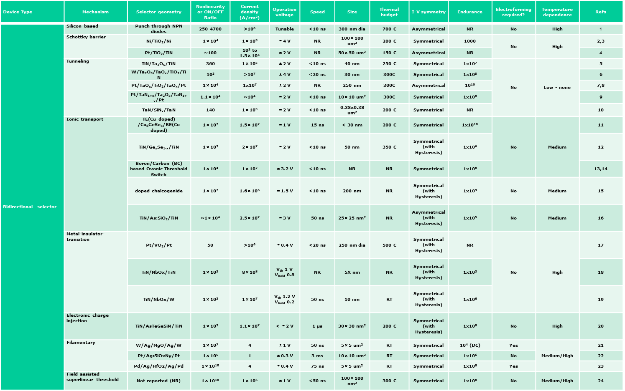
(Srinivasan et al. 2012)
(Huang et al. 2011)
(Shin et al. 2011)

(Bogdan Govoreanu et al. 2014)
(Woo et al. 2014)
(W. Lee et al. 2012)
(Choi et al. 2016)

(Kawahara et al. 2013)

(Sengupta, Shim, and Roy 2016)

(B. Govoreanu et al. 2017)

(Yasuda et al. 2017)

(Yang et al. 2015)

(S. G. Kim et al. 2018)

(Son et al. 2011)

(Kim et al. 2014)

(Cha et al. 2013)

(M. J. Lee et al. 2012)

(Sun et al. 2018)

(Wang et al. 2017)
(Midya et al. 2017)

(Jo et al. 2015)

Supplementary Figure S1. Summary of different types of bipolar selectors proposed so far.

Supporting information 2
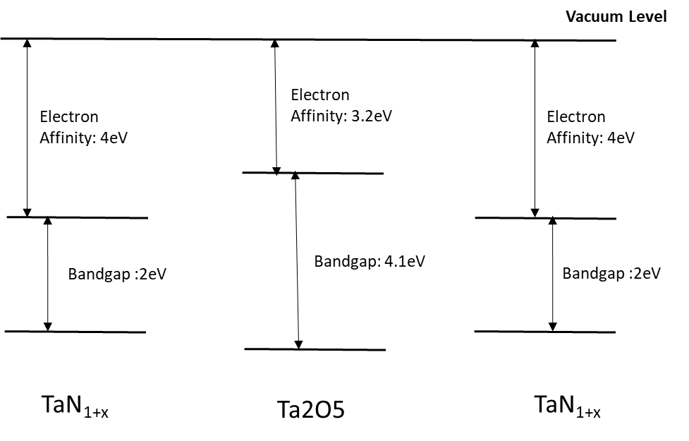
Supplementary Figure S2. Energy band diagram of TLTB (TaN_{1+x}/Ta₂O₅/TaN_{1+x}) layer.

Supporting information 3
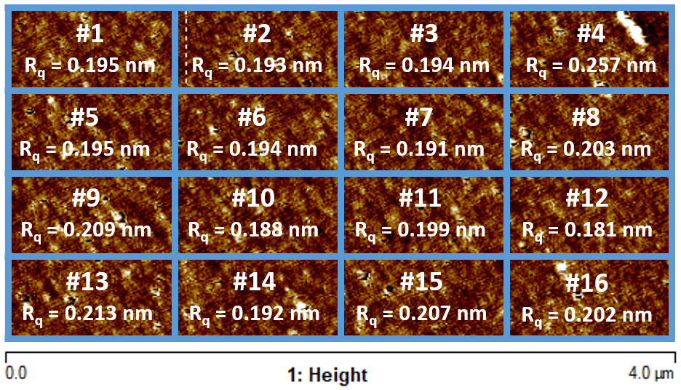
Supplementary Figure S3. rms roughness value for 16 (4x4) equally divided sub regions of the total scanned surface area of the Ge/Pt layer. The measured R_{q} values are indicated in the respective boxes. For these 16 boxes, the value of R_{q} varies between 181 and 257, which shows that R_{q} values for Ge/Pt layer always lie much below their respective values for the Ta/Pt and Ti/Pt layers.

Supporting information 4
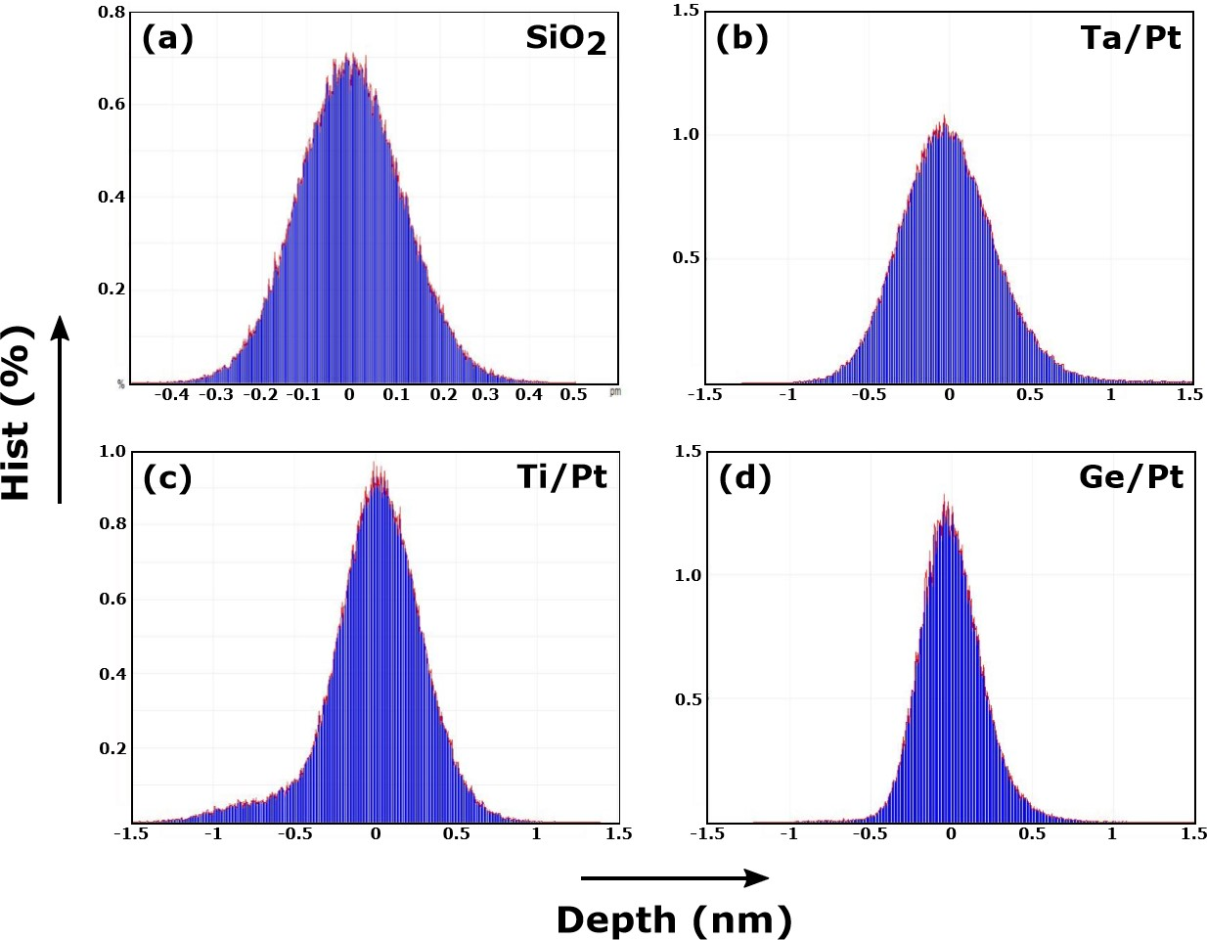
Supplementary Figure S4. The peak-to-valley surface topological height distribution for : a) SiO₂ (Substrate) surface, b) Ta/Pt, c) Ti/Pt, d) Ge/Pt.

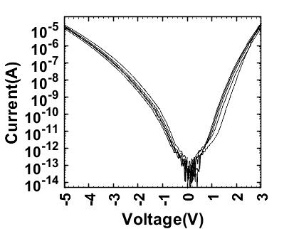
Supporting information 5

Supplementary Figure S5. Multicycle I-V characteristics of the selector device.

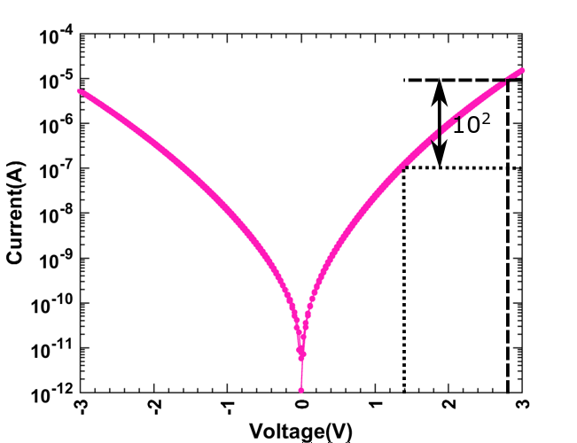
Supporting information 6

Supplementary Figure S6. I-V characteristics of the trilayer tunnel selector device with Ti/Pt as BE (Ti/Pt/TaN_{1+x}/Ta₂O₅/TaN_{1+x}/Pd).
Supporting information 7

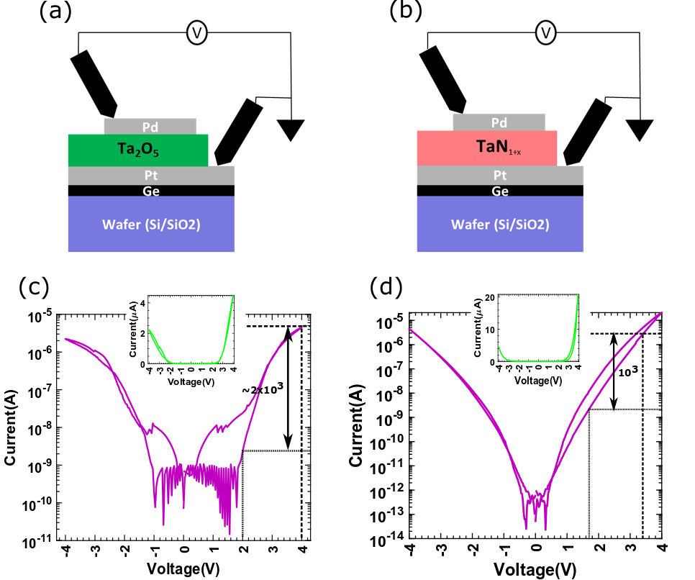
Supplementary Figure S7. Single-layer tunnel selector devices: Schematic of the a) Ta₂O₅ & b) TaN_{1+x} based tunnel selectors with Ge/Pt BE. I-V characteristics of the c) Ta₂O₅ & d) TaN_{1+x} based single-layer tunnel barrier based selector devices.

Supporting information 8
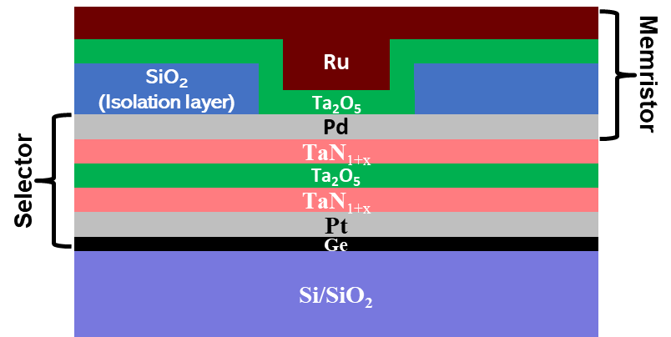

Supplementary Figure S8. Schematic showing a wide-angle view of cross-section of the vertically integrated 1S1R cell.

Supporting information 9

Supplementary Figure S9. The HRS and LRS resistance of the selected device in a CBA with different size capacity and biasing schemes. The HRS resistance decreases with array size due to larger sneak path current. 1/3V biasing scheme is more resilient to the sneak path current.

References:
Cha, Euijun, Jiyong Woo, Daeseok Lee, Sangheon Lee, Jeonghwan Song, Yunmo Koo, Jihyun Lee, et al. 2013. “Nanoscale (∼10nm) 3D Vertical ReRAM and NbO2 Threshold Selector with TiN Electrode.” In Technical Digest - International Electron Devices Meeting, IEDM. https://doi.org/10.1109/IEDM.2013.6724602.
Choi, Byung Joon, Jiaming Zhang, Kate Norris, Gary Gibson, Kyung Min Kim, Warren Jackson, Min Xian Max Zhang, Zhiyong Li, J. Joshua Yang, and R. Stanley Williams. 2016. “Trilayer Tunnel Selectors for Memristor Memory Cells.” Advanced Materials 28 (2): 356–62. https://doi.org/10.1002/adma.201503604.
Govoreanu, B., G.L. Donadio, K. Opsomer, W. Devulder, V.V. Afanas’ ev, Clima Witters, T., N S Avasarala, et al. 2017. “Thermally Stable Integrated Se-Based OTS Selectors with >20 MA/Cm2 Current Drive, >3.103 Half-Bias Nonlinearity, Tunable Threshold Voltage and Excellent Endurance.” IEEE Symposium on VLSI Technology. https://doi.org/10.23919/VLSIT.2017.7998207.
Govoreanu, Bogdan, Christoph Adelmann, Augusto Redolfi, Leqi Zhang, Sergiu Clima, and Malgorzata Jurczak. 2014. “High-Performance Metal-Insulator-Metal Tunnel Diode Selectors.” IEEE Electron Device Letters. https://doi.org/10.1109/LED.2013.2291911.
Huang, Jiun Jia, Yi Ming Tseng, Chung Wei Hsu, and Tuo Hung Hou. 2011. “Bipolar Nonlinear Ni/TiO2/Ni Selector for 1S1R Crossbar Array Applications.” IEEE Electron Device Letters. https://doi.org/10.1109/LED.2011.2161601.
Jo, Sung Hyun, Tanmay Kumar, Sundar Narayanan, Wei D. Lu, and Hagop Nazarian. 2015. “3D-Stackable Crossbar Resistive Memory Based on Field Assisted Superlinear Threshold (FAST) Selector.” In Technical Digest - International Electron Devices Meeting, IEDM. https://doi.org/10.1109/IEDM.2014.7046999.
Kawahara, Akifumi, Ryotaro Azuma, Yuuichirou Ikeda, Ken Kawai, Yoshikazu Katoh, Yukio Hayakawa, Kiyotaka Tsuji, et al. 2013. “An 8 Mb Multi-Layered Cross-Point ReRAM Macro with 443 MB/s Write Throughput.” IEEE Journal of Solid-State Circuits 48 (1): 178–85. https://doi.org/10.1109/JSSC.2012.2215121.
Kim, Soo Gil, Jong Chul Lee, Tae Jung Ha, Jong Ho Lee, Jae Yeon Lee, Yong Taek Park, Kyung Wan Kim, et al. 2018. “Breakthrough of Selector Technology for Cross-Point 25-Nm ReRAM.” In Technical Digest - International Electron Devices Meeting, IEDM. https://doi.org/10.1109/IEDM.2017.8268309.
Kim, Wan Gee, Hyun Min Lee, Beom Yong Kim, Kyoo Ho Jung, Tae Geun Seong, Seonghyun Kim, Ha Chang Jung, et al. 2014. “NbO2-Based Low Power and Cost Effective 1S1R Switching for High Density Cross Point ReRAM Application.” In Digest of Technical Papers - Symposium on VLSI Technology. https://doi.org/10.1109/VLSIT.2014.6894405.
Lee, Myoung Jae, Dongsoo Lee, Hojung Kim, Hyun Sik Choi, Jong Bong Park, Hee Goo Kim, Young Kwan Cha, U. In Chung, In Kyeong Yoo, and Kinam Kim. 2012. “Highly-Scalable Threshold Switching Select Device Based on Chaclogenide Glasses for 3D Nanoscaled Memory Arrays.” In Technical Digest - International Electron Devices Meeting, IEDM. https://doi.org/10.1109/IEDM.2012.6478966.
Lee, Wootae, Jubong Park, Seonghyun Kim, Jiyong Woo, Jungho Shin, Godeuni Choi, Sangsu Park, et al. 2012. “High Current Density and Nonlinearity Combination of Selection Device Based on TaO x/TiO 2/TaO x Structure for One Selector-One Resistor Arrays.” ACS Nano. https://doi.org/10.1021/nn3028776.
Midya, Rivu, Zhongrui Wang, Jiaming Zhang, Sergey E. Savel’ev, Can Li, Mingyi Rao, Moon Hyung Jang, et al. 2017. “Anatomy of Ag/Hafnia-Based Selectors with 1010Nonlinearity.” Advanced Materials 29 (12): 1–8. https://doi.org/10.1002/adma.201604457.
Sengupta, Abhronil, Yong Shim, and Kaushik Roy. 2016. “Proposal for an All-Spin Artificial Neural Network: Emulating Neural and Synaptic Functionalities through Domain Wall Motion in Ferromagnets.” IEEE Transactions on Biomedical Circuits and Systems 10 (6): 1152–60. https://doi.org/10.1109/TBCAS.2016.2525823.
Shin, Jungho, Insung Kim, Kuyyadi P. Biju, Minseok Jo, Jubong Park, Joonmyoung Lee, Seungjae Jung, et al. 2011. “TiO2-Based Metal-Insulator-Metal Selection Device for Bipolar Resistive Random Access Memory Cross-Point Application.” Journal of Applied Physics 109 (3). https://doi.org/10.1063/1.3544205.
Son, Myungwoo, Joonmyoung Lee, Jubong Park, Jungho Shin, Godeuni Choi, Seungjae Jung, Wootae Lee, Seonghyun Kim, Sangsu Park, and Hyunsang Hwang. 2011. “Excellent Selector Characteristics of Nanoscale VO2 for High-Density Bipolar ReRAM Applications.” IEEE Electron Device Letters. https://doi.org/10.1109/LED.2011.2163697.
Srinivasan, V. S.S., S. Chopra, P. Karkare, P. Bafna, S. Lashkare, P. Kumbhare, Y. Kim, et al. 2012. “Punchthrough-Diode-Based Bipolar RRAM Selector by Si Epitaxy.” IEEE Electron Device Letters. https://doi.org/10.1109/LED.2012.2209394.
Sun, Jing, Hong Wang, Fang Song, Zhan Wang, Bingjie Dang, Mei Yang, Haixia Gao, Xiaohua Ma, and Yue Hao. 2018. “Physically Transient Threshold Switching Device Based on Magnesium Oxide for Security Application.” Small. https://doi.org/10.1002/smll.201800945.
Wang, Zhongrui, Saumil Joshi, Sergey E. Savel’ev, Hao Jiang, Rivu Midya, Peng Lin, Miao Hu, et al. 2017. “Memristors with Diffusive Dynamics as Synaptic Emulators for Neuromorphic Computing.” Nature Materials 16 (1): 101–8. https://doi.org/10.1038/nmat4756.
Woo, Jiyong, Jeonghwan Song, Kibong Moon, Ji Hyun Lee, Euijun Cha, Amit Prakash, Daeseok Lee, et al. 2014. “Electrical and Reliability Characteristics of a Scaled (∼30nm) Tunnel Barrier Selector (W/Ta2O5/TaOx/TiO2/TiN) with Excellent Performance (JMAX > 107A/Cm2).” In Digest of Technical Papers - Symposium on VLSI Technology. https://doi.org/10.1109/VLSIT.2014.6894431.
Yang, Hongxin, Minghua Li, Wei He, Yu Jiang, Kian Guan Lim, Wendong Song, Victor Yi Qian Zhuo, et al. 2015. “Novel Selector for High Density Non-Volatile Memory with Ultra-Low Holding Voltage and 107 on/off Ratio.” In Digest of Technical Papers - Symposium on VLSI Technology. https://doi.org/10.1109/VLSIT.2015.7223716.
Yasuda, Shuichiro, Kazuhiro Ohba, Tetsuya Mizuguchi, Hiroaki Sei, Masayuki Shimuta, Katsuhisa Aratani, Tsunenori Shiimoto, et al. 2017. “A Cross Point Cu-ReRAM with a Novel OTS Selector for Storage Class Memory Applications.” In Digest of Technical Papers - Symposium on VLSI Technology. https://doi.org/10.23919/VLSIT.2017.7998189.

