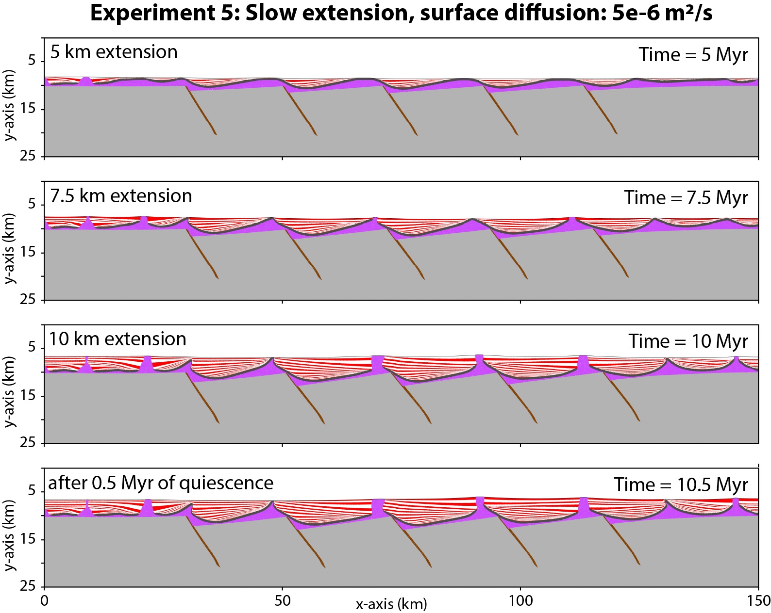
Figure S1. Marker composition of thick-skinned extension and tectonic quiescence with a linear viscous salt rheology, a slow extension rate = 1 mm/yr, and a surface diffusion coefficient of 5·10⁻⁶ m²/s. See Fig. 2 for color code.
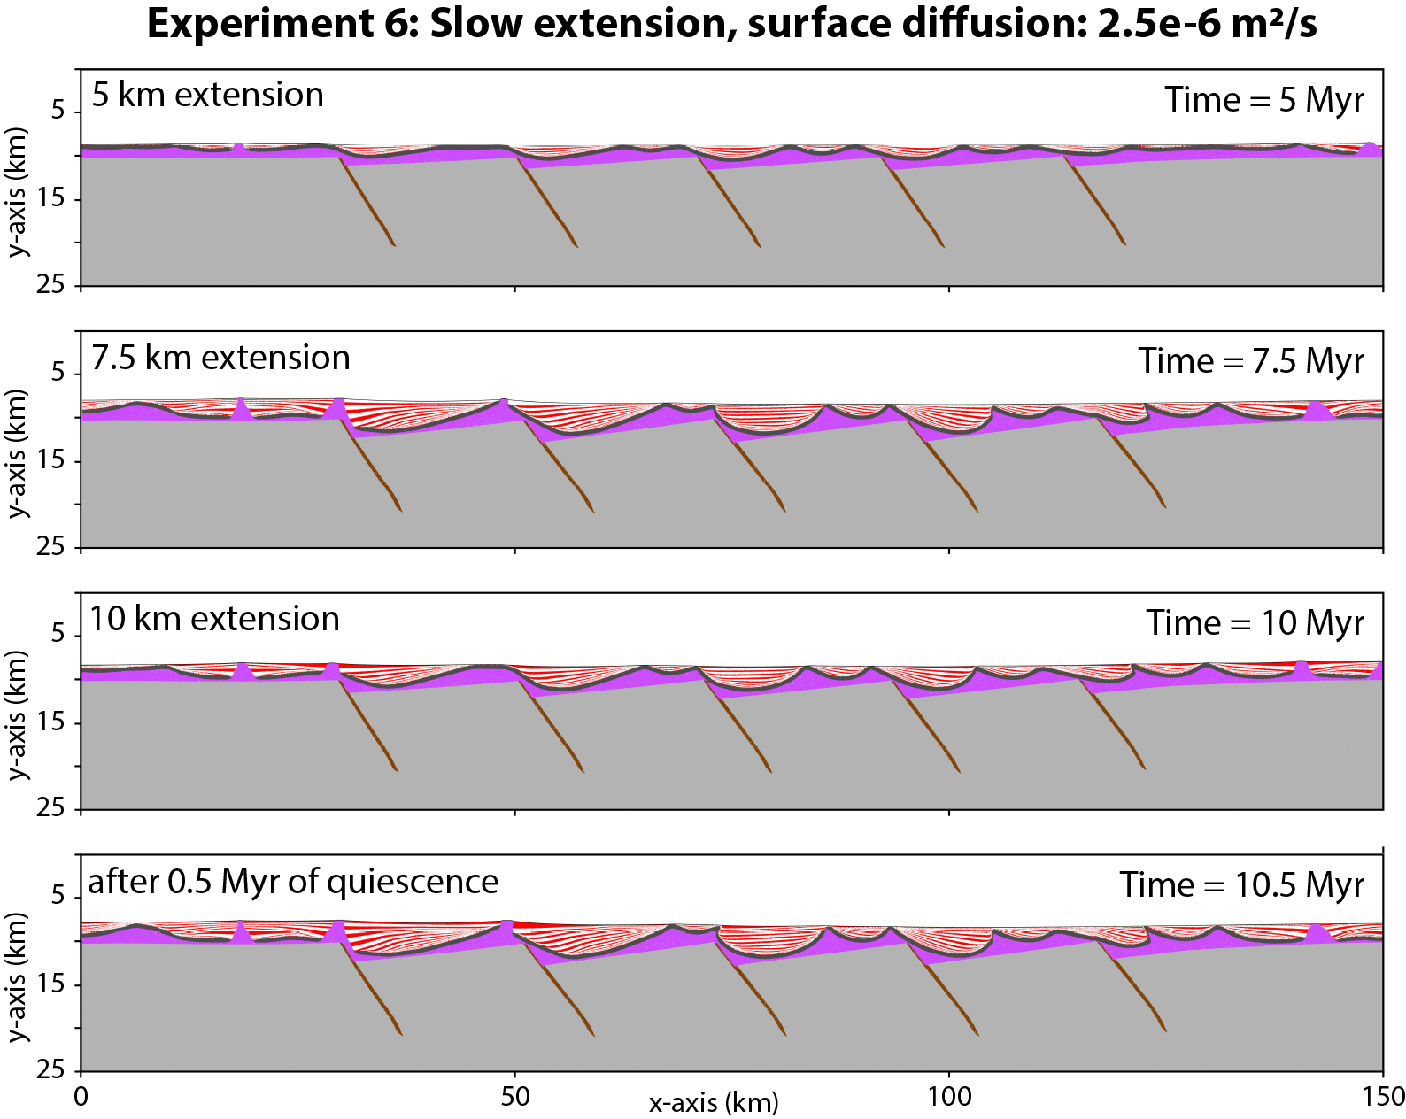
Figure S2. Marker composition of thick-skinned extension and tectonic quiescence with a linear viscous salt rheology, a slow extension rate = 1 mm/yr, and a surface diffusion coefficient of 2.5·10⁻⁶ m²/s. See Fig. 2 for color code.
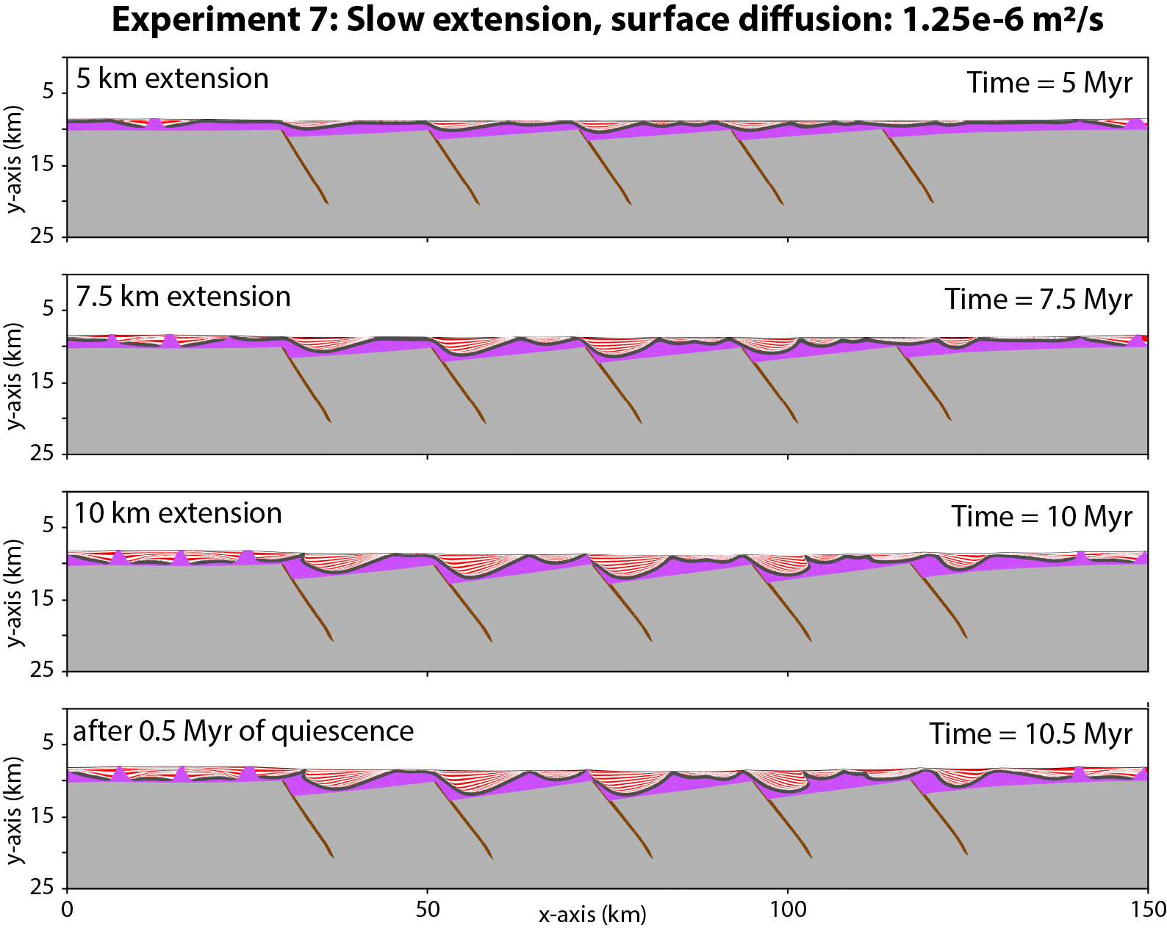
Figure S3. Marker composition of thick-skinned extension and tectonic quiescence with a linear viscous salt rheology, a slow extension rate = 1 mm/yr, and a surface diffusion coefficient of 1.25·10⁻⁶ m²/s. See Fig. 2 for color code.

