Tutorial: Step by step. How we work in Qgis
- Open JPEG image with QGis
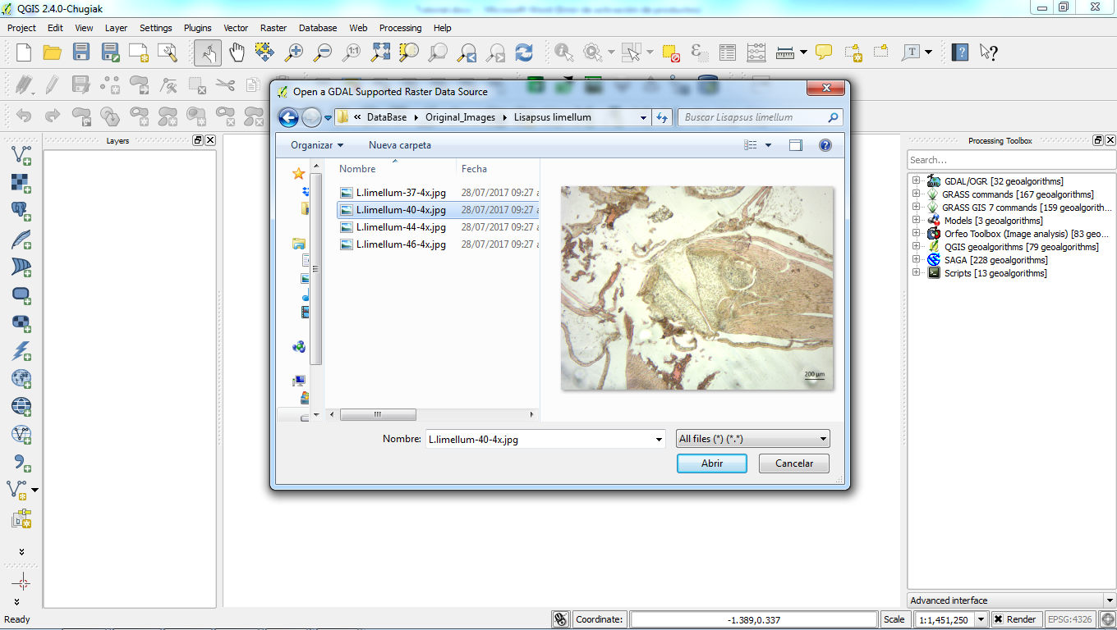
- Specify CRS for layer
* SRC generado (+proj=tmerc +lat_0=0 +lon_0=0 +k=1 +x_0=0.1 +y_0=0.1 +datum=WGS84 +units=mm +no_defs)
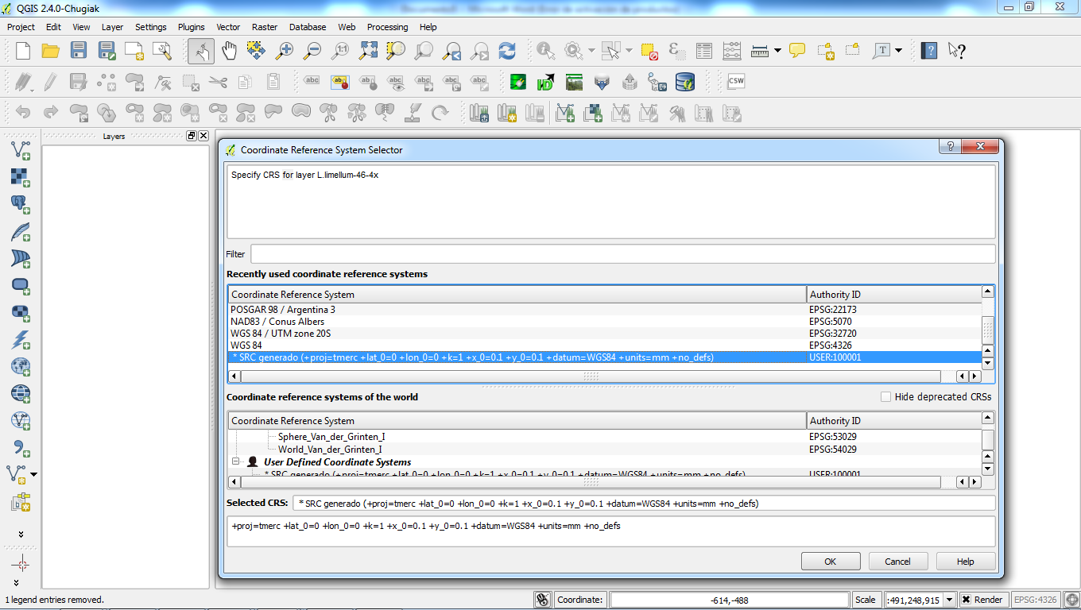

- Work area from the base and through the sagittal plane (1.6 mm x 0.8 mm)
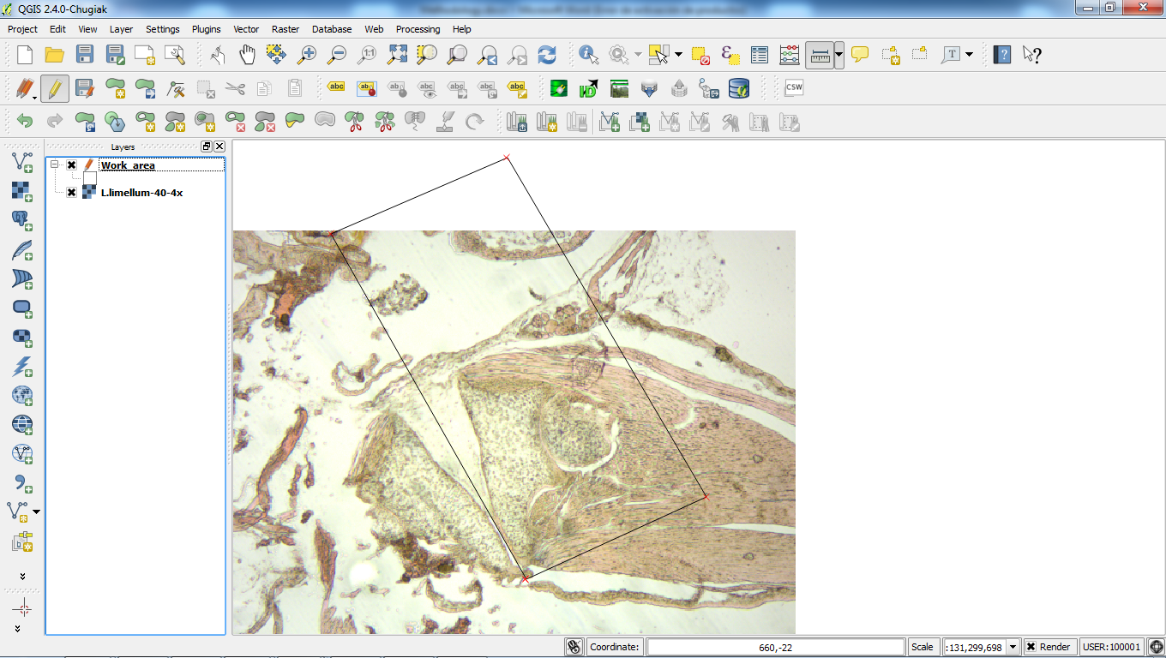
0.8 mm

1.6 mm

- Enter the reference parameters for the spatial referencing of the image

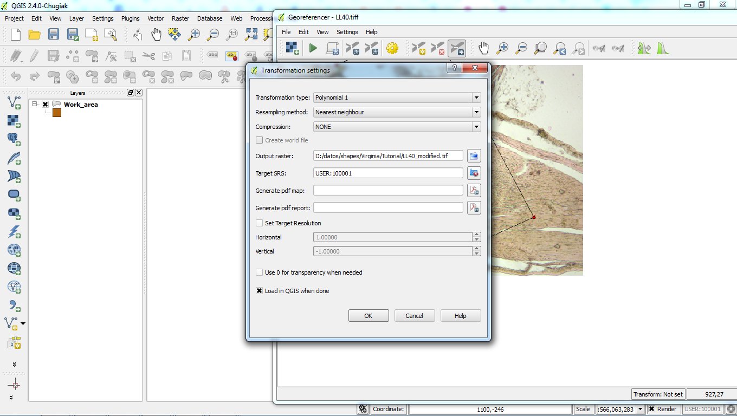

- Find reference points between the work area with defined spatial reference and the image without spatial reference
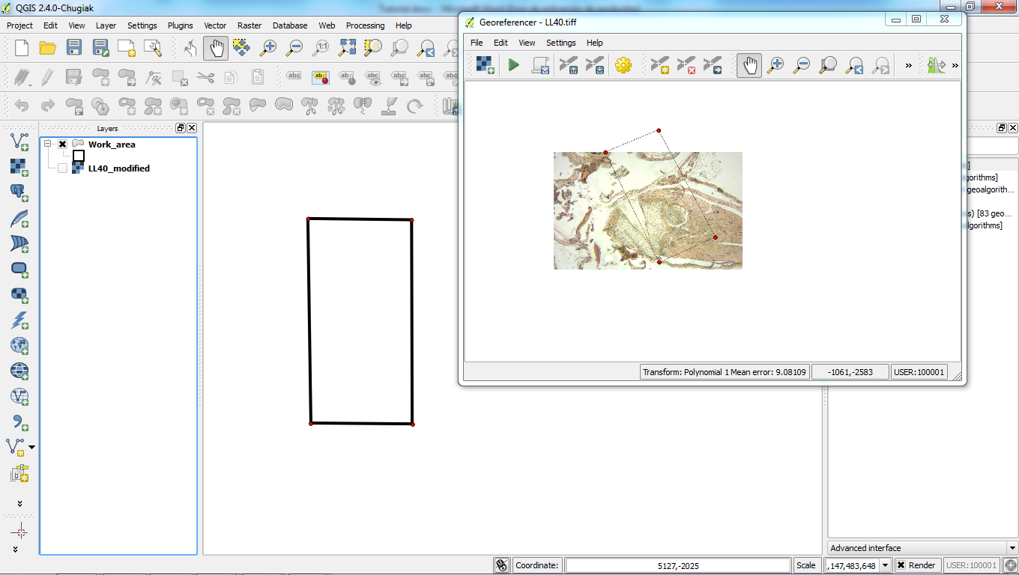
Point 1

Point 1

- Save the image with spatial reference.

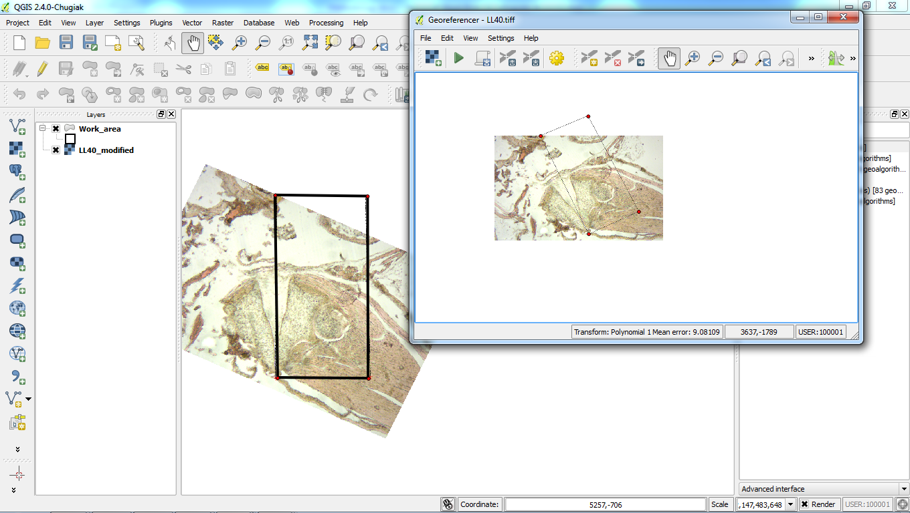
- Identify and digitize the structures and tissues of each stadium in shapefile format with its associated attribute table.

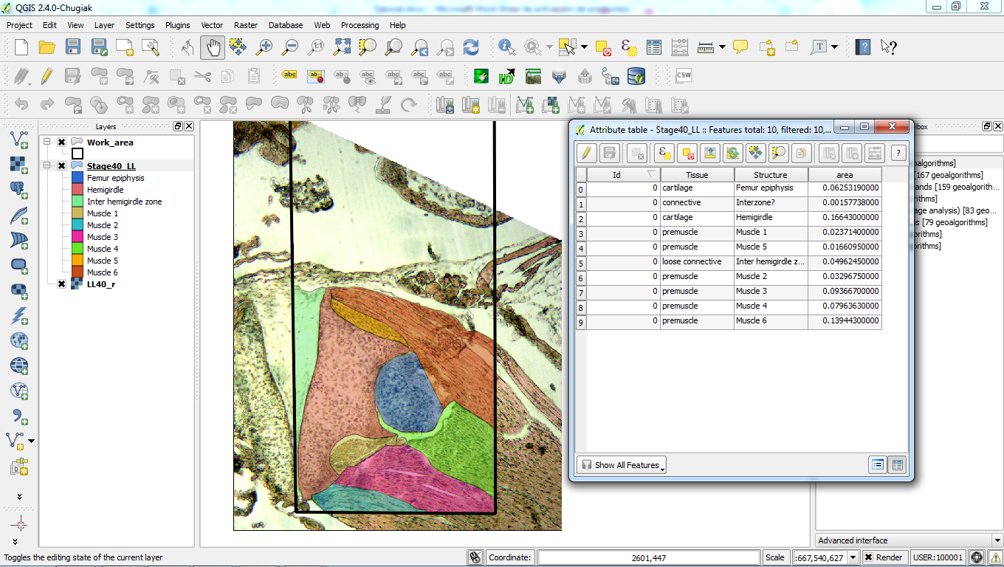

8. From these generated polygons, we compare and analyze the movement, position, and surface of tissues and structures throughout the stages. We identify the middle point of the femur epiphysis and follow it in the cuts of all stages of anuran and chicken. We then construct a trajectory that allows a visual approach of the movement of this bone thoroughly during development.
Besides, we created a polygon neighborhood network and calculated the length of the shared perimeter between the different structures throughout the stages, emphasizing the contact between the hemigirdle and the femur epiphysis. The shared measurements are shown in the table inserted below.

Table 1. Shared perimeters between the anatomical structures of Lisapsus limellum identified in our paper. Data on the femur epiphysis and hemigirdles showed in red.



