Supplementary data
Phytoconstituents, In Vitro Anti-Infective Activity of Buddleja indica Lam., and In Silico Evaluation of its SARS-CoV-2 Inhibitory Potential
Fadia S. Youssef, Ahmed E. Altyar, Abdelsattar M. Omar and Mohamed L. Ashour

Figure S1: A scheme representing the isolation of compounds (1-6) from the B .indica total methanol leaves extract
Figure S2-S19: 1D and 2D spectral data for most of the isolated compounds
Figure S20. Validation of the docking experiments for DNA-gyrase (A), topoisomerase IV (B), dihydrofolate reductase (C), β-lactamase (D), SARS-CoV-2 M^{Pro} (E), SARS-CoV-2PL^{pro} (F) and SARS-CoV-2 3CL^{pro} (G)
Figure S21. 2D and 3D binding modes of (A) DNA-gyrase ligand (Levofloxacin), (B) Topoisomerase IV ligand (Moxifloxacin) and (C) SARS-CoV-2 M^{Pro} ligand (FHR/PRD_002347) in active sites of their respective enzymes
Figure S22. 2D and 3D binding modes of dihydrofolate reductase ligand (Trimethoprim) in dihydrofolate reductase active sites
Figure S23. 2D and 3D binding modes of (A) β-lactamase ligand (Cefuroxime), (B) SARS-CoV-2PL^{pro} ligand (S88) and (C) SARS-CoV-2 3CL^{pro} ligand (3WL) in active sites of their respective enzymes
Figure S24. 2D binding modes of p-hydroxy benzoic acid (A), quercetin 3-O- β-D-glucoside-7-O-α-L-rhamnoside (B) kaempferol 3-O- β-D glucoside-7-O- α-L-rhamnoside (C), quercetin 7-O- β-D glucoside (D) and kaempferol (E) in active sites of DNA-gyrase; dotted green lines indicate H-bonds; dotted light green lines indicate C-H-bonds; dotted purple lines indicate π-bonds; dotted orange bonds indicate salt bridge formation
Figure S25. 2D binding modes of p-hydroxy benzoic acid (A), quercetin 3-O- β-D-glucoside-7-O-α-L-rhamnoside (B) kaempferol 3-O- β-D glucoside-7-O- α-L-rhamnoside (C), quercetin 7-O- β-D glucoside (D) and kaempferol (E) in active sites of topoisomerase IV; dotted green lines indicate H-bonds; dotted light green lines indicate C-H-bonds; dotted purple lines indicate π-bonds; dotted orange bonds indicate salt bridge formation
Figure S26. 2D binding modes of p-hydroxy benzoic acid (A), quercetin 3-O- β-D-glucoside-7-O-α-L-rhamnoside (B) kaempferol 3-O- β-D glucoside-7-O- α-L-rhamnoside (C), quercetin 7-O- β-D glucoside (D) and caffeic acid l (E) in active sites of SARS-CoV-2 3CL^{pro}; dotted green lines indicate H-bonds; dotted light green lines indicate C-H-bonds; dotted purple lines indicate π-bonds; dotted orange bonds indicate salt bridge formation

Figure S27. 2D binding modes of p-hydroxy benzoic acid (A), quercetin 3-O- β-D-glucoside-7-O-α-L-rhamnoside (B) kaempferol 3-O- β-D glucoside-7-O- α-L-rhamnoside (C), quercetin 7-O- β-D glucoside (D) and kaempferol (E) in active sites of SARS-CoV-2 M^{Pro}; dotted green lines indicate H-bonds; dotted light green lines indicate C-H-bonds; dotted purple lines indicate π-bonds; dotted orange bonds indicate salt bridge formation
Figure S28. 2D binding modes of p-hydroxy benzoic acid (A), quercetin 3-O- β-D-glucoside-7-O-α-L-rhamnoside (B) kaempferol 3-O- β-D glucoside-7-O- α-L-rhamnoside (C), quercetin 7-O- β-D glucoside (D) and caffeic acid l (E) in active sites of β-lactamase; dotted green lines indicate H-bonds; dotted light green lines indicate C-H-bonds; dotted purple lines indicate π-bonds; dotted orange bonds indicate salt bridge formation
Figure S29. 2D binding modes of p-hydroxy benzoic acid (A), quercetin 3-O- β-D-glucoside-7-O-α-L-rhamnoside (B) kaempferol 3-O- β-D glucoside-7-O- α-L-rhamnoside (C), quercetin 7-O- β-D glucoside (D) and caffeic acid l (E) in active sites of SARS-CoV-2PL^{pro}; dotted green lines indicate H-bonds; dotted light green lines indicate C-H-bonds; dotted purple lines indicate π-bonds; dotted orange bonds indicate salt bridge formation; red bonds; unfavorable interaction
Figure S30. 2D binding modes of p-hydroxy benzoic acid (A), quercetin 3-O- β-D-glucoside-7-O-α-L-rhamnoside (B) kaempferol 3-O- β-D glucoside-7-O- α-L-rhamnoside (C) kaempferol (D) and caffeic acid (E) in active sites of dihydrofolate reductase; dotted green lines indicate H-bonds; dotted light green lines indicate C-H-bonds; dotted purple lines indicate π-bonds; dotted orange bonds indicate salt bridge formation; red bonds; unfavorable interaction
Table S1 Effect of different BIT concentrations on the viral replication using the direct plaque reduction assay
Table S2 Inhibitory percentage of BIT and isoniazid (standard) against Mycobacterium tuberculosis growth
Table S3 Inhibitory percentage of BIT and Clarithromycin (standard) against Helicobacter pylori growth

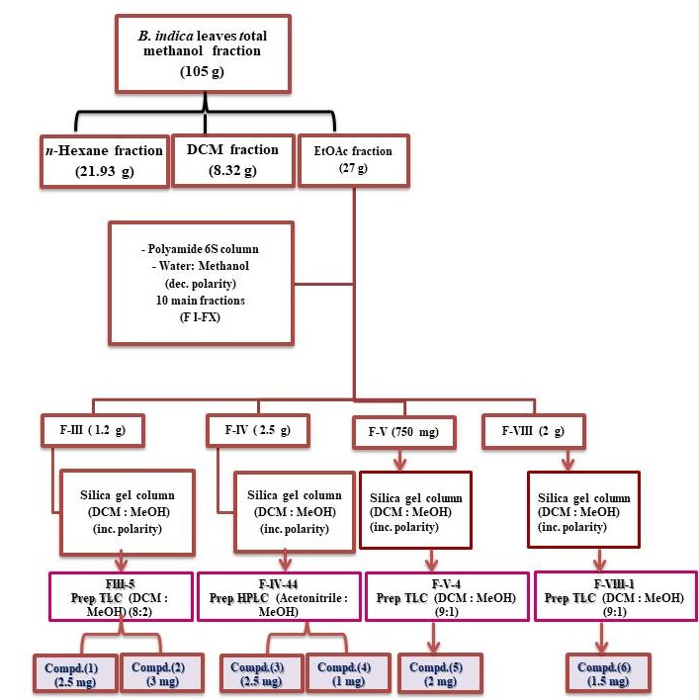
Figure S1: A scheme representing the isolation of compounds (1-6) from the B .indica Lam. total methanol leaves extract

Fig. S2: ¹H NMR spectrum for p-hydroxy benzoic acid (1)

Fig. S3: APT NMR spectrum for p-hydroxy benzoic acid (1)
Fig. S4: ¹H NMR spectrum for caffeic acid (2)

Fig. S5: APT NMR spectrum for caffeic acid (2)

Fig. S6: ¹H-¹H COSY spectrum for caffeic acid (2)

Fig. S7: HSQC spectrum for caffeic acid (2)

Fig. S8: HMBC spectrum for caffeic acid (2)

Fig. S9: ¹H NMR spectrum for quercetin 3-O- β-D-glucoside-7-O-α-L-rhamnoside (3)

Fig. S10: APT- NMR spectrum for quercetin 3-O- β-D-glucoside-7-O-α-L-rhamnoside (3)
Fig. S11: ¹H NMR spectrum for kaempferol 3-O- β-D-glucoside-7-O-α-L-rhamnoside (4)

Fig. S12: APT⁻-NMR spectrum for kaempferol 3-O- β-D-glucoside-7-O-α-L-rhamnoside (4)

Fig. S13: ¹H-¹H COSY spectrum for kaempferol 3-O- β-D-glucoside-7-O-α-L-rhamnoside (4)

Fig. S14: HSQC spectrum for kaempferol 3-O- β-D-glucoside-7-O-α-L-rhamnoside (4)
Fig. S15: HMBC spectrum for kaempferol 3-O- β-D-glucoside-7-O-α-L-rhamnoside (4)

Fig. S16: ¹H NMR spectrum for quercetin 7-O- β-D-glucoside (5)

Fig. S17: APT- NMR spectrum for quercetin 7-O- β-D-glucoside (5)

Fig. S18: ¹H NMR spectrum for kaempferol (6)

Fig. S19: ¹H NMR spectrum for kaempferol (6)
Figure S20. Validation of the docking experiments for DNA-gyrase (A), topoisomerase IV (B), dihydrofolate reductase (C), β-lactamase (D), SARS-CoV-2 M^{Pro} (E), SARS-CoV-2PL^{pro} (F) and SARS-CoV-2 3CL^{pro} (G)

(A)
(B)
(C)
(D)
(E)
(F)
(G)
(G)
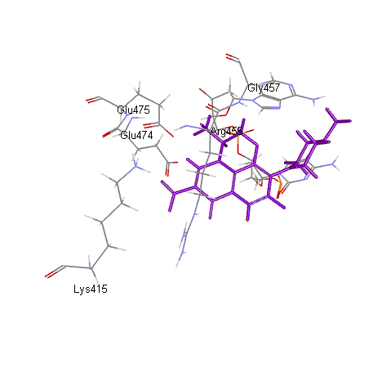
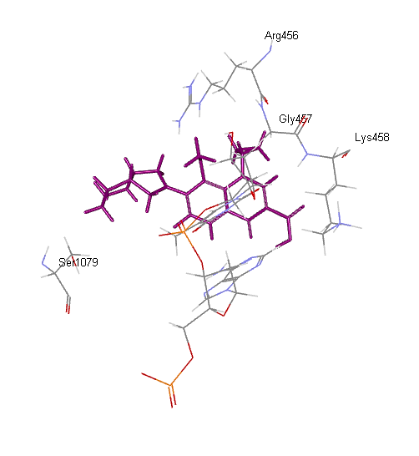
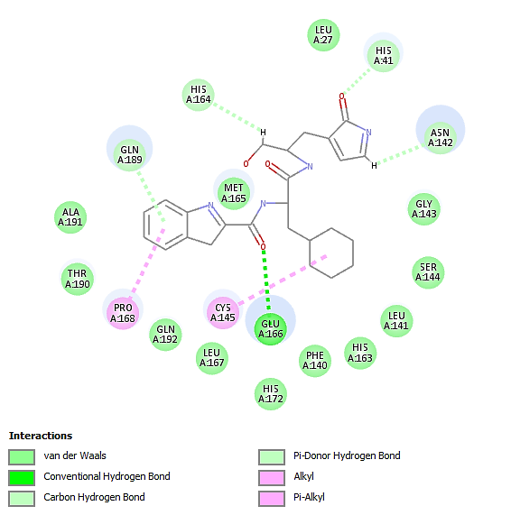
(A)
(B)
(C)

Figure S21. 2D and 3D binding modes of (A) DNA-gyrase ligand (Levofloxacin), (B) Topoisomerase IV ligand (Moxifloxacin) and (C) SARS-CoV-2 M^{Pro} ligand (FHR/PRD_002347) in active sites of their respective enzymes

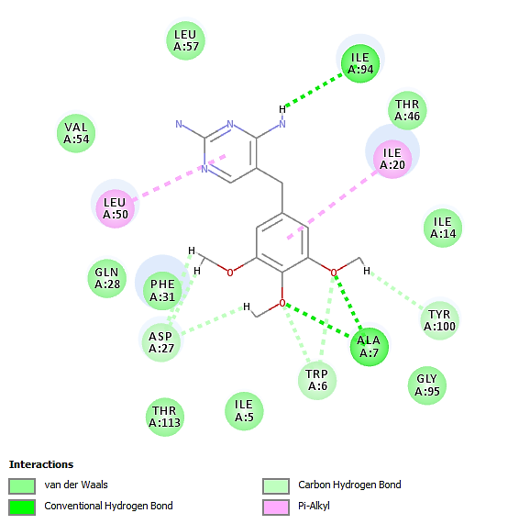
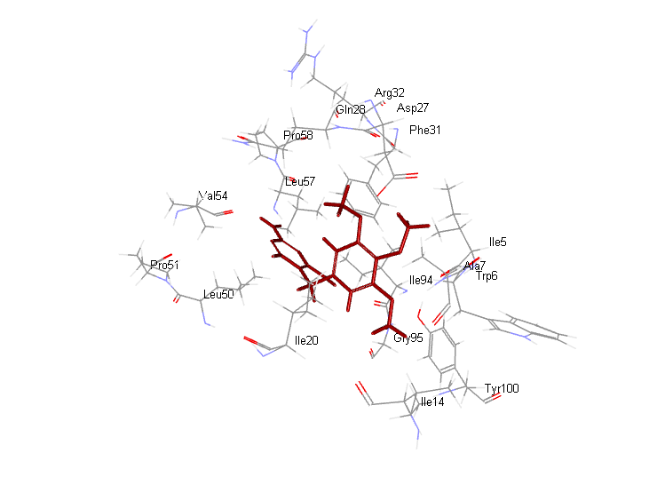

Figure S22. 2D and 3D binding modes of dihydrofolate reductase ligand (Trimethoprim) in dihydrofolate reductase active sites

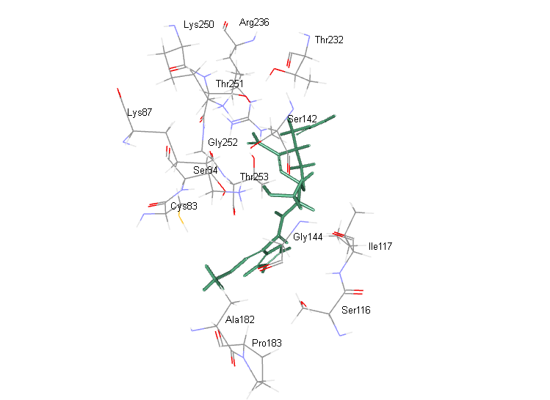
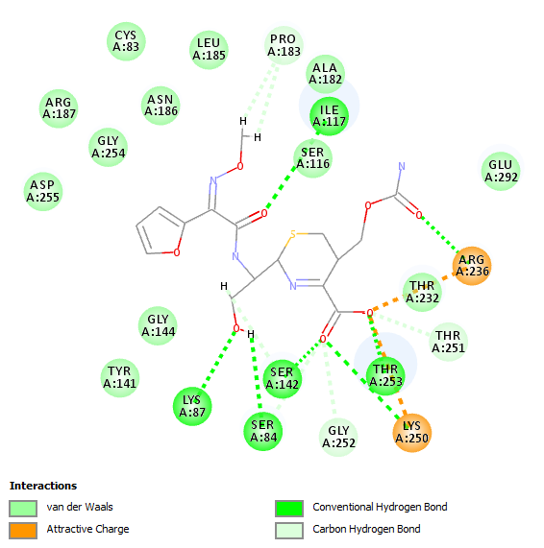
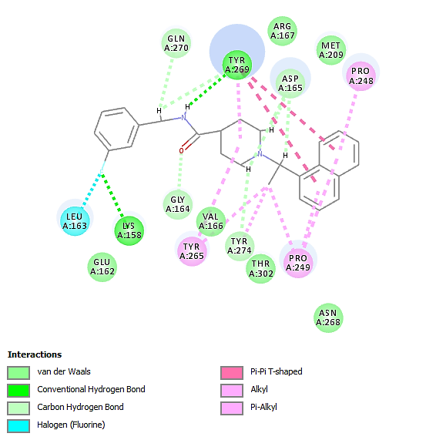
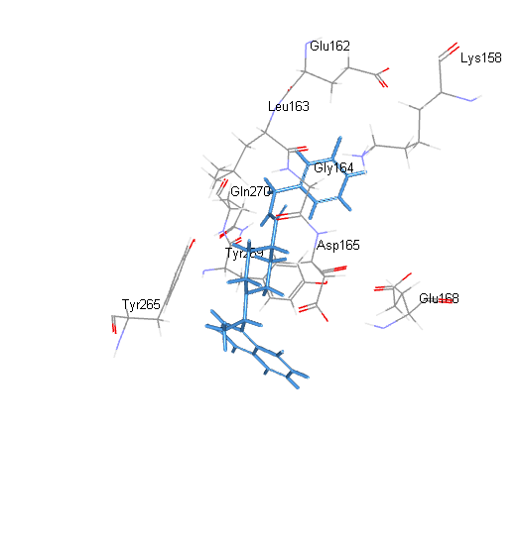
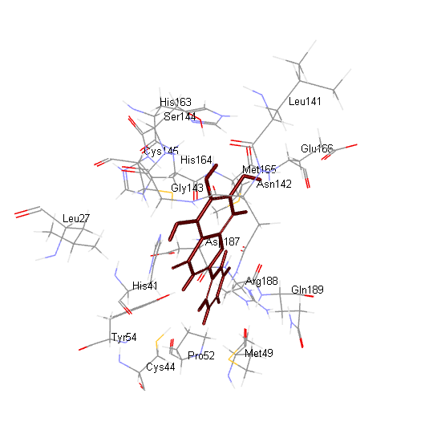
(A)
(B)
(C)

Figure S23 . 2D and 3D binding modes of (A) β-lactamase ligand (Cefuroxime), (B) SARS-CoV-2PL^{pro} ligand (S88) and (C) SARS-CoV-2 3CL^{pro} ligand (3WL) in active sites of their respective enzymes
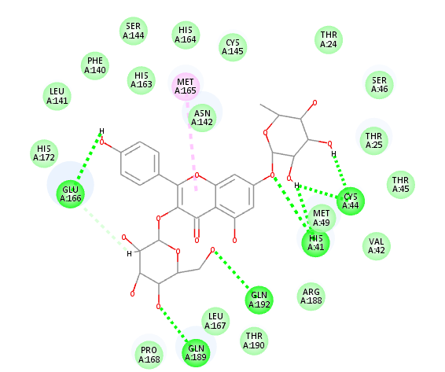
(B)
(A)

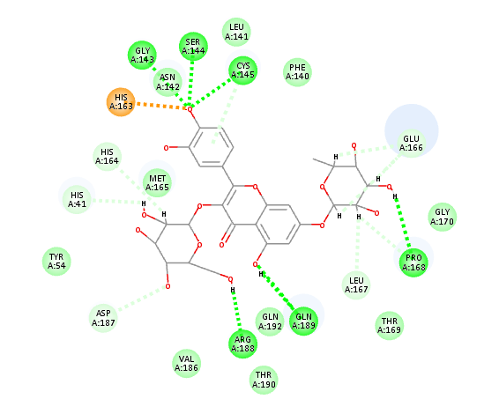
(C)
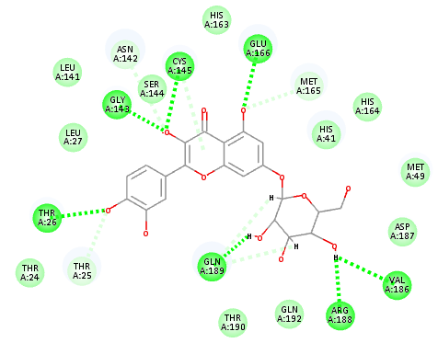
(D)
(E)
Figure S24 . 2D binding modes of p-hydroxy benzoic acid (A), quercetin 3-O- β-D-glucoside-7-O-α-L-rhamnoside (B) kaempferol 3-O- β-D glucoside-7-O- α-L-rhamnoside (C), quercetin 7-O- β-D glucoside (D) and kaempferol (E) in active sites of DNA-gyrase; dotted green lines indicate H-bonds; dotted light green lines indicate C-H-bonds; dotted purple lines indicate π-bonds; dotted orange bonds indicate salt bridge formation

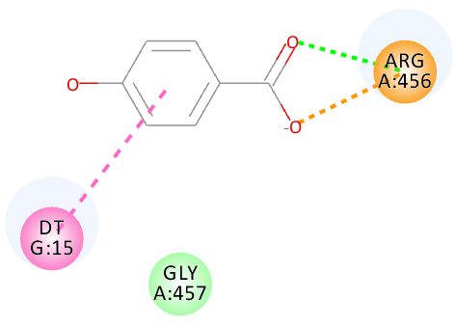
(C)
(B)
(A)

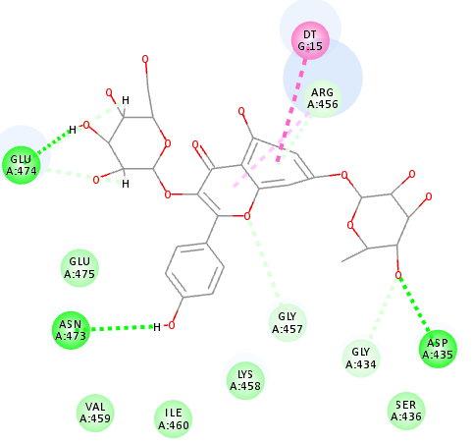

(D)

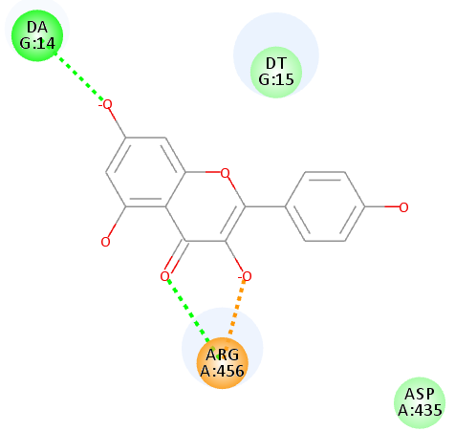
(E)

Figure S25 . 2D binding modes of p-hydroxy benzoic acid (A), quercetin 3-O- β-D-glucoside-7-O-α-L-rhamnoside (B) kaempferol 3-O- β-D glucoside-7-O- α-L-rhamnoside (C), quercetin 7-O- β-D glucoside (D) and kaempferol (E) in active sites of topoisomerase IV; dotted green lines indicate H-bonds; dotted light green lines indicate C-H-bonds; dotted purple lines indicate π-bonds; dotted orange bonds indicate salt bridge formation
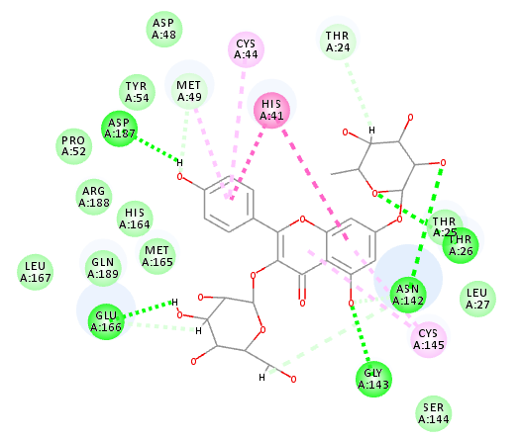
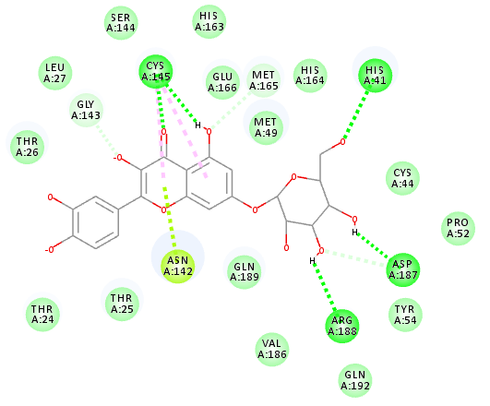
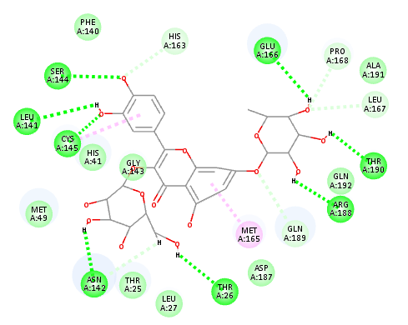
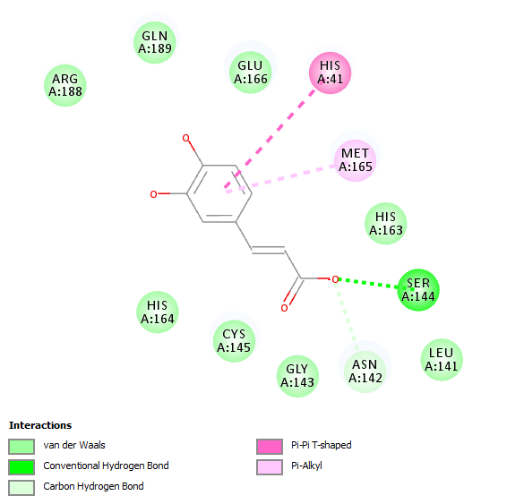
(A)
(D)
(C)
(B)
(E)
Figure S26. 2D binding modes of p-hydroxy benzoic acid (A), quercetin 3-O- β-D-glucoside-7-O-α-L-rhamnoside (B) kaempferol 3-O- β-D glucoside-7-O- α-L-rhamnoside (C), quercetin 7-O- β-D glucoside (D) and caffeic acid l (E) in active sites of SARS-CoV-2 3CL^{pro}; dotted green lines indicate H-bonds; dotted light green lines indicate C-H-bonds; dotted purple lines indicate π-bonds; dotted orange bonds indicate salt bridge formation

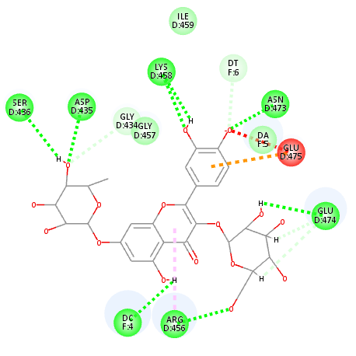
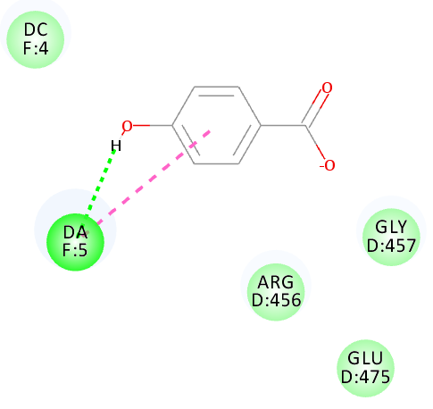
(B)
(A)

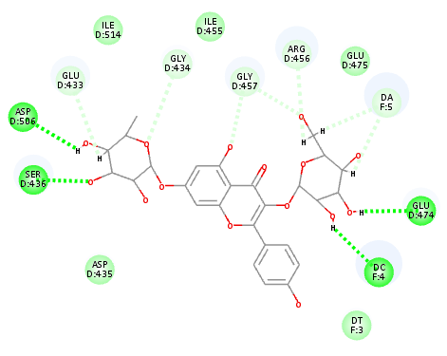
(C)
(D)
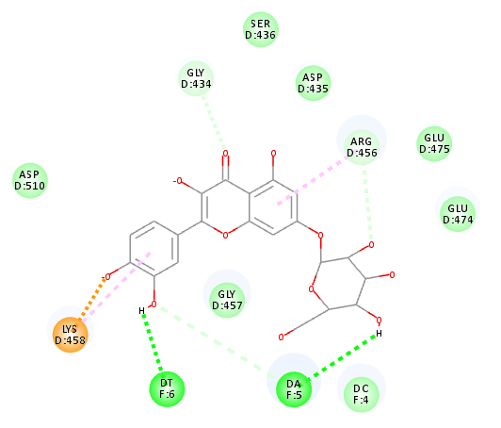
(E)

Figure S27 2D binding modes of p-hydroxy benzoic acid (A), quercetin 3-O- β-D-glucoside-7-O-α-L-rhamnoside (B) kaempferol 3-O- β-D glucoside-7-O- α-L-rhamnoside (C), quercetin 7-O- β-D glucoside (D) and kaempferol (E) in active sites of SARS-CoV-2 M^{Pro}; dotted green lines indicate H-bonds; dotted light green lines indicate C-H-bonds; dotted purple lines indicate π-bonds; dotted orange bonds indicate salt bridge formation; red bonds; unfavorable interaction

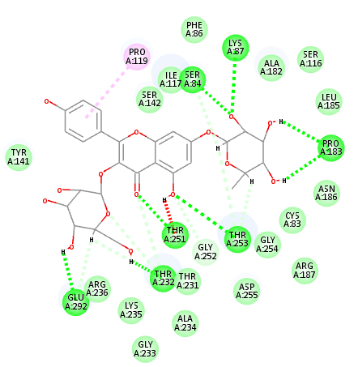
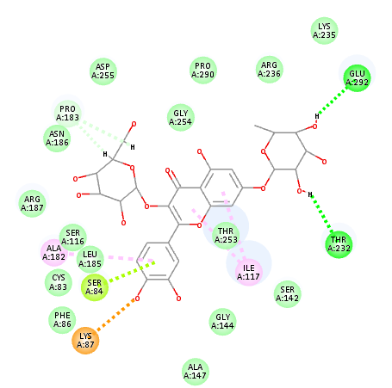
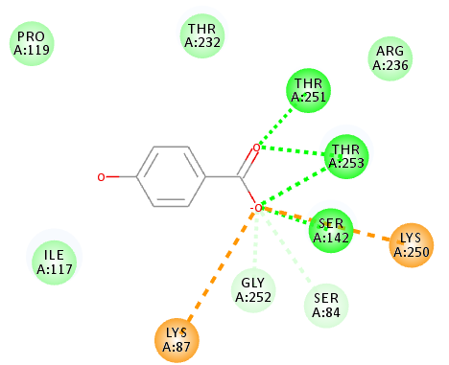
(D)
(C)
(A)
(B)
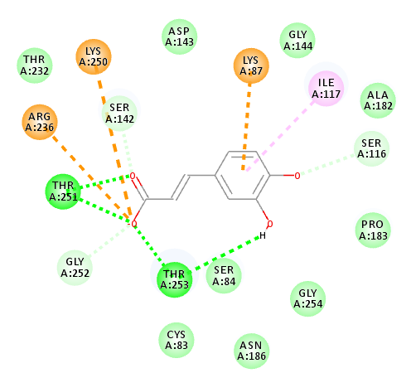
(E)
Figure S28. 2D binding modes of p-hydroxy benzoic acid (A), quercetin 3-O- β-D-glucoside-7-O-α-L-rhamnoside (B) kaempferol 3-O- β-D glucoside-7-O- α-L-rhamnoside (C), quercetin 7-O- β-D glucoside (D) and caffeic acid l (E) in active sites of β-lactamase; dotted green lines indicate H-bonds; dotted light green lines indicate C-H-bonds; dotted purple lines indicate π-bonds; dotted orange bonds indicate salt bridge formation; red bonds; unfavorable interaction
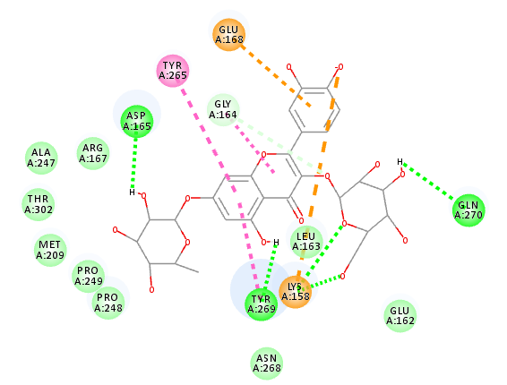
(B)
(A)

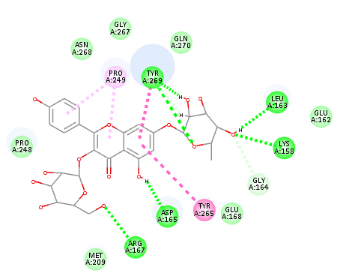
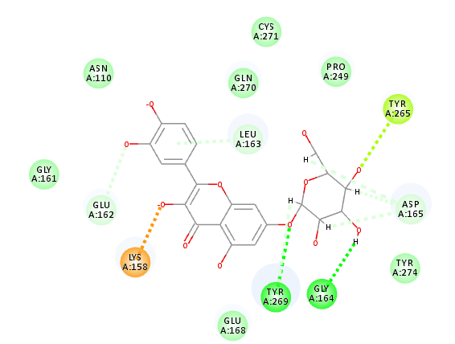
(D)
(C)
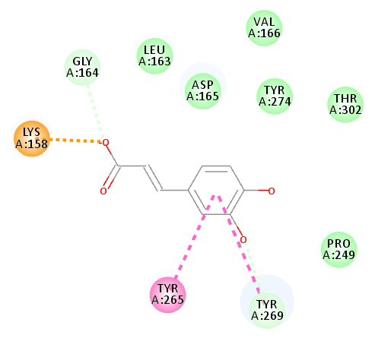
(E)
Figure S29. 2D binding modes of p-hydroxy benzoic acid (A), quercetin 3-O- β-D-glucoside-7-O-α-L-rhamnoside (B) kaempferol 3-O- β-D glucoside-7-O- α-L-rhamnoside (C), quercetin 7-O- β-D glucoside (D) and caffeic acid (E) in active sites of SARS-CoV-2PL^{pro}; dotted green lines indicate H-bonds; dotted light green lines indicate C-H-bonds; dotted purple lines indicate π-bonds; dotted orange bonds indicate salt bridge formation; red bonds; unfavorable interaction

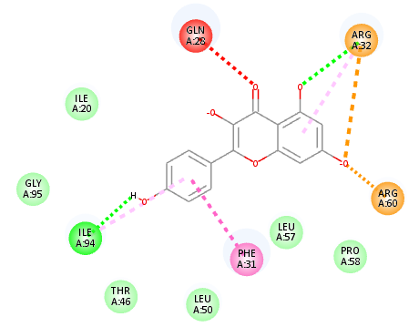
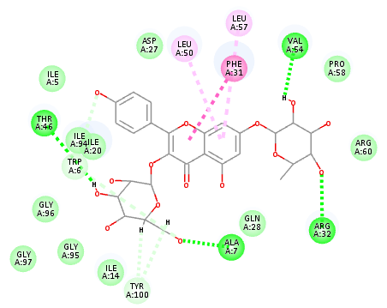
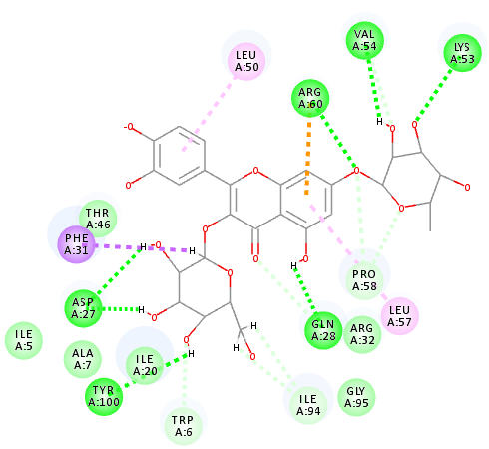
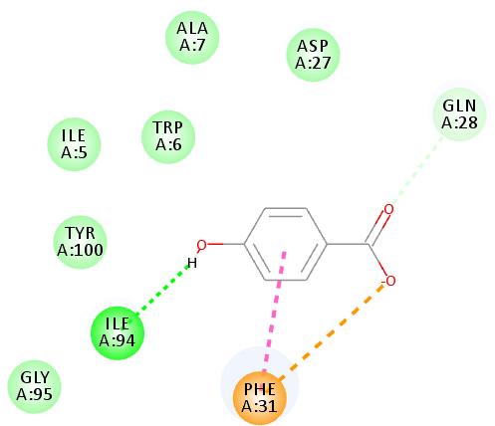
(D)
(C)
(B)
(A)
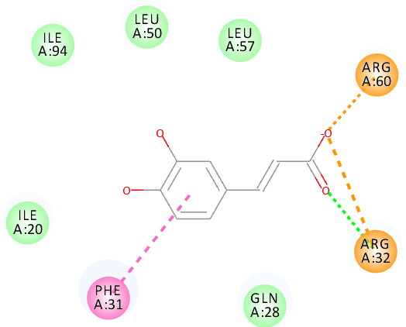
Figure S30. 2D binding modes of p-hydroxy benzoic acid (A), quercetin 3-O- β-D-glucoside-7-O-α-L-rhamnoside (B) kaempferol 3-O- β-D glucoside-7-O- α-L-rhamnoside (C) kaempferol (D) and caffeic acid (E) in active sites of dihydrofolate reductase; dotted green lines indicate H-bonds; dotted light green lines indicate C-H-bonds; dotted purple lines indicate π-bonds; dotted orange bonds indicate salt bridge formation; red bonds; unfavorable interaction
(E)
Table S1 Effect of different BIT concentration on the viral replication using the direct plaque reduction assay
 | % Inhibition in viral replication
 | HSV-1 | VSV
BI extract
6.25 μg/ml | 07.05 ± 1.16 | 12.18 ± 2.21
12.50 μg/ml | 11.63 ± 2.86 | 18.52 ± 1.70
25.00 μg/ml | 26.97 ± 3.09 | 32.54 ± 2.81
50.00 μg/ml | 41.85 ± 2.32 | 48.38 ± 2.51
100 μg/ml | 100 | 100

Data are presented as means ± S.D. n=3.
HSV-1: Herpes Simplex type-1 virus, VSV: Vesicular stomatitis virus

Table S2 Inhibitory percentage of BIT and isoniazid (standard) against Mycobacterium tuberculosis growth
Sample | BIT | Isoniazid
200 µg/mL | 100± 0 | 100± 0
100 µg/mL | 100± 0 | 100± 0
50 µg/mL | 90.74± 1.2 | 100± 0
25 µg/mL | 79.4± 1.5 | 100± 0
12.5 µg/mL | 75.8± 0.72 | 93.24± 2.1
Minimum inhibitory concentration (µg/mL) | 100 | 25

Table S3 Inhibitory percentage of BIT and Clarithromycin (standard) against Helicobacter pylori growth
Sample | BIT | Isoniazid
160 µg/mL | 100± 0 | 100± 0
80 µg/mL | 100± 0 | 100± 0
40 µg/mL | 94.58± 0.72 | 100± 0
20 µg/mL | 89.71± 1.2 | 100± 0
10 µg/mL | 73.4± 1.5 | 95.37± 2.1
Minimum inhibitory concentration (µg/mL) | 80 | 20

