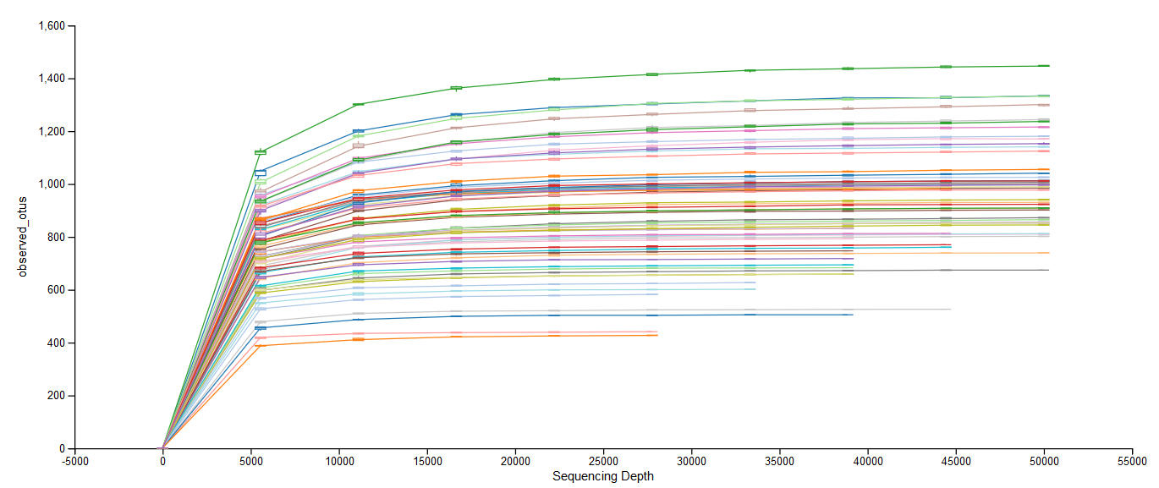
SUPPLEMENTARY FIGURE 1 Alpha rarefaction plot showing the number of unique OTUs at an increasing number of randomly sampled sequences for each fecal sample.

