Supplementary Material

Supplementary Tables
Supplementary Table 1. Consumption of main food groups during confinement in servings per days or week among the diet-COVID-19 survey respondents in Colombia by regions
 | National | Atlántica |  | Bogotá | Central | Oriental | Orinoquía and Amazonas | Pacífica | p-value¹
 | N=2,745 (%) | N=262 (%) | N=1,374 (%) |  | N=272 (%) | N=476 (%) | N=91 (%) | N=270 (%)
Cereals servings/d |  |  |  |  |  |  |  |  | <0.001
0 | 46 (1.68) | 5 (1.91) | 28 (2.04) |  | 2 (0.74) | 4 (0.84) | 1 (1.10) | 6 (2.22)
1 | 819 (29.8) | 74 (28.2) | 426 (31.0) |  | 71 (26.1) | 166 (34.9) | 27 (29.7) | 55 (20.4)
2 | 1,076 (39.2) | 110 (42.0) | 556 (40.5) |  | 91 (33.5) | 169 (35.5) | 35 (38.5) | 115 (42.6)
3 | 511 (18.6) | 40 (15.3) | 250 (18.2) |  | 50 (18.4) | 98 (20.6) | 13 (14.3) | 60 (22.2)
4 | 206 (7.50) | 26 (9.92) | 86 (6.26) |  | 31 (11.4) | 26 (5.46) | 10 (11.0) | 27 (10.0)
5 | 87 (3.17) | 7 (2.67) | 28 (2.04) |  | 27 (9.93) | 13 (2.73) | 5 (5.49) | 7 (2.59)
Bakery and pastries servings/d |  |  |  |  |  |  |  |  | 0.001
0 | 250 (9.11) | 32 (12.2) | 110 (8.01) |  | 15 (5.51) | 49 (10.3) | 7 (7.69) | 37 (13.7)
1 | 991 (36.1) | 115 (43.9) | 483 (35.2) |  | 91 (33.5) | 167 (35.1) | 38 (41.8) | 97 (35.9)
2 | 906 (33.0) | 75 (28.6) | 443 (32.2) |  | 112 (41.2) | 159 (33.4) | 25 (27.5) | 92 (34.1)
3 | 399 (14.5) | 31 (11.8) | 222 (16.2) |  | 35 (12.9) | 71 (14.9) | 12 (13.2) | 28 (10.4)
4 | 140 (5.10) | 6 (2.29) | 80 (5.82) |  | 12 (4.41) | 24 (5.04) | 7 (7.69) | 11 (4.07)
5 | 59 (2.15) | 3 (1.15) | 36 (2.62) |  | 7 (2.57) | 6 (1.26) | 2 (2.20) | 5 (1.85)
Tubers and plantains servings/d |  |  |  |  |  |  |  |  | <0.001
0 | 235 (8.56) | 13 (4.96) | 142 (10.3) |  | 16 (5.88) | 32 (6.72) | 7 (7.69) | 25 (9.26)
1 | 1678 (61.1) | 166 (63.4) | 847 (61.6) |  | 167 (61.4) | 293 (61.6) | 47 (51.6) | 158 (58.5)
2 | 674 (24.6) | 65 (24.8) | 322 (23.4) |  | 70 (25.7) | 123 (25.8) | 27 (29.7) | 67 (24.8)
3 | 120 (4.37) | 13 (4.96) | 46 (3.35) |  | 14 (5.15) | 25 (5.25) | 7 (7.69) | 15 (5.56)
4 | 38 (1.38) | 5 (1.91) | 17 (1.24) |  | 5 (1.84) | 3 (0.63) | 3 (3.30) | 5 (1.85)
Fruits and vegetables servings/d |  |  |  |  |  |  |  |  | 0.026
0 | 131 (4.77) | 22 (8.40) | 44 (3.20) |  | 13 (4.78) | 27 (5.67) | 14 (15.4) | 11 (4.07)
1 | 716 (26.1) | 82 (31.3) | 343 (25.0) |  | 67 (24.6) | 116 (24.4) | 29 (31.9) | 79 (29.3)
2 | 833 (30.3) | 77 (29.4) | 419 (30.5) |  | 88 (32.4) | 142 (29.8) | 23 (25.3) | 84 (31.1)
3 | 671 (24.4) | 53 (20.2) | 351 (25.5) |  | 52 (19.1) | 139 (29.2) | 14 (15.4) | 62 (23.0)
4 | 256 (9.33) | 18 (6.87) | 136 (9.90) |  | 35 (12.9) | 39 (8.19) | 8 (8.79) | 20 (7.41)
5 | 138 (5.03) | 10 (3.82) | 81 (5.90) |  | 17 (6.25) | 13 (2.73) | 3 (3.30) | 14 (5.19)
Milk and dairy products servings/d |  |  |  |  |  |  |  |  | 0.015
0 | 272 (9.91) | 24 (9.16) | 132 (9.61) |  | 29 (10.7) | 41 (8.61) | 18 (19.8) | 28 (10.4)
1 | 1085 (39.5) | 121 (46.2) | 513 (37.3) |  | 97 (35.7) | 214 (45.0) | 37 (40.7) | 103 (38.1)
2 | 902 (32.9) | 82 (31.3) | 463 (33.7) |  | 89 (32.7) | 156 (32.8) | 21 (23.1) | 91 (33.7)
3 | 357 (13.0) | 27 (10.3) | 197 (14.3) |  | 40 (14.7) | 48 (10.1) | 12 (13.2) | 33 (12.2)
4 | 97 (3.53) | 3 (1.15) | 54 (3.93) |  | 12 (4.41) | 15 (3.15) | 3 (3.30) | 10 (3.70)
5 | 32 (1.17) | 5 (1.91) | 15 (1.09) |  | 5 (1.84) | 2 (0.42) | 0 (0.00) | 5 (1.85)
Red meat and processed servings/wk |  |  |  |  |  |  |  |  | 0.008
0 | 293 (10.7) | 23 (8.78) | 157 (11.4) |  | 33 (12.1) | 35 (7.35) | 8 (8.79) | 37 (13.7)
1 | 556 (20.3) | 51 (19.5) | 286 (20.8) |  | 51 (18.8) | 95 (20.0) | 21 (23.1) | 52 (19.3)
2 | 690 (25.1) | 76 (29.0) | 334 (24.3) |  | 58 (21.3) | 131 (27.5) | 19 (20.9) | 72 (26.7)
3 | 572 (20.8) | 63 (24.0) | 282 (20.5) |  | 46 (16.9) | 115 (24.2) | 15 (16.5) | 51 (18.9)
4 | 293 (10.7) | 22 (8.40) | 142 (10.3) |  | 34 (12.5) | 59 (12.4) | 11 (12.1) | 25 (9.26)
5 | 341 (12.4) | 27 (10.3) | 173 (12.6) |  | 50 (18.4) | 41 (8.61) | 17 (18.7) | 33 (12.2)
Fish servings/wk |  |  |  |  |  |  |  |  | 0.035
0 | 783 (28.5) | 59 (22.5) | 360 (26.2) |  | 91 (33.5) | 144 (30.3) | 33 (36.3) | 96 (35.6)
1 | 1290 (47.0) | 139 (53.1) | 640 (46.6) |  | 124 (45.6) | 236 (49.6) | 34 (37.4) | 117 (43.3)
2 | 464 (16.9) | 46 (17.6) | 255 (18.6) |  | 38 (14.0) | 67 (14.1) | 14 (15.4) | 44 (16.3)
3 | 151 (5.50) | 14 (5.34) | 85 (6.19) |  | 15 (5.51) | 22 (4.62) | 6 (6.59) | 9 (3.33)
4 | 38 (1.38) | 2 (0.76) | 24 (1.75) |  | 3 (1.10) | 5 (1.05) | 2 (2.20) | 2 (0.74)
5 | 19 (0.69) | 2 (0.76) | 10 (0.73) |  | 1 (0.37) | 2 (0.42) | 2 (2.20) | 2 (0.74)
Poultry and processed servings/wk |  |  |  |  |  |  |  |  | <0.001
0 | 123 (4.48) | 12 (4.58) | 58 (4.22) |  | 20 (7.35) | 12 (2.52) | 7 (7.69) | 14 (5.19)
1 | 356 (13.0) | 48 (18.3) | 152 (11.1) |  | 59 (21.7) | 51 (10.7) | 10 (11.0) | 36 (13.3)
2 | 752 (27.4) | 75 (28.6) | 387 (28.2) |  | 77 (28.3) | 132 (27.7) | 26 (28.6) | 55 (20.4)
3 | 836 (30.5) | 81 (30.9) | 421 (30.6) |  | 70 (25.7) | 144 (30.3) | 28 (30.8) | 92 (34.1)
4 | 386 (14.1) | 25 (9.54) | 200 (14.6) |  | 27 (9.93) | 87 (18.3) | 11 (12.1) | 36 (13.3)
5 | 292 (10.6) | 21 (8.02) | 156 (11.4) |  | 19 (6.99) | 50 (10.5) | 9 (9.89) | 37 (13.7)
Eggs servings/wk |  |  |  |  |  |  |  |  | <0.001
0 | 66 (2.40) | 11 (4.20) | 28 (2.04) |  | 13 (4.78) | 5 (1.05) | 2 (2.20) | 7 (2.59)
1.5 | 449 (16.4) | 74 (28.2) | 207 (15.1) |  | 48 (17.6) | 61 (12.8) | 24 (26.4) | 35 (13.0)
3.5 | 834 (30.4) | 100 (38.2) | 428 (31.1) |  | 73 (26.8) | 136 (28.6) | 29 (31.9) | 68 (25.2)
5.5 | 720 (26.2) | 41 (15.6) | 361 (26.3) |  | 62 (22.8) | 152 (31.9) | 15 (16.5) | 89 (33.0)
7 | 676 (24.6) | 36 (13.7) | 350 (25.5) |  | 76 (27.9) | 122 (25.6) | 21 (23.1) | 71 (26.3)
Legumes servings/wk |  |  |  |  |  |  |  |  | 0.001
0 | 198 (7.21) | 19 (7.25) | 112 (8.15) |  | 13 (4.78) | 38 (7.98) | 6 (6.59) | 10 (3.70)
1 | 734 (26.7) | 69 (26.3) | 368 (26.8) |  | 90 (33.1) | 130 (27.3) | 23 (25.3) | 54 (20.0)
2 | 791 (28.8) | 100 (38.2) | 388 (28.2) |  | 75 (27.6) | 126 (26.5) | 24 (26.4) | 78 (28.9)
3 | 643 (23.4) | 58 (22.1) | 327 (23.8) |  | 54 (19.9) | 111 (23.3) | 22 (24.2) | 71 (26.3)
4 | 233 (8.49) | 7 (2.67) | 109 (7.93) |  | 26 (9.56) | 46 (9.66) | 9 (9.89) | 36 (13.3)
5 | 146 (5.32) | 9 (3.44) | 70 (5.09) |  | 14 (5.15) | 25 (5.25) | 7 (7.69) | 21 (7.78)
Nuts servings/wk |  |  |  |  |  |  |  |  | 0.004
0 | 1028 (37.4) | 120 (45.8) | 474 (34.5) |  | 87 (32.0) | 205 (43.1) | 46 (50.5) | 96 (35.6)
1 | 734 (26.7) | 69 (26.3) | 372 (27.1) |  | 77 (28.3) | 118 (24.8) | 19 (20.9) | 79 (29.3)
2 | 442 (16.1) | 38 (14.5) | 219 (15.9) |  | 48 (17.6) | 74 (15.5) | 15 (16.5) | 48 (17.8)
3 | 256 (9.33) | 14 (5.34) | 149 (10.8) |  | 31 (11.4) | 40 (8.40) | 5 (5.49) | 17 (6.30)
4 | 144 (5.25) | 9 (3.44) | 86 (6.26) |  | 14 (5.15) | 15 (3.15) | 3 (3.30) | 17 (6.30)
5 | 141 (5.14) | 12 (4.58) | 74 (5.39) |  | 15 (5.51) | 24 (5.04) | 3 (3.30) | 13 (4.81)
Fats servings/wk |  |  |  |  |  |  |  |  | <0.001
0 | 852 (31.0) | 77 (29.4) | 465 (33.8) |  | 59 (21.7) | 142 (29.8) | 25 (27.5) | 84 (31.1)
1 | 738 (26.9) | 83 (31.7) | 362 (26.3) |  | 52 (19.1) | 143 (30.0) | 25 (27.5) | 73 (27.0)
2 | 494 (18.0) | 54 (20.6) | 240 (17.5) |  | 52 (19.1) | 82 (17.2) | 17 (18.7) | 49 (18.1)
3 | 339 (12.3) | 28 (10.7) | 162 (11.8) |  | 38 (14.0) | 64 (13.4) | 14 (15.4) | 33 (12.2)
4 | 158 (5.76) | 14 (5.34) | 77 (5.60) |  | 24 (8.82) | 24 (5.04) | 5 (5.49) | 14 (5.19)
5 | 164 (5.97) | 6 (2.29) | 68 (4.95) |  | 47 (17.3) | 21 (4.41) | 5 (5.49) | 17 (6.30)
Soft beverages servings/d |  |  |  |  |  |  |  |  | <0.001
0 | 1767 (64.4) | 142 (54.2) | 924 (67.2) |  | 178 (65.4) | 305 (64.1) | 45 (49.5) | 173 (64.1)
1 | 599 (21.8) | 70 (26.7) | 291 (21.2) |  | 52 (19.1) | 111 (23.3) | 22 (24.2) | 53 (19.6)
2 | 207 (7.54) | 26 (9.92) | 85 (6.19) |  | 27 (9.93) | 30 (6.30) | 9 (9.89) | 30 (11.1)
3 | 91 (3.32) | 13 (4.96) | 39 (2.84) |  | 6 (2.21) | 23 (4.83) | 6 (6.59) | 4 (1.48)
4 | 81 (2.95) | 11 (4.20) | 35 (2.55) |  | 9 (3.31) | 7 (1.47) | 9 (9.89) | 10 (3.70)
Coffee servings/d |  |  |  |  |  |  |  |  | <0.001
0 | 592 (21.6) | 72 (27.5) | 287 (20.9) |  | 55 (20.2) | 94 (19.7) | 25 (27.5) | 59 (21.9)
1 | 760 (27.7) | 99 (37.8) | 364 (26.5) |  | 81 (29.8) | 114 (23.9) | 26 (28.6) | 76 (28.1)
2 | 633 (23.1) | 55 (21.0) | 302 (22.0) |  | 73 (26.8) | 111 (23.3) | 19 (20.9) | 73 (27.0)
3 | 370 (13.5) | 17 (6.49) | 203 (14.8) |  | 26 (9.56) | 82 (17.2) | 15 (16.5) | 27 (10.0)
4 | 390 (14.2) | 19 (7.25) | 218 (15.9) |  | 37 (13.6) | 75 (15.8) | 6 (6.59) | 35 (13.0)
Sugar cane beverages servings/d |  |  |  |  |  |  |  |  | <0.001
0 | 1329 (48.4) | 126 (48.1) | 710 (51.7) |  | 130 (47.8) | 203 (42.6) | 33 (36.3) | 127 (47.0)
1 | 819 (29.8) | 92 (35.1) | 393 (28.6) |  | 80 (29.4) | 156 (32.8) | 24 (26.4) | 74 (27.4)
2 | 337 (12.3) | 27 (10.3) | 148 (10.8) |  | 37 (13.6) | 58 (12.2) | 23 (25.3) | 44 (16.3)
3 | 147 (5.36) | 12 (4.58) | 71 (5.17) |  | 11 (4.04) | 28 (5.88) | 9 (9.89) | 16 (5.93)
4 | 113 (4.12) | 5 (1.91) | 52 (3.78) |  | 14 (5.15) | 31 (6.51) | 2 (2.20) | 9 (3.33)
Sugar or sugar cane servings/d |  |  |  |  |  |  |  |  | <0.001
0 | 1078 (39.3) | 71 (27.1) | 596 (43.4) |  | 119 (43.8) | 169 (35.5) | 23 (25.3) | 100 (37.0)
1 | 589 (21.5) | 60 (22.9) | 296 (21.5) |  | 59 (21.7) | 113 (23.7) | 19 (20.9) | 42 (15.6)
2 | 535 (19.5) | 59 (22.5) | 249 (18.1) |  | 53 (19.5) | 92 (19.3) | 18 (19.8) | 64 (23.7)
3 | 290 (10.6) | 43 (16.4) | 122 (8.88) |  | 20 (7.35) | 57 (12.0) | 16 (17.6) | 32 (11.9)
4 | 133 (4.85) | 14 (5.34) | 61 (4.44) |  | 13 (4.78) | 23 (4.83) | 5 (5.49) | 17 (6.30)
5 | 120 (4.37) | 15 (5.73) | 50 (3.64) |  | 8 (2.94) | 22 (4.62) | 10 (11.0) | 15 (5.56)
Desserts and sweets servings/d |  |  |  |  |  |  |  |  | <0.001
0 | 1271 (46.3) | 146 (55.7) | 600 (43.7) |  | 109 (40.1) | 233 (48.9) | 50 (54.9) | 133 (49.3)
1 | 1169 (42.6) | 86 (32.8) | 626 (45.6) |  | 139 (51.1) | 190 (39.9) | 22 (24.2) | 106 (39.3)
2 | 228 (8.31) | 22 (8.40) | 107 (7.79) |  | 17 (6.25) | 40 (8.40) | 14 (15.4) | 28 (10.4)
3 | 77 (2.81) | 8 (3.05) | 41 (2.98) |  | 7 (2.57) | 13 (2.73) | 5 (5.49) | 3 (1.11)
Snacks servings/d |  |  |  |  |  |  |  |  | 0.087
0 | 1655 (60.3) | 158 (60.3) | 804 (58.5) |  | 174 (64.0) | 304 (63.9) | 51 (56.0) | 164 (60.7)
1 | 806 (29.4) | 71 (27.1) | 418 (30.4) |  | 81 (29.8) | 133 (27.9) | 21 (23.1) | 82 (30.4)
2 | 204 (7.43) | 26 (9.92) | 110 (8.01) |  | 11 (4.04) | 25 (5.25) | 14 (15.4) | 18 (6.67)
3 | 51 (1.86) | 4 (1.53) | 28 (2.04) |  | 3 (1.10) | 9 (1.89) | 4 (4.40) | 3 (1.11)
4 | 29 (1.06) | 3 (1.15) | 14 (1.02) |  | 3 (1.10) | 5 (1.05) | 1 (1.10) | 3 (1.11)
¹ Differences between groups were evaluated by chi-squared test. Differences between groups were evaluate by Fisher’s exact test there were less than 5 observations in some categories.

Supplementary Table 2. Factor loadings for main foods denoting dietary clusters derived from principal component analysis among the diet-COVID-19 survey respondents in Colombia, before and during the confinement
 | Before |  |  | During
 | Protein foods | Carbohydrate foods | Sugar foods | Westernized | Carbohydrate foods | Animal protein foods | Fish, fruits and vegetables
Legumes | 0.5 | 0.22 | 0.23 | -0.14 | 0.64 | 0.04 | -0.04
Cereals (cereals. bakery and pastries) | 0.11 | 0.76 | 0.01 | 0.24 | 0.64 | 0.16 | 0.1
Beverages (soft beverages and sugar cane beverages) | 0.1 | 0.18 | 0.61 | 0.3 | 0.35 | -0.06 | -0.25
Snacks (nuts and snacks) | 0.01 | 0.06 | 0.02 | 0.71 | 0.07 | -0.07 | 0.11
Tubers and plantain | 0.14 | 0.66 | 0.25 | 0.13 | 0.73 | 0.04 | -0.01
Fruits and vegetables | 0.06 | 0.34 | -0.68 | 0.003 | 0.12 | 0.13 | 0.74
Milk and dairy products | -0.001 | 0.5 | -0.21 | 0.37 | 0.12 | 0.34 | 0.24
Red meat and processed | 0.51 | 0.09 | 0.09 | 0.33 | 0.02 | 0.61 | -0.27
Fish | 0.56 | -0.13 | -0.14 | 0.14 | -0.08 | -0.01 | 0.66
Poultry and processed | 0.64 | 0.06 | -0.06 | 0.02 | 0.01 | 0.61 | 0.17
Eggs | 0.46 | 0.17 | -0.15 | -0.18 | 0.15 | 0.7 | 0.08
Fats | 0.46 | 0.03 | 0.21 | 0.44 | 0.04 | 0.36 | -0.21
Coffee | 0.01 | -0.06 | 0.08 | -0.07 | -0.1 | 0.14 | 0.14
Sugar or sugar cane | 0.02 | 0.25 | 0.66 | 0.19 | 0.38 | 0.01 | -0.43
Desserts and sweets | 0.04 | 0.14 | 0.21 | 0.74 | 0.06 | 0.01 | 0.02
Explained variance | 33% |  |  | 45%
Kaiser-Meyer-Olkin index | 0.72 |  |  | 0.68
Factor loadings higher than 3 are highlighted in bold.

Supplementary Table 3: Differences in scores of adherence to dietary patterns by regions, before and during the confinement
Region | Before |  |  | During
 | Protein foods | Carbohydrate foods | Sugar foods | Westernized | Carbohydrate foods | Animal protein foods | Fish, fruits and vegetables
Atlántica | -0.009 | -0.112 | 0.259 | -0.145 | -0.08 | -0.387 | -0.217
Bogotá | -0.092 | -0.108 | -0.108 | -0.119 | -0.182 | 0.037 | 0.08
Central | -0.078 | 0.167 | -0.041 | 0.029 | -0.072 | 0.083 | -0.227
Oriental | -0.069 | -0.117 | -0.003 | -0.251 | -0.075 | 0.069 | -0.12
Orinoquia y Amazonas | 0.246 | -0.065 | 0.347 | -0.038 | 0.188 | -0.284 | -0.43
Pacífica | 0.005 | 0.05 | 0.072 | -0.262 | 0.186 | 0.146 | -0.223
p-value¹ | 0.003 | 0.001 | <0.001 | <0.001 | <0.001 | <0.001 | <0.001
¹ Within-region differences evaluated via Kruskal-Wallis Rank sum test with Welch´s heteroscedastic F test (one-way ANOVA for non-normal and heteroskedastic data). Pairwise-comparisons corrected via Bonferroni.

Supplementary Figures
Supplementary Figure 1. Radial charts showing consumption of main food groups in servings/day among the diet-COVID-19 survey respondents in Colombia by regions. Before (A) and during (B) the confinement.
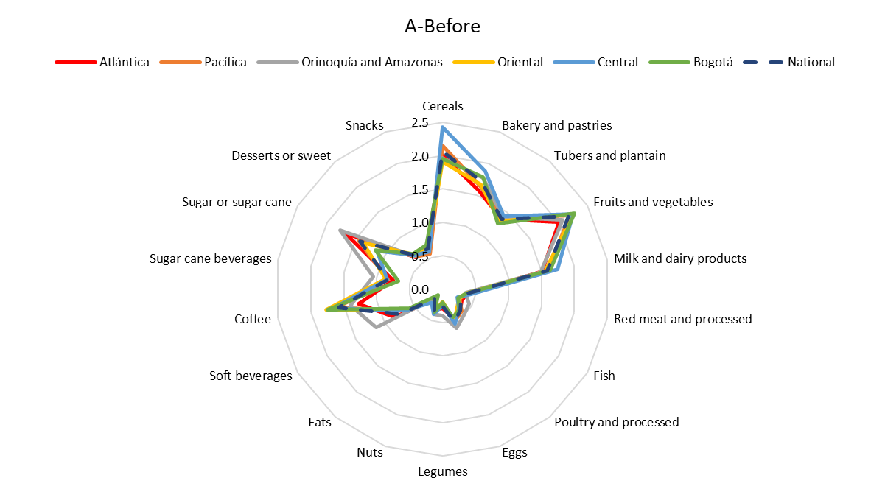
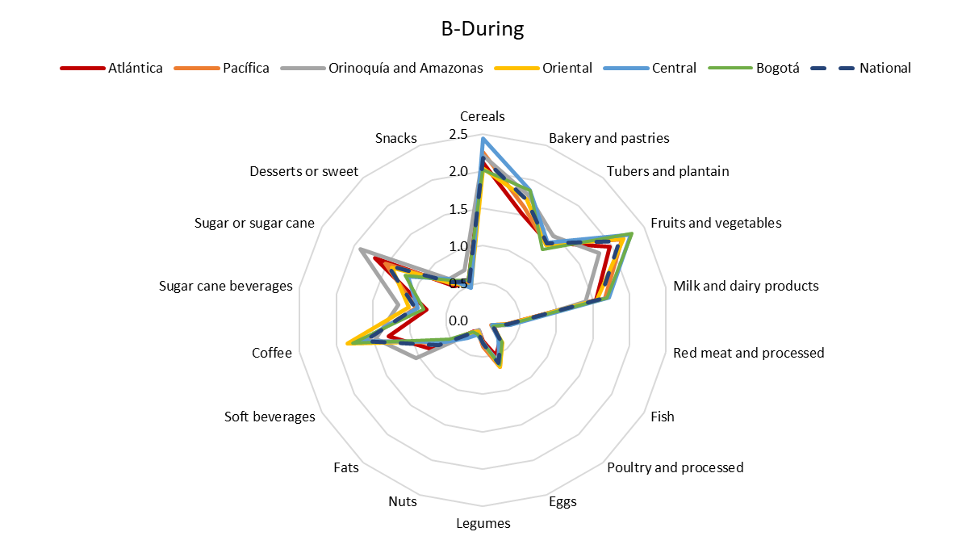

Supplementary Figure 2. Variation in consumption of main food groups during confinement when compared to previous dietary intake among the diet-COVID-19 survey respondents in Colombia by regions
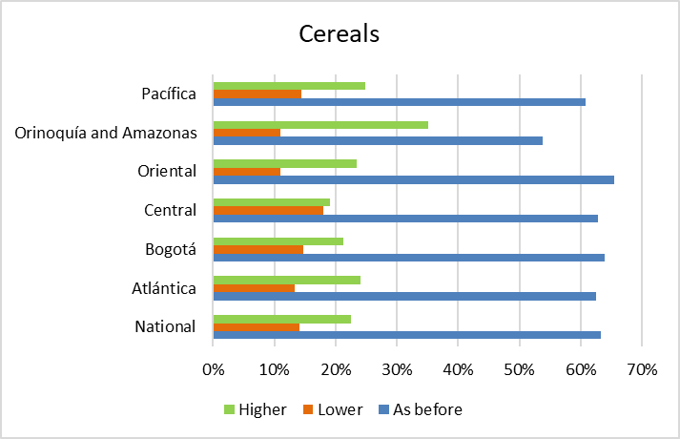 | 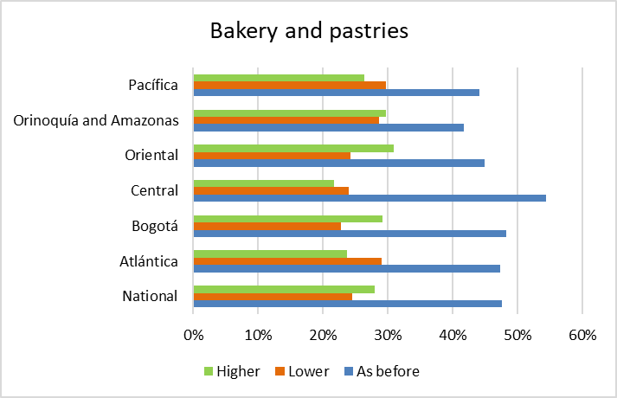
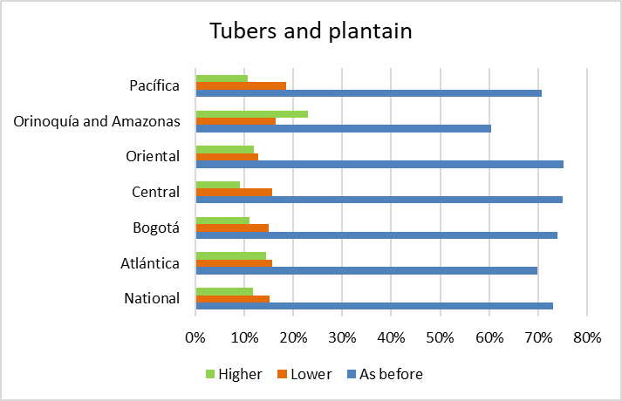 | 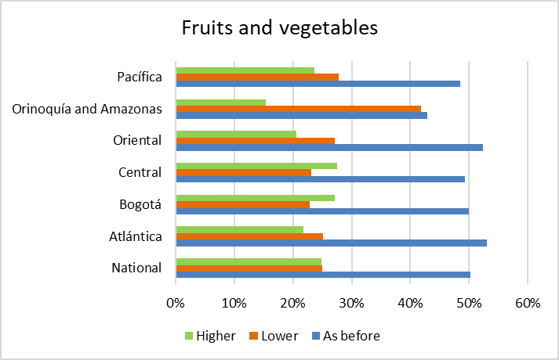
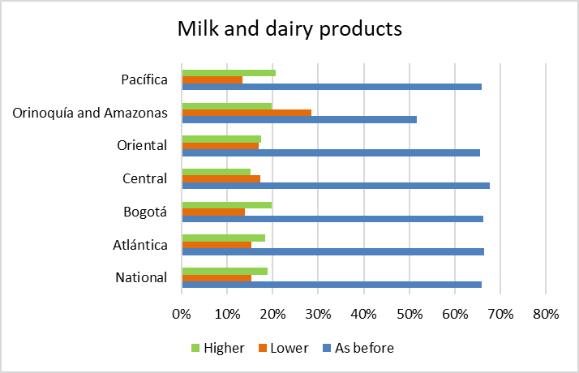 | 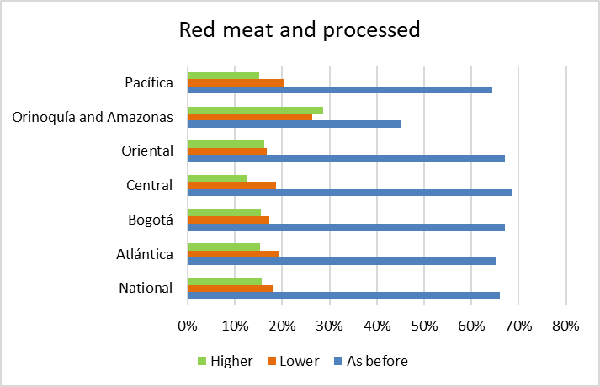
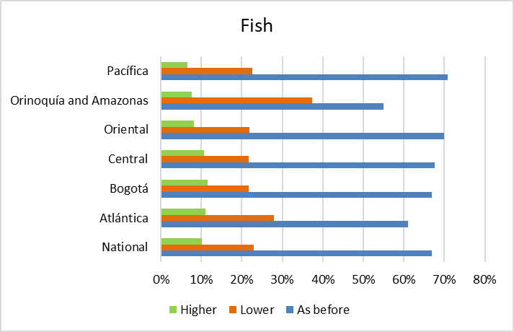 | 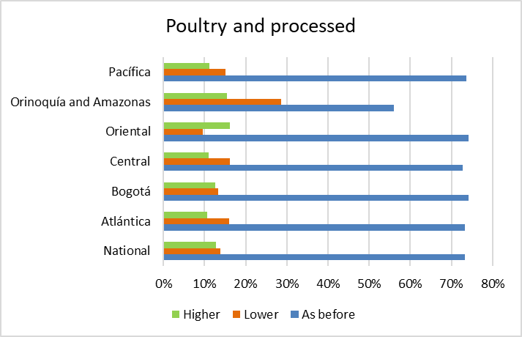
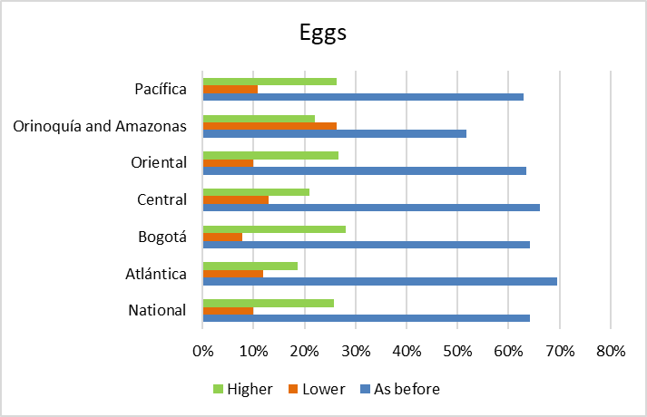 | 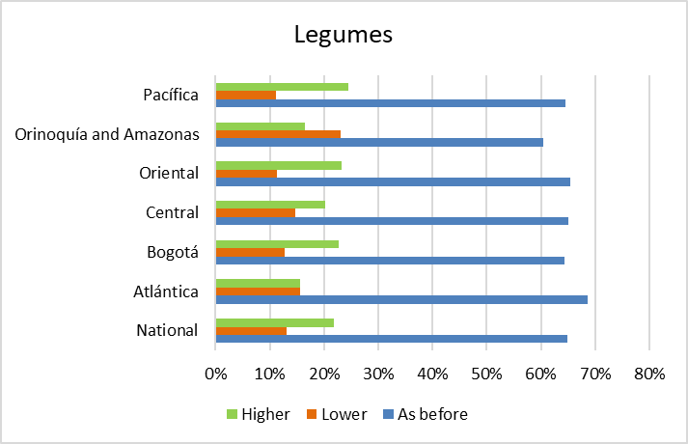
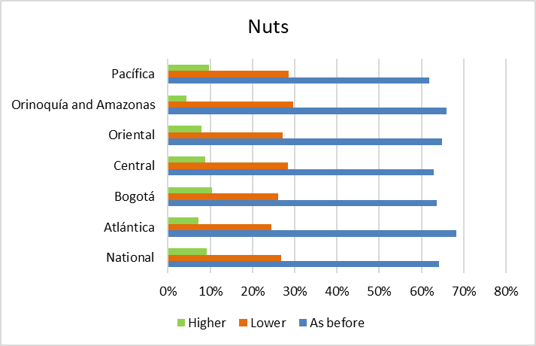 | 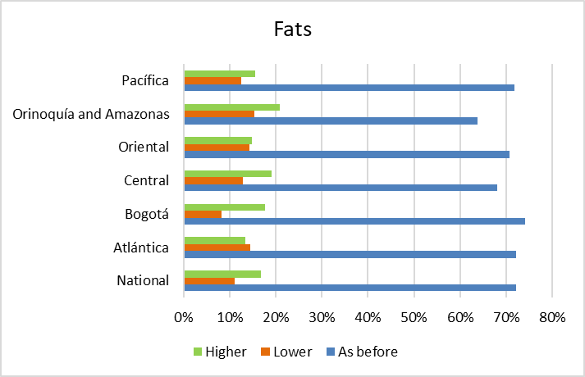
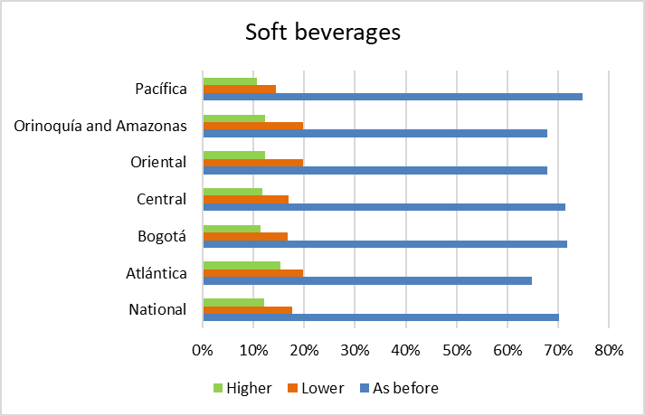 | 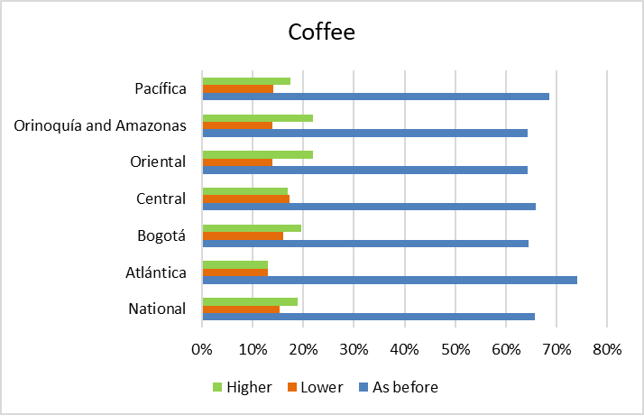
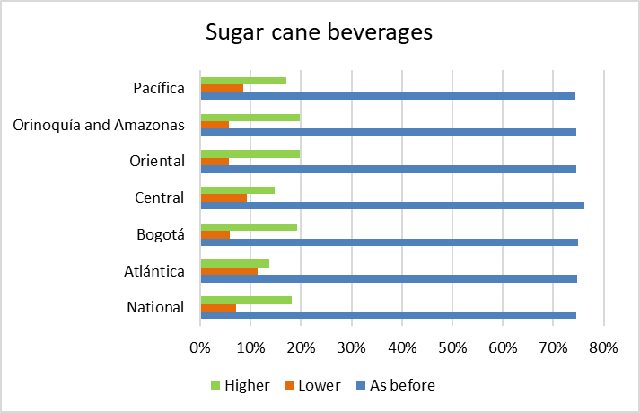 | 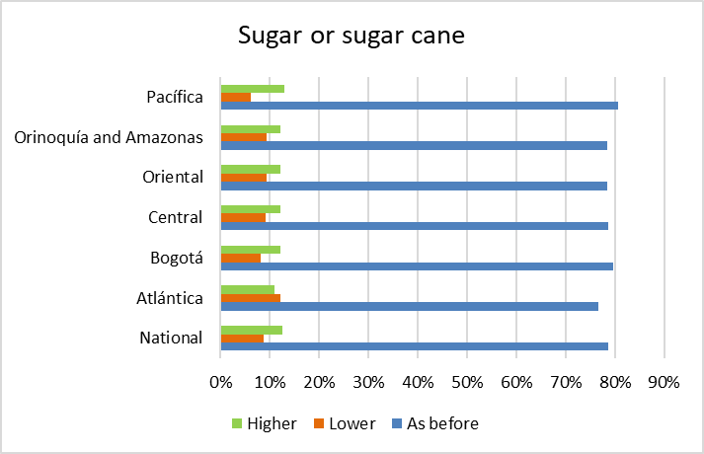
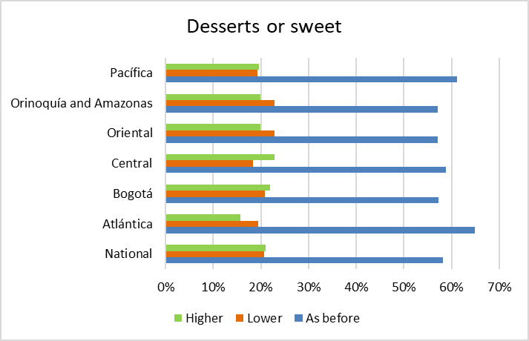

Supplementary Figure 3. Radial charts showing dietary clusters derived from principal component analysis among the diet-COVID-19 survey respondents in Columbia by weeks of confinement: from the second week (A) from the fourth week (B) of confinement.
A-From the second week of confinement
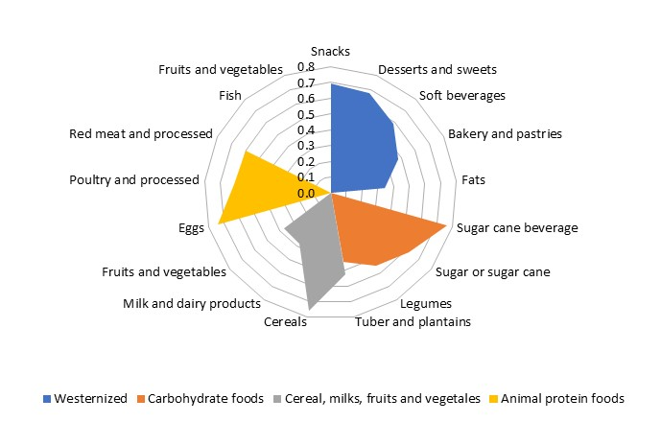
B-From the fourth week of confinement
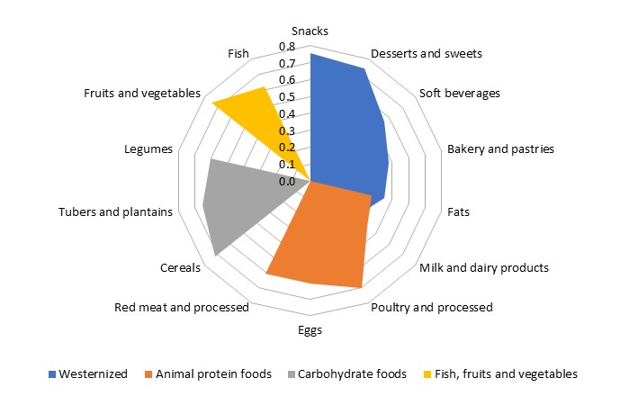

Supplementary Figure 4. Radial charts showing dietary clusters derived from principal component analysis among the diet-COVID-19 survey respondents in Columbia for every region (A – Atlántica; B – Bogota. C – Orinoquía and Amazonas. D – Central. E – Oriental. F – Pacifica), before and during the confinement
A | Atlántica
 | before | during
 | 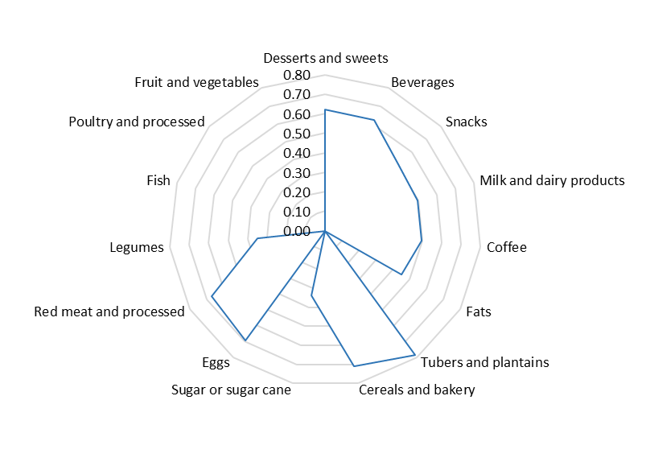 | 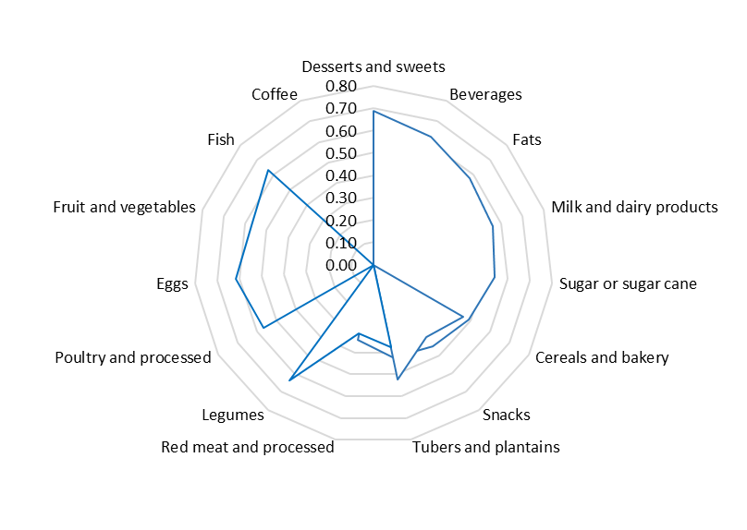
B | Bogotá
 | before | during
 | 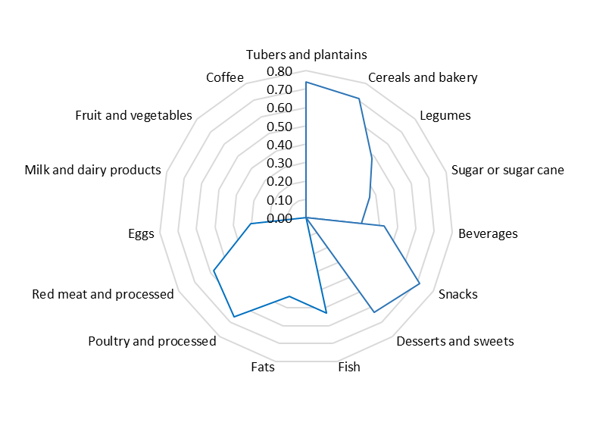 | 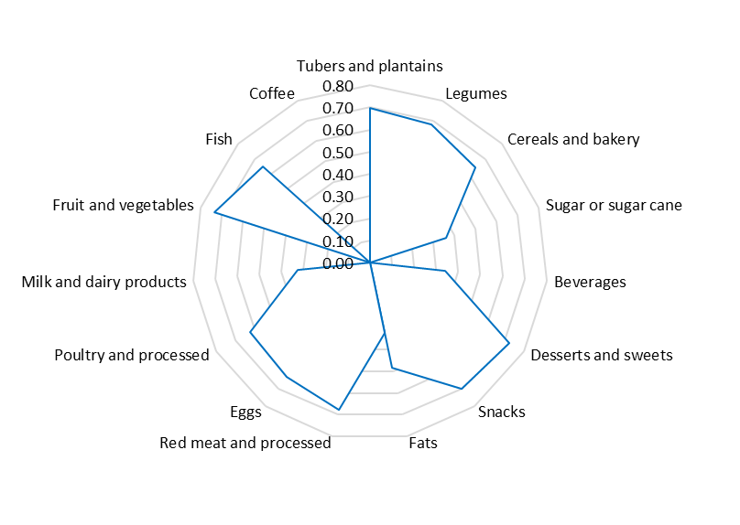
C | Central
 | before | during
 | 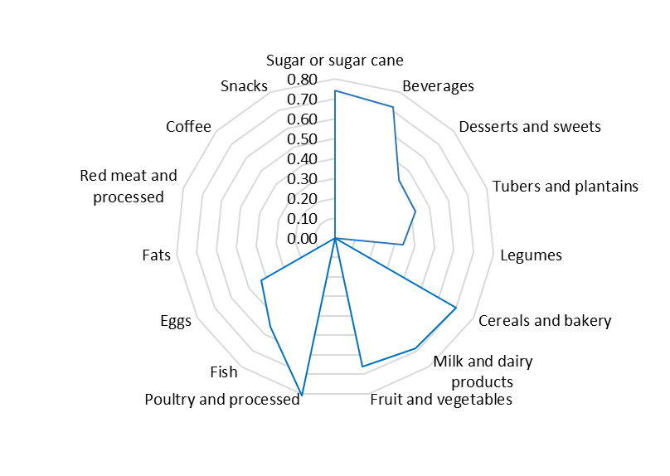 | 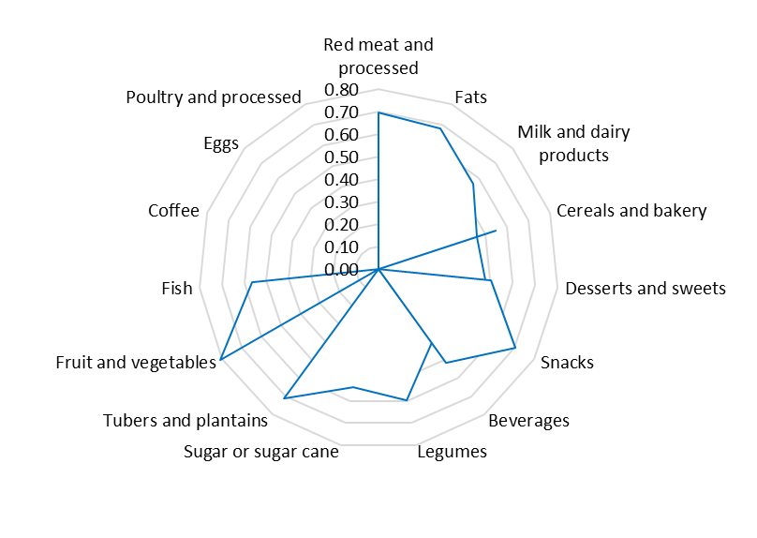
D | Oriental
 | before | during
 | 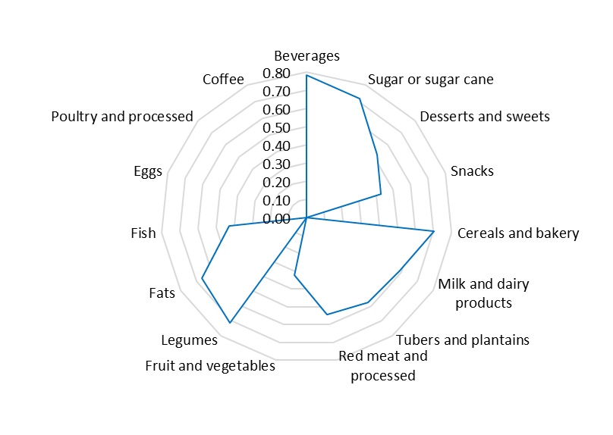 | 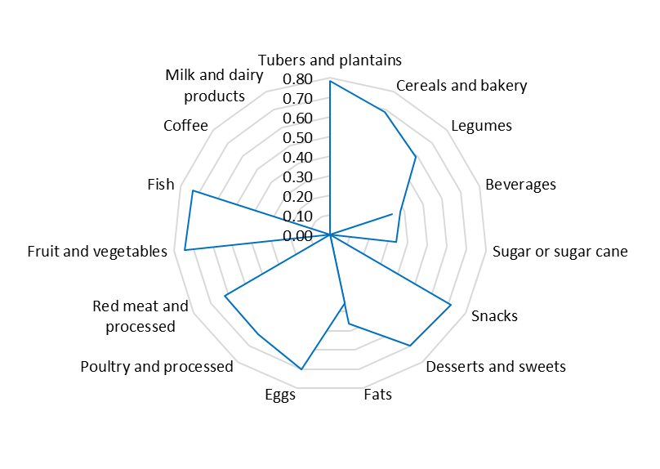
E | Orinoquía and Amazonía
 | before | during
 | 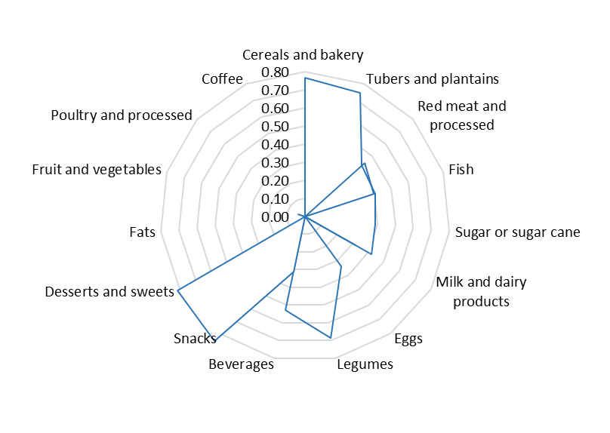 | 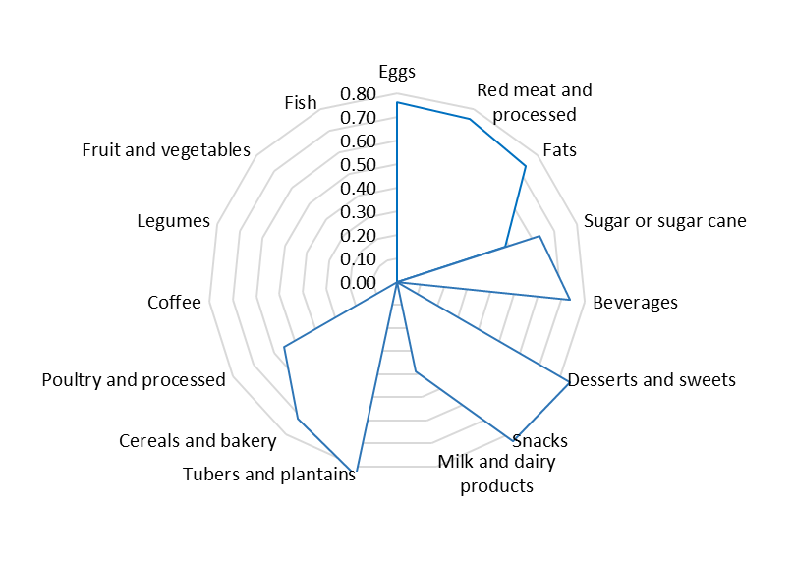
F | Pacífica
 | before | during
 | 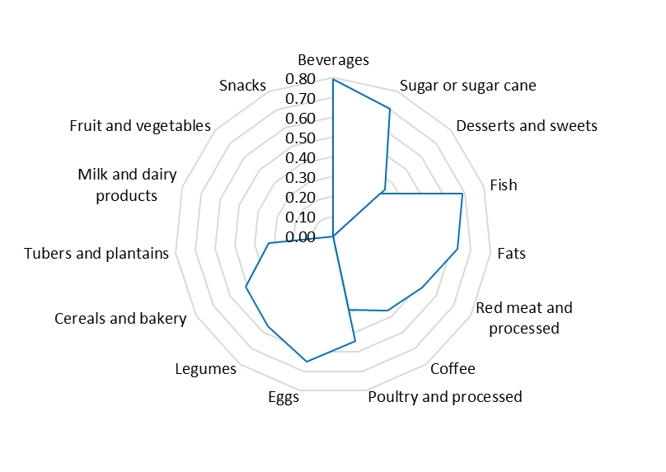 | 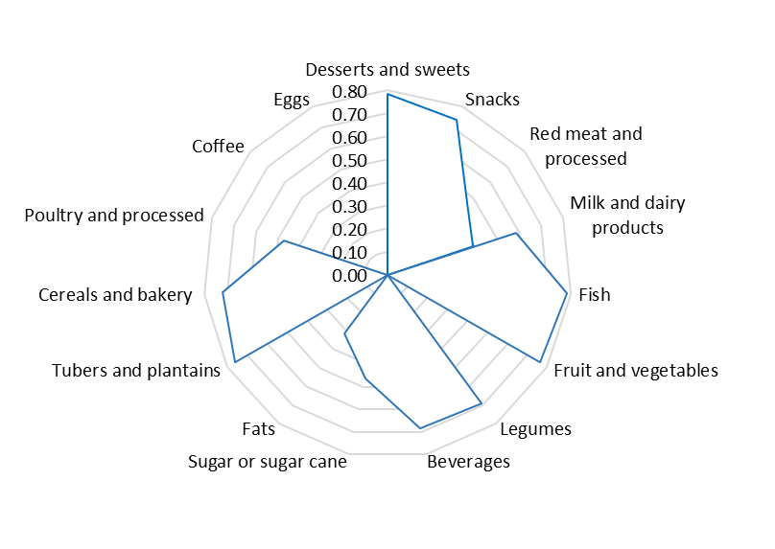

Supplementary Figure 5. Factor loadings of each food group and their contribution to the dietary patterns derived from principal component analysis for every region, before (A) and during (B) confinement.
A-Before confinement
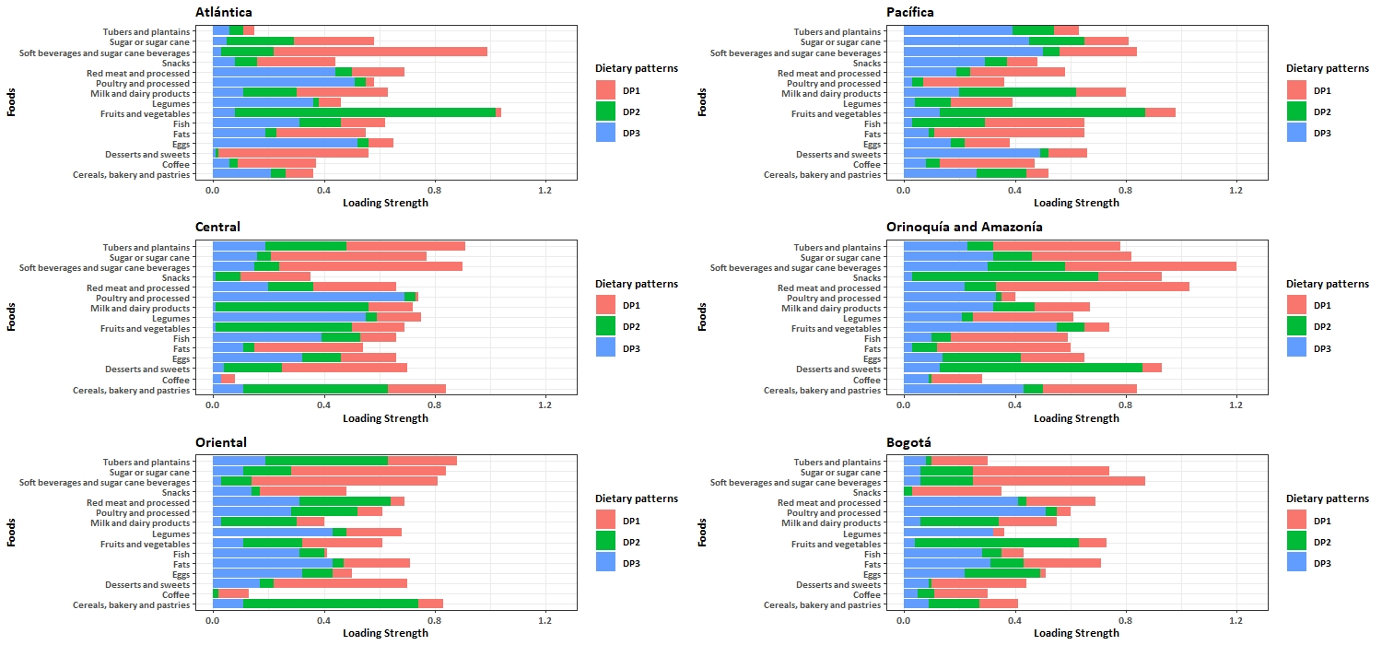

B-During confinement
