SUPPLEMENTARY FIGURES

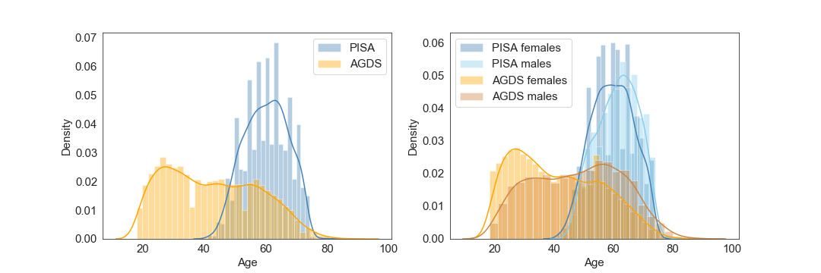
Supplementary Figure 1. Age and sex distributions in AGDS and PISA cohorts
Histograms with kernel density plots showing (left) the distribution of ages for AGDS and PISA cohorts and (right) after stratification by sex. Note that the PISA cohort is on average older at the time the participants responded to the questionnaire, but have lower rates of chronic pain on average than the AGDS (depression-enriched) cohort.

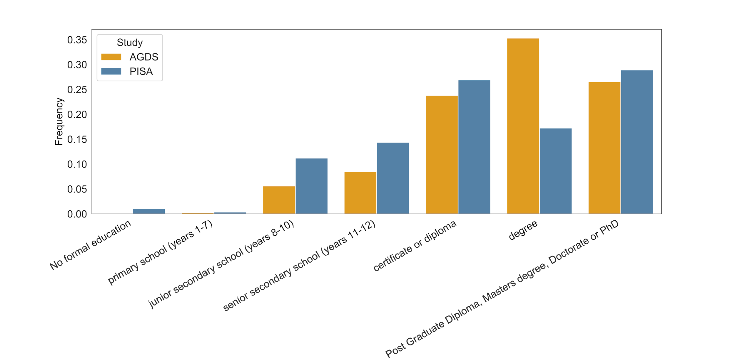
Supplementary Figure 2. Significant difference in educational attainment between AGDS and PISA cohorts
Barplots showing the frequency of educational attainment for the AGDS and PISA cohorts. The difference is statistically significant (χ2 test p<E-100).

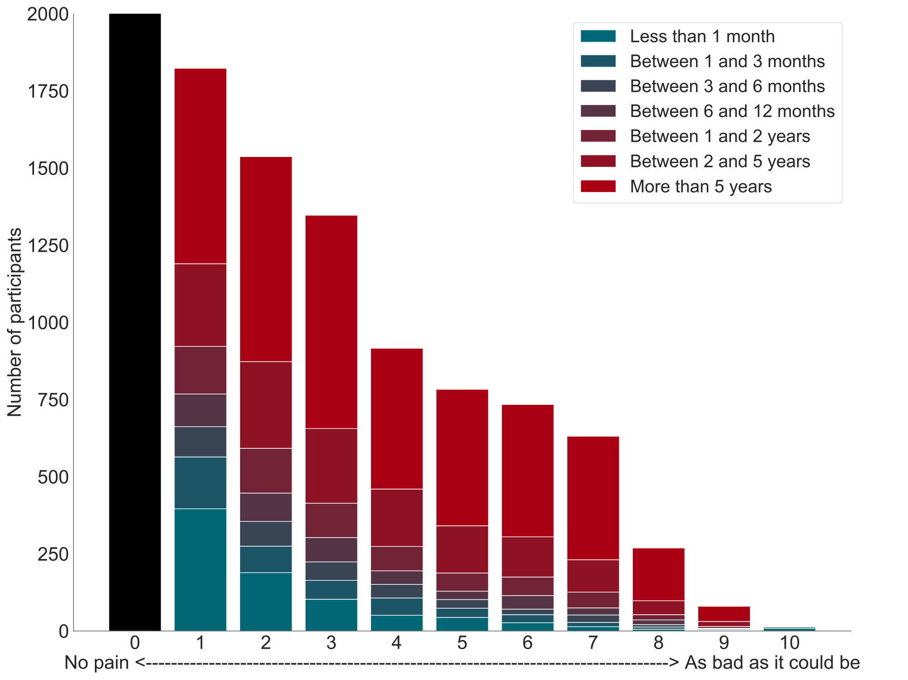
Supplementary Figure 3. Positive association between pain intensity and pain duration in AGDS cohort
Bar plots illustrate average pain intensity (x-axis) stratified by pain duration, with a strong positive relationship found between these measures (p=5.5e-106 linear regression; AGDS data only).

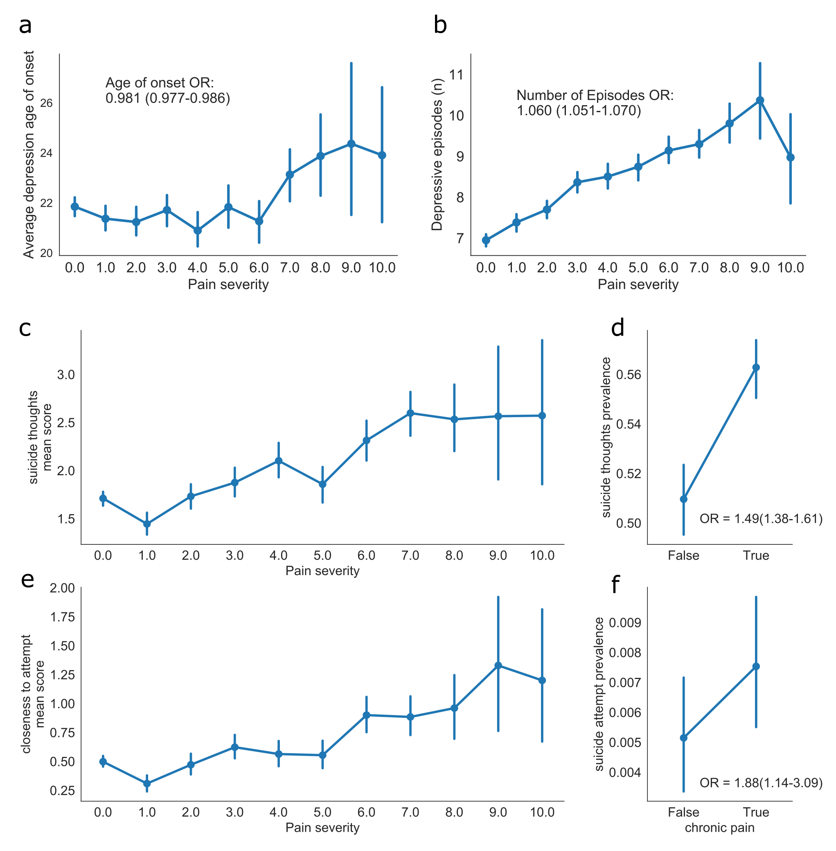
Supplementary Figure 4. Positive association between chronic pain severity (intensity), depression (number of episodes) and suicidality in AGDS cohort
Point plots comparing chronic pain severity with: (a) average age of onset; (b) average number of depressive episodes; (c) average suicide thoughts score; or (e) suicide attempt score. Also shown are differences in the prevalence of (d) recent suicide thoughts and (f) recent suicide attempts. Error bars denote 95% confidence intervals (AGDS data only).

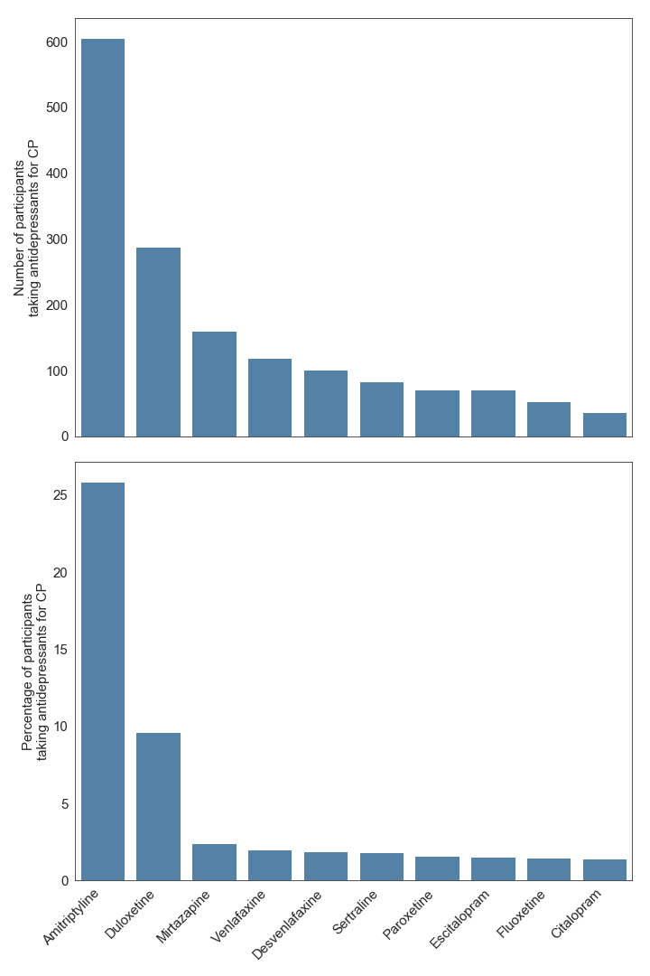
Supplementary Figure 5. Antidepressant intake by chronic pain participants
Barplots showing the percentage (number) of participants with comorbid chronic pain (CP) and depression taking ten commonly used antidepressants in Australia (AGDS data only).

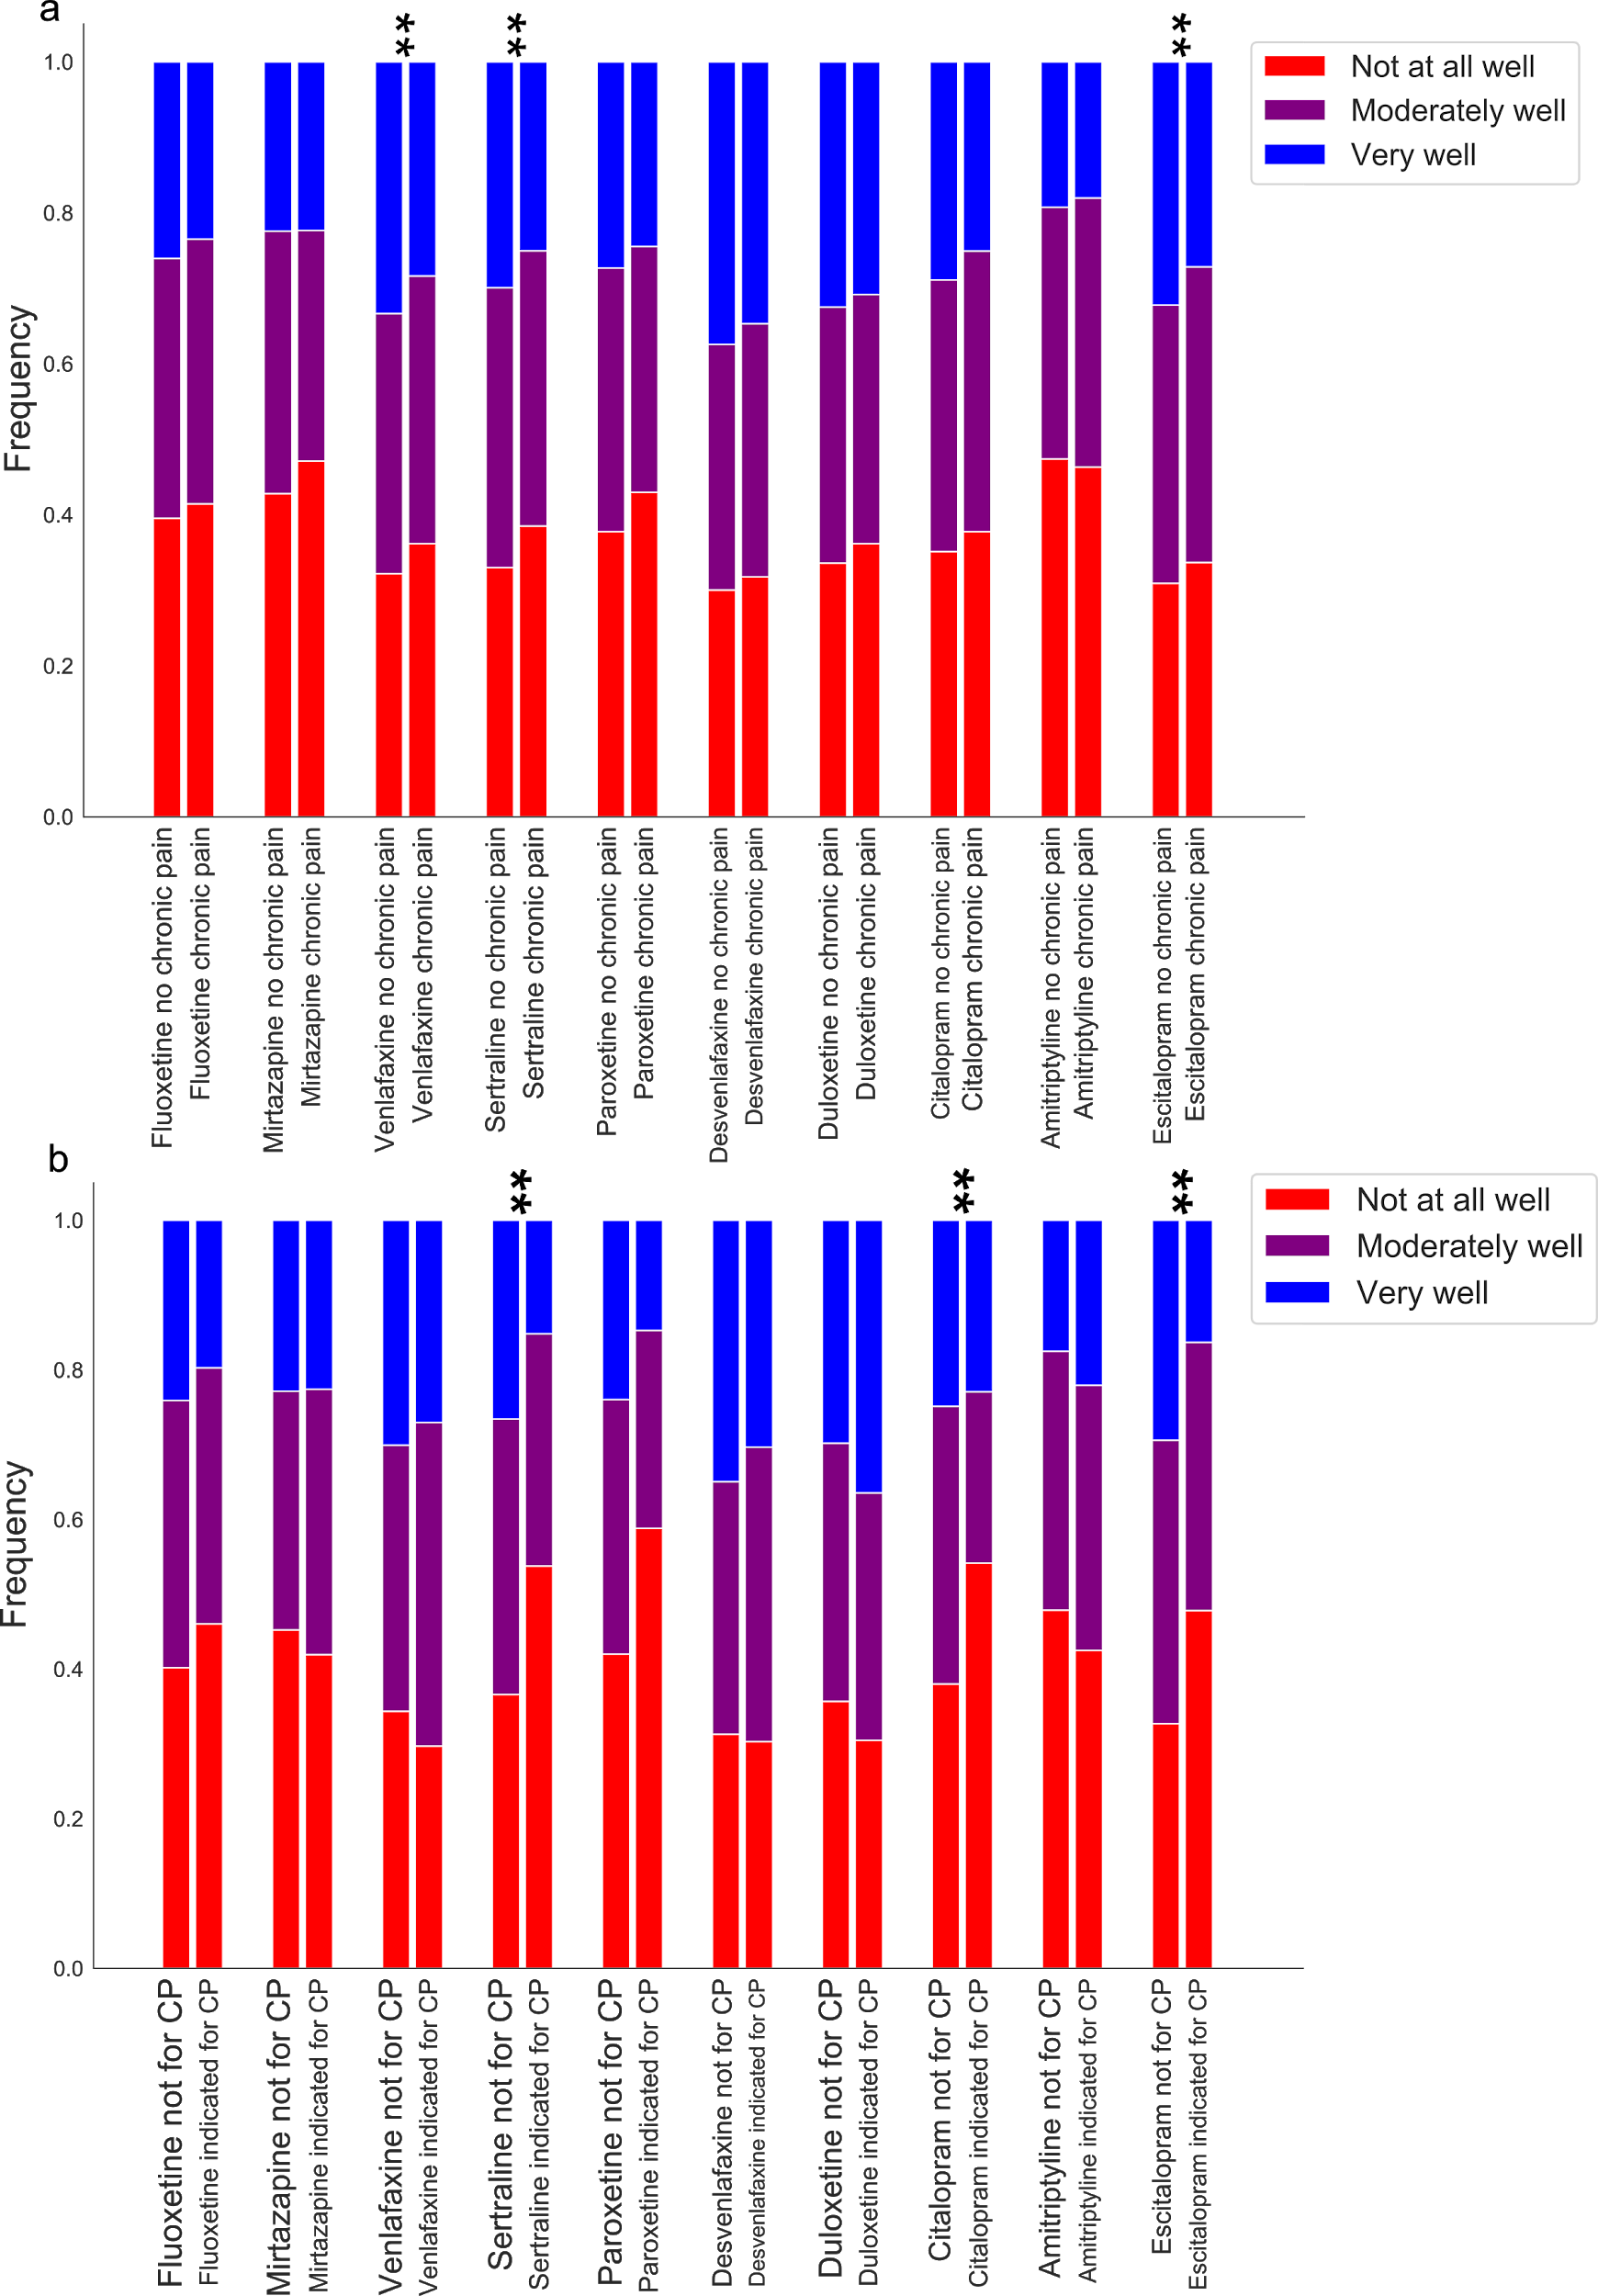
Supplementary Figure 6. Association between antidepressant response, participants with chronic pain and antidepressant prescription for chronic pain
Bar plots depicting the average antidepressant response score across antidepressants stratified by participants reporting chronic pain (CP), regardless of: (a) the clinical indication for the antidepressant: or (b) whether the antidepressant was prescribed for chronic pain. Further details including p-values from a cumulative link logistic regression are in Supplementary Tables 4 and 5 (AGDS data only).

SUPPLEMENTARY TABLES

Supplementary Table 1. Effect of demographic variables, depression and cohort on chronic pain
 | OR (95%CI) | p-value
Cohort (AGDS) | 1.31 (0.96–1.77) | 0.086
Sex (female) | 1.16 (1.07–1.26) | 0.0003
Depression* | 1.95 (1.42–2.66) | 2.80E-05
Education | 0.887 (0.86–0.91) | 1.00E-14
Age | 1.02 (1.02–1.03) | 6.90E-74
These results are from a multivariate logistic regression on chronic pain. Fully adjusted ORs are shown. Cohort represents a categorical variable of whether participants were from the AGDS cohort compared to the PISA cohort. *The effect of self-reported depression available on PISA and AGDS (all cases). Note the lack of association with cohort after adjustment for sex, age, education and depression.

Supplementary Table 2. Other psychiatric comorbidities with chronic pain
Diagnosis | OR (95% CI) | p-value
Bipolar disorder | 0.947 (0.82–1.09) | 0.4570
Premenstrual dysphoria | 1.19 (0.90–1.57) | 0.2355
Schizophrenia | 1.58 (0.97–2.58) | 0.0675
Anorexia nervosa | 0.788 (0.62–0.99) | 0.0443
Bulimia | 1.17 (0.92–1.49) | 0.2003
ADD/ADHD | 0.826 (0.68–1.01) | 0.0602
Autism/Asperger | 1.14 (0.82–1.60) | 0.4294
Tourette's | 1.12 (0.36–3.49) | 0.8502
Generalized anxiety | 0.999 (0.92–1.09) | 0.9889
Panic disorder | 1.02 (0.88–1.18) | 0.8050
Obsessive-compulsive disorder | 0.945 (0.79–1.13) | 0.5344
Hoarding disorder | 1.29 (0.72–2.32) | 0.3870
PTSD | 0.987 (0.88–1.11) | 0.8335
Phobia | 1.03 (0.82–1.29) | 0.7949
Seasonal disorder | 0.885 (0.70–1.12) | 0.3179
Social anxiety | 1.19 (1.04–1.36) | 0.0096
Agoraphobia | 0.828 (0.63 1.09) | 0.1724
Personality disorder | 1.11 (0.93–1.32) | 0.2440
Substance use | 0.984 (0.79–1.22) | 0.8814
Multivariate logistic regression assessing chronic pain comorbidities.
Multiple testing corrected significance threshold: p<0.0026

Supplementary Table 3. Correlations between recent substance use and chronic pain (CP)
Substance | CP OR (95%CI) | p-value
GHB (gamma hydroxybutyrate) | 0.409 (0.14–1.21) | 0.105
Inhalants | 0.723 (0.54–0.98) | 0.035
Cocaine | 0.811 (0.65–1.01) | 0.060
Ecstasy | 0.857 (0.69–1.06) | 0.161
Other party drugs | 0.886 (0.54–1.46) | 0.632
Stimulants | 0.986 (0.91–1.07) | 0.744
Alcohol | 0.997 (0.99–1.00) | 3.17E-04
Ketamine | 1.02 (0.71–1.45) | 0.933
Hallucinogens | 1.03 (0.76–1.40) | 0.850
E-cigarettes | 1.03 (0.95–1.12) | 0.421
Amphetamines | 1.05 (0.86–1.28) | 0.640
Sedatives or sleeping pills | 1.05 (0.99–1.11) | 0.080
Tobacco | 1.05 (1.02–1.09) | 0.002
Cannabis | 1.07 (1.01–1.13) | 0.016
Painkillers or analgesics* | 1.29 (1.24–1.35) | 1.00E-29
Opioids* | 1.31 (1.06–1.62) | 0.012
Alcohol use was measured as the number of days drinking three or more standard drinks in the past three months. All other variables were measured on a scale ranging from never to daily or almost daily for the past three months.*Non-medical use of opioids & over-the-counter or other painkillers/analgesics

Supplementary Table 4. Percentage of chronic pain participants with an antidepressant indication for chronic pain or for depression
Antidepressant | Chronic pain indication % | Depression indication %
Sertraline | 2.83 | 97.29
Escitalopram | 2.62 | 96.45
Venlafaxine | 3.28 | 96.97
Amitriptyline | 31.05 | 61.60
Mirtazapine | 4.37 | 89.78
Desvenlafaxine | 3.31 | 96.96
Citalopram | 2.18 | 95.45
Fluoxetine | 2.46 | 95.35
Duloxetine | 15.32 | 94.95
Paroxetine | 2.11 | 92.67

Supplementary Table 5. Functional benefits associated with antidepressant use in participants with chronic pain
Self-reported benefit | OR (95% C.I.) | p-value
Relief of depressive symptoms | 0.78 (0.71–0.87) | 1.5E-06
Return of normal emotions | 0.80 (0.74–0.86) | 2.6E-08
Getting back to normal daily activities | 0.82 (0.76–0.89) | 9.2E-07
Improved relationships with those I am close to | 0.90 (0.83–0.97) | 0.01
Restored control over my mood and actions | 0.90 (0.83–0.98) | 0.01
Relief of other key symptoms | 0.94 (0.87–1.02) | 0.15
Reduction in suicidal thinking or actions | 1.09 (1.01–1.18) | 0.03

Supplementary Table 6. Effect of chronic pain on antidepressant response
Antidepressant | N | beta | S.E. | p-value
Sertraline* | 5,189 | -0.29132 | 0.053 | 4.42E-08
Escitalopram* | 3,877 | -0.28702 | 0.061 | 2.96E-06
Venlafaxine* | 3,540 | -0.25168 | 0.065 | 1.13E-04
Amitriptyline | 1,293 | -0.06086 | 0.134 | 0.650
Mirtazapine | 1,718 | -0.16407 | 9.48E-02 | 0.083
Desvenlafaxine | 2,262 | -0.14898 | 0.080 | 0.063
Citalopram | 2,236 | -0.19203 | 0.082 | 0.019
Fluoxetine | 3,178 | -0.1739 | 0.069 | 0.012
Duloxetine | 1,776 | -0.18966 | 0.093 | 0.042
Paroxetine | 1,361 | -0.30056 | 0.107 | 0.005
*p<0.05 after Bonferroni multiple-testing correction for 10 variables/antidepressants

Supplementary Table 7. Effect of chronic pain indication on antidepressant treatment response
Antidepressant | N | beta | S.E. | p-value
Sertraline* | 5,189 | -0.80599 | 0.207 | 1.00E-04
Escitalopram* | 3,877 | -0.79848 | 0.253 | 0.002
Venlafaxine | 3,540 | 0.143459 | 0.214 | 0.503
Amitriptyline | 1,293 | 0.220429 | 0.119 | 0.064
Mirtazapine | 1,718 | 0.003402 | 0.271 | 0.990
Desvenlafaxine | 2,262 | -0.39922 | 0.270 | 0.140
Citalopram* | 2,236 | -1.14947 | 0.379 | 0.002
Fluoxetine | 3,178 | -0.40595 | 0.268 | 0.130
Duloxetine | 1,776 | 0.2071 | 0.148 | 0.161
Paroxetine | 1,361 | -0.50542 | 0.503 | 0.315
*p<0.05 after Bonferroni multiple-testing correction for 10 variables/antidepressants

