**SUPPLEMENTARY FIGURES AND TABLES**

**CTAB-assisted synthesis of C@Na3V2(PO4)2F3 with optimized morphology for application as cathode material for Na-ion batteries**

Ana Criado1, Pedro Lavela1, Gregorio F. Ortiz1, José L. Tirado1*, Somaya Gzouli2, Zineb Edfouf2, Carlos Pérez-Vicente1

1 Departamento de Química Inorgánica e Ingeniería Química, Instituto Universitario de Investigación en Química Fina y Nanoquímica, Universidad de Córdoba, Campus de Rabanales, Edificio Marie Curie, E-14071 Córdoba, Spain

2 Materials and Nanomaterials for Photovoltaic Conversion and Electrochemical Storage, Faculty of Science, University of Mohammed V, 4 Av Ibn Battota B. P 1014, Rabat, Morocco

**Supplementary Table S1** Parameters of the gaussian components calculated from the deconvoluted Raman spectra ascribable to the amorphous carbon phase existing in C@Na3V2(PO4)2F3 samples.

|  |  |  |  |  |
| --- | --- | --- | --- | --- |
|  |  | Integrated area·× 104  /counts×cm | Shift1  /cm-1 | FWHM2  /cm-1 |
| NVPF  *I*G/*I*D1=0.43 | D4 | 59.9 | 1185.8 | 167.4 |
| D1 | 365 | 1346.4 | 171.6 |
| D3 | 242 | 1507.9 | 162.5 |
| G | 156 | 1598.8 | 92.0 |
| D2 | 17.7 | 1686.7 | 106.1 |
| NVPF-CTAB02  *I*G/*I*D1=0.43 | D4 | 42.4 | 1185.6 | 164.5 |
| D1 | 229 | 1350.1 | 179.3 |
| D3 | 114 | 1506.7 | 138.3 |
| G | 99 | 1595.3 | 92.4 |
| D2 | 18.8 | 1683.1 | 149.7 |
| NVPF-CTAB05  *I*G/*I*D1=0.43 | D4 | 63.0 | 1189.2 | 167.0 |
| D1 | 310 | 1349.0 | 177.3 |
| D3 | 148 | 1509.7 | 138.7 |
| G | 134 | 1595.4 | 87.8 |
| D2 | 19.4 | 1684.9 | 115.2 |
| NVPF-CTAB10  *I*G/*I*D1=0.43 | D4 | 48.3 | 1189.2 | 164.3 |
| D1 | 269 | 1353.4 | 177.5 |
| D3 | 117 | 1510.9 | 128.0 |
| G | 116 | 1597.2 | 85.3 |
| D2 | 18.6 | 1684.3 | 115.6 |

1Raman shift; 2Full width at half maximum.

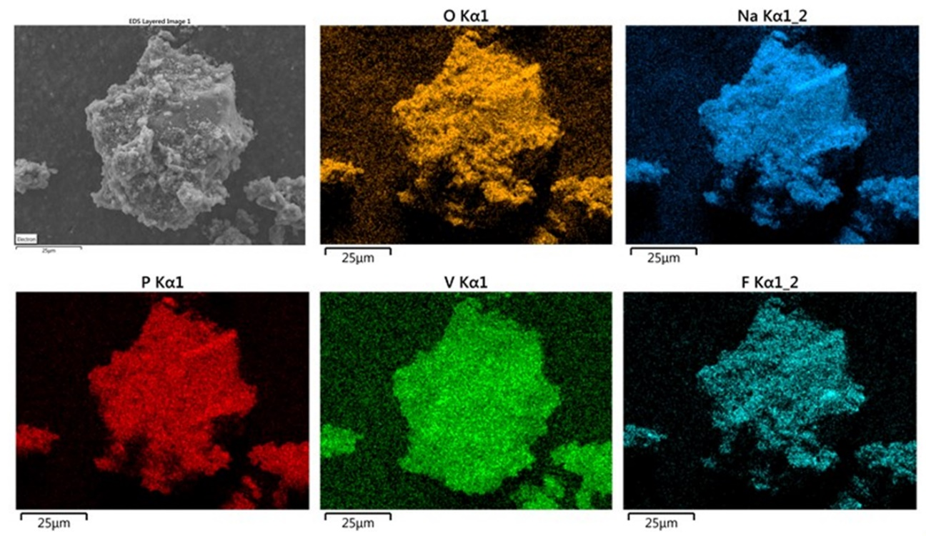

**Supplementary Figure S1:** EDX elemental distribution maps for NVPF-0.5 sample.

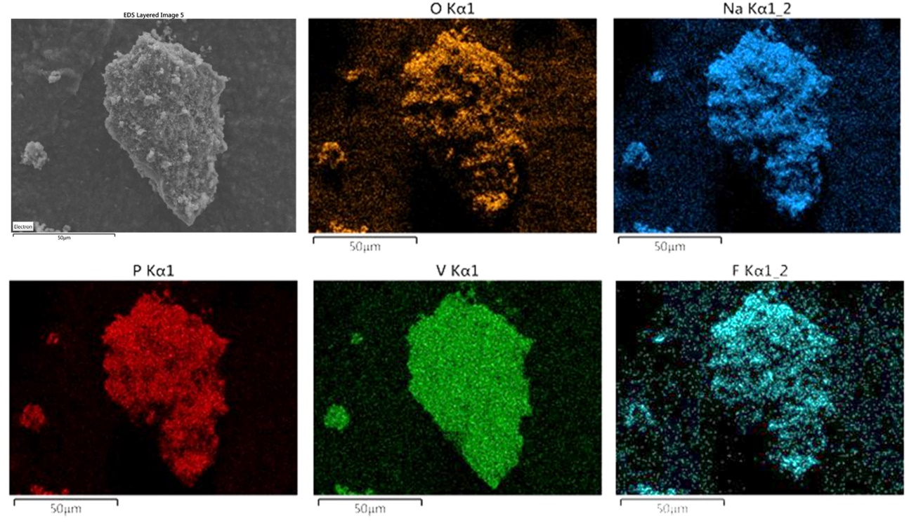

**Supplementary Figure S2:** EDX elemental distribution maps for NVPF-1.0 sample.



**Supplementary Figure S3:** Plots of the average voltage of charge and discharge plateaus observed in galvanostatic curves recorded at several C rated for the studied samples.



**Supplementary Figure S4:** Plots of cell polarization versus cycling current in a logarithmic scale.