SUPPLEMENTAL MATERIAL (TABLES AND FIGURES)
SUPPLEMENTAL TABLES
Supplemental Table 1.
Descriptives for attention, phonological and semantic fluency and speed of processing in different modalities of text presentation (visual, auditory and dual).
 |  |  | N | Mean | Std. Desviation | Std. Error
Attention | TOT | visual | 58 | 324.22 | 75.01 | 9.85
 |  | auditory | 48 | 317.04 | 75.29 | 10.86
 |  | dual | 44 | 328.68 | 63.57 | 9.58
 |  | total | 150 | 323.23 | 71.61 | 5.84
 | CON | visual | 58 | 131.15 | 36.06 | 4.73
 |  | auditory | 48 | 123.37 | 47.22 | 6.81
 |  | dual | 44 | 126.02 | 37.05 | 5.58
 |  | total | 150 | 127.16 | 40.10 | 3.27
Phonological and semantic fluency | F | visual | 64 | 9.57 | 3.39 | 0.42
 |  | auditory | 54 | 9.53 | 3.22 | 0.43
 |  | dual | 59 | 8.42 | 3.14 | 0.40
 |  | total | 177 | 9.18 | 3.28 | 0.24
 | A | visual | 64 | 9.18 | 3.24 | 0.40
 |  | auditory | 54 | 9.09 | 2.87 | 0.39
 |  | dual | 59 | 8.20 | 3.08 | 0.40
 |  | total | 177 | 8.85 | 3.09 | 0.23
 | S | visual | 64 | 11.67 | 3.05 | 0.38
 |  | auditory | 54 | 11.43 | 3.57 | 0.48
 |  | dual | 59 | 10.57 | 2.96 | 0.38
 |  | total | 177 | 11.24 | 3.21 | 0.24
 | Fruits | visual | 64 | 11.21 | 2.05 | 0.25
 |  | auditory | 54 | 11.74 | 3.02 | 0.41
 |  | dual | 59 | 11.81 | 2.65 | 0.34
 |  | total | 177 | 11.57 | 2.58 | 0.19
 | Animals | visual | 64 | 16.29 | 2.62 | 0.32
 |  | auditory | 54 | 15.16 | 4.35 | 0.59
 |  | dual | 59 | 15 | 3.69 | 0.48
 |  | total | 177 | 15.51 | 3.61 | 0.27
Speed of processing | Keys | visual | 64 | 57.56 | 12.17 | 1.52
 |  | auditory | 54 | 57.07 | 11.52 | 1.56
 |  | dual | 59 | 58.37 | 12.30 | 1.60
 |  | total | 177 | 57.68 | 11.96 | 0.89
Abbreviations: TOT. total test effectiveness; CON. concentration index

Supplemental Table 2.
Multiple mean comparisons of attention. phonological and semantic fluency and speed of processing between different groups of presentation modality.
ANOVA
 |  |  | Sum of Squares | df | Mean Square | F | Sig.
Attention (d2) | TOT | Between Groups | 3203.2 | 2 | 1601.64 | 0.30 | 0.734
 |  | Within Groups | 760999.5 | 147 | 5176.86
 |  | Total | 764202.8 | 149
 | CON | Between Groups | 1670.3 | 2 | 835.16 | 0.51 | 0.598
 |  | Within Groups | 238015.8 | 147 | 1619.15
 |  | Total | 239686.2 | 149
Phonological* and semantic^ fluency | F* | Between Groups | 50.7 | 2 | 25.38 | 2.38 | 0.095
 |  | Within Groups | 1853.4 | 174 | 10.65
 |  | Total | 1904.2 | 176
 | A* | Between Groups | 29.0 | 2 | 14.54 | 1.53 | 0.219
 |  | Within Groups | 1652.3 | 174 | 9.49
 |  | Total | 1681.4 | 176
 | S* | Between Groups | 40.6 | 2 | 20.30 | 1.98 | 0.14
 |  | Within Groups | 1775.9 | 174 | 10.20
 |  | Total | 1816.5 | 176
 | Fruits^ | Between Groups | 12.9 | 2 | 6.48 | 0 .97 | 0.38
 |  | Within Groups | 1160.2 | 174 | 6.66
 |  | Total | 1173.2 | 176
 | Animal^ | Between Groups | 61.3 | 2 | 30.66 | 2.38 | 0.095
 |  | Within Groups | 2232.8 | 174 | 12.83
 |  | Total | 2294.1 | 176
Speed of processing | Keys | Between Groups | 49.0 | 2 | 24.51 | 0.17 | 0.844
 |  | Within Groups | 25157.2 | 174 | 144.58
 |  | Total | 25206.2 | 176
Abbreviations: TOT. total test effectiveness; CON. concentration index

Supplemental Table 3.
Descriptives for attention, phonological and semantic fluency and speed of processing according to sex.
 | Sex | N | Mean | Std. Deviation | Std. Error Mean
Age | boys | 66 | 12.92 | 0.75 | 0.09
 | girls | 84 | 12.87 | 0.67 | 0.07
Spanish grade | boys | 76 | 5.57 | 1.69 | 0.19
 | girls | 100 | 6.43 | 1.69 | 0.17
Text comprehension | boys | 94 | 4.39 | 2.23 | 0.23
 | girls | 121 | 4.29 | 1.98 | 0.18
F* | boys | 77 | 8.13 | 2.99 | 0.34
 | girls | 100 | 9.99 | 3.28 | 0.32
A* | boys | 77 | 8.32 | 3.14 | 0.35
 | girls | 100 | 9.27 | 2.99 | 0.29
S* | boys | 77 | 10.55 | 3.00 | 0.34
 | girls | 100 | 11.78 | 3.27 | 0.32
Animals* | boys | 77 | 15.04 | 3.45 | 0.39
 | girls | 100 | 15.89 | 3.70 | 0.37
Fruits* | boys | 77 | 11.27 | 2.62 | 0.29
 | girls | 100 | 11.81 | 2.53 | 0.25
Speed Processing | boys | 77 | 55.43 | 12.82 | 1.46
 | girls | 100 | 59.42 | 11.02 | 1.10
TR (d2) | boys | 77 | 359.57 | 76.97 | 8.77
 | girls | 100 | 331.63 | 81.65 | 8.16
TA (d2) | boys | 77 | 138.83 | 37.64 | 4.29
 | girls | 100 | 125.20 | 35.08 | 3.50
O (d2) | boys | 77 | 17.65 | 25.32 | 2.88
 | girls | 100 | 17.90 | 28.66 | 2.86
C (d2) | boys | 77 | 6.90 | 20.58 | 2.34
 | girls | 100 | 5.25 | 14.31 | 1.43
TOT d2 (TR - (O+C)) | boys | 66 | 337.47 | 68.72 | 8.45
 | girls | 84 | 312.05 | 72.25 | 7.88
CON d2 (TA - C) | boys | 66 | 133.68 | 39.43 | 4.85
 | girls | 84 | 122.04 | 40.12 | 4.37
Abbreviations: TR. total number of responses; TA. total number of correct answers; O. omissions; C. commissions; TOT. total test effectiveness; CON. concentration index.
*Verbal fluency test.

Supplemental Table 4.
Mean Comparison of attention, phonological and semantic fluency and speed of processing tests between sexes.
t-test for Equality of Means
 |  |  |  |  |  | 95% CI of Difference
 | t | df | Sig. (2 tailed) | Mean Difference | Std.Err.Dif | Lower | Upper
F* | -3.88 | 175 | 0.000 | -1.86 | 0.47 | -2.80 | -.091
A* | -2.03 | 175 | 0.043 | -.94 | .46 | -1.86 | -0.03
S * | -2.48 | 174 | 0.014 | -1.19 | .47 | -2.13 | -0.24
Animals * | -1.56 | 175 | 0.120 | -.85 | .54 | -1.92 | 0.22
Fruits* | -1.37 | 175 | 0.171 | -.53 | .39 | -1.30 | 0.23
Speed Processing | -2.22 | 175 | 0.027 | -3.99 | 1.79 | -7.53 | -0.45
TR (d2) | 2.31 | 175 | 0.022 | 27.94 | 12.07 | 4.10 | 51.77
TA (d2) | 2.48 | 175 | 0.014 | 13.63 | 5.49 | 2.79 | 24.46
O (d2) | -.06 | 175 | 0.952 | -.25 | 4.13 | -8.40 | 7.90
C (d2) | .62 | 175 | 0.532 | 1.64 | 2.62 | -3.53 | 6.82
TOT (d2) (TR - (O+C)) | 2.18 | 148 | 0.030 | 25.42 | 11.63 | 2.43 | 48.41
CON (d2) (TA - C) | 1.77 | 148 | 0.077 | 11.64 | 6.55 | -1.29 | 24.59
Abbreviations: TR. total number of responses; TA. total number of correct answers; O. omissions; C. commissions; TOT. total test effectiveness; CON. concentration index.*Verbal fluency test.

Supplemental Table 5.
Descriptives and multiple comparisons of grades in Spanish among different modalities of text presentation.
Descriptives
Grades in Spanish
 | N | Mean | Std. Deviation | Std. Error | 95% Confidence Interval for Mean
 |  |  |  |  | Lower Bound | Upper Bound
visual | 64 | 6.19 | 1.75 | 0.219 | 5.75 | 6.63
auditory | 53 | 6.51 | 1.68 | 0.231 | 6.05 | 6.97
dual | 59 | 5.51 | 1.66 | 0.217 | 5.07 | 5.94
Total | 176 | 6.06 | 1.74 | 0.131 | 5.80 | 6.32

ANOVA
Grades in Spanish
 | Sum of Squares | df | Mean Square | F | Sig.
Between Groups | 29.69 | 2 | 14.84 | 5.119 | 0.007
Within Groups | 501.74 | 173 | 2.90
Total | 531.43 | 175

Multiple Comparisons
Dependent Variable: Grades in Spanish
Bonferroni
(I) Modality | (J) Modality | Mean Diff. | Std. Error | Sig. | 95% Confidence Interval
 |  |  |  |  | Lower Bound | Upper Bound
visual | auditory | -0.32 | 0.316 | 0.931 | -1.09 | 0.44
 | dual | 0.67 | 0.307 | 0.085 | -0.06 | 1.42
auditory | visual | 0.32 | 0.316 | 0.931 | -0.44 | 1.09
 | dual | 1.00* | 0.322 | 0.007 | 0.22 | 1.78
dual | visual | -0.67 | 0.307 | 0.085 | -1.42 | 0.06
 | auditory | -1.00* | 0.322 | 0.007 | -1.78 | -0.22
*. The mean difference is significant at the 0.05 level.

SUPPLEMENTAL FIGURES
Supplemental Figure 1.
Correlation between grades in Spanish and verbal comprehension in boys and girls for different presentation modalities.

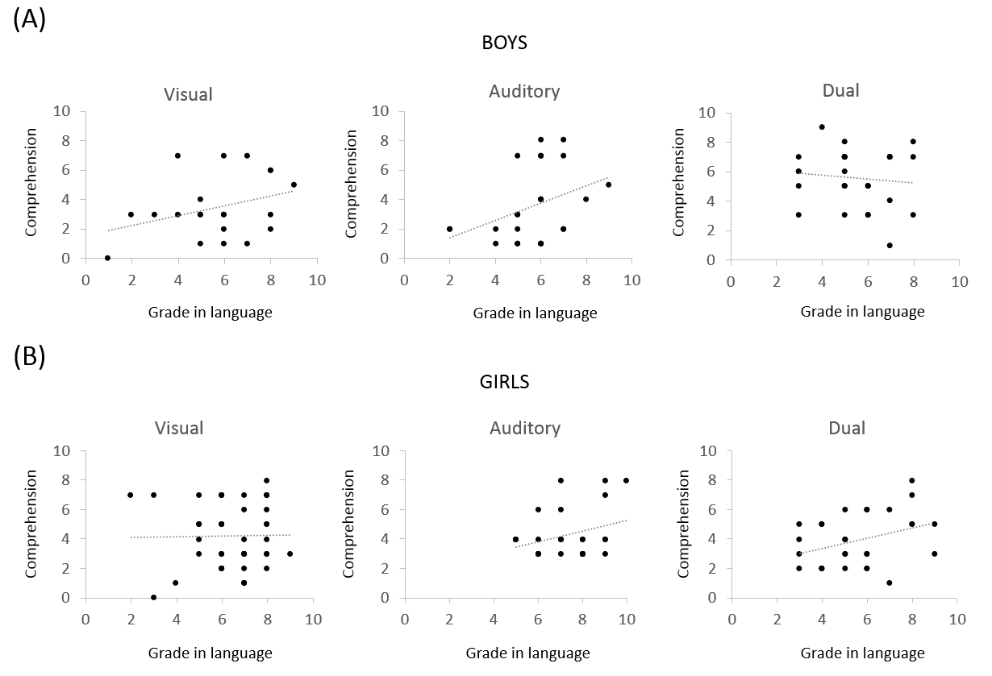

Notes: A. Graphs showing individual data for text comprehension and grades in Spanish native language in boys. Every dot corresponds to a student. B. Same graphs for girls. Some dots overlap. Dotted lines are regression lines fitted to the experimental data.

