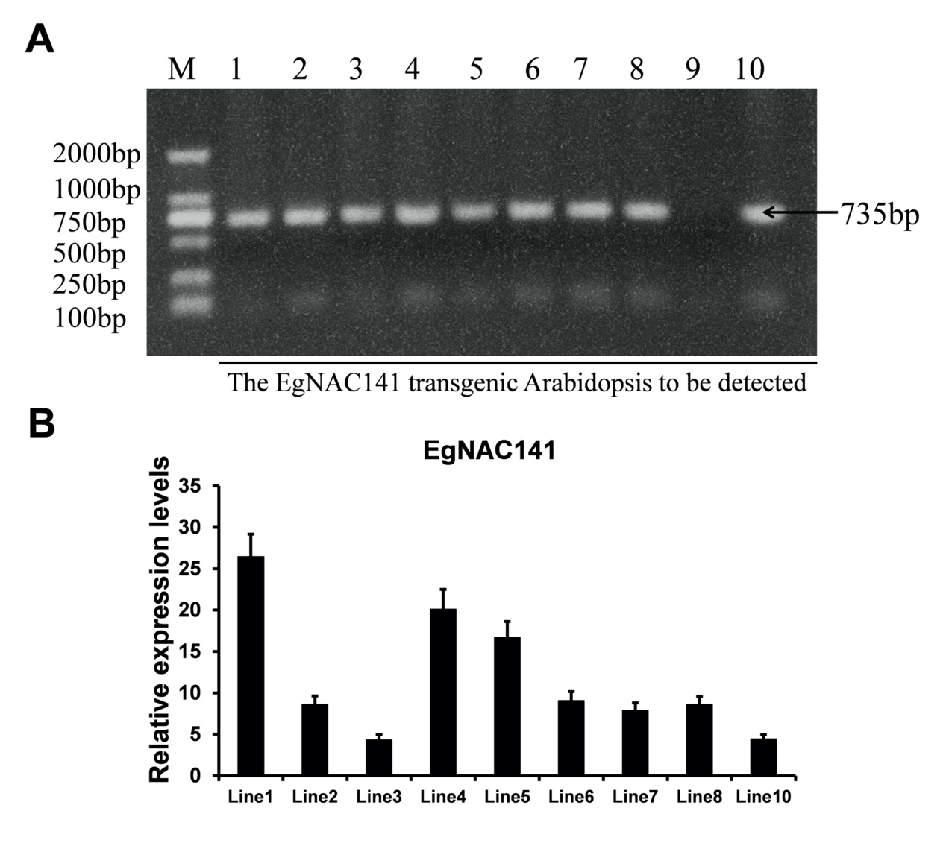
Supplementary Figure 1. A, The genomic-PCR detection of EgNAC141 in transgenic Arabidopsis. B, The qRT-PCR analysis of EgNAC141 in transgenic Arabidopsis.
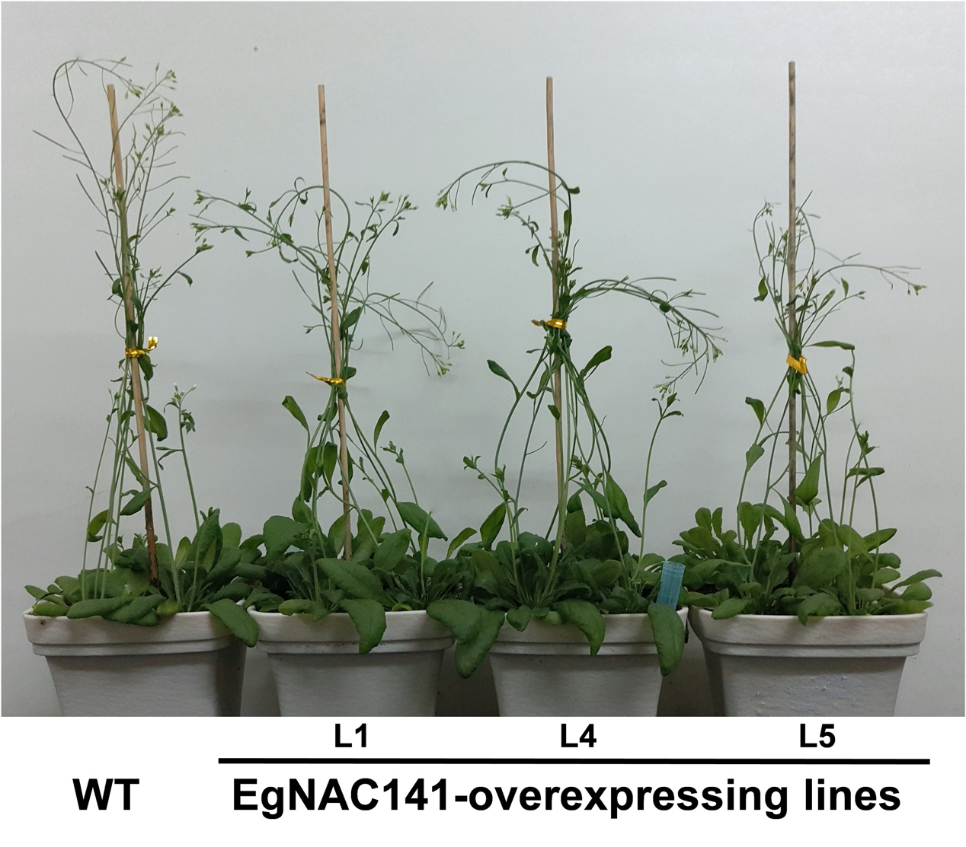
Supplementary Figure 2. The phenotype of 30-day old EgNAC141-Overexpression Arabidopsis.

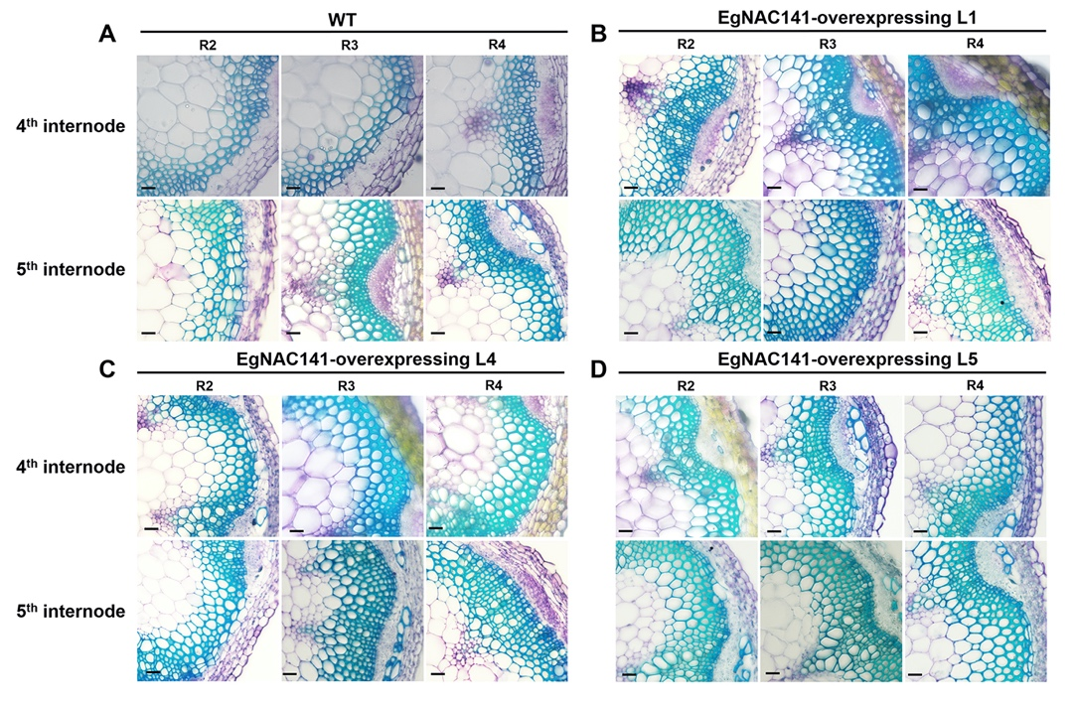
Supplementary Figure 3. ﻿Microscopic analyses of stems from the control and EgNAC141-overexpressing Arabidopsis plants. ﻿General view of the stem vascular tissues stained by TBO in the 4th and 5th internode of 2-month-old inflorescence stem transverse sections: WT and EgNAC141-overexpressing plants (L1, L4, and L5). R2-R4 represent biologic repeats.

