Supplementary Material

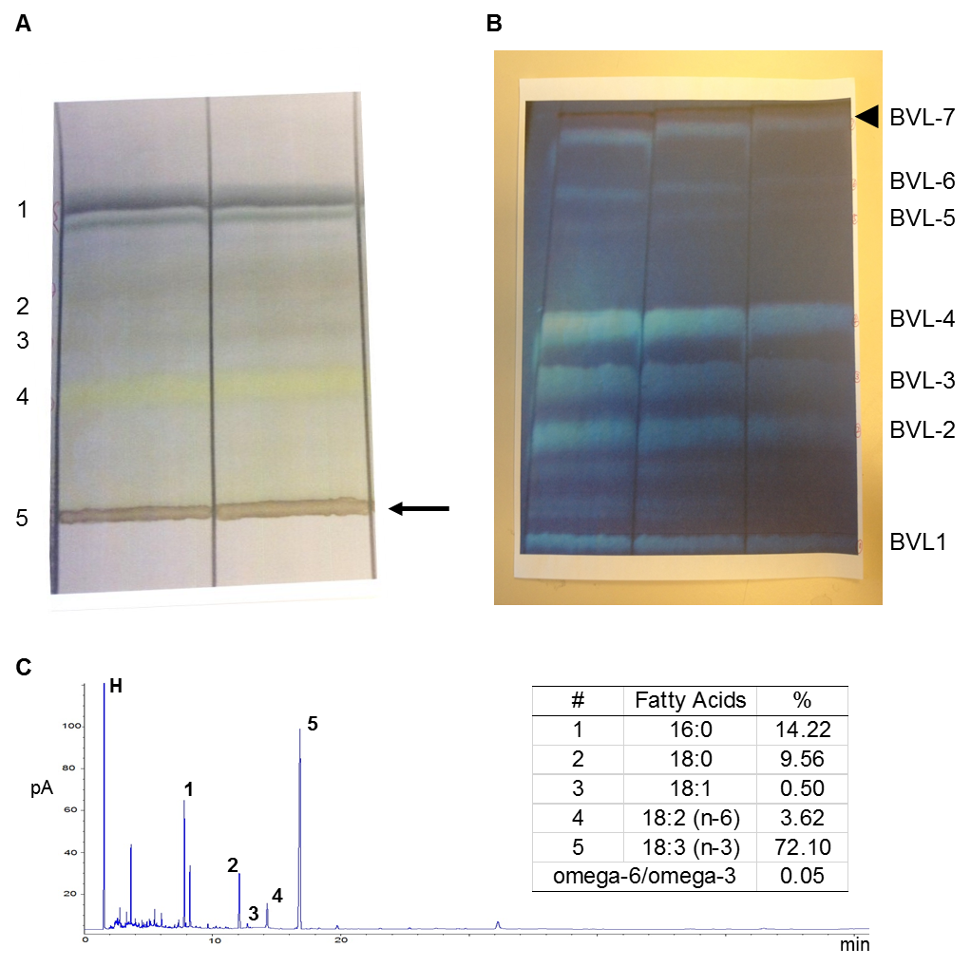
Supplementary Figure 1.
(A) The representative image showed that phospholipid-rich BVL (arrow) was obtained using TLC method. The mobile phase was consisted of Heptane: Diethyl Ether: Acetic Acid (60:40:3, v/v/v). (B) The representative image showed that BVL (arrowhead) was obtained using TLC method. The mobile phase was consisted of Chloroform: Methanol: Acetic acid (100:30:3, v/v/v). (C) The representative GC chromatogram showed the detection of fatty acids in BV-7. The table on the top-right corner showed the percentage of fatty acids to the corresponding standard and the ratio of omega-6 to omega-3 fatty acids.

Supplementary Table 1. Parameters of body composition on mice after a 4-week intervention.

Parameters | Control | BVL | p value
BW (g) | 34.44±1.10 | 30.99±1.02 | 0.031
Tissue Weight (g)
Ing | 1.15±0.11 | 0.85±0.12 | 0.003
Epi | 2.38±0.10 | 1.75±0.23 | 0.031
BAT | 0.09±0.01 | 0.07±0.01 | 0.069
Liver | 0.94±0.13 | 0.87±0.04 | 0.325
Mus | 0.26±0.02 | 0.33±0.03 | 0.049
Relative Percentage to BW (%)
Ing | 3.31±0.23 | 2.73±0.32 | 0.001
Epi | 6.92±0.12 | 5.6±0.53 | 0.042
BAT | 0.27±0.02 | 0.24±0.01 | 0.115
Liver | 2.69±0.26 | 2.81±0.13 | 0.350
Mus | 0.76±0.08 | 1.06±0.11 | 0.024
n=4 per group. The difference between two groups was considered significant when p < 0.05.

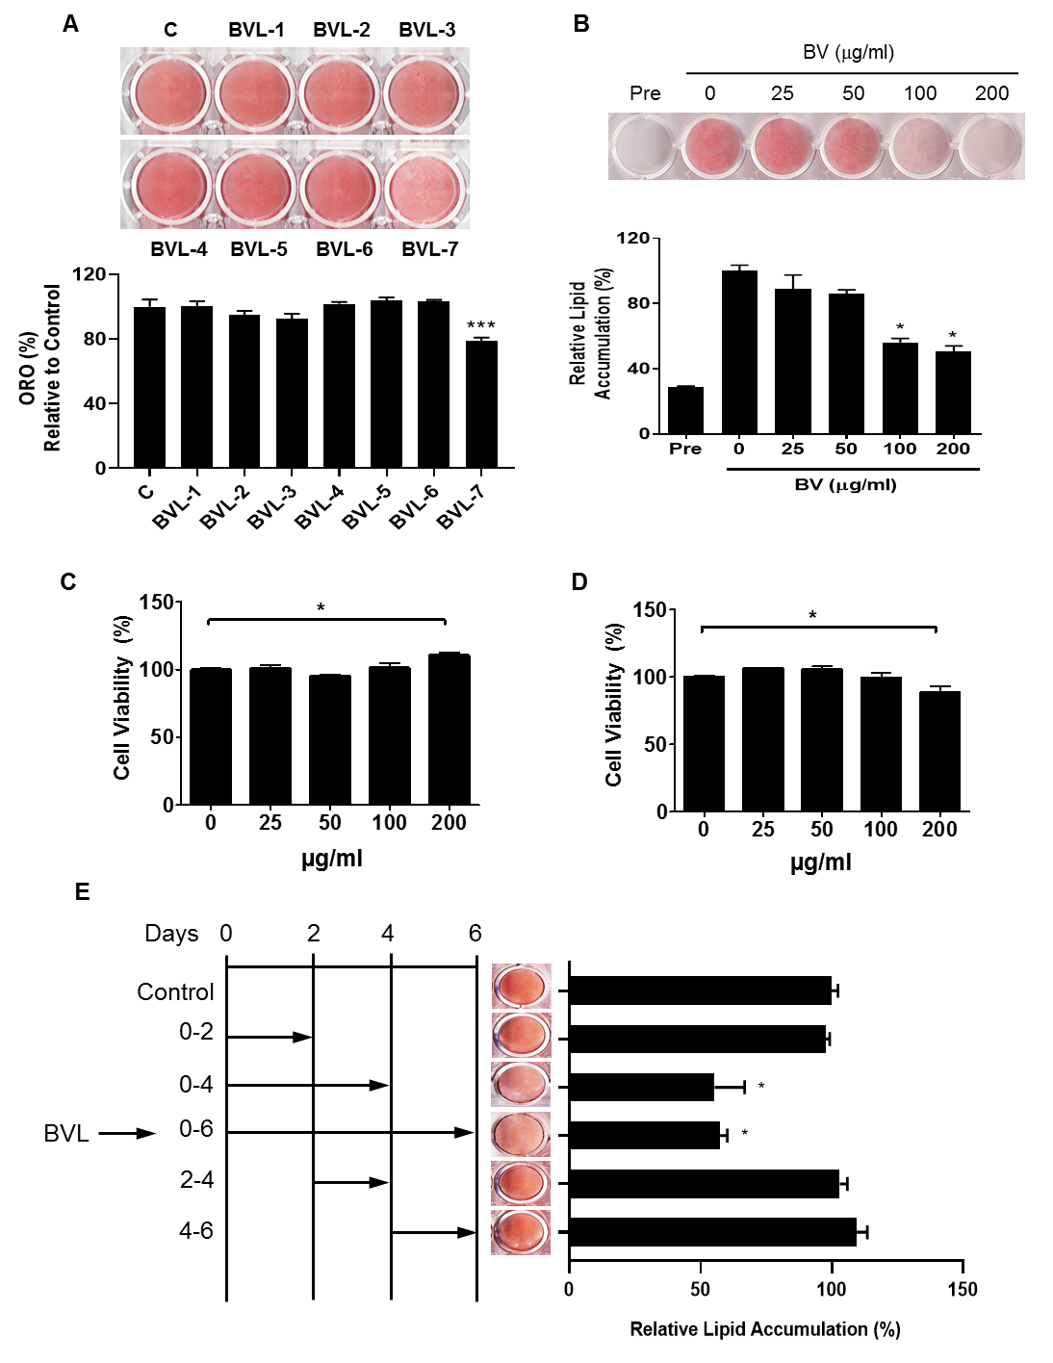
Supplementary Figure 2. (A) 3T3-L1 cells were differentiated with or without various fractions of BVL (BVL-1-BVL-7) at 75 µg/ml. ORO staining from adipocytes (D8) and quantitative analysis were shown. (B) 3T3-L1 cells were treated with indicated doses during the adipocyte differentiation. The representative ORO staining image and the quantitative analysis were shown. The cell viability in preadipocytes (C) and adipocytes (D) was detected using MTT assay. (E) 3T3-L1 preadipocytes were differentiated with or without BVL (100 µg/ml) at the indicated time. After 8 days of differentiation, ORO staining was performed, and the corresponding quantification was shown to determine the intracellular lipid content. The values were presented using mean ± SEM and each experiment was repeated at least 3 times. * p<0.05.

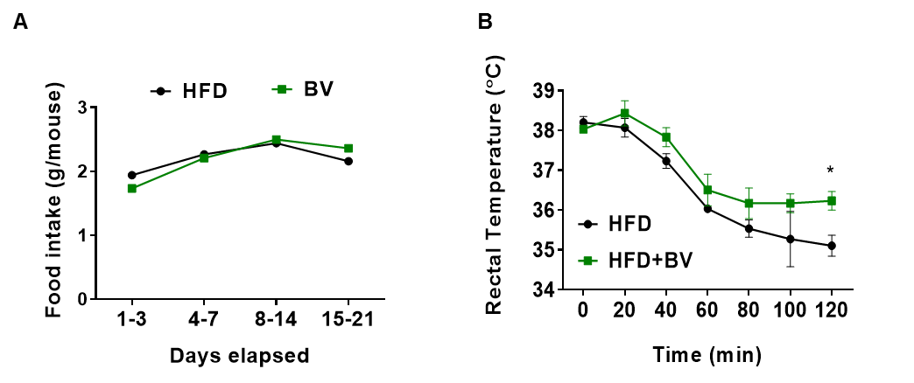
Supplementary Figure 3. (A) Food intake. (B) Rectal core body temperature of HFD fed mice and HFD+BV fed mice was measured at 4°C. * p<0.05 (n=4).

