Supplementary Material: Supplementary Figures

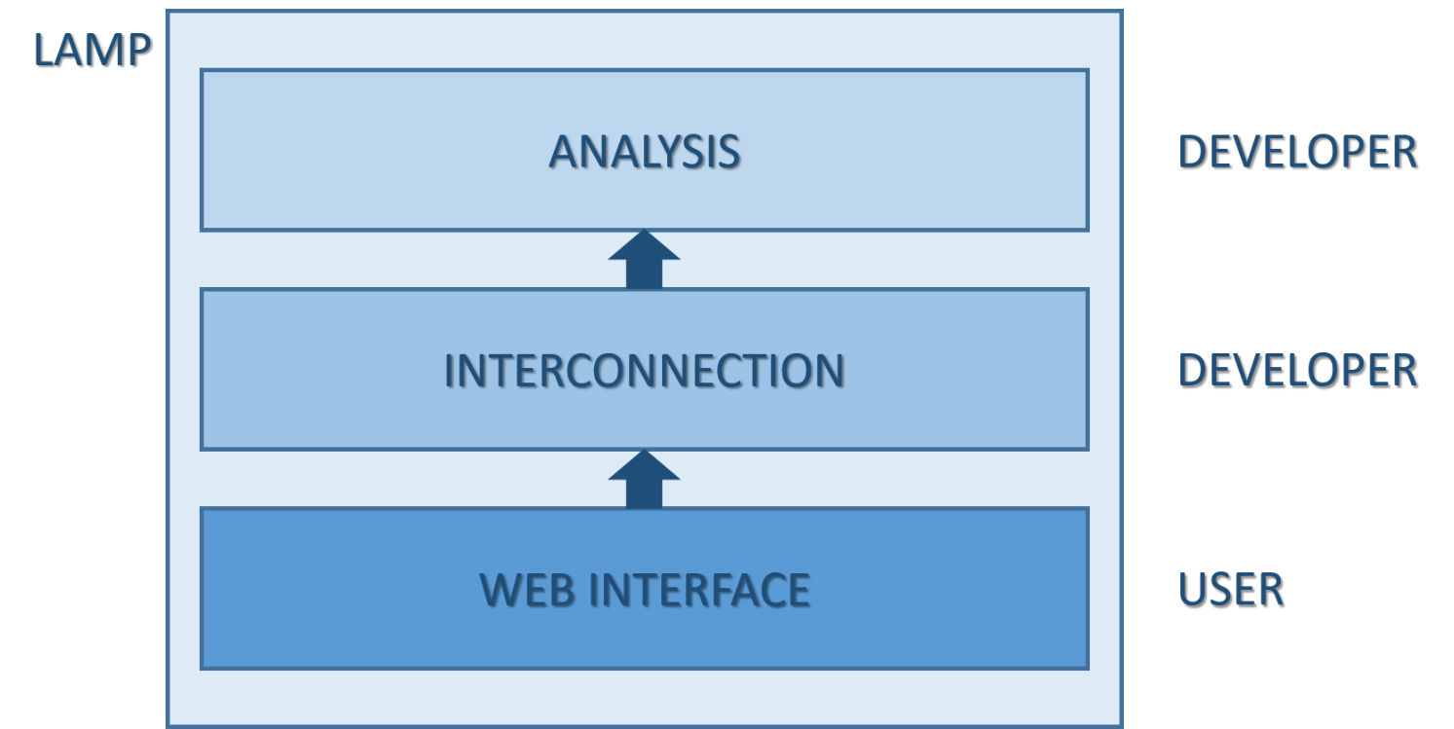
Supplementary Fig.1. Overall structure of GeenaR. Three different layers are inside the LAMP box. The Web Interface layer is linked to user’s choice of the methods and parameters; the Analysis and the Interconnection layers are not visible to the user and are linked to the connection step of the user’s choice, the pre-processing and analysis of the MALDI-TOF mass spectra, and the storage of the results.

Supplementary Fig.2. Peak intensity heatmap of the feature matrix for Case Study 1 (ovarian cancer). Rows represent the samples, columns represent the relevant peaks in the feature matrix. Colors represent the normalized intensity.
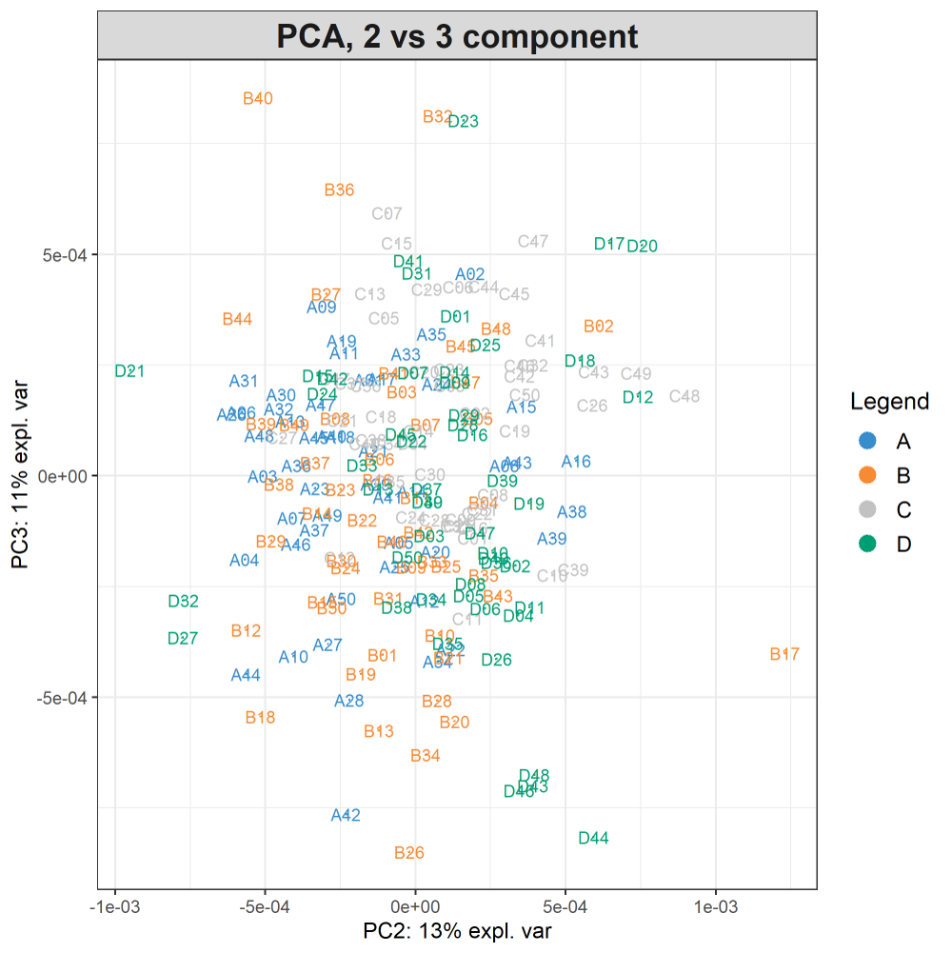
Supplementary Fig.3. PC2vsPC3 plot (ovarian cancer). The total explained variance for PC2 and PC3 is 24%. The legend on the right shows the four groups in terms of colors. Ovarian cancer groups (A, B) and control groups (C, D) are superimposed.

Supplementary Fig.4. A subset of the peak intensity heatmap of the feature matrix Case Study 2 (colorectal cancer). Similar to Supplementary Fig.2. The heatmap contains only relevant peaks in the 500-675 m/z range.

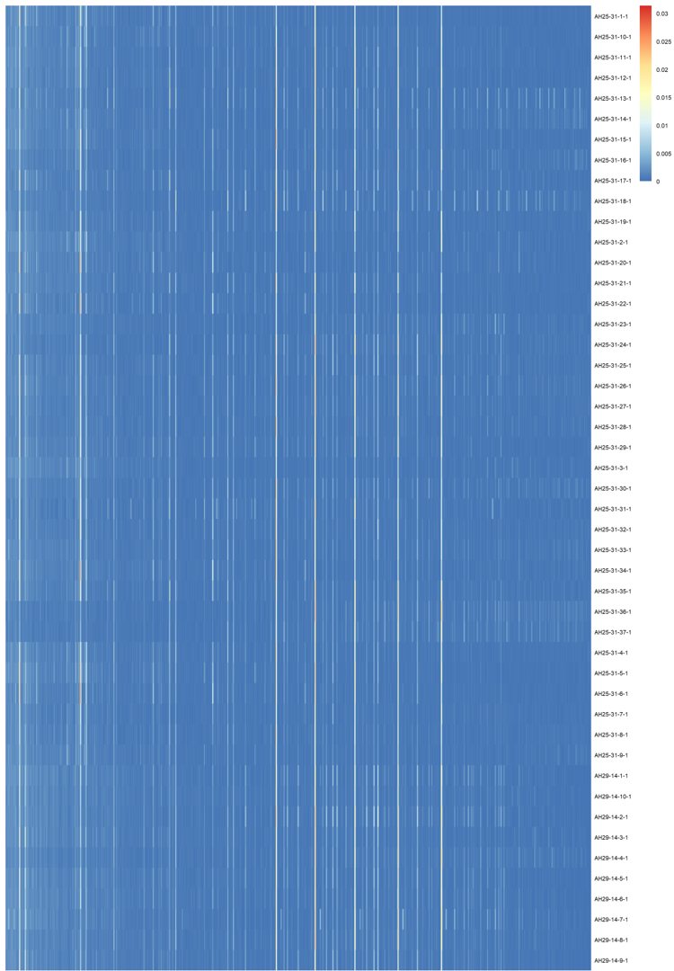
Supplementary Fig.5. Complete peak intensity heatmap of the feature matrix Case Study 2 (colon-rectal cancer). Similar to Supplementary Fig.2.

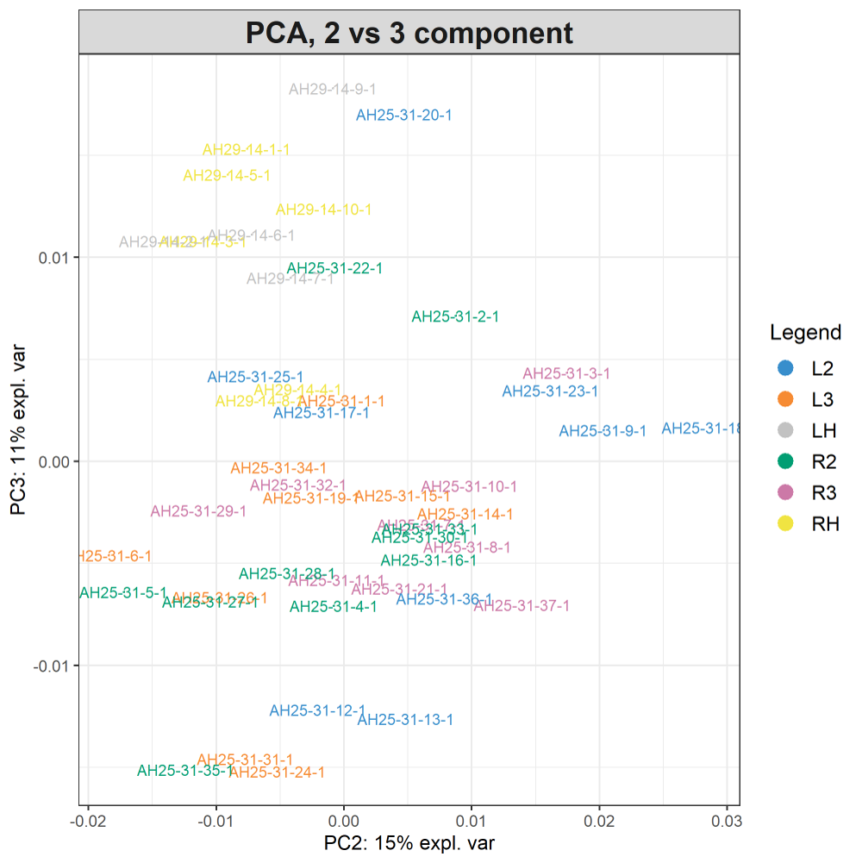
Supplementary Fig.6. PC2vsPC3 plot (colon-rectal cancer). The total explained variance for PC2 and PC3 is 26%. The legend on the right shows the four groups in terms of colors. Colon-rectal cancer groups (L2, L3, R2, R3) are less superimposed, whilst control groups (LH, RH) are superimposed in the II quadrant.

