Supplementary Material

Supplementary Figures
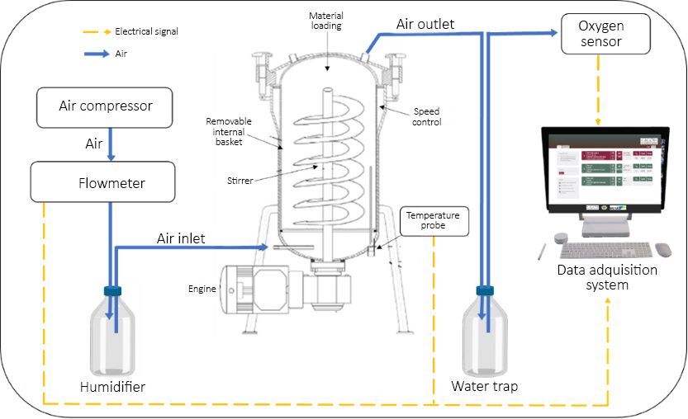
Supplementary Figure 11. Scheme for the R22 fermentation system.
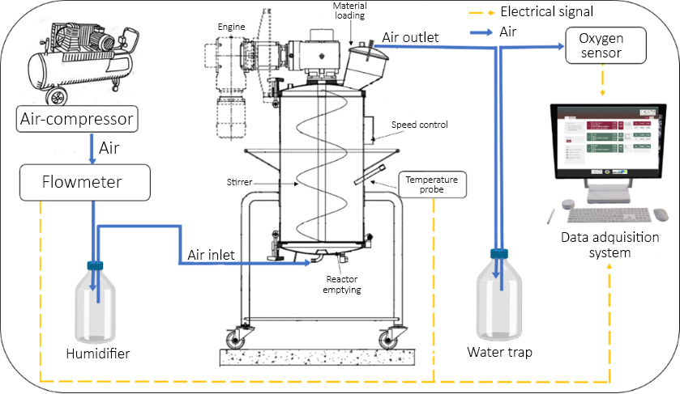
Supplementary Figure 12. Scheme for the R100 fermentation system.

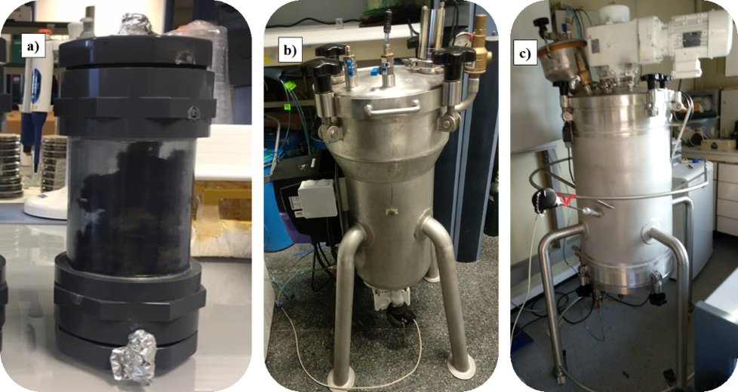
Supplementary Figure 13. Images of the three bioreactors compared in this study: a) lab scale 0.5L; b) R22 and c) R100.

