Table 4. Results of D.A.B.I. Analysis, Impacts  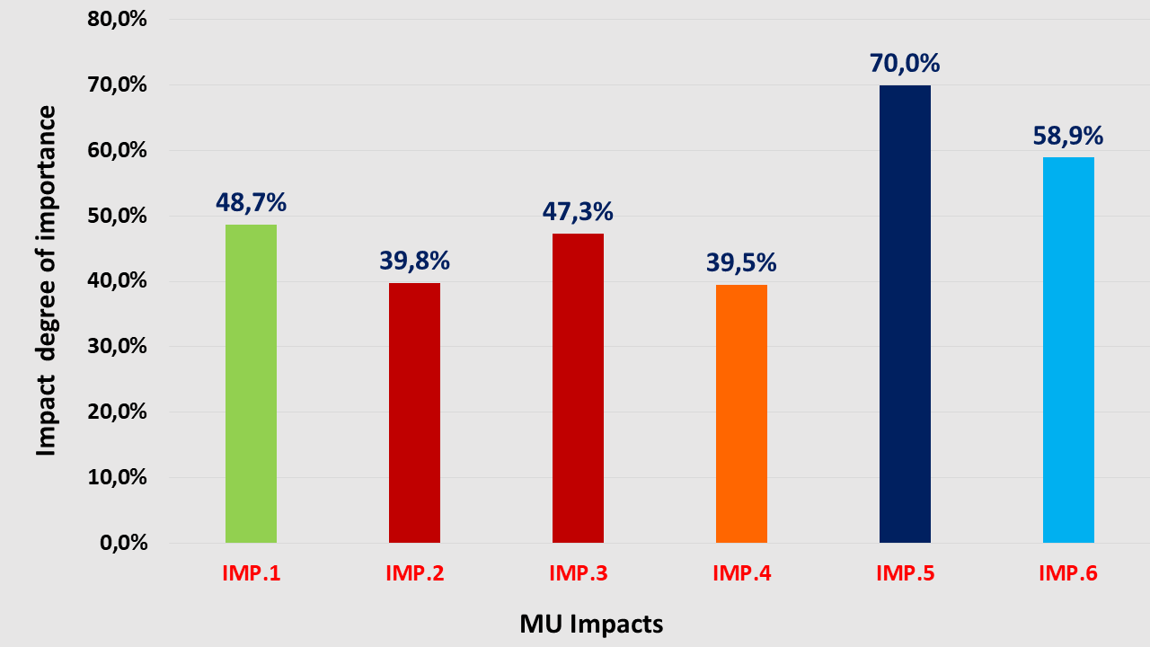 | Impacts of Fisheries-Tourism-Nature Conservation MU in Greece  IMP.1 Environmental pollution/marine rubbish created by tourism activities (by non-informed tourists, etc.) (Env)  IMP.2 Risk for fishers to lose compensation related to missed opportunities of fishing activities (P).  IMP.3 Additional taxation for tourism activities, which makes the coexistence of fishing and tourism activities a non-viable business activity (P).  IMP.4 Potentially increased competition by other professional groups (e.g. other local coastal tourism enterprises) (Ec)  IMP.5 High investment costs for adapting the existing vessels to the requirements of tourism activities (following the existing legal provisions) (T).  IMP.6 Risk of low tourist satisfaction due to the ageing and low educational level of fishers and the lack of specialization of on-board workers (S).  S=Social, Ec=Economic, P=Political, Env=Environmental, T=Technological

