Supplementary Material
Coupling Hierarchical Ultrathin Co Nanosheets with N-doped Carbon Plate as High-Efficiency Oxygen Evolution Electrocatalysts
Yue Wang¹, Meng Li¹, Qixing Zhou², Qin Wang¹, Xingyuan Zhang¹, Dongmei Sun¹* and Yawen Tang¹*
¹Jiangsu key laboratory of New Power Batteries. Jiangsu Collaborative Innovation center of Biomedical Functional materials, School of Chemistry and Materials Science, Nanjing Normal University, 210023 Nanjing, China
²School of Chemistry and Chemical Engineering, Southeast University, Nanjing 211189, PR China.
* Correspondence: sundongmei@njnu.edu.cn (D. Sun); tangyawen@njnu.edu.cn (Y. Tang)

Part I: Figures
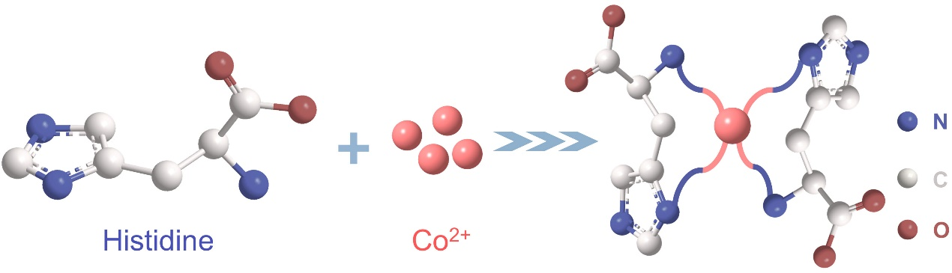
Supplementary Figure 1. Schematic interaction between histidine and Cobalt ion.
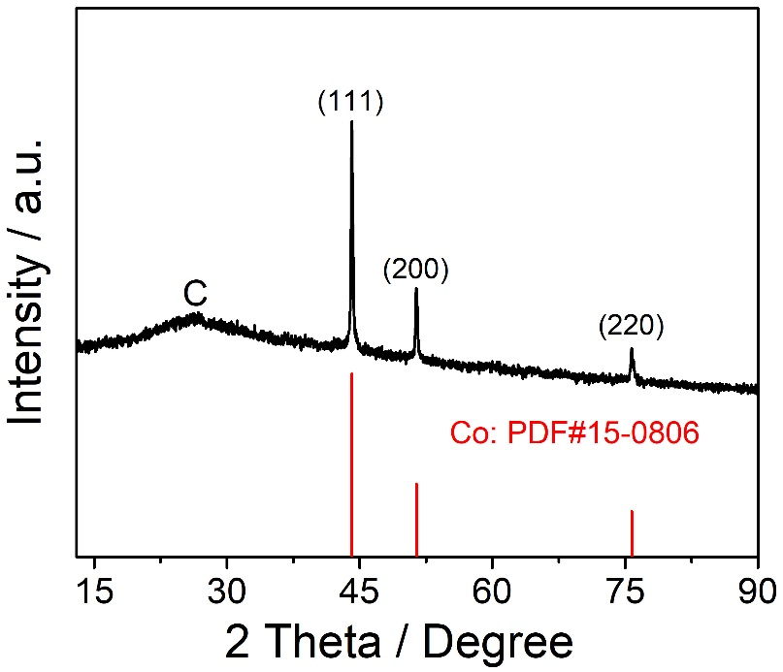
Supplementary Figure 2. XRD pattern of Co-NS@NCP-700 catalyst.
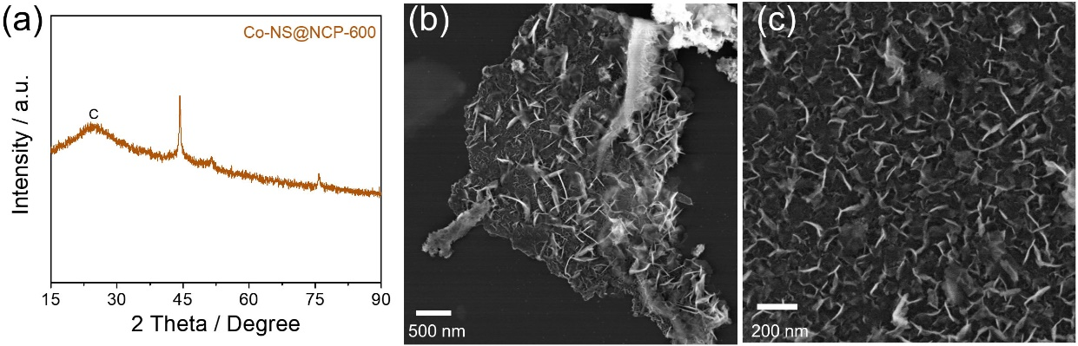
Supplementary Figure 3. (a) XRD pattern; and (b) SEM images of Co-NS@NCP-600 catalyst.

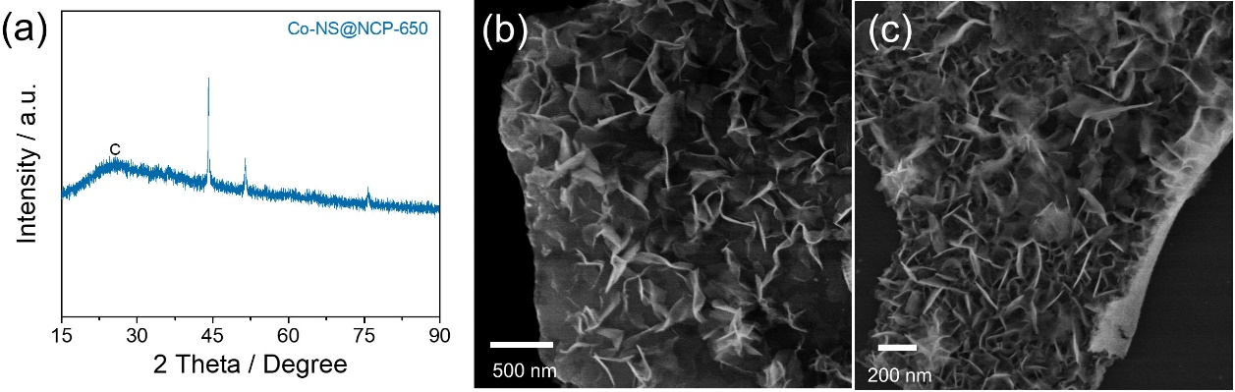
Supplementary Figure 4. (a) XRD pattern; and (b) SEM images of Co-NS@NCP-650 catalyst.

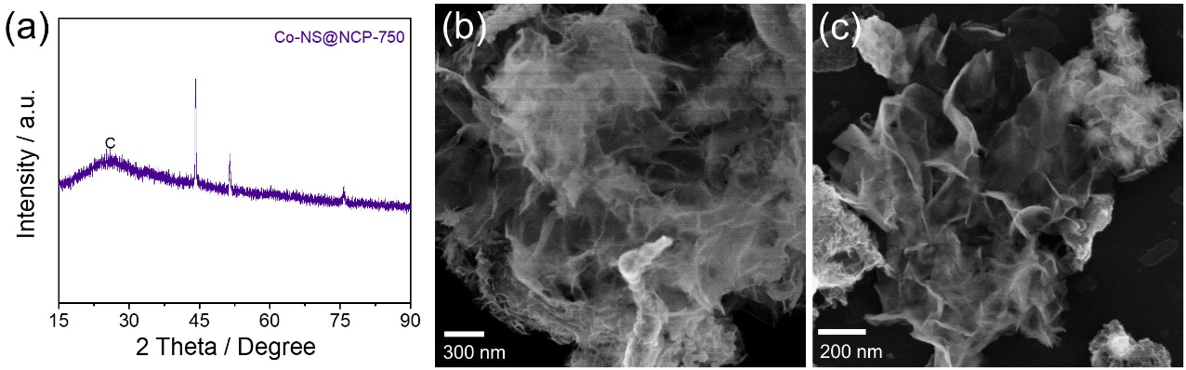
Supplementary Figure 5. (a) XRD pattern; and (b) SEM images of Co-NS@NCP-750 catalyst.
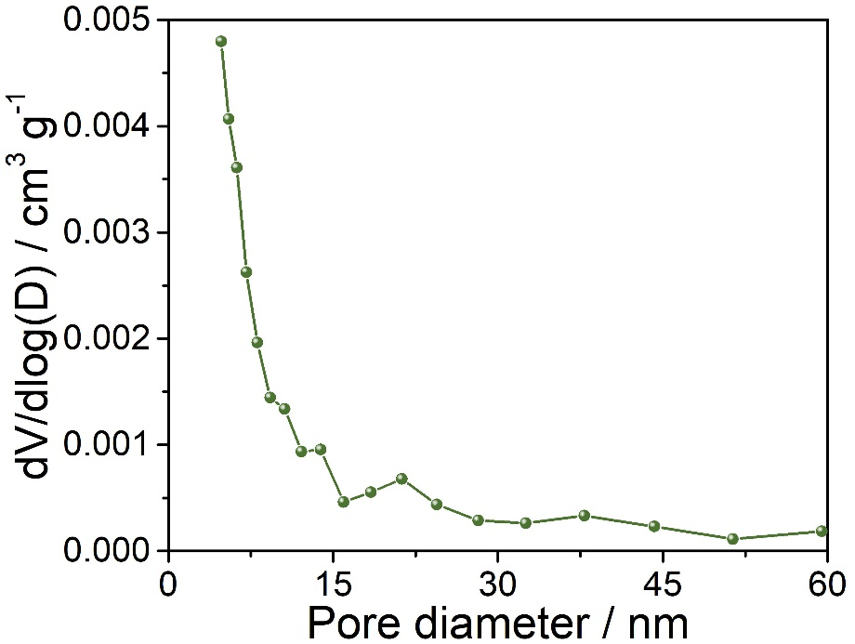
Supplementary Figure 6. pore-size distribution curve of Co-NS@NCP-700 catalyst.

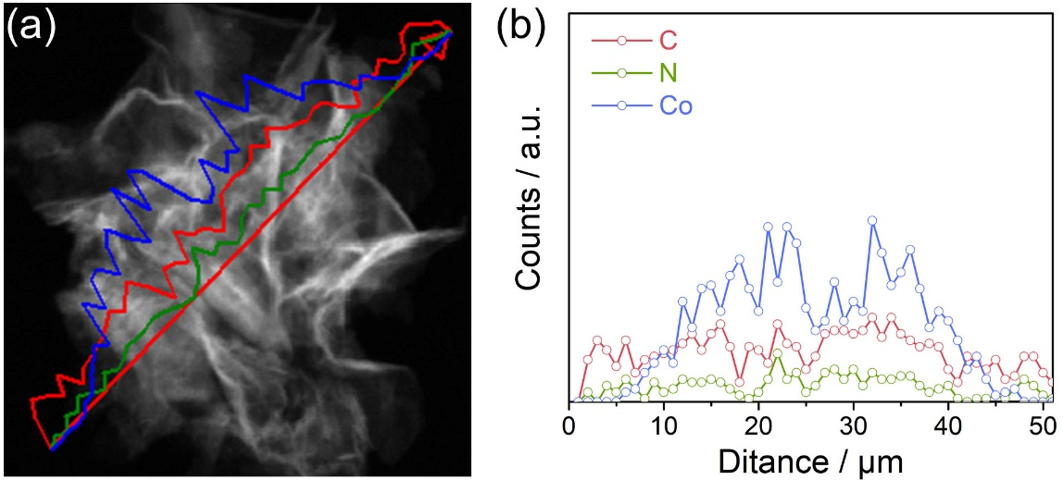
Supplementary Figure 7. (a) HAADF-STEM image; and (b) EDX line-scan profiles of Co-NS@NCP-700 catalyst.

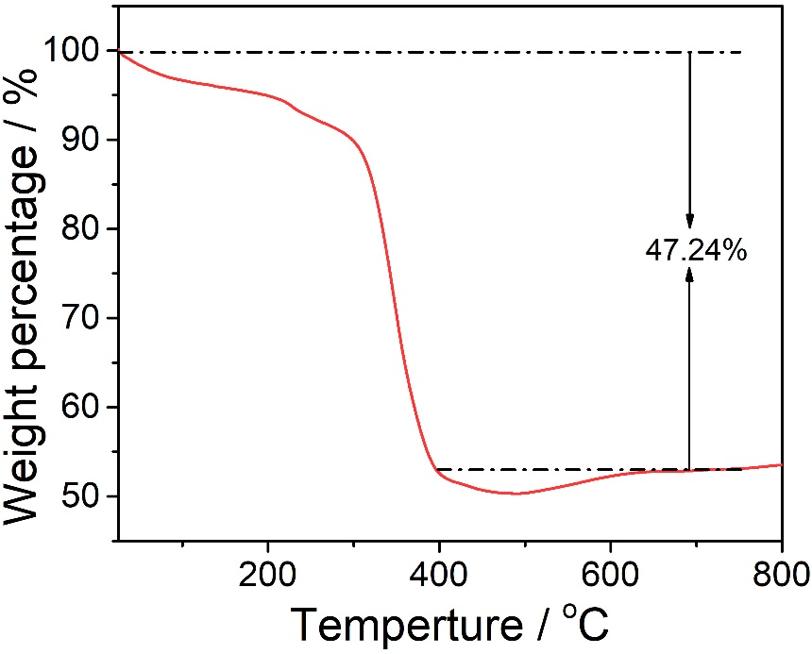
Supplementary Figure 8. TGA curve of Co-NS@NCP-700 catalyst.

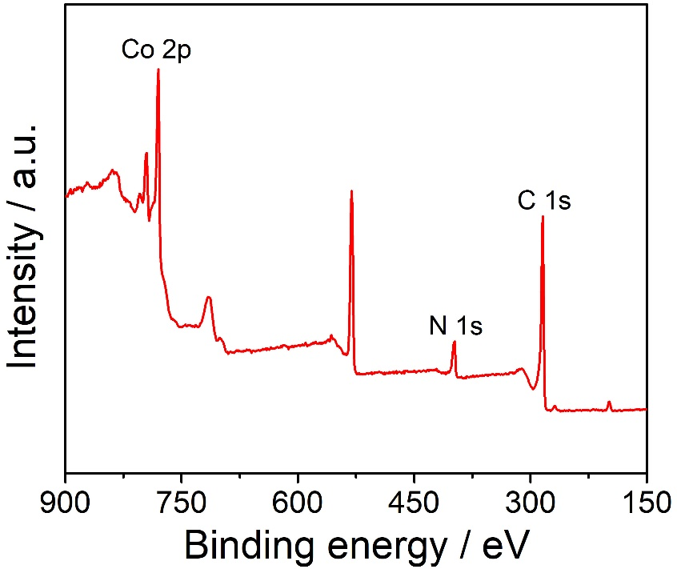
Supplementary Figure 9. The XPS survey scan spectrum of Co-NS@NCP-700 catalyst.

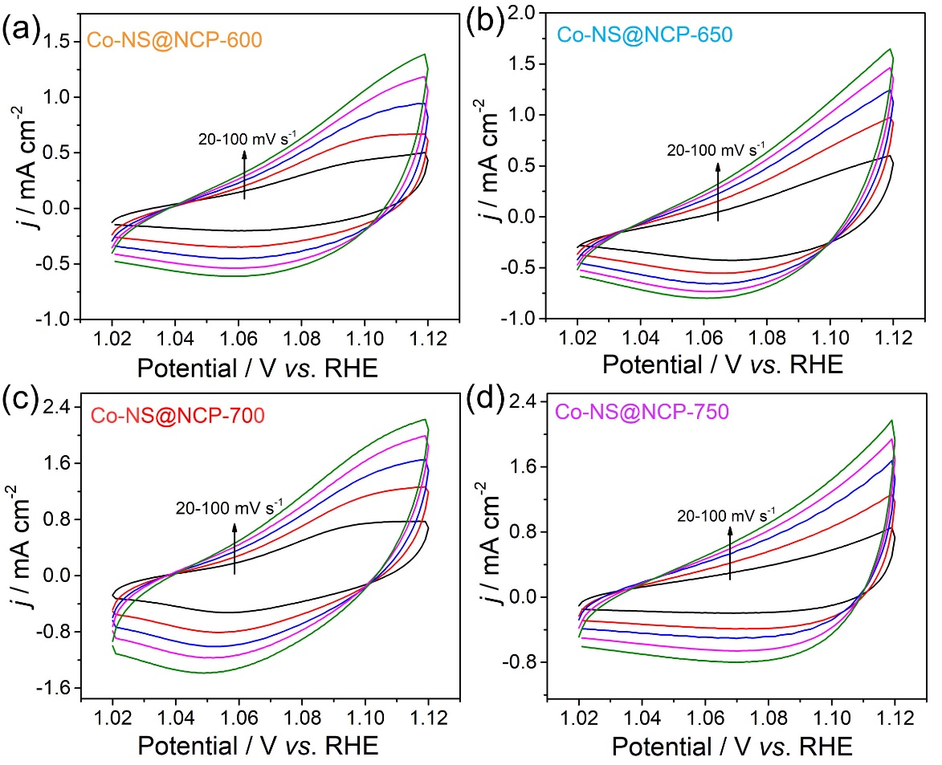
Supplementary Figure 10. CV curves of the synthesized Co-NS@NCP catalysts in the non-Faradaic region (-1 - 1.1 V) were obtained at different scanning rates. (a) Co-NS@NCP-600; (b) Co-NS@NCP-650; (c) Co-NS@NCP-700; and (d) Co-NS@NCP-750.

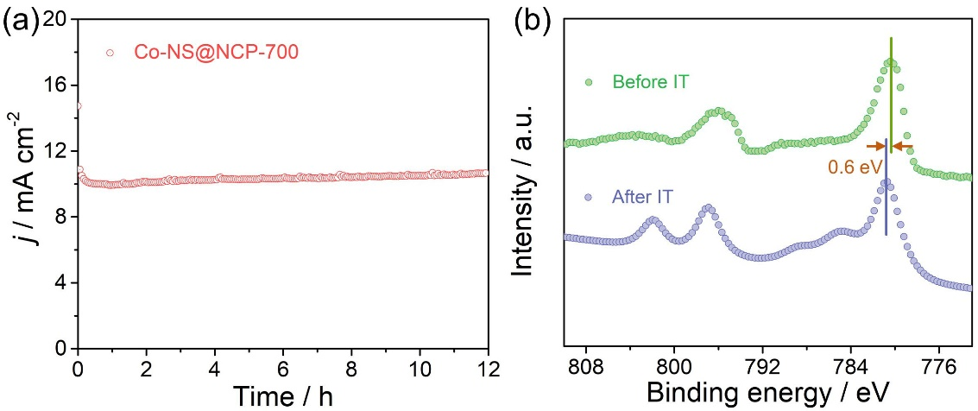
Supplementary Figure 11. (a) The chronopotentiometry curve at overpotential of 300 mV; and (b) High-resolution Co 2p XPS spectra of Co-NS@NCP-700 catalyst before and after i-t test.

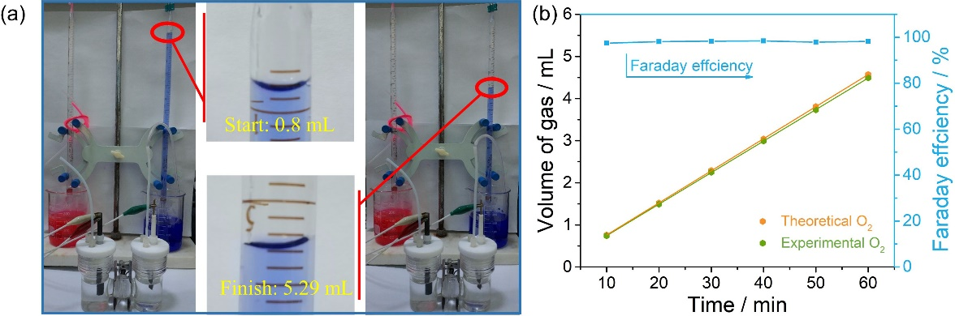
Supplementary Figure 12. Faraday efficiency of Co-NS@NCP-700 catalyst: (a) test process diagram; and (b) curves.

Part II. Tables
Supplementary Table 1. Comparison of OER performance of Co-NS@NCP-700 catalyst with some previously reported Co-based catalysts in 1.0 M KOH solution.
Number | Catalyst | η _{j} = 10 mA cm⁻²  / mV | Reference
1 | Co-NS@NCP-700 | 278 | This work
2 | NC-Co SA | 360 | ACS Catal. 2018, 8, 8961−8969
3 | Co BTC-5wt% rGO | 290 | Renewable Energy 2020, 156, 1040
4 | rGO@CoFe₂O₄ | 300 | ACS Catal. 2019, 9, 3878−3887
5 | Co₃O₄/HNCP-40 | 333 | ACS Catal. 2018, 8, 7879−7888
6 | CoNC-NB2 | 350 | Small 2020, 16, 2001171
7 | Co NPS@CNT | 380 | Applied Surface Science 2020, 507, 145155
8 | Co-UNMS | 400 | ACS Catal. 2018, 8, 1913−1920
9 | Co/CoO | 350 | ACS Energy Lett. 2017, 2, 1208−1213
10 | Co-NTMCs@NSC | 284 | Nanoscale, 2019, 11, 21302
11 | Co₃N@NA-CNCs | 280 | Nano Res. 2019, 12, 1605–1611
12 | Co/CoP-5 | 340 | Adv. Energy Mater. 2017, 7, 1602355
13 | FeCo/Co₂P@NPCF | 330 | Adv. Energy Mater. 2020, 10, 1903854.
14 | CoO_{x}-4h | 306 | Nano Energy, 2018, 43, 110-116
15 | Co₂P@NC-Fe₂P-2 | 290 | ACS Appl. Mater. Interfaces, 2020, 12, 25884
16 | 3D CoS_{0.46}P_{0.54} | 302 | Small Methods, 2020, 2000043
17 | Co_{0.30}CuO_{x} | 290 | ACS Catal., 2018, 8, 12030-12040
18 | CoP-2 | 310 | Adv. Funct. Mater., 2019, 1905252
19 | CoP/NCNHP | 310 | J. Am. Chem. Soc., 2018, 140, 2610
20 | Ni-CoP@C | 279 | Nano Energy, 2019, 62, 136-143

