Supplementary Material
Supplementary Table 1. All the species included within the study.
Common Name | Scientific Name
Red-throated Diver | Gavia stellata
Black-necked Grebe | Podiceps nigricollis
Marsh Harrier | Circus aeruginosus
Hen Harrier | Circus cyaneus
Goshawk | Accipiter gentilis
Sparrowhawk | Accipiter nisus
Buzzard | Buteo buteo
Golden Eagle | Aquila chrysaetos
Osprey | Pandion haliaetus
Kestrel | Falco tinnunculus
Merlin | Falco columbarius
Hobby | Falco subbuteo
Peregrine | Falco peregrinus
Red Grouse | Lagopus lagopus
Ptarmigan | Lagopus muta
Black Grouse | Lyrurus tetrix
Capercaillie | Tetrao urogallus
Red-legged Partridge | Alectoris rufa
Grey Partridge | Perdix perdix
Quail | Coturnix coturnix
Pheasant | Phasianus colchicus
Golden Pheasant | Chrysolophus pictus
Lady Amherst's Pheasant | Chrysolophus amherstiae
Water Rail | Rallus aquaticus
Spotted Crake | Porzana porzana
Corncrake | Crex crex
Moorhen | Gallinula chloropus
Coot | Fulica atra
Oystercatcher | Haematopus ostralegus
Common/Scottish Crossbill* | Loxia curvirostra/scotica
Avocet | Recurvirostra avosetta
Stone-curlew | Burhinus oedicnemus
Rock/Water Pipit* | Anthus petrosus/spinoletta
Little Ringed Plover | Charadrius dubius
Ringed Plover | Charadrius hiaticula
Dotterel | Charadrius morinellus
Golden Plover | Pluvialis apricaria
Lapwing | Vanellus vanellus
Snipe | Gallinago gallinago
Woodcock | Scolopax rusticola
Black-tailed Godwit | Limosa limosa
Black-throated Diver | Gavia arctica
Whimbrel | Numenius phaeopus
Curlew | Numenius arquata
Redshank | Tringa totanus
Greenshank | Tringa nebularia
Common Sandpiper | Actitis hypoleucos
Rock Dove | Columba livia
Stock Dove | Columba oenas
Woodpigeon | Columba palumbus
Collared Dove | Streptopelia decaocto
Turtle Dove | Streptopelia turtur
Ring-necked Parakeet | Psittacula krameri
Cuckoo | Cuculus canorus
Barn Owl | Tyto alba
Little Owl | Athene noctua
Tawny Owl | Strix aluco
Long-eared Owl | Asio otus
Short-eared Owl | Asio flammeus
Nightjar | Caprimulgus europaeus
Swift | Apus apus
Bittern | Botaurus stellaris
Kingfisher | Alcedo atthis
Green Woodpecker | Picus viridis
Great Spotted Woodpecker | Dendrocopos major
Lesser Spotted Woodpecker | Dryobates minor
Woodlark | Lullula arborea
Skylark | Alauda arvensis
Sand Martin | Riparia riparia
Swallow | Hirundo rustica
House Martin | Delichon urbicum
Tree Pipit | Anthus trivialis
Meadow Pipit | Anthus pratensis
Yellow Wagtail | Motacilla flava
Grey Wagtail | Motacilla cinerea
Pied/White Wagtail | Motacilla alba
Dipper | Cinclus cinclus
Wren | Troglodytes troglodytes
Dunnock | Prunella modularis
Robin | Erithacus rubecula
Nightingale | Luscinia megarhynchos
Black Redstart | Phoenicurus ochruros
Redstart | Phoenicurus phoenicurus
Whinchat | Saxicola rubetra
Stonechat | Saxicola rubicola
Wheatear | Oenanthe oenanthe
Little Egret | Egretta garzetta
Ring Ouzel | Turdus torquatus
Blackbird | Turdus merula
Song Thrush | Turdus philomelos
Redwing | Turdus iliacus
Mistle Thrush | Turdus viscivorus
Cetti's Warbler | Cettia cetti
Grasshopper Warbler | Locustella naevia
Sedge Warbler | Acrocephalus schoenobaenus
Grey Heron | Ardea cinerea
Reed Warbler | Acrocephalus scirpaceus
Dartford Warbler | Sylvia undata
Lesser Whitethroat | Sylvia curruca
Whitethroat | Sylvia communis
Garden Warbler | Sylvia borin
Blackcap | Sylvia atricapilla
Wood Warbler | Phylloscopus sibilatrix
Chiffchaff | Phylloscopus collybita
Willow Warbler | Phylloscopus trochilus
Goldcrest | Regulus regulus
Firecrest | Regulus ignicapilla
Spotted Flycatcher | Muscicapa striata
Pied Flycatcher | Ficedula hypoleuca
Bearded Tit | Panurus biarmicus
Long-tailed Tit | Aegithalos caudatus
Marsh Tit | Poecile palustris
Willow Tit | Poecile montanus
Crested Tit | Lophophanes cristatus
Coal Tit | Periparus ater
Blue Tit | Cyanistes caeruleus
Great Tit | Parus major
Nuthatch | Sitta europaea
Treecreeper | Certhia familiaris
Jay | Garrulus glandarius
Magpie | Pica pica
Chough | Pyrrhocorax pyrrhocorax
Jackdaw | Coloeus monedula
Rook | Corvus frugilegus
Carrion Crow | Corvus corone
Raven | Corvus corax
Starling | Sturnus vulgaris
House Sparrow | Passer domesticus
Mute Swan | Cygnus olor
Tree Sparrow | Passer montanus
Chaffinch | Fringilla coelebs
Greenfinch | Chloris chloris
Goldfinch | Carduelis carduelis
Siskin | Spinus spinus
Linnet | Linaria cannabina
Twite | Linaria flavirostris
Common/Lesser Redpoll* | Acanthis flammea/cabaret
Bullfinch | Pyrrhula pyrrhula
Hawfinch | Coccothraustes coccothraustes
Snow Bunting | Plectrophenax nivalis
Yellowhammer | Emberiza citrinella
Cirl Bunting | Emberiza cirlus
Reed Bunting | Emberiza schoeniclus
Corn Bunting | Emberiza calandra
Greylag Goose | Anser anser
Canada Goose | Branta canadensis
Egyptian Goose | Alopochen aegyptiaca
Little Grebe | Tachybaptus ruficollis
Shelduck | Tadorna tadorna
Mandarin Duck | Aix galericulata
Wigeon | Mareca penelope
Gadwall | Mareca strepera
Teal | Anas crecca
Mallard | Anas platyrhynchos
Great Crested Grebe | Podiceps cristatus
Pintail | Anas acuta
Garganey | Spatula querquedula
Shoveler | Spatula clypeata
Red-crested Pochard | Netta rufina
Pochard | Aythya ferina
Tufted Duck | Aythya fuligula
Eider | Somateria mollissima
Common Scoter | Melanitta nigra
Goldeneye | Bucephala clangula
Hooded Crow | Corvus cornix
Red-breasted Merganser | Mergus serrator
Goosander | Mergus merganser
Ruddy Duck | Oxyura jamaicensis
Red Kite | Milvus milvus
*These species/subspecies were aggregated to species level

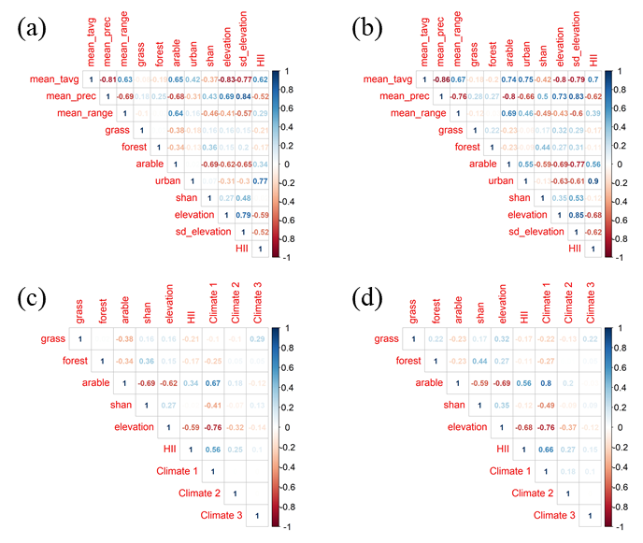

Supplementary Figure. 1. Correlation plots of the variables considered for inclusion in the models. Plots a and b show the Pearson’s and Spearman’s correlations, respectively, between all variables considered. Plots c and d show the Pearson’s and Spearman’s correlations, respectively, between the variables selected for the final models.

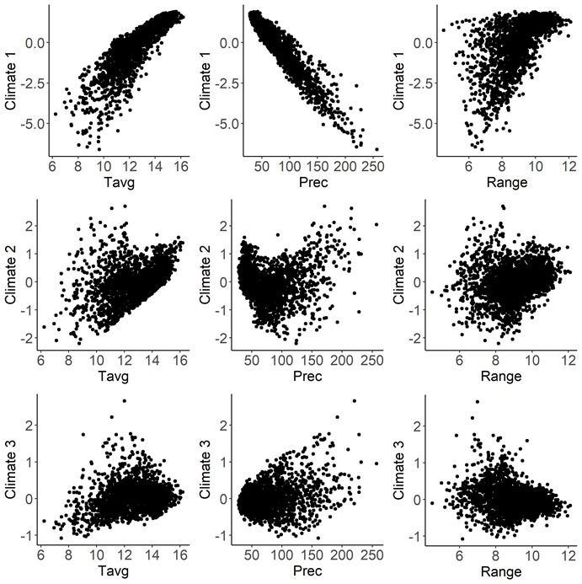

Supplementary Figure. 2. Scatter plots showing the correlation between the original climate variables (average temperature (Tavg), average total precipitation (Prec), and average range in temperature (Range)) and the resultant axes from a principal component analysis.

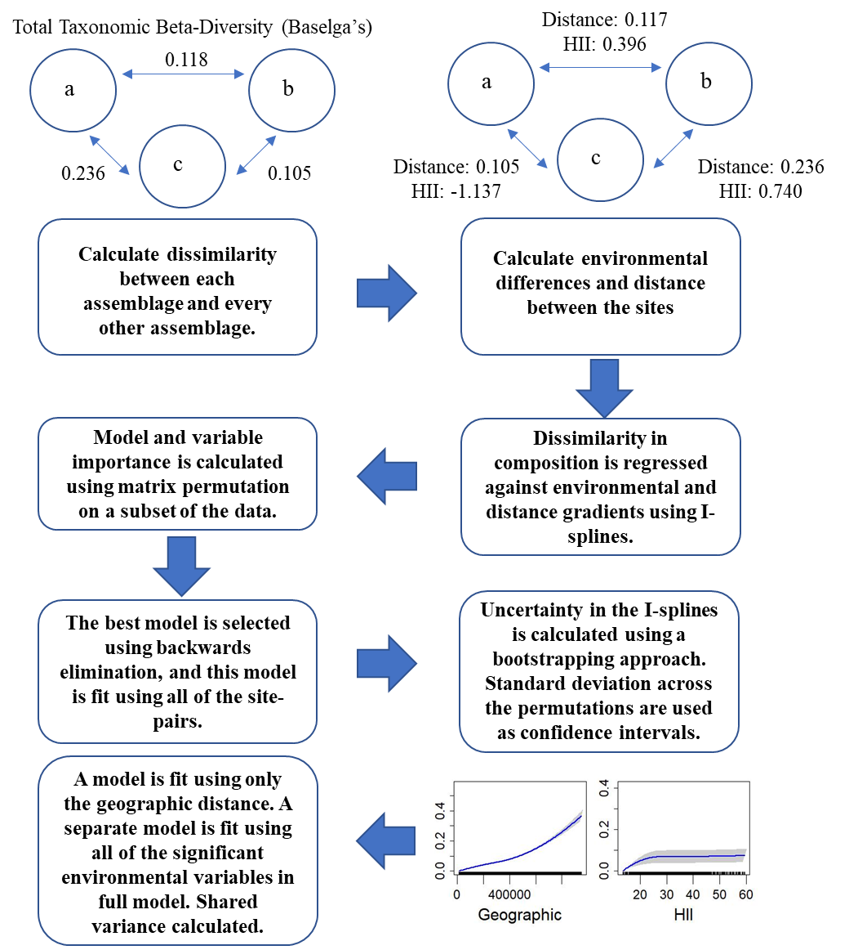

Supplementary Figure. 3. Flow chart displaying the process of fitting generalized dissimilarity models utilized in this study. In the top row, a, b, and c are different sites.

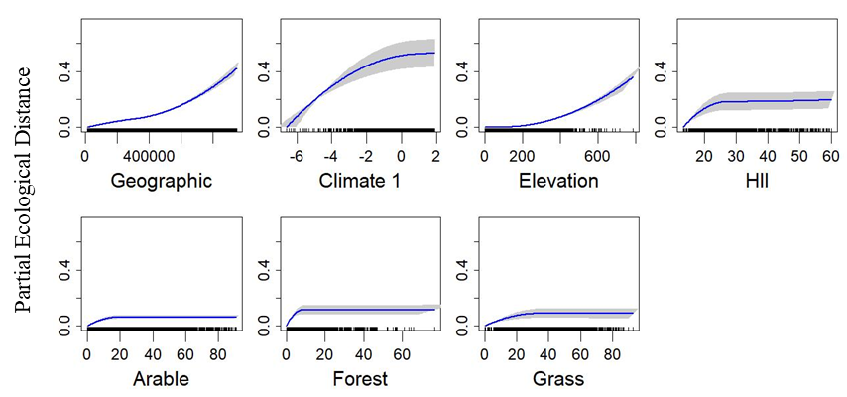

Supplementary Figure. 4. Plotted I-splines of the significant, important variables (determined from variable importance scores) from a generalised dissimilarity model analysing the relationship between environmental gradients and geographic distance (Geographic), and spatial variation in community the composition (total Sorenson’s beta-diversity) of British breeding birds. Climate 1 is the first axis from a principal component analysis using three measures of average climate (temperature, range, and precipitation). All the land use predictors (Forest, Grass, and Arable) are percentage cover. HII is the human influence index, calculated as the average within each quadrat. Curves show the relationship between the gradients and community dissimilarity obtained using I-splines. The most important variables are on the left with decreasing variable importance to the right (top to bottom). Blue lines show the I-Spline correlations, with standard deviation (grey shaded area) calculated through bootstrapping (100 permutations) on a portion of the dataset. A rug plot on the x axis shows the spread of the data. Note the varying y-axis for each measure.

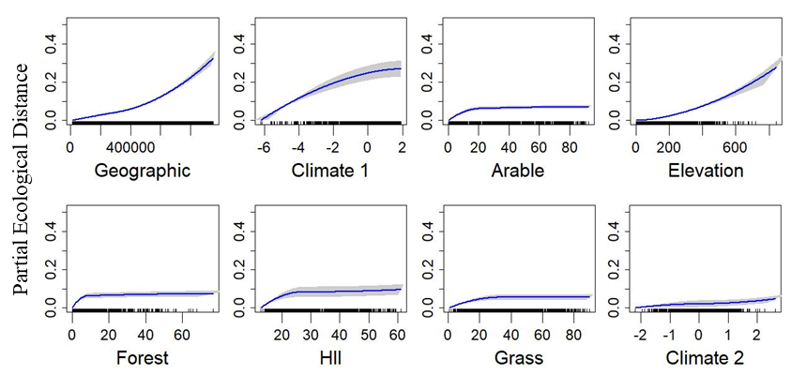
Supplementary Figure. 5. PPlotted I-splines of the significant, important variables (determined from variable importance scores) from a generalised dissimilarity model analysing the relationship between environmental gradients and geographic distance (Geographic), and spatial variation in community the composition (turnover component of Sorenson’s beta-diversity) of British breeding birds. Climate 1 and Climate 2 are the first and second axes, respectively, from a principal component analysis using three measures of average climate (temperature, range, and precipitation). All the land use predictors (Forest, Grass, and Arable) are percentage cover. HII is the human influence index, calculated as the average within each quadrat. Curves show the relationship between the gradients and community dissimilarity obtained using I-splines. The most important variables are on the left with decreasing variable importance to the right (top to bottom). Blue lines show the I-Spline correlations, with standard deviation (grey shaded area) calculated through bootstrapping (100 permutations) on a portion of the dataset. A rug plot on the x axis shows the spread of the data. Note the varying y-axis for each measure.

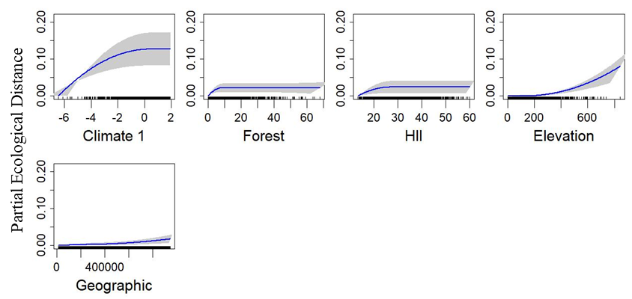

Supplementary Figure. 6. Plotted I-splines of the significant, important variables (determined from variable importance scores) from a generalised dissimilarity model analysing the relationship between environmental gradients and geographic distance (Geographic), and spatial variation in community the composition (nestedness resultant dissimilarity component of Sorenson’s beta-diversity) of British breeding birds. Climate 1 is the first axis from a principal component analysis using three measures of average climate (temperature, range, and precipitation). All the land use predictors (Forest) are percentage cover. HII is the human influence index, calculated as the average within each quadrat. Curves show the relationship between the gradients and community dissimilarity obtained using I-splines. The most important variables are on the left with decreasing variable importance to the right (top to bottom). Blue lines show the I-Spline correlations, with standard deviation (grey shaded area) calculated through bootstrapping (100 permutations) on a portion of the dataset. A rug plot on the x axis shows the spread of the data. Note the varying y-axis for each measure.

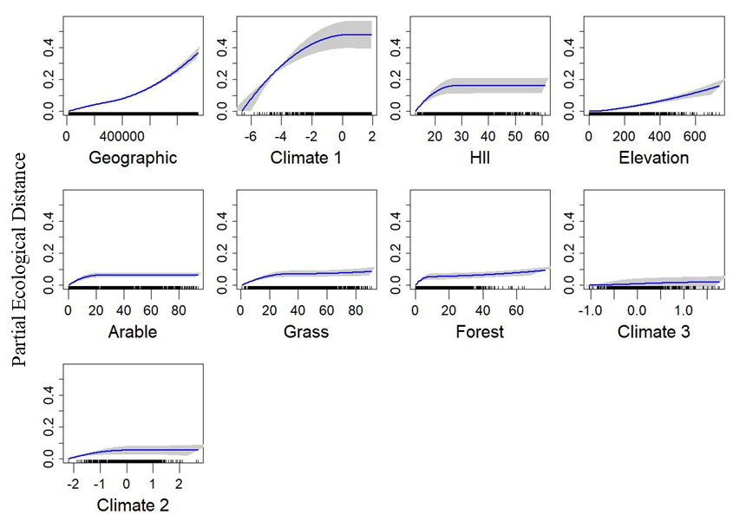

Supplementary Figure. 7. Plotted I-splines of the significant, important variables (determined from variable importance scores) from a generalised dissimilarity model analysing the relationship between environmental gradients and geographic distance (Geographic), and spatial variation in community the composition (total functional Sorenson’s beta-diversity) of British breeding birds. Climate 1, Climate 2, and Climate 3 are the first, second, and third axes, respectively, from a principal component analysis using three measures of average climate (temperature, range, and precipitation). All the land use predictors (Forest, Grass, and Arable) are percentage cover. HII is the human influence index, calculated as the average within each quadrat. Curves show the relationship between the gradients and community dissimilarity obtained using I-splines. The most important variables are on the left with decreasing variable importance to the right (top to bottom). Blue lines show the I-Spline correlations, with standard deviation (grey shaded area) calculated through bootstrapping (100 permutations) on a portion of the dataset. A rug plot on the x axis shows the spread of the data. Note the varying y-axis for each measure.

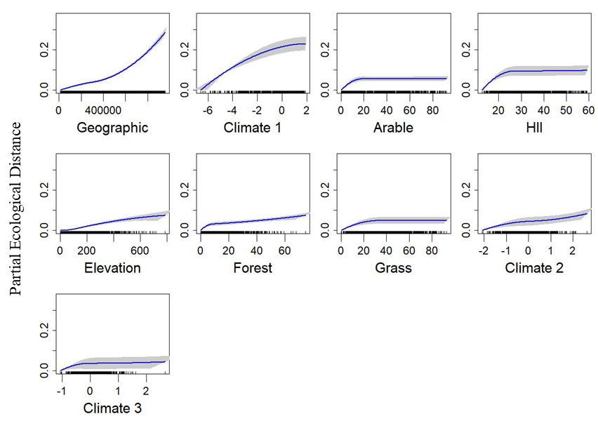

Supplementary Figure. 8. Plotted I-splines of the significant, important variables (determined from variable importance scores) from a generalised dissimilarity model analysing the relationship between environmental gradients and geographic distance (Geographic), and spatial variation in community the composition (turnover component of functional Sorenson’s beta-diversity) of British breeding birds. Climate 1, Climate 2, and Climate 3 are the first, second, and third axes, respectively, from a principal component analysis using three measures of average climate (temperature, range, and precipitation). All the land use predictors (Forest, Grass, and Arable) are percentage cover. HII is the human influence index, calculated as the average within each quadrat. Curves show the relationship between the gradients and community dissimilarity obtained using I-splines. The most important variables are on the left with decreasing variable importance to the right (top to bottom). Blue lines show the I-Spline correlations, with standard deviation (grey shaded area) calculated through bootstrapping (100 permutations) on a portion of the dataset. A rug plot on the x axis shows the spread of the data. Note the varying y-axis for each measure.

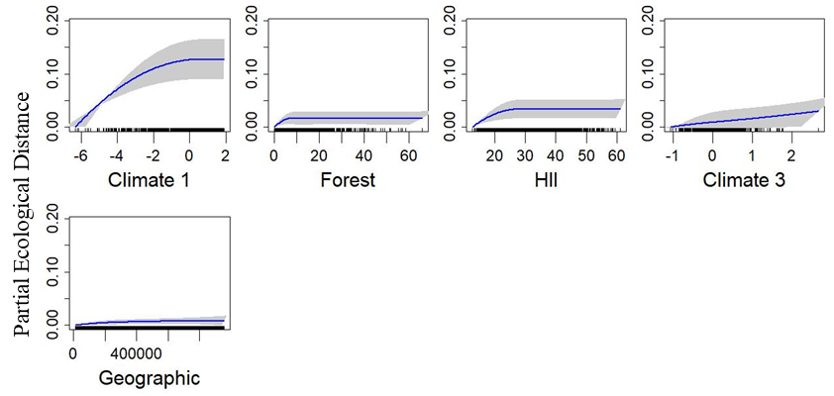

Supplementary Figure. 9. Plotted I-splines of the significant, important variables (determined from variable importance scores) from a generalised dissimilarity model analysing the relationship between environmental gradients and geographic distance (Geographic), and spatial variation in community the composition (nestedness resultant dissimilarity component of functional Sorenson’s beta-diversity) of British breeding birds. Climate 1 and Climate 3 are the first and third axes, respectively, from a principal component analysis using three measures of average climate (temperature, range, and precipitation). All the land use predictors (Forest) are percentage cover. HII is the human influence index, calculated as the average within each quadrat. Curves show the relationship between the gradients and community dissimilarity obtained using I-splines. The most important variables are on the left with decreasing variable importance to the right (top to bottom). Blue lines show the I-Spline correlations, with standard deviation (grey shaded area) calculated through bootstrapping (100 permutations) on a portion of the dataset. A rug plot on the x axis shows the spread of the data. Note the varying y-axis for each measure.

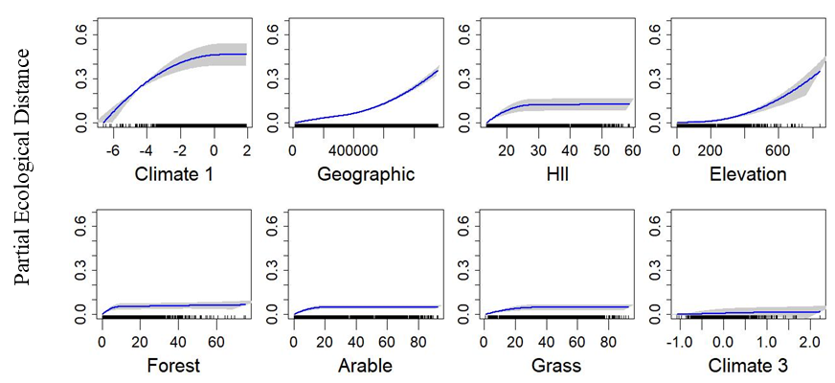

Supplementary Figure. 10.Plotted I-splines of the significant, important variables (determined from variable importance scores) from a generalised dissimilarity model analysing the relationship between environmental gradients and geographic distance (Geographic), and spatial variation in community the composition (mean nearest taxon distance (MNTD)) of British breeding birds. . Climate 1 and Climate 3 are the first and third axes, respectively, from a principal component analysis using three measures of average climate (temperature, range, and precipitation). All the land use predictors (Forest, Grass, and Arable) are percentage cover. HII is the human influence index, calculated as the average within each quadrat. Curves show the relationship between the gradients and community dissimilarity obtained using I-splines. The most important variables are on the left with decreasing variable importance to the right (top to bottom). Blue lines show the I-Spline correlations, with standard deviation (grey shaded area) calculated through bootstrapping (100 permutations) on a portion of the dataset. A rug plot on the x axis shows the spread of the data. Note the varying y-axis for each measure.

