Supplementary Material for the paper
Spatio-temporal variability of peat CH₄ and N₂O fluxes and their contribution to peat GHG budgets in Indonesian forests and oil palm plantations
Erin Swails, Kristell Hergoualc’h, Louis Verchot, Nisa Novita, Deborah Lawrence

Supplementary Methods on CH₄ and N₂O Flux Rate Determination
Cases where we would discard the final point from the regression analysis for determination of CH₄ and N₂O flux rates are illustrated below (Figure S1).
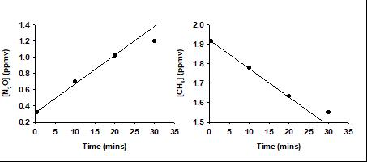
(b)
(a)
Figure S1. Cases where the final observation of gas concentration was discarded from the analysis of N₂O (a) and CH₄ (b) flux rates.
Additionally, in the case where any of the vials except the one with the sample at closure time had a concentration equal to ambient value and the other points indicate a clear trend over time (Figure S2), we assumed that the vial with the ambient concentration leaked. We discarded the observation, unless we had a clear indication at the time of analysis that the vial had remained pressurized. In the cases where there was no clear trend, which occurs when the flux is zero or very low, these observations were retained in the analysis.
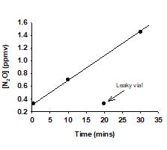
Figure S2. Case where an observation equal to ambient N₂O concentration was discarded from the analysis of flux rate.

Supplementary Methods and Results on Soil Respiration and Soil Respiration Partitioning Ratios at the Research Site
Total soil respiration was monitored concurrently with soil fluxes of CH₄ and N₂O at the study sites (Swails et al., 2019). Cumulative plot-scale soil respiration was higher in oil palm than in forest (Table S1). In the latter, the soil respired at a higher rate in FOR-1 which was a secondary forest than in the primary forests. In oil palm, the highest rate was recorded in OP-2009.
Table S1: Cumulative plot-scale soil respiration rates ± standard error at the study sites
Land use | Plot | CO₂ (Mg ha⁻¹ yr⁻¹)
Forest | Average | 45.2 | ± 3.1 ª
 | FOR-1 | 54.3 | ± 3.8 ^{ƚ}
 | FOR-2 | 42.0 | ± 1.5 #
 | FOR-3 | 39.4 | ± 2.8 #
Oil Palm | Average | 61.5 | ± 4.8 ^{b}
 | OP-2007 | 55.9 | ± 3.2 ^{ƚ}
 | OP-2009 | 79.5 | ± 3.7 #
 | OP-2011 | 49.1 | ± 4.7 ^{ƚ}
a and b indicate significant differences between land-uses. ƚ and # indicate significant differences between plots within a land use
In addition, total and heterotrophic soil respiration rates were monitored over 13 months (from June 2013 to June 2014) in FOR-3, OP-2012 located at the side of OP-2011, and OP-2007 (Hergoualc’h et al., 2017). Measurements were conducted in paired control and trenched plots replicated twelve times at each site. The contribution of heterotrophic to total soil respiration was computed from cumulative values (Table S1). In our study, we applied the average of the partitioning ratios in OP-2012 and OP-2007 (71.8 ± 10.8%) to all oil palm plots, and the partitioning ratio of FOR-3 to all forest plots.
Table S2. Partitioning ratios (%SRh) applied to estimate heterotrophic soil respiration in forest and oil palm (after Hergoualc’h et al., 2017).
Land use | Plot | %SRh
Forest | FOR-3 | 55.1 ± 2.8
Oil palm | OP-2012 | 82.5 ± 5.7
Oil palm | OP-2009 | 61.0 ± 2.3

Supplementary Results on Environmental Variables (Precipitation, Water Table Level, Soil WFPS, and Litterfall in Forest)
Annual precipitation during 2014 was 2250 mm. Monthly precipitation was ≤ 100 mm during the months of Jul-Oct 2014 and Jun-Sep 2015 (Figure SI3a). Water table level decreased in dry months in both ecosystems and rose close to the soil surface in wet months.
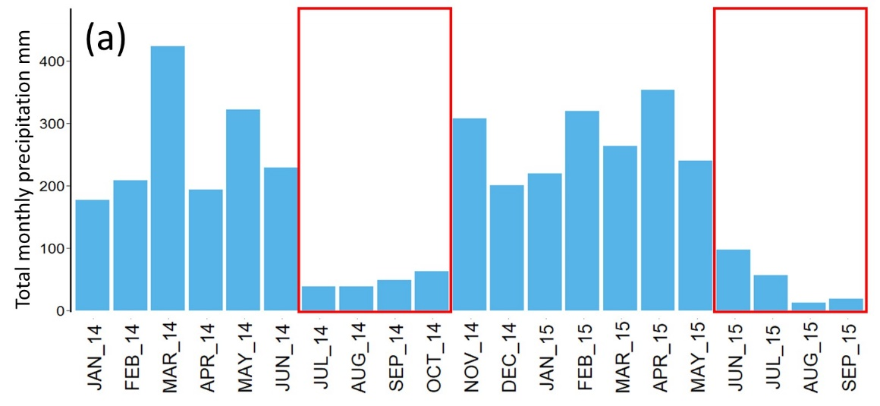
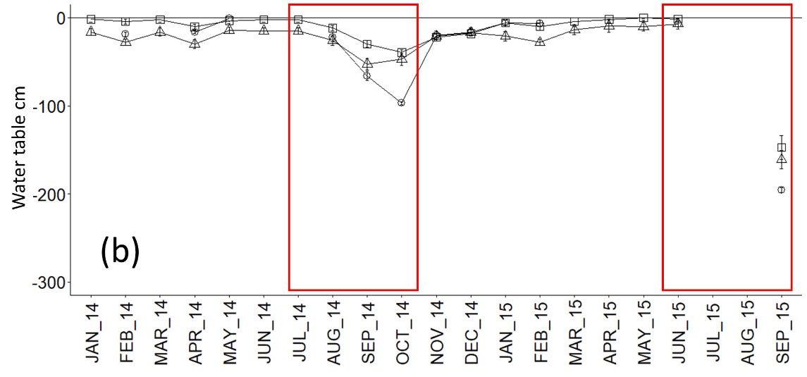
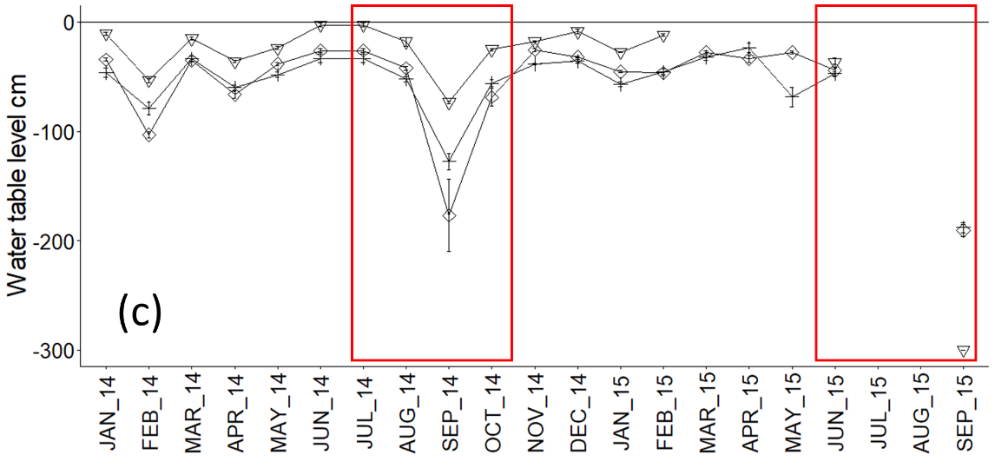
Figure S3. Daily precipitation (a) and monthly mean water table level in forest (b) and oil palm (c) plots from January 2014 to September 2015. Plot-scale values were calculated as the average of sub-plot values. Error bars represent standard error of the mean (n = 6). Square: FOR-1; Circle: FOR-2; Triangle: FOR-3; Cross: OP-2007; Diamond: OP-2009; Upside-down triangle: OP-2011. Dry months are indicated by red boxes.
The water table level was closer to the surface in FOR-3 than FOR-2 (p = 0.01) and in hollows than hummocks in FOR-1 (p < 0.0001) and FOR-3 (p = 0.008) (Table S3). In oil palm water table level was nearer to ground surface in OP-2011 than in OP-2009 and OP-2007 (p < 0.0001 for both comparisons). Soils in FOR-1 had higher WFPS than soils in FOR-2 and FOR-3 (p < 0.0001 and p = 0.0006, respectively), while in oil palm WFPS was lower in OP-2009 than in OP-2011 (p = 0.0002) and OP-2007 (p < 0.0001). Soil WFPS was higher in hollows than hummocks in FOR-2 (p = 0.003) and higher far from palms than near palms in OP-2007 (p = 0.02) and OP-2009 (p = 0.02). Detailed description of temporal and spatial variation of physical variables (water table level, soil moisture, air and soil temperature) is presented by Swails et al. (2019).
Table S3. Water table level (WT) and soil water-filled pore space (WFPS) in forest and oil palm, at plot level (bold) and per spatial position. Values are mean ± standard error.
Plot | Spatial Position | WT (cm) |  |  |  |  | WFPS (%)
FOR-1 |  | -24.0 | ± | 2.9 | ^{ab} |  | 70.3 | ± | 3.1 |  |  | ª
Hum |  | -33.7 | ± | 2.4 | ^{α} |  | 66.8 |  | 8.8
Hol |  | -14.4 | ± | 2.4 | ^{β} |  | 73.7 |  | 7.7
FOR-2 |  | -28.8 | ± | 2.9 | ª |  | 56.7 | ± | 3.1 |  |  | ^{b}
Hum |  | -34.9 | ± | 4 |  |  | 50.3 |  | 3.1 |  |  | ^{α}
Hol |  | -22.4 | ± | 4 |  |  | 63.4 |  | 2.2 |  |  | ^{β}
FOR-3 |  | -16.7 | ± | 2.9 | ^{b} |  | 59.7 | ± | 3.1 |  |  | ^{b}
Hum |  | -22.4 | ± | 3.5 | ^{α} |  | 56.3 |  | 5.0
Hol |  | -9.2 | ± | 3.5 | ^{β} |  | 64.3 |  | 3.5
OP-2007 |  | -58.1 | ± | 2.2 | ª |  | 67.4 | ± | 3.0 |  |  | ª
Near |  | -43.1 | ± | 12.5 |  |  | 53.3 |  | 5.0 |  |  | ^{α}
Far |  | -60.1 | ± | 12.9 |  |  | 75.7 |  | 4.2 |  |  | ^{β}
OP-2009 |  | -58.0 | ± | 2.4 | ª |  | 51.5 | ± | 3.0 |  |  | ^{b}
Near |  | -56.0 | ± | 3.5 |  |  | 42.2 |  | 3.5 |  |  | ^{α}
Far |  | -56.8 | ± | 3.5 |  |  | 55.0 |  | 3.9 |  |  | ^{β}
OP-2011 |  | -33.5 | ± | 2.2 | ^{b} |  | 60.4 | ± | 3.0 |  |  | ª
Near |  | -34.7 | ± | 1.2 |  |  | 54.1 |  | 4.9
Far |  | -33.1 | ± | 1.2 |  |  | 62.5 |  | 12.3
Plot-level values consider the representativeness of the spatial positions per plot. Hummock to hollow area ratios in forest plots were 49:51 (FOR-1), 51:49 (FOR-2), and 57:43 (FOR-3). Near to far ratio in oil palm plots were 25:75 (OP-2011), 27:73 (OP-2009), and 37:63 (OP-2007). Significant differences among plots within a land-use are indicated by a, b. Significant differences between spatial positions within a plot are indicated by α, β. Hum: Hummocks, Hol: Hollows, Near: Near to palm, Far: At mid-distance between two palms.
Monthly litterfall varied across forest plots from a high of 1.6 Mg d.m. ha⁻¹ in Mar 2014 to a low of 0.6 Mg d.m. ha⁻¹ in Nov 2014 with an annualized rate of 11.5 ± 1.7 Mg d.m. ha⁻¹ yr⁻¹ (Figure S4a). Litterfall rates were similar in wet and dry months. Annualized litterfall rates (d.m. ha⁻¹ yr⁻¹) were lower in FOR-2 (9.6 ± 0.8) than in FOR-1 and FOR-3 (12.1 ± 1.2, and 12.6 ± 1.0, respectively) (Figure S4b, c, d).
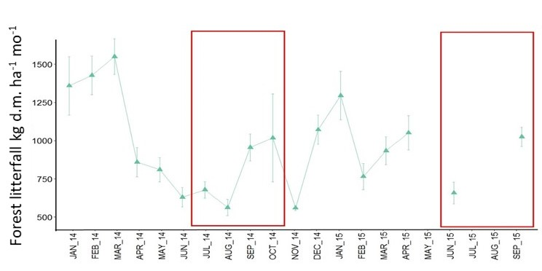
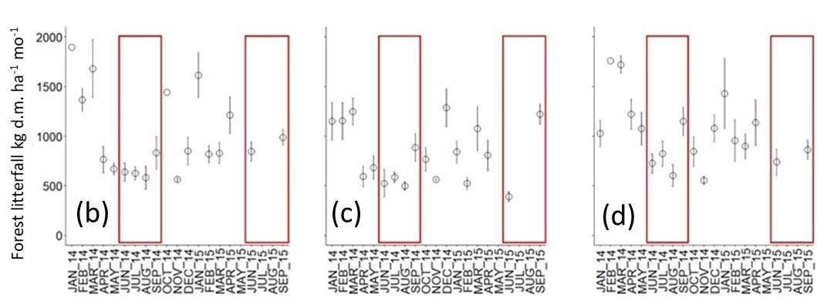
Figure S4. Monthly mean litterfall across forest plots (a) and within FOR-1 (b) FOR-2 (c) and FOR-3 (d) plots from January 2014 to September 2015. Error bars represent standard error of the mean (n = 18 for a; n =6 for b, c, d). Dry months are indicated by red boxes.

Supplementary Results on Relationship Trends Between Soil GHG Fluxes in Forest
In forest plots, cumulative emissions of CH₄ and N₂O tended to increase with increasing cumulative total soil respiration (Figure S5) and to be positively correlated with each other.
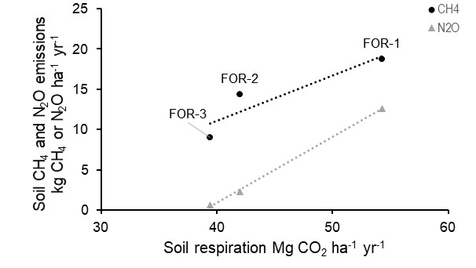
Figure S5. Mean soil CH₄ and N₂O emissions and soil respiration in forest plots. FOR-1 was a secondary forest located closest to river, FOR-2 and FOR-3 were primary forests located further from river. No statistical test was performed due to limited number of points.

References of Supplementary Information
Hergoualc’h, K., Hendry, D.T., Murdiyarso, D., Verchot, L.V. (2017) Total and heterotrophic soil respiration in a swamp forest and oil palm plantations on peat in Central Kalimantan, Indonesia. Biogeochemistry 135, 203-220.
Pansu M., Gautheyrou J., Loyer J.Y. (2001). Soil analysis. Sampling, instrumentation, quality control. A.A. Balkema Publishers, Lisse.
Swails, E., Jaye, D., Verchot, L., Hergoualc’h, K., Schirrmann, M., Borchard, N., Lawrence, D. (2018). Will CO2 emissions from drained tropical peatlands decline over time? Links between soil organic matter quality, nutrients, and C mineralization rates. Ecosystems 21, 868–885
Swails, E., Hertanti, D., Hergoualc’h, K., Verchot, L., & Lawrence, D. (2019). The response of soil respiration to climatic drivers in undrained forest and drained oil palm plantations in an Indonesian peatland. Biogeochemistry 142, 37–51

