Figure S1. MR leave-one-out sensitivity analysis for SNPs of IBD
Figure S2. MR leave-one-out sensitivity analysis for SNPs of UC
Figure S3. MR leave-one-out sensitivity analysis for SNPs of CD
Figure S4. Single SNPs used in the Mendelian randomization analysis of the effects of IBD on PSC.
Figure S5. Single SNPs used in the Mendelian randomization analysis of the effects of UC on PSC.
Figure S6. Single SNPs used in the Mendelian randomization analysis of the effects of CD on PSC.
Figure S7. Funel plot of single SNPs used in the Mendelian randomization analysis of the effects of IBD on PSC.
Figure S8. Funel plot of single SNPs used in the Mendelian randomization analysis of the effects of UC on PSC.
Figure S9. Funel plot of single SNPs used in the Mendelian randomization analysis of the effects of CD on PSC.
Figure S10. MR estimates from each method of assessing the causal effects of IBD on PSC.
Figure S11. MR estimates from each method of assessing the causal effects of UC on PSC.
Figure S12. MR estimates from each method of assessing the causal effects of CD on PSC.

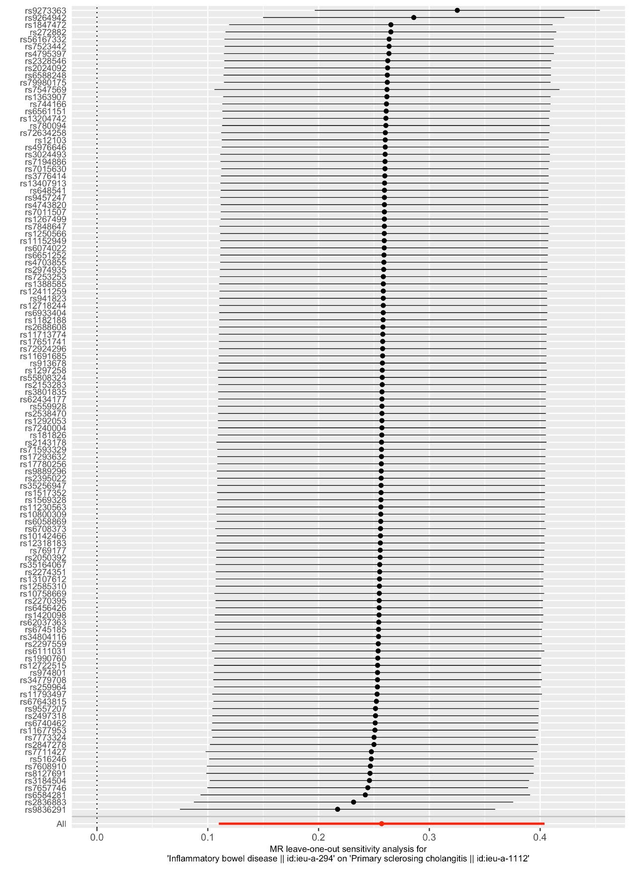
Figure S1. MR leave-one-out sensitivity analysis for SNPs of IBD
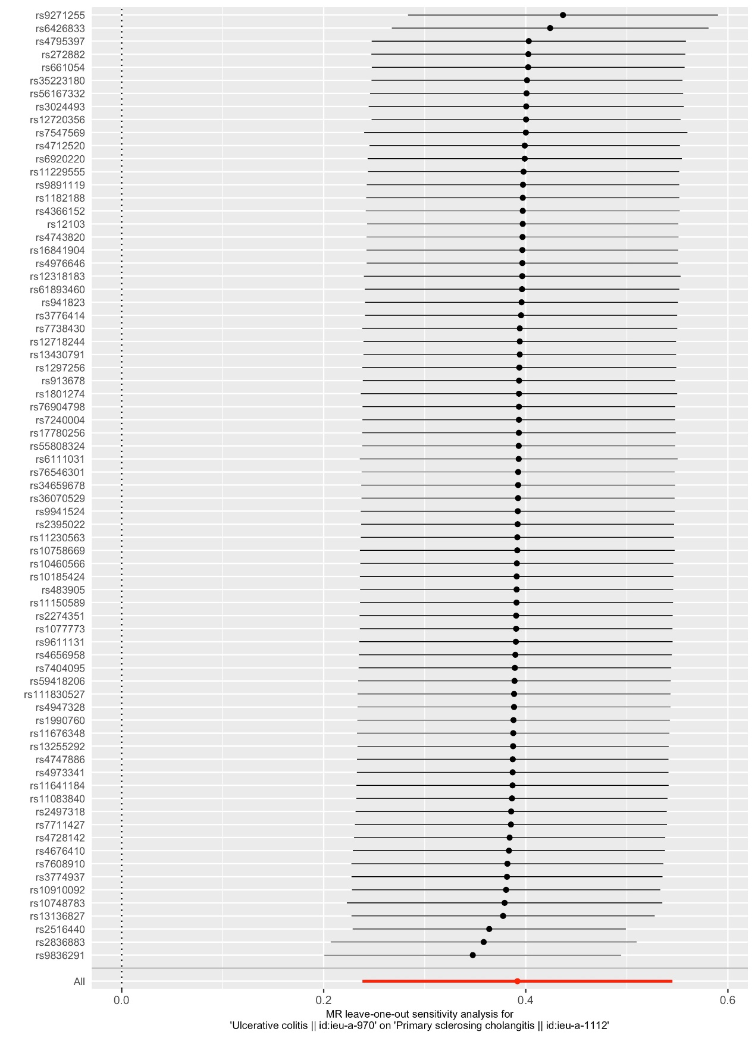
Figure S2. MR leave-one-out sensitivity analysis for SNPs of UC
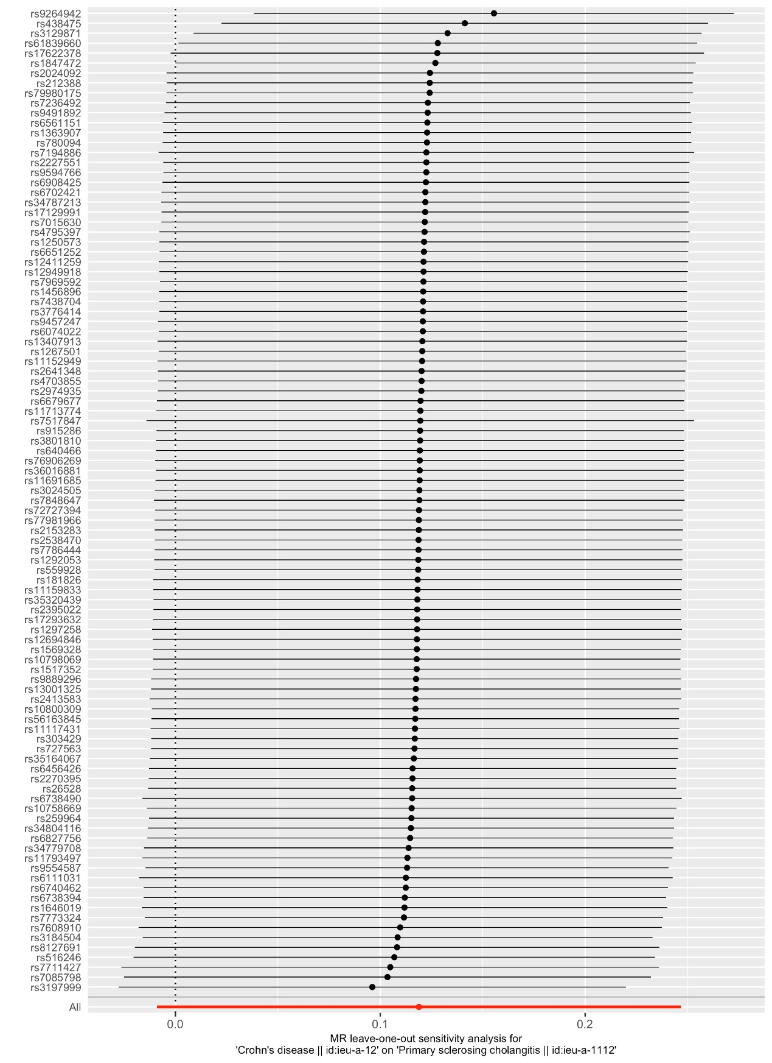
Figure S3. MR leave-one-out sensitivity analysis for SNPs of CD

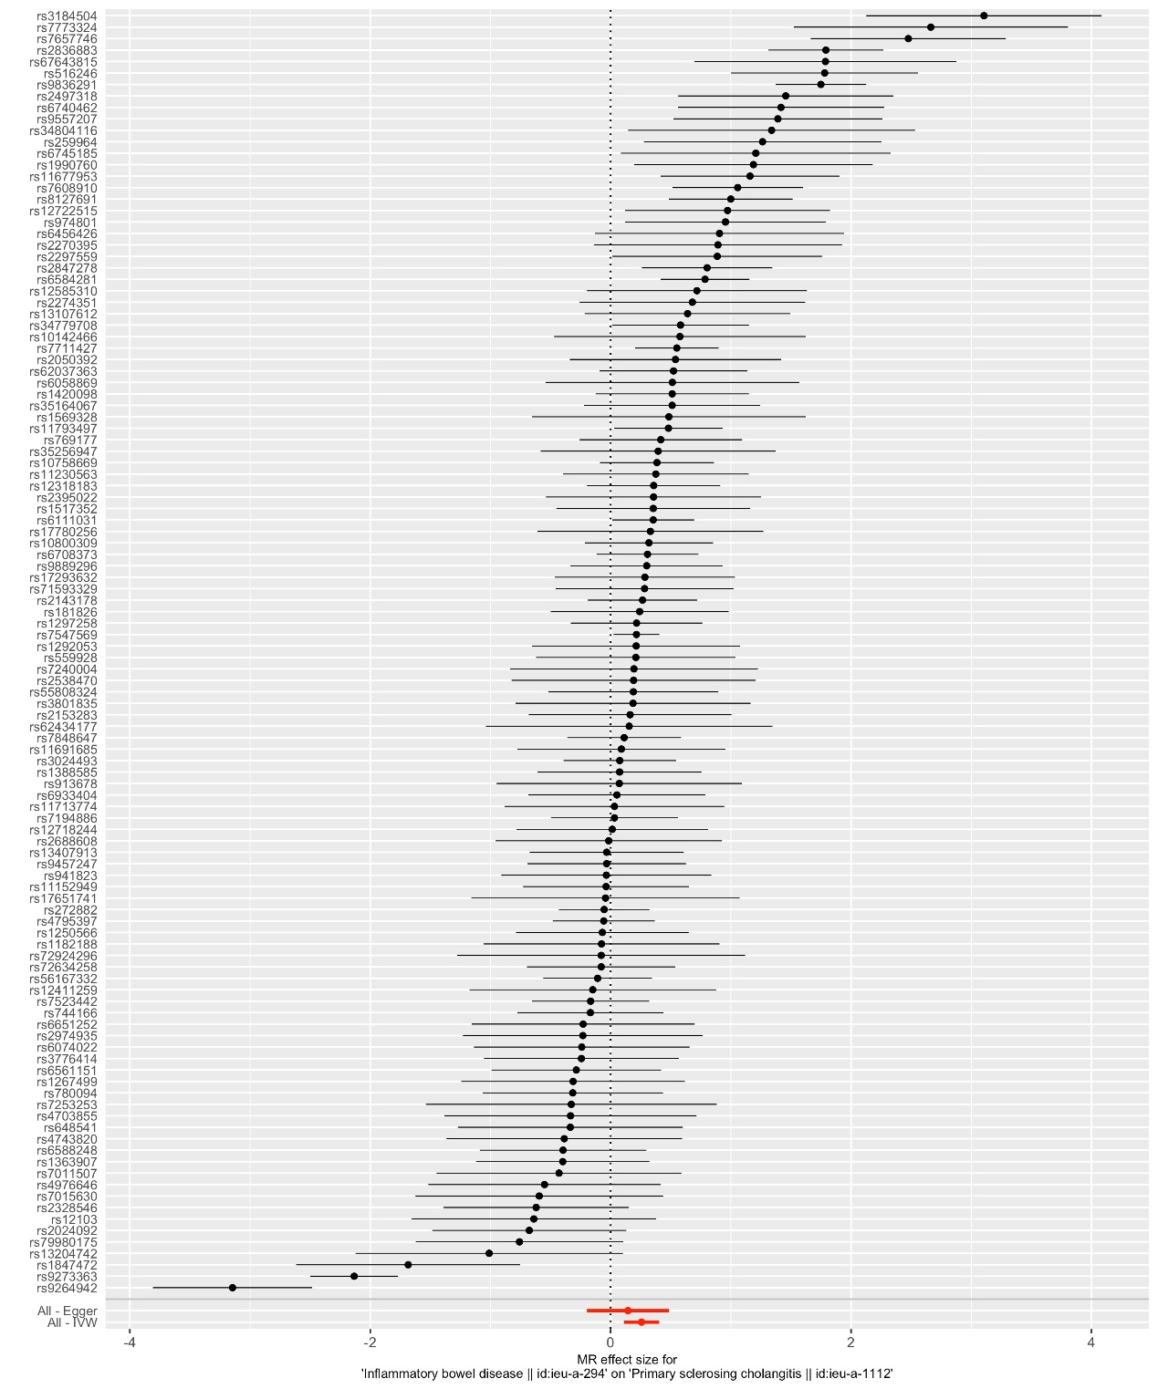
Figure S4. Single SNPs used in the Mendelian randomization analysis of the effects of IBD on PSC. 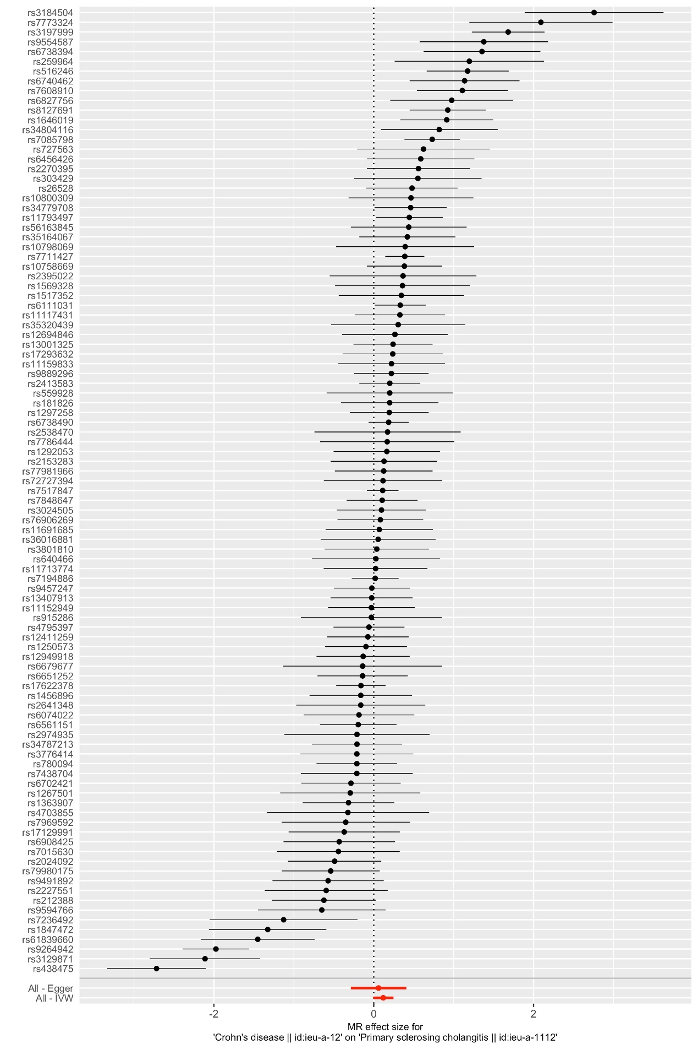
Figure S5. Single SNPs used in the Mendelian randomization analysis of the effects of UC on PSC. 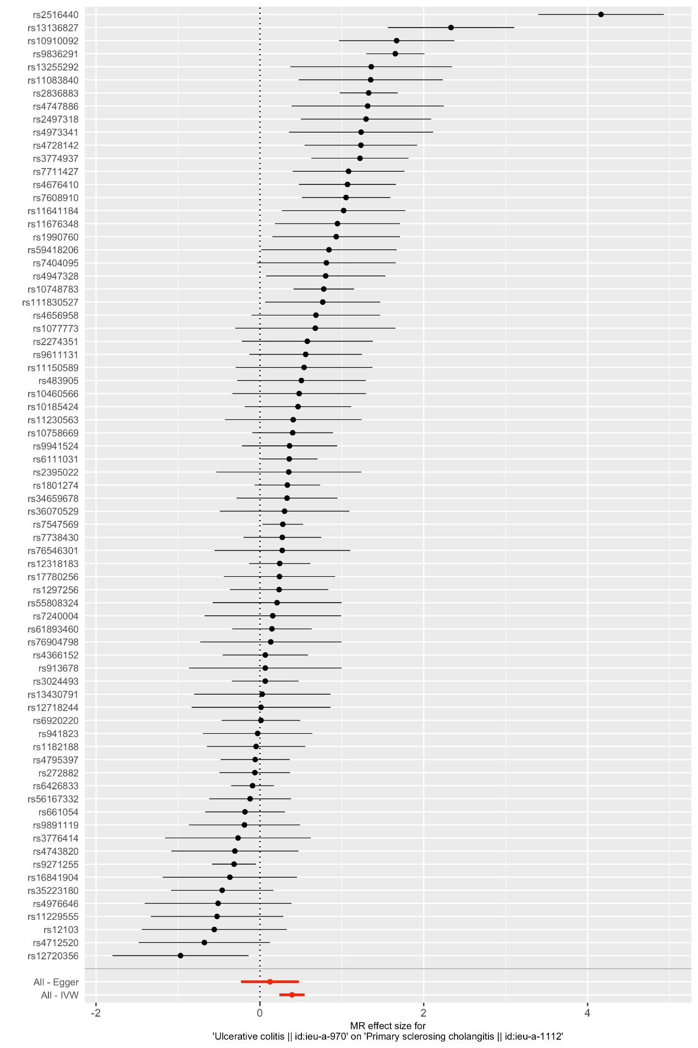
Figure S6. Single SNPs used in the Mendelian randomization analysis of the effects of CD on PSC.

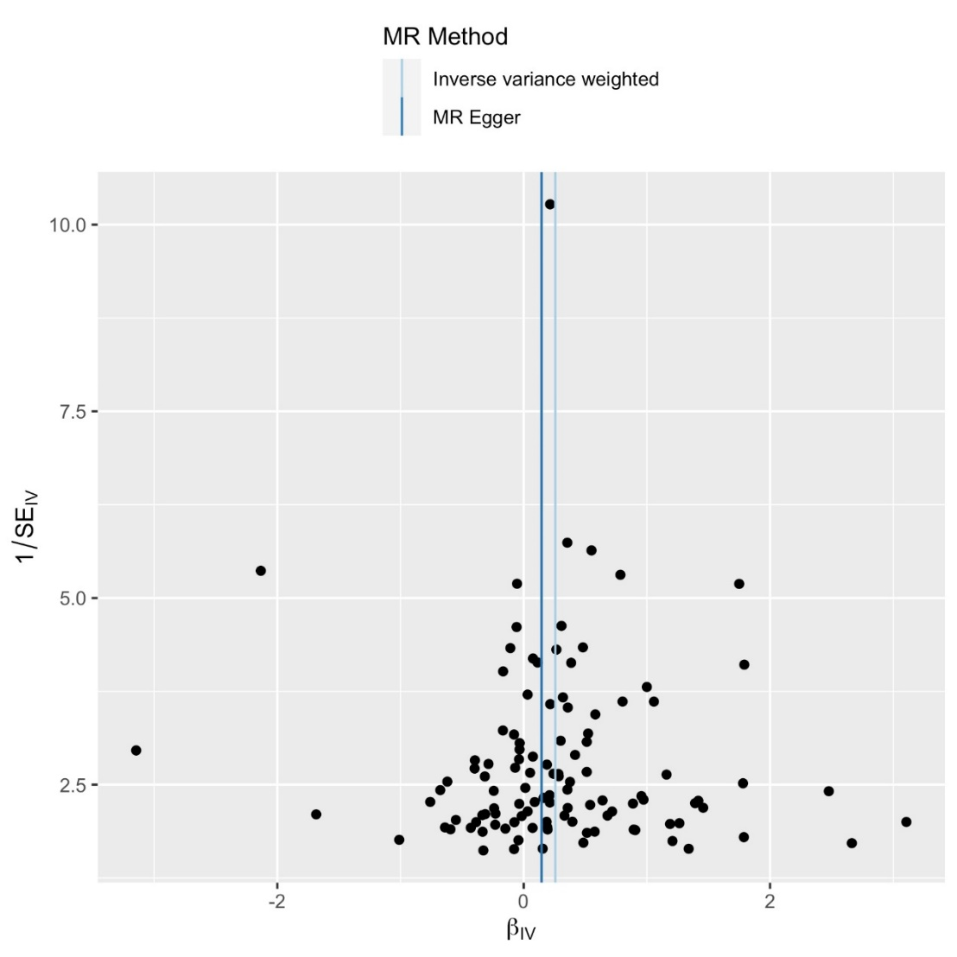
Figure S7. Funel plot of single SNPs used in the Mendelian randomization analysis of the effects of IBD on PSC.
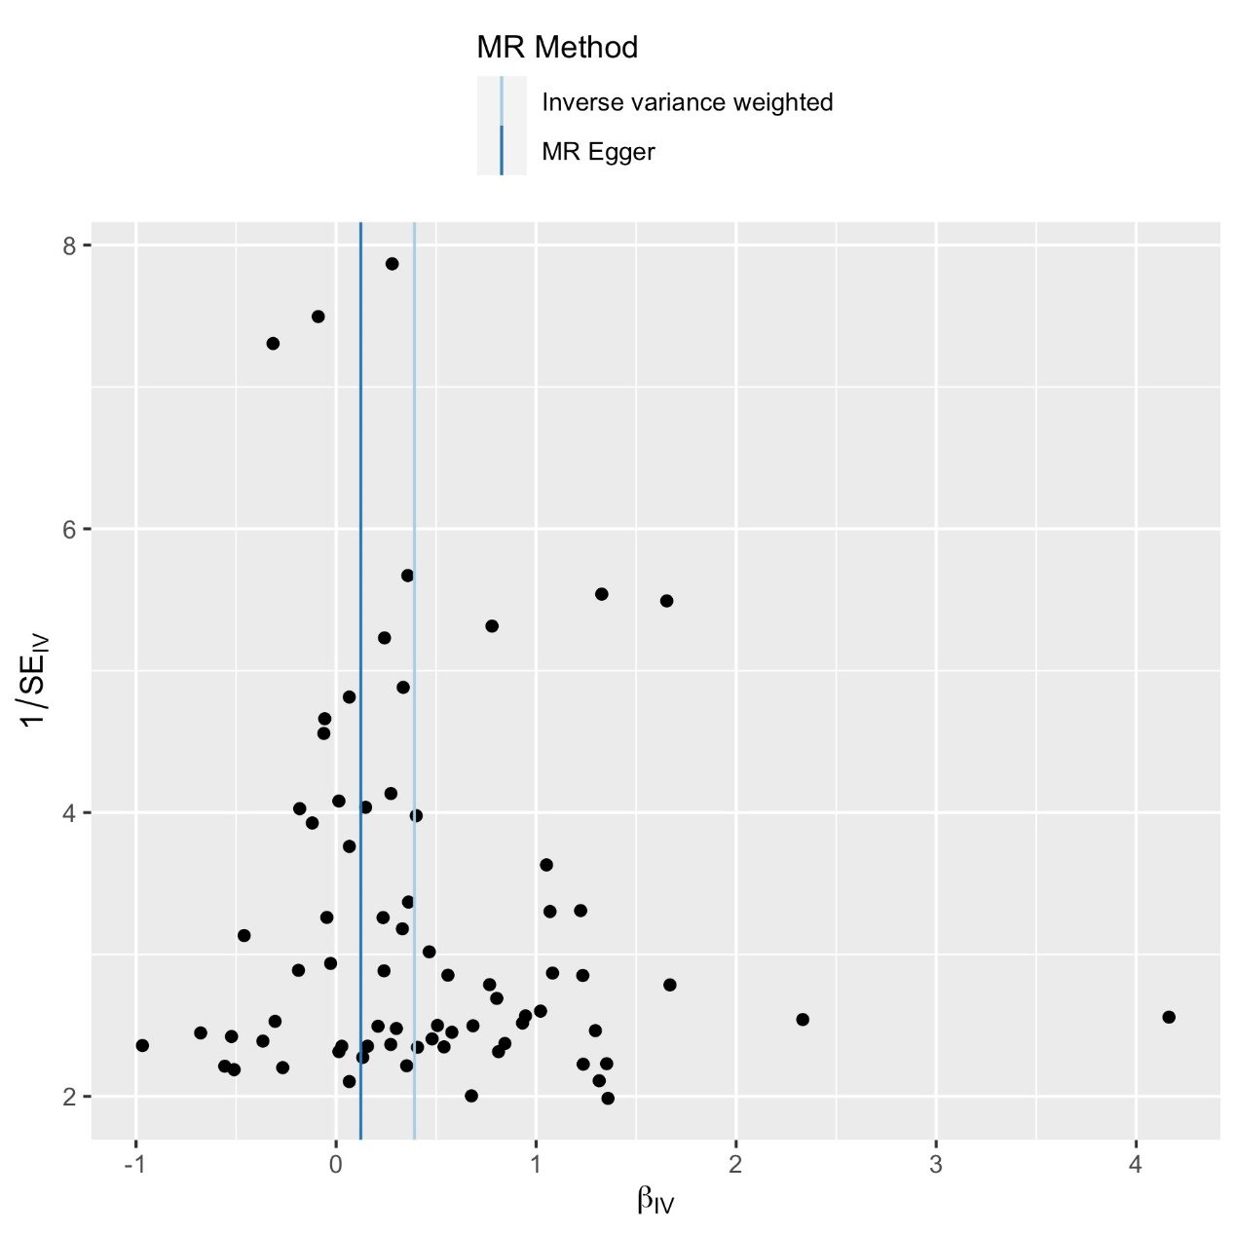
Figure S8. Funel plot of single SNPs used in the Mendelian randomization analysis of the effects of UC on PSC.
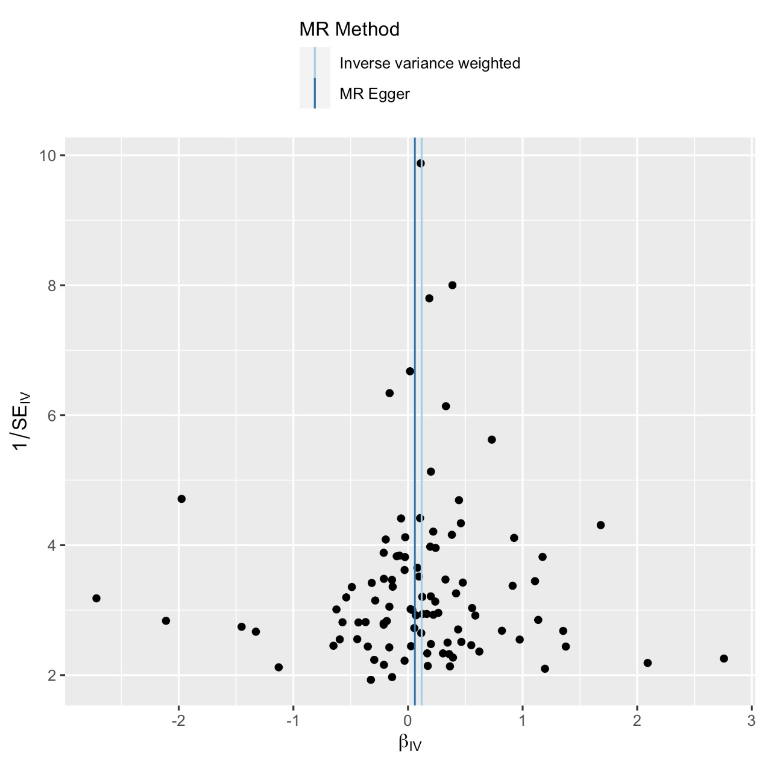
Figure S9. Funel plot of single SNPs used in the Mendelian randomization analysis of the effects of CD on PSC.

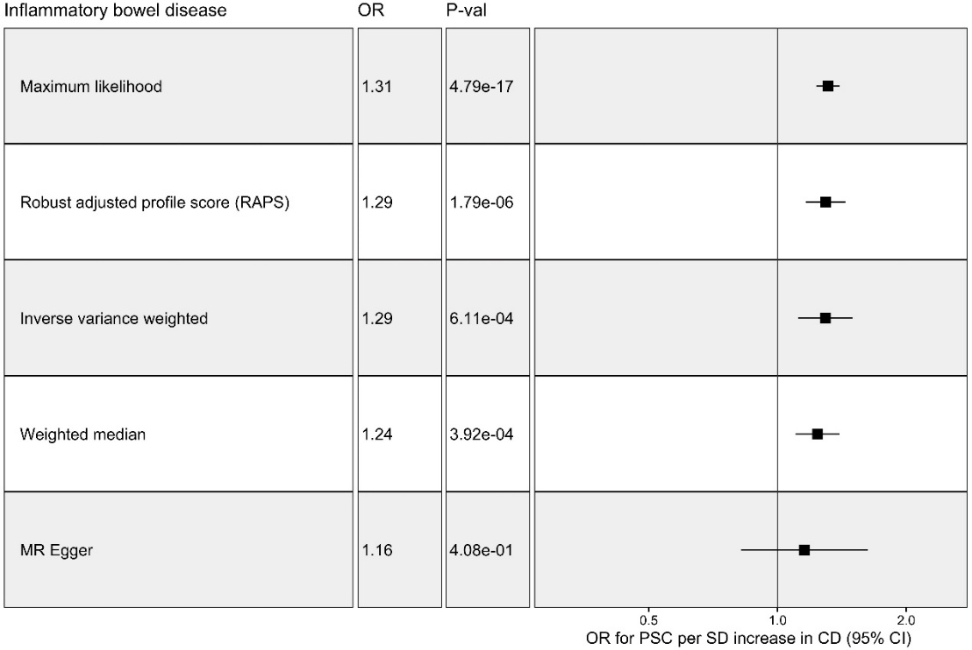
Figure S10. MR estimates from each method of assessing the causal effects of IBD on PSC.

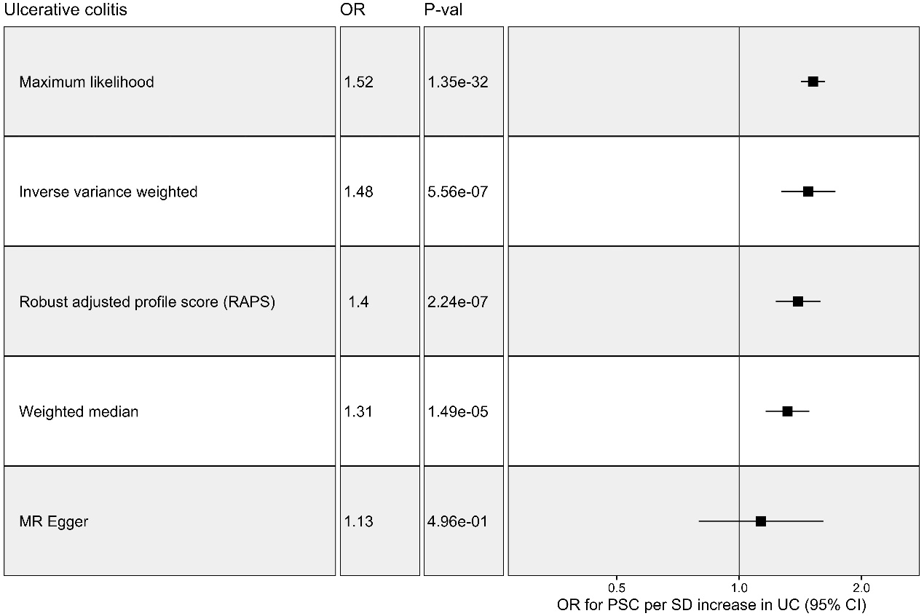
Figure S11. MR estimates from each method of assessing the causal effects of UC on PSC.

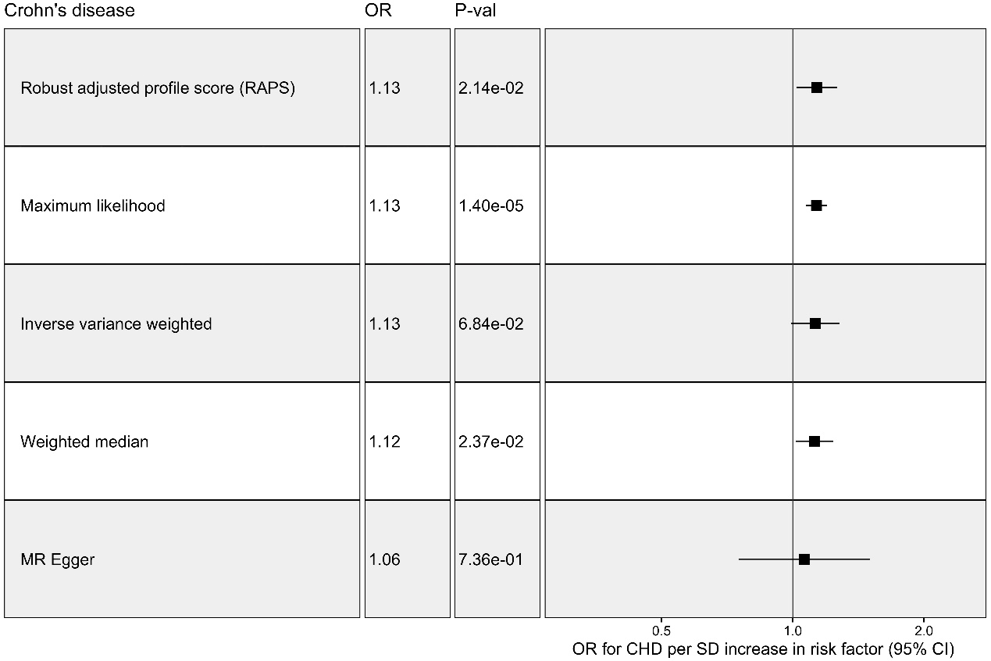
Figure S12. MR estimates from each method of assessing the causal effects of CD on PSC.

