Supplemental Figure 5. The structure of BR downstream genes in nine rosaceae species
Supplemental Figure 5-1 The structure of BR downstream genes in Malus domestica
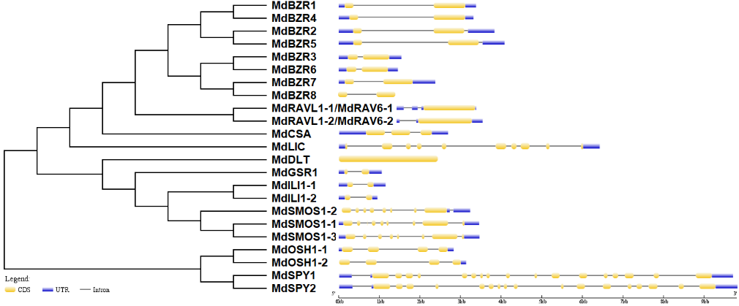
Supplemental Figure 5-2 The structure of BR downstream genes in Fragaria vesca
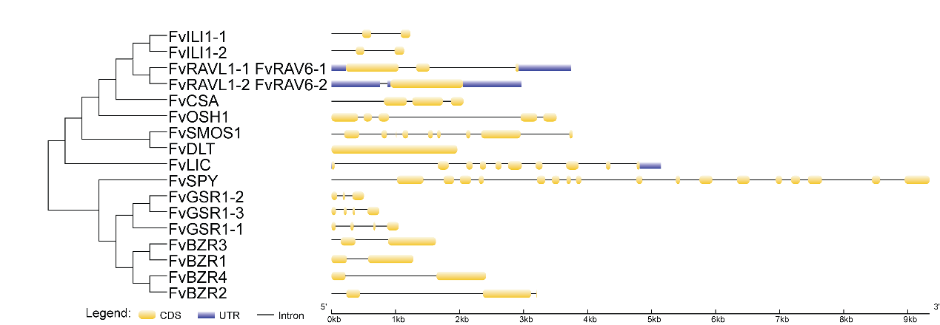
Supplemental Figure 5-3 The structure of BR downstream genes in Rubus occidentalis
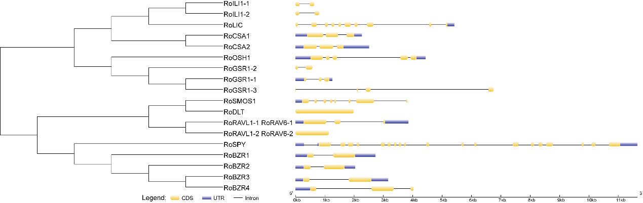
Supplemental Figure 5-4 The structure of BR downstream genes in Pyrus communis 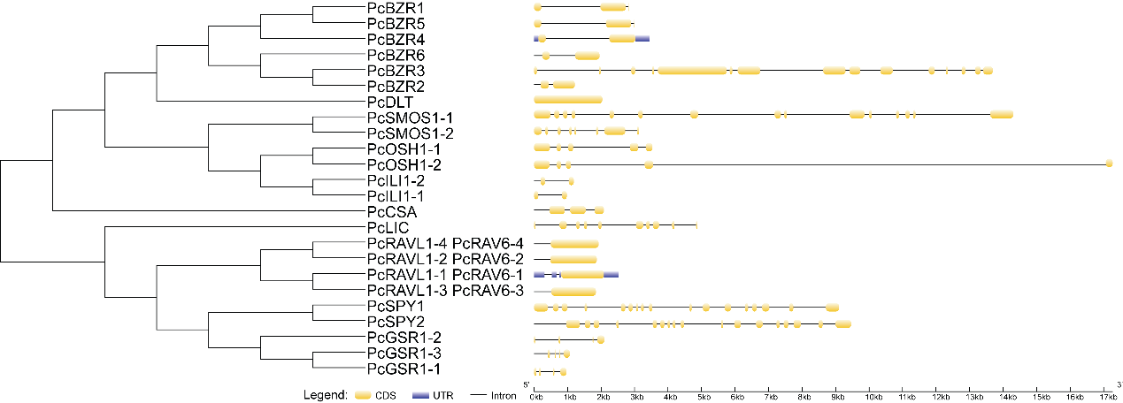

Supplemental Figure 5-5 The structure of BR downstream genes in Prunus persica 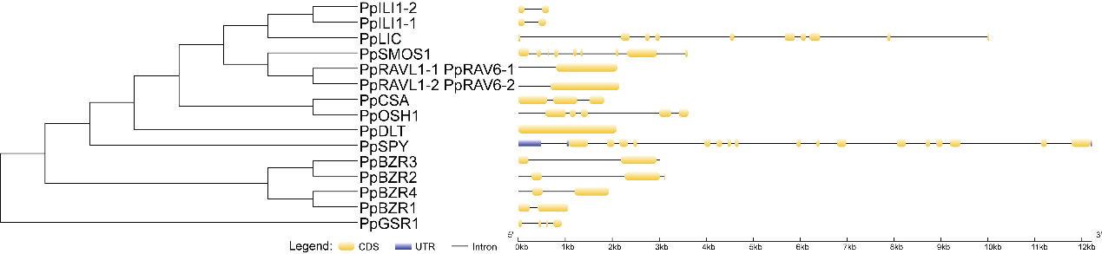
Supplemental Figure 5-6 The structure of BR downstream genes in Prunus avium 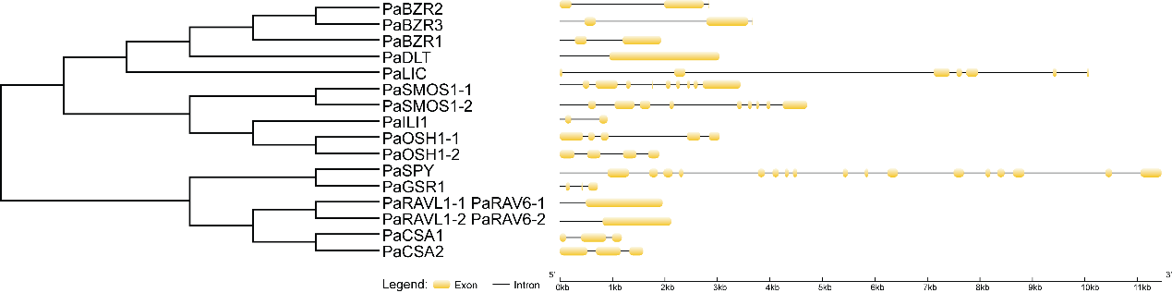
Supplemental Figure 5-7 The structure of BR downstream genes in Prunus dulcis 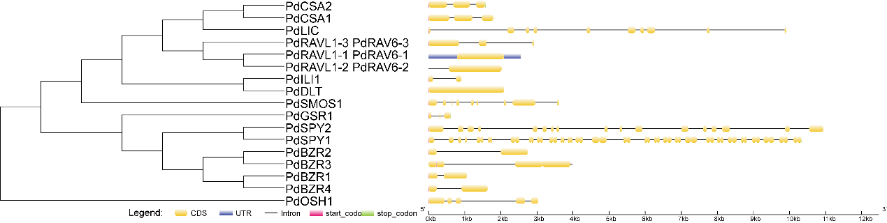
Supplemental Figure 5-8 The structure of BR downstream genes in Rosa chinensis 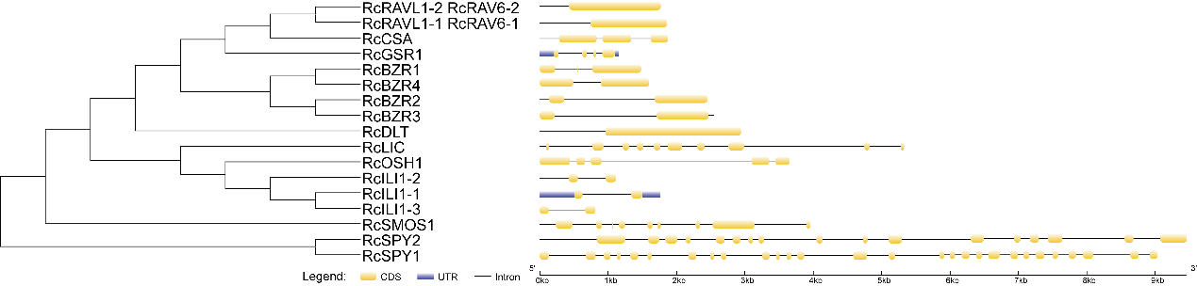
Supplemental Figure 5-9 The structure of BR downstream genes in Prunus mume 