Supplemental Figure 3. Synteny analysis of BR downstream genes in each rosaceae specie
Supplemental Figure 3-1 Synteny analysis of BR downstream genes in Malus domestica
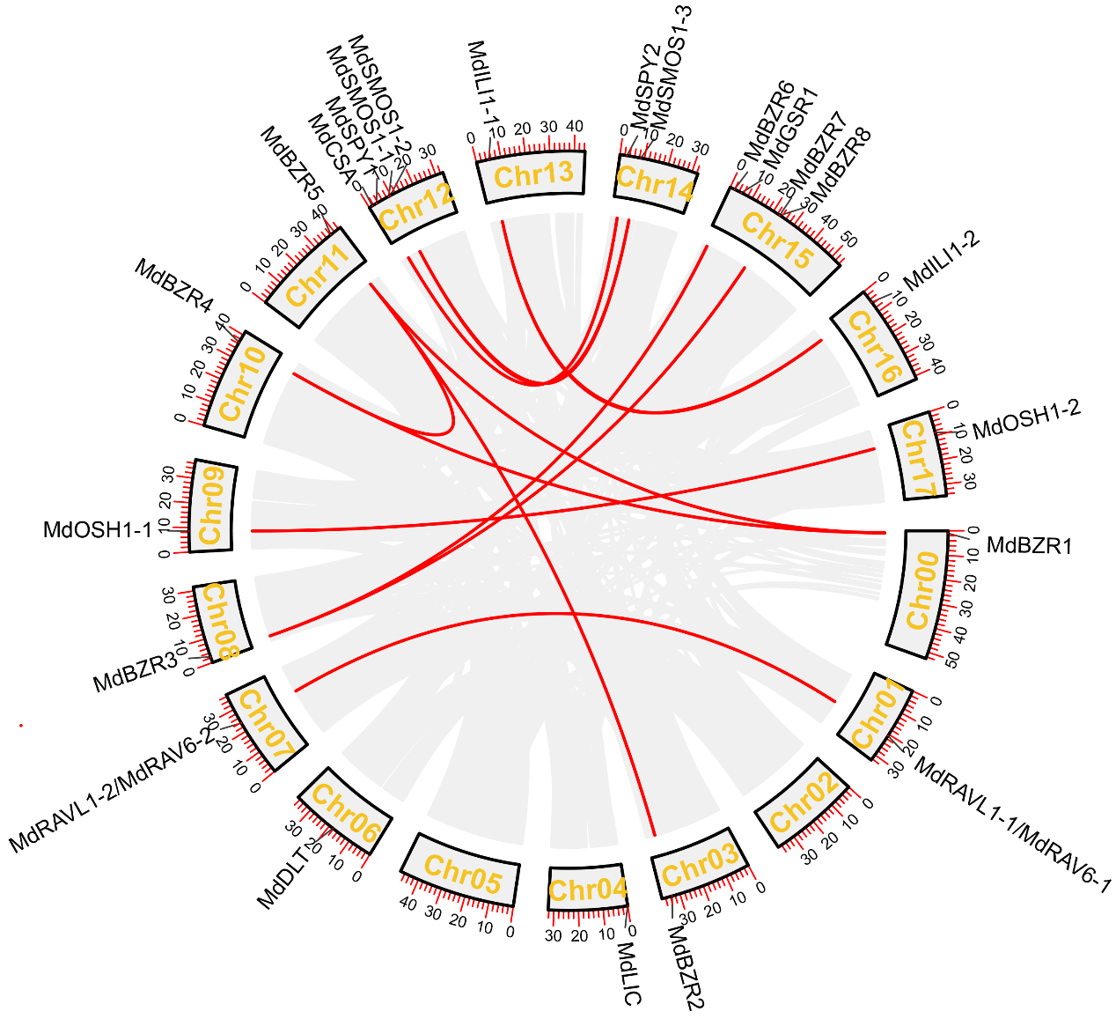
Supplemental Figure 3-2 Synteny analysis of BR downstream genes in Fragaria vesca

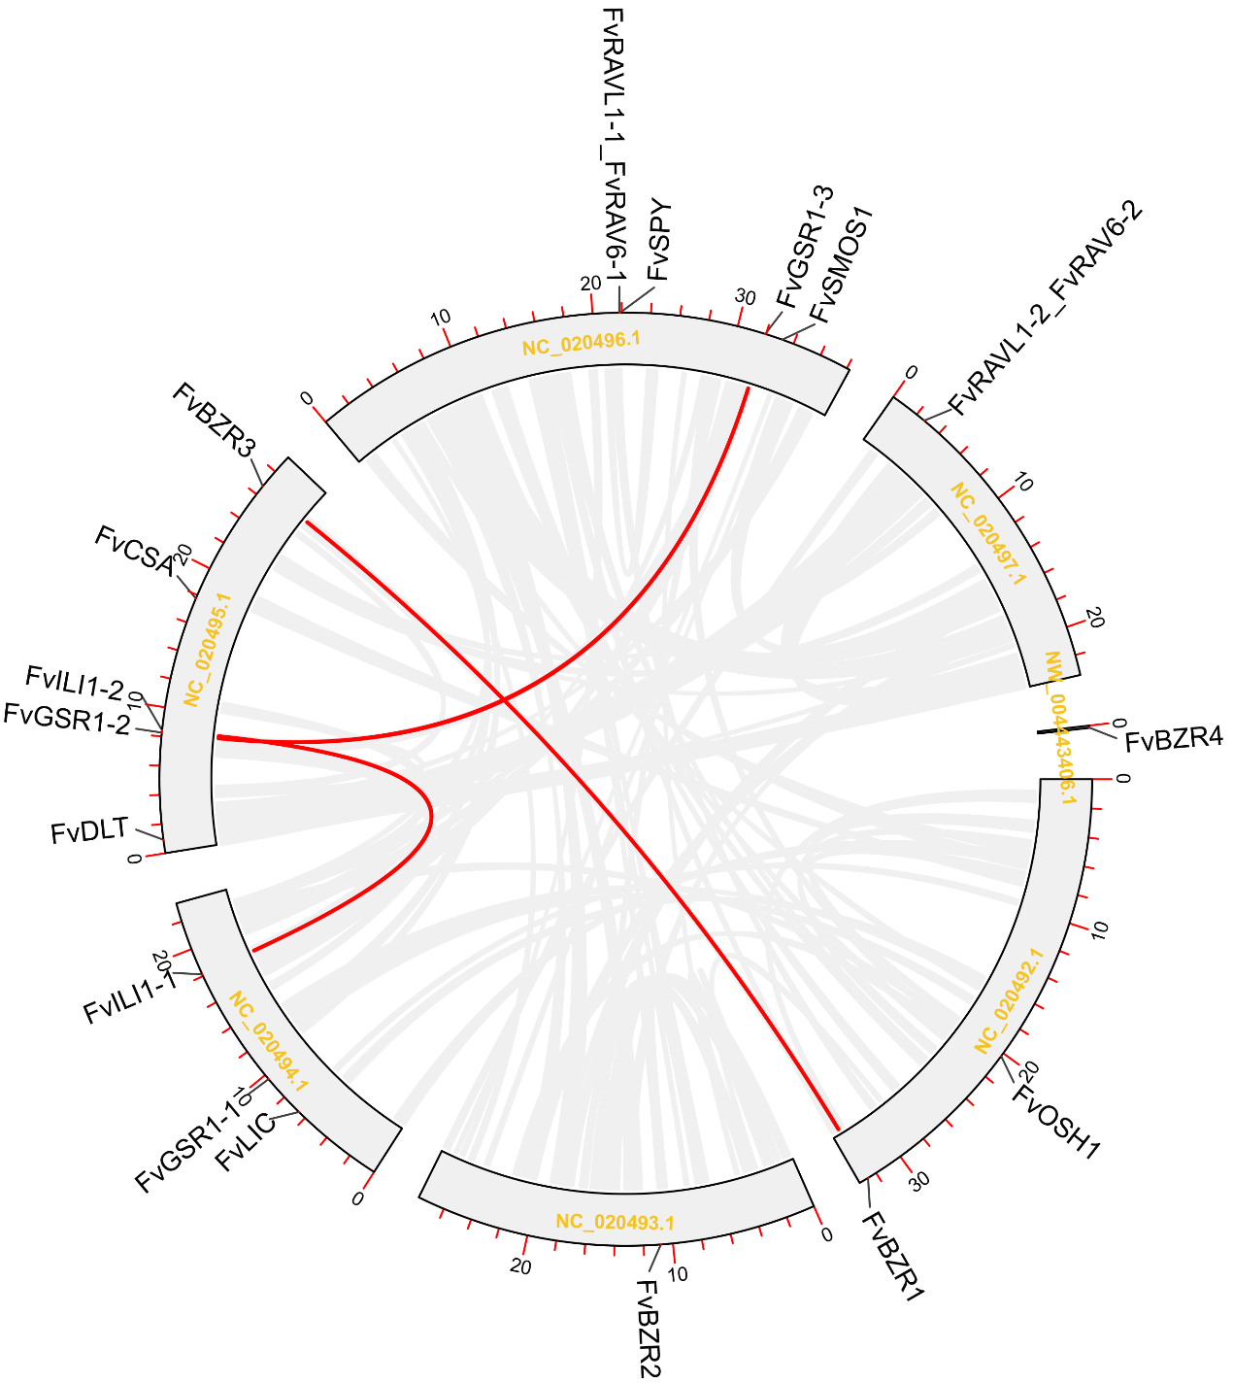

Supplemental Figure 3-3 Synteny analysis of BR downstream genes in Rubus occidentalis
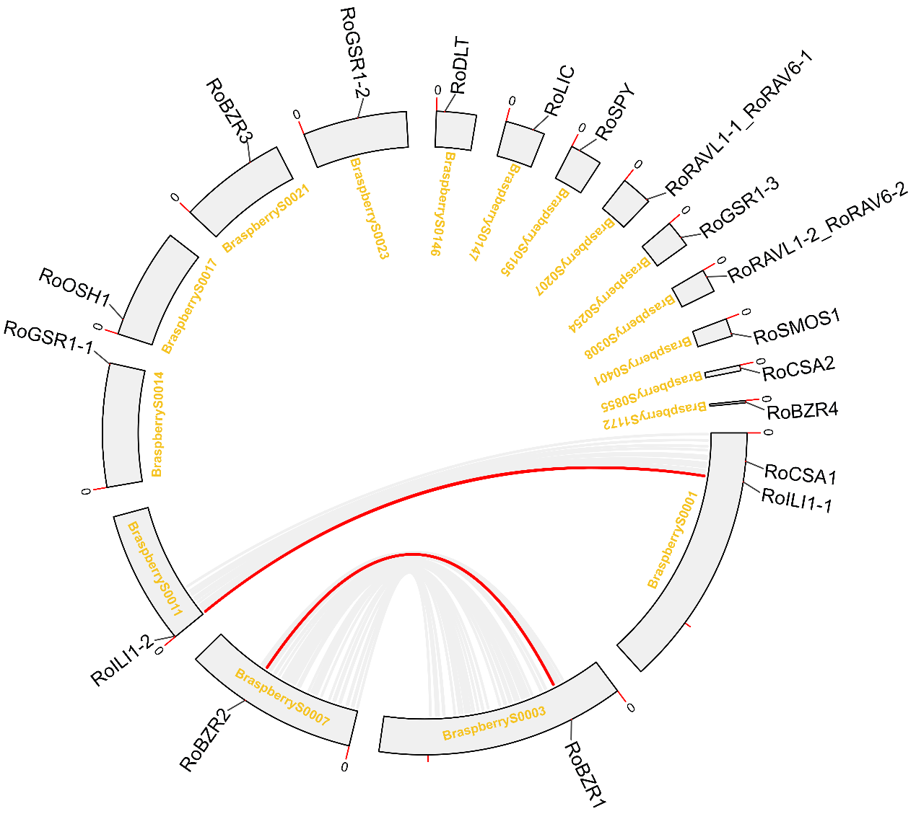

Supplemental Figure 3-4 Synteny analysis of BR downstream genes in Pyrus communis
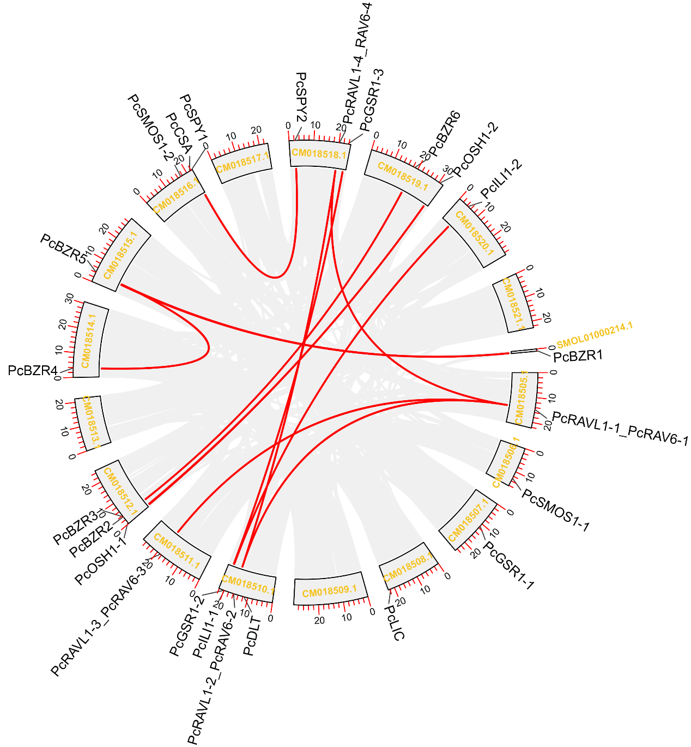
Supplemental Figure 3-5 Synteny analysis of BR downstream genes in Prunus persica
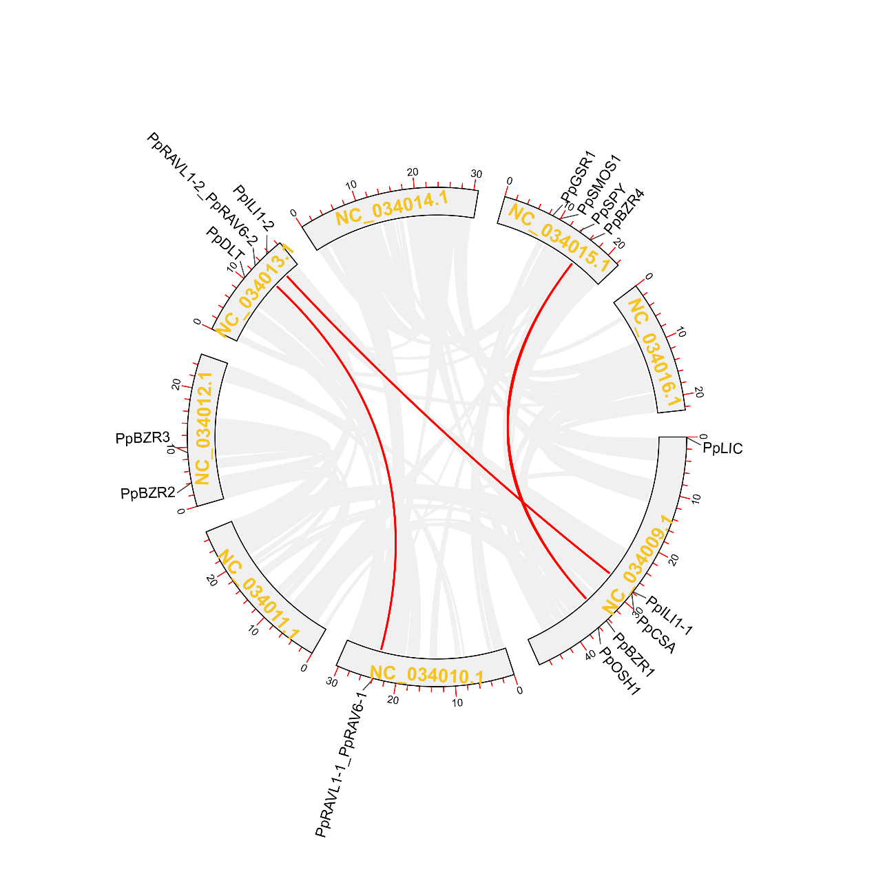
Supplemental Figure 3-6 Synteny analysis of BR downstream genes in Prunus avium
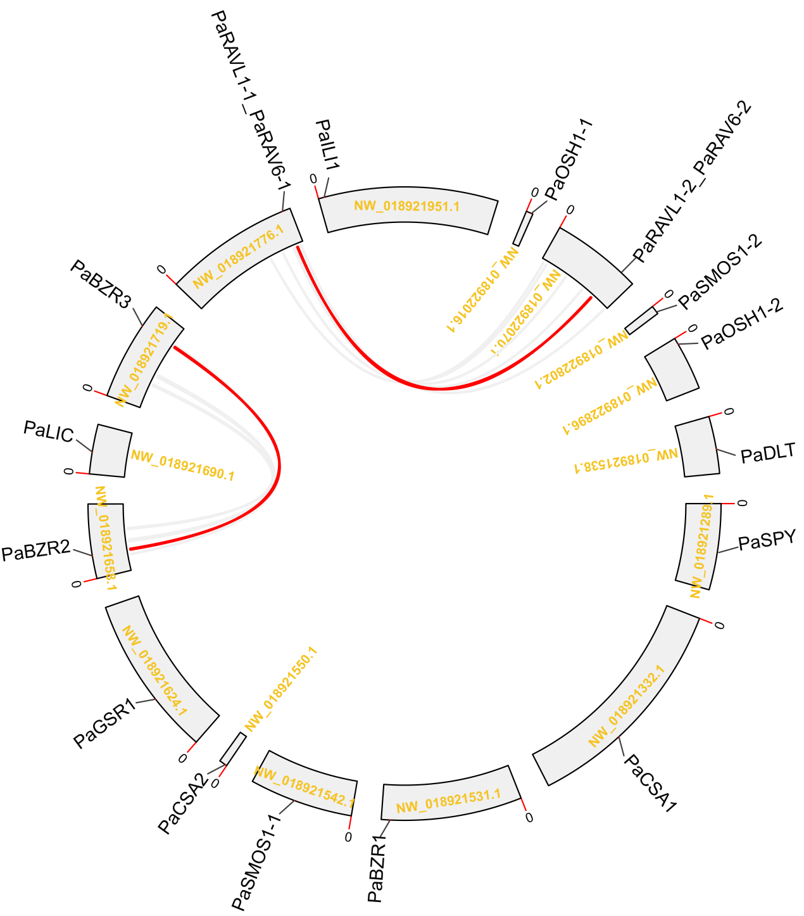
Supplemental Figure 3-7 Synteny analysis of BR downstream genes in Prunus dulcis
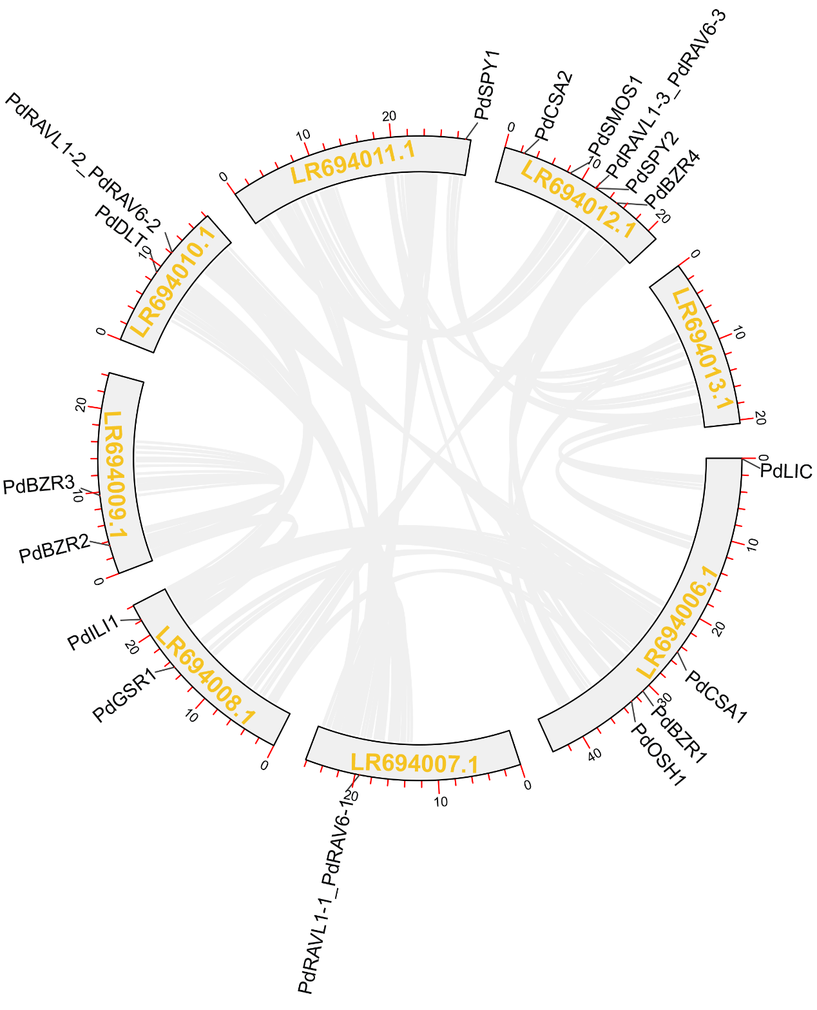
Supplemental Figure 3-8 Synteny analysis of BR downstream genes in Rosa chinensis
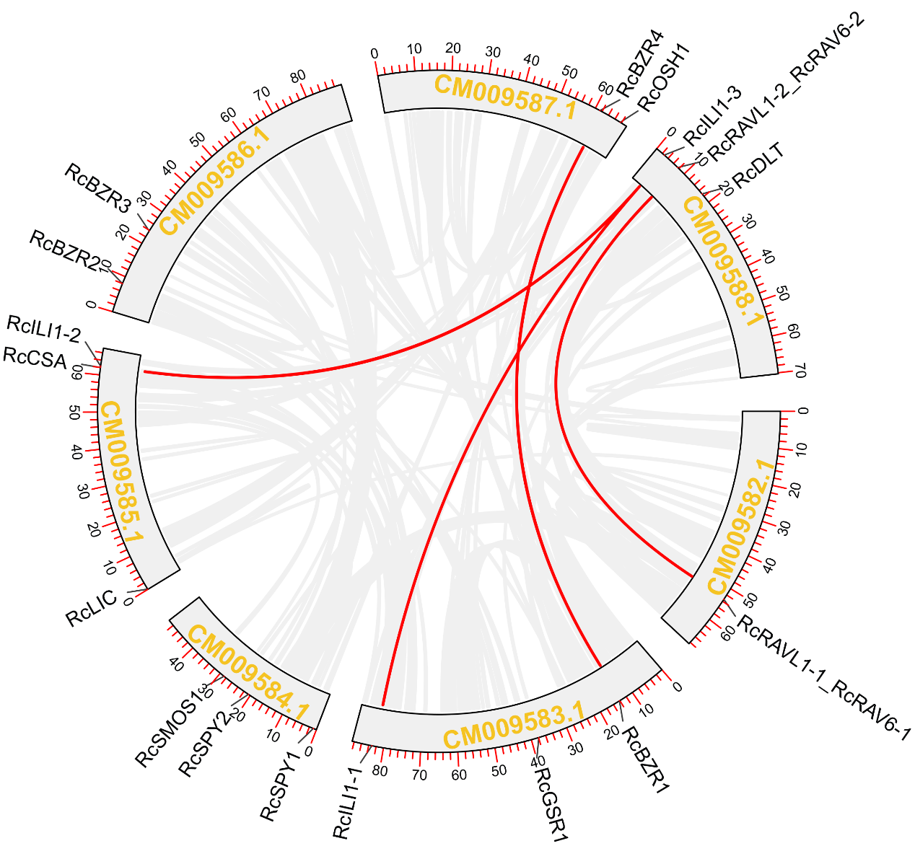

Supplemental Figure 3-9 Synteny analysis of BR downstream genes in Prunus mume
