Supplemental Figure 2 Transmembrane topology analysis of BR downstream proteins
The red peaks indicate the predicted transmembrane helice.
Supplemental Figure 2-1 Transmembrane topology analysis of BZRs proteins

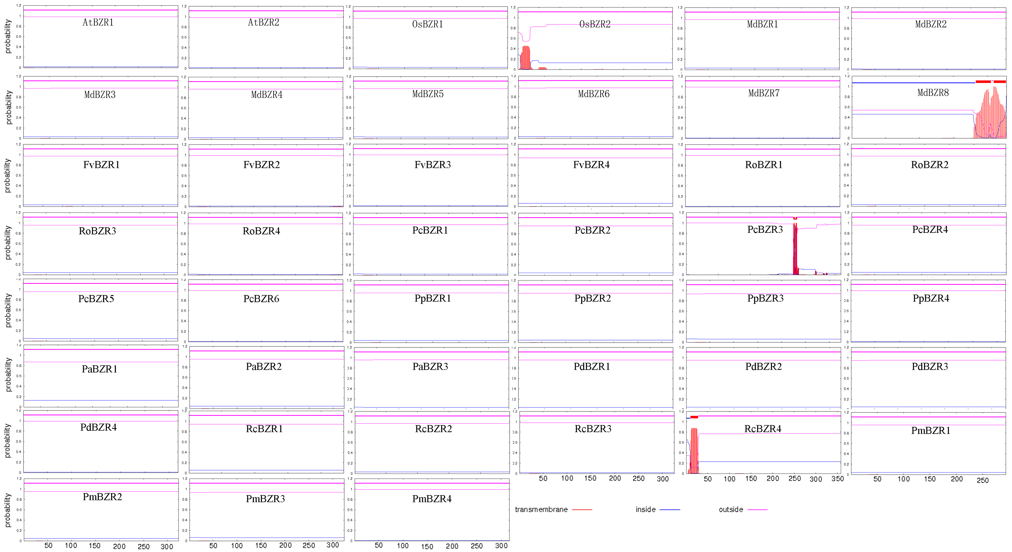
Supplemental Figure 2-2 Transmembrane topology analysis of DLT proteins
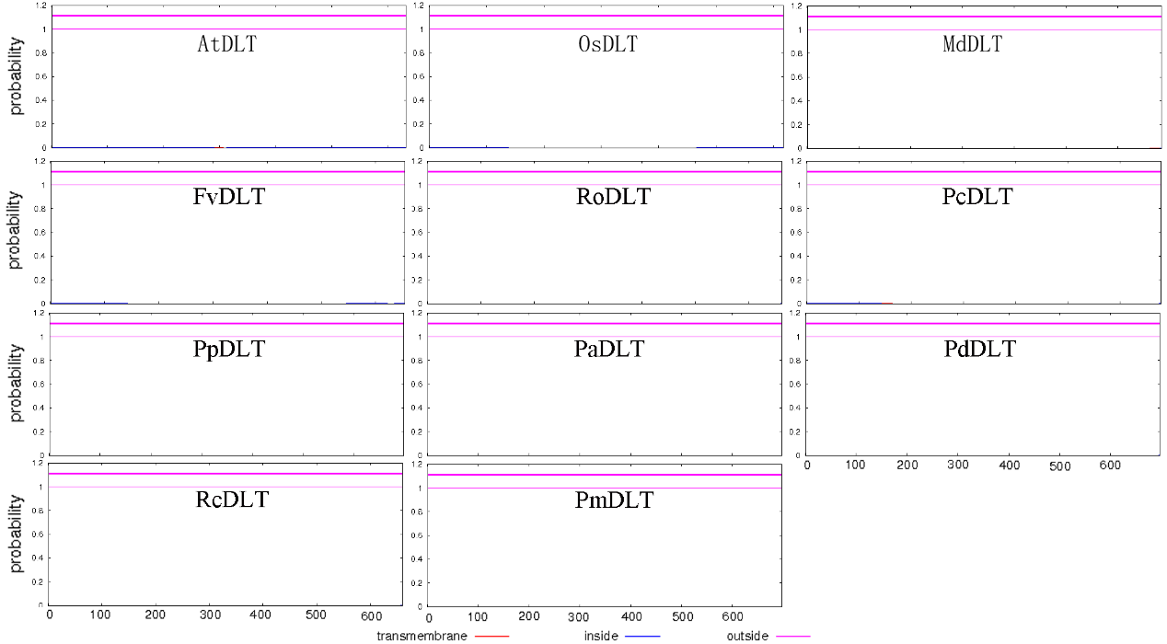
Supplemental Figure 2-3 Transmembrane topology analysis of LIC proteins
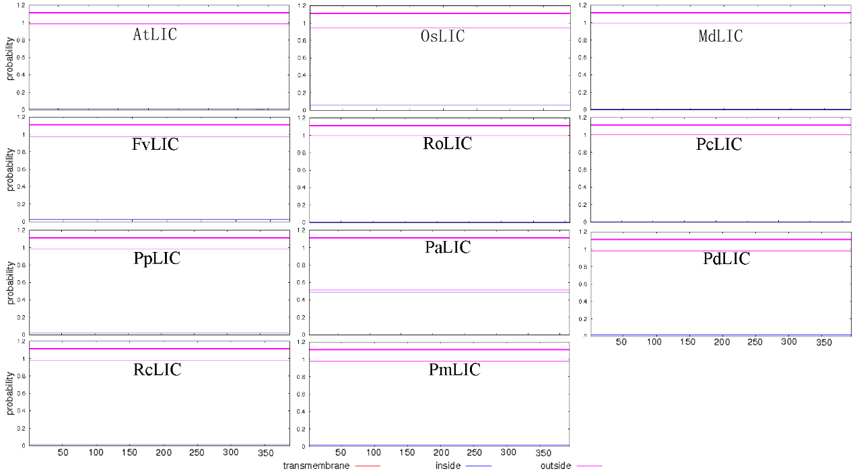
Supplemental Figure 2-4 Transmembrane topology analysis of ILI1 proteins
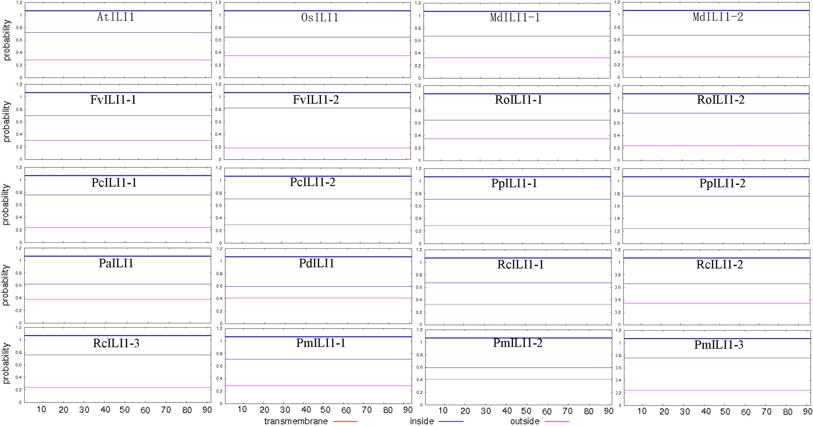
Supplemental Figure 2-5 Transmembrane topology analysis of OSH1 proteins
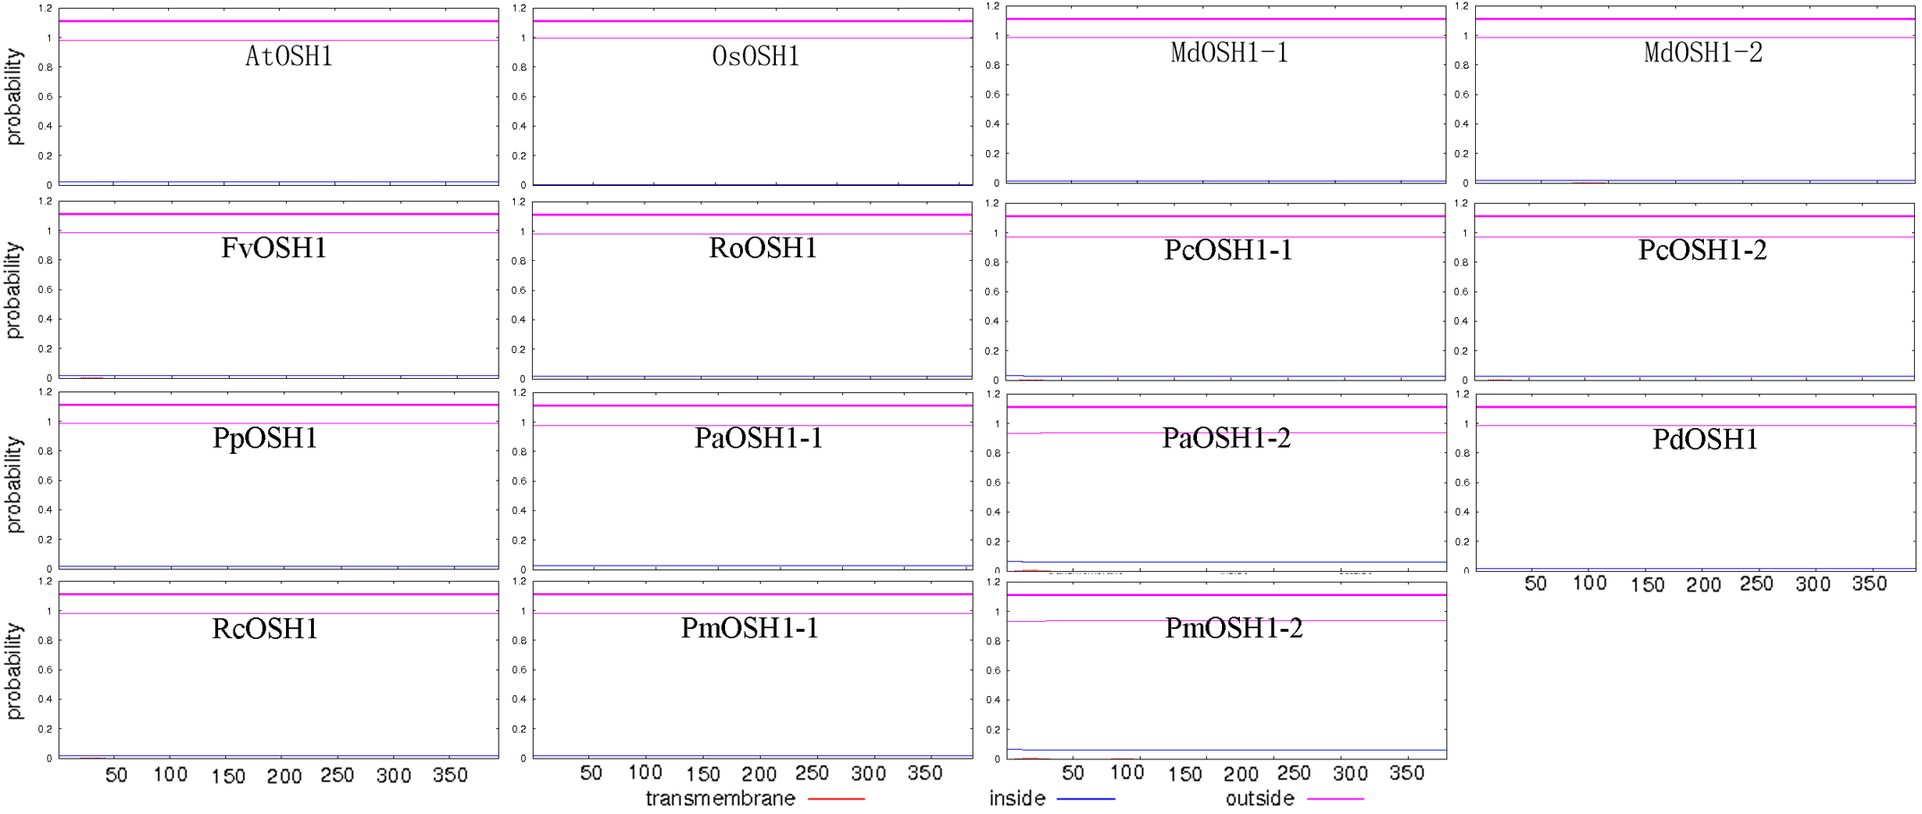
Supplemental Figure 2-6 Transmembrane topology analysis of RAVL1/RAV6 proteins
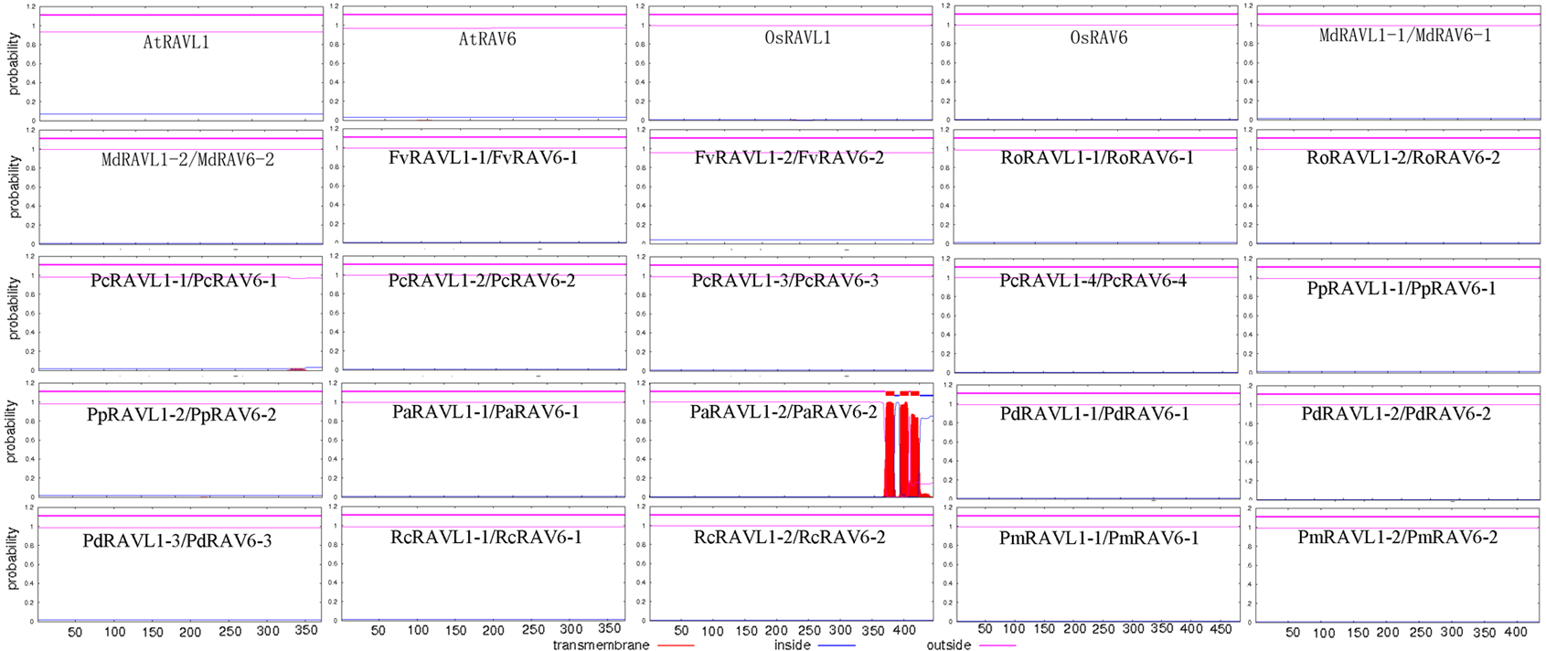
Supplemental Figure 2-7 Transmembrane topology analysis of SMOS1 proteins
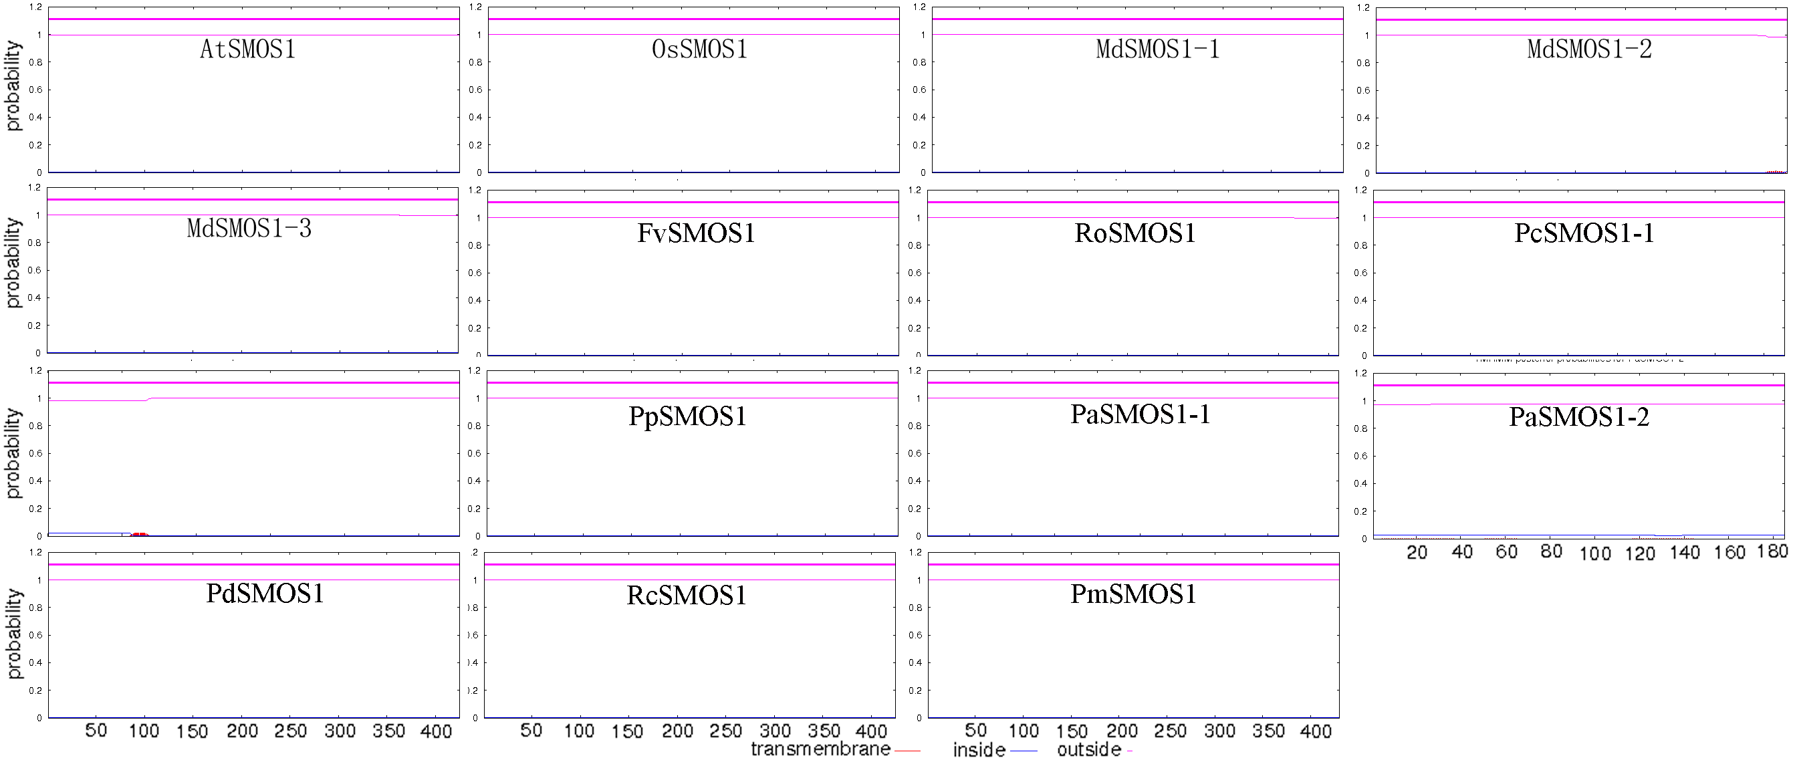
Supplemental Figure 2-8 Transmembrane topology analysis of CSA proteins
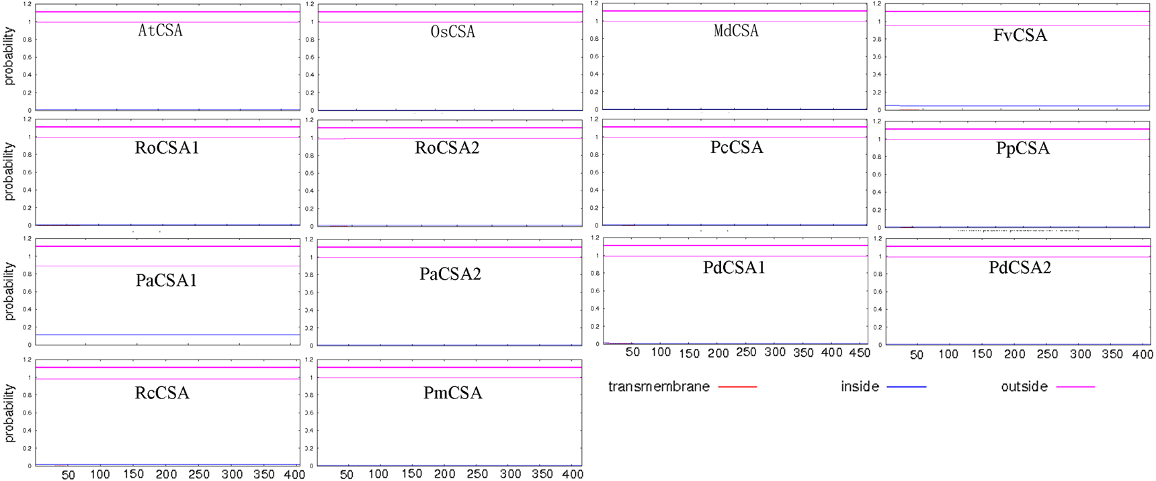
Supplemental Figure 2-9 Transmembrane topology analysis of SPY proteins
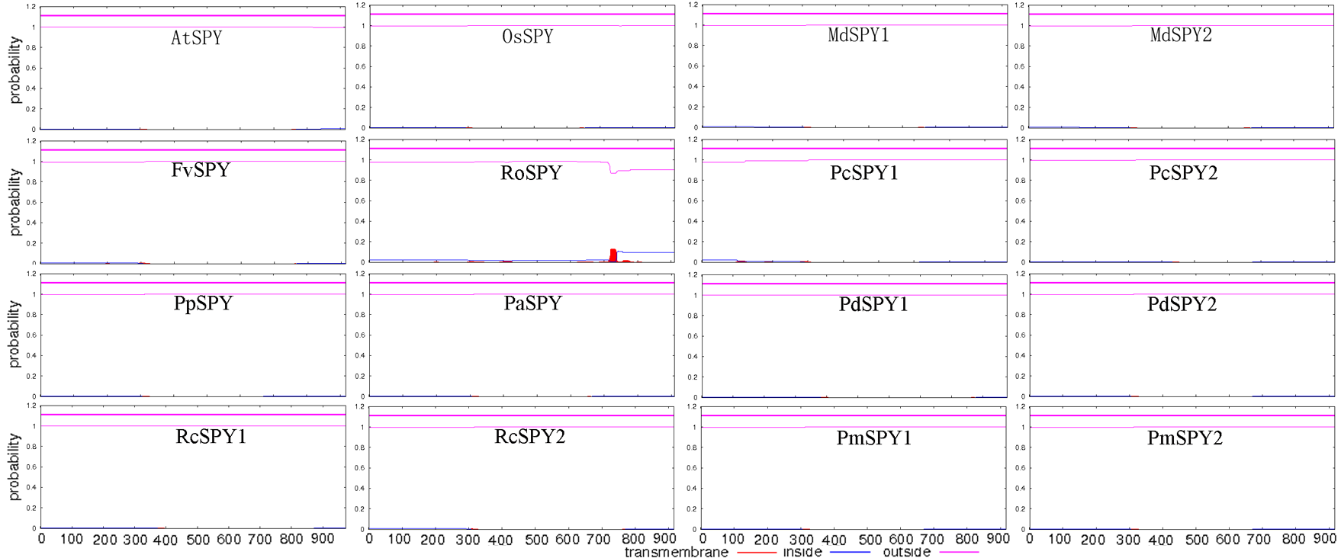
Supplemental Figure 2-10 Transmembrane topology analysis of GSR1 proteins
