Supplementary material to
“Psychophysiological benefits of real-time heart rate feedback in physical education”
Stöckel, Tino & Grimm, Robert

S1. Student self-report on anticipation to run (before running)
S2. Student self-report on joy of running (after running)
S3. Student self-report on perceived exertion (after running)

S1. Anticipation to run: Before any running the student were asked to self-report whether they are looking forward to the upcoming 30 minute run. The students were handed a piece of paper with the following information and question on it, and were asked to make a cross underneath the respective smiley that best represented their current anticipation to run on an individual basis.

Name: ____________________________
Sensor number: ____
Date and time: ____________________ ____________________
Class: ____

Please report whether you agree with the following: I AM LOOKING FORWARD TO RUN TODAY!
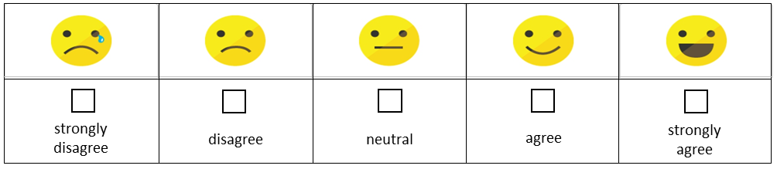

S2. Joy of running: Directly after the 30 minute run, the student were asked to self-report whether they enjoyed the 30 minute run. Again the students were handed a new piece of paper with the following information and question on it, and were asked to make a cross underneath the respective smiley that best represented their enjoyment during running on an individual basis.

Name: ____________________________
Sensor number: ____
Date and time: ____________________ ____________________
Class: ____

Please report whether you agree with the following: I ENJOYED RUNNING TODAY!
S3. Rating of Perceived Exertion (Borg RPE scale): Directly after the 30 minute run and together with reporting the joy of running, the student were asked to self-report how exhausted they felt during the 30 minute run. On an individual basis, they had to make a cross at the description that best matched their level of exertion during running.

Please report your level of exertion during the 30 minute run – how hard you had to push yourself?
Make a cross at the respective number/description!

Name: ____________________________
Sensor number: ____
cross | Borg Scale
 | 6 No exertion
 | 7 Extremely light
 | 8
 | 9 Very light
 | 10
 | 11 Light
 | 12
 | 13 Somewhat hard
 | 14
 | 15 Hard
 | 16
 | 17 Very hard
 | 18
 | 19 Extremely hard
 | 20 Maximal exertion

