Appendix

Table A1 (partial). Feeling thermometer by perceived personality trait
 | Candidate vignette:  Extraversion |  |  | Candidate vignette:  Agreeableness |  |  | Candidate vignette:  Conscientiousness |  |  | Candidate vignette:  Emotional stability
 | M1 |  |  | M2 |  |  | M3 |  |  | M4
 | Coef. | Se | sig | Coef. | Se | sig | Coef. | Se | sig | Coef. | Se | sig
Perceived Extraversion | -0.36 | (1.08)
Perceived Agreeableness |  |  |  | 5.06 | (0.91) | ***
Perceived Conscientiousness |  |  |  |  |  |  | 3.35 | (1.07) | **
Perceived Emotional stability |  |  |  |  |  |  |  |  |  | 3.74 | (1.11) | ***
Constant | 67.07 | (6.66) | *** | 44.06 | (5.19) | *** | 47.70 | (6.57) | *** | 49.88 | (6.82) | ***
Observations | 249 |  |  | 250 |  |  | 234 |  |  | 245
R-squared | 0.00 |  |  | 0.11 |  |  | 0.04 |  |  | 0.04
In all models the dependent variable is the feeling thermometer for the fictive candidate, and ranges between 0 “very cold” and 100 “very warm” feelings towards him.
*** p<0.001, ** p<0.01, * p<0.05, † p<0.1

Table A1 (continued). Feeling thermometer by perceived personality trait
 | Candidate vignette:  Openness |  |  | Candidate vignette:  Narcissism |  |  | Candidate vignette:  Psychopathy |  |  | Candidate vignette:  Machiavellianism
 | M5 |  |  | M6 |  |  | M7 |  |  | M8
 | Coef. | Se | sig | Coef. | Se | sig | Coef. | Se | sig | Coef. | Se | sig
Perceived Openness | 4.90 | (1.02) | ***
Perceived Narcissism |  |  |  | -13.50 | (1.43) | ***
Perceived Psychopathy |  |  |  |  |  |  | -9.62 | (1.18) | ***
Perceived Machiavellianism |  |  |  |  |  |  |  |  |  | -11.74 | (1.30) | ***
Constant | 38.25 | (5.41) | *** | 124.87 | (8.60) | *** | 93.70 | (6.31) | *** | 105.14 | (7.69) | ***
Observations | 251 |  |  | 247 |  |  | 247 |  |  | 248
R-squared | 0.09 |  |  | 0.27 |  |  | 0.21 |  |  | 0.25
In all models the dependent variable is the feeling thermometer for the fictive candidate, and ranges between 0 “very cold” and 100 “very warm” feelings towards him.
*** p<0.001, ** p<0.01, * p<0.05, † p<0.1

Table A2 (partial). Feeling thermometer by perceived personality trait * strength of partisanship
 | Candidate vignette:  Extraversion |  |  | Candidate vignette:  Agreeableness |  |  | Candidate vignette:  Conscientiousness |  |  |  | Candidate vignette:  Emotional stability
 | M1 |  |  | M2 |  |  | M3 |  |  | M4
 | Coef. | Se | sig | Coef. | Se | sig | Coef. | Se | sig | Coef. |  | Se | sig
Strength of partisanship (SP) ª | 24.19 | (18.84) |  | 33.82 | (9.83) | *** | 0.96 | (16.21) |  | 45.85 |  | (14.79) | **
Perceived Extraversion (E) | 2.40 | (2.67)
SP * E | -3.44 | (2.97)
Perceived Agreeableness (A) |  |  |  | 7.60 | (1.40) | ***
SP * A |  |  |  | -5.08 | (1.76) | **
Perceived Conscient. (C) |  |  |  |  |  |  | 3.18 | (2.11)
SP * C |  |  |  |  |  |  | 0.23 | (2.63)
Perceived Emotional stab. (Es) |  |  |  |  |  |  |  |  |  | 6.18 |  | (1.92) | **
SP * Es |  |  |  |  |  |  |  |  |  | -6.66 |  | (2.42) | **
Constant | 50.54 | (17.23) | ** | 29.68 | (7.77) | *** | 47.45 | (13.25) | *** | 33.03 |  | (11.75) | **
Observations | 176 |  |  | 172 |  |  | 168 |  |  | 179
R-squared | 0.01 |  |  | 0.21 |  |  | 0.04 |  |  | 0.08
In all models the dependent variable is the feeling thermometer for the fictive candidate, and ranges between 0 “very cold” and 100 “very warm” feelings towards him.
ª Binary variable (0 “Weak party attachment”, 1 “Strong party attachment”).
*** p<0.001, ** p<0.01, * p<0.05, † p<0.1

Table A2 (continued). Feeling thermometer by perceived personality trait * strength of partisanship
 | Candidate vignette:  Openness |  |  | Candidate vignette:  Narcissism |  |  | Candidate vignette:  Psychopathy |  |  | Candidate vignette:  Machiavellianism
 | M5 |  |  | M6 |  |  | M7 |  |  | M8
 | Coef. | Se | sig | Coef. | Se | sig | Coef. | Se | sig | Coef. | Se | sig
Strength of partisanship (SP) ª | -1.85 | (13.36) |  | 27.58 | (20.69) |  | -14.35 | (14.74) |  | 28.27 | (17.66)
Perceived Openness (O) | 3.46 | (1.88) | †
SP * O | -0.37 | (2.48)
Perceived Narcissism (N) |  |  |  | -10.30 | (2.85) | ***
SP * N |  |  |  | -4.20 | (3.52)
Perceived Psychopathy (P) |  |  |  |  |  |  | -12.37 | (2.16) | ***
SP * P |  |  |  |  |  |  | 4.71 | (2.78) | †
Perceived Machiav. (M) |  |  |  |  |  |  |  |  |  | -10.49 | (1.98) | ***
SP * M |  |  |  |  |  |  |  |  |  | -3.51 | (2.98)
Constant | 49.12 | (10.31) | *** | 105.32 | (16.67) | *** | 104.47 | (11.29) | *** | 94.75 | (11.53) | ***
Observations | 188 |  |  | 182 |  |  | 188 |  |  | 183
R-squared | 0.05 |  |  | 0.26 |  |  | 0.24 |  |  | 0.28
In all models the dependent variable is the feeling thermometer for the fictive candidate, and ranges between 0 “very cold” and 100 “very warm” feelings towards him.
ª Binary variable (0 “Weak party attachment”, 1 “Strong party attachment”).
*** p<0.001, ** p<0.01, * p<0.05, † p<0.1

Figure A1. Perceived personality traits of the fictive candidate by exposure to vignettes
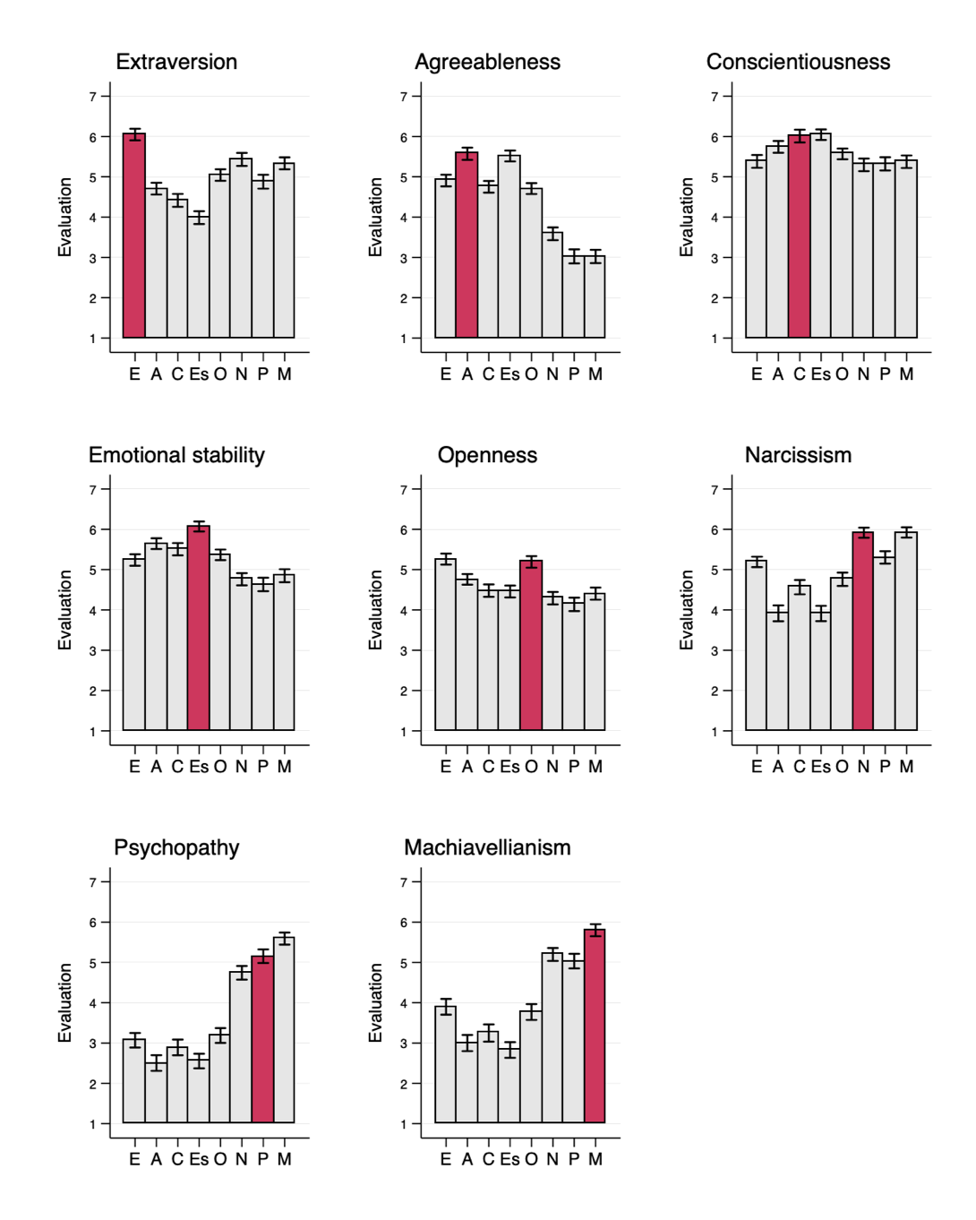
Note. In all panels, bars represent the “personality vignette” that respondents were randomly exposed to. In all panels, the y-axis represents the score that respondents assigned to the fictive candidate on the trait represented in the panel. Thus, for instance, the top-left panel presents the average score on extraversion that respondents have assigned to the fictive candidate, for each of the eight “personality vignettes” they were randomly exposed to.
Big Five: E ‘Extraversion’, A ‘Agreeableness’, C ‘Conscientiousness’, Es ‘Emotional Stability’, O 'Openness’
Dark Triad: N ‘Narcissism’, P ‘Psychopathy’, M ‘Machiavellianism’

