Appendix A
Table A1: Definition of symbols
Chl-a | Chlorophyll-a
PC | Phycocyanin
PC:chl-a | PC to chl-a ratio
C_{chl} | Chlorophyll-a concentration (mg/m³)
C_{pc} | Phycocyanin concentration (mg/m³)
NAP | Nonalgal particles
R_{rs} | Remote sensing reflectance
C_{nap} | Nonalgal particles concentration (mg/m³)
SIOPs | Specific inherent optical properties
$$S_{f}$$ | Admixture weighting factor
$$S_{ad}$$ | Scaled admixture parameter
a*_{phy} (λ) | Spectral specific absorption of phytoplankton (m²/g)
$$L_{f}\left(685\right)$$ | Amplitude of fluorescence peak at 685 nm (Wm⁻²sr⁻¹μm⁻¹)
$$∅_{f}$$ | Fluorescence quantum yield
$$C_{f}$$ | Coefficient for assumed fluorescence shape
$$Q_{a}^{*}$$ | Algal reabsorption coefficient
$$E_{o}^{-}(λ)$$ | Downwelling irradiance just below the surface (μmol phot/m²s)
$$K\left(λ\right)$$ | Attenuation coefficient in fluorescence excitation zone
$$K_{Lu}\left(λ\right)$$ | Upwelling attenuation coefficient
$$C_{tot}\left(λ\right)$$ | Total attenuation at 685 nm (m⁻¹)
$$a_{pc}\left(λ\right)$$ | Absorption due to PC (m⁻¹)
$$a_{pc}^{*}\left(λ\right)$$ | Specific absorption of PC (m²/g)
$$a_{Chla}\left(λ\right)$$ | Absorption due to chl-a (m⁻¹)
$$a_{Chla}^{*}\left(λ\right)$$ | Specific absorption of chl-a (m²/g)
$$a_{Chlb}\left(λ\right)$$ | Absorption due to chl-b
$$a_{Chlb}^{*}\left(λ\right)$$ | Specific absorption of chl-b (m²/g)
$$a_{Chlc}\left(λ\right)$$ | Absorption due to chl-c
$$a_{Chlc}^{*}\left(λ\right)$$ | Specific absorption of chl-c (m²/g)
$$a_{phy-cy}\left(λ\right)$$ | Absorption due to phytoplankton from cyanobacteria component (m⁻¹)
$$a\left(λ\right)$$ | Total spectral absorption coefficient (m⁻¹)
$$a_{w}\left(λ\right)$$ | Water absorption spectrum (m⁻¹)
$$a_{g}\left(λ\right)$$ | CDOM spectral absorption (m⁻¹)
$$a_{phy}\left(λ\right)$$ | Phytoplankton spectral absorption (m⁻¹)
$$a_{nap}\left(λ\right)$$ | Nonalgal particle spectral absorption (m⁻¹)
$$a_{g}\left(440\right)$$ | CDOM absorption at 440 nm (m⁻¹)
$$S_{g}$$ | CDOM spectral slope
$$S_{nap}$$ | Nonalgal particle spectral slope
$$a_{nap}\left(440\right)$$ | Nonalgal particle absorption at 440 nm (m⁻¹)
$a_{nap}^{*}$(440) | Specific absorption of nonalgal particles at 440 nm (m²/g)
$$a_{cy}^{*}(λ)$$ | Spectral specific absorption of cyanobacteria (m²/g)
$$a_{euk}^{*}(λ)$$ | Spectral specific absorption of eukaryotes (m²/g)
$$b\left(λ\right)$$ | Total spectral scattering coefficient (m⁻¹)
$$b_{w}(λ)$$ | Water scattering spectrum (m⁻¹)
$$b_{phy}(λ)$$ | Phytoplankton scattering spectrum (m⁻¹)
$$b_{nap}(λ)$$ | Nonalgal particle scattering spectrum (m⁻¹)
$$b_{nap}(550)$$ | Nonalgal scattering at 550 nm (m⁻¹)
$$γ_{2}$$ | Nonalgal exponent parameter
$b_{nap}^{*}$(440) | Specific scattering of nonalgal particles at 440 nm (m²/g)
$$b_{cy}^{*}(λ)$$ | Spectral scattering of cyanobacteria (m²/g)
$$b_{euk}^{*}(λ)$$ | Spectral scattering of eukaryotes (m²/g)
$$b_{b}\left(λ\right)$$ | Total spectral backscattering (m⁻¹)
$$b_{bw}(λ)$$ | Water backscattering spectrum (m⁻¹)
$$b_{bphy}(λ)$$ | Phytoplankton backscattering spectrum (m⁻¹)
$$b_{bnap}^{˜}$$ | Backscattering ratio for nonalgal particles
$$b_{bcy}^{*}(λ)$$ | Spectral backscattering of cyanobacteria (m²/g)
$$b_{beuk}^{*}(λ)$$ | Spectral backscattering of eukaryotes (m²/g)

Table A2: List of equations and relationships used for bio-optical modeling
Absorption | Parameters
$$a\left(λ\right)=a_{w}\left(λ\right)+a_{g}\left(λ\right)+a_{phy}\left(λ\right)+a_{nap}\left(λ\right)$$
$$a_{g}\left(λ\right)={a_{g}\left(440\right)}^{(-S_{g}\left(λ-440\right))}$$ | S_{g} = 0.012 – 0.021
$$a_{nap}\left(λ\right)={a_{nap}\left(440\right)}^{(-S_{nap}\left(λ-440\right))}$$ | S_{nap} = 0.007 – 0.015
$$a_{nap}\left(440\right)=C_{nap}* a_{nap}^{*}(440)$$ | $a_{nap}^{*}$ = 0.02 – 0.3 m²/g
$$a_{phy}\left(λ\right)=\left({\left[Chl\right]* a}_{cy}^{*}(λ)* S_{f}\right)+([Chl]*a_{euk}^{*}(λ)*(1-S_{f}))$$ | S_{f} = [0.1,0.2,0.3…1.0]
Scattering
$$b\left(λ\right)= b_{w}(λ)+b_{phy}(λ)+b_{nap}(λ)$$
$$b_{nap}\left(λ\right)=b_{nap}(550){({550}/λ)}^{γ_{2}}$$ | $γ_{2}=$ 0.5 – 2.0
$$b_{nap}\left(550\right)=C_{nap}* b_{nap}^{*}(440)$$ | $b_{nap}^{*}$ = 0.5 – 1.0 m²/g
$$b_{phy}\left(λ\right)=\left({\left[Chl\right]* b}_{cy}^{*}(λ)* S_{f}\right)+([Chl]*b_{euk}^{*}(λ)*(1-S_{f}))$$ | S_{f} = [0.1,0.2,0.3…1.0]
Backscattering
$$b_{b}\left(λ\right)= b_{bw}(λ)+b_{bphy}(λ)+(b_{bnap}^{˜}* b_{nap}\left(λ\right))$$ | $b_{bnap}^{˜}=$ 0.02
$$b_{bphy}\left(λ\right)=\left({\left[Chl\right]* b}_{bcy}^{*}(λ)* S_{f}\right)+([Chl]*b_{beuk}^{*}(λ)*(1-S_{f}))$$ | S_{f} = [0.1,0.2,0.3…1.0]

Table A3: Mode and standard deviation for log-normal distribution of modeling parameters
Dataset | Chl-a |  | C_{nap} |  | a_{g} (440)
 | mode | st. dev | mode | st. dev | mode | st. dev
Case 1 | 1 | 5 | - | - | - | -
ISM | 3 | 300 | 50 | 200 | 0.7 | 1.2
CDOM | 10 | 40 | 1 | 4 | 5 | 10
Cyano | 5 | 1000 | 0.1 | 5 | 1 | 1

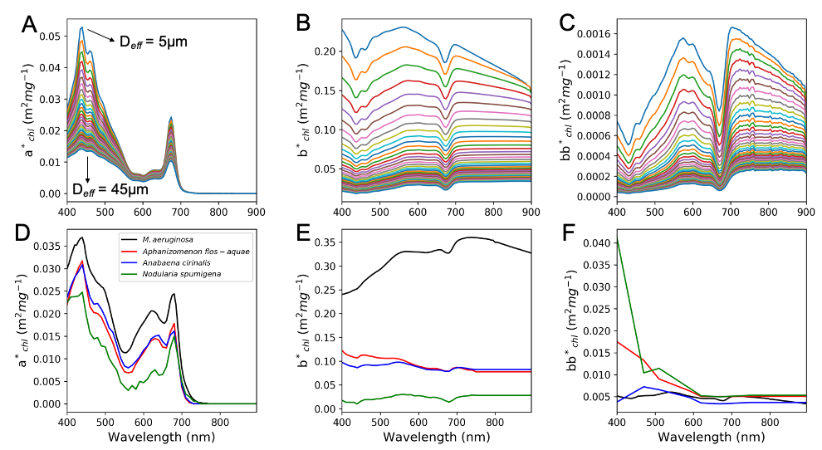
Figure A1: Phytoplankton SIOPs used in the RTM. A), B), C), are eukaryotic specific spectral absorption, scattering, and backscattering, respectively. Different colors indicate increasing effective diameter (D_{eff}) from top spectra to bottom spectra. D), E), F), are cyanobacteria specific spectral absorption, scattering, and backscattering, respectively. Eukaryotic and M. aeruginosa spectra were modeled from EAP 2-layer code, while Aphanizomenon, Anabaena, and Nodularia were taken from Kutser et al. (2006).

Appendix B

Appendix B.1 - Chl-a fluorescence modeling
To overcome the simplifications outlined in section 2.1.2, firstly, fluorescence amplitude is calculated at both 685 nm and 730 nm. Secondly, the integration of absorbed radiation over the visible spectrum is separated into a carotenoid containing eukaryotic component, in which 100% of the chl-a is assumed to be contained in PSII, and a cyanobacteria component, in which only 15% of chl-a is assumed to be contained in PSII (Eqs. B1 and B2). Given the increased attenuation of upwelling radiance in the presence of cyanobacteria due to elevated scattering relative to eukaryotic phytoplankton (Matthews and Bernard, 2013), total attenuation at both 685 nm and 730 nm (C_{tot} ($λ$)) is considered to more appropriately define loss of the upwelling fluorescence signal.
$L_{f}\left(685\right)=0.54L_{f}^{-}\left(685\right)=0.54\frac{1∅_{f}}{4πC_{f}}Q_{a}^{*}[Chl]\int_{400}^{700}{ \frac{{(a}_{Euk}^{*}(λ)(1-S_{f})E_{o}^{-}(λ))+ {(a}_{Cy}^{*}(λ)(S_{f})(0.15)E_{o}^{-}(λ))}{K\left(λ\right)+C_{tot}(685)}}dλ$ (B1)
$L_{f}\left(730\right)=0.54L_{f}^{-}\left(730\right)=0.54\frac{1∅_{f}}{4πC_{f}}Q_{a}^{*}[Chl]\int_{400}^{700}{ \frac{{(a}_{Euk}^{*}(λ)(1-S_{f})E_{o}^{-}(λ))+ {(a}_{Cy}^{*}(λ)(S_{f})(0.15)E_{o}^{-}(λ))}{K\left(λ\right)+C_{tot}(730)}}dλ$ (B2)
The actual spectral emission signal is then modeled as a double Gaussian function with the 730 nm peak modeled with a FWHM of 50 nm:
$L_{f}\left(λ\right)= L_{f}\left(685\right)exp⁡(-4\log\left(2\right)\left[\frac{\left(λ-685\right)}{25}\right])$ + $L_{f}\left(730\right)exp⁡(-4\log\left(2\right)\left[\frac{\left(λ-730\right)}{50}\right])$ (B3)
While variability in fluorescence amplitude for oligotrophic marine waters can mostly be attributed to high fluorescence quantum yield ($∅_{f}$) variability (Roesler and Perry, 1995; Fischer and Kronfeld 1990), variability in coastal and inland waters is largely due to stronger absorption from CDOM and NAP (Gilerson et al., 2007; 2008, Huot et al., 2013). Gilerson et al. (2008) proposed that variability of $∅_{f}$ for more turbid, productive waters is potentially much smaller than previously estimated, and suggested that an $∅_{f}$ of 1% is a good estimate for these waters and that an FQY of 2% would begin to produce unrealistic reflectances. For our dataset, FQY was varied between 0.005% and 1%, which should encompass natural variability for various light and pigment packaging conditions. (Gilerson et al., 2007; Gilerson et al., 2008; Babin et al., 1996; Behrenfeld et al., 2009). The reabsorption coefficient of algal cells ($Q_{a}^{*})$ was randomly chosen between 0.3 and 0.6 (Babin et al., 1996). Figure B1 shows the changes in red/NIR spectral peaks using the described modeling approaches for a C_{chl} of 10 mg/m³ with an FQY of 1% and similar contributions of non-algal constituents.
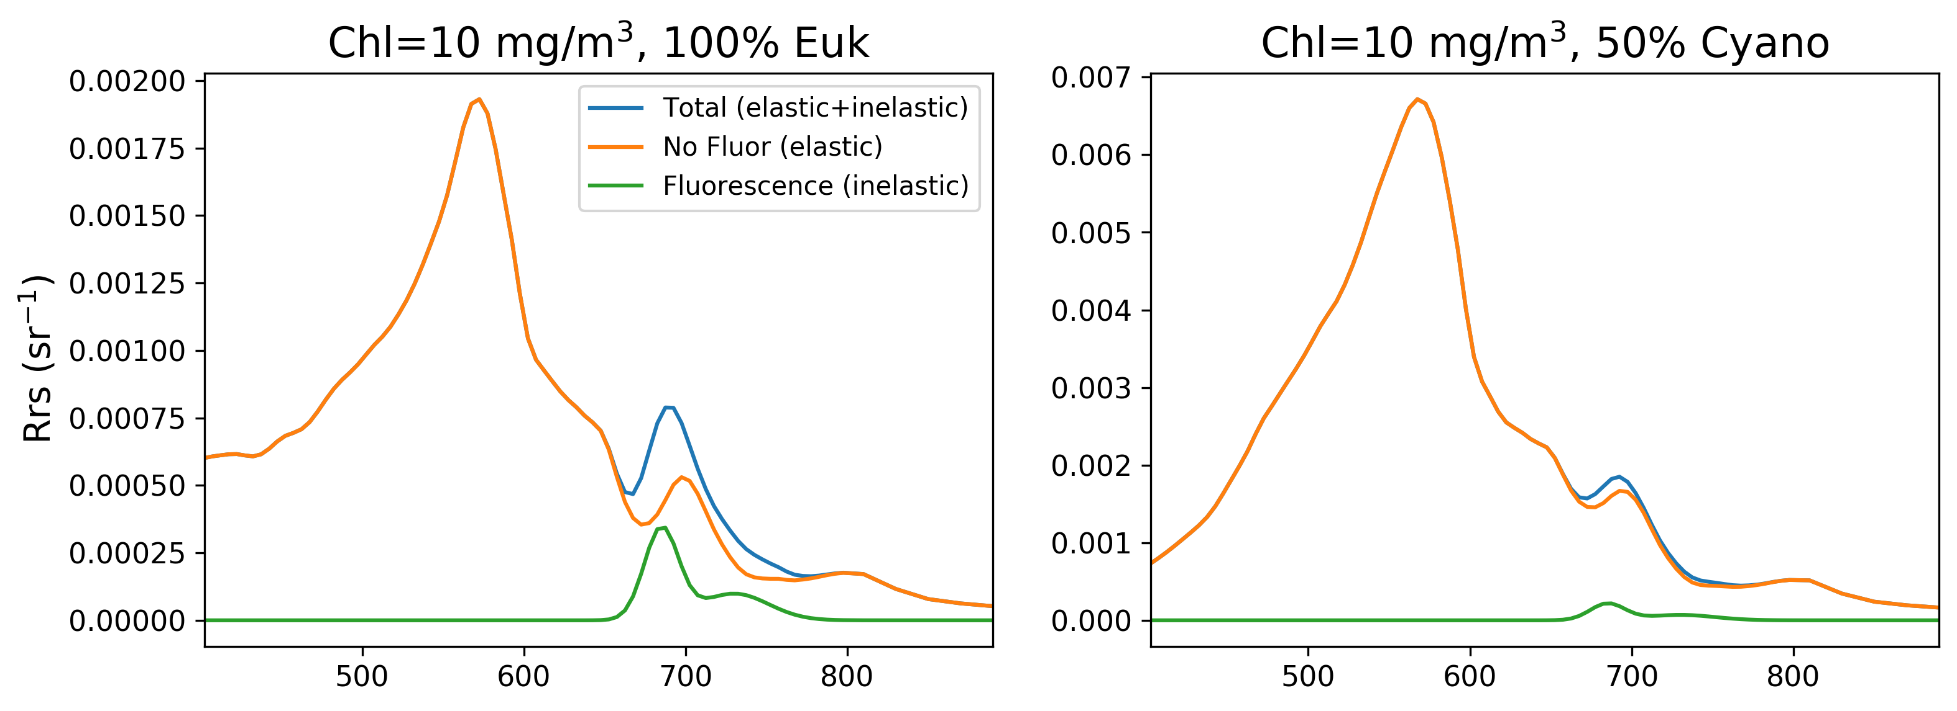
Figure B1: Red/NIR spectral changes with and without modeled fluorescence included for a 100% eukaryotic population and a 50/50 eukaryotic/cyanobacteria population.
To qualitatively validate our modeled fluorescence amplitudes, they were compared with previously validated simplified fluorescence equations for calculating fluorescence amplitudes in low non algal particle concentration (0 < C_{nap} < 1 mg/m³), medium concentration (1 < C_{nap} < 10 mg/m³), and high concentration (C_{nap} > 10 mg/m³) (Figure A2) (Gilerson et al. 2007, Gilerson et al., 2008; Mishra et al., Eds. 2017). The figure also depicts a 50/50 eukaryotic/cyanobacteria population and a 100% cyanobacteria population. The validated equations (black lines in Figure B2) are built assuming a 1% FQY and compared with the portion of our data equaling 1% FQY (colored dots), with lower FQYs plotted in the background (faded black dots). The close relationships for the 100% eukaryotic population give us confidence in our fluorescence calculations. The decrease in fluorescence amplitude with increasing cyanobacteria fraction is apparent for mixed assemblage waters.

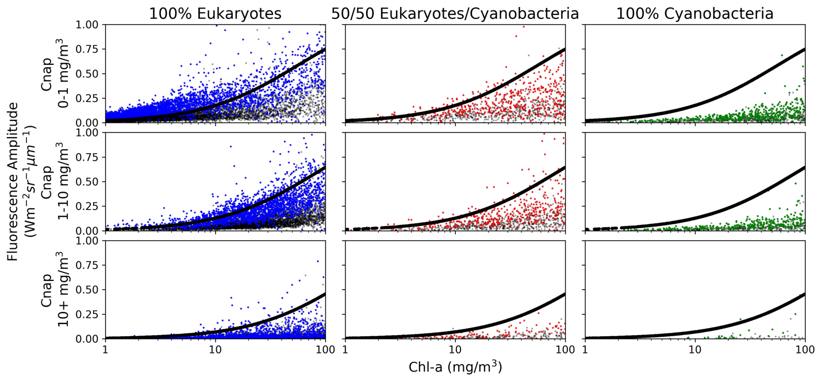
Figure B2: Fluorescence amplitude calculated in radiance units for synthetically derived spectra. Columns represent the different phytoplankton assemblages, while rows signify increasing NAP concentrations. Black lines are fluorescence amplitude calculated from simplified models defined in Gilerson et al. (2007) for varying C_{nap} ranges. The colored dots show spectra modeled with 1% FQY, while the faded black dots indicate FQY < 1%.

Appendix B.2 – PC modeling
Quantifying the amount of absorption solely due to PC at 620 nm requires removing the effect of all other optical constituents and pigments at 620 nm. This was completed following similar logic to Yacobi et al. (2015) to remove the absorption due to chl-a and its accessory pigments, chl-b and chl-c, using calculated pigment ratios (Yacobi et al., 2015) and calculated specific pigment absorption ratios (Bidigare et al. 1990).
$a_{chla}\left(620\right)= a_{cy}\left(675\right)$ * ${[a}_{chla}^{*}$(620)/ $a_{chla}^{*}$(675)] (B4)
$a_{chlb}\left(620\right)= {[a}_{cy}\left(620\right)-$ $a_{chla}\left(620\right)$] * [chl-b/chl-a] * ${[a}_{chlb}^{*}$(620)/ $a_{chla}^{*}$(620)] (B5)
$a_{chlc}\left(620\right)= {[a}_{cy}\left(620\right)-$ $a_{chla}\left(620\right)$] * [chl-c/chl-a] * ${[a}_{chlc}^{*}$(620)/ $a_{chla}^{*}$(620)] (B6)
Where $a_{cy}\left(λ\right)$ is the phytoplankton absorption from PC containing cyanobacteria. The [chl-b/chl-a] and [chl-c/chl-a] ratios used in equations B5 and B6 are 0.44 and 0.059, respectively, from median values calculated from cyanobacteria dominated waters by Yacobi et al. (2015). The ${[a}_{chla}^{*}$(620)/ $a_{chla}^{*}$(675)], ${[a}_{chlb}^{*}$(620)/ $a_{chla}^{*}$(620)], and ${[a}_{chlc}^{*}$(620)/ $a_{chla}^{*}$(620)] terms were calculated from measured unpackaged specific absorption values in Bidigare et al. (1990), resulting in values of 0.179, 0.64, and 1.14, respectively. The $a_{pc}$(620) term was then calculated as follows:
$a_{pc}$(620) = $a_{phy-cy}\left(620\right)$ – [$a_{chla}\left(620\right)+ a_{chlb}\left(620\right)+ a_{chlc}\left(620\right)]$ (B7)

Appendix C
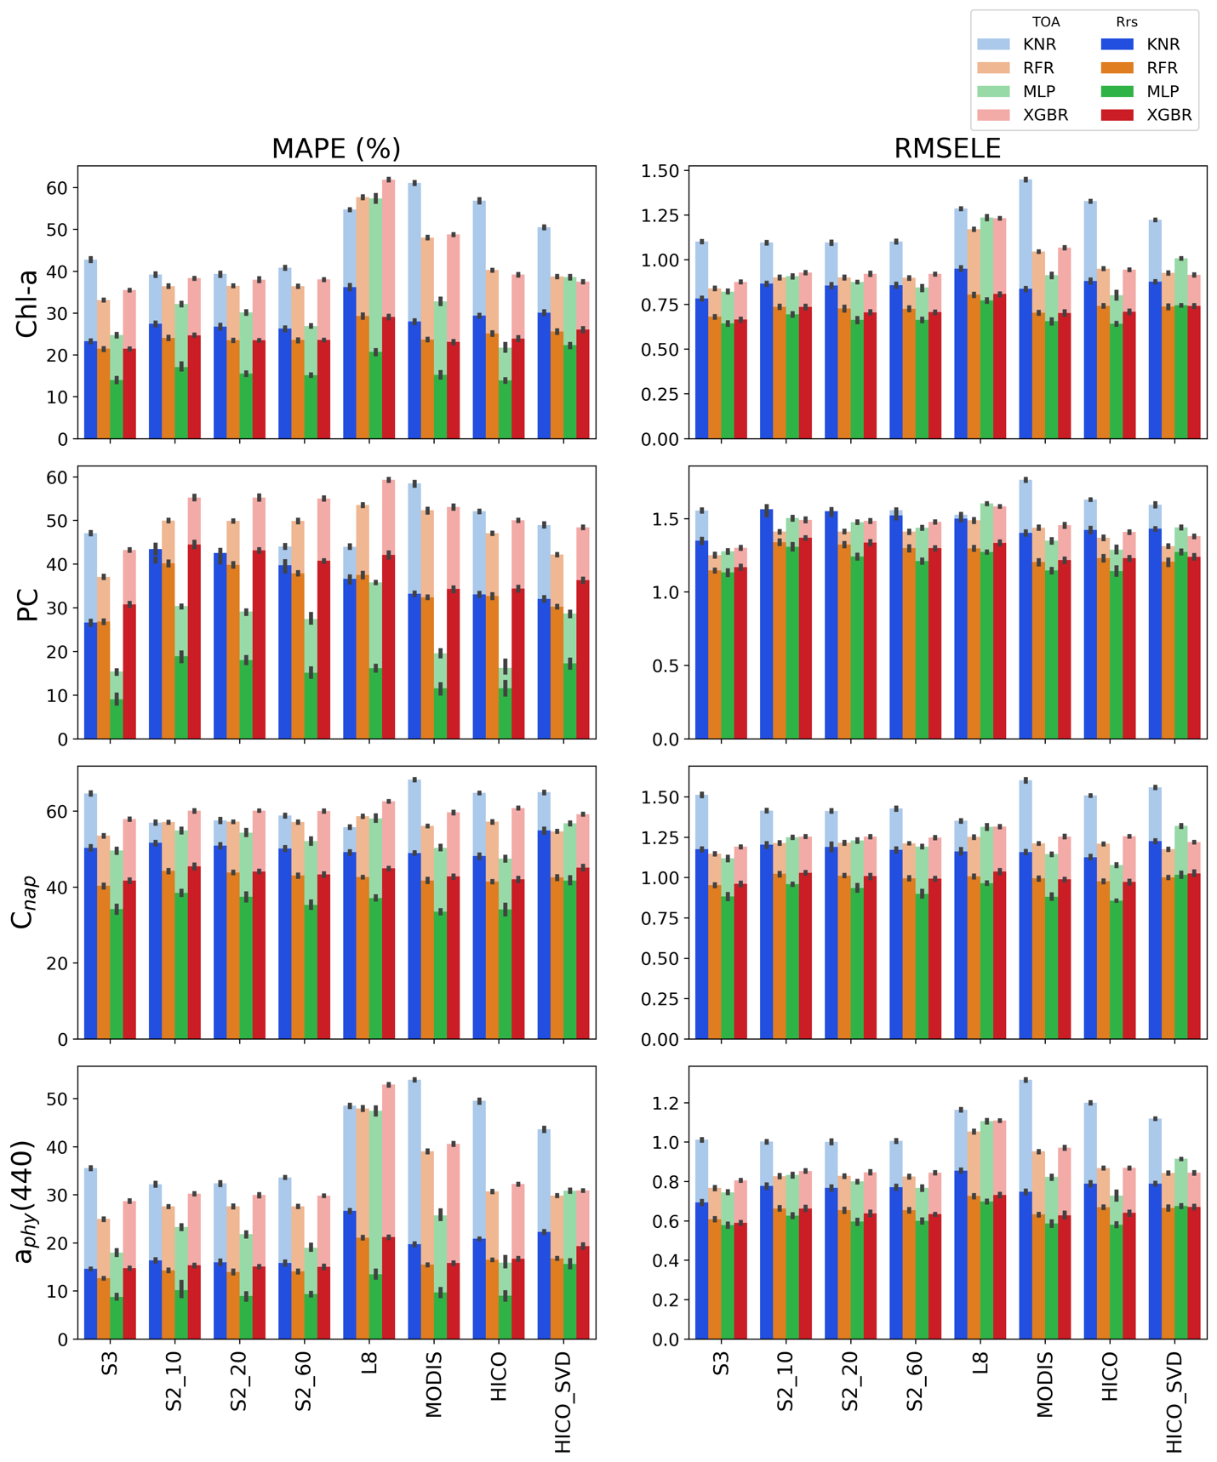
Figure C1: Overall model performance based on MAPE and RMSELE for each sensor configuration using both TOA reflectance and R_{rs}. Retrieval errors using R_{rs} are in solid, bright colors, while retrieval errors using TOA reflectance are stacked in corresponding opaque colors. A lower MAPE or RMSELE corresponds to better performance. Error bars represent the standard deviation for the five-fold cross validation. Additional statistics can be found in supplementary material.

