Supplementary Material

Supplementary Data
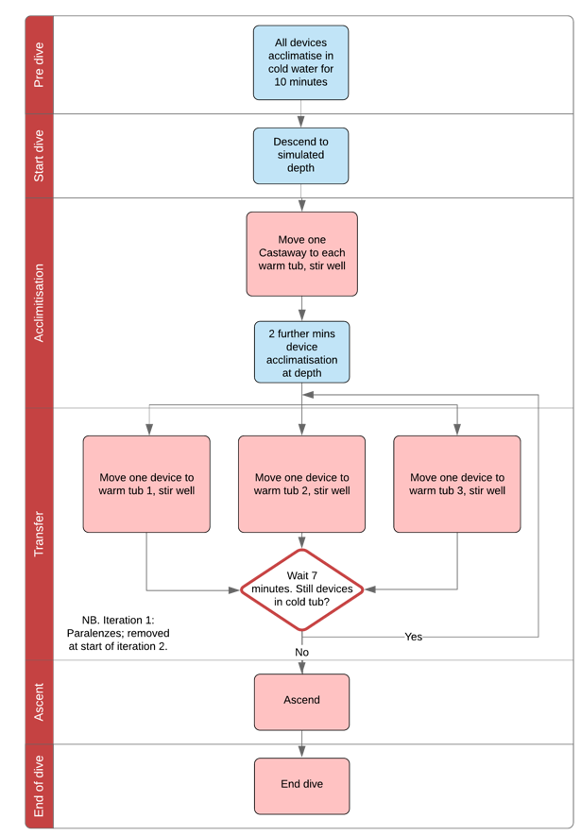
Fig 1: Schematic showing device movement in chamber dives for time constant.
Fig 2: Schematic showing device movement in chamber dives for accuracy.

Table 1: Device sizes and pressure sensor locations
Model | Front view | Pressure sensor location
Aqualung i750TC | 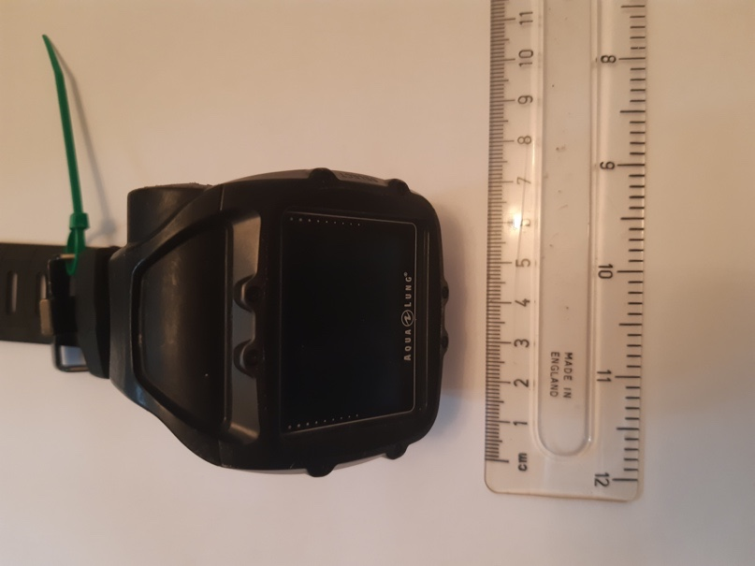 | 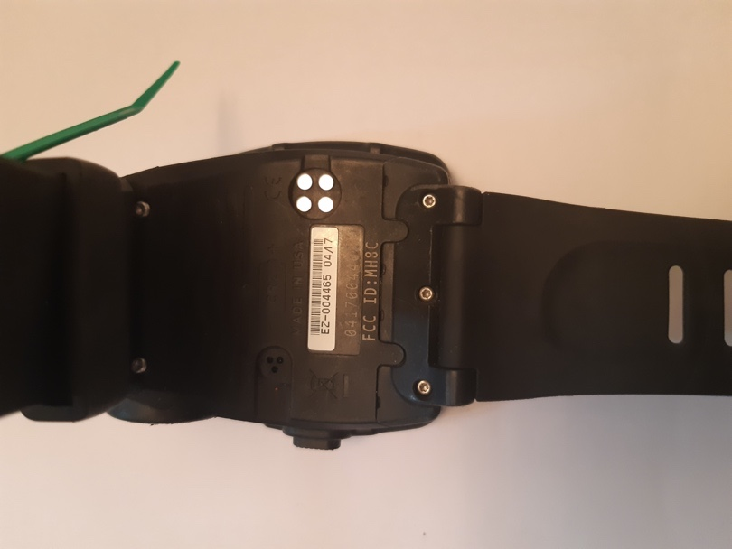
Garmin Descent Mk1 | 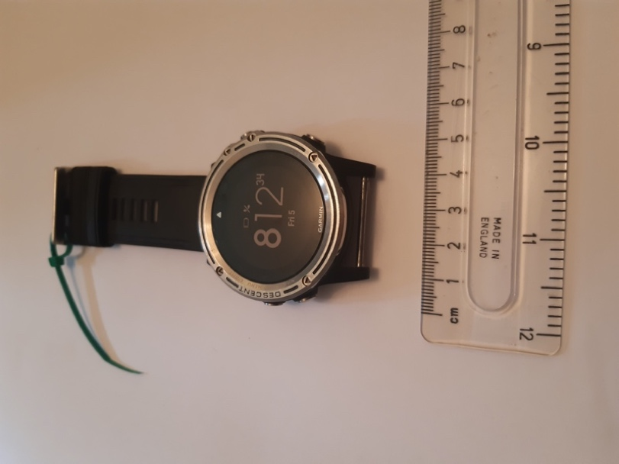 | 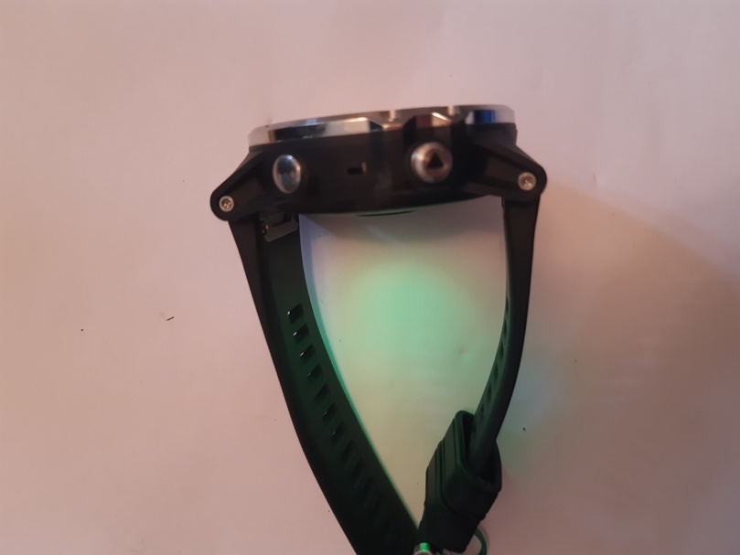
Mares Matrix | 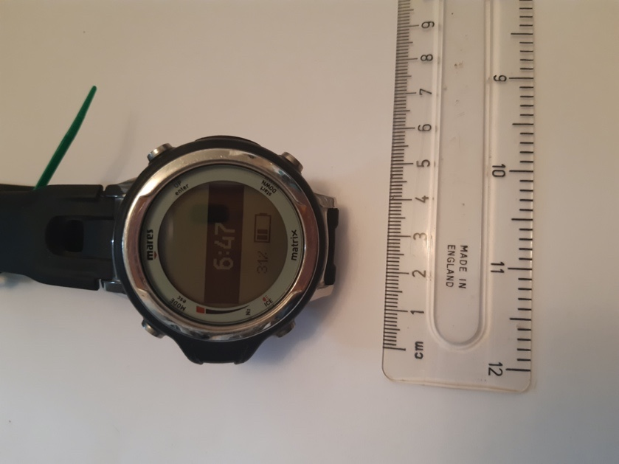 | 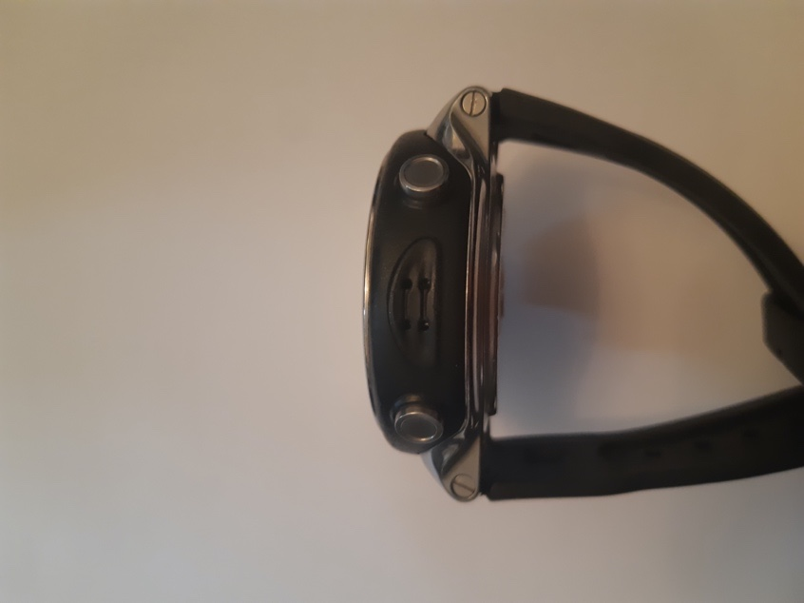
Mares Puck Pro | 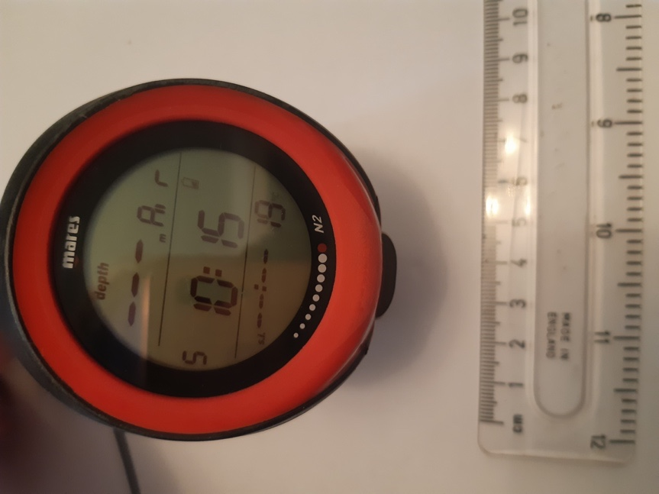 | 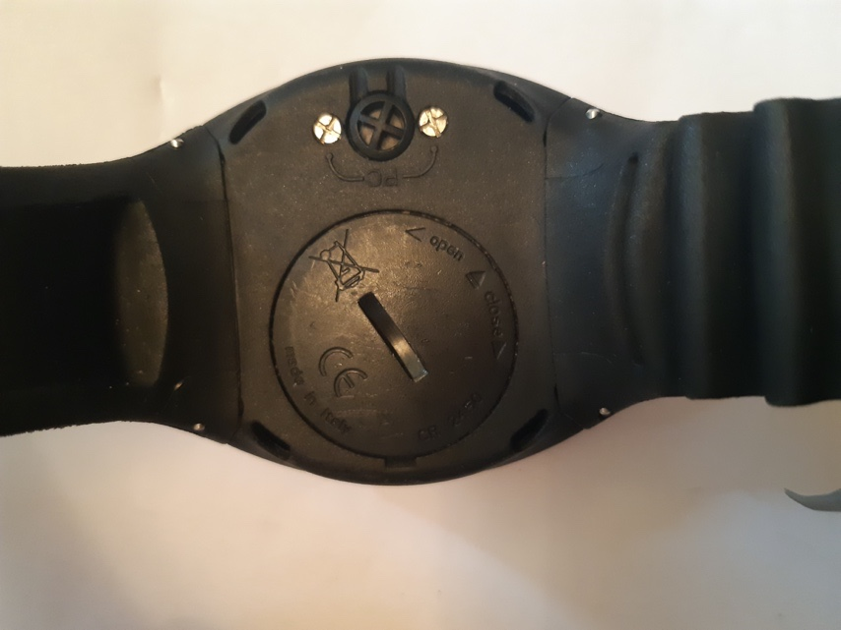
Paralenz Dive Camera+ | 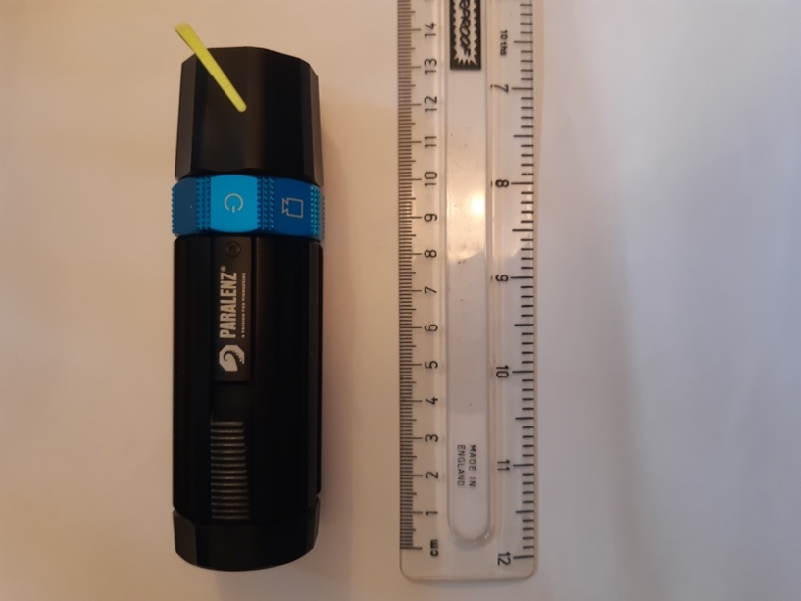 | Underneath pull switch
Ratio iX3M GPS Deep | 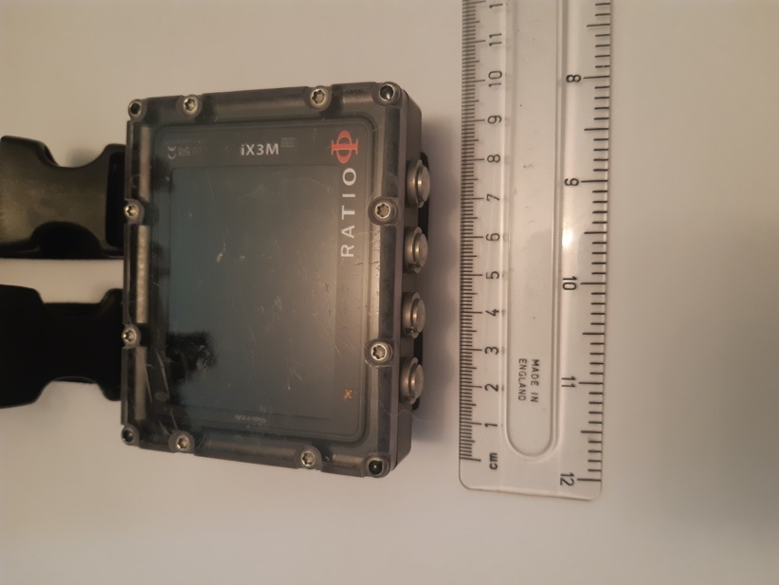 | 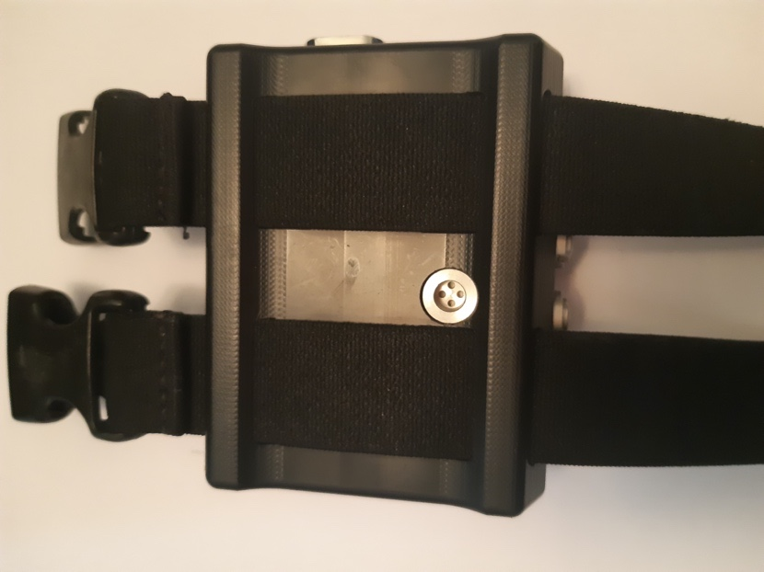
Scubapro G2 | 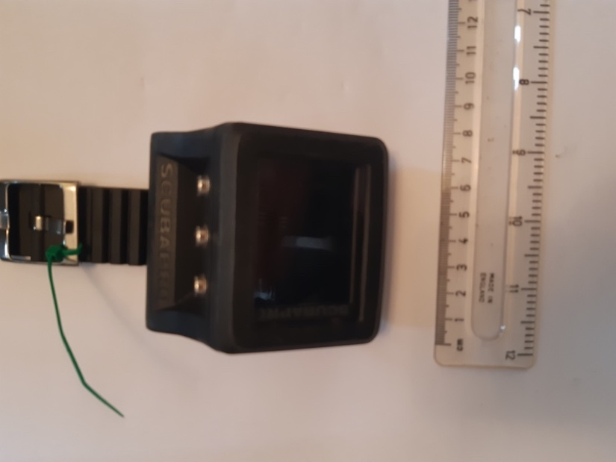 | 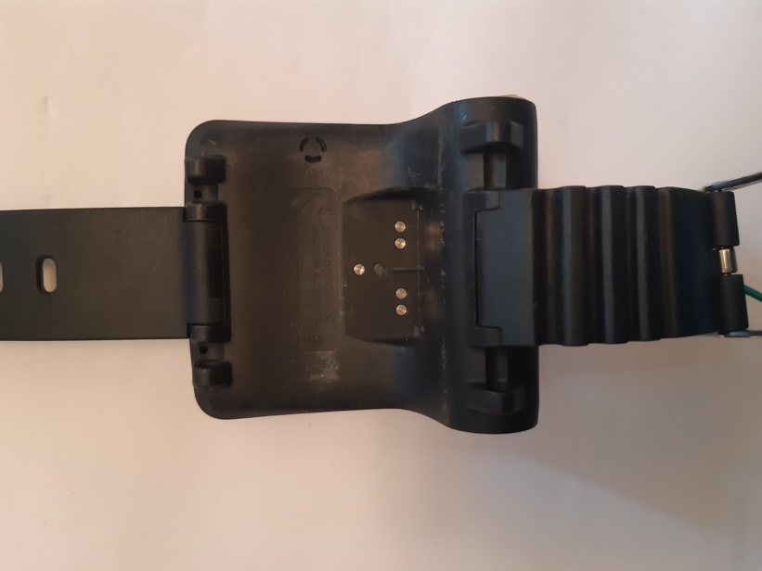
Shearwater Perdix | 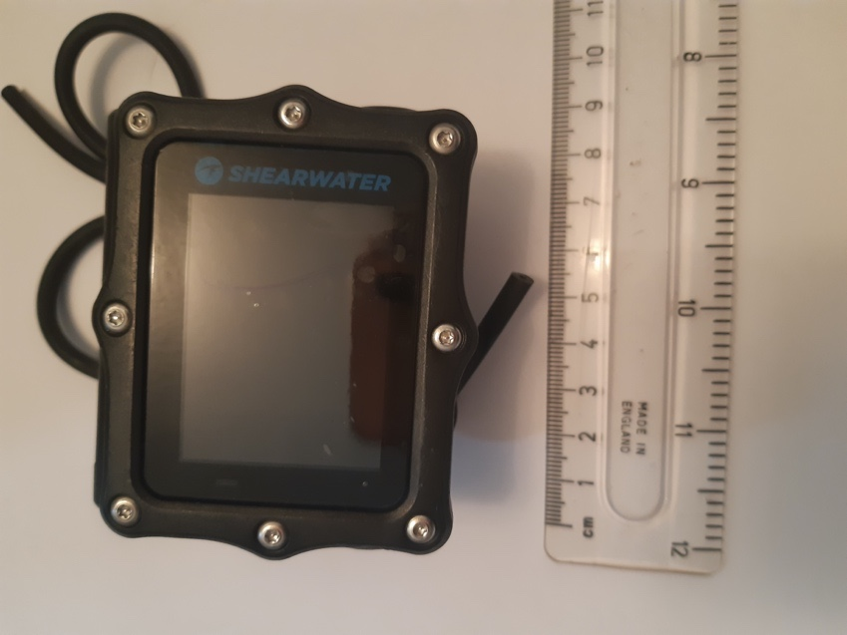 | 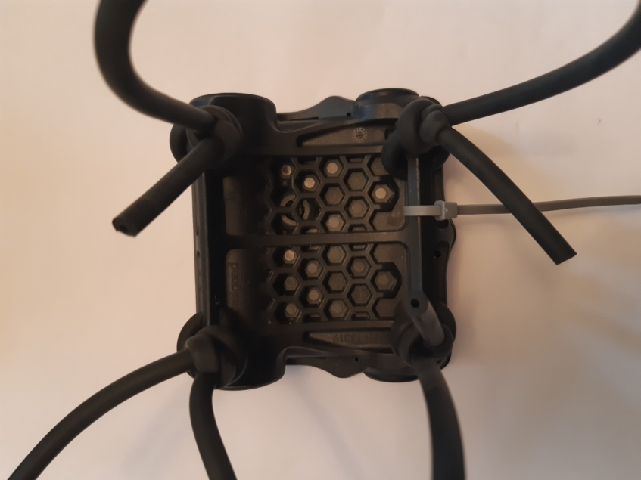
Suunto D4i | 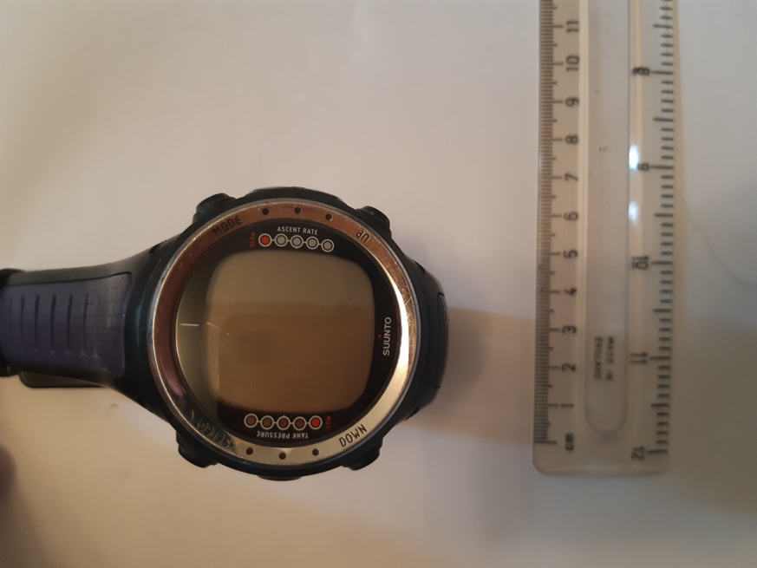 | 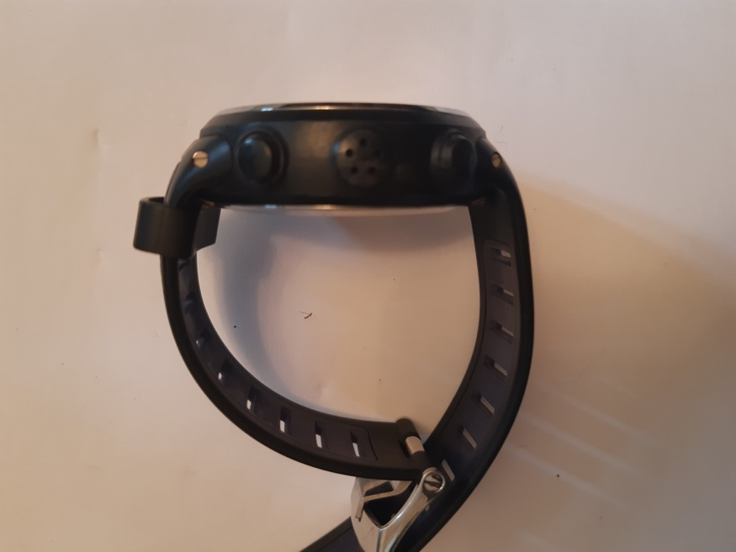
Suunto D6i | 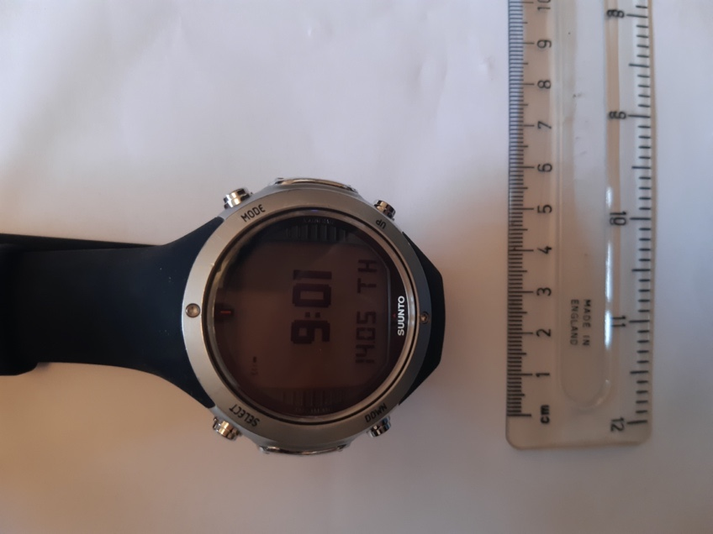 | 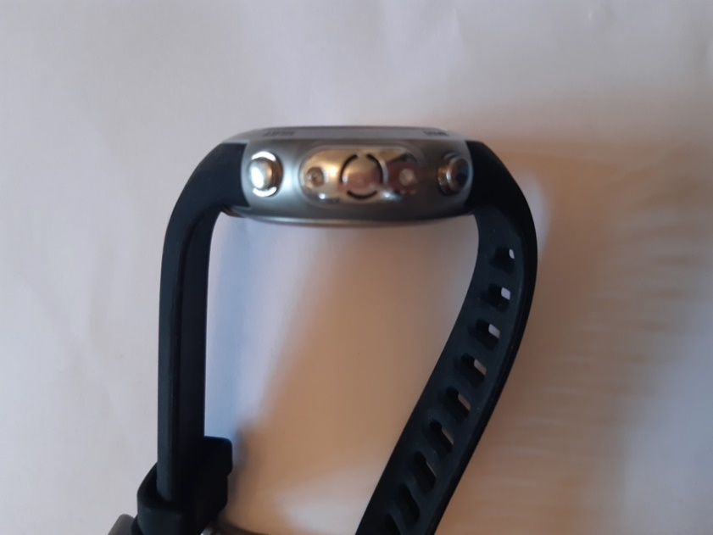
Suunto EON Steel | 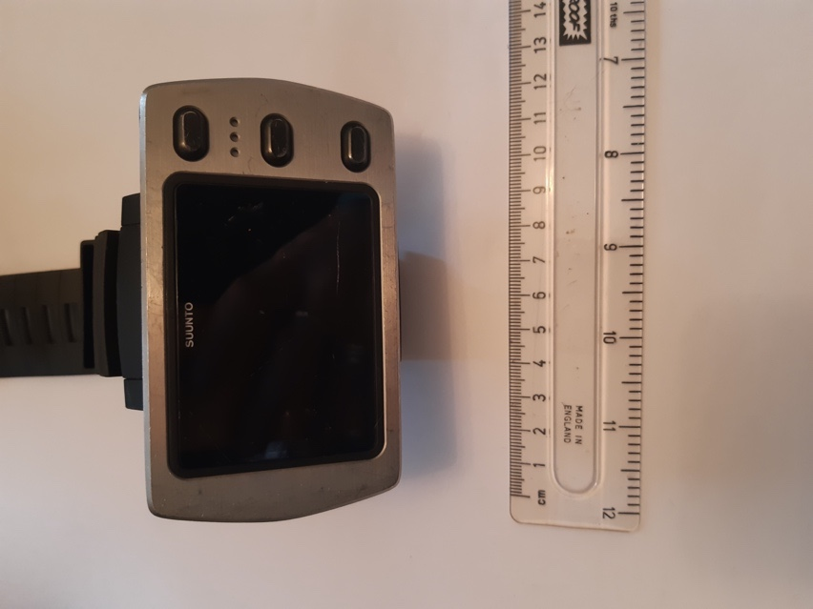 | 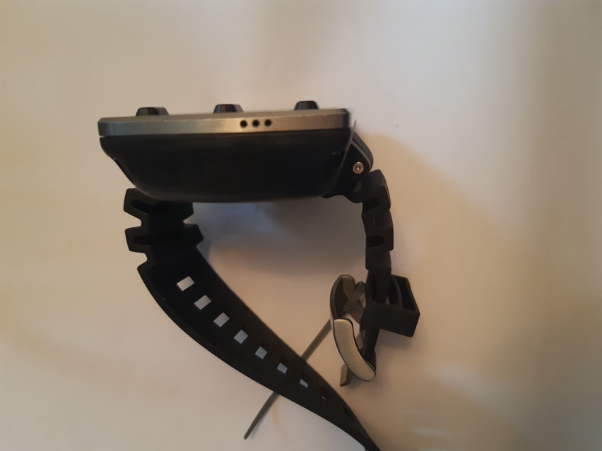
Suunto Vyper | 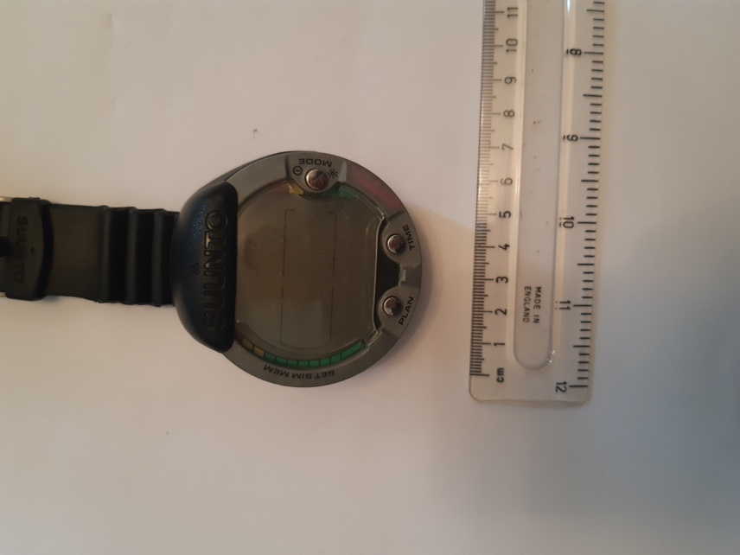 | 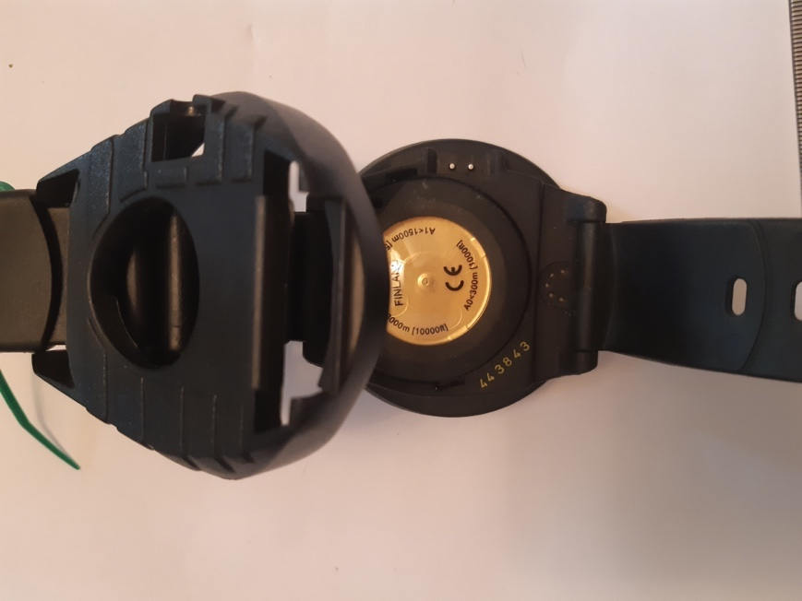

Fig 3: Mean device temperature as function of time during the final 180 s at >2.5 m by dive and bucket. NB. Devices in different buckets, but same dive, are not comparable in this plot due to different baseline bucket temperatures.

Fig 4: Castaway data for Oban sea dives; horizontal lines showing the cut off depth (top of the bottom mixed layer) for each dive. Baseline temperature for comparison was calculated from the mean temperature from the final 180 seconds of temperature data below this depth.

Fig 5: Final 180 s data below cut off depth by device. Bias was calculated as mean temperature across this time period, contrasted with the mean Castaway temperature from the same depth/time period.

Table 2: Mean response time (τ), by model.
Model | n(dives) | τ_{mean} / s | sd(τ ) | Classification (τ)
Aqualung i750TC | 20 | 151 | 11 | Slow
Garmin Descent Mk1 | 25 | 48 | 9 | Quick
Mares Matrix | 18 | 46 | 5 | Quick
Mares Puck Pro | 18 | 111 | 5 | Intermediate
Paralenz Dive Camera+ | 16 | 22 | 3 | Quick
Scubapro G2 | 27 | 73 | 8 | Intermediate
Shearwater Perdix | 25 | 304 | 45 | Slow
Suunto D4i | 7 | 46 | 5 | Quick
Suunto D6i | 27 | 18 | 5 | Quick
Suunto EON Steel | 27 | 42 | 5 | Quick

Table 3: Mean response time (τ), by device. S(τ fit) represents 95 % confidence intervals in the regression fit, based on the standard error of the regression.
Model | Device ID | n(dives) | τ_{mean} / s | sd(τ ) | S(τ fit) | Classification
Aqualung i750TC | Aqualung 1 | 6 | 148 | 15 | 2±1 | Slow
Aqualung i750TC | Aqualung 2 | 7 | 149 | 7 | 2±1 | Slow
Aqualung i750TC | Aqualung 3 | 7 | 157 | 12 | 3±2 | Slow
Garmin Descent Mk1 | Garmin 3 | 7 | 44 | 4 | 1 | Quick
Garmin Descent Mk2 | Garmin 2 | 9 | 52 | 11 | 0.5±0.5 | Quick
Garmin Descent Mk3 | Garmin 1 | 9 | 46 | 8 | 0.5±0.5 | Quick
Mares Matrix | Mares Matrix 1 | 9 | 46 | 5 | 1.5±0.5 | Quick
Mares Matrix | Mares Matrix 2 | 9 | 46 | 6 | 1.5±0.5 | Quick
Mares Puck Pro | Mares Puck Pro 1 | 9 | 111 | 3 | 1.5±0.5 | Intermediate
Mares Puck Pro | Mares Puck Pro 2 | 9 | 112 | 7 | 2±1 | Intermediate
Paralenz Dive Camera+ | Paralenz 1 | 6 | 24 | 4 | 0.5±0.5 | Quick
Paralenz Dive Camera+ | Paralenz 2 | 6 | 20 | 2 | 0 | Quick
Paralenz Dive Camera+ | Paralenz 3 | 4 | 22 | 1 | 0 | Quick
Scubapro G2 | Scubapro 3 | 9 | 70 | 8 | 2.5±1.5 | Intermediate
Scubapro G3 | Scubapro 2 | 9 | 74 | 5 | 1.5±0.5 | Intermediate
Scubapro G4 | Scubapro 1 | 9 | 76 | 10 | 2.5±1.5 | Intermediate
Shearwater Perdix | Shearwater 1 | 9 | 291 | 45 | 2.5±2.5 | Slow
Shearwater Perdix | Shearwater 2 | 9 | 303 | 47 | 6±3 | Slow
Shearwater Perdix | Shearwater 3 | 7 | 322 | 45 | 5.5±2.5 | Slow
Suunto D4i | Suunto D4i 1 | 7 | 46 | 5 | 1.5±0.5 | Quick
Suunto D6i | Suunto D6i 1 | 9 | 18 | 4 | 4±4 | Quick
Suunto D6i | Suunto D6i 2 | 9 | 17 | 6 | 3.5±3.5 | Quick
Suunto D6i | Suunto D6i 3 | 9 | 20 | 6 | 2.5±2.5 | Quick
Suunto EON Steel | Suunto EON Steel 1 | 9 | 42 | 5 | 2±1 | Quick
Suunto EON Steel | Suunto EON Steel 2 | 9 | 41 | 3 | 2±1 | Quick
Suunto EON Steel | Suunto EON Steel 3 | 9 | 42 | 7 | 2.5±1.5 | Quick

Table 4: Mean bias and uncertainties by model in water bath trials
Model | Water bath
 | n (dives) | Mean bias ΔT/ºC | sd (mean bias)
Aqualung i750TC | 9 | -1 | 1.7
Garmin Descent Mk1 | 9 | -0.7 | 0.5
Mares Matrix | 6 | -0.8 | 0.4
Mares Puck Pro | 6 | -1 | 0
Paralenz Dive Camera+ | NA | NA | NA
Ratio iX3M GPS Deep | 9 | -0.2 | 0.4
Scubapro G2 | 9 | 0 | 0
Shearwater Perdix | 9 | -0.8 | 0.4
Suunto D4i | 3 | -0.3 | 0.6
Suunto D6i | 8 | 0 | 0
Suunto EON Steel | 9 | -0.8 | 0.4
Suunto Vyper | 6 | -0.7 | 0.5

Table 5: Mean bias and uncertainties by device in water bath trials
Model | Device ID | Water bath
 |  | n (dives) | Mean bias ΔT/ºC | sd (mean bias)
Aqualung i750TC | Aqualung 1 | 3 | -2.3 | 1.5
Aqualung i750TC | Aqualung 2 | 3 | -1.7 | 0.6
Aqualung i750TC | Aqualung 3 | 3 | 1 | 0
Garmin Descent Mk1 | Garmin 1 | 3 | -1 | 0
Garmin Descent Mk1 | Garmin 2 | 3 | -1 | 0
Garmin Descent Mk1 | Garmin 3 | 3 | 0 | 0
Mares Matrix | Mares Matrix 1 | 3 | -1 | 0
Mares Matrix | Mares Matrix 2 | 3 | -0.7 | 0.6
Mares Puck Pro | Mares Puck Pro 1 | 3 | -1 | 0
Mares Puck Pro | Mares Puck Pro 2 | 3 | -1 | 0
Paralenz Dive Camera+ | Paralenz 1 | NA | NA | NA
Paralenz Dive Camera+ | Paralenz 2 | NA | NA | NA
Paralenz Dive Camera+ | Paralenz 3 | NA | NA | NA
Ratio iX3M GPS Deep | Ratio 1 | 3 | -0.2 | 0.5
Ratio iX3M GPS Deep | Ratio 2 | 3 | 0 | 0.3
Ratio iX3M GPS Deep | Ratio 3 | 3 | -0.3 | 0.4
Scubapro G2 | Scubapro 1 | 3 | 0 | 0
Scubapro G2 | Scubapro 2 | 3 | 0 | 0
Scubapro G2 | Scubapro 3 | 3 | 0 | 0
Shearwater Perdix | Shearwater 1 | 3 | -0.7 | 0.6
Shearwater Perdix | Shearwater 2 | 3 | -0.7 | 0.6
Shearwater Perdix | Shearwater 3 | 3 | -1 | 0
Suunto D4i | Suunto D4i 1 | 3 | -0.3 | 0.6
Suunto D6i | Suunto D6i 1 | 3 | 0 | 0
Suunto D6i | Suunto D6i 2 | 2 | 0 | 0
Suunto D6i | Suunto D6i 3 | 3 | 0 | 0
Suunto EON Steel | Suunto EON Steel 1 | 3 | -1 | 0
Suunto EON Steel | Suunto EON Steel 2 | 3 | -0.7 | 0.6
Suunto EON Steel | Suunto EON Steel 3 | 3 | -0.7 | 0.6
Suunto Vyper | Suunto Vyper 1 | 3 | -0.7 | 0.6
Suunto Vyper | Suunto Vyper 2 | 3 | -0.7 | 0.6

Table 6: Comparison of mean bias by device worn ‘on arm’ vs loose on a frame. Mean temperature derived from final 180 s sea dives below top of the mixed layer, compared to baseline Castaway temperature data over same time.
Model | Device ID | ‘On frame’ mean ΔT/ºC | sd (‘on frame’ mean) | ‘On arm’ mean ΔT/ºC | sd (‘on arm’ mean) | Absolute difference  ΔT/ºC
Aqualung i750TC | Aqualung 1 | -3.6 | 0 | -3.5 | 0.2 | 0.1
Aqualung i750TC | Aqualung 2 | -1.9 | 0.1 | -1.9 | 0 | 0
Aqualung i750TC | Aqualung 3 | 1.3 | 0.1 | 1.7 | 0.6 | 0.4
Garmin Descent Mk1 | Garmin 1 | -0.5 | 0.3 | -0.1 | 0.5 | 0.4
Garmin Descent Mk1 | Garmin 2 | -0.9 | 0.2 | -0.9 | 0.2 | 0
Garmin Descent Mk1 | Garmin 3 | 0 | 0.4 | 0.6 | 0.6 | 0.6
Mares Matrix | Mares Matrix 1 | 0.1 | 0.1 | 0.1 | 0.1 | 0
Mares Matrix | Mares Matrix 2 | 0.1 | 0 | 0.2 | 0.1 | 0.1
Mares Puck Pro | Mares Puck Pro 1 | 0.1 | 0.1 | 0.3 | 0.4 | 0.2
Mares Puck Pro | Mares Puck Pro 2 | 0 | 0.1 | 0 | 0.1 | 0
Ratio iX3M GPS Deep | Ratio 1 | 0.8 | 0.5 | 1.9 | 0.4 | 1.1
Ratio iX3M GPS Deep | Ratio 2 | 0.3 | 0.1 | 2.3 | 2.3 | 2
Ratio iX3M GPS Deep | Ratio 3 | 0.4 | 0.1 | 1.9 | 0.5 | 1.5
Scubapro G2 | Scubapro 1 | -0.3 | 0 | 0.7 | 1.4 | 1
Scubapro G2 | Scubapro 2 | -0.2 | 0.1 | -0.2 | 0.1 | 0
Scubapro G2 | Scubapro 3 | -0.2 | 0.1 | 0.1 | 0.4 | 0.3
Shearwater Perdix | Shearwater 1 | -0.4 | 0.4 | 0.2 | 0.2 | 0.6
Shearwater Perdix | Shearwater 2 | -0.4 | 0.3 | 0 | 0.5 | 0.4
Shearwater Perdix | Shearwater 3 | -0.7 | 0.1 | -0.1 | 0.5 | 0.6
Suunto D4i | Suunto D4i 1 | -0.7 | 0.1 | -0.4 | 0.3 | 0.3
Suunto D6i | Suunto D6i 1 | -0.4 | 0.3 | 0 | 0.5 | 0.4
Suunto D6i | Suunto D6i 2 | -0.4 | 0.4 | -0.1 | 0.5 | 0.3
Suunto D6i | Suunto D6i 3 | -0.4 | 0.3 | 0 | 0.5 | 0.4
Suunto EON Steel | Suunto EON Steel 1 | -0.8 | 0 | -0.7 | 0 | 0.1
Suunto EON Steel | Suunto EON Steel 2 | -0.6 | 0 | -0.5 | 0.1 | 0.1
Suunto EON Steel | Suunto EON Steel 3 | -0.6 | 0 | -0.6 | 0 | 0
Suunto Vyper | Suunto Vyper 1 | -0.4 | 0.4 | -0.1 | 0.5 | 0.3
Suunto Vyper | Suunto Vyper 2 | -0.4 | 0.3 | -0.1 | 0.5 | 0.3

Table 7: Total mean bias by device across sea and chamber dives
Model | Device ID | n(dives) | Mean bias ΔT/ºC | Absolute mean bias ΔT/ºC | sd (mean bias) ΔT/ºC
Aqualung i750TC | Aqualung 1 | 11 | -3.4 | 3.4 | 1
Aqualung i750TC | Aqualung 2 | 11 | -1.9 | 1.9 | 0.5
Aqualung i750TC | Aqualung 3 | 11 | 1.2 | 1.2 | 0.7
Garmin Descent Mk1 | Garmin 1 | 11 | 0 | 0 | 0.6
Garmin Descent Mk1 | Garmin 2 | 11 | -0.7 | 0.7 | 0.7
Garmin Descent Mk1 | Garmin 3 | 11 | 0.3 | 0.3 | 0.8
Mares Matrix | Mares Matrix 1 | 11 | -0.1 | 0.1 | 0.4
Mares Matrix | Mares Matrix 2 | 11 | 0 | 0 | 0.6
Mares Puck Pro | Mares Puck Pro 1 | 11 | -0.1 | 0.1 | 0.6
Mares Puck Pro | Mares Puck Pro 2 | 11 | -0.1 | 0.1 | 0.6
Paralenz Dive Camera+ | Paralenz 1 | 10 | 0.6 | 0.6 | 0.5
Paralenz Dive Camera+ | Paralenz 2 | 10 | 0.8 | 0.8 | 0.5
Paralenz Dive Camera+ | Paralenz 3 | 9 | 0.8 | 0.8 | 0.3
Ratio iX3M GPS Deep | Ratio 1 | 11 | 0.8 | 0.8 | 0.6
Ratio iX3M GPS Deep | Ratio 2 | 11 | 0.1 | 0.1 | 0.6
Ratio iX3M GPS Deep | Ratio 3 | 11 | 0.4 | 0.4 | 0.6
Scubapro G2 | Scubapro 1 | 11 | -0.2 | 0.2 | 1
Scubapro G2 | Scubapro 2 | 11 | -0.3 | 0.3 | 0.8
Scubapro G2 | Scubapro 3 | 11 | -0.3 | 0.3 | 0.7
Shearwater Perdix | Shearwater 1 | 11 | -0.6 | 0.6 | 0.7
Shearwater Perdix | Shearwater 2 | 11 | -0.6 | 0.6 | 0.6
Shearwater Perdix | Shearwater 3 | 11 | -0.7 | 0.7 | 0.6
Suunto D4i | Suunto D4i 1 | 11 | -0.5 | 0.5 | 0.6
Suunto D6i | Suunto D6i 1 | 11 | -0.2 | 0.2 | 0.9
Suunto D6i | Suunto D6i 2 | 11 | -0.3 | 0.3 | 0.7
Suunto D6i | Suunto D6i 3 | 11 | -0.3 | 0.3 | 0.7
Suunto EON Steel | Suunto EON Steel 1 | 11 | -0.7 | 0.7 | 0.7
Suunto EON Steel | Suunto EON Steel 2 | 11 | -0.4 | 0.4 | 0.4
Suunto EON Steel | Suunto EON Steel 3 | 11 | -0.5 | 0.5 | 0.5
Suunto Vyper | Suunto Vyper 1 | 11 | -0.3 | 0.3 | 1.6
Suunto Vyper | Suunto Vyper 2 | 11 | -0.2 | 0.2 | 2.6

Table 8: Model classification. Accuracy and precision across sea & chamber conditions, overall, plus response to temperature change
Model | Accuracy (sea) | Precision (sea) | Accuracy (chamber) | Precision (chamber) | Accuracy (overall) | Precision (overall) | Classification (τ)
Aqualung i750TC | Poor | Poor | Poor | Poor | Poor | Poor | Slow
Garmin Descent Mk1 | Good | Moderate | Good | Moderate | Good | Moderate | Quick
Mares Matrix | Good | Good | Good | Moderate | Good | Good | Quick
Mares Puck Pro | Good | Good | Good | Moderate | Good | Moderate | Intermediate
Paralenz Dive Camera+ | Moderate | Good | Moderate | Moderate | Moderate | Good | Quick
Ratio iX3M GPS Deep | Moderate | Moderate | Good | Good | Good | Moderate | Excluded from analysis
Scubapro G2 | Good | Moderate | Good | Moderate | Good | Moderate | Intermediate
Shearwater Perdix | Good | Good | Moderate | Moderate | Moderate | Moderate | Slow
Suunto D4i | Good | Good | Good | Moderate | Good | Moderate | Quick
Suunto D6i | Good | Good | Good | Moderate | Good | Moderate | Quick
Suunto EON Steel | Moderate | Good | Good | Moderate | Good | Moderate | Quick
Suunto Vyper | Good | Good | Good | Poor | Good | Poor | N/A

