Supplemental Material
Table S1. The primers used in this study.

Primers for quantitative PCR
 | Forward primer (5’-3’) | Reverse Primer (5’-3’)
MYH7B(Chicken) | CCAGGAGCTCTTGAGGGAAC | AGTCCGCCATCACATCGGAG
MEF2A(Chicken) | GAAACGGAGCCTTTTGGGCTT | CTTTCCCTTCCTTTGCAATCCAG
myogenin(Chicken) | CACCAACCCCGCAGATCAC | TTCCAGCATCACCATCCCAC
Myod1(Chicken) | GGGAGTCGGGAACCCTCC | AGGTCTCACCCACCTCTGG
Pax7(Chicken) | CGGACATCTACACCAGGGAGGAG | ATCTTGCTCGTCGGTTGCTGAAC
Myf5(Chicken) | CCAGGAGCTCTTGAGGGAAC | AGTCCGCCATCACATCGGAG
BMP4(Chicken) | GATCCGCTTCGTCTTCAACCTCAG | CTCGGCTCCTCCACCTGCTC
RALDH2(Chicken) | ATTCCTGCAAGCCTTCTACG | ATTCCTGCAAGCCTTCTACG
GAPDH(Chicken) | GGGCACGCCATCACTATCTT | TCACAAACATGGGGGCATCA
Shh(Chicken) | CCTGGCCAACGTGTCTATGT | CAACACCCGGTTGATGAGGA
Wnt3a(Chicken)  Caspase3(Chicken)  Cyclin D1(Chicken)  Caspase3(Mouse)  Cyclin D1(Mouse)  RALDH2(Mouse)  BMP4(Mouse)  Shh(Mouse)  GAPDH(Mouse) | TCATCCCGCCTCGGAAGAAA  TGGTGGAGGTGGAGGAGC  CACTTGGATGCTGGAGGTCTG  GAAACTCTTCATCATTCAGGCC  CGTATCTTACTTCAAGTGCGTG  ATGTTCACCTGGAAAATTGCTC  CGAATGCTGATGGTCGTTTTAT  GAAGGTCTTCTACGTGATCGAG  TCAAATGGGCAGATGCAGGT | AGAGCCTGACTCAACCCACA  GCGTGGTCCATCTTTTATGTCT  GCACAGTTTTTCTGCGGTCA  GCGAGTGAGAATGTGCATAAAT  ATGGTCTCCTTCATCTTAGAGG  CAATCTTGTCTATGCCGATGTG  GATCCCTCATGTAATCCGGAAT  TTCAGCCACCACGTACAC  AGCTGAGGGAGCTGAGATGA

Primers for in situ hybridization
 | Forward primer (5’-3’) | Reverse Primer (5’-3’)
RALDH2 | ATTCCTGCAAGCCTTCTACG | TTGCTCCTTCAGTAATGCCG
Myf5 | GAAGGCAGCCACTATGAGGG | ATAGCGCCTGGTAGGTCCG
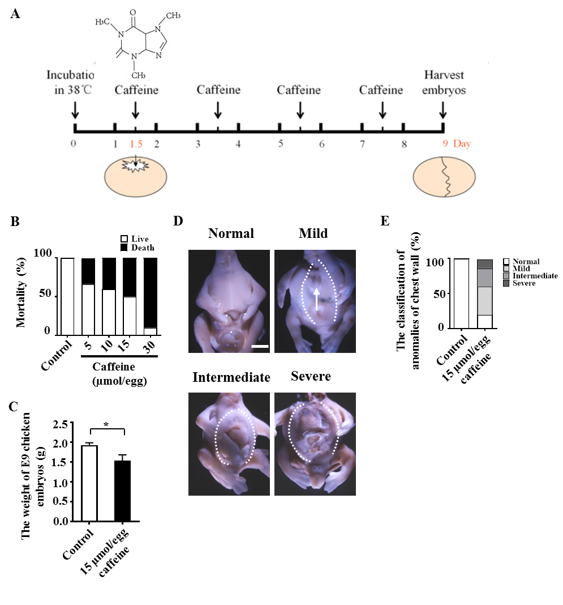Figure S1. Assessment of the development of chicken embryos treated with caffeine. (A) The sketch illustrates how E1.5 (HH10) chicken embryos were treated with either PBS or caffeine and then harvested on Day 9. (B-C) The bar charts showing the comparisons of E9 chicken embryo mortality (B), and embryo weight (C) between control and caffeine-treated groups. (D) The representative E9 chicken embryos from 15 μmol/egg caffeine-treated group, with normal chest wall, mild, intermediate or severe unclosed chest wall. (E) The bar chart showing the comparisons of E9 chicken embryos in classification of abnormal chest wall between control and 15 μmol/egg caffeine-treated groups. Scale bars=200 μm in (D).

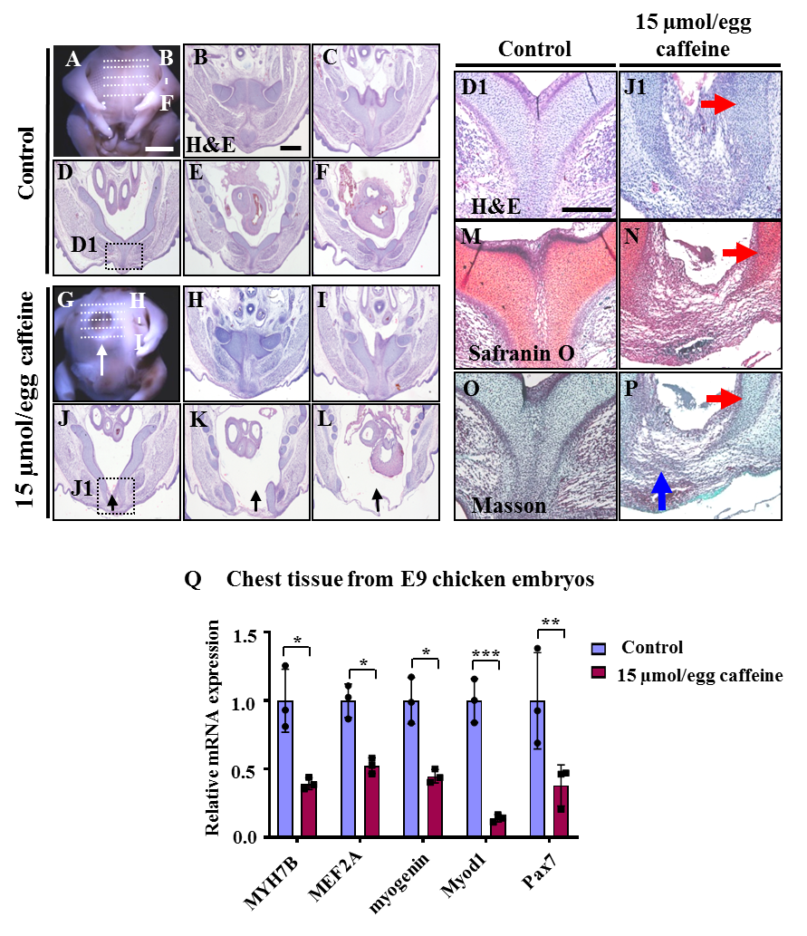
Figure S2. Assessment of myogenesis in E9 chicken embryos following 15 μmol/egg caffeine treatment. (A, G) Whole images of the chicken embryos from the control and 15 μmol/egg caffeine-treated groups. The white arrow represent the unclosed chest wall in (G). (B-F) and (H-L) H&E staining was performed on transverse sections of the chest wall indicated by dotted lines in (A) and (G). The black arrows represent the areas of unclosed chest wall in (J-L), corresponding to the areas represented by the white arrow in (G). (D1, J1, M, N, O, P) High magnification image from the sites indicated by (D) and (J), respectively, which were stained by H&E (D1, J1), Safranin O (M, N) and Masson (O, P). The red arrows represent the areas of cartilage in (J1, N, P), while the blue arrow represents the areas of muscle tissue in (P). (Q) Quantitative RT-PCR data showing the mRNA expression of MYH7B, MEF2A, myogenin, Myod1 and Pax7. Scale bars=200 μm in A and G; 100 μm in (B-F) and (H-L); 100 μm in (D1, J1and M-P).

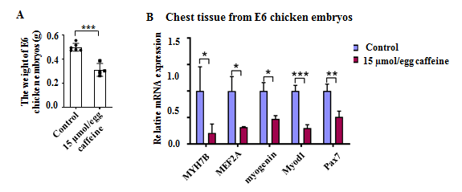
Figure S3. Assessment of myogenesis in E6 chicken embryos following 15 μmol/egg caffeine treatment. (A) The bar chart showing the comparisons of chicken embryo weight between the control and caffeine-treated groups. (B) Quantitative RT-PCR data showing the mRNA expression of MYH7B, MEF2A, myogenin, Myod1 and Pax7.

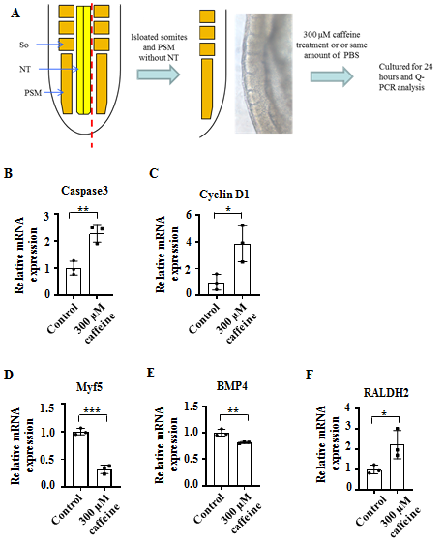
Figure S4. Quantitative RT-PCR data on determining the somitogenesis-related genes following caffeine treatment. (A) The sketch illustrates the development of isolated somites and PSM with or without caffeine treatment. (B) Quantitative RT-PCR data showing the mRNA expression of Caspase3, Cyclin D1, Myf5, BMP4 and RALDH2. NT, neural tube; So, somite; PSM, presomitic mesoderm.

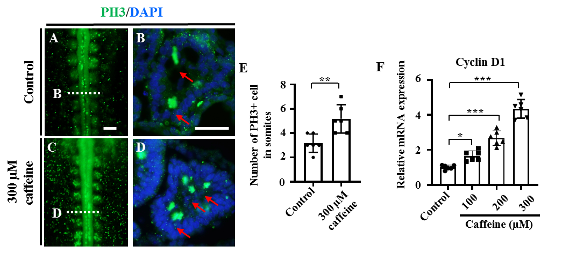Figure S5. Determination of cell proliferation in the developing somites of HH10 embryos and C2C12 cells following caffeine treatment. (A-D) Immunofluorescent staining of PH3 in the chicken embryos from the control (A) and caffeine-treated (C) groups, and the corresponding transverse sections for PH3 and merge with DAPI staining (B, D). B/D is from the 5th pair of somites. (E) The bar chart showing the proportion of PH3 positive cell numbers in somite from the control and caffeine-treated groups. (F) Quantitative RT-PCR data showing the mRNA expression of Cyclin D1 in C2C12 cells after caffeine treatment. Scale bars=100 μm in (A,C); 50 μm in (B, D).

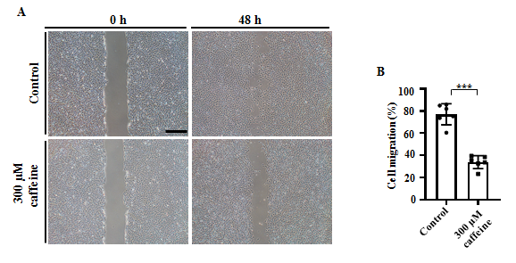
Figure S6. Assessment of the cell migration ability of C2C12 myoblast cells following 48 h treatment of caffeine. (A) Representative images of transwell migration assay from the control and caffeine-treated groups were taken after incubating C2C12 with caffeine for 0 h and 48 hours. (B) The bar charts showing the comparisons of cell migration ratios between the control and caffeine-treated groups. Scale bars= 300 μm in (A).

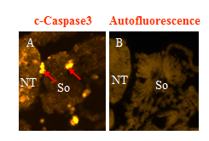
Figure S7. The negative control of c-Caspase3 immunofluorescence. (A) Immunofluorescent staining of c-Caspase3 in the chicken embryos. (B) The negative control of c-Caspase3 immunofluorescence. NT, neural tube; So, somite.

More details on statistics of all the figures included
Figure S1:
B: Statistical analysis of mortality rate (%) of E9 chicken embryos:
Control: live: 100%, death: 0%, 60 embryos counted;
5 µM: live: 67%, death: 33%, 60 embryos counted;
10 µM: live: 60 %, death: 40%, 60 embryos counted;
15 µM: live: 50%, death: 50 %, 60 embryos counted;
30 µM: live: 10%, death: 90%, 60 embryos counted.
C: Statistical analysis of the weight (g) of E9 chicken embryos by independent samples t test:
Control: 1.9242 ± 0.31226, 28 embryos analyzed; Caffeine: 1.5364 ± 0.60328, 17 embryos analyzed. There is significant difference between the groups (p＜0.05, *).
E: Statistical analysis of the anomaly ratio (%) of chest wall :
Control: normal: 100%, mild: 0%, intermediate: 0%, severe: 0%, 30 embryos analyzed;
Caffeine: normal: 20%, mild: 40%, intermediate: 26%, severe: 13%, 30 embryos analyzed
.
Figure S2:
Q: Statistical analysis of the relative mRNA expression of chest tissue from E9 chicken embryo by independent samples t test. The RT-PCR result was representative of at least three independent experiments:
MYH7B: Control: 1.0 ± 0.230245; Caffeine: 0.393034 ± 0.042935. There is significant difference between the groups (p＜0.05, *).
MEF2A: Control: 1.0 ± 0.123021, Caffeine: 0.524485 ± 0.05736. There is significant difference between the groups (p＜0.01, **).
myogenin：Control: 1.0 ± 0.168876; Caffeine: 0.44757 ± 0.049486. There is significant difference between the groups ( p＜0.01, **).
Myod1: Control: 1.0 ± 0.159814; Caffeine: 0.140795 ± 0.026718. There is significant difference between the groups ( p＜0.001, ***).
Pax7: Control: 1.0 ± 0.352073, Caffeine: 0.380319 ± 0.150462. There is significant difference between the groups ( p＜0.05, *).
Figure S3:
A: Statistical analysis of weight of E6 chicken embryo (g) by independent samples t test:
Control: 0.499000 ± 0.0320974, 6 embryos analyzed; Caffeine: 0.311300 ± 0.0533819, 4 embryos analyzed. There is significant difference between the groups (p＜0.001, ***).
B: Statistical analysis of the relative mRNA expression of chest tissue from E6 chicken embryo by independent samples t test. The RT-PCR result was representative of at least three independent experiments:
MYH7B: Control: 1.0 ± 0.456363; Caffeine: 0.207328 ± 0.168904. There is significant difference between the groups (p＜0.05,*).
MEF2A: Control: 1.0 ± 0.270431; Caffeine: 0.317569 ± 0.010237. There is significant difference between the groups (p＜0.05, *).
myogenin: Control: 1.0 ± 0.157457; Caffeine: 0.472968 ± 0.060514. There is significant difference between the groups (p＜0.05, *).
Myod1: Control: 1.0 ± 0.105052; Caffeine: 0.301665 ± 0.060797. There is significant difference between the groups (p＜0.001, ***).
Pax7: Control: 1.0 ± 0.129500; Caffeine: 0.512500 ± 0.106640. There is significant difference between the groups (p＜0.01, **).

Figure S4:
B: Statistical analysis of somite from HH10 chicken embryo by independent samples t test. The RT-PCR result was representative of at least three independent experiments:
Caspase3: Control: 1.0000 ± 0.32250; Caffeine: 3.4722 ± 0.30582. There is significant difference between the groups (p＜0.001, ***).
C: Statistical analysis of somite from HH10 chicken embryo by independent samples t test. The RT-PCR result was representative of at least three independent experiments:
Cyclin D1: Control: 1.0000 ± 0.12975; Caffeine: 3.5704 ± 0.86986; There is significant difference between the groups (p＜0.01, **).
D: Statistical analysis of somite from HH10 chicken embryo by independent samples t test. The RT-PCR result was representative of at least three independent experiments:
Myf5: Control: 1.0000 ± 0.09656; Caffeine: 0.6577 ± 0.15505; There is significant difference between the groups (p＜0.05, *).
E: Statistical analysis of somite from HH10 chicken embryo by independent samples t test. The RT-PCR result was representative of at least three independent experiments:
BMP4: Control: 1.0000 ± 0.17088; Caffeine: 0.3322 ± 0.08528; There is significant difference between the groups (p＜0.01, **).
F: Statistical analysis of somite from HH10 chicken embryo by independent samples t test. The RT-PCR result was representative of at least three independent experiments:
RALDH2: Control: 1.0000 ± 0.36104; Caffeine: 2.8540 ± 0.85093; There is significant difference between the groups (p＜0.05, *).

Figure S5:
E: Statistical analysis of number of PH3+ cells in somite by independent samples t test:
Control: 3.5000 ± 1.04881, a total of three embryos (six sections) were analyzed; Caffeine: 5.1667 ± 1.16905, a total of three embryos (six sections) were analyzed. There is significant difference between the groups (p＜0.05, *).
F: Statistical analysis of relative mRNA expression of C2C12 cell by Turkey’s multiple comparisons test. The RT-PCR result was representative of at least three independent experiments:
CyclinD1: Control: 1.0000 ± 0.13057; 100µM Caffeine: 1.6571 ± 0.29281; 200µM Caffeine 2.6725 ± 0.42062; 300µM Caffeine: 4.3554 ± 0.53082. There is significant difference between 100µM Caffeine group and Control group (p＜0.05, *). There is significant difference between 200µM Caffeine group and Control group (p＜0.001, ***). There is significant difference between 300µM Caffeine group and Control group (p＜0.001, ***).

Figure S6:
B: Statistical analysis of cell migration rate by independent samples t test:
Control: 0.7697 ± 0.09535; Caffeine: 0.3388 ± 0.05843; There is significant difference between the groups (p＜0.001, ***)

Figure 1:
C: Statistical analysis of mortality rate (%)：
Control: 12h: 0%; 18h: 0%; 38h: 0%, 9 embryos counted;
Caffeine: 12h: 0%; 18h: 15%; 38h: 37%, 16 embryos counted;
D: Statistical analysis of the length of embryos (mm) by independent samples t test.
12h: Control: 2.076111 ± 0.0448426, 9 embryos analyzed; Caffeine: 12h: 2.050875 ±0.038593, 16 embryos analyzed. There is no significant difference between the groups (p＞0.05, NS).
18h: Control: 2.577500 ± 0.2094039, 8 embryos analyzed; Caffeine: 2.2669 ± 0.10094, 14 embryos analyzed. There is significant difference between the groups (p＜0.01, **).
34h: Control: 4.484286 ± 0.1820126, 7 embryos analyzed; Caffeine: 3.870769 ± 0.2092232, 13 embryos analyzed. There is significant difference between the groups ( p＜0.001, ***).
E: Statistical analysis of the pairs of somites at 34 h-incubated chicken embryos by independent samples t test.
Control: 9.571429 ± 1.2392394, 7 embryos analyzed; Caffeine: 7.833333 ± 1.3291601, 6 embryos analyzed. There is significant difference between the groups (p＜0.05, *).
L: Statistical analysis of the relative mRNA expression by independent samples t test. The RT-PCR result was representative of at least three independent experiments
Pax7: Control: 1.0 ± 0.05492; Caffeine: 0.5981 ± 0.06049. There is significant difference between the groups (p＜0.01, **).

Figure 2:
E: Statistical analysis of the number of c-Caspase3+ cells in somite by independent samples t test:
Control: 2.250000 ± 2.5495098, a total of three embryos (eight sections) were analyzed; Caffeine: 9.750000 ± 2.9640706, a total of three embryos (eight sections) were analyzed. There is significant difference between the groups (p＜0.001, ***).
F: Statistical analysis of relative protein level of c-Caspase3 by independent samples t test:
Control: 1.0702 ± 0.12558; Caffeine: 2.6176 ± 0.42646. There is significant difference between the groups (p＜0.01, **).
G: Statistical analysis of the relative mRNA expression of C2C12 cell by Turkey’s multiple comparisons test. The RT-PCR result was representative of at least three independent experiments:
Caspase3: Control: 1.0000 ± 0.23535; 100µM Caffeine: 1.8760 ± 0.38317; 200µM Caffeine 2.6243 ± 0.72528; 300µM Caffeine: 2.7111 ± 0.64484. There is significant difference between 100µM Caffeine group and Control group (p＜0.05, *). There is significant difference between 200µM Caffeine group and Control group (p＜0.001, ***). There is significant difference between 300µM Caffeine group and Control group (p＜0.001, ***)

Figure 3:
E: Statistical analysis of the relative mRNA expression by independent samples t test.The RT-PCR result was representative of at least three independent experiments:
Myf5: Control: 1.0 ± 0.05398; Caffeine: 0.0518 ± 0.00960. There is significant difference between the groups (p＜0.001, ***).
L: Statistical analysis of the relative mRNA expression by independent samples t test.The RT-PCR result was representative of at least three independent experiments:
BMP4: Control: 1.0 ± 0.05496; Caffeine: 0.1793 ± 0.04234. There is significant difference between the groups (p＜0.001, ***).
M: Statistical analysis of the relative mRNA expression by independent samples t test.The RT-PCR result was representative of at least three independent experiments
Wnt3a: Control: 1.0000 ± 0.07683; Caffeine: 0.6979 ± 0.12614. There is significant difference between the groups (p＜0.05, *)
N: Statistical analysis of the relative mRNA expression by independent samples t test. The RT-PCR result was representative of at least three independent experiments
Shh: Control: 1.0000 ± 0.06727; Caffeine: 1.7616 ± 0.14036. There is significant difference between the groups ( p＜0.01, **)

Figure 4:
A: Statistical analysis of the concentration of RA(ng/mg) by independent samples t test:
Control: 0.264231267 ± 0.0280459442; Caffeine: 0.344258567 ± 0.0151073625. 15 embryos were mixied for 1 simple, N>3 simples in each group. There is significant difference between the groups (p＜0.05, *).
B: Statistical analysis of the relative mRNA expression by independent samples t test. The RT-PCR result was representative of at least three independent experiments:
RALDH2: Control: 1.0 ± 0.13178; Caffeine: 1.4541 ± 0.21102. There is significant difference between the groups (p＜0.05, *).
B1：Statistical analysis of the relative mRNA expression of C2C12 cell by Turkey’s multiple comparisons test. The RT-PCR result was representative of at least three independent experiments:
RALDH2: Control: 1.0000 ± 0.19400; 100µM Caffeine: 1.9975 ± 0.30960; 200µM Caffeine 2.3960 ± 0.17861; 300µM Caffeine: 2.8336 ± 0.61432. There is significant difference between 100µM Caffeine group and Control group (p＜0.01, **). There is significant difference between 200µM Caffeine group and Control group (p＜0.001, ***). There is significant difference between 300µM Caffeine group and Control group (p＜0.001, ***).
H：Statistical analysis of the immunofluorescence staining area of somite from E2.5 chicken embryos by Turkey’s multiple comparisons test.
MF20: Control: 28008.6508 ± 2854.11255, 6 embryos analyzed; Caffeine: 14528.4222 ± 1542.98298, 6 embryos analyzed; Caffeine + AGN: 9405.4907 ± 937.45110, 6 embryos analyzed. There is significant difference between Caffeine group and Control group (p＜0.001, ***). There is significant difference between Caffeine group and Caffeine + AGN group (p＜0.001, ***).

Figure 5:
B: Statistical analysis of Pairs of somites at 38h chicken embryo by independent samples t test:
Control: 11.8148 ± 0.87868, 27 embryos analyzed; Caffeine: 8.5000 ± 1.76608, 22 embryos analyzed; Caffeine + AGN: 9.8000 ± 1.25831, 25 embryos analyzed. There is significant difference between Caffeine group and Control group (p＜0.01, **). There is significant difference between Caffeine group and Caffeine + AGN group (p＜0.05 , *).

Figure 6:
A: Statistical analysis of the relative mRNA expression of C2C12 cell by Turkey’s multiple comparisons test. The RT-PCR result was representative of at least three independent experiments:
Caspase3: Control: 1.0000 ± 0.09651; 25µM Caffeine: 5.5905 ± 0.31243; 25µM Caffeine + 10⁻⁵ M AGN: 1.4354 ± 0.21453; 50µM Caffeine: 7.7227 ± 1.33177; 50µM Caffeine + 10⁻⁵ M AGN: 2.5458 ± 0.37264. There is significant difference between 25µM Caffeine group and Control group (p＜0.001, *** ). There is significant difference between 25µM Caffeine + 10⁻⁵ M AGN group and 25µM Caffeine group (p＜0.001, ***). There is significant difference between 50µM Caffeine group and Control group (p＜0.001, *** ). There is significant difference between 50µM Caffeine + 10⁻⁵ M AGN group and 50µM Caffeine group (p＜0.001, ***).
B: Statistical analysis of the relative mRNA expression of C2C12 cell by Turkey’s multiple comparisons test. The RT-PCR result was representative of at least three independent experiments:

CyclinD1: Control: 1.0000 ± 0.36540; 25µM Caffeine: 5.8654 ± 0.72837; 25µM Caffeine + 10⁻⁵ M AGN: 2.5681 ± 0.15468; 50µM Caffeine: 10.8297 ± 1.71153; 50µM Caffeine + 10⁻⁵ M AGN: 3.7820 ± 0.24034. There is significant difference between 25µM Caffeine group and Control group (p＜0.001, *** ). There is significant difference between 25µM Caffeine + 10⁻⁵ M AGN group and 25µM Caffeine group (p＜0.01, **). There is significant difference between 50µM Caffeine group and Control group (p＜0.001, *** ). There is significant difference between 50µM Caffeine + 10⁻⁵ M AGN group and 50µM Caffeine group (p＜0.001, ***).
C: Statistical analysis of the relative mRNA expression of C2C12 cell by Turkey’s multiple comparisons test. The RT-PCR result was representative of at least three independent experiments:

Myf5: Control: 1.0000 ± 0.05369; 25µM Caffeine: 0.1332 ± 0.02006; 25µM Caffeine + 10⁻⁵ M AGN: 0.7685 ± 0.16540; 50µM Caffeine: 0.0952 ± 0.00923; 50µM Caffeine + 10⁻⁵ M AGN: 0.4337 ± 0.14522. There is significant difference between 25µM Caffeine group and Control group (p＜0.001, *** ). There is significant difference between 25µM Caffeine + 10⁻⁵ M AGN group and 25µM Caffeine group (p＜0.001, ***). There is significant difference between 50µM Caffeine group and Control group (p＜0.001, *** ). There is significant difference between 50µM Caffeine + 10⁻⁵ M AGN group and 50µM Caffeine group (p＜0.05, *).
D: Statistical analysis of the relative mRNA expression of C2C12 cell by Turkey’s multiple comparisons test. The RT-PCR result was representative of at least three independent experiments:

BMP4: Control: 1.0000 ± 0.13432; 25µM Caffeine: 0.1278 ± 0.01239; 25µM Caffeine + 10⁻⁵ M AGN: 0.8270 ± 0.05128; 50µM Caffeine: 0.0955 ± 0.01203; 50µM Caffeine + 10⁻⁵ M AGN: 0.4344 ± 0.01041. There is significant difference between 25µM Caffeine group and Control group (p＜0.001, *** ). There is significant difference between 25µM Caffeine + 10⁻⁵ M AGN group and 25µM Caffeine group (p＜0.001, ***). There is significant difference between 50µM Caffeine group and Control group (p＜0.001, *** ). There is significant difference between 50µM Caffeine + 10⁻⁵ M AGN group and 50µM Caffeine group (p＜0.01, **).
E: Statistical analysis of the relative mRNA expression of C2C12 cell by Turkey’s multiple comparisons test. The RT-PCR result was representative of at least three independent experiments:

RALDH2: Control: 1.0000 ± 0.40329; 25µM Caffeine: 2.5789 ± 0.45990; 50µM Caffeine: 4.1102 ± 0.48665; There is significant difference between 25µM Caffeine group and Control group (p＜0.05, * ). There is significant difference between 50µM Caffeine group and Control group (p＜0.001, *** ).

