Supplementary Material
Studies on the changes of pharmacokinetics behaviors of phytochemicals and the influence on endogenous metabolites after the combination of Radix Bupleuri and Radix Paeoniae Alba based on multi-component pharmacokinetics and metabolomics
Congcong Chen ^{1, 2}, Qicai Yin ^{1, 2}, Junshen Tian ¹, Xiaoxia Gao ¹,
Xuemei Qin ¹, Guanhua Du ^{1, 3}, Yuzhi Zhou ^{1,*}
¹ Modern Research Center for Traditional Chinese Medicine of Shanxi University, No.92, Wucheng Road, Taiyuan 030006, People’s Republic of China;
² College of Chemistry and Chemical Engineering, Shanxi University, No. 92,
Wucheng Road, Taiyuan 030006, P. R. China
³ Institute of Materia Medica, Chinese Academy of Medical Sciences & Peking Union Medical College, Beijing 100050, P. R. China
* Correspondence authors. Tel: +86-351-7011202; Fax: +86-351-7011202
E-mail addresses: zhouyuzhi@sxu.edu.cn (Yu-Zhi Zhou);

Supplementary Files:
Fig. S1. The base peak chromatograms of herb extracts and mixed standards (saikosaponin A: SSa, saikosaponin D: SSd, saikosaponin C: SSc, saikosaponin B₂: SSb₂, paeoniflorin, albiflorin, oxypaeoniflorin, methyl gallate, and the Internal standard). A: Radix Bupleuri extract; B: Radix Paeoniae Alba extract; C: mixture of Radix Bupleuri and Radix Paeoniae Alba extract; D: mixed standards.
Table S1. The content of eight compounds in single extract and mixture extract. Radix Bupleuri extract: RB; Radix Paeoniae Alba extract: RPA; mixture of Radix Bupleuri and Radix Paeoniae Alba extract: RB-RPA. All data were expressed as mean ± SD, (n = 6).
Fig. S2. Extracted-ion chromatograms of SSa, SSd, and SSb₂ (I), SSc (II), paeoniflorin and albiflorin (III), oxypaeoniflorin (IV), methyl gallate (V). (A) Blank plasma; (B) drug-containing plasma after administration of Radix Bupleuri extract; (C) drug-containing plasma after administration of Radix Paeoniae Alba extract; (D) drug-containing plasma after administration of mixture of Radix Bupleuri and Radix Paeoniae Alba extract; (E) blank plasma spiked with reference compound.
Table S2. Liner range, regression equation, correlation coefficient for eight compounds.
Table S3. Recovery and the matrix effect of eight target analytes in QC plasma samples (n = 6).
Table S4. Precision and accuracy of eight target analytes in QC plasma samples (mean ± SD, n = 6).
Table S5. Stability of eight target analytes in QC plasma samples (mean ± SD, n = 5).
Table S6. Main pharmacokinetic parameters of the 23 compounds from RB in rat plasma after oral administration of the single extract (RB) and the mixed extracts (RB-RPA). All data were expressed as mean ± SD, (n = 7).
Table S7. Main pharmacokinetic parameters of the 15 compounds from RPA in rat plasma after oral administration of the single extract (RPA) and the mixed extracts (RB-RPA). All data were expressed as mean ± SD, (n = 7).
Fig. S3. UPLC-MS/MS base peak chromatograms of plasma samples after oral administration of RB-RPA
Table S8. Relative distance calculation between post-dose all time points metabolite profiles and pre-dose metabolite profile from the score plot of PCA with average value (x-axis and y-axis) of all samples. Values are presented as mean± SD, (n = 6).
Table S9. List of the altered endogenous metabolites in response to RB-RPA intervention and the data were normalized by IS (glycyrrhizin). Values are presented as mean± SD, (n = 6).

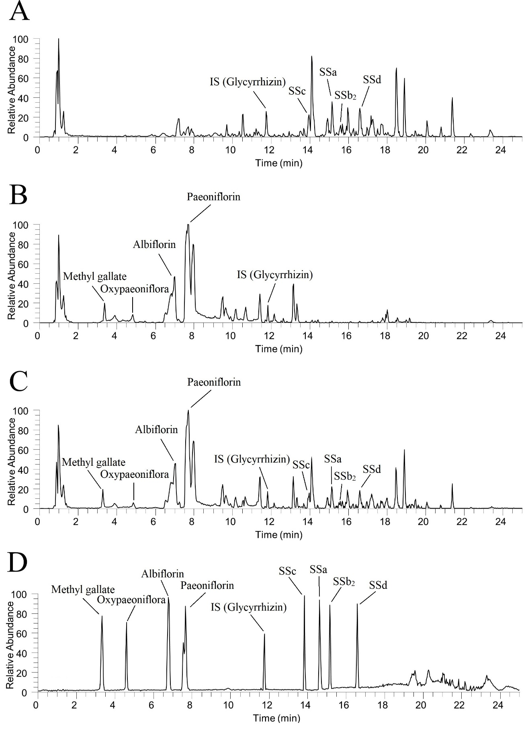
Fig. S1. The base peak chromatograms of herb extracts and mixed standards (saikosaponin A: SSa, saikosaponin D: SSd, saikosaponin C: SSc, saikosaponin B₂: SSb₂, paeoniflorin, albiflorin, oxypaeoniflorin, methyl gallate, and the Internal standard). A: Radix Bupleuri extract; B: Radix Paeoniae Alba extract; C: mixture of Radix Bupleuri and Radix Paeoniae Alba extract; D: mixed standards.

Table S1. The content of eight compounds in single extract and mixture extract. Radix Bupleuri extract: RB; Radix Paeoniae Alba extract: RPA; mixture of Radix Bupleuri and Radix Paeoniae Alba extract: RB-RPA. All data were expressed as mean ± SD, (n = 6).
Compounds | RB (mg/ml) | RPA (mg/ml) | RB-RPA (mg/ml)
Saikosaponin A | 5.195±0.008 | 0 | 5.181±0.011
Saikosaponin D | 3.925±0.006 | 0 | 3.911±0.007
Saikosaponin C | 2.091±0.004 | 0 | 2.082±0.007
Saikosaponin B₂ | 1.082±0.003 | 0 | 1.066±0.006
Paeoniflorin | 0 | 38.751±0.037 | 38.982±0.041
Albiflorin | 0 | 6.463±0.010 | 6.531±0.008
Oxypaeoniflorin | 0 | 0.673±0.005 | 0.691±0.005
Methyl gallate | 0 | 1.613±0.008 | 1.625±0.007

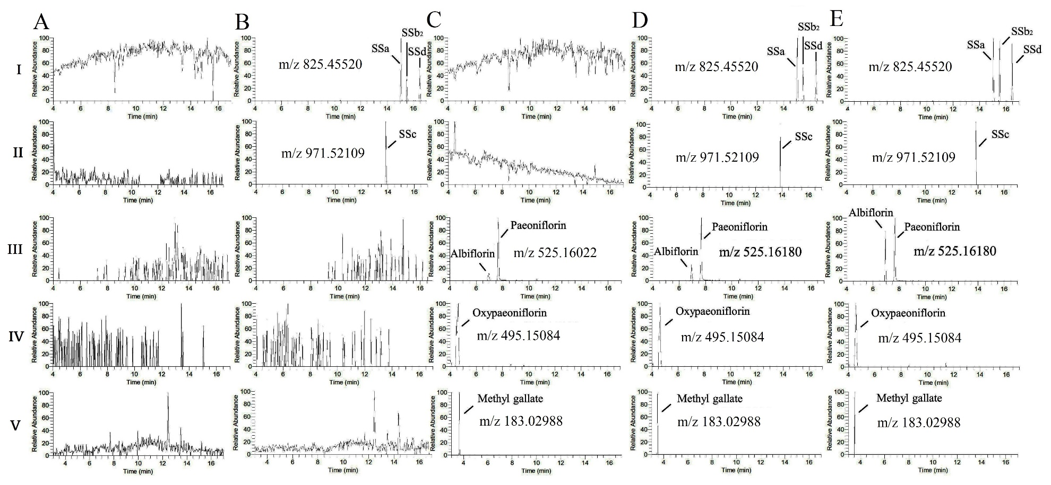
Fig. S2. Extracted-ion chromatograms of SSa, SSd, and SSb₂ (I), SSc (II), paeoniflorin and albiflorin (III), oxypaeoniflorin (IV), methyl gallate (V). (A) Blank plasma; (B) drug-containing plasma after administration of Radix Bupleuri extract; (C) drug-containing plasma after administration of Radix Paeoniae Alba extract; (D) drug-containing plasma after administration of mixture of Radix Bupleuri and Radix Paeoniae Alba extract; (E) blank plasma spiked with reference compound.

Table S2. Liner range, regression equation, correlation coefficient for eight compounds.
Compounds | Liner range (ng/ml) | Regression equation | Correlation coefficient (r²) | LLOQ ng/ml
Saikosaponin A | 0.2-500 | y = 0.0541x + 0.0246 | 0.9993 | 0.2
Saikosaponin D | 0.1-250 | y = 0.0231x + 0.0311 | 0.9968 | 0.1
Saikosaponin C | 0.1-250 | y = 0.0384x + 0.0421 | 0.9982 | 0.1
Saikosaponin B₂ | 0.1-250 | y = 0.0263x + 0.0289 | 0.9985 | 0.1
Paeoniflorin  Albiflorin  Oxypaeoniflorin  Methyl gallate | 2-5000  0.5-1250  0.1-250  0.2-500 | y = 0.0943x + 0.0747  y = 0.1484x + 0.0517  y = 0.1013x + 0.0933  y = 0.0762x + 0.0046 | 0.9996  0.9994  0.9979  0.9991 | 2  0.5  0.1  0.2

Table S3. Recovery and the matrix effect of eight target analytes in QC plasma samples (n = 6).
Compounds | QC conc.  (ng/ml) | Recovery (%, mean ± SD) | Matrix effect (%, mean ± SD)
Saikosaponin A | 100 | 98.84±2.12 | 96.41±1.97
 | 10 | 94.13±2.48 | 97.75±2.28
 | 0.4 | 90.96±3.39 | 92.82±2.86
Saikosaponin D | 50 | 104.63±3.19 | 93.14±3.62
 | 5 | 95.47±3.81 | 95.23±1.92
 | 0.2 | 89.88±3.56 | 91.74±2.81
Saikosaponin C | 50 | 86.27±5.14 | 104.92±4.19
 | 5 | 87.42±3.68 | 91.59±4.83
 | 0.2 | 85.83±2.95 | 87.75±3.22
Saikosaponin B₂ | 50 | 93.81±1.77 | 104.45±2.33
 | 5 | 86.75±3.41 | 103.85±2.18
 | 0.2 | 81.32±5.59 | 82.8±5.96
Albiflorin | 250 | 105.32±3.75 | 93.73±2.34
 | 20 | 89.23±4.37 | 84.38±4.50
 | 1 | 91.86±5.23 | 94.04±3.96
Paeoniflorin | 1000 | 98.59±2.25 | 99.33±1.42
 | 100 | 97.32±1.96 | 96.38±1.84
 | 4 | 98.93±1.58 | 98.75±2.13
Oxypaeoniflorin | 50 | 103.39±3.77 | 82.383±5.33
 | 5 | 105.22±3.25 | 79.61±7.22
 | 0.2 | 106.83±6.27 | 85.53±5.85
Methyl gallate | 100 | 102.51±2.27 | 98.2±2.83
 | 10 | 95.34±3.94 | 106.26±3.88
 | 0.4 | 97.23±2.45 | 111.53±4.32

Table S4. Precision and accuracy of eight target analytes in QC plasma samples (mean ± SD, n = 6).
Compounds | QC conc.  (ng/ml) | Intra-day |  |  | Inter-day
 |  | Calc. conc. (ng/ml) | Precision  RSD (%) | Accuracy  RE (%) | Calc. conc. (ng/ml) | Precision  RSD (%) | Accuracy  RE (%)
Saikosaponin A | 100 | 96.96±6.39 | 6.59 | -3.04 | 95.68±7.96 | 8.32 | -4.32
 | 10 | 9.55±0.76 | 7.96 | -4.49 | 10.81±0.63 | 5.83 | 8.12
 | 0.4 | 0.41±0.03 | 7.18 | 2.42 | 0.42±0.04 | 9.09 | 5.23
Saikosaponin D | 50 | 52.12±3.11 | 5.97 | 4.24 | 52.92±4.38 | 8.28 | 5.84
 | 5 | 4.82±0.28 | 5.82 | 3.58 | 4.93±0.13 | 2.64 | -1.4
 | 0.2 | 0.21±0.02 | 9.11 | 8.12 | 0.22±0.02 | 9.81 | 8.02
Saikosaponin C | 50 | 48.23±1.43 | 2.96 | -3.54 | 48.02±2.48 | 5.16 | -3.96
 | 5 | 4.77±0.22 | 4.61 | -4.58 | 4.65±0.35 | 7.53 | -7.11
 | 0.2 | 0.18±0.02 | 9.06 | -8.05 | 0.18±0.02 | 10.04 | -8.11
Saikosaponin B₂ | 50 | 49.62±1.13 | 2.27 | -0.76 | 48.12±3.58 | 7.44 | -3.76
 | 5 | 4.75±0.11 | 2.32 | -4.98 | 4.81±0.12 | 2.49 | --3.84
 | 0.2 | 0.19±0.01 | 8.34 | -7.98 | 0.21±0.02 | 11.48 | 7.93
Albiflorin | 250 | 252.52±9.29 | 3.68 | 1.01 | 249.31±11.52 | 4.62 | -0.28
 | 25 | 24.94±1.26 | 4.35 | -0.24 | 24.12±1.56 | 6.46 | -3.52
 | 1 | 1.06±0.08 | 7.55 | 6.01 | 1.04±0.07 | 6.73 | 4.34
Paeoniflorin | 1000 | 986.28±54.25 | 5.50 | -1.37 | 991.23±42.94 | 4.33 | 0.88
 | 100 | 103.34±1.88 | 1.82 | 3.34 | 97.21±2.14 | 2.21 | -2.79
 | 4 | 4.21±0.33 | 7.84 | 5.25 | 3.78±0.29 | 7.67 | -5.48
Oxypaeoniflorin | 50 | 50.65±1.21 | 2.39 | 1.3 | 51.43±3.53 | 6.86 | 2.86
 | 5 | 5.24±4.23 | 8.07 | 4.8 | 5.21±0.32 | 6.14 | 4.22
 | 0.2 | 0.19±0.01 | 8.95 | -7.78 | 0.20±0.01 | 9.23 | 3.24
Methyl gallate | 100 | 104.82±2.42 | 2.31 | 4.82 | 105.32±3.15 | 2.99 | 5.32
 | 10 | 9.48±0.52 | 5.49 | -5.19 | 9.18±0.83 | 9.04 | -0.82
 | 0.4 | 0.41±0.04 | 9.09 | 2.81 | 0.42±0.05 | 11.42 | 5.89

Table S5. Stability of eight target analytes in QC plasma samples (mean ± SD, n = 5).
Compounds | QC conc.  (ng/ml) | Long-term stability  -20°C for 30 d |  | Freeze-thaw stability  3 freeze-thaw cycles |  | Short-term stability  24 h in room temperature |  | Post-preparative stability  24 h in the autosampler (4°C)
 |  | Calc. conc. (ng/ml) | Accuracy  RE (%) | Calc. conc. (ng/ml) | Accuracy  RE (%) | Calc. conc. (ng/ml) | Accuracy  RE (%) | Calc. conc. (ng/ml) | Accuracy  RE (%)
Saikosaponin A | 100 | 94.67±5.36 | -5.33 | 93.84±7.25 | -6.56 | 92.89±7.86 | -7.11 | 95.81±3.53 | -4.19
 | 10 | 9.24±0.63 | -7.61 | 10.19±0.88 | 1.92 | 9.11±0.78 | -8.91 | 9.42±0.24 | -5.85
 | 0.4 | 0.38±0.03 | -4.81 | 0.38±0.03 | -5.53 | 0.36±0.03 | -8.72 | 0.41±0.03 | 2.51
Saikosaponin D | 50 | 52.78±4.23 | 5.56 | 52.98±4.14 | 5.97 | 46.35±4.32 | -7.33 | 51.04±2.83 | 2.08
 | 5 | 4.83±0.36 | -3.38 | 5.18±0.43 | 3.63 | 4.71±0.34 | -5.82 | 4.92±0.32 | -1.63
 | 0.2 | 0.19±0.01 | -7.98 | 0.19±0.01 | -5.26 | 0.18±0.01 | -8.73 | 0.19±0.01 | -6.43
Saikosaponin C | 50 | 48.12±2.25 | -3.76 | 52.02±3.54 | 4.04 | 47.52±3.24 | -4.96 | 48.83±2.08 | -2.34
 | 5 | 4.92±0.21 | -1.61 | 4.83±0.33 | -3.41 | 4.77±0.27 | -4.64 | 5.11±0.36 | 2.26
 | 0.2 | 0.19±0.01 | -0.82 | 0.21±0.02 | 5.11 | 0.19±0.01 | -8.64 | 0.19±0.01 | -8.17
Saikosaponin B₂ | 50 | 49.31±3.22 | -1.38 | 48.97±4.02 | -2.06 | 48.02±3.76 | -3.96 | 50.83±1.43 | 1.66
 | 5 | 4.89±0.18 | -2.27 | 4.84±0.22 | -3.23 | 4.72±0.24 | -5.62 | 4.81±0.22 | -3.82
 | 0.2 | 0.19±0.01 | -7.87 | 0.19±0.01 | -8.21 | 0.19±0.01 | -8.32 | 0.20±0.00 | -3.18
Albiflorin | 250 | 253.35±15.55 | 1.34 | 252.24±16.45 | -0.90 | 253.42±15.43 | 1.37 | 256.64±17.53 | 2.66
 | 25 | 26.35±1.88 | 5.41 | 26.57±2.65 | 6.28 | 26.53±3.23 | 6.12 | 26.04±3.13 | 4.16
 | 1 | 1.04±0.08 | 4.51 | 0.96±0.06 | -4.13 | 0.91±0.04 | -8.92 | 0.93±0.05 | -6.55
Paeoniflorin | 1000 | 988.53±53.63 | -1.15 | 979.24±58.46 | -2.08 | 971.37±60.52 | -2.86 | 991.03±42.65 | 0.99
 | 100 | 106.35±8.14 | 6.35 | 94.53±8.03 | -5.47 | 107.35±9.34 | 7.35 | 96.35±6.34 | -3.65
 | 4 | 3.89±0.17 | -2.75 | 3.77±0.22 | -5.75 | 3.71±0.24 | -7.25 | 3.91±0.11 | -2.25
Oxypaeoniflorin | 50 | 49.24±2.95 | -1.52 | 48.78±3.76 | -2.44 | 46.32±4.11 | -7.36 | 48.52±3.48 | -2.96
 | 5 | 5.11±0.29 | 2.24 | 4.87±0.32 | -2.65 | 4.73±0.39 | -5.43 | 4.84±0.27 | -3.22
 | 0.2 | 0.21±0.01 | 5.32 | 0.19±0.01 | -8.12 | 0.21±0.02 | 7.42 | 0.20±0.00 | 3.98
Methyl gallate | 100 | 97.35±6.23 | -2.66 | 95.38±8.35 | -4.62 | 93.28±7.32 | -6.72 | 98.42±3.52 | -1.58
 | 10 | 10.38±0.93 | 3.78 | 9.52±0.87 | -4.83 | 10.24±0.92 | 2.43 | 10.32±0.85 | 0.32
 | 0.4 | 0.37±0.03 | -7.52 | 0.37±0.03 | -0.15 | 0.38±0.03 | -5.22 | 0.42±0.03 | 5.12

Table S6. Main pharmacokinetic parameters of the 23 compounds from RB in rat plasma after oral administration of the single extract (RB) and the mixed extracts (RB-RPA). All data were expressed as mean ± SD, (n = 7).
Compounds | Group | Parameters
 |  | t_{max} /h | t_{1/2} /h | C_{max} /ng·mL⁻¹ | AUC_{0-t} /ng·mL⁻¹·h | AUC_{0-∞} /ng·mL⁻¹·h
Saikosaponin A | RB | 0.54±0.10 | 2.13±0.43 | 68.37±16.95 | 101.52± 38.54 | 103.55±38.59
 | RB-RPA | 0.63±0.21 | 3.55±0.57 | 46.47±12.41 | 170.31±48.21 | 175.55±45.92
Saikosaponin D | RB | 0.50±0.16 | 2.01±0.34 | 42.84±11.53 | 67.73±18.62 | 69.92±17.38
 | RB-RPA | 0.87±0.38 | 2.98±0.89 | 26.57±6.99 | 99.98±31.48 | 103.56±33.67
Saikosaponin C | RB | 0.50±0.16 | 2.07±1.12 | 31.12±11.08 | 38.82±9.84 | 42.15±8.73
 | RB-RPA | 0.66±0.30 | 2.53± 1.54 | 20.63±5.65 | 51.33±16.19 | 53.67± 16.16
Saikosaponin B₂ | RB | 0.67±0.13 | 2.70±1.52 | 22.33±2.99 | 65.14±19.35 | 67.92±19.39
 | RB-RPA | 0.83±0.20 | 2.89±1.14 | 28.19±5.50 | 98.63±18.36 | 104.39±23.28
Acetyl-saikosaponin A | RB | 0.46±0.19 | 3.50±0.74 | 29.39±11.24 | 51.16±11.83 | 57.19± 10.74
 | RB-RPA | 0.54±0.19 | 4.38±1.27 | 27.55±9.89 | 62.08±16.91 | 67.17±16.28
Acetyl-saikosaponin B₂ | RB | 0.42±0.13 | 3.81±1.29 | 14.82±4.41 | 16.86±4.34 | 19.75±3.88
 | RB-RPA | 0.42±0.13 | 3.18±1.01 | 12.94±6.29 | 23.18±12.77 | 26.03± 13.58
Acetyl-saikosaponin D | RB | 0.50±0.27 | 2.68±0.71 | 19.20±6.70 | 23.58±6.77 | 25.54±7.23
 | RB-RPA | 0.50±0.27 | 4.39±1.55 | 20.31±12.42 | 38.05±21.32 | 43.25±27.08
Prosaikogenin F | RB | 1.54±0.78 | 2.91±0.84 | 14.68±6.91 | 54.21±25.01 | 57.97±25.49
 | RB-RPA | 1.62±0.74 | 3.46±0.55 | 18.36±8.50 | 71.62±34.91 | 77.58±36.46
Prosaikogenin D | RB | 0.83±0.52  1.75±1.02 | 3.38±1.75 | 7.47±3.88  6.32±3.38 | 27.23±10.38 | 31.50±8.81
 | RB-RPA | 0.71±0.40  1.86±0.92 | 2.98±1.07 | 8.53±4.68  8.42±4.54 | 32.79±15.58 | 34.59±14.83
Prosaikogenin G | RB | 0.79±0.10 | 1.48±0.50 | 5.81±2.73 | 10.10±4.96 | 11.33±5.65
 | RB-RPA | 0.75±0.16 | 1.48±0.63 | 6.08±3.17 | 11.50±5.88 | 12.94±6.57
Saikogenin E | RB | 0.75±0.16 | 3.40±1.47 | 12.31±5.03 | 34.53±9.88 | 38.46±9.92
 | RB-RPA | 0.79±0.10 | 3.99±2.19 | 13.41±6.28 | 40.24±15.68 | 45.24±14.83
Saikogenin F | RB | 1.04±0.25 | 4.01±1.88 | 30.25±13.93 | 156.14±83.93 | 159.01±82.32
 | RB-RPA | 1.17±0.26 | 6.80±2.11 | 34.09±17.25 | 301.08±199.77 | 347.02±174.43
Saikogenin D | RB | 1.17±0.26 | 5.10±1.21 | 16.51±8.25 | 81.39±36.37 | 85.33±40.21
 | RB-RPA | 0.92±0.20 | 5.78±2.37 | 19.75±10.49 | 131.78±59.75 | 141.32±65.28
Saikogenin G | RB | 0.75±0.00 | 3.96±1.59 | 11.26±4.74 | 50.01±16.60 | 57.20±17.81
 | RB-RPA | 0.71±0.10 | 6.53±2.21 | 12.67±4.42 | 88.79±41.87 | 99.59±41.70
Hydroxy-saikogenin F | RB | 2.75±0.61 | 5.29±2.00 | 34.43±15.19 | 237.85±117.07 | 253.83±125.27
 | RB-RPA | 3.08±1.11 | 5.07±2.65 | 37.67±18.73 | 284.07±151.66 | 299.39±151.57
Dihydroxyl-dehydrogenation- saikogenin F | RB | 5.50±1.23 | 8.08±1.96 | 41.56±21.39 | 565.88±297.32 | 669.73±348.43
 | RB-RPA | 4.67±0.82 | 9.89±4.62 | 53.36±28.16 | 770.57±432.52 | 1188.66±456.66
Hydroxyl-dehydrogenation-saikogenin F | RB | 5.17±1.60 | 8.50±1.65 | 25.74±13.02 | 351.13±169.69 | 430.07±234.73
 | RB-RPA | 4.67±0.82 | 8.58±1.88 | 31.81±13.51 | 454.10±194.14 | 588.75±229.02
Dihydroxyl-saikogenin F | RB | 3.33±0.82 | 4.23±0.54 | 49.49±23.51 | 359.11±170.82 | 366.41±173.11
 | RB-RPA | 3.00±0.00 | 4.12±1.37 | 51.59±26.78 | 427.20±192.43 | 437.57±195.32
Trihydroxyl-dehydrogenation-saikogenin F | RB | 4.67±0.82 | 3.91±1.45 | 5.75±2.17 | 35.93±8.86 | 42.63±8.82
 | RB-RPA | 4.67±0.82 | 3.33±1.09 | 7.37±2.58 | 47.58±19.85 | 54.43±21.64
Hydroxy-saikogenin E | RB | 3.33±0.82 | 3.46±0.90 | 9.87±4.21 | 49.547±21.50 | 54.58±21.01
 | RB-RPA | 2.75±0.61 | 3.05±0.40 | 8.91±4.37 | 53.19±25.97 | 58.61±29.74
Dihydroxyl-dehydrogenation- saikogenin E | RB | 5.67±1.97 | 5.83±0.83 | 20.54±9.91 | 203.22±104.23 | 221.70±120.78
 | RB-RPA | 4.42±1.43 | 9.33±1.75 | 25.39±12.57 | 348.34±191.81 | 467.14±231.86
Hydroxyl-dehydrogenation- saikogenin E | RB | 5.50±1.23 | 3.03±0.91 | 6.56±3.25 | 39.92±18.64 | 43.64±18.60
 | RB-RPA | 4.50±1.97 | 3.44±0.97 | 8.85±3.18 | 57.72±23.92 | 62.20±25.92
Dihydroxyl-saikogenin E | RB | 2.75±0.61 | 2.74±0.37 | 10.47±4.55 | 60.01±18.25 | 64.15±30.19
 | RB-RPA | 2.75±0.61 | 3.41±1.47 | 12.36±6.22 | 73.89±34.57 | 83.79±35.53

Table S7. Main pharmacokinetic parameters of the 15 compounds from RPA in rat plasma after oral administration of the single extract (RPA) and the mixed extracts (RB-RPA). All data were expressed as mean ± SD, (n = 7).
Compounds | Group | Parameters
 |  | t_{max} /h |  | t_{1/2} /h |  | C_{max} /ng·mL⁻¹ |  | AUC_{0-t} /ng·mL⁻¹·h |  | AUC_{0-∞} /ng·mL⁻¹·h
Paeoniflorin | RPA | 0.50±0.16 |  | 2.71±0.72 |  | 1776.42±513.40 |  | 4255.05±868.84 |  | 4264.82±873.40
 | RB-RPA | 0.33±0.13 |  | 1.96±0.37 |  | 2932.12±385.77 |  | 7165.68±1143.59 |  | 7167.91±1144.02
Albiflorin | RPA | 1.25±0.89 |  | 3.19±0.58 |  | 271.50±63.29 |  | 1202.69± 302.31 |  | 1210.33± 303.04
 | RB-RPA | 0.71±0.25 |  | 3.46±0.56 |  | 365.94±41.75 |  | 1834.06±191.89 |  | 1849.80±396.92
Oxypaeoniflorin | RPA | 0.71±0.19 |  | 2.81±0.72 |  | 21.62±2.97 |  | 74.40± 21.91 |  | 79.59± 25.23
 | RB-RPA | 0.58±0.13 |  | 2.87±0.71 |  | 26.64±7.12 |  | 93.27± 25.68 |  | 99.49± 30.27
Methyl gallate | RPA | 0.58±0.13 |  | 4.11±2.31 |  | 48.56±9.47 |  | 140.81±61.26 |  | 144.03±59.06
 | RB-RPA | 0.50±0.16 |  | 4.77±3.32 |  | 57.65±7.34 |  | 186.61±42.39 |  | 212.56± 40.47
Desbenzoylpaeoniflorin | RPA | 0.75±0.16 |  | 2.72±1.32 |  | 8.76±4.90 |  | 18.66±9.99 |  | 20.34±9.44
 | RB-RPA | 0.58±0.13 |  | 2.17±0.95 |  | 10.12±5.32 |  | 27.39±15.84 |  | 28.66±16.13
Methylgallic acid glucuronide | RPA | 6.33±2.58 |  | 11.72±4.53 |  | 85.28±24.44 |  | 1240.17±313.17 |  | 1723.01±554.35
 | RB-RPA | 7.00±1.55 |  | 11.06±6.32 |  | 105.82±34.86 |  | 1437.33±310.18 |  | 2082.54±511.34
Methylgallic acid sulfate | RPA | 3.08±1.11 |  | 3.03±1.31 |  | 17.76±5.10 |  | 71.89±26.20 |  | 76.36±28.87
 | RB-RPA | 3.08±1.11 |  | 5.22±1.95 |  | 14.45±5.53 |  | 119.34±52.47 |  | 126.46±50.77
3,4-di-O-methyl gallic acid sulfate | RPA | 1.46±0.81 |  | 6.80±2.59 |  | 8.32±2.81 |  | 85.32± 31.73 |  | 97.99±29.10
 | RB-RPA | 1.33±0.82 |  | 5.07±1.83 |  | 7.91±4.09 |  | 50.23± 20.16 |  | 59.59±23.85
Pyrogallol glucuronide | RPA |  | 2.67±1.85 |  | 6.16±2.02 |  | 34.21±4.94 |  | 262.73±101.68 | 336.41±159.76
 | RB-RPA |  | 2.92±1.43 |  | 10.49±2.78 |  | 47.97±13.98 |  | 643.56±348.44 | 825.47±393.90
Pyrogallol sulfate | RPA |  | 2.50±0.78 |  | 7.72±3.81 |  | 18.42±5.81 |  | 164.21±79.60 | 187.63±91.25
 | RB-RPA |  | 1.75±0.61 |  | 7.54±3.63 |  | 24.16±13.26 |  | 217.62±126.82 | 257.66±175.61
Methylpyrogallol sulfate | RPA |  | 3.33±0.81 |  | 6.70±1.28 |  | 57.35±21.95 |  | 579.49±257.63 | 638.90±286.06
 | RB-RPA |  | 4.25±2.28 |  | 7.97±3.51 |  | 63.18±20.78 |  | 837.85±407.48 | 1042.62±632.06
Methylpyrogallol glucuronide | RPA |  | 4.33±1.03 |  | 6.35±3.00 |  | 23.02±10.52 |  | 169.96±78.63 | 183.67±75.44
 | RB-RPA |  | 4.42±1.43 |  | 8.15±4.29 |  | 29.04±9.69 |  | 304.97±128.19 | 363.84±125.30
Paeonimetabolin I | RPA |  | 0.75±0.00 |  | 7.39±0.45 |  | 658.61±349.75 |  | 4864.64±2525.32 | 5467.27±2837.33
 | RB-RPA |  | 0.83±0.13 |  | 7.11±2.01 |  | 575.13±257.81 |  | 4248.67±1970.10 | 4806.68±2129.42
Paeonimetabolin II | RPA |  | 1.04±0.37 |  | 9.22±2.04 |  | 850.12±292.63 |  | 6694.27±2468.69 | 8022.12±2764.81
 | RB-RPA |  | 1.17±0.90 |  | 9.30±2.76 |  | 984.50±452.44 |  | 9490.91±4705.90 | 13198.67±4477.34
Paeonimetabolin I glucuronide isomer | RPA |  | 1.08±0.20 |  | 1.89±0.38 |  | 23.3±6.10 |  | 91.88±43.73 | 97.36±45.56
 | RB-RPA |  | 1.17±0.26 |  | 2.10±0.28 |  | 19.20±9.49 |  | 74.56±33.42 | 79.46±34.34

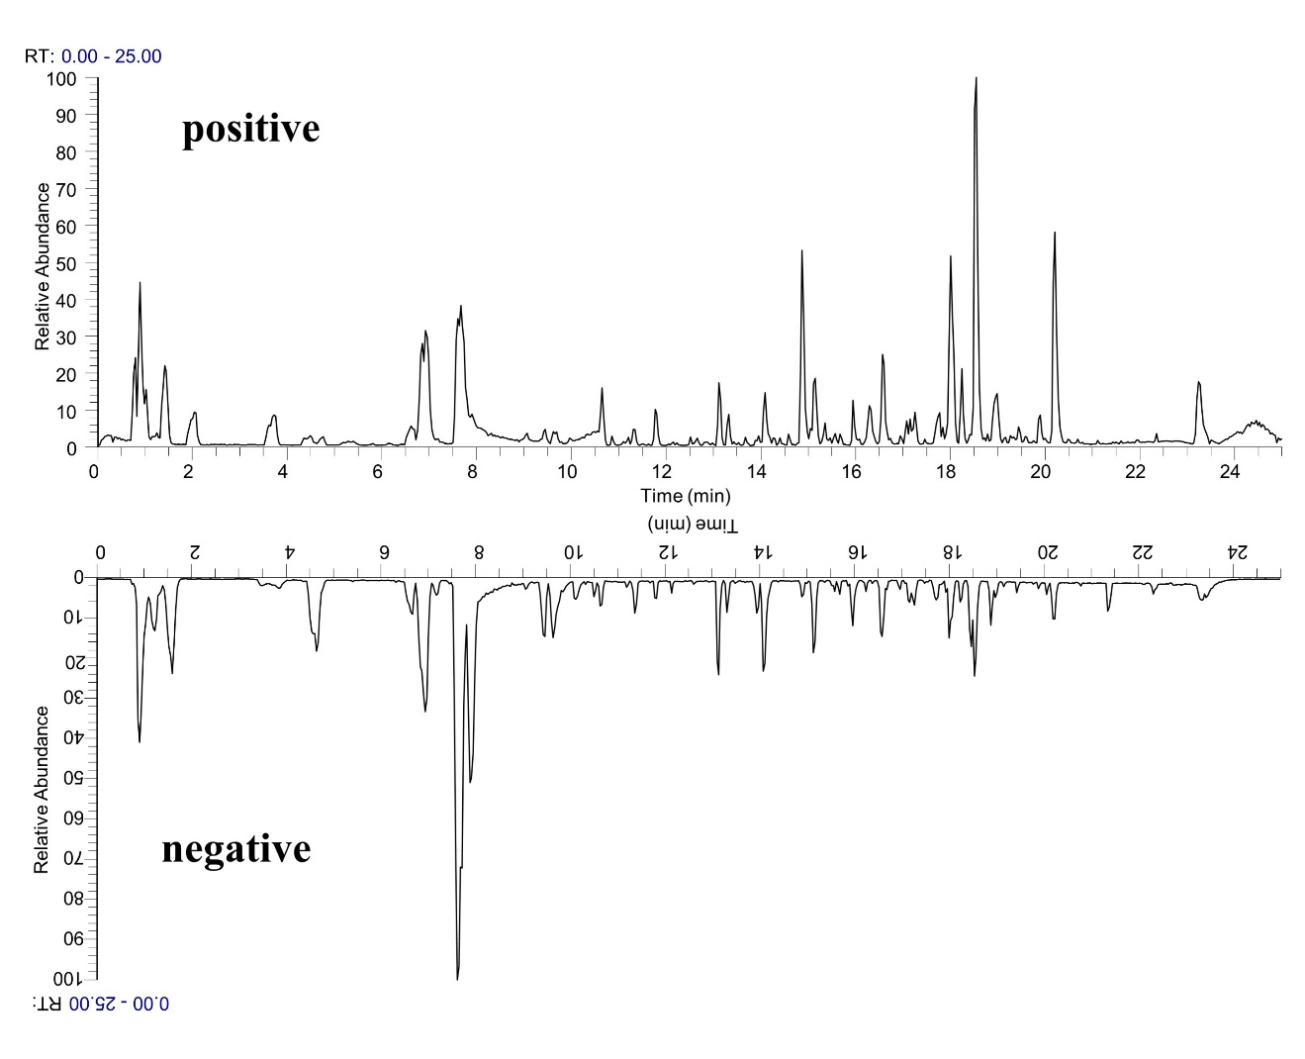
Fig. S3. UPLC-MS/MS base peak chromatograms of plasma samples after oral administration of RB-RPA

Table S8. Relative distance calculation between post-dose all time points metabolite profiles and pre-dose metabolite profile from the score plot of PCA with average value (x-axis and y-axis) of all samples. Values are presented as mean± SD, (n = 6).
pre-dose time point (0 h) |  | Each time points after administration | Distance
x-Axis (mean) | y-Axis (mean)
6.23 | 19.88 | 0.083 h | 11.42±0.92
 |  | 0.25 h | 17.62±0.71
 |  | 0.5 h | 20.75±0.63
 |  | 0.75 h | 19.89±0.68
 |  | 1 h  1.5 h | 26.52±0.74  29.45±0.78
 |  | 3 h  5 h  8 h  12 h  24 h | 34.66±0.89  29.81±1.31  27.71±0.98  26.41±1.52  14.15±0.86

Table S9. List of the altered endogenous metabolites in response to RB-RPA intervention, and the data were normalized by IS (glycyrrhizin). Values are presented as mean± SD, (n = 6).
No. | Metabolites | 0 h | 0.083 h |  | 0.25 h |  | 0.5 h | 0.75 h | 1 h | 1.5 h | 3 h | 5 h | 8 h | 12 h | 24 h
1 | DL-Ornithine | 0.158±0.023 | 0.118±0.044 | 0.198±0.053 |  | 0.186±0.061 |  | 0.213±0.077 | 0.241±0.064 | 0.233±0.074 | 0.251±0.089 | 0.271±0.091 | 0.223±0.078 | 0.143±0.088 |  | 0.166±0.053
2 | DL-Histidine | 0.252±0.032 | 0.291±0.036 | 0.277±0.064 |  | 0.312±0.088 |  | 0.201±0.092 | 0.365±0.076 | 0.292±0.043 | 0.321±0.071 | 0.387±0.085 | 0.282±0.065 | 0.221±0.083 |  | 0.232±0.095
3 | Choline | 2.392±0.143 | 2.434±0.264 | 2.954±0.942 |  | 1.432±0.743 |  | 1.954±0.533 | 3.481±0.768 | 3.734±1.059 | 4.066±1.235 | 3.893±1.188 | 3.622±1.365 | 3.283±0.845 |  | 2.717±0.974
4 | gamma-Aminobutyric acid | 0.064±0.018 | 0.057±0.016 | 0.071±0.022 |  | 0.078±0.021 |  | 0.084±0.029 | 0.091±0.033 | 0.121±0.038 | 0.109±0.031 | 0.092±0.034 | 0.112±0.044 | 0.074±0.024 |  | 0.055±0.020
5 | L-Glutamic acid | 0.205±0.021 | 0.242±0.033 | 0.165±0.077 |  | 0.294±0.038 |  | 0.223±0.065 | 0.399±0.051 | 0.378±0.072 | 0.449±0.051 | 0.456±0.066 | 0.476±0.083 | 0.418±0.079 |  | 0.375±0.067
6 | Valine | 5.557±1.824 | 5.508±1.792 | 5.834±1.943 |  | 6.285±1.921 |  | 7.021±2.191 | 8.651±2.624 | 9.214±2.415 | 9.008±2.149 | 8.771±3.012 | 7.363±3.131 | 6.411±2.341 |  | 5.913±2.041
7 | DL-Glutamine | 0.106±0.018 | 0.144±0.023 | 0.111±0.010 |  | 0.165±0.071 |  | 0.074±0.022 | 0.061±0.008 | 0.066±0.012 | 0.048±0.009 | 0.131±0.097 | 0.033±0.006 | 0.061±0.009 |  | 0.085±0.012
8 | alpha-Ketoglutaric acid | 0.177±0.033 | 0.182±0.041 | 0.204±0.039 |  | 0.288±0.044 |  | 0.331±0.025 | 0.387±0.044 | 0.433±0.049 | 0.398±0.032 | 0.353±0.025 | 0.319±0.030 | 0.234±0.041 |  | 0.199±0.036
9 | L-(-)-Asparagine | 0.063±0.007 | 0.049±0.011 | 0.041±0.008 |  | 0.068±0.014 |  | 0.075±0.012 | 0.085±0.017 | 0.051±0.014 | 0.077±0.011 | 0.058±0.008 | 0.031±0.005 | 0.064±0.006 |  | 0.059±0.010
10 | Citric acid | 0.104±0.011 | 0.097±0.008 | 0.143±0.052 |  | 0.088±0.023 |  | 0.079±0.018 | 0.066±0.027 | 0.071±0.010 | 0.050±0.009 | 0.047±0.006 | 0.069±0.011 | 0.121±0.032 |  | 0.087±0.029
11 | L-Tyrosine | 5.902±1.639 | 5.212±1.453 | 4.029±1.582 |  | 3.206±1.734 |  | 6.349±1.349 | 5.413±1.022 | 5.559±1.183 | 2.645±0.892 | 4.952±1.005 | 5.214±1.325 | 6.525±2.109 |  | 5.311±1.444
12 | Itaconic acid | 0.008±0.001 | 0.011±0.003 | 0.013±0.003 |  | 0.015±0.004 |  | 0.019±0.005 | 0.024±0.005 | 0.017±0.007 | 0.020±0.007 | 0.016±0.009 | 0.014±0.006 | 0.010±0.003 |  | 0.012±0.004
13 | Picolinic acid | 0.021±0.007 | 0.023±0.006 | 0.031±0.008 |  | 0.039±0.011 |  | 0.046±0.014 | 0.041±0.022 | 0.033±0.009 | 0.043±0.013 | 0.031±0.010 | 0.023±0.009 | 0.016±0.007 |  | 0.019±0.008
14 | DL-Tryptophan | 0.012±0.001 | 0.018±0.006 | 0.012±0.005 |  | 0.009±0.002 |  | 0.006±0.003 | 0.010±0.005 | 0.006±0.002 | 0.009±0.003 | 0.008±0.001 | 0.012±0.004 | 0.008±0.002 |  | 0.014±0.005
15 | N-Acetyl-L-leucine | 0.018±0.003 | 0.020±0.004 | 0.011±0.006 |  | 0.019±0.003 |  | 0.021±0.002 | 0.017±0.008 | 0.015±0.007 | 0.024±0.002 | 0.022±0.003 | 0.021±0.03 | 0.016±0.09 |  | 0.020±0.004
16 | L-Glutathione oxidized | 0.061±0.008 | 0.055±0.012 | 0.048±0.015 |  | 0.033±0.011 |  | 0.021±0.008 | 0.027±0.009 | 0.033±0.007 | 0.036±0.009 | 0.048±0.011 | 0.051±0.013 | 0.053±0.021 |  | 0.063±0.019
17 | Thymidine 5'-monophosphate | 0.143±0.022 | 0.121±0.034 | 0.130±0.028 |  | 0.157±0.042 |  | 0.128±0.036 | 0.119±0.042 | 0.123±0.039 | 0.114±0.027 | 0.126±0.033 | 0.119±0.029 | 0.133±0.042 |  | 0.139±0.038
18 | Taurochenodeoxycholic acid | 0.011±0.003 | 0.013±0005 | 0.015±0.06 |  | 0.012±0.005 |  | 0.009±0.002 | 0.010±0.004 | 0.008±0.001 | 0.007±0.001 | 0.009±0.003 | 0.011±0.004 | 0.008±0.003 |  | 0.010±0.002
19 | Cholic acid | 0.043±0.009 | 0.040±0.007 | 0.037±0.011 |  | 0.031±0.010 |  | 0.028±0.007 | 0.021±0.006 | 0.016±0.003 | 0.019±0.002 | 0.025±0.005 | 0.029±0.007 | 0.037±0.009 |  | 0.041±0.012
20 | α-Linolenic acid | 0.039±0.005 | 0.031±0.011 | 0.058±0.013 |  | 0.062±0.012 |  | 0.087±0.013 | 0.058±0.020 | 0.056±0.011 | 0.049±0.011 | 0.047±0.015 | 0.042±0.015 | 0.036±0.012 |  | 0.038±0.010
21 | LysoPC(18:3) | 0.123±0.032 | 0.126±0.029 | 0.113±0.041 |  | 0.108±0.036 |  | 0.103±0.049 | 0.095±0.015 | 0.107±0.021 | 0.093±0.035 | 0.087±0.022 | 0.097±0.017 | 0.118±0.019 |  | 0.114±0.020

