Table S1. Summary of RNA-seq data from barley shoots of the diploid and tetrploid barley (n=3).
 | Diploid |  |  |  | Tetrploid
 | D-1 | D-2 | D-3 |  | T-1 | T-2 | T-3
Raw bases (Gb) | 7.41 | 7.41 | 7.41 |  | 7.41 | 7.41 | 7.41
Clean bases (Gb) | 6.73 | 6.82 | 6.77 |  | 6.74 | 6.75 | 6.87
Q30 (%) | 92.75 | 93.28 | 93.15 |  | 92.93 | 92.79 | 93.24
GC (%) | 56.09 | 56.72 | 56.39 |  | 56.83 | 56.63 | 56.54

Table S2. Details of the eleven differential expressed genes and nucleotide sequences of primers used in the qRT-PCR analyses.
Gene Id/name | Description/annotation | Primer nucleotide sequence (5′-3′) | Amplicon (bp) | PCR efficiency | Origin
HORVU1Hr1G088900 | Chlorophyll a-b binding protein, chloroplastic | F: CGGCTGATCCTGAGACCTTC | 193 | 1.774 | This study
 |  | R: GGGTTGCCAAGGTAGTCGAG
HORVU1Hr1G088920 |  | F: AAGGCGGTGAAGAATGTCCC | 131 | 1.798
 |  | R: AGGTAGAGCACACGATCAGC
HORVU1Hr1G089180 |  | F: CCCTGAAGAACTTGCCCTCG | 197 | 1.754
 |  | R: GGTGTCCCATCCGTAGTCAC
HORVU6Hr1G016850 |  | F: ATCGTCAACTCTCTTCGGCG | 179 | 1.793
 |  | R: TGTCCCACCCATAGTCACCA
HORVU6Hr1G016880 |  | F: GAGATCAAGAACGGTCGCCT | 148 | 1.777
 |  | R: CAAAGTTGGTAGCGAACGCC
HORVU6Hr1G016940 |  | F: GACAACCTCGCTGACCACAT | 83 | 1.784
 |  | R: CCTTACTTGCCGGGGACAAA
HORVU6Hr1G091650 |  | F: GCTGATCGTGTGCTCTACCT | 198 | 1.798
 |  | R: CAACTCAGGGAACACGCA
HORVU6Hr1G091660 |  | F: GCTGATCGTGTGCTCTACCT | 198 | 1.777
 |  | R: CAACTCAGGGAACACGCAAC
HORVU7Hr1G040370 |  | F: TGCTGATCGTGTGCTCTACC | 168 | 1.811
 |  | R: AGCATAGCCCATCGACAGTG
HORVU7Hr1G040380 |  | F: CCTCGACTATCTCGGCAACC | 81 | 1.793
 |  | R: CCCATGAGCACAACTTGGCA
GAPDH | glycolytic glyceraldehyde-3-phosphate  dehydrogenase | F: AAGCATGAAGATACAGGGAGTGTG | 74 | 1.769 | Quan et al., 2016
 |  | R: AATTTATTCTCGGAAGAGGTTGTACA

Table S3. The length and width of seed and shoot dry weight of diploid and tetraploid barley
Ploidy | Seed length (mm) | Seed width (mm) | Shoot dry weight (g)
Diploid | 9.05±0.65a | 3.05±0.26a | 0.1045±0.0199a
Tetraploid | 11.22±0.84b | 4.01±0.36b | 0.1380±0.0374b
Values represent the mean ± standard deviation (n=30 for seed length and seed width, while n=15 for shoot dry weight). Different letters indicate significant differences between the diploid and tetraploid barley for each trait.

Figure S1. Spearman correlations and principal component analysis (PCA) for gene expressions of all samples. A. Spearman correlations. B. PCA. D-1,2,3 represent three biological replicates of the diploid barley; T-1,2,3 represent three biological replicates of the tetraploid barley.

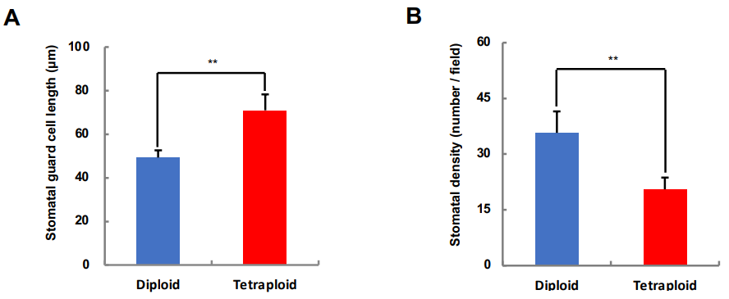
Figure S2. The length of stomatal guard cell and stomatal density of the diploid and teraploid barley. A. The length of stomatal guard cell. B. The stomatal density. “**” represents significant difference between the diploid and tetraploid barley at 0.01 level by t test (n=55 for the stomatal guard cell length, while n=15 for the stomatal density).

