S1 Table – Crude concentrations of eleven cytokines and six chemokines in the cervicovaginal lavage of 212 Zambian women

Analyte | % (n)  Above LLOQ | Median (IQR) *  concentration | Mean (SD) *  concentration | LLOQ  Serum | LLOQ  CVL
Eotaxin | 73.6 (156) | 4.83 (3.60 – 6.64) | 5.22 (2.46) | 4.0 | 0.98
Interferon–γ | 84.0 (178) | 1.03 (0.70 – 1.67) | 2.03 (4.44) | 0.8 | 0.33
IL–10 | 90.1 (191) | 1.21 (0.75 – 2.55) | 2.53 (6.00) | 1.1 | 0.33
IL–13 | 32.6 (69) | 0.76 (0.49 – 1.35) | 1.10 (1.09) | 1.3 | 0.31
IL–15 | 47.2 (100) | 0.75 (0.48 – 1.24) | 1.09 (1.10) | 1.2 | 0.34
IL–17A | 93.4 (198) | 1.52 (0.92 – 3.04) | 4.32 (14.64) | 0.7 | 0.26
IL1–α | 99.5 (211) | 50.00 (19.89 – 164.86) | 225.99 (551.30) | 9.4 | 0.97
IL1–β | 93.4 (198) | 13.05 (2.88 – 72.83) | 161.49 (414.08) | 0.8 | 0.35
IL–4 | 96.2 (204) | 2.87 (1.63 – 5.03) | 3.86 (3.49) | 4.5 | 0.31
IL–5 | 17.0 (36) | 0.50 (0.38 – 0.72) | 0.64 (0.54) | 0.5 | 0.32
IL–6 | 87.7 (186) | 4.09 (1.56 – 13.66) | 13.54 (43.36) | 0.9 | 0.32
IL–8 | 100.0 (212) | 531.22 (230.01 – 1268.70) | 1034.25 (1261.70) | 0.4 | 5.66
IP–10 | 100.0 (212) | 101.74 (32.66 – 276.30) | 393.23 (1143.74) | 8.6 | 1.37
MCP–1 | 100.0 (212) | 27.84 (8.15 – 72.09) | 76.83 (191.26) | 1.9 | 1.03
MIP1–α | 98.1 (208) | 4.27 (2.12 – 15.04) | 13.18 (27.32) | 2.9 | 0.55
MIP1–β | 83.5 (177) | 2.02 (0.85 – 5.44) | 6.59 (19.29) | 3.0 | 0.28
TNF–α | 41.0 (87) | 1.18 (0.53 – 3.77) | 4.99 (13.04) | 0.7 | 0.32

Abbreviations: IQR – interquartile range, LLOQ – lower limit of quantification, SD – standard deviation, CVL – cervicovaginal lavage

* Concentrations are reported in pg/mL

This table shows the concentrations of soluble immune proteins prior to imputation for those analytes below the limit of quantification.

S2 Table – Principal component analysis on data from log-transformed cytokines and chemokines

 | Comp1 | Comp2 | Comp3 | Comp4 | Comp5 | Comp6 | Comp7 | Comp8 | Comp9 | Comp10 | Comp11 | Comp12 | Comp13 | Comp14 | Comp15 | Comp16 | Comp17
Eotaxin | 0.099 | 0.597 | -0.123 | 0.295 | -0.343 | 0.423 | 0.214 | -0.098 | -0.132 | 0.266 | 0.196 | 0.011 | 0.008 | 0.099 | 0.012 | 0.201 | 0.051
INF–γ | 0.258 | 0.154 | -0.158 | -0.234 | -0.099 | -0.119 | -0.585 | -0.149 | 0.147 | 0.364 | 0.017 | -0.159 | -0.241 | -0.095 | 0.432 | -0.048 | -0.072
IL–10 | 0.295 | 0.026 | -0.021 | -0.094 | -0.232 | -0.272 | -0.170 | -0.023 | 0.166 | -0.110 | -0.197 | 0.038 | -0.023 | 0.049 | -0.453 | 0.652 | 0.181
IL–13 | 0.262 | -0.020 | -0.262 | -0.334 | -0.003 | 0.091 | 0.228 | -0.153 | -0.105 | -0.285 | -0.165 | 0.200 | 0.480 | -0.066 | 0.472 | 0.207 | -0.088
IL–15 | 0.268 | 0.284 | -0.205 | -0.074 | 0.202 | 0.366 | -0.254 | 0.026 | -0.340 | -0.246 | -0.074 | -0.528 | 0.063 | 0.091 | -0.330 | -0.098 | -0.224
IL–17a | 0.248 | 0.225 | -0.076 | 0.261 | 0.140 | -0.178 | -0.257 | 0.583 | -0.370 | -0.132 | -0.043 | 0.402 | -0.023 | -0.086 | 0.089 | -0.089 | 0.127
IL1–α | 0.206 | -0.212 | -0.336 | 0.333 | 0.430 | 0.078 | -0.044 | -0.052 | 0.349 | 0.211 | 0.387 | 0.106 | 0.244 | -0.265 | -0.135 | 0.129 | -0.043
IL1–β | 0.265 | -0.284 | 0.008 | 0.299 | 0.182 | 0.064 | 0.180 | 0.102 | 0.065 | 0.093 | -0.219 | -0.287 | -0.146 | 0.466 | 0.348 | 0.114 | 0.407
IL–4 | 0.260 | 0.310 | -0.075 | 0.161 | -0.151 | -0.075 | 0.102 | -0.003 | 0.571 | -0.293 | -0.264 | -0.075 | 0.105 | -0.043 | -0.087 | -0.506 | 0.050
IL–5 | 0.225 | 0.014 | -0.278 | -0.437 | 0.034 | -0.083 | 0.521 | 0.373 | 0.046 | 0.132 | 0.175 | -0.085 | -0.420 | -0.118 | -0.098 | -0.037 | -0.061
IL–6 | 0.246 | -0.175 | 0.367 | 0.029 | -0.076 | 0.239 | 0.098 | 0.155 | -0.041 | 0.478 | -0.492 | 0.029 | 0.148 | -0.381 | -0.091 | -0.028 | -0.169
IL–8 | 0.259 | 0.089 | 0.143 | 0.247 | 0.269 | -0.157 | 0.191 | -0.541 | -0.211 | -0.190 | -0.108 | 0.119 | -0.474 | -0.218 | 0.030 | 0.037 | -0.189
IP–10 | 0.163 | 0.395 | 0.369 | -0.221 | 0.420 | -0.351 | 0.107 | -0.072 | -0.060 | 0.262 | 0.132 | -0.111 | 0.360 | 0.271 | -0.093 | -0.053 | 0.019
MCP–1 | 0.190 | 0.036 | 0.464 | -0.285 | 0.168 | 0.535 | -0.151 | 0.051 | 0.254 | -0.250 | 0.243 | 0.249 | -0.185 | 0.007 | 0.033 | 0.044 | 0.204
MIP1–α | 0.267 | -0.188 | 0.264 | 0.196 | -0.293 | -0.126 | 0.017 | 0.188 | 0.099 | -0.118 | 0.305 | -0.010 | 0.027 | 0.298 | 0.126 | 0.071 | -0.649
MIP1–β | 0.266 | -0.200 | 0.198 | 0.040 | -0.344 | -0.166 | 0.051 | -0.098 | -0.252 | -0.103 | 0.407 | -0.288 | 0.163 | -0.374 | 0.030 | -0.157 | 0.420
TNF–α | 0.266 | -0.275 | -0.179 | -0.128 | -0.174 | 0.046 | -0.041 | -0.286 | -0.169 | 0.222 | 0.026 | 0.463 | -0.003 | 0.403 | -0.277 | -0.385 | 0.092
POV | 0.519 | 0.087 | 0.081 | 0.062 | 0.046 | 0.037 | 0.027 | 0.024 | 0.021 | 0.018 | 0.017 | 0.015 | 0.013 | 0.011 | 0.011 | 0.007 | 0.005
CPOV | 0.519 | 0.606 | 0.687 | 0.749 | 0.795 | 0.831 | 0.856 | 0.882 | 0.903 | 0.921 | 0.939 | 0.954 | 0.966 | 0.977 | 0.989 | 0.995 | 1.000

Abbreviations: Comp – component, CPOV – cumulative proportion of variance explained, IL–interleukin, INF –γ Interferon-γ, MCP1 – monocyte chemoattractant protein-1, MIP1-α – macrophage inflammatory protein 1–α, MIP1-β – macrophage inflammatory protein 1-β, POV – proportion of variance explained, TNF-α – Tumor necrosis factor–α

S1 Figure – Causal diagram for the association between FGS and a concentration change of cytokines and chemokines

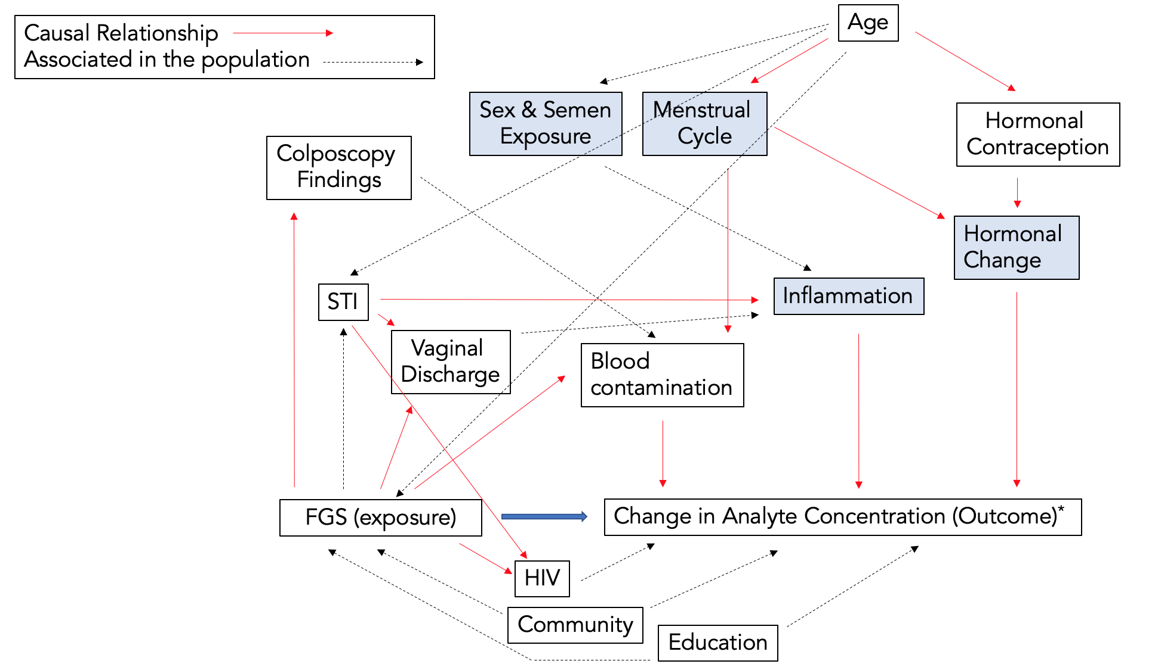

Shaded items were not measured objectively.

Adapted from Francis SC, et al. Immune Activation in the Female Genital Tract: Expression Profiles of Soluble Proteins in Women at High Risk for HIV Infection. PloS one (2016) 11(1):e0143109.

S2 Figure – Spearman’s Rank Correlations by Cytokine and Chemokine Panel

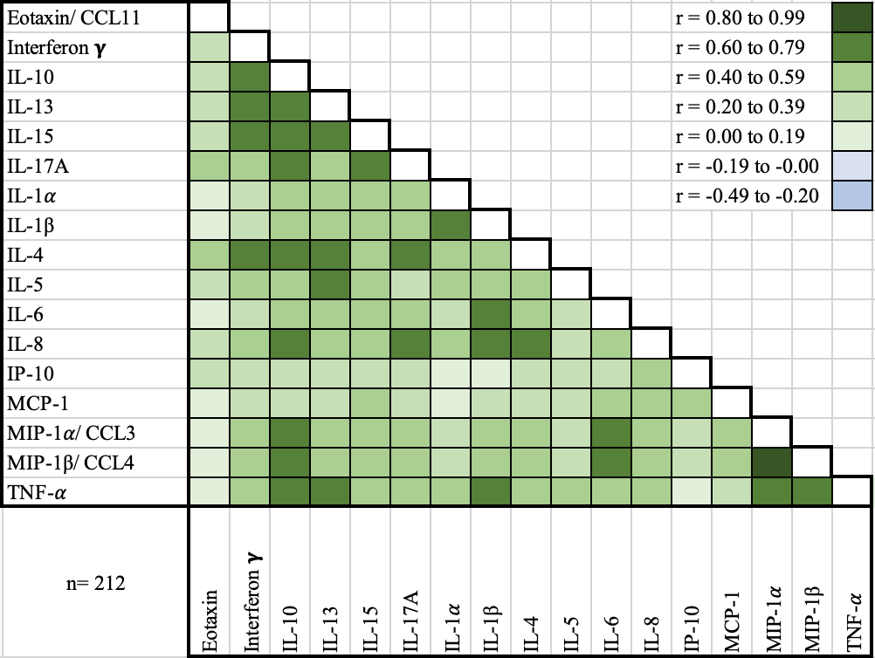

S3 Figure – Scatterplot of the first two principal component scores by FGS Status

S4 Figure – Median with interquartile range of the log-transformed crude concentrations of eleven cytokines and six chemokines in cervicovaginal lavage of participants with FGS and Probable FGS (n=53) and without female genital schistosomiasis (FGS negative: n=159)^{χ}

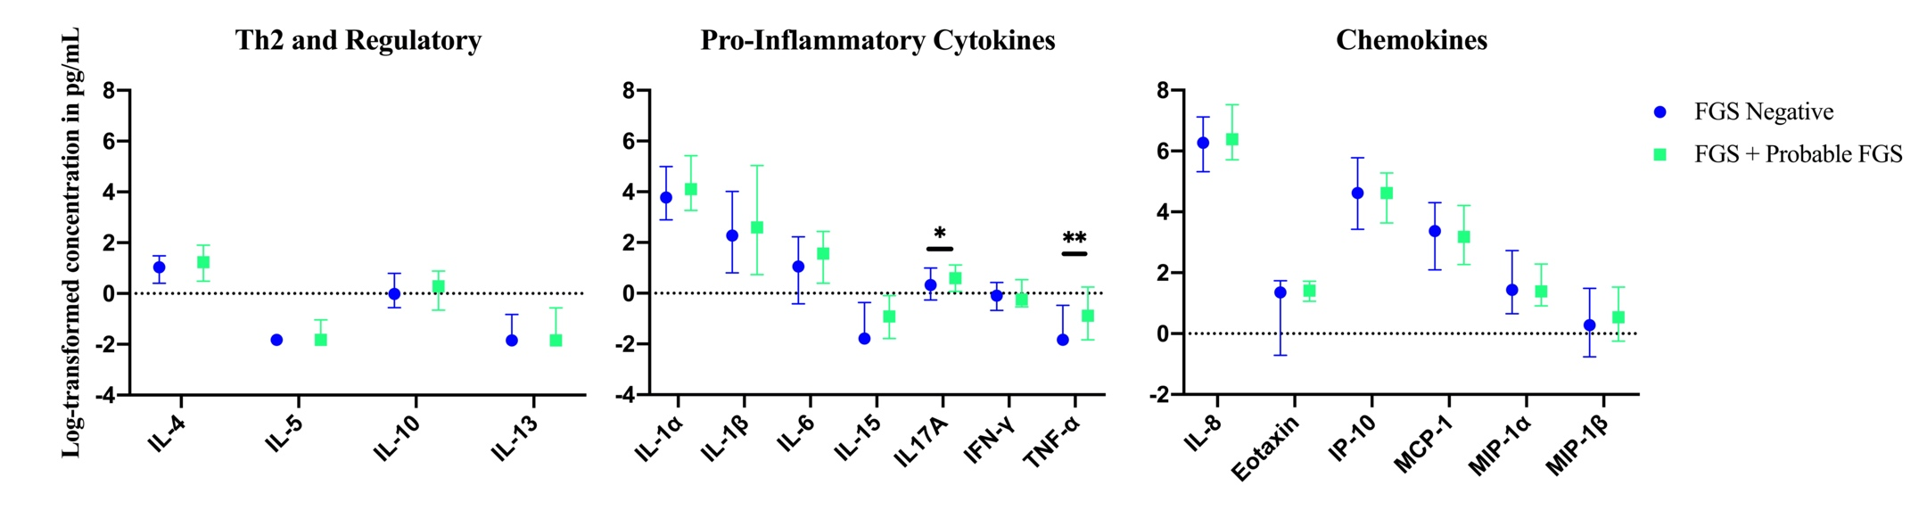

S4 Figure Caption
^{χ}FGS – Schistosoma PCR positive specimen from cervicovaginal lavage, vaginal swab or cervical swab; FGS negative – negative genital PCR and negative circulating anodic antigen and negative urine microscopy and negative expert-reviewed colposcopy imaging
p-value after adjustment for multiple testing with a Monte-Carlo simulation approach, p=0.09

p-value symbol legend:
*p<0.1
**p<0.05

S5 Figure – Comparison of the concentration or presence of eleven cytokines and six chemokines in cervicovaginal lavage in participants with (FGS + Probable FGS, n=53) and without (negative FGS, n=159) female genital schistosomiasis^{χ}

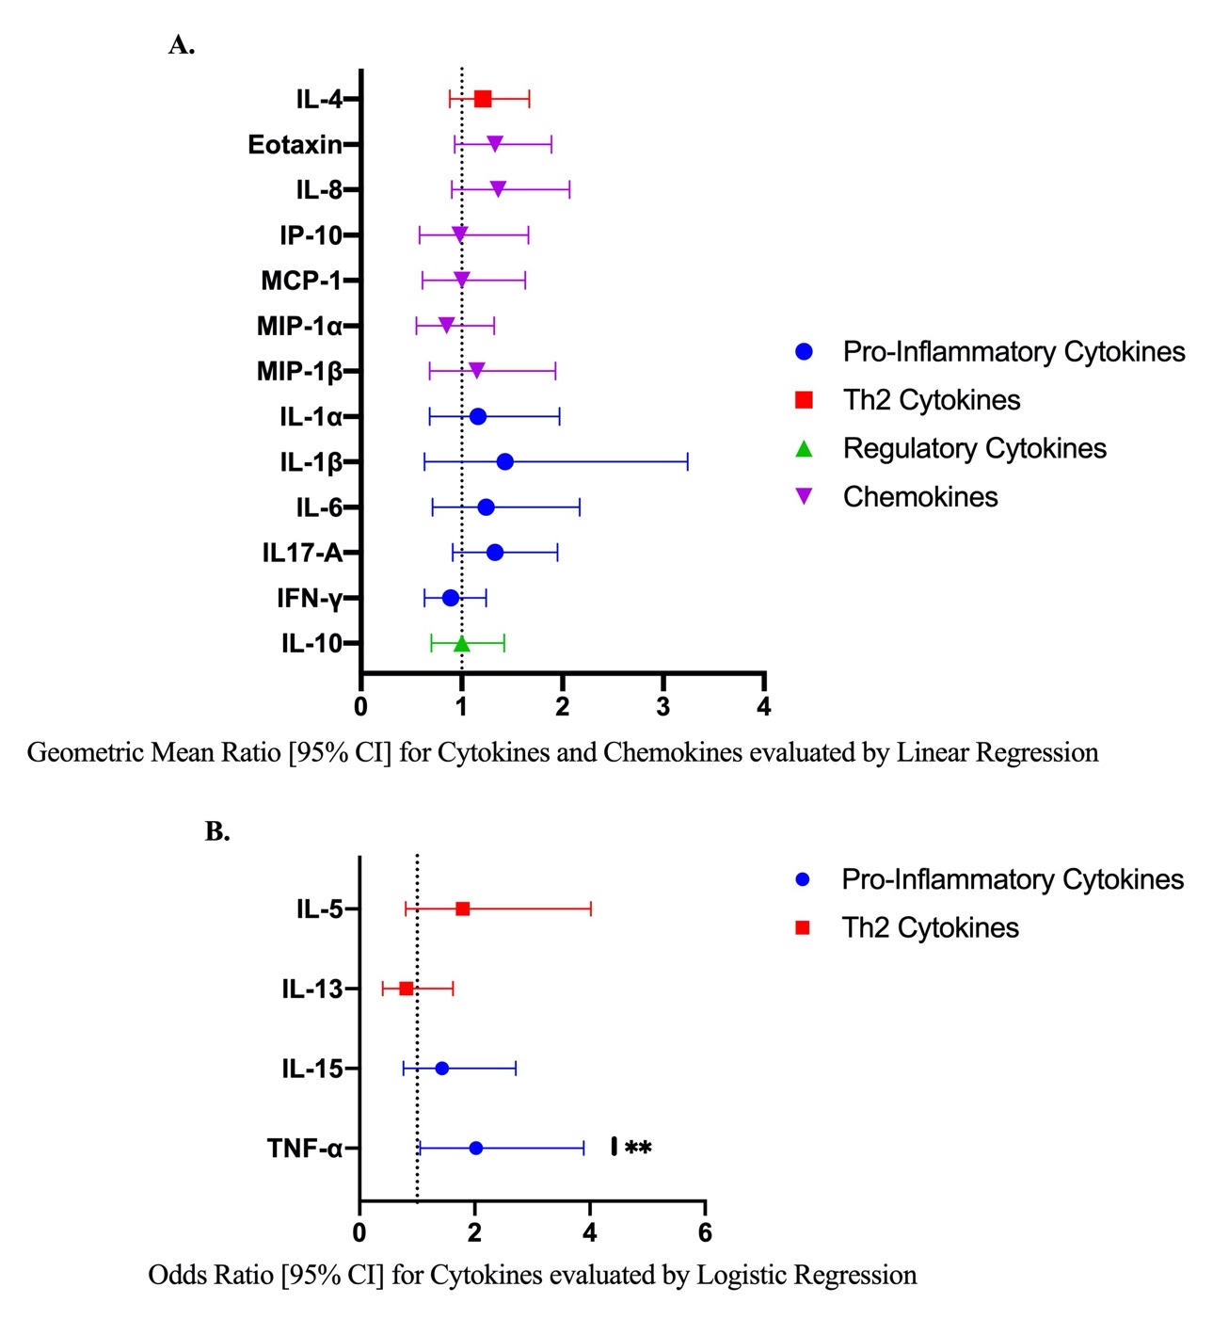

Figure S5 Caption
A. Concentrations of eotaxin, IFN-γ, IL-1α, IL-1β, IL-4, IL-6, IL-8, IL-10, MCP-1, MIP-1α, and MIP-1β were compared between FGS and FGS negative by linear regression adjusted for age, community of residence, education, presence of sexually transmitted infection and hormonal contraceptive use, with results shown as geometric mean ratios with 95% CI.

B. Presence/absence of IL-5, IL-13, IL-15 and TNF-α were compared by logistic regression and adjusted for age and sexually transmitted infection, with results shown as odds ratio with 95% CI.
The line at 1 indicates the value at which there is no difference between the FGS and negative FGS groups

p-value symbol legend:
**p<0.05

^{χ}female genital schistosomiasis – Schistosoma PCR positive specimen from cervicovaginal lavage, vaginal swab or cervical swab; FGS negative – negative genital PCR and negative urine circulating anodic antigen and negative urine microscopy and negative expert-reviewed colposcopy imaging

S6 Figure – Sensitivity analysis: Median with interquartile range of the log-transformed concentrations of eleven cytokines and six chemokines in cervicovaginal lavage by FGS Status (FGS: n=23, FGS negative: n=133), participants with HIV-1 excluded^{χ}

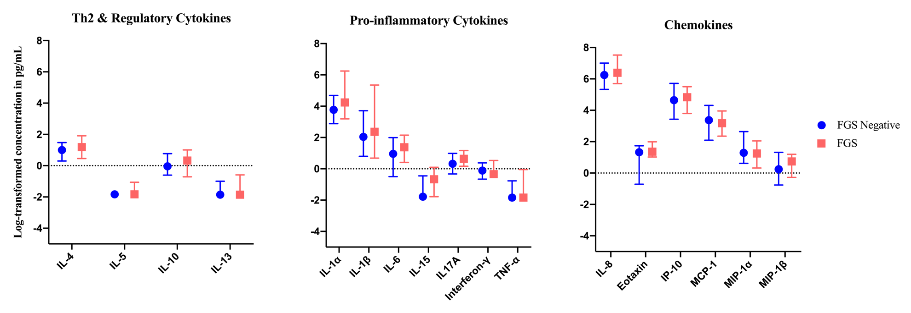

^{χ}FGS – PCR positive specimen from cervicovaginal lavage, vaginal swab or cervical swab; FGS negative – negative Schistosoma PCR and negative circulating anodic antigen and negative urine microscopy and negative expert-reviewed colposcopy imaging

All p-values are greater than 0.1

S7 Figure – Sensitivity analysis: Median with interquartile range of the log-transformed crude concentrations of eleven cytokines and six chemokines in cervicovaginal lavage by FGS Status (FGS: n=8, FGS negative: n=57), participants with hemoglobin detected in cervicovaginal lavage excluded^{χ}

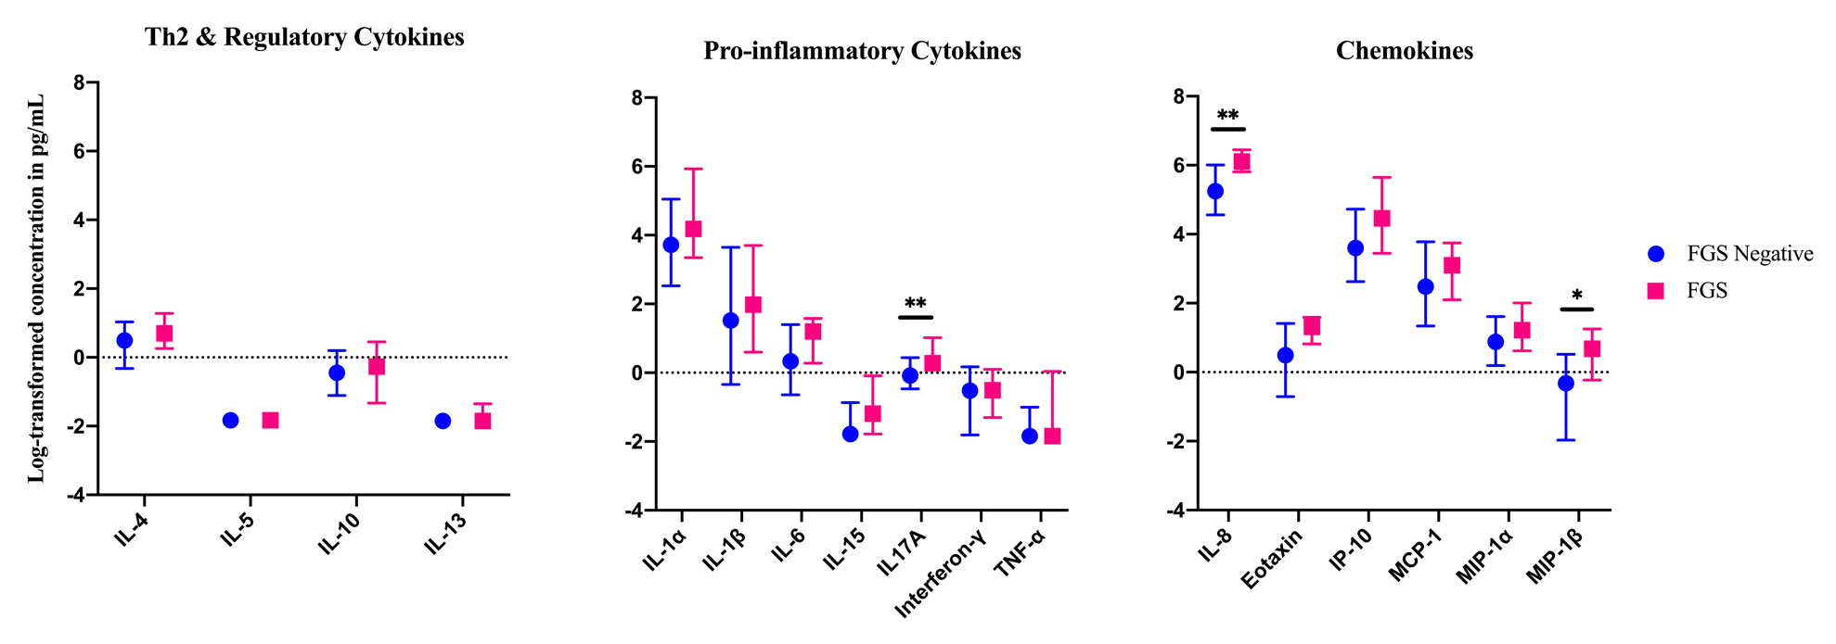

^{χ}FGS – PCR positive specimen from cervicovaginal lavage, vaginal swab or cervical swab; FGS negative – negative Schistosoma PCR and negative circulating anodic antigen and negative urine microscopy and negative expert-reviewed colposcopy imaging
p-value after adjustment for multiple testing with a Monte-Carlo simulation approach, p=0.13

p-value symbol legend:
*p<0.1
** p<0.05

