Atmospheric and oceanographic forcing impact particle flux composition and carbon sequestration in the Eastern Mediterranean Sea: a three-year time-series study in the deep Ierapetra Basin (Pedrosa-Pamies et al., 2021)
Supplementary Material

Table S1. Location, depth, and collection date of sediment samples.
Sample  Code | Latitude  (N) | Longitude  (E) | Water depth (m) | Date of collection | Physiographic regions
Ierapetra Basin
Red13 | 34.95 | 25.93 | 1101 | Juny-12 | Cretan-Rhodes Ridge
BF19 | 34.51 | 25.76 | 1200 | Juny-09 | Hellenic Trench
BF22 | 34.48 | 25.87 | 2015 | Juny-09 | Hellenic Trench
Red15.1 | 34.61 | 25.92 | 2428 | Juny-12 | Hellenic Trench
Red1.1 | 34.40 | 26.25 | 3568 | Juny-12 | Hellenic Trench
Ier01 | 34.44 | 26.19 | 3626 | Jan-07 | Hellenic Trench
Open Sea
Rho02 | 35.62 | 27.70 | 1305 | Jan-07 | Rhodes Strait
Her01 | 33.92 | 27.74 | 2680 | Jan-07 | EM Ridge
BF24 | 34.15 | 25.57 | 2902 | Juny-09 | Pliny Trench
Her03 | 33.67 | 29.00 | 3090 | Jan-07 | Herodotus Basin
January 2007 samples were collected during the M71 (Leg 3) cruise onboard the R/V Meteor (University of Hamburg, Germany), June 2009 samples during the Biofun1 cruise onboard the R/V Sarmiento de Gamboa (CSIC-UB, Spain), May 2010, 2011 and June 2012 samples during the ReDEco cruises onboard the R/V Aegaeo (HCMR, Greece).

Figure S1. Plot of the percentage of particulate organic carbon (POC) vs a) lithogenic, b) carbonates (CaCO₃) and c) opal in settling particles. Symbol shapes correspond to different seasons: spring (square: March, April, May), summer (diamond: June, July, August), fall (circle: September, October, November) and winter (triangle: December, January, February); color corresponds to sampling year.

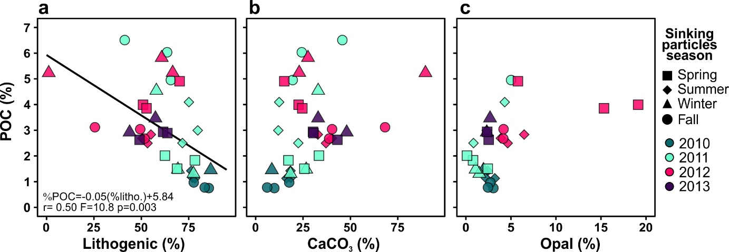

Figure S2. Pearson correlation heatmap matrix with significance level expressed by asterisks (*** p-value≤0.001, ** p-value≤0.05, *p-value≤0.1) of each season POC-normalized concentrations of lipid biomarkers, CPI_{NA}, total atmospheric deposition and net primary production. Positive correlations are displayed in blue and negative correlations in red color. Color intensity is proportional to the correlation coefficients.

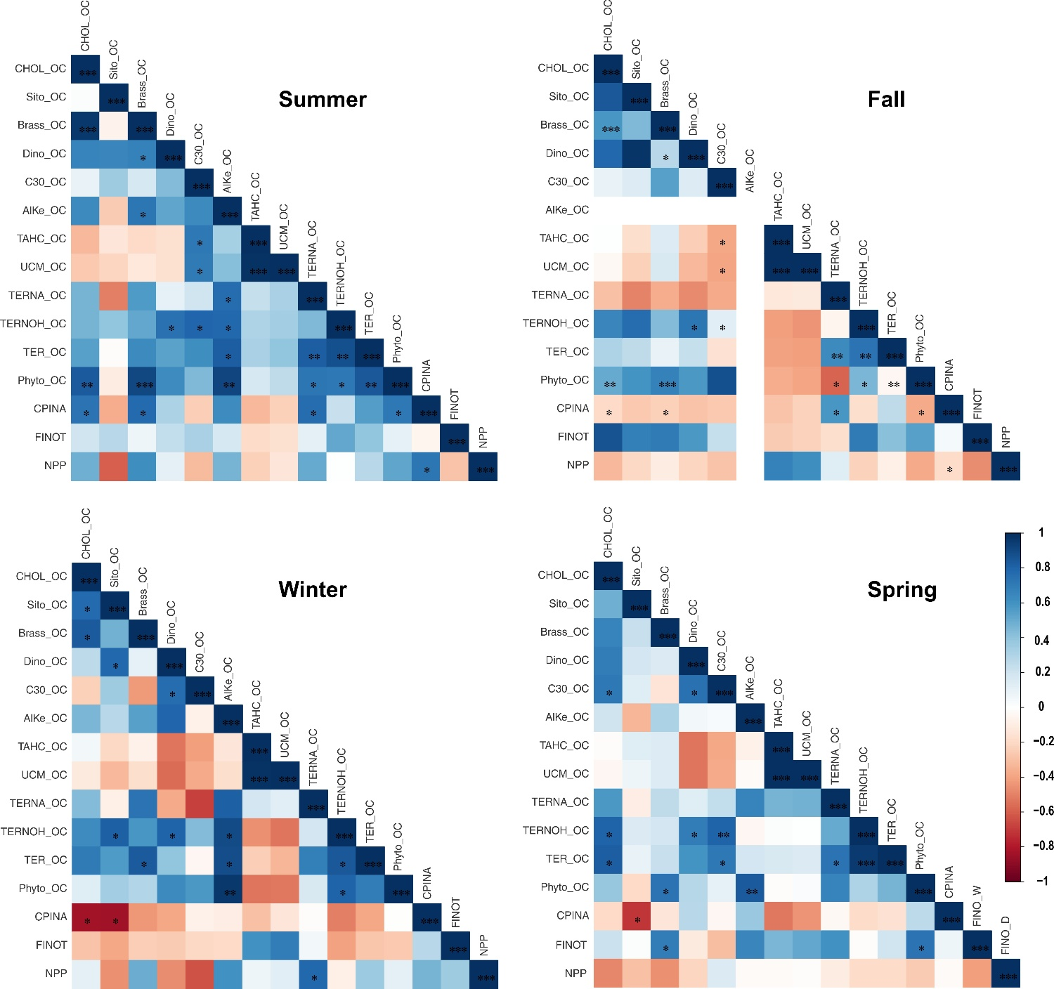

Figure S3. Air mass 5-day back trajectories arriving at 1000m (red line) and 3000m (blue line) above Finokalia (35º 20' N, 25º 40' E) on July 27th 2011 at 12 UTC. Points in the trajectories are marking intervals of 6 hours. In summer (July) 2011 high aerosol dry deposition has been recorded, associated with air masses from the south, carrying significant amounts of desert dust. Air masses are also marked by local influence and are associated with relatively high TERNA, TERNOH and CPI.
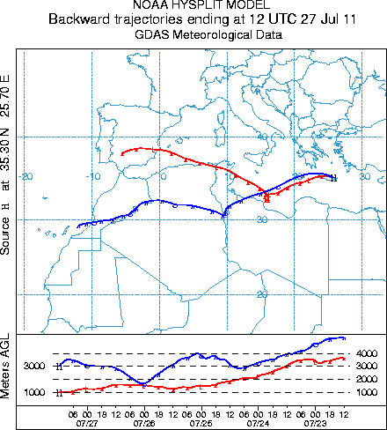

Figure S4. Air mass 5-day back trajectories arriving at 1000m (red line) and 3000m (blue line) above Finokalia (35º 20' N, 25º 40' E) on May 22th (top left) and 29th (top right), and on April 28th (bottom left) and May 23rd 2013 at 12 UTC. Points in the trajectories are marking intervals of 6 hours. In spring 2013 air masses arriving at Finokalia have been enriched in material from land affected by both south and north continental areas surrounding the Mediterranean Sea. Therefore, it is expected that atmospheric deposition in spring 2013 will be rich in land originating material.

Figure S5. Air mass 5-day back trajectories arriving at 1000m (red line) and 3000m (blue line) above Finokalia (35º 20' N, 25º 40' E) on September 18th (left) and 20th (right) 2011 at 12 UTC. Points in the trajectories are marking intervals of 6 hours. In September 2011 when high total atmospheric deposition has been recorded, air masses had significant continental and regional influence, either coming from the northeast and sweeping the Balkans and Turkey (18th Sept 2011) or having strong regional character (sweeping the west coast of Turkey, Peloponnesus and then returning eastwards to reach the station from the West (20th Sept 2011), while higher up air masses came from the African continent. Therefore, during this period atmospheric deposition provided terrestrial material from soil dust and vegetation to the ocean and this was associated with the highest TERNA, TERNOH concentrations.
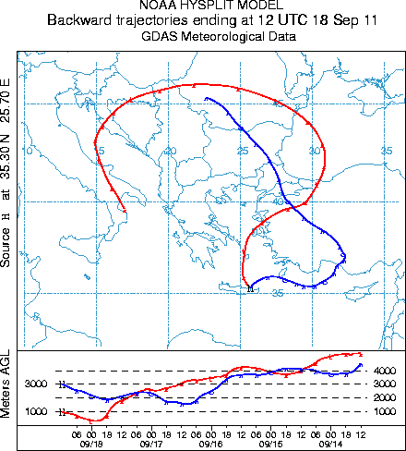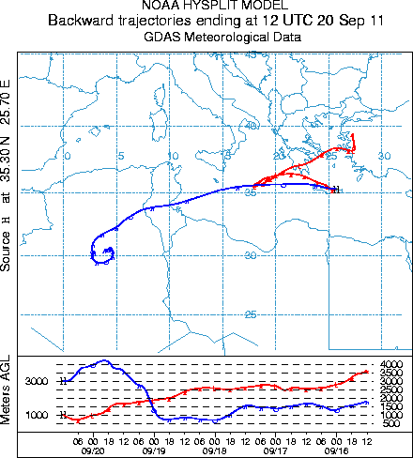

Figure S6. Air mass 5-day back trajectories arriving at 1000m (red line) and 3000m (blue line) above Finokalia (35º 20' N, 25º 40' E) on February 8th (left) and 24th (right) 2011 at 12 UTC. Points in the trajectories are marking intervals of 6 hours. Note that the trajectories indicate the center of gravity of the transported air mass plume. The bottom plot in each panel shows the height (meters above ground level) through which the air mass was transported. Therefore, in February 2011 that was a winter month with high wet and dry atmospheric deposition, air masses were significantly influenced by land, either coming from the Atlantic close-by the northwest Africa and reaching the East Mediterranean after having swept Central and Eastern Europe, overpassing Istanbul and the west coast of Turkey (8 Feb), or directly coming from the African continent thus rich in desert dust particles (24 Feb). Atmospheric deposition during that period had a continental signature as seen by the high UCM peak detected in the sediment trap.

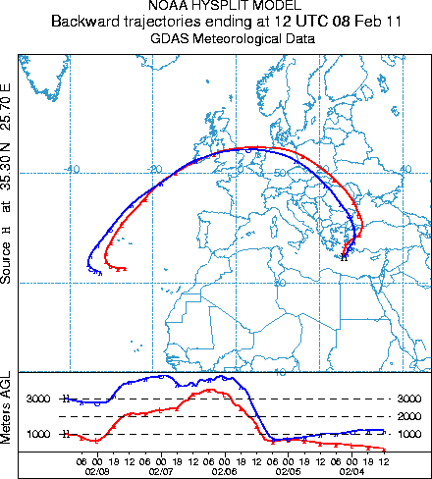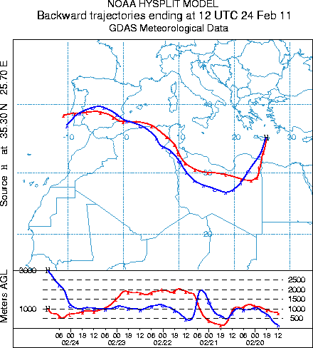

Figure S7. Air mass 5-day back trajectories arriving at 1000m (red line) and 3000m (blue line) above Finokalia (35º 20' N, 25º 40' E) on February 7th (left) and 16th (center) and 27th (right) 2012 at 12 UTC. Points in the trajectories are marking intervals of 6 hours. In February 2012 air masses were arriving at Finokalia station from the west, having passed over south Italy/Sicily and thereby on their way to Finokalia they have collected pollutants emitted from Etna. In addition, the 5-day back trajectories show that during the first part of the month, the air masses arriving at Finokalia in the low free troposphere have been subjected to long-range transport from the Atlantic Ocean or even the North American coast. During the second part of February, the air masses arriving at Finokalia at 3 km a.s.l. had a more regional character and coming from the west have been also enriched by Sahara dust aerosol.

Figure S8. Air mass 5-day back trajectories arriving at 1000m (red line) and 3000m (blue line) above Finokalia (35º 20' N, 25º 40' E) on March 6th (left) and 9th (center) and 26th (right) 2012 at 12 UTC. Points in the trajectories are marking intervals of 6 hours. The west flow of air masses shown in Fig. S7 remains also during the first part of March, when the air masses were influenced by volcanic activities in the Etna region together with marine emissions for the Mediterranean Sea but also from land emissions over Africa (first part of the month) or Central Europe and long-range transport (second part of the month). Therefore, atmospheric deposition during this month integrates all potential sources surrounding the East Mediterranean, including Etna’s emissions, except the East sector source (sources in the Middle-East).

