Deficiency of dietary fiber modulates gut microbiota composition, neutrophil recruitment and worsens experimental colitis

Sj Shen¹, Kathryn Prame Kumar¹, Shu Wen Wen¹, Raymond Shim¹, Brooke J. Wanrooy¹, Dragana Stanley², Robert J. Moore^{3, 4}, Thi Thu Hao Van⁴, Remy Robert⁵, Michael J. Hickey¹ and Connie H. Y. Wong^{1,} *

¹ Centre for Inflammatory Diseases, Department of Medicine, School of Clinical Sciences at Monash Health, Monash Medical Centre, Monash University, Clayton, Victoria, Australia.
² School of Health Medical and Applied Sciences, Central Queensland University, Rockhampton, Australia;
³ Infection and Immunity Program, Monash Biomedicine Discovery Institute and Department of Microbiology, Monash University, Australia;
⁴ School of Science, Royal Melbourne Institute of Technology (RMIT) University, Australia;
⁵ Monash Biomedicine Discovery Institute and Department of Physiology, Monash University, Clayton, Victoria, Australia.

*Address for correspondence: Connie H. Y. Wong, PhD., Centre for Inflammatory Diseases, Department of Medicine, School of Clinical Sciences at Monash Health, Monash Medical Centre, Monash University, Clayton, VIC 3168 Australia; Email: connie.wong@monash.edu

Running title: Dietary fiber and neutrophil recruitment

Data deposition statement:
All the sequencing data are submitted to the Metagenomics Analysis Server (MG-RAST) under project ID 433886.

Supplementary material
Supplementary Tables: 4
Supplementary Figures: 5

Supplemental Table 1. Composition of the experimental diets.

 | Control (Ctrl) diet | No fibre (NF) diet
Diet code from Specialty Feeds | SF09-091  (g/kg) | SF09-028  (g/kg)
Casein (Acid) | 200 | 200
Sucrose | 100 | 0
Canola Oil | 70 | 70
Cellulose | 50 | 0
Wheat Starch | 399 | 0
Dextrinised Starch | 132 | 0
DL Methionine | 3.0 | 3.0
Calcium Carbonate | 13.1 | 13.1
Sodium Chloride | 2.6 | 2.6
AIN93 Trace Minerals | 1.4 | 1.4
Potassium Citrate | 2.5 | 2.5
Potassium Dihydrogen Phosphate | 6.9 | 6.9
Potassium Sulphate | 1.6 | 1.6
Choline Chloride (75%) | 2.5 | 2.5
AIN93 Vitamins | 15 | 10
Vitamin K Supplement | 0.87 | 0
Dextrose Monohydrate | 0 | 686

Supplemental Table 2. Primer sequences

Primer target |  | Sequence (5’ – 3’)
18S | F | CTT AGA GGG ACA AGT GGC G
 | R | ACG CTG AGC CAG TCA GTG TA
Cxcl1 | F | CCG AAG TCA TAG CCA CAC TCA A
 | R | GCA GTC TGT CTT CTT TCT CCG TTA C
Cxcl2 | F | CCA ACC ACC AGG CTA CAG G
 | R | GCG TCA CAC TCA AGC TCT G
Icam1 | F | CAC CGT GTA TTC GTT TCC G
 | R | TGA GGT CCT TGC CTA CTT GC
Il1b | F | GTC GCT CAG GGT CAC AAG AA
 | R | GTG CTG CCT AAT GTC CCC TT
Il10 | F | GTA GAA GTG ATG CCC CAG GC
 | R | AAA TCG ATG ACA GCG CCT CAG
Sele (E-selectin) | F | CAT GCA AAG CTG TGA CCT GT
 | R | TGC AAC GTG AAA CTC TGC TC
Selp (P-selectin) | F | GTC CAC GGA GAG TTT GGT GT
 | R | TGT TAT GCC TTT GCA GGT TG
Tgfb | F | GAG CCA GAA CGA GAA GTA CCG
 | R | CCT CAA GAC GAG CAA TTT CAT CA
Tnfa | F | ATG AGC ACA GAA AGC ATG ATC CGC
 | R | CCA AAG TAG ACC TGC CCG GAC TC
Vcam1 | F | TTT GGA AAC GAC CTT CAT CC
 | R | GGG CAA CGT TGA CAT AAA GAG

Supplemental Table 3. Correlations between bacterial strains differentially represented in the gut microbiota of mice fed on a no-fibre diet and Disease Activity Index (DAI) at the phylum level.
Taxa | P value | R | Mean Abundance
Verrucomicrobia | 0.0016 | -0.9984 | 0.515
Actinobacteria | 0.072 | -0.928 | 1.638
Deferribacteres | 0.24 | 0.7635 | 0.325
Tenericutes | 0.57 | 0.4343 | 4.285
Firmicutes | 0.73 | 0.2715 | 5.535
Bacteroidetes | 0.74 | -0.2596 | 5.297
Proteobacteria | 0.92 | -0.0814 | 2.995

Supplemental Table 4. Correlations between bacterial strains differentially represented in the gut microbiota of mice fed on a no-fibre diet and Disease Activity Index (DAI) at the genus level.
Taxa | P value | R | Mean Abundance
Akkermansia | 0.0016 | -0.9984 | 0.515
Unclassified.Coriobacteriaceae | 0.16 | -0.8381 | 1.462
Blautia | 0.16 | -0.8442 | 0.112
Mucispirillum | 0.24 | 0.7635 | 0.325
Unclassified.Catabacteriaceae | 0.36 | -0.6427 | 0.242
Unclassified.Alphaproteobacteria | 0.36 | -0.6378 | 0.202
Unclassified.Lachnospiraceae | 0.4 | 0.5986 | 3.978
Bilophila | 0.4 | 0.5995 | 0.53
Unclassified.Betaproteobacteria | 0.47 | -0.5304 | 0.167
Bacteroides | 0.47 | -0.5261 | 1.548
Unclassified.Erysipelotrichaceae | 0.49 | -0.5119 | 0.362
Allobaculum | 0.54 | 0.4587 | 4.247
Unclassified.Clostridiales | 0.56 | 0.4382 | 0.29
Lactobacillus | 0.63 | 0.3713 | 1.242
Parabacteroides | 0.68 | -0.3215 | 0.57
Unclassified.Bacteroidales | 0.77 | -0.2306 | 4.872
Dehalobacterium | 0.8 | 0.2015 | 0.132
Oscillospira | 0.82 | 0.1791 | 1.062
Alistipes | 0.86 | -0.14 | 1.18
Desulfovibrio | 0.88 | -0.1155 | 2.143
Clostridium | 0.89 | -0.1116 | 2.163
Unclassified.Alcaligenaceae | 0.92 | -0.0814 | 1.44
Unclassified.Ruminococcaceae | 0.93 | -0.0674 | 2.285
Coprococcus | 0.97 | -0.0326 | 0.42
Adlercreutzia | 0.97 | 0.0331 | 0.68

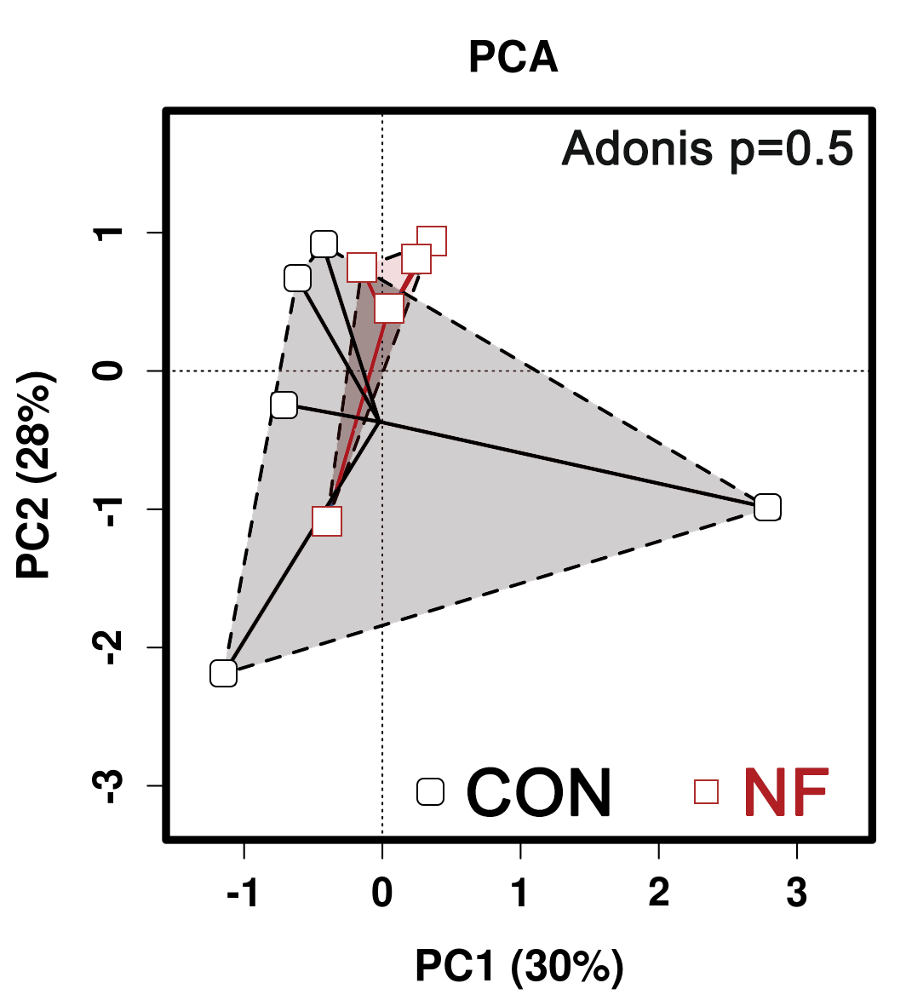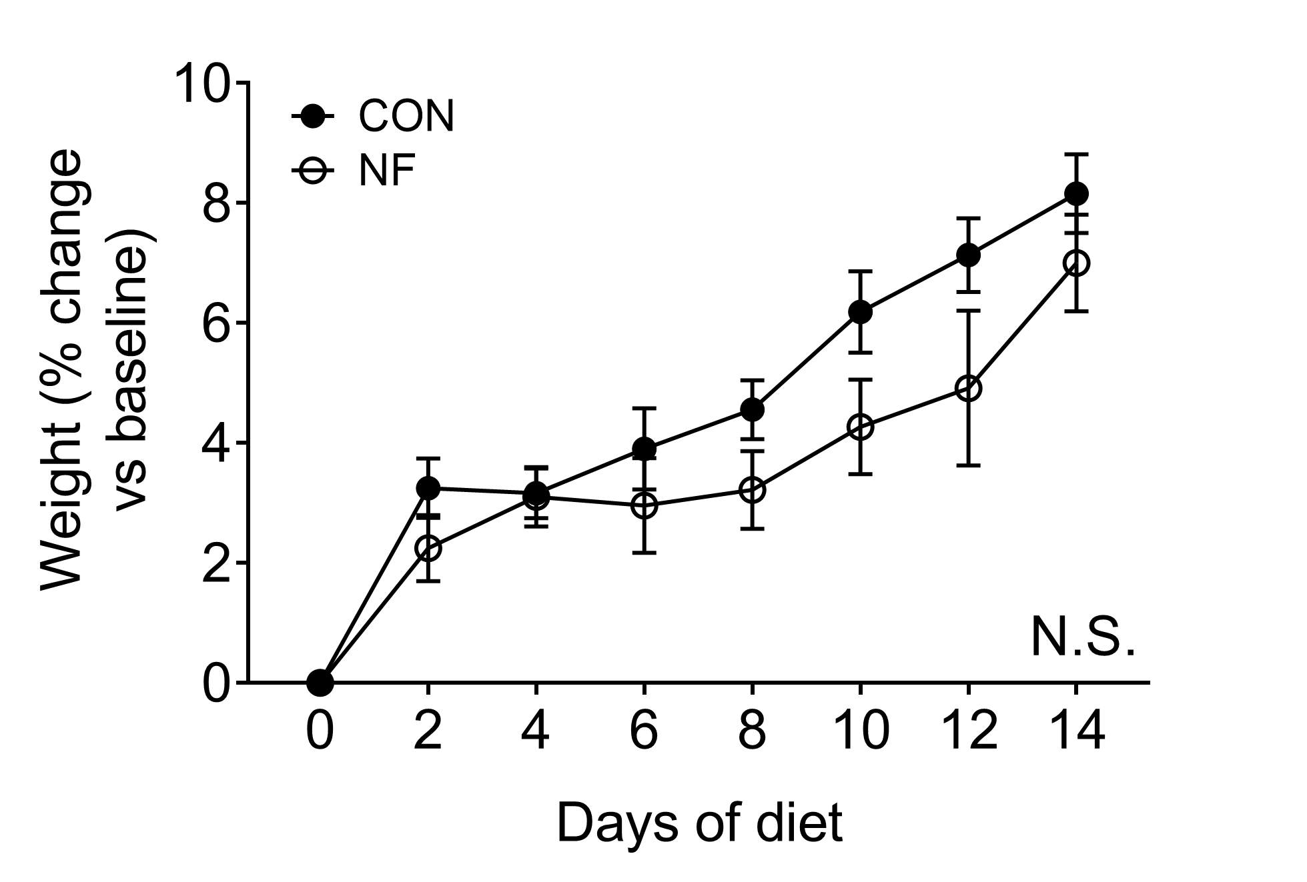
(B)
(A)

Supplemental Figure 1: No difference in microbiota composition of mice prior to experimental diets or weight change after 2 weeks of experimental diet feeding. (A) Comparable microbiota composition between the mice randomly assigned to experimental groups at the start of experiment. Dots represent individual mice, N ≥ 4. (B) Comparable weight gain over the 2 weeks of experimental diet between the mice randomly assigned to control or no-fibre feeding. Data displayed as mean ± SEM. N ≥ 50 individual mice per group. Two-way ANOVA was performed for all data across all time point and N.S. denotes no statistical significance.

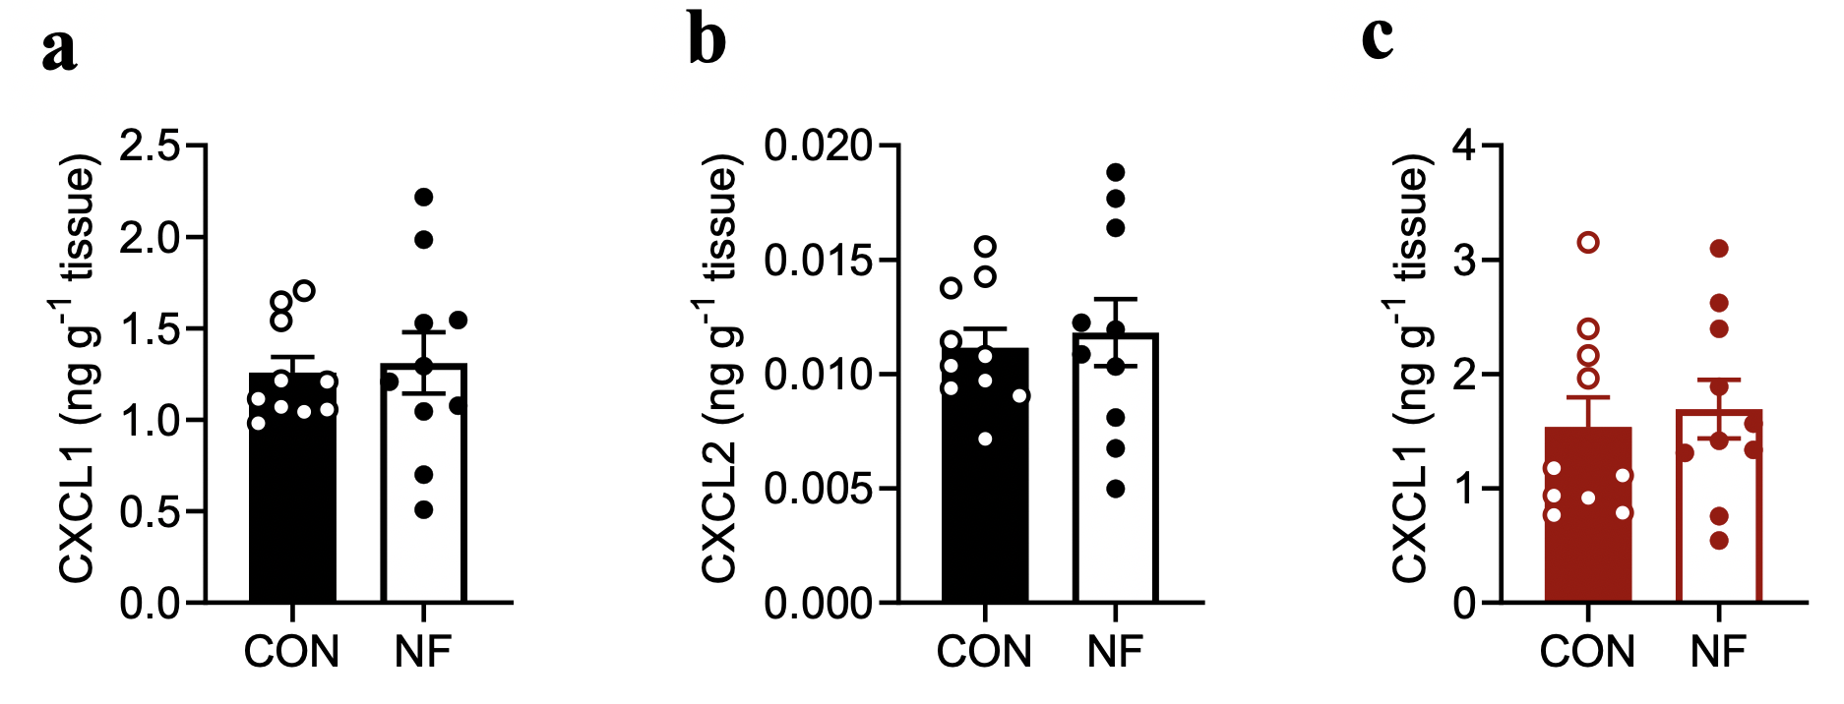
(A)
(C)
(B)

Supplemental Figure 2: Protein levels of CXCL1 and CXCL2 in the colon. Colonic protein levels of CXCL1 (A) and CXCL2 (B) following 2 weeks of the experimental diet were determined via ELISA. In addition, comparable colonic protein level of CXCL1 (C) was found in mice following the 2-week experimental diet feeding and DSS-induced colitis. Data displayed as mean ± SEM. One independent experiment was performed, N ≥ 9 individual mice per group.

(A)
(B)

Supplemental Figure 3: Correlation of gut microbiota with DAI. Negative correlation of the abundance and presence of Verrucomicrobia at the phylum level (A) and Akkermansia at the genus level (B) with disease activity index (DAI) following DSS-induced colitis was found in the no-fibre feeding cohort. One independent experiment was performed, N = 4 individual mice per group.

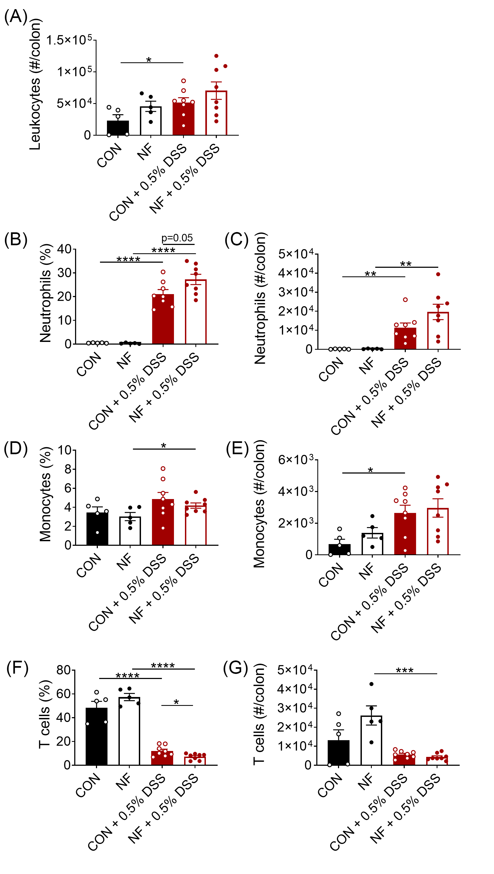
Supplemental Figure 4: Colonic leukocyte populations in mice fed NF diet following DSS-induced colitis. WT mice were fed either a control (CON) or no fibre (NF) diet for 14 days prior to and during 7 days of 0.5% DSS-induced colitis. At experimental endpoint, the colon was collected, and leukocytes quantitated by flow cytometry using fluorescent counting beads. (A) Total numbers of colonic leukocytes, the proportions and numbers of (B, C) neutrophils, (D, E) monocytes, and (F, G) T cells were enumerated. N = 5-8 per group. Dots represent individual mouse. Lines represent mean ± SEM. Student’s t test was performed, comparing CON vs NF; CON vs CON + 0.5% DSS; NF vs NF + 0.5% DSS; CON + 0.5% DSS vs NF + 0.5% DSS. *P < 0.05, **P < 0.01, ***P < 0.001, ****P < 0.0001.

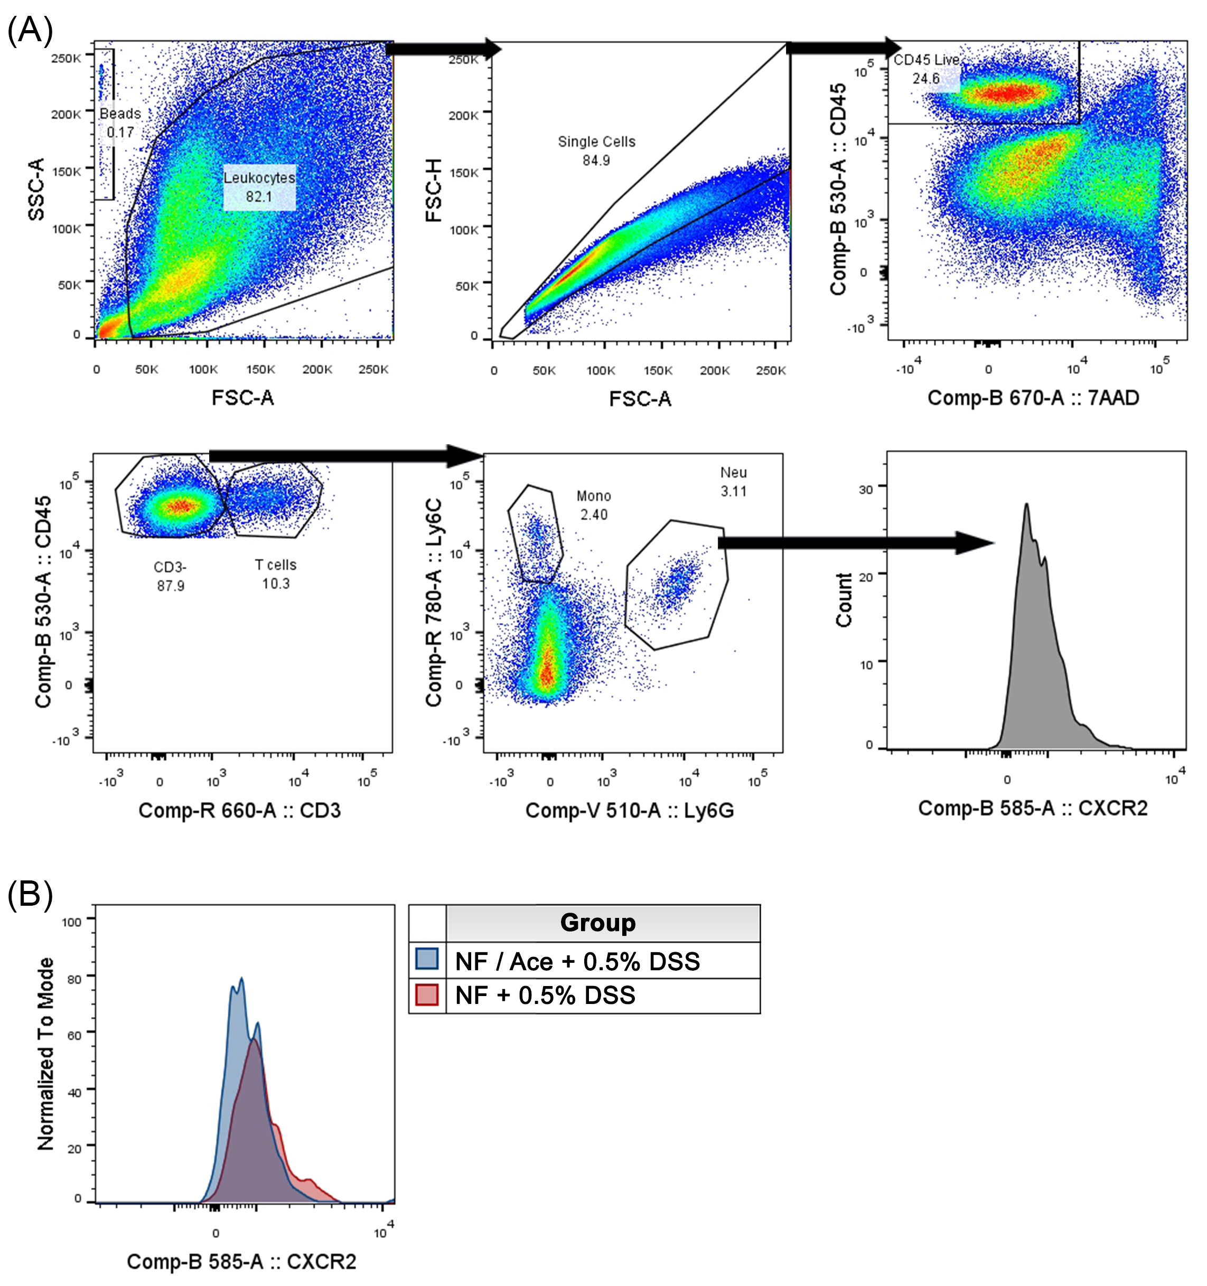
Supplemental Figure 5: Representative flow cytometry plots. (A) Gating strategy employed to identify colonic neutrophils (CD45⁺CD3⁻Ly6G⁺) for the study as well as for the investigation of cell surface expression of CXCR2. (B) Representative histogram demonstrating reduced CXCR2 surface expression on colonic neutrophils in no-fibre fed mice post-DSS that were supplemented with acetate compared to those that were not.

