Supplementary Material

Leaf-air temperature decoupling correction
To approximate the leaf-air temperature decoupling in alpine environments while generating climate scenario projected temperatures, we applied a regression between air and plant temperature data, which is presented originally in Salisbury and Spomer (1964) in their Figure 3. The regression formula was y = 1.3964x with R² = 0.9892.

Chlorophyll fluorescence assays
After the five-day heatwave treatment, we removed one leaf per plant from both heatwave and non-heatwave plants to measure the maximum efficiency of the photosystem II (F_{v}/F_{m}), critical hot temperature (T_{crit}), the temperature at 50% fluorescence (T₅₀), and the temperature at maximum fluorescence (T_{max}). Harvested leaves were attached with a double-sided tape to filter paper that was then placed on a Peltier plate (CP-121HT; TE-Technology, Inc., Michigan, USA) controlled by a bi-polar proportional-integral-derivative temperature controller (TC-36-25; TE-Technology, Inc.). Double-glazed glass was placed on top to insulate the samples and ensure maximum thermal contact between leaves on the filter paper to the Peltier plate. The Peltier plate was set to a constant ambient temperature (21 ± 1 °C) and leaves were dark-adapted for 30 minutes.
After dark adaptation, we measured minimum chlorophyll fluorescence (F₀) (i.e., fluorescence in absence of photosynthetic light) and maximum fluorescence (F_{m}) (i.e., fluorescence after delivering to a saturating pulse for a short duration). Chlorophyll fluorescence was measured on an area of interest set to the center of the widest section of each leaf, by means of a chlorophyll fluorescence imaging system (MAXI-Imaging-PAM; Heinz Walz GmbH, Effeltrich, Germany). We used the initial F₀ and F_{m} parameters to calculate F_{v}/F_{m} as the ratio of (F_{m} - F₀)/ F_{m} (n = 276). Unfortunately, the F_{v}/F_{m} measurements for 43 individuals were not recorded due to software errors. After measuring F_{v}/F_{m} we raised the temperature of the Peltier plate from 21 to 60°C at a ramp speed of 60 °C h⁻¹. We recorded F₀ values every 10 s during the temperature ramp. The temperature of the leaf samples was measured using two type-T thermocouples that were attached to the underside of two randomly selected leaves, and a thermistor (MP-3193; TE-Technology, Inc.) attached to the Peltier plate. We logged the thermocouple data using a dual-channel data logger (EL-GFX-DTC; Lascar Electronics Ltd., Salisbury, UK). The average temperature of these two thermocouples was then used for all subsequent temperature calculations because, being directly attached to the leaves, we considered it to be a more reliable estimate of leaf temperatures. The difference in temperatures measured by the two thermocouples (average) and the thermistor was on average 2.5 °C across all runs and became larger at higher temperatures.
For 19 individuals the T-F₀ curves did not reach a fluorescence maximum and could not measure T_{max} and T₅₀ because they would have been underestimated. We included those individuals in the analysis considering them as having T_{max} = 61 °C and estimated their T₅₀ as (T_{crit} + (61 °C - T_{crit}) / 2) + 0.69 °C, where 0.69 °C is the average difference between T₅₀ and (T_{crit} + ((T_{max} - T_{crit}) / 2) between the rest of the 300 individuals. The distribution of curves in which F₀ had not reached a maximum, was distributed across elevation and climate scenarios, however 17 out of these 19 individuals did not experience a heatwave. For two individuals we did not obtain canonical T-F₀ curves and could not estimate thermal tolerance parameters.

Table S1. Table of the families used during the experiment, the elevation where seeds of the respective mothers and fathers were collected, the elevation classification and the distance as the crow flies of the parental pair.
F1 Line | Elevation of the mother | Elevation of the father | Elevation | Distance (Km)
F1.101 | 1621 | 1590 | Low | 6.98
F1.102 | 1732.9 | 1738.8 | Low | 0.19
F1.103 | 1744 | 1741 | Low | 2.28
F1.104 | 1765 | 1744 | Low | 3.33
F1.106 | 1889.4 | 1852.9 | High | 2.05
F1.107 | 1930.9 | 1926.5 | High | 0.58
F1.108 | 2095.7 | 2094.9 | High | 0.16
F1.109 | 1741 | 1754 | Low | 0.05
F1.110 | 1884.6 | 1837.3 | High | 0.67
F1.111 | 1590 | 1618.3 | Low | 6.92
F1.112 | 1956 | 1977 | High | 1.44
F1.114 | 1733.5 | 1741 | Low | 1.34
F1.115 | 1918.2 | 1902.7 | High | 0.24
F1.117 | 1937 | 1929.5 | High | 1.32
F1.118 | 1754 | 1741 | Low | 0.05
F1.119 | 1765 | 1740 | Low | 5.7
F1.120 | 2096.3 | 2090 | High | 0.36
F1.122 | 1744 | 1721 | Low | 5.97
F1.123 | 2060.7 | 2100 | High | 0.64
F1.125 | 1640 | 1621.3 | Low | 4.18
F1.126 | 1744 | 1741 | Low | 2.27
F1.127 | 1930 | 1956 | High | 0.93
F1.128 | 1956 | 1930 | High | 0.93
F1.129 | 1956 | 1930 | High | 0.93
F1.130 | 1706.4 | 1706.4 | Low | 6.64
F1.137 | 1721 | 1754 | Low | 3.77
F1.138 | 1765 | 1721 | Low | 2.6
F1.142 | 1977 | 1935 | High | 1.48
F1.144 | 1930 | 1892 | High | 4.5
F1.149 | 1977 | 1956 | High | 1.48

Days | Historical scenario temperatures (d/n °C) | Future scenario temperatures (d/n °C) | Photoperiod (d/n hr)
0 | 25/20 | 25/20 | 12/12
1 | 21/15 | 25/15 | 12/12
9 | 20/12 | 25/12 | 12/12
23 | 20/12 | 27/12 | 13/11
37 | 22/13 | 28/19 | 13/11
51 | 22/13 | 29/19 | 14/10
65 | 23/13 | 29/20 | 14/10
79 | 24/13 | 29/20 | 14/10
93 | 24/12 | 29/20 | 14.5/9.5
107 | 23/13 | 28/20 | 14.5/9.5
121 | 21/13 | 26/20 | 14.5/9.5
135 | 18/13 | 24/15 | 14.5/9.5
149 | 16/13 | 21/15 | 13.5/10.5
163 | 16/13 | 18/13 | 13.5/10.5
177 | 16/13 | 17/13 | 12.5/11.5
191 | 16/13 | 17/13 | 12.5/11.5
Table S2. Day/night temperatures for historical climate scenario (base period) and future climate scenario (projected period), and photoperiod from the imposition of treatments (day 1) to the end of the experiment (day 191).

Table S3. Effects of temperature treatments on number of seeds (LM), seed mass and chlorophyll content: results from linear random intercept models. Main effects model has no interactions; full model has all 2-way interactions. 3-way interactions were never significant and results for them are not presented. Estimates and standard error for seed production and seed mass are in the logarithmic scale. Number of seeds includes only individuals that produced seeds. (no zeros). NA = factor not included in the model for that trait or result not provided by the model. The intercept corresponds to high elevation, historical climate and no heatwave, and other parameter values are relative to this. Significant results, as for p-value < 0.05 from the lmerTest package in R, are presented in bold. e(l) = elevation (low); c(f) = climate (future); hw = heatwave; est. = estimated effect; ML = maximum likelihood; Pr(ML) = p-value of the likelihood ratio test between the models with and without the random effect. Random effects parameters are the variance components associated with that random effect.
 | Number of seeds (LM) |  |  | Seed mass (ln) |  |  | Chlorophyll content
n | 233 |  |  | 234 |  |  | 301
main effects model: | est. | (sd) | P-value | est. | (sd) | P-value | est. | (sd) | P-value
intercept | 7.182 | 0.275 | NA | -3.498 | 0.268 | NA | 58.226 | 1.193 | NA
elevation (low) | -0.720 | 0.308 | 0.027 | -0.621 | 0.285 | 0.037 | 0.532 | 1.399 | 0.707
climate (future) | -0.754 | 0.187 | <0.0001 | -0.952 | 0.007 | <0.0001 | 1.009 | 0.817 | 0.218
heatwave(yes) | -0.139 | 0.175 | 0.430 | -0.134 | 0.179 | 0.458 | NA | NA | NA
block(B) | 0.092 | 0.218 | 0.674 | 0.050 | 0.224 | 0.825 | -0.892 | 1.013 | 0.379
block(C) | 0.031 | 0.221 | 0.887 | 0.003 | 0.227 | 0.989 | -0.948 | 1.007 | 0.348
 | Marginal R²: 0.103 |  |  | Marginal R²: 0.117 |  |  | Marginal R²: 0.008
 | Conditional R²: 0.324 |  |  | Conditional R²: 0.306 |  |  | Conditional R²: 0.170
full model: | est. | (sd) | P-value | est. | (sd) | P-value | est. | (sd) | P-value
intercept | 7.306 | 0.297 | NA | -3.330 | 0.288 | NA | 57.667 | 1.241 | NA
elevation (low) | -1.391 | 0.378 | 0.001 | -1.460 | 0.360 | <<.001 | 1.696 | 1.582 | 0.289
climate (future) | -0.805 | 0.296 | 0.007 | -1.103 | 0.297 | 0.000 | 2.161 | 1.103 | 0.051
heatwave(yes) | -0.090 | 0.253 | 0.724 | -0.060 | 0.256 | 0.815 | NA | NA | NA
block(B) | 0.080 | 0.205 | 0.697 | 0.029 | 0.207 | 0.888 | -0.851 | 1.009 | 0.400
block(C) | 0.082 | 0.208 | 0.696 | 0.056 | 0.210 | 0.788 | -0.917 | 1.004 | 0.362
e(l)*C(f) | 1.133 | 0.353 | 0.002 | 1.473 | 0.353 | <0.001 | -2.520 | 1.628 | 0.123
c(f)*Hw(y) | -0.950 | 0.352 | 0.008 | -1.041 | 0.351 | 0.003 | NA | NA | NA
e(l)*Hw(y) | 0.594 | 0.348 | 0.089 | 0.654 | 0.354 | 0.066 | NA | NA | NA
 | Marginal R²: 0.156 |  |  | Marginal R²: 0.195 |  |  | Marginal R²: 0.115
 | Conditional R²: 0.417 |  |  | Conditional R²: 0.427 |  |  | Conditional R²: 0.175
Random effects: | var.(int.) |  | Pr(ML) | var.(int.) |  | Pr(ML) | var.(int.) |  | Pr(ML)
Family | 0.5094 |  | <<0.0001 | 0.3839 |  | <0.0001 | 9.5100 |  | <0.0001
Position | 0.1696 |  | 0.0480 | 0.2394 |  | 0.0111 | NA |  | NA
Residual | 1.5184 |  | NA | 1.5355 |  | NA | 48.9600 |  | NA

Trait | Log transformation | Model | Fixed effects | Random effects | REML | Family
F_{v}/F_{m} | no | lmer | elev*clim scn*hw+block | position | false | \
T_{crit} | no | lmer | elev*clim scn*hw+block | position | false | \
T₅₀ | yes | lmer | elev*clim scn*hw+block | position | false | \
T_{max} | yes | lmer | elev*clim scn*hw+block | position | false | \
Flowering onset | yes | lmer | elev*clim scn +block | family | false | \
Number of flowers | no | glmer.nb | elev*clim scn*hw+block | family; position | \ | negative binomial
Number of seeds | no | glmer.nb | elev*clim scn*hw+block | family | \ | negative binomial
Individual seed weight | no | lmer | elev*clim scn*hw+block | family | false | \
Biomass | no | lmer | elev*clim scn*hw+block | clim scn|family; position | false | \
Survival | no | coxme | elev*clim scn*hw+block | family; position | \ | \
Probability of seed production | no | glmer | elev*clim scn*hw+block | family; position | \ | binomial
Number of seeds (LM) | No | lmer | elev*clim scn*hw+block | family; position | false | \
Seed mass | yes | lmer | elev*clim scn*hw+block | family; position | false | \
Chlorophyll content | no | lmer | elev*clim scn +block | family | false | \
Table S4. Table of the models used to analyze each trait. Removal of the 3-way interaction was obtained using the update function in ‘base’ R package. elev = elevation; clim scn = climate scenario; hw = heatwave.
 | Elevation |  | Climate scenario |  | Heatwave |  | Elevation x Climate scenario |  |  |  | Elevation x Heatwave |  |  |  | Climate scenario x Heatwave |  |  |  | Total
 | High | Low | Historical | Future | No | Yes | H x C | H x F | L x C | L x F | H x N | H x Y | L x N | L x Y | C x N | C x Y | F x N | F x Y
Fv/Fm | 148 | 128 | 147 | 129 | 142 | 134 | 77 | 71 | 70 | 58 | 76 | 72 | 66 | 62 | 74 | 73 | 68 | 61 | 276
Tcrit | 167 | 152 | 172 | 147 | 163 | 156 | 89 | 78 | 83 | 69 | 85 | 82 | 78 | 74 | 87 | 85 | 76 | 71 | 319
T50 | 167 | 152 | 172 | 147 | 163 | 156 | 89 | 78 | 83 | 69 | 85 | 82 | 78 | 74 | 87 | 85 | 76 | 71 | 319
Tmax | 167 | 152 | 172 | 147 | 163 | 156 | 89 | 78 | 83 | 69 | 85 | 82 | 78 | 74 | 87 | 85 | 76 | 71 | 319
Flowering onset | 165 | 148 | 167 | 146 | 160 | 153 | 87 | 78 | 80 | 68 | 84 | 81 | 76 | 72 | 84 | 83 | 76 | 70 | 313
Longevity | 168 | 153 | 173 | 148 | 164 | 157 | 89 | 79 | 84 | 69 | 86 | 82 | 78 | 75 | 87 | 86 | 77 | 71 | 321
Biomass | 89 | 71 | 86 | 74 | 92 | 68 | 47 | 42 | 39 | 32 | 50 | 39 | 42 | 29 | 46 | 40 | 46 | 28 | 160
Number of flowers | 168 | 153 | 173 | 148 | 164 | 157 | 89 | 79 | 84 | 69 | 86 | 82 | 78 | 75 | 87 | 86 | 77 | 71 | 321
Number of seeds | 166 | 152 | 173 | 145 | 163 | 155 | 89 | 77 | 84 | 68 | 86 | 80 | 77 | 75 | 87 | 86 | 76 | 69 | 318
Individual seed weight | 128 | 105 | 153 | 80 | 116 | 117 | 85 | 43 | 68 | 37 | 63 | 65 | 53 | 52 | 75 | 78 | 41 | 39 | 233
Probability to produce seeds | 168 | 153 | 173 | 148 | 164 | 157 | 89 | 79 | 84 | 69 | 86 | 82 | 78 | 75 | 87 | 86 | 77 | 71 | 321
Table S5. Sample sizes for each trait and each factor level. All fixed effects and their interactions are presented except for ‘block’. H = ‘high elevation’; C = ‘historical climate’; F = ‘future climate’; L = ‘low elevation’; N = ‘no heatwave’; Y = ‘heatwave (yes)’.

Table S6. Correlation between longevity and total seed production: results from linear random intercept models. Individuals that did not produce seeds were removed from the analysis. Main effects model has no interactions; full model has all 2-way interactions. 3-way interactions were never significant and results for them are not presented. Estimates and standard error are in the logarithmic scale. NA = factor not included in the model for that trait or result not provided by the model. The intercept corresponds to high elevation, historical climate and no heatwave, and other parameter values are relative to this. Significant results, as for p-value < 0.05 from the lmerTest package in R, are presented in bold. e(l) = elevation (low); c(f) = climate (future); hw = heatwave; est. = estimated effect; ML = maximum likelihood; Pr(ML) = p-value of the likelihood ratio test between the models with and without the random effect. Random effects parameters are the variance components associated with that random effect.
 | Total seed production (n)
main effects model: | est. | (se) | p-value
intercept | 6.169 | 0.381 | NA
longevity | 0.012 | 0.003 | <0.001
elevation (low) | -0.728 | 0.295 | 0.020
climate (future) | -0.730 | 0.185 | <0.001
heatwave(yes) | -0.022 | 0.177 | 0.899
block(B) | 0.103 | 0.217 | 0.636
block(C) | -0.013 | 0.219 | 0.952
 | Marginal R²: 0.146
 | Conditional R²: 0.313
full model: | est. | (se) | p-value
intercept | 6.349 | 0.400 | NA
longevity | 0.011 | 0.003 | 0.001
elevation (low) | -1.231 | 0.377 | 0.002
climate (future) | -0.752 | 0.306 | 0.015
heatwave(yes) | 0.118 | 0.260 | 0.651
block(B) | 0.081 | 0.213 | 0.705
block(C) | 0.026 | 0.215 | 0.906
e(l)*C(f) | 1.017 | 0.365 | 0.006
c(f)*Hw(y) | -0.890 | 0.364 | 0.015
e(l)*Hw(y) | 0.325 | 0.344 | 0.345
 | Marginal R²: 0.179
 | Conditional R²: 0.370
Random effects: | var.(int.) |  | Pr(ML)
Family(int.) | 0.5018 |  | <0.0001
Position | NA |  | NA
Residual | 1.6621 |  | NA

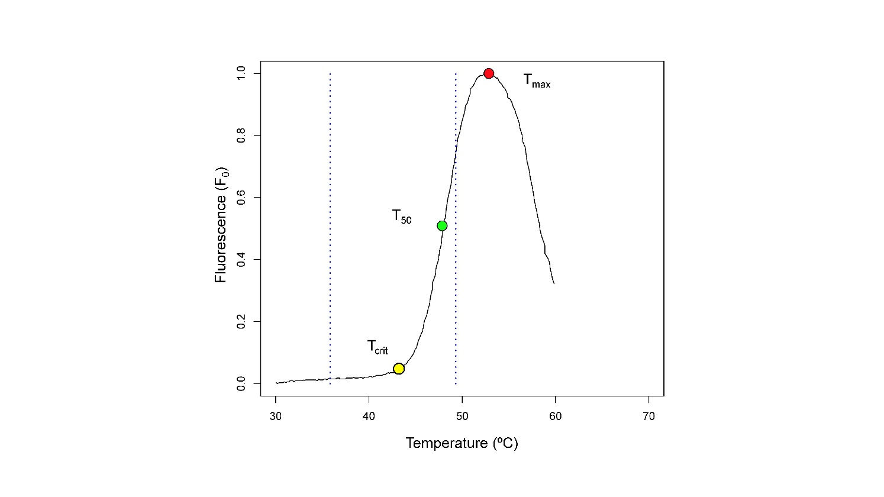
Figure S1. Example of a T-F₀ curve. This curve was obtained using real data. T_{crit} was estimated as the intersection between the two straight lines tangential to the flat and steep part of the curve, using a break-point regression analysis conducted with the ‘segmented’ R package (Muggeo 2017).
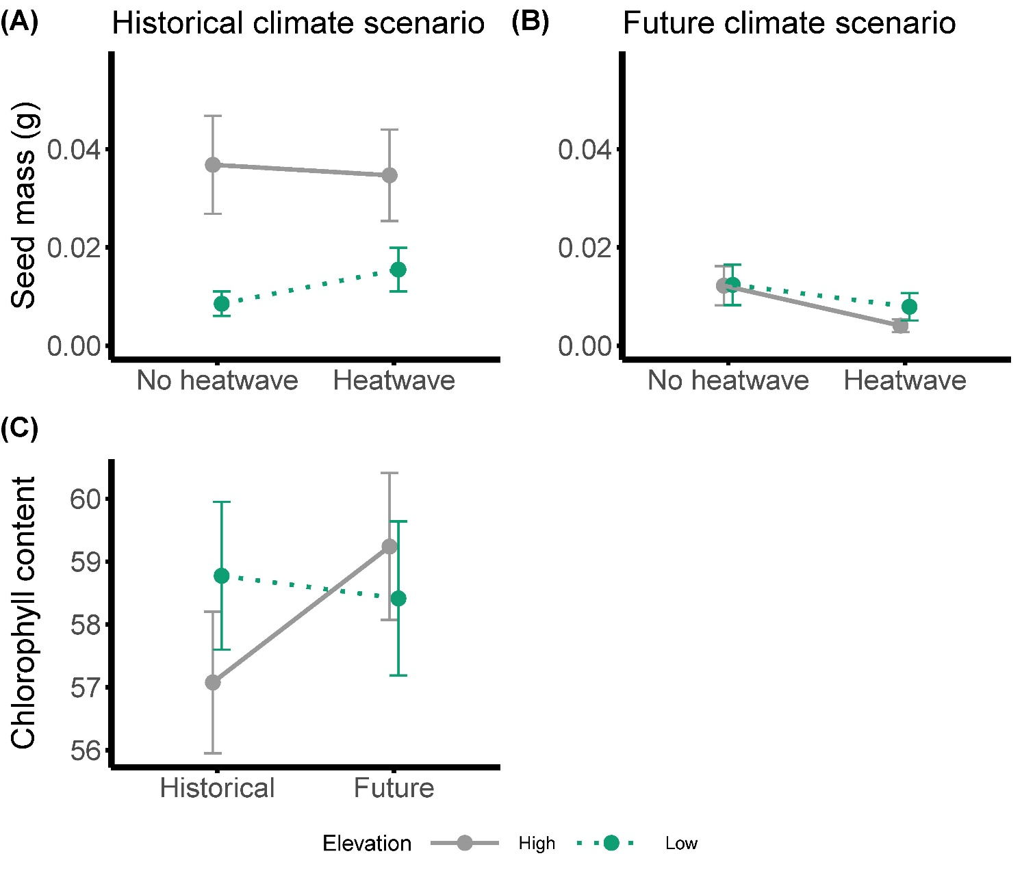
Figure S2. Reaction norms for (A) seed mass in response to the heatwave treatment under a historical climate scenario and (B) under a future scenario and for (C) chlorophyll content in response to climate scenario. Grey and solid lines = high-elevation families; green and dotted lines = low-elevation families. Values were estimated from the models using the emmeans function in ‘emmeans’ package, in R; error bars are standard errors.

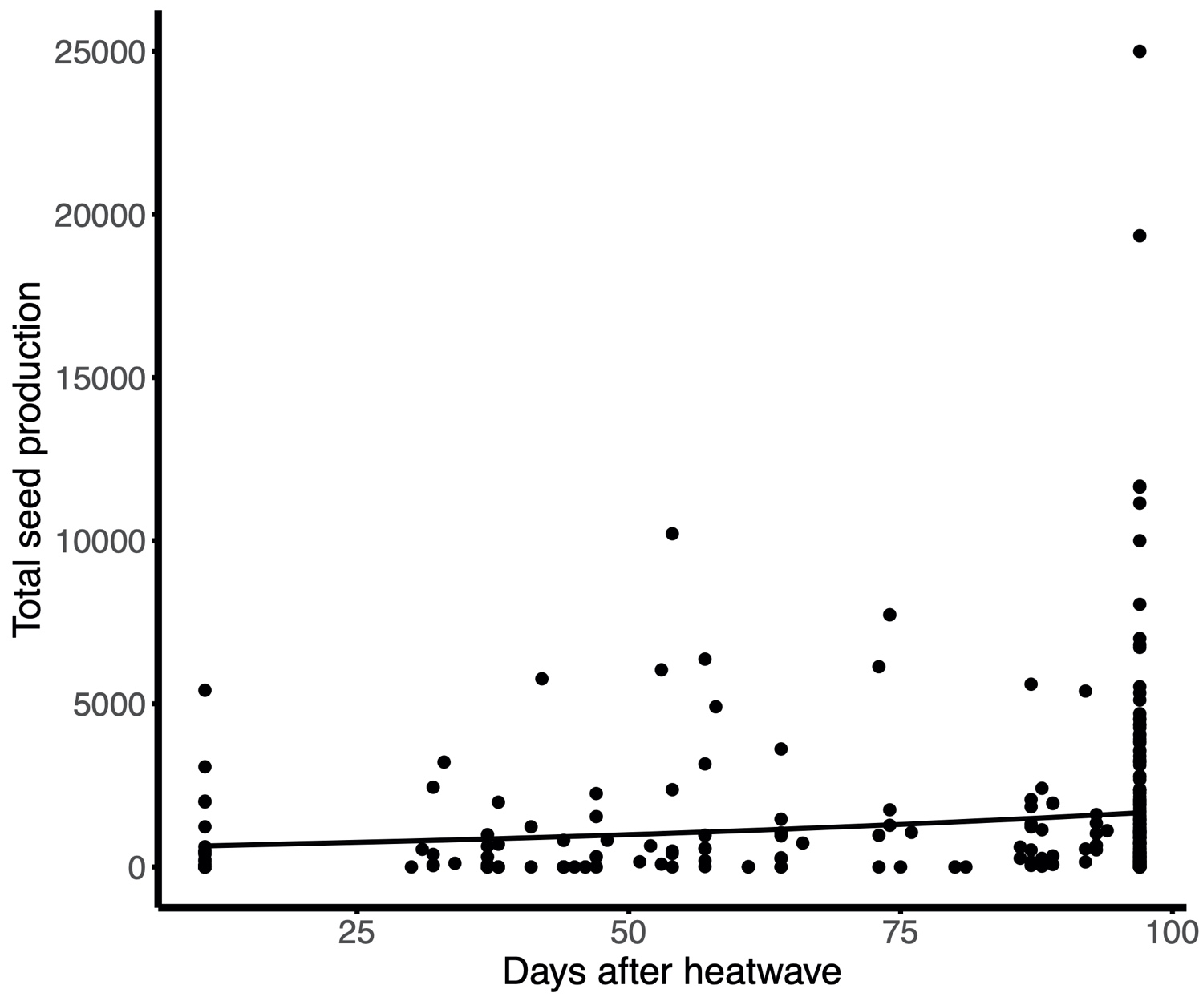
Figure S3. Correlation between longevity (days from the end of the heatwave treatment to death) and total seed production. Only individuals that produced seeds were included in the analysis. The correlation was analyzed using linear mixed effects models (lmer function in ‘lme4’ package in R) with total seed production as response variable and longevity, elevation, climate scenario and heatwaves as fixed effects. Random effects were family, block, and position nested in block (block:position). Predictions from the model to plot the graph were obtained using the ggpredict function in ‘ggeffects’ package. Black dots = raw data.

