Suppl. 2
Binding interactions of selected drugs with human ACE-2 protein and TMPRSS2 protein

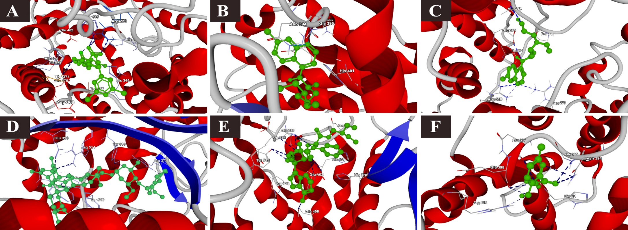
1) Binding interactions of selected drugs with human ACE-2 protein

a) MLN-476, b) chloroquine, c) hydroxychloroquine, d) ivermectin, e) remdesivir and f) favipiravir

2) Binding interactions of selected drugs with human TMPRSS2 protein
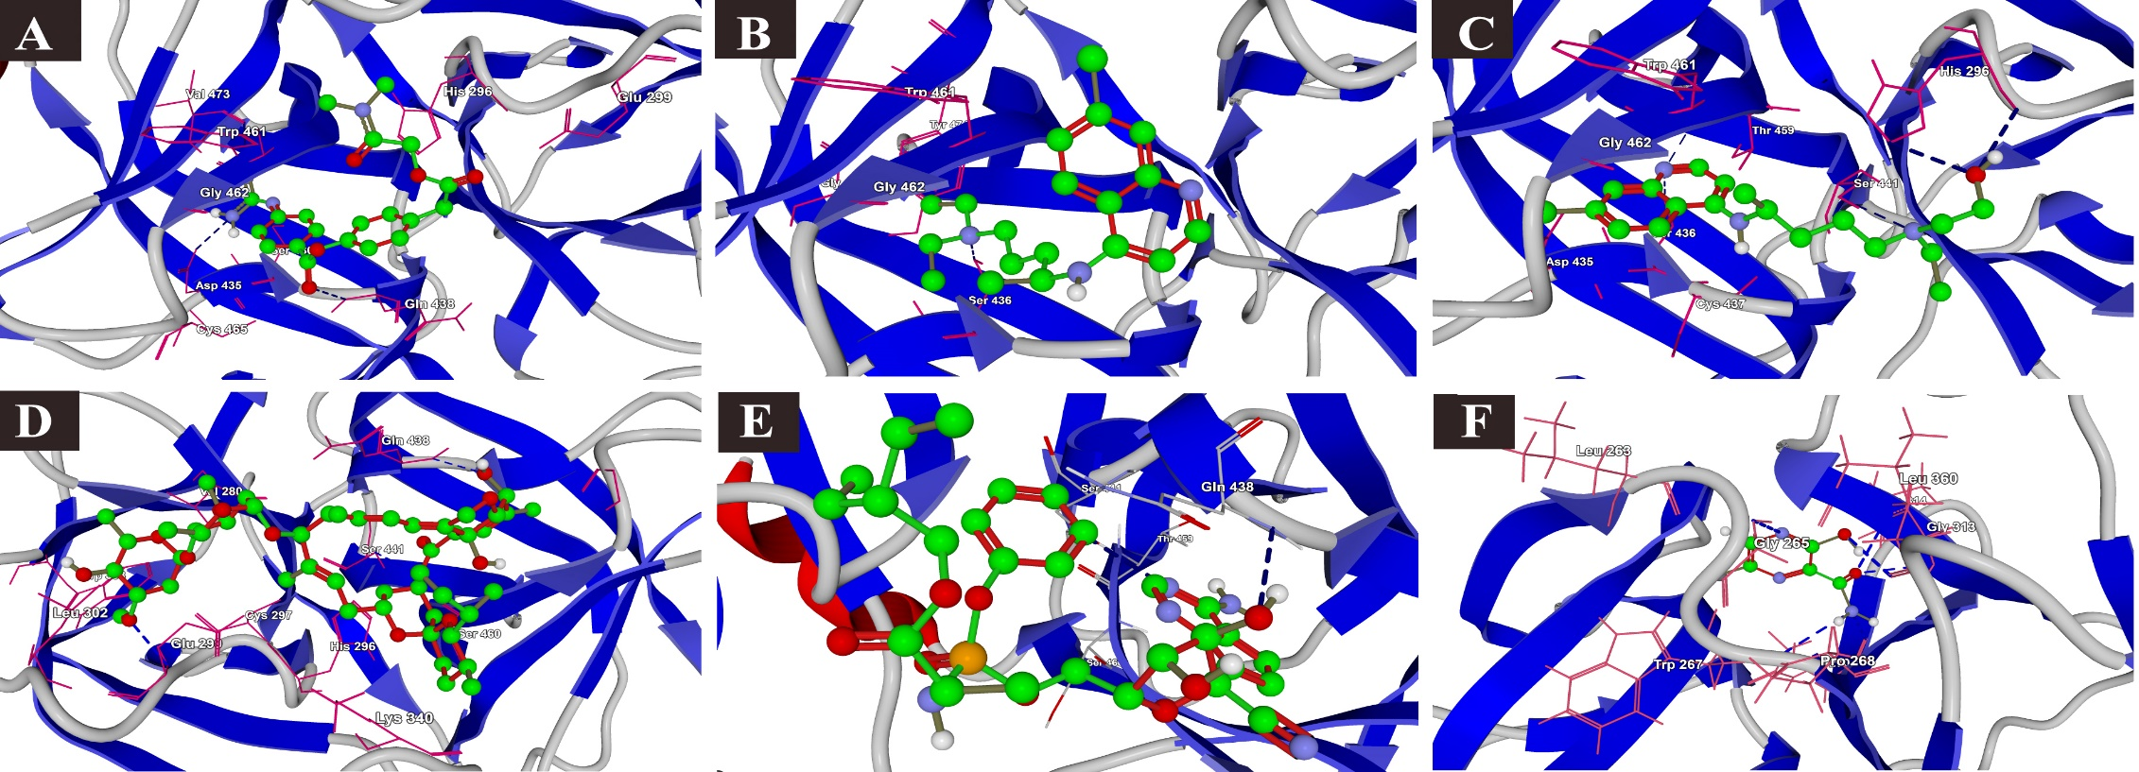

a) Comstat b) chloroquine, c) hydroxychloroquine, d) ivermectin, e) remdesivir and f) favipiravir.

