Supplementary Material

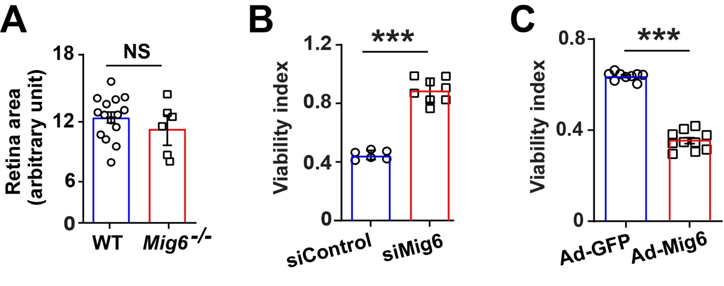
Supplementary Figure 1. Mig6 inhibits EC sprouts and vascular outgrowth. (A) Data are shown that there is no difference in total retinal area between wild type (WT) and Mig6^{-/-} mice. (B) Mig6 knockdown (siMig6) increased HREC proliferation in an MTT assay. (C) Mig6 overexpression (Ad-Mig6) decreased HREC proliferation in an MTT assay. The data are shown as the mean ± SEM from three independent experiments. *** p < 0.001, NS: not significant (paired Student’s t-test, two-tailed).

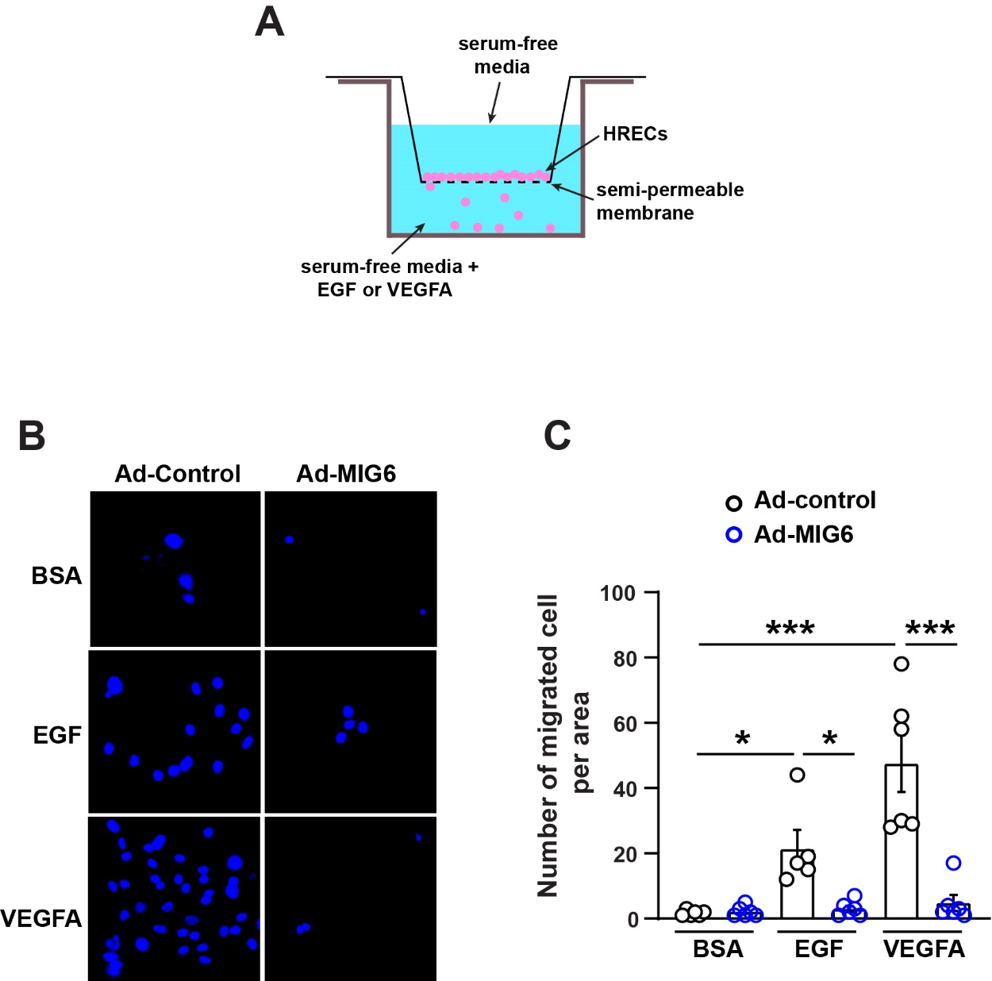

Supplementary Figure 2. Mig6 overexpression inhibits EGF- or VEGFA-induced HREC migration. (A) Schematic image of Trans-well migration assay. HREC (7.5 x 10⁴) was seeded in the top chamber after two days infection with Ad-control or Ad-MIG6. Each 50 ng/ml of either EGF or VEGFA was added into the bottom chamber. (B) Representative DAPI staining images of HREC migration infected with Ad-Control or Ad-Mig6. (C) Quantification represents the number of migrated cells infected with Ad-GFP or Ad-Mig6. The data are shown as the mean ± SEM from three independent experiments. * p < 0.05, *** p < 0.001 (paired Student’s t-test, two-tailed).

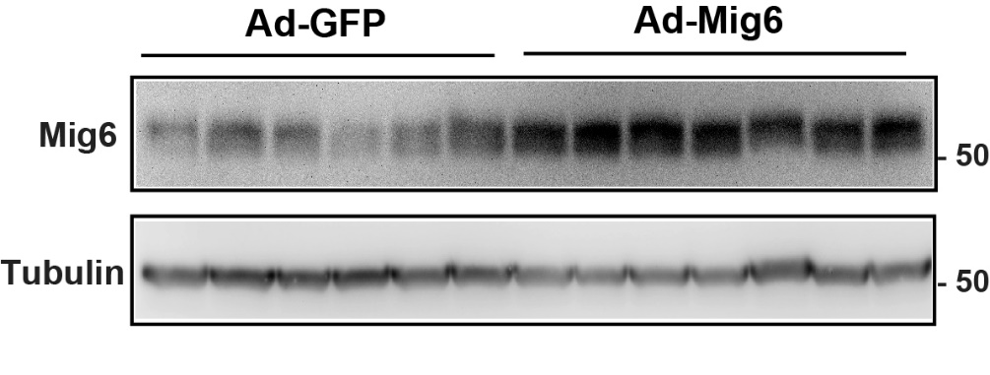

Supplementary Figure 3. Mig6 expression in mouse retina by intravitreally injected adenoviruses. Adenoviruses expressing Mig6 (Ad-Mig6) were intravitreally injected into the mouse eyes at P12 and incubated for 5 days. Ad-GFP was used as a control.

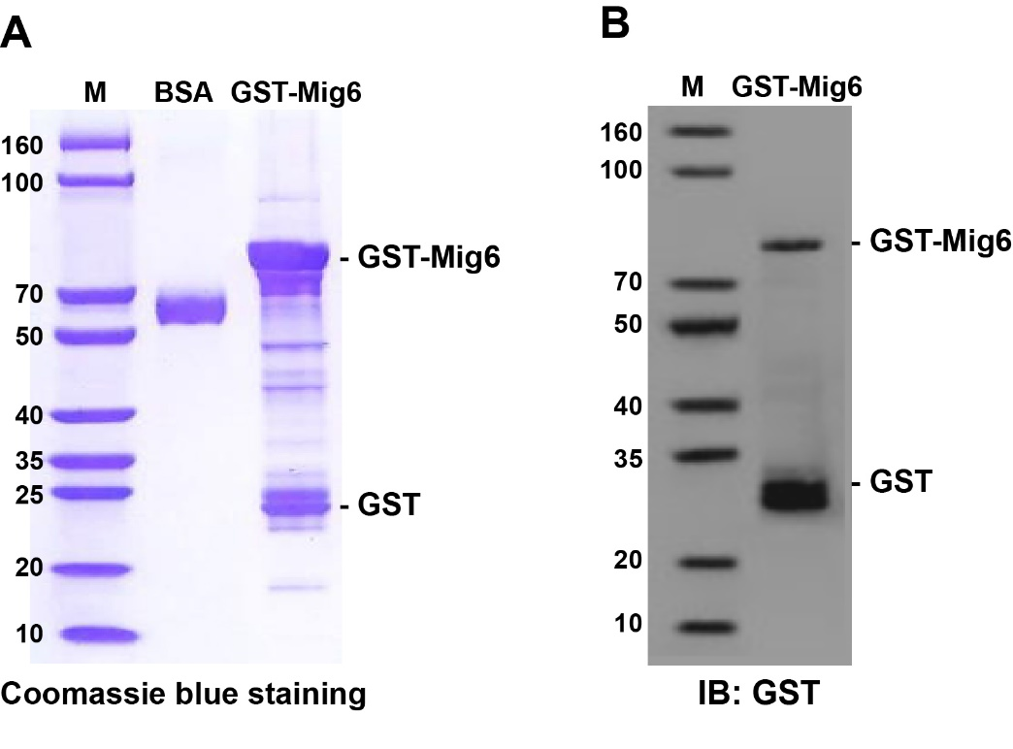
Supplementary Figure 4. GST-Mig6 fusion protein expression. (A, B) GST-fusion protein of Mig6 was expressed and purified from E. coli. GST-Mig6 fusion protein was validated by (A) Coomassie blue staining and (B) Western blot.

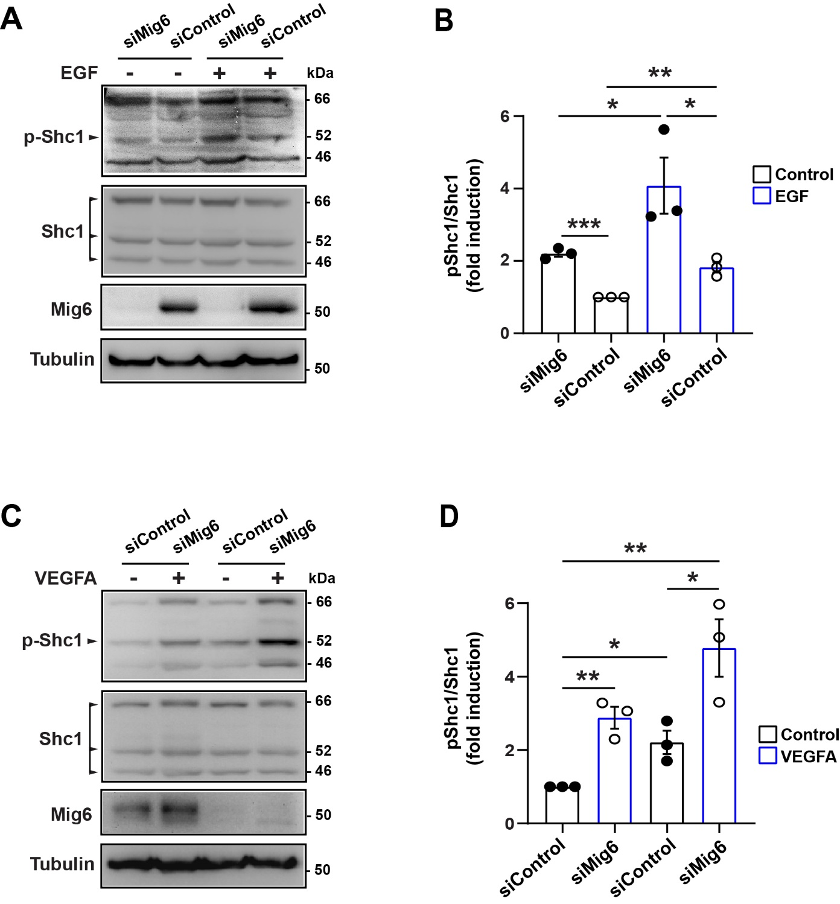
Supplementary Figure 5. Mig6 knockdown in HREC upregulates Shc1 phosphorylation. (A, C) Western blots showing that Mig6 knockdown increases Shc1 phosphorylation in HRECs both at the baseline level and in the presence of EGF (A) or VEGFA (C). (B, D) Tyrosine phosphorylation of Shc1 was analyzed by densitometry and normalized by total Shc1. Fold induction relative to the siControl is shown. The graph represents the mean ± SEM from three independent experiments. * p < 0.05, ** p < 0.01, *** p < 0.001 (paired Student’s t-test, two-tailed).

