Supplementary Figure 1: Frequency distribution of 190 RILs for ZPR- Zinc content in Polished Rice (ppm); ZBR- Zinc content in Brown Rice (ppm); IPR- Iron content in Polished Rice (ppm); IBR- Iron content in Brown Rice (ppm); SPY- Single Plant Yield(g); TW: Test weight (g); PH- Plant Height (cm); PL- Panicle Length (cm); NT-Number of Tillers per plant; DFF-Days to fifty percent flowering (days).

Supplementary Figure 2: Box plots for 190 RILs for ZPR- Zinc content in Polished Rice (ppm); ZBR- Zinc content in Brown Rice (ppm); IPR- Iron content in Polished Rice (ppm); IBR-Iron content in Brown Rice (ppm); SPY- Single Plant Yield(g); TW: Test weight (g); PH- Plant Height (cm); PL- Panicle Length (cm); NT-Number of Tillers per plant; DFF-Days to fifty percent flowering (days).

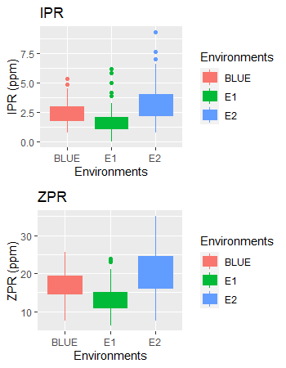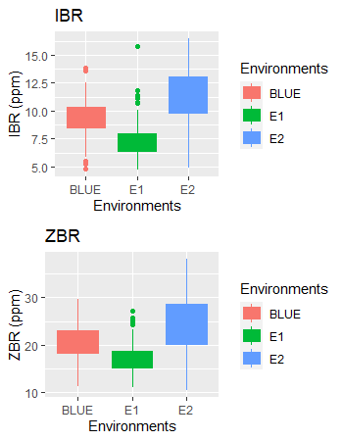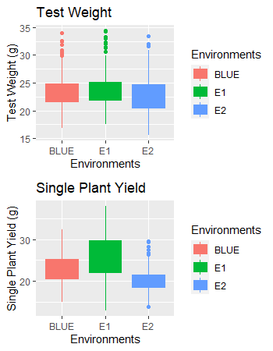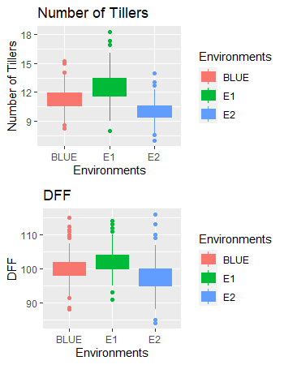
Supplementary Figure 3: Frequency distribution of 44 RILs for ZPR- Zinc content in Polished Rice (ppm); ZBR- Zinc content in Brown Rice (ppm); IPR- Iron content in Polished Rice (ppm); IBR- Iron content in Brown Rice (ppm); SPY- Single Plant Yield(g); TW: Test weight (g); PH- Plant Height (cm); PL- Panicle Length (cm); NT-Number of Tillers per plant; DFF-Days to fifty percent flowering (days).

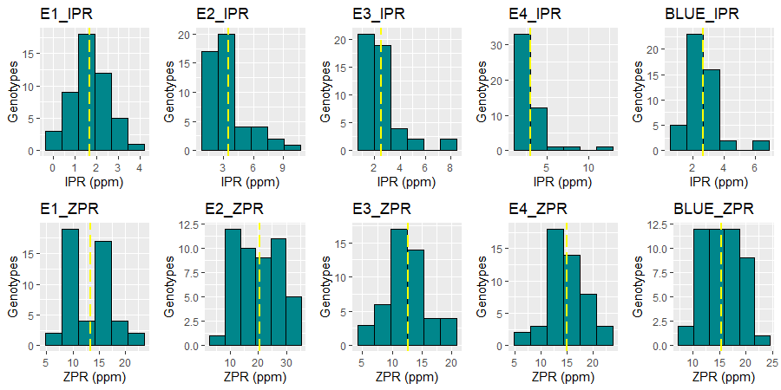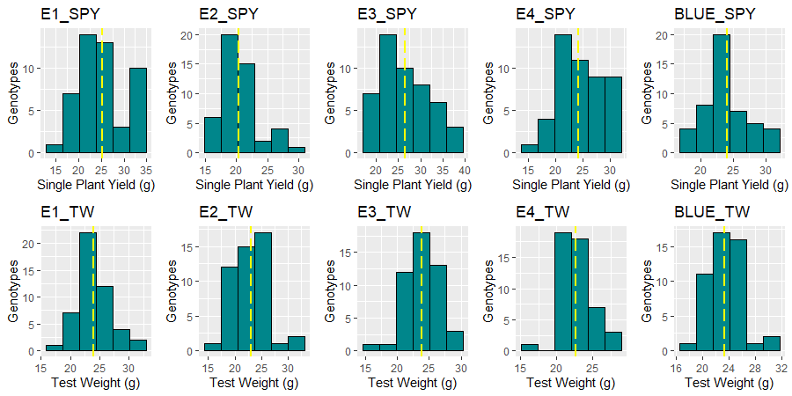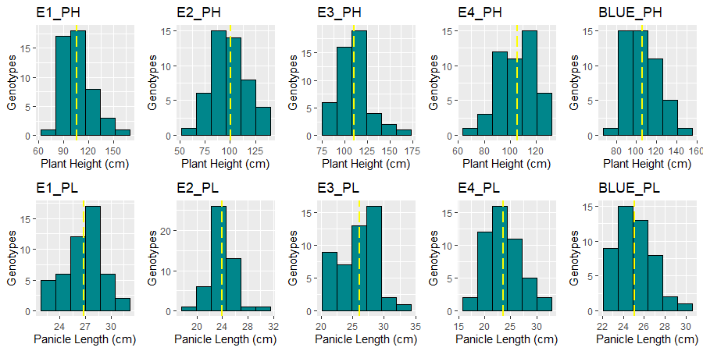

Supplementary Figure 4: Box plots for 44 RILs for ZPR- Zinc content in Polished Rice (ppm); ZBR- Zinc content in Brown Rice (ppm); IPR- Iron content in Polished Rice (ppm); IBR-Iron content in Brown Rice (ppm); SPY- Single Plant Yield(g); TW: Test weight (g); PH- Plant Height (cm); PL- Panicle Length (cm); NT-Number of Tillers per plant; DFF-Days to fifty percent flowering (days).

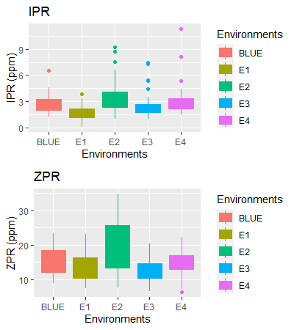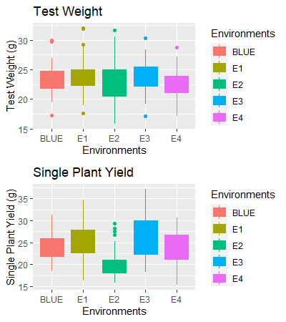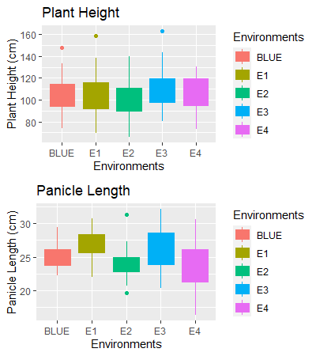

Supplementary Figure 5: D-Square analysis of 190 and 44 RILs for ten traits based on morphological characters.

Supplementary Figure 6: PCA of 190 and 44 RILs for ten traits based on morphological characters.

Supplementary Figure 7: AMMI and GGE biplot for ZBR in different Environments: ZBR-AMMI biplot, ZBR-GGE biplot, ZBR-Mean vs Stability and ZBR-Which Won Where/What.

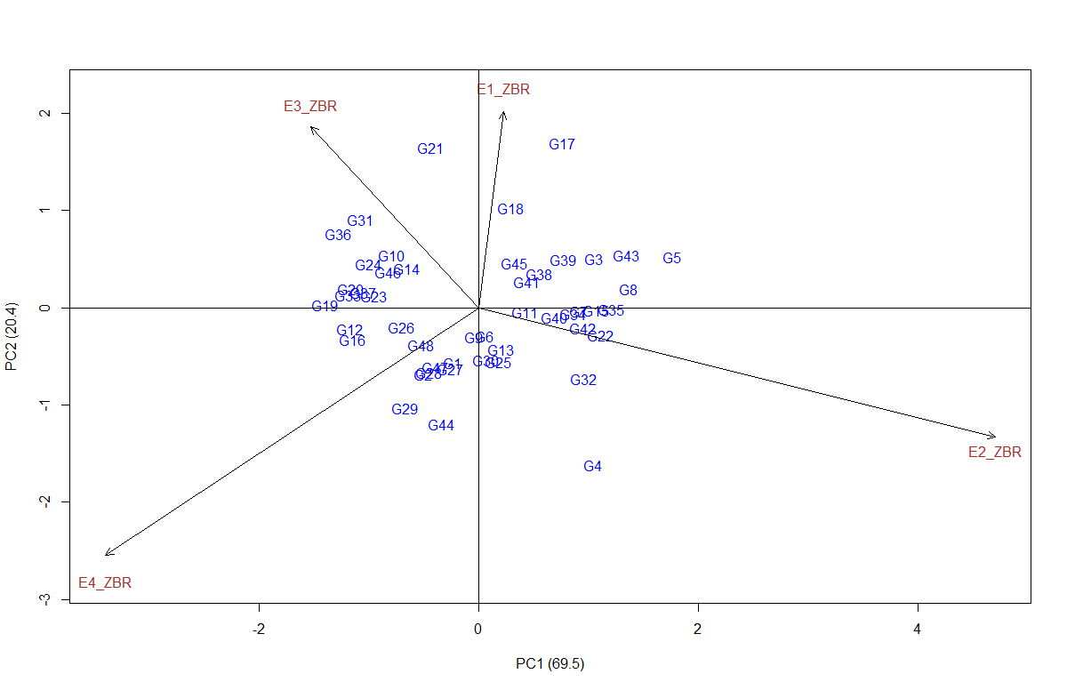 | 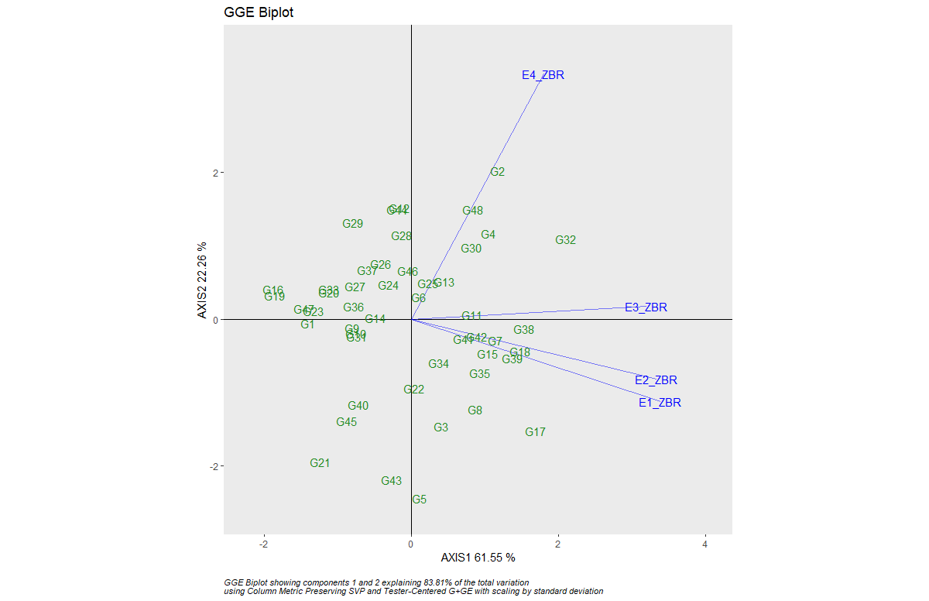
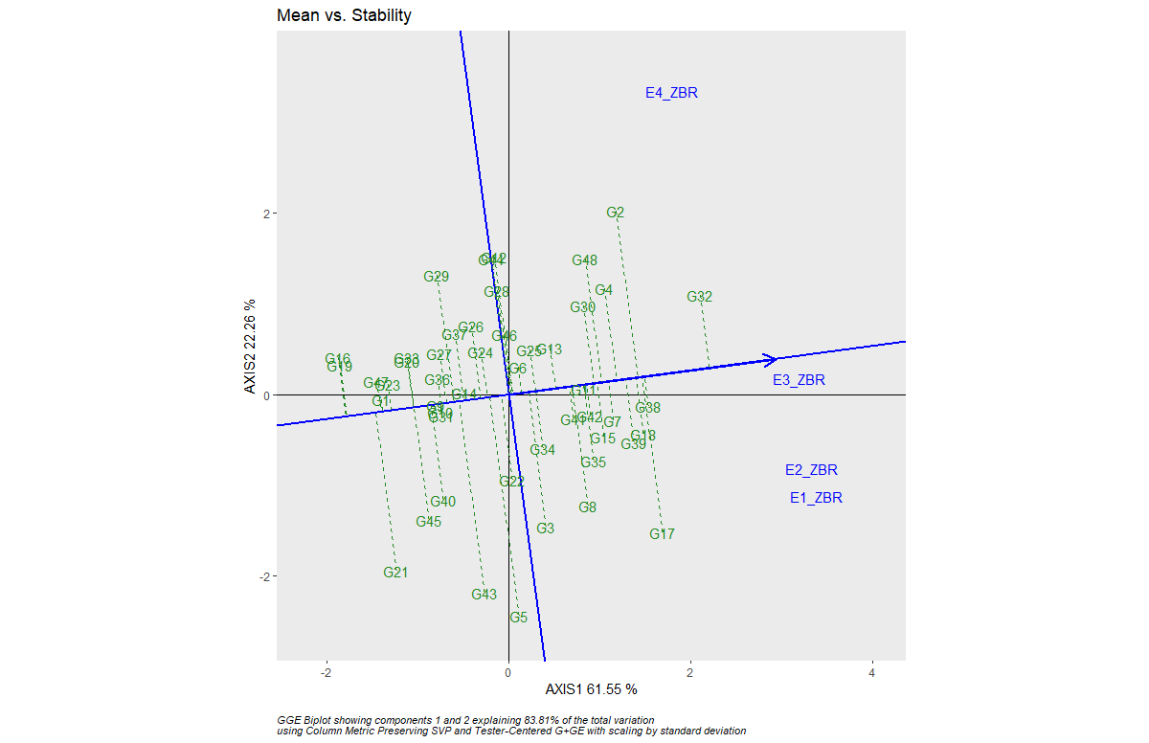 | 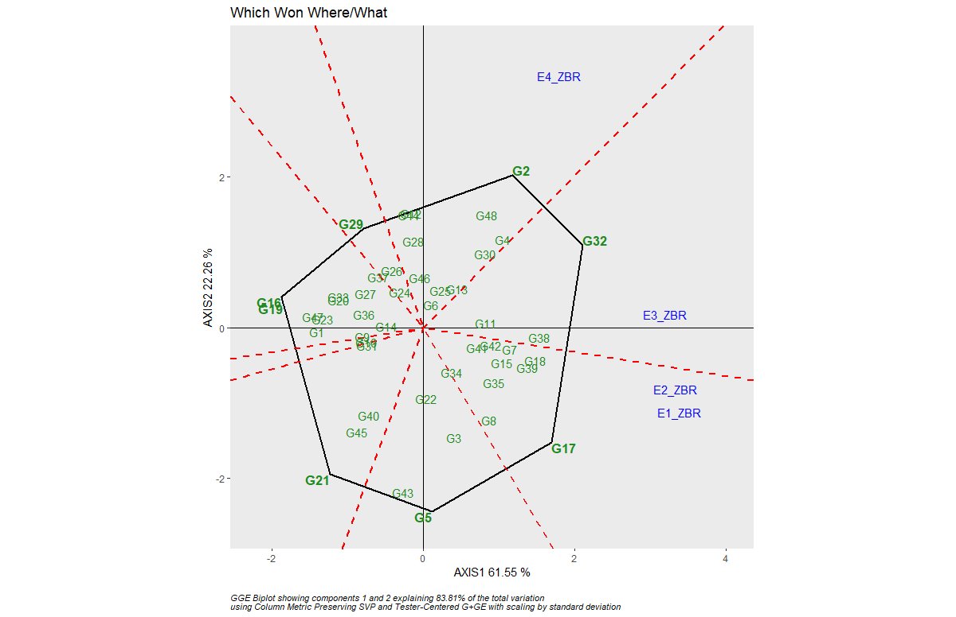

Supplementary Figure 8: AMMI and GGE biplot for IPR in different Environments: IPR-AMMI biplot, IPR-GGE biplot, IPR-Mean vs Stability and IPR-Which Won Where/What.
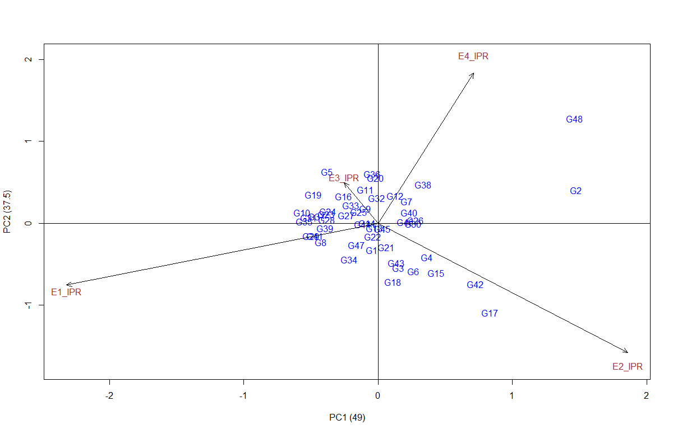 | 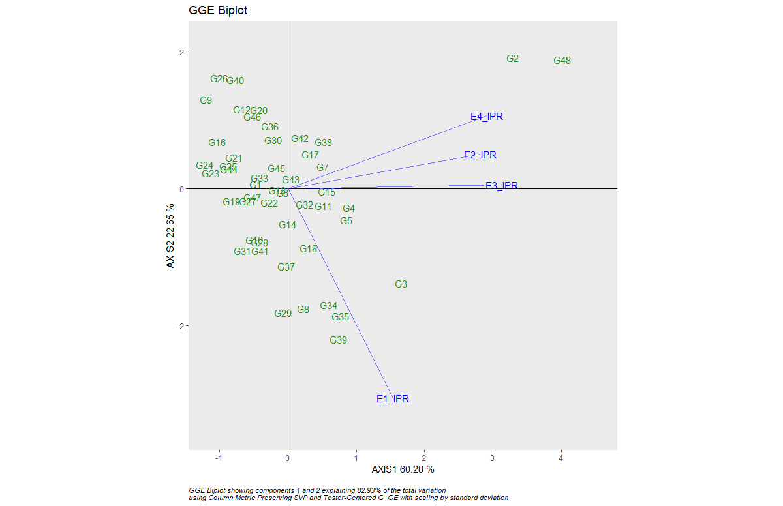
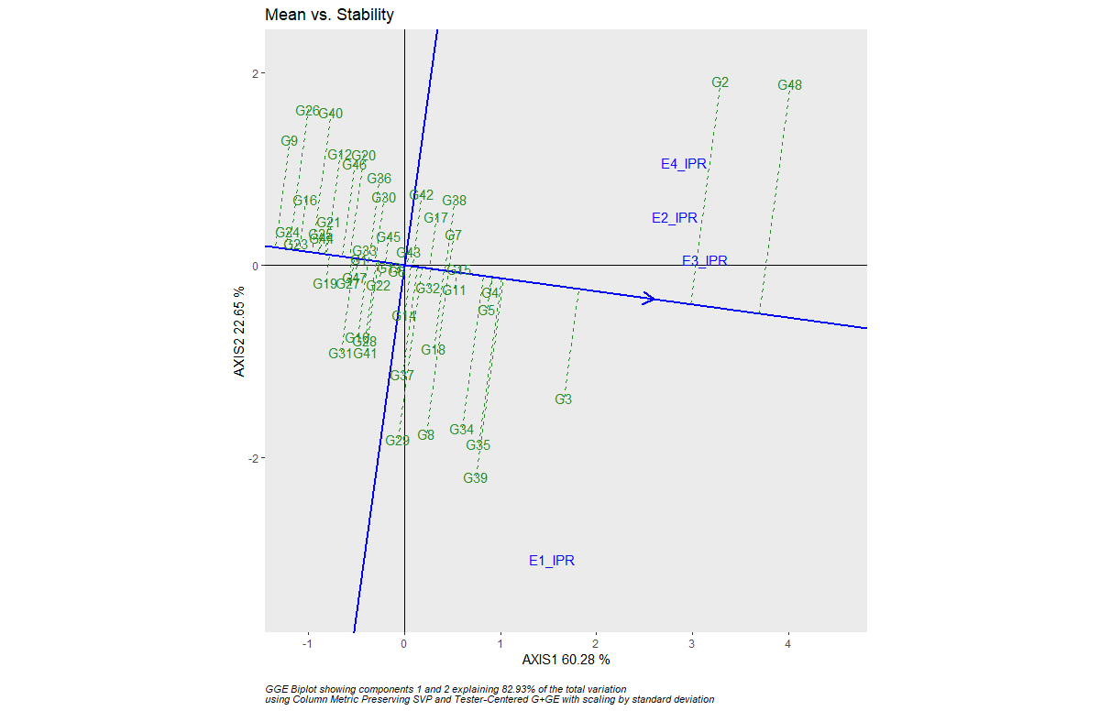 | 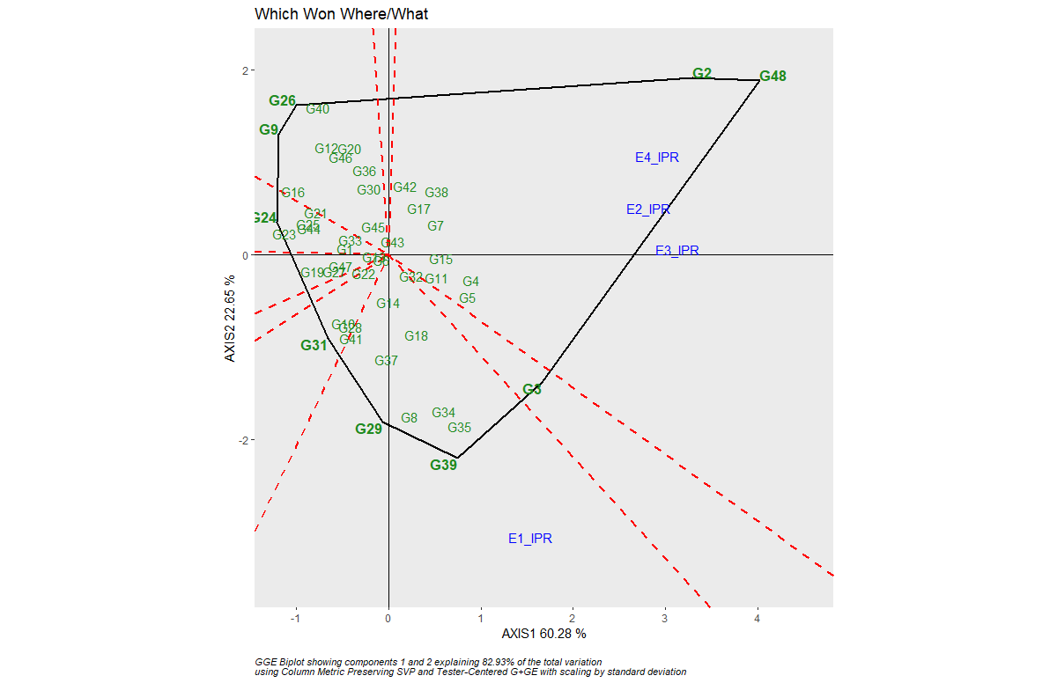
Supplementary Figure 9: AMMI and GGE biplot for IBR in different Environments: IBR-AMMI biplot, IBR-GGE biplot, IBR-Mean vs Stability and IBR-Which Won Where/What.
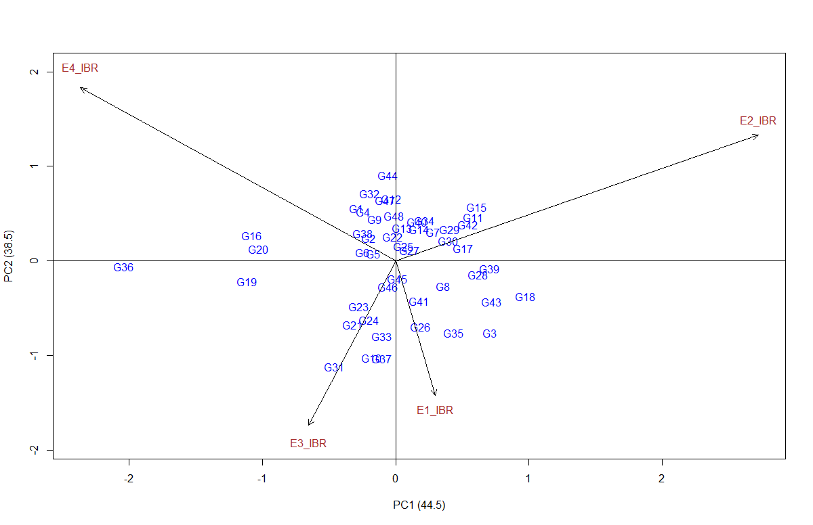 | 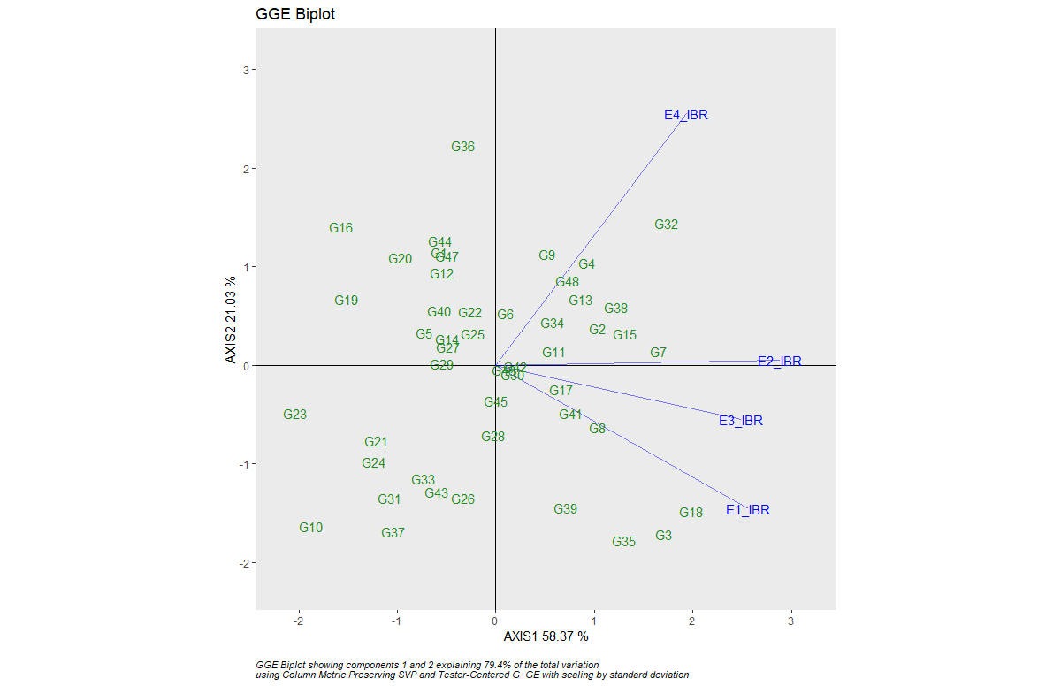
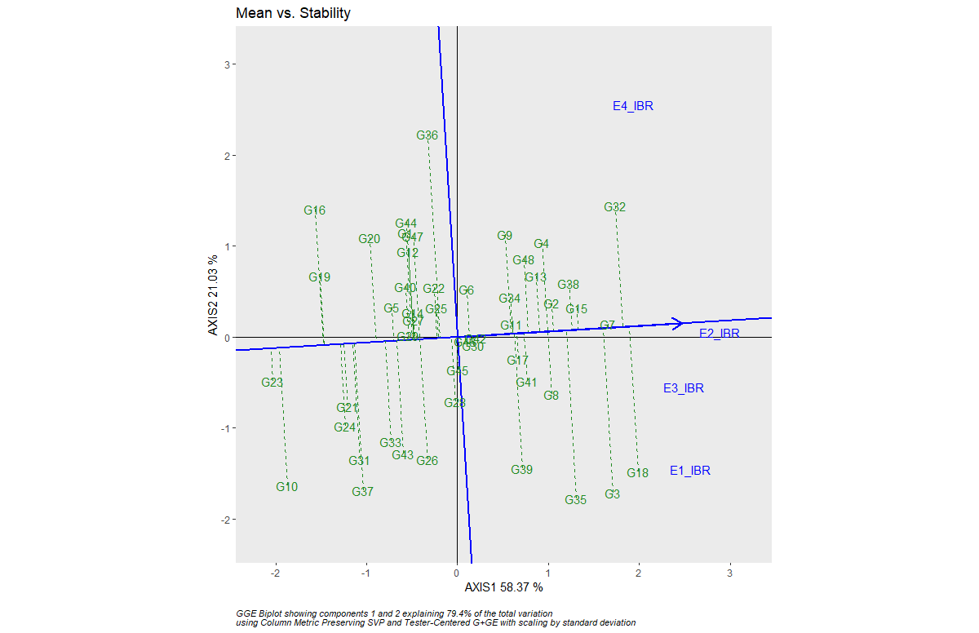 | 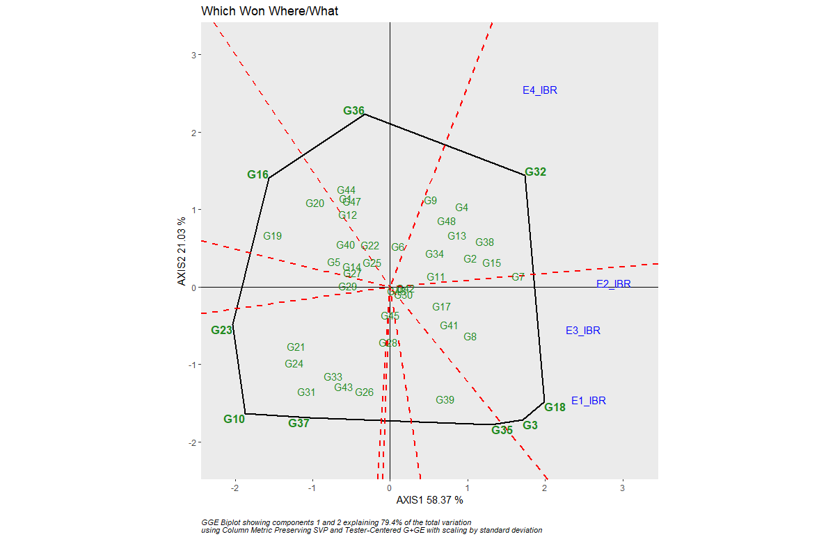

Supplementary Figure 10: AMMI and GGE biplot for TW in different Environments: TW-AMMI biplot, TW-GGE biplot, TW-Mean vs Stability and TW-Which Won Where/What.
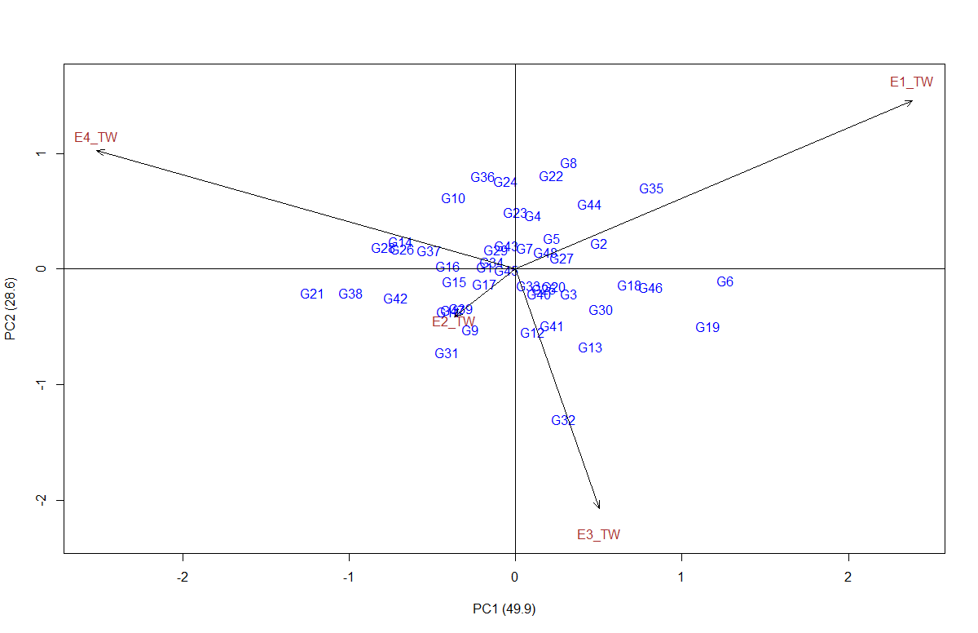 | 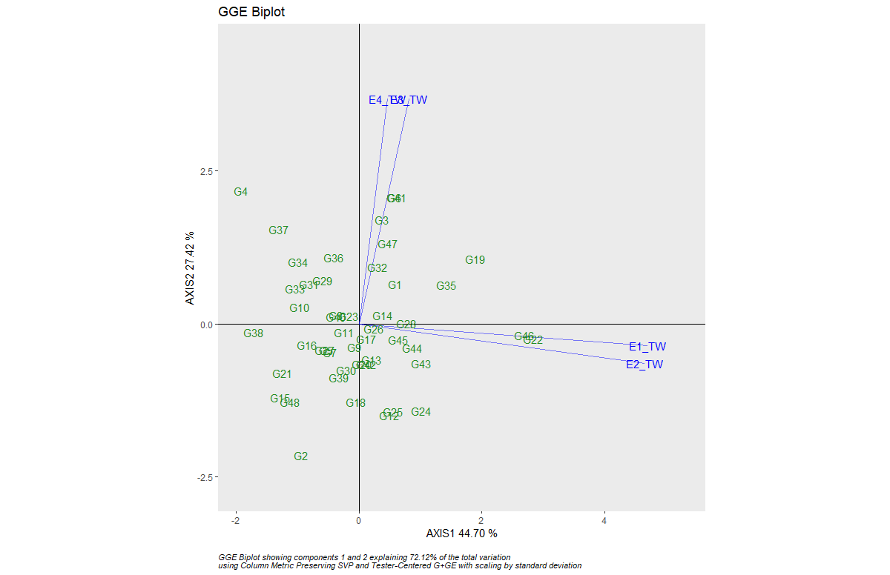
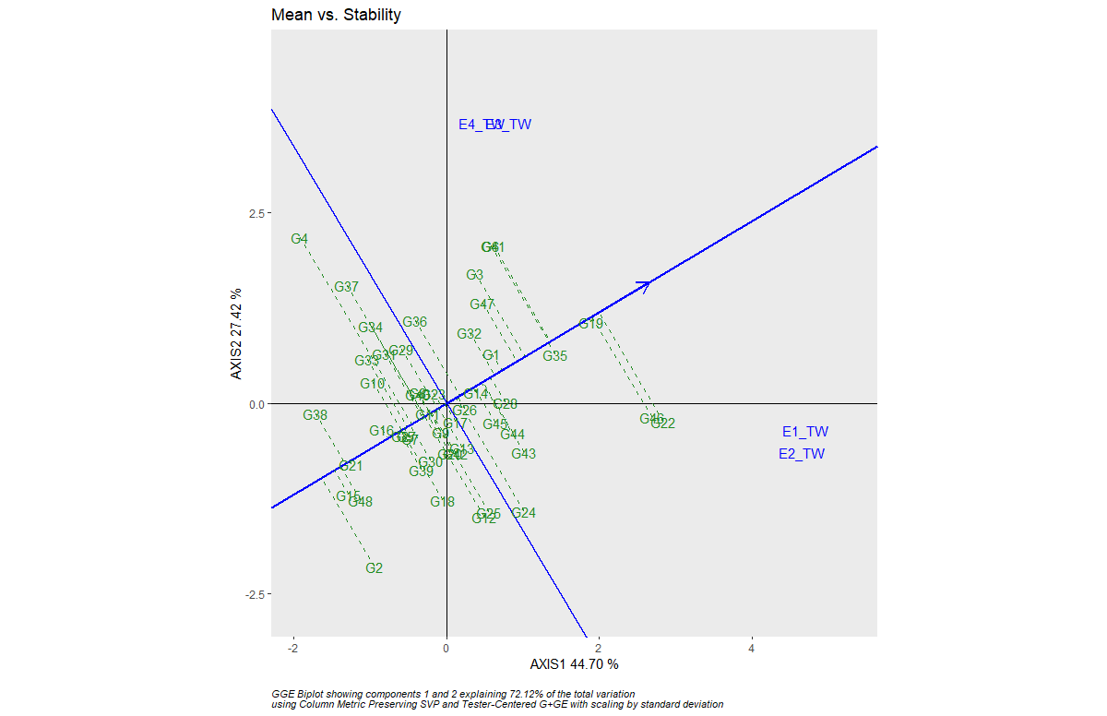 | 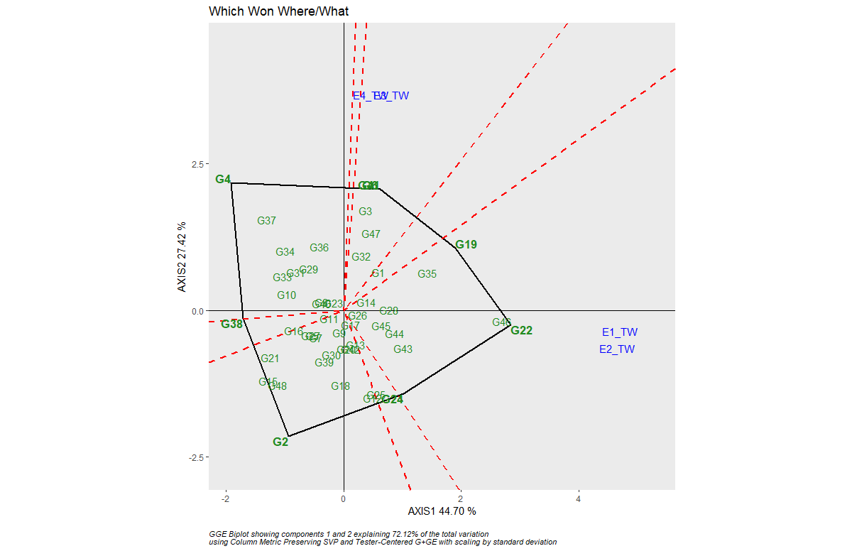
Supplementary Figure 11: AMMI and GGE biplot for PH in different Environments: PH-AMMI biplot, PH-GGE biplot, PH-Mean vs Stability and PH-Which Won Where/What.
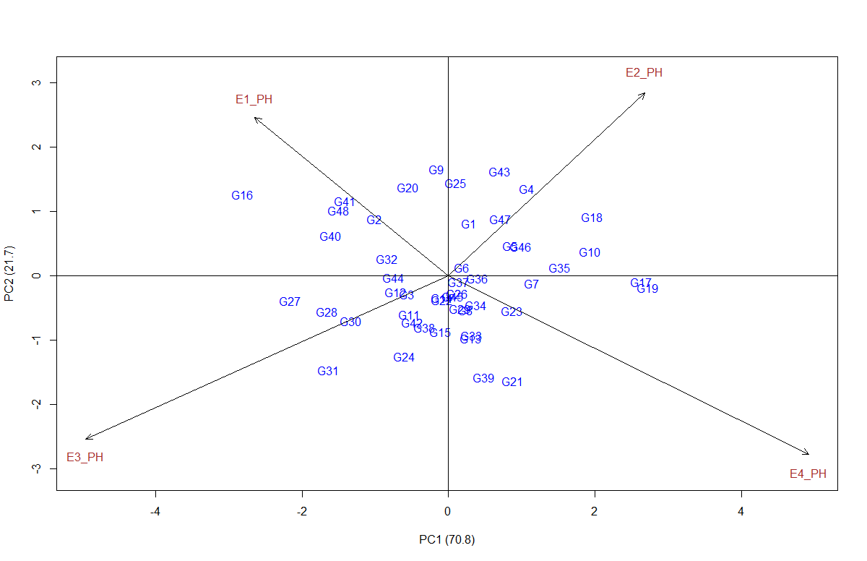 | 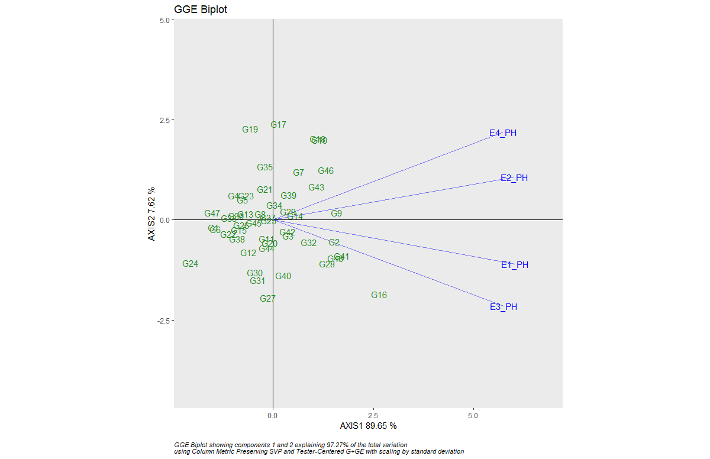
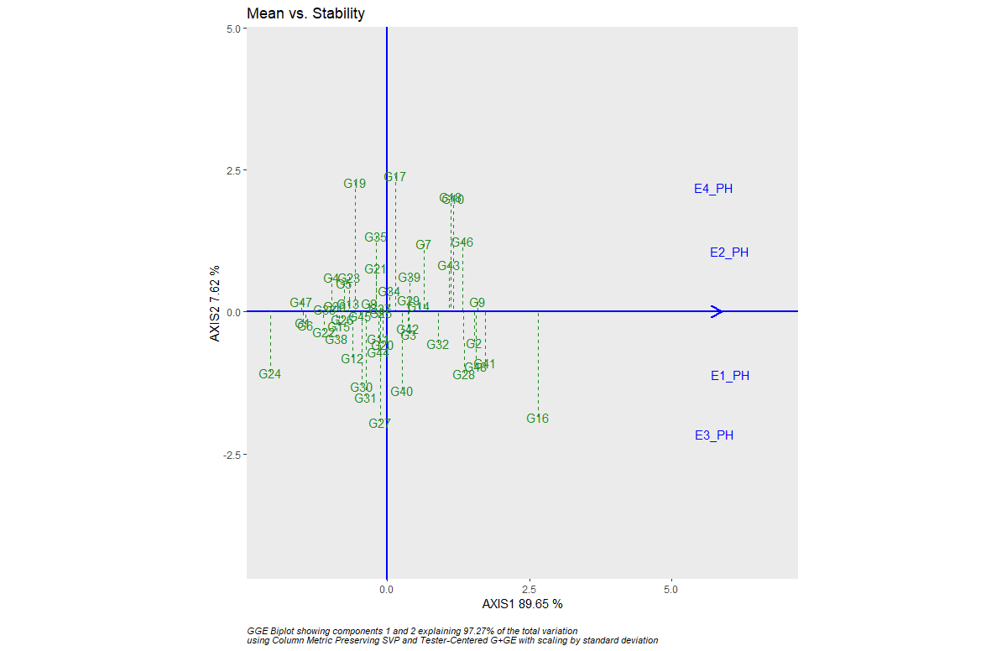 | 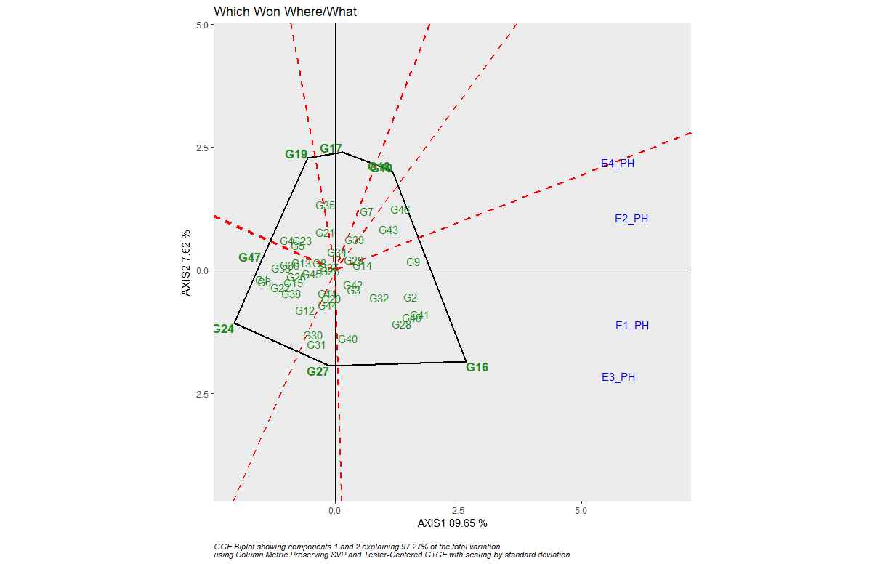
Supplementary Figure 12: AMMI and GGE biplot for PL in different Environments: PL-AMMI biplot, PL-GGE biplot, PL-Mean vs Stability and PL-Which Won Where/What.

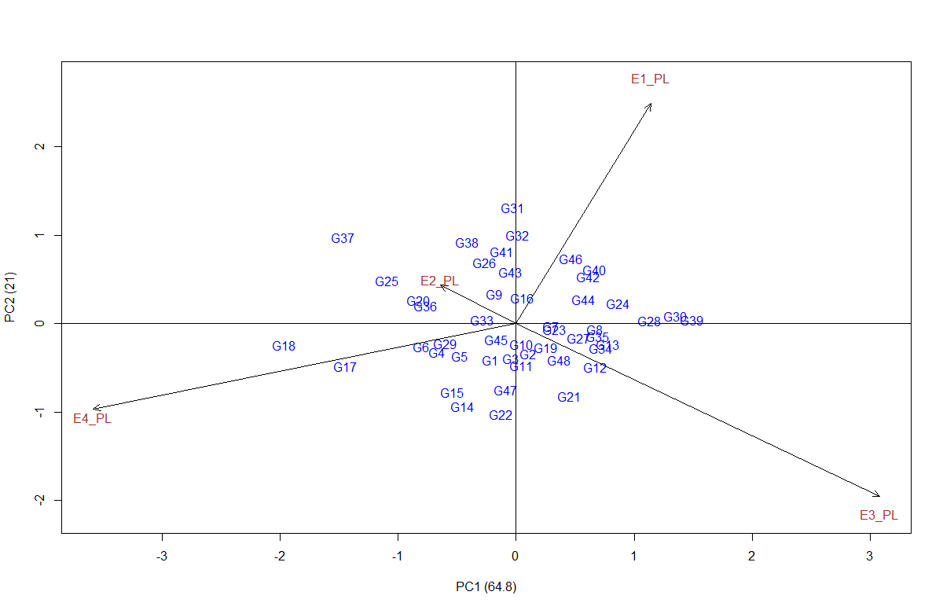 | 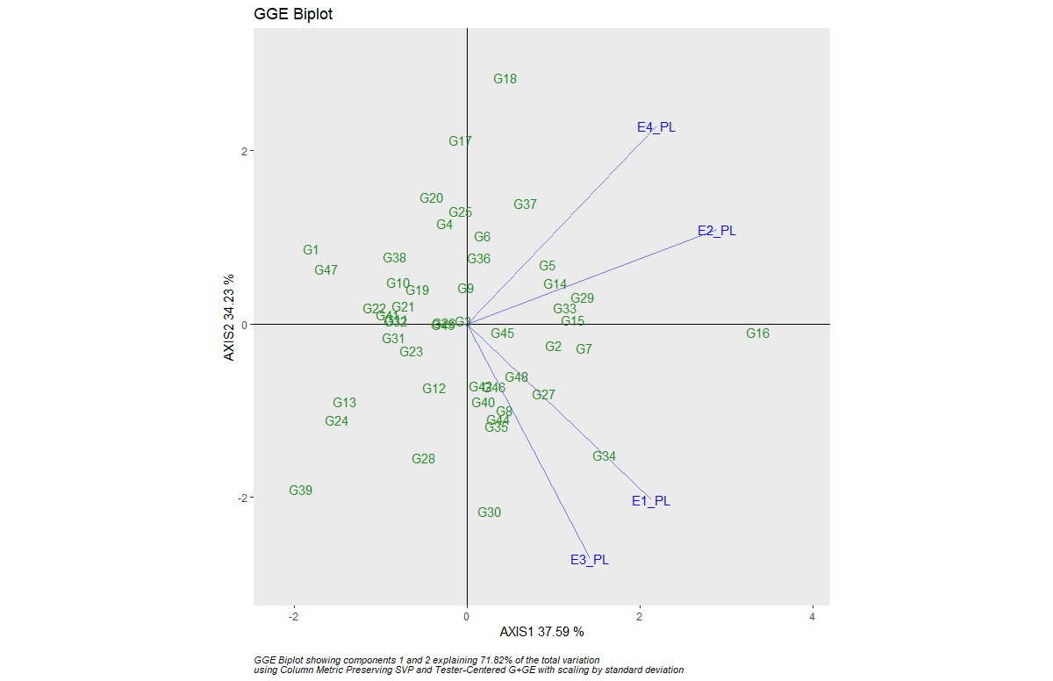
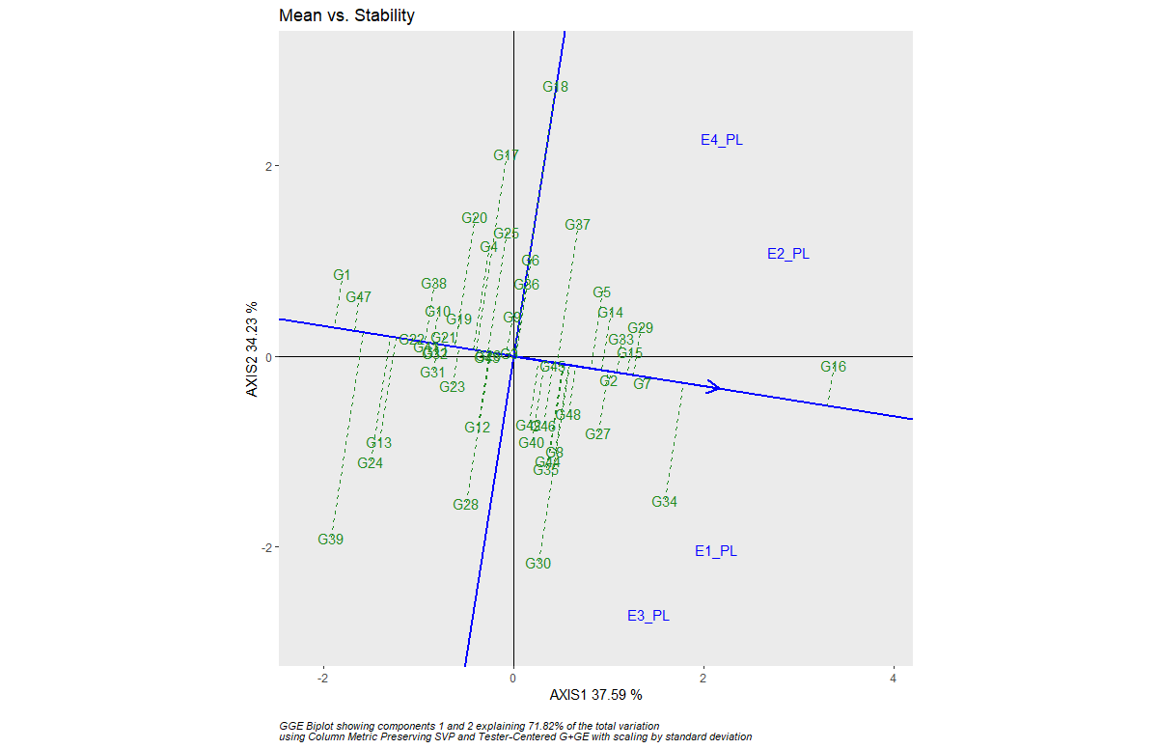 | 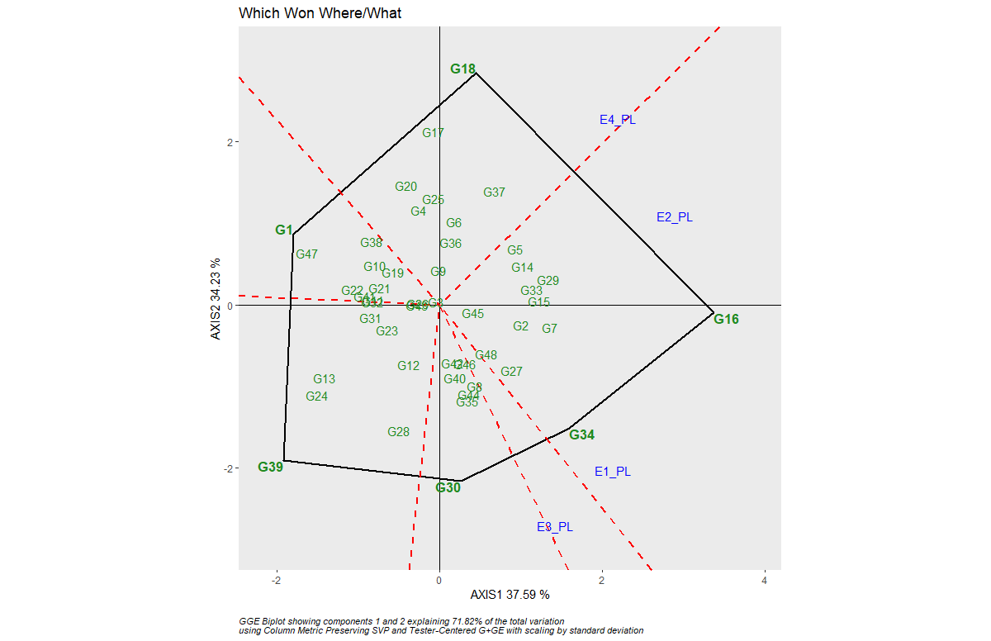
Supplementary Figure 13: AMMI and GGE biplot for NT in different Environments: NT-AMMI biplot, NT-GGE biplot, NT-Mean vs Stability and NT-Which Won Where/What
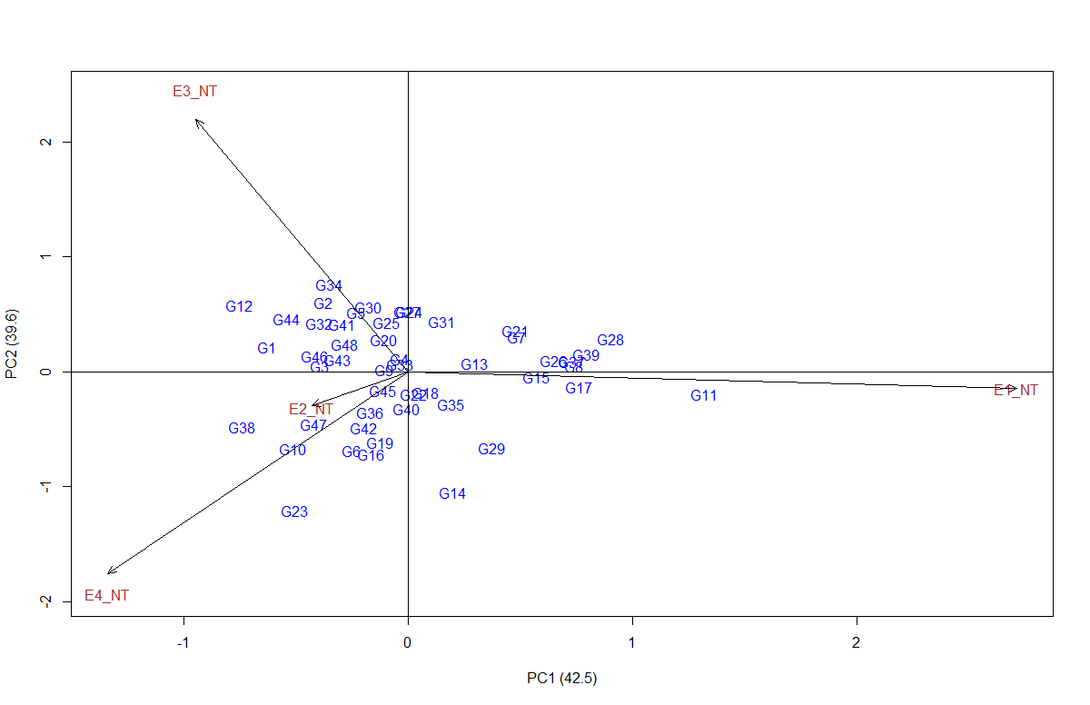 | 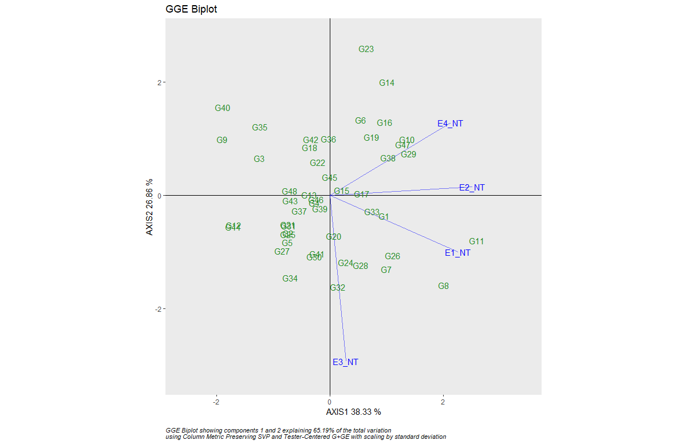
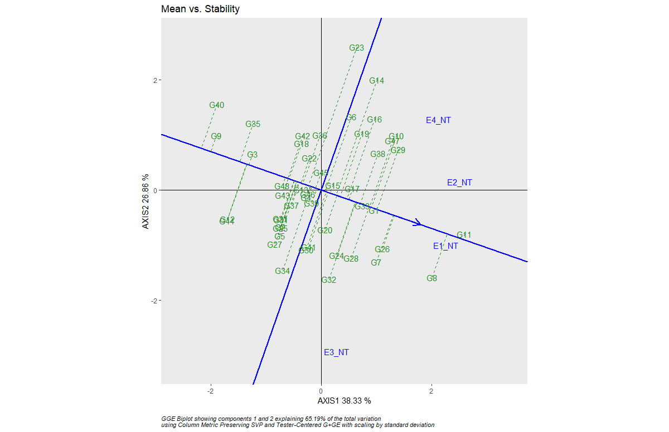 | 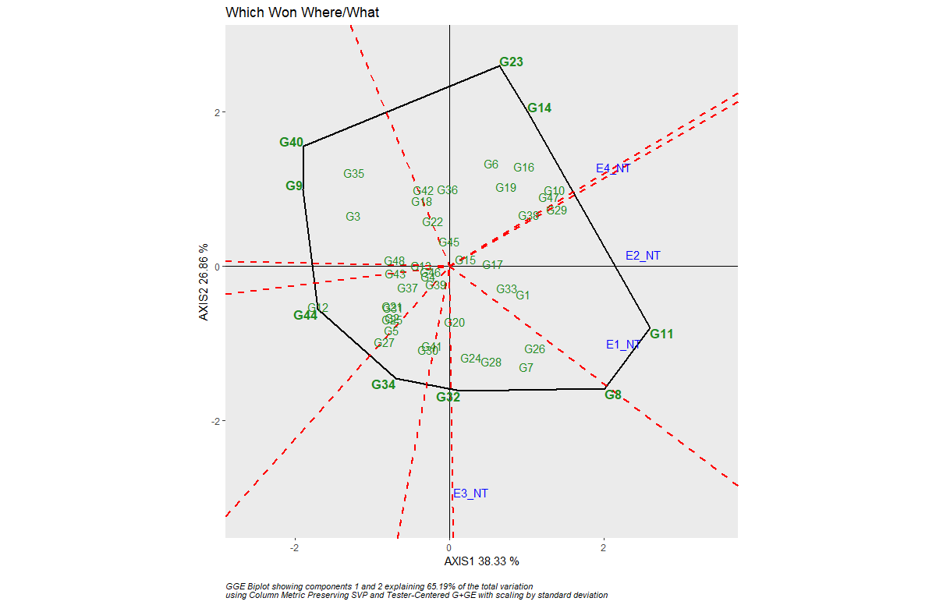
Supplementary Figure 14: AMMI and GGE biplot for DFF in different Environments: DFF-AMMI biplot, DFF-GGE biplot, DFF-Mean vs Stability and DFF-Which Won Where/What
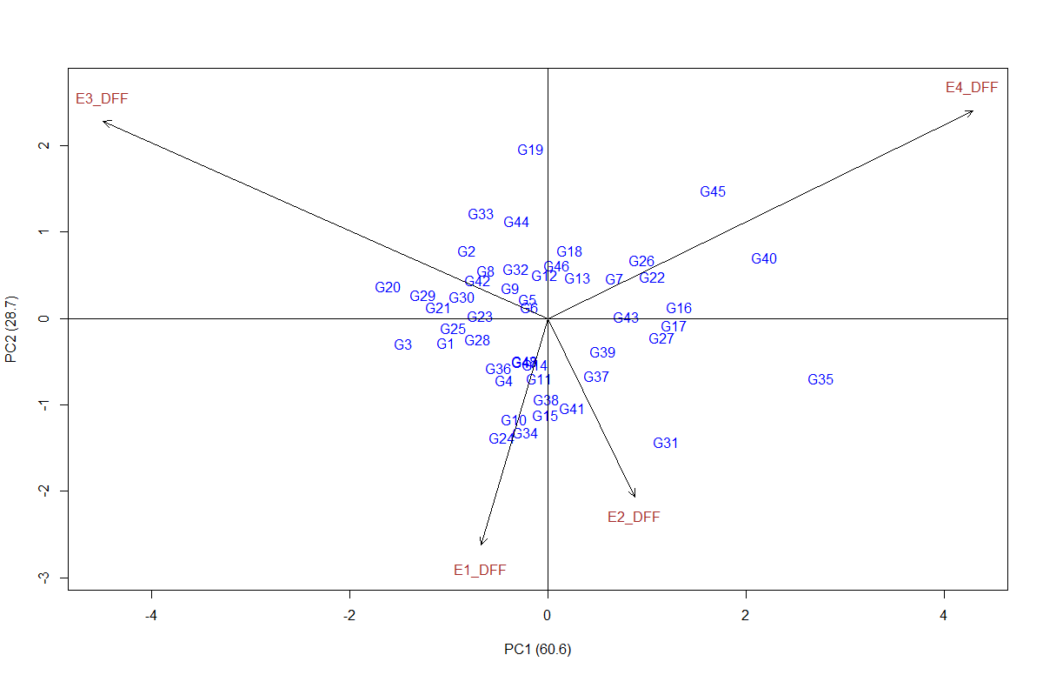 | 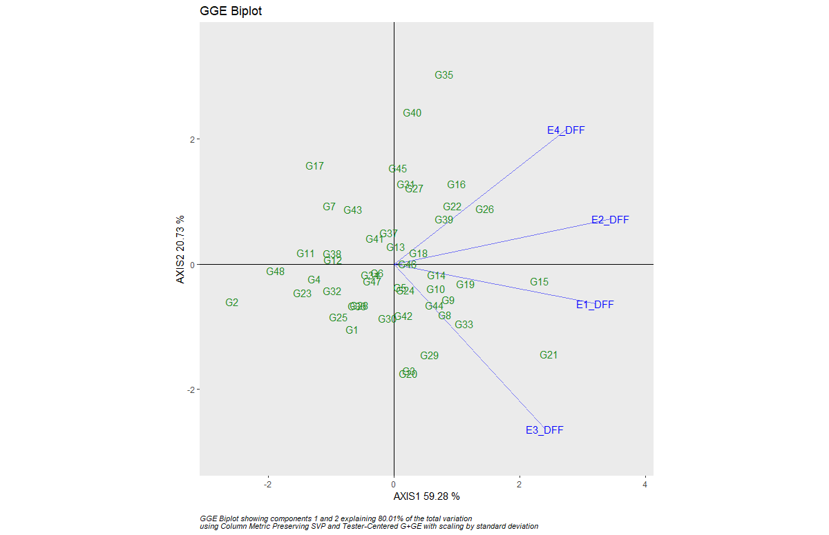
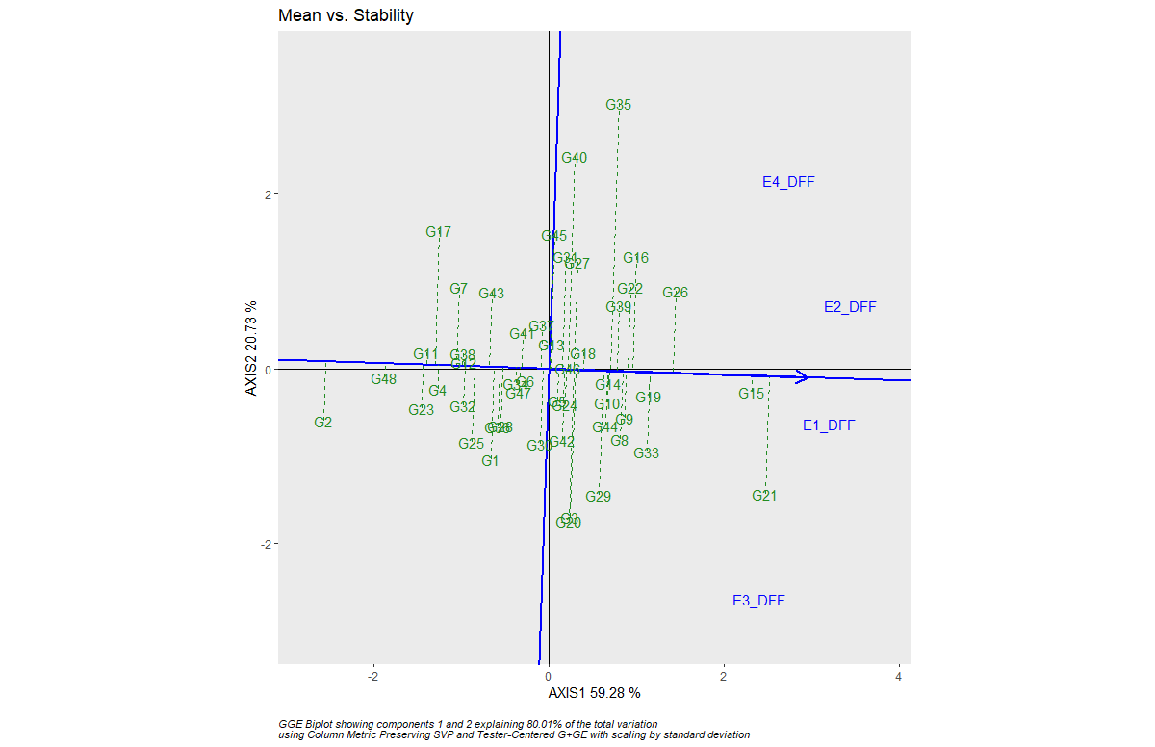 | 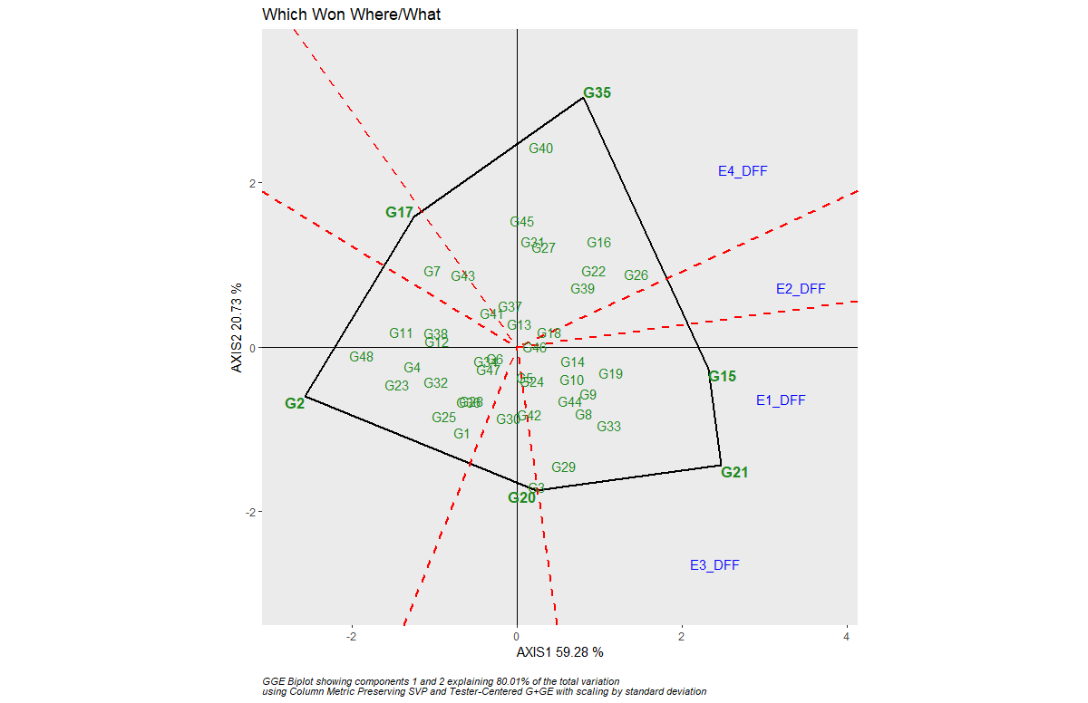

Supplementary Figure 15: Identified Candidate genes in the QTL regions (qZPR.1.1, qAOC_ZPR.1.1 and qZBR.1.1on chromosome 1; qZPR.11.1 and qAOC_ZPR.11.1 on chromosome 11) by using WEGO analysis.

Supplementary Figure 16: Identified two putative candidate genes and their temporal and spatial expression

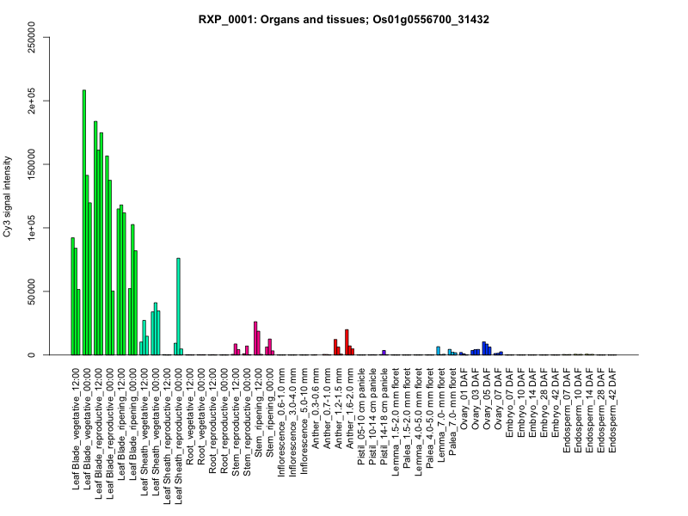 | 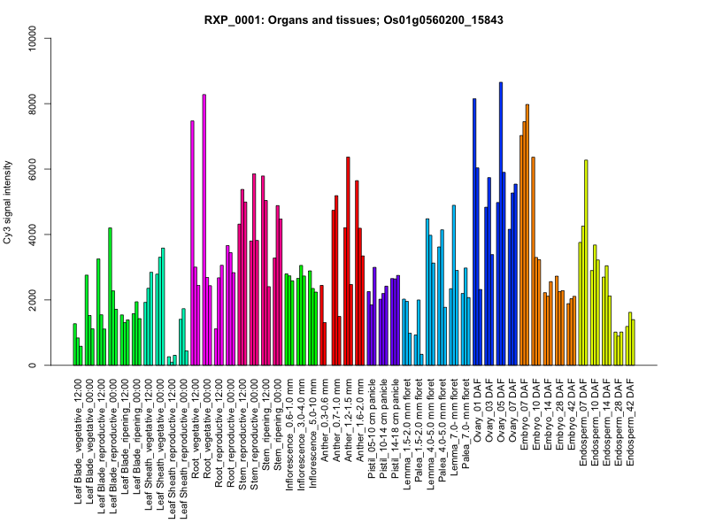

Supplementary Figure 17: Candidate gene (Os01g0560200-vesicle transport v-SNARE protein, putative, expressed positioned) network by using KNet miner.

.

