Supplementary Material

Supplementary Figures

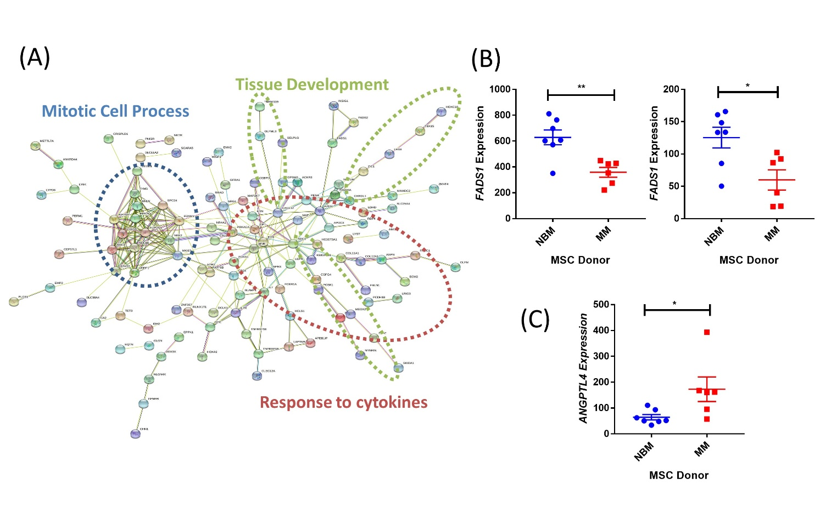
Supplemental Figure 1. Expression of critical genes altered in myeloma patient MSCs. String-db analysis of significantly downregulated (p<0.05, FC≤-2) transcripts in MM-MSCs compared to NBM-MSCs (A). Additional transcript expression for FADS1 (B) and ANGPTL4 (C). Analysis of publicly available data from Corre et al. 2007, Leukemia.

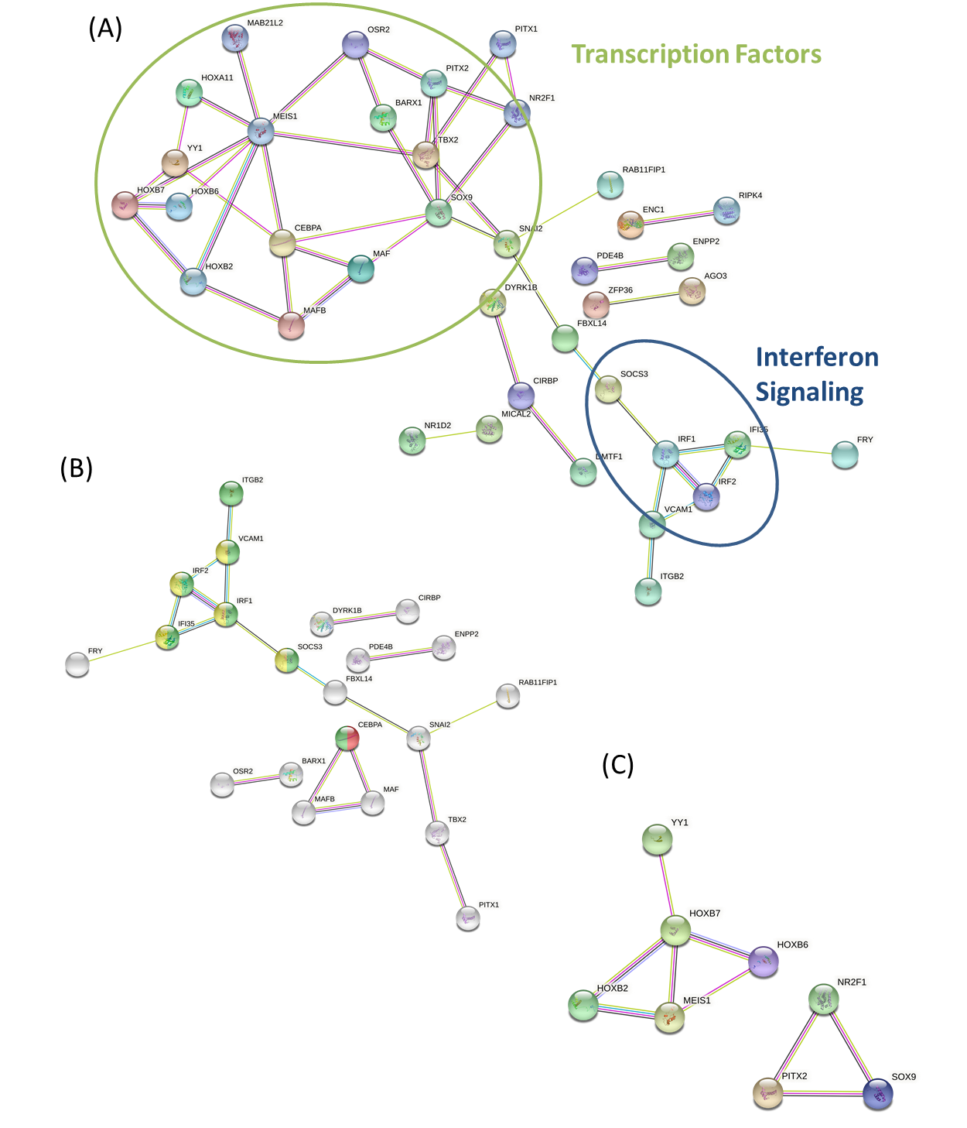
Supplementary Figure 2. Differentially expressed genes in myeloma patient MSCs. String-db analysis of all differentially expressed genes (A), as well as downregulated (B) and upregulated genes in MM-MSCs compared to NBM-MSCs. Nodes highlighted in downregulated genes: red= positive regulation of fat cell differentiation (GO: 0045600), green= cellular response to cytokine stimulus (GO:0071345), yellow=interferon signaling (HSA-9133531). Analysis of publicly available data from Todoerti et al. 2007, Experimental Hematology.

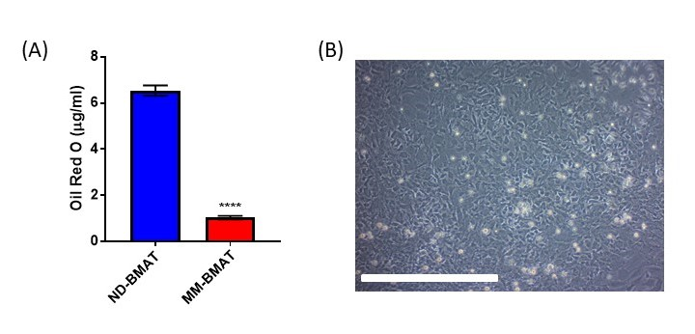
Supplementary Figure 3. Adipogenic capacity in myeloma-associated stromal cells. Quantification of oil red o (A) from ND-MSCs differentiated into bone marrow adipose tissue (ND-BMAT) and MM-MSCs differentiated into bone marrow adipose tissue (MM-BMAT) using 21 days of adipogenic media (n=16 wells, 1 donor). Undifferentiated mouse MSCs (B), imaged with 10X objective; scale bar = 500 µm.

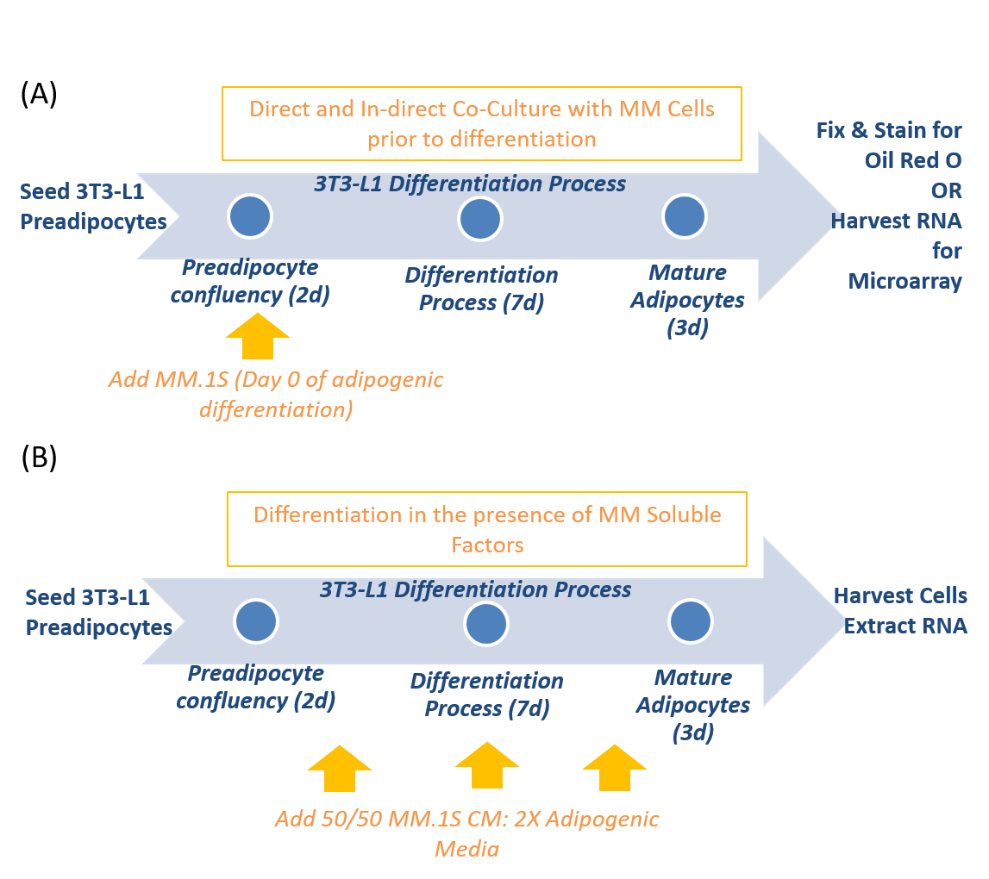
Supplemental Figure 4. Adipogenic differentiation of preadipocytes is inhibited by MM cells. Experimental design of experiments comparing 3T3-L1 preadipocytes exposed to MM cells for 48 hours prior to differentiation (A). Experimental design of qPCR experiment comparing the differentiation of 3T3-L1 preadipocytes in the presence or absence of MM soluble factors by exposure to myeloma conditioned media (CM) (B).

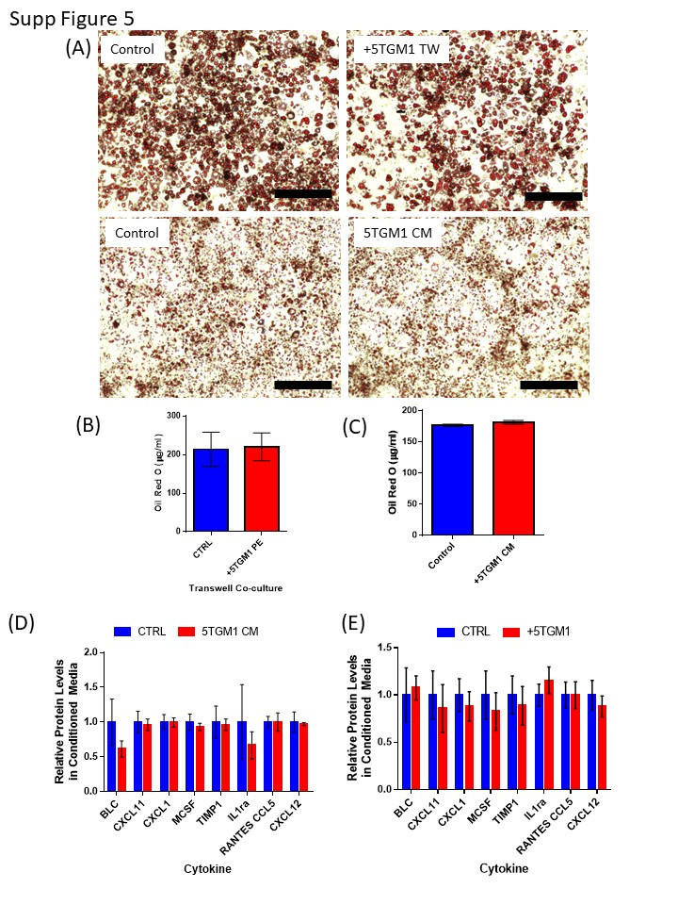
Supplemental Figure 5. Characterization of the effects of 5TGM1 soluble factors on 3T3L1 adipogenesis. 3T3-L1 adipocytes were differentiated after exposure to 5TGM1 cells via transwell (TW) for 48 hours, or in the presence 5TGM1 conditioned media (CM) for 7 days prior to the collection of conditioned media and fixation and staining with Oil Red O (A; scale bar= 300 µm). Lipid content was assessed by oil red-o elution and quantification (B-C). 3T3-L1 adipocytes exhibit no significant differences in cytokine production in response to either (D) 5TGM1 conditioned media administered during differentiation or (E) indirect co-culture of 5TGM1 cells via transwell co-culture prior to differentiation; n=3 experiments. Conditioned media was collected for 48 hours at the end of adipogenic differentiation and assessed via mouse cytokine array.

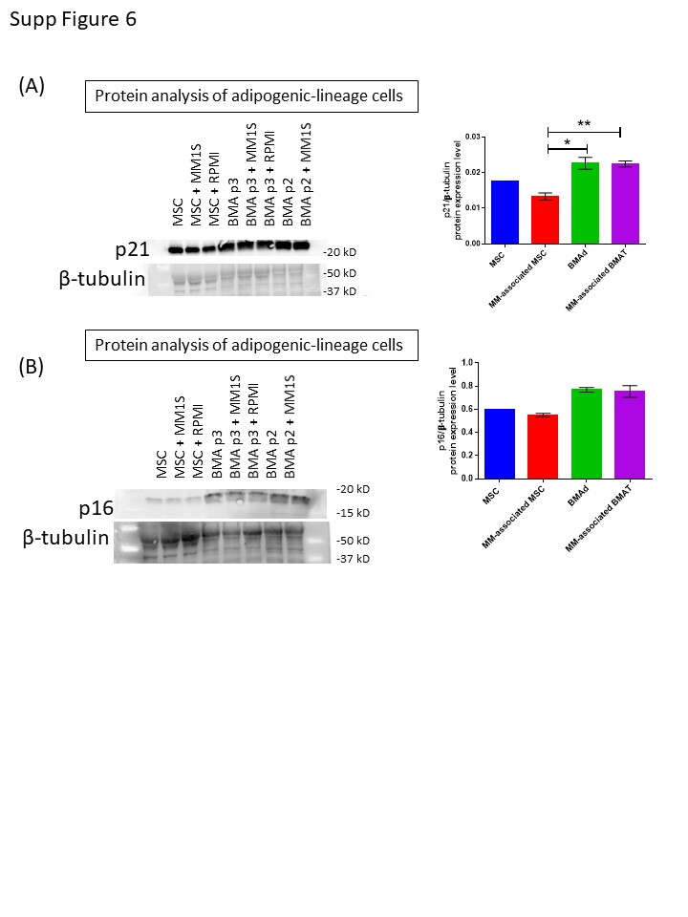
Supplemental Figure 6. Effects of soluble myeloma-derived factors on senescence-associated markers. p21(A) and p16 (B) protein levels were assessed in hMSCs exposed to MM.1S cells via transwell, immediately after exposure (MM-associated MSC), or after 21 days of differentiation following pre-exposure with MM.1S cells (MM-associated BMAT). Two-way ANOVA with Tukey’s post-hoc analysis was used to assess significance.

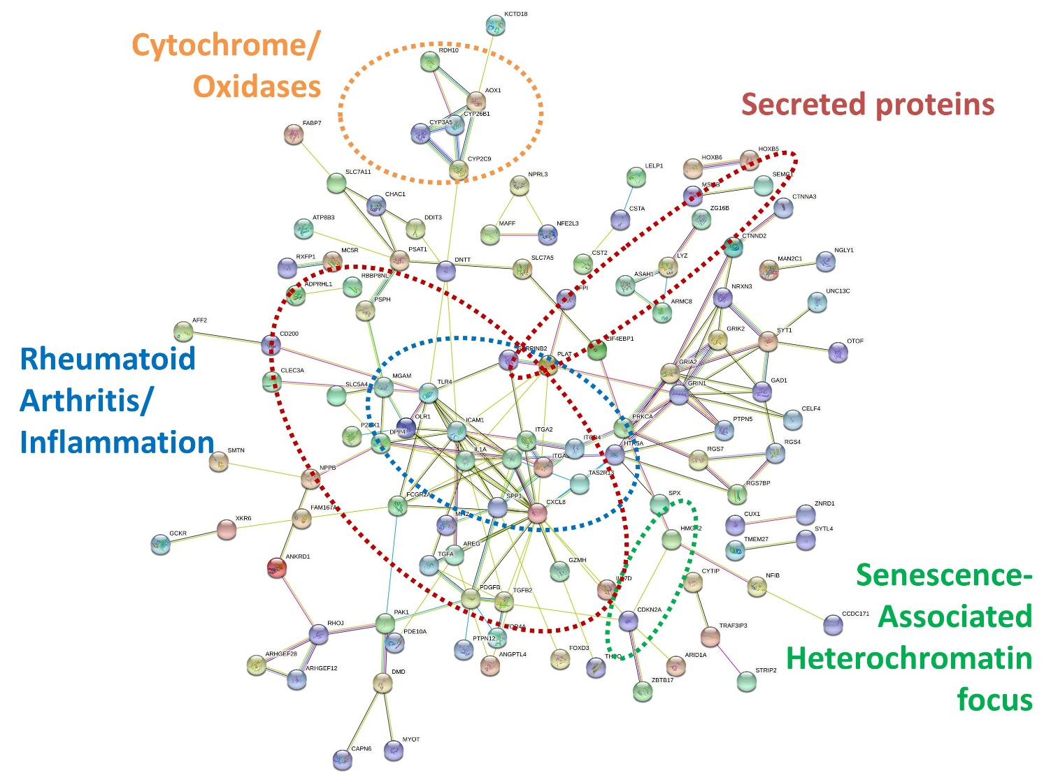
Supplemental Figure 7. Upregulated transcripts in MM-MSCs reveal increased expression of inflammatory cytokines. String-db analysis of significantly upregulated (p<0.05, FC≥2) transcripts in MM-MSCs compared to NBM-MSCs. Analysis of publicly available data from Corre et al. 2007, Leukemia.

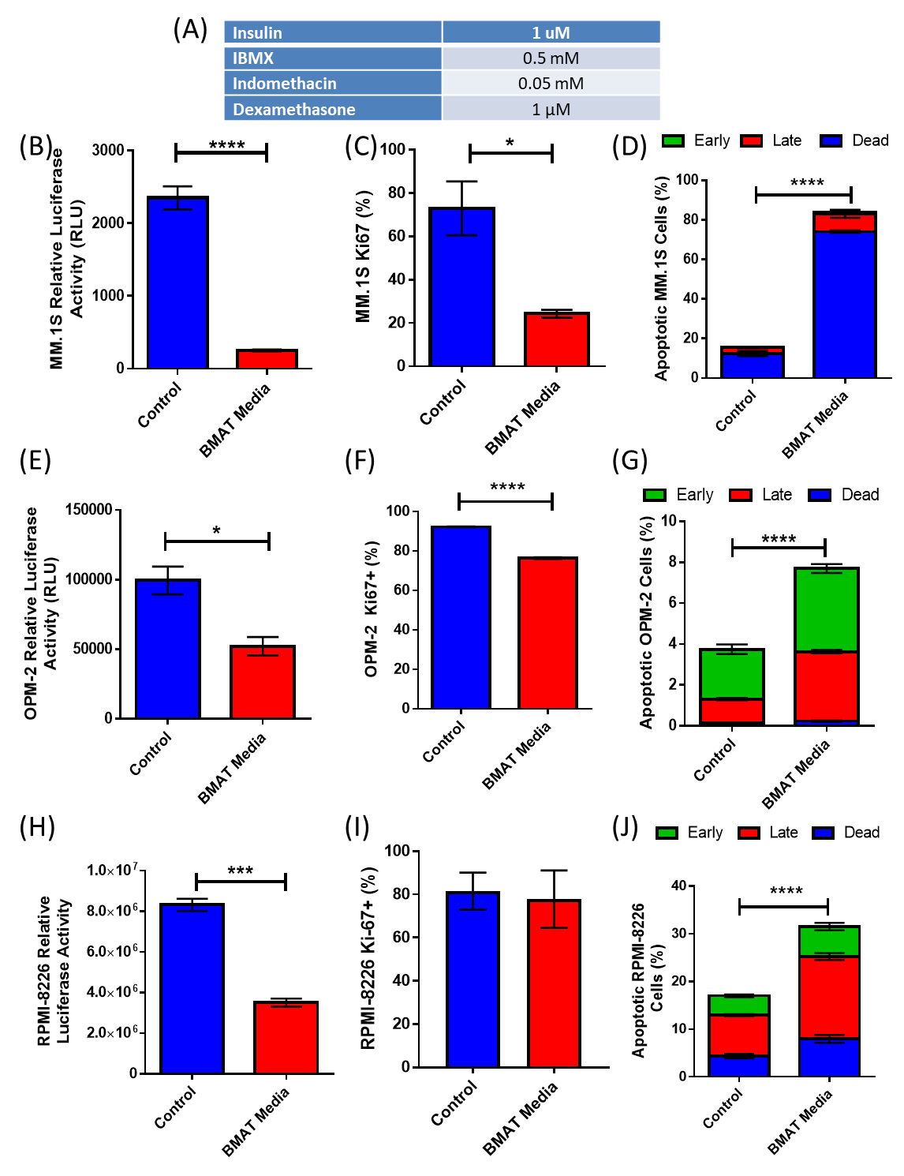
Supplemental Figure 8. Myeloma cell lines are affected by adipogenic differentiation media with implications for co-culture experiments. Concentrations of various components used in adipogenic differentiation (AD) media (A). Effects of AD on MM.1S^{gfp+luc+} (B-D) cell number (B), proliferation (C), and apoptosis (D); OPM-2^{mcherry+luc+} (E-G) cell number (E), proliferation (F), and apoptosis (G); RPMI-8226 (H-J) cell number (H), proliferation (I), and apoptosis (J). Cell number was assessed by luciferase activity by luciferin spike in for MM.1S and OPM-2, and CellTiter Glo in RPMI-8226. Proliferation and apoptosis were assessed utilizing flow cytometery with Ki67 labeling, and Annexin V/DAPI labeling respectively. *p < 0.05, ***p < 0.001, ****p < 0.0001.

Supplementary Tables
Supplementary Table 1. Significantly upregulated genes in 3T3-L1 adipocytes exposed to MM.1S cells prior to adipogenic differentiation. 105 genes were upregulated by a fold-change of >1.5 and met the p-value cutoff of p<0.05.
Gene Symbol | RefSeq | p-value | Fold-Change (MM1S vs. Control)
Camp | NM_009921 | 0.0469083 | 3.72546
Irak3 | NM_028679 | 0.0111517 | 3.64475
C4a | NM_011413 | 0.00494647 | 2.40538
Lcn2 | NM_008491 | 0.0128835 | 2.34621
C4b | NM_009780 | 0.000832202 | 2.30039
Fgl1 | NM_145594 | 0.0190904 | 2.24146
Id3 | NM_008321 | 0.00221037 | 2.1954
A4galt | NM_001004150 | 0.0477032 | 2.18086
Hp | NM_017370 | 0.00487906 | 2.17003
Steap4 | NM_054098 | 0.0147021 | 2.12538
Clu | NM_013492 | 0.00801329 | 2.12235
Itih4 | NM_001159299 | 0.0151637 | 2.10771
Ereg | NM_007950 | 0.0358901 | 2.08879
Grem1 | NM_011824 | 0.000907029 | 2.02669
St14 | NM_011176 | 0.00341382 | 2.02231
Ccl20 | NM_001159738 | 0.0445496 | 1.99698
Pde8b | NM_001170669 | 0.0364435 | 1.97279
Il6 | NM_031168 | 0.0479097 | 1.95355
Frmpd1 | NM_001081172 | 0.0127849 | 1.92557
Sall4 | NM_175303 | 0.0214699 | 1.91396
Dram1 | NM_027878 | 0.00235566 | 1.90215
Ins2 | NM_001185083 | 0.0389931 | 1.88911
Hivep3 | NM_010657 | 0.000224723 | 1.88139
Trpv5 | NM_001007572 | 0.0444293 | 1.86192
Rgs16 | NM_011267 | 0.0299276 | 1.85746
Defb34 | NM_183035 | 0.00397214 | 1.83704
Gm10717 | ENSMUST00000075573 | 0.0189944 | 1.83146
Wdr64 | NM_029453 | 0.0289294 | 1.82466
Cyp2c50 | NM_001167875 | 0.0441895 | 1.81041
Id1 | NM_010495 | 0.00067358 | 1.78665
Cd14 | NM_009841 | 0.0270081 | 1.77449
Slc9a9 | NM_177909 | 0.0126696 | 1.76749
Ostn | NM_198112 | 0.0341075 | 1.76103
Pde1b | NM_001285890 | 0.0336929 | 1.76035
Olfr142 | NM_146984 | 0.02391 | 1.75737
Gabra2 | NM_008066 | 0.0475318 | 1.75475
Lrrn4cl | NM_001013019 | 0.0105767 | 1.74632
Ap1g2 | NM_007455 | 0.0222297 | 1.73513
Olfr498 | NM_146307 | 0.0433498 | 1.72864
Olfr325 | NM_207153 | 0.0213064 | 1.72192
Vstm2a | NM_145967 | 0.0398428 | 1.72105
Abca8a | NM_153145 | 0.0259487 | 1.70572
Dusp15 | NM_001159376 | 0.0393336 | 1.7053
Myh13 | NM_001081250 | 0.00282801 | 1.69065
Ccl6 | NM_009139 | 0.0189107 | 1.6839
Wdr66 | BC138176 | 0.00588127 | 1.6835
Tomm40l | NM_001037170 | 0.0230187 | 1.68227
Tmem69 | NM_177670 | 0.00955769 | 1.6818
Bpifb9a | NM_175167 | 0.0392147 | 1.68152
Mrgprb13 | XM_884524.1 | 0.00937781 | 1.67676
Lgi2 | NM_144945 | 0.0368476 | 1.67356
1700040L02Rik | NM_028491 | 0.0236681 | 1.67328
Gm11168 | ENSMUST00000177722 | 0.00993062 | 1.6704
Frrs1l | NM_001142965 | 0.0375884 | 1.65743
Tex15 | NM_031374 | 0.00820703 | 1.64894
Atf3 | NM_007498 | 0.0428791 | 1.64782
Olfr522 | NM_146952 | 0.0123422 | 1.63793
Sla2 | NM_029983 | 0.000381624 | 1.63517
1110008P14Rik | NM_198001 | 0.047498 | 1.63482
Mageb16-ps1 | NR_033647 | 0.038158 | 1.61754
Mettl13 | NM_144877 | 0.0159868 | 1.61356
Gm10800 | ENSMUST00000099683 | 0.000188034 | 1.60875
Lgals2 | NM_025622 | 0.00662435 | 1.60721
Iqcf5 | NM_029300 | 0.0170504 | 1.60694
Gm10720 | ENSMUST00000099050 | 0.0479136 | 1.60378
Slpi | NM_011414 | 0.0270927 | 1.60228
Rab3b | NM_023537 | 0.0432969 | 1.60045
Hspa1l | NM_013558 | 0.0492045 | 1.59856
Wfdc21 | NM_183249 | 0.0391166 | 1.59771
Cyp2f2 | NM_007817 | 0.00374465 | 1.59765
Slc38a6 | NM_001037717 | 0.0483509 | 1.59723
P2rx3 | NM_145526 | 0.00445631 | 1.59327
Krt16 | NM_008470 | 0.00755071 | 1.59229
Lilrb4a | NM_013532 | 0.00777996 | 1.59162
Six4 | NM_011382 | 0.0134765 | 1.5911
Il1a | NM_010554 | 0.00179691 | 1.58414
Cxcl12 | NM_001012477 | 0.0124545 | 1.57787
Sp7 | NM_130458 | 0.0099214 | 1.57681
Camkk2 | NM_001199676 | 0.00226949 | 1.57502
Msx3 | NM_010836 | 0.00906309 | 1.57104
Gm10721 | ENSMUST00000143083 | 0.0318448 | 1.56975
Ackr3 | NM_001271607 | 0.0136647 | 1.56614
Trnp1 | NM_001081156 | 0.0342377 | 1.56432
Nkx1-1 | ENSMUST00000173348 | 0.0162189 | 1.56218
4930597O21Rik | ENSMUST00000065878 | 0.00646505 | 1.56002
Necab2 | NM_054095 | 0.0193049 | 1.5541
Mup4 | NM_008648 | 0.0232165 | 1.54728
Clca3a1 | NM_009899 | 0.0251766 | 1.54198
Defb10 | NM_139225 | 0.0331585 | 1.54177
Abcc2 | NM_013806 | 0.00969951 | 1.53815
Defb22 | NM_001002791 | 0.0428185 | 1.53665
Clca3a2 | NM_030601 | 0.0460015 | 1.53313
Gm10718 | ENSMUST00000099046 | 0.0306704 | 1.53249
Parvg | NM_001162500 | 0.0438121 | 1.52903
Abcg4 | NM_138955 | 0.000856541 | 1.52894
Clvs1 | NM_028940 | 0.0138639 | 1.51896
Gm7714 | NM_001110779 | 0.00433872 | 1.51384
Adh6-ps1 | NR_033581 | 0.0390807 | 1.51333
Gm5460 | NM_001034880 | 0.0448829 | 1.51325
Klhl13 | NM_026167 | 0.049952 | 1.51289
H2-Q1 | NM_010390 | 0.0497745 | 1.50653
Gm13084 | NM_001005371 | 0.0494844 | 1.50646
Ttr | NM_013697 | 0.00351779 | 1.50367
Gm10676 | ENSMUST00000098778 | 0.0398489 | 1.5026

Supplementary Table 2: Significantly downregulated genes in 3T3-L1 adipocytes exposed to MM.1S cells prior to adipogenic differentiation. 179 genes were downregulated by a fold-change of <-1.5 and met the p-value cutoff of p<0.05.

Gene Symbol | RefSeq | p-value | Fold-Change (MM1S vs. Control)
Brca2 | NM_001081001 | 0.0171 | -1.5035
Fhl2 | NM_001289533 | 0.0324068 | -1.50374
Fam63b | NM_172772 | 0.0125922 | -1.50737
Angel2 | NM_001199020 | 0.0470518 | -1.50768
Gm10197 | ENSMUST00000086887 | 0.0320131 | -1.50796
Col11a1 | NM_007729 | 0.0414051 | -1.51222
Dhrs1 | NM_026819 | 0.0284668 | -1.51224
Plk4 | NM_011495 | 0.0139595 | -1.51402
Fbn1 | NM_007993 | 0.018272 | -1.51429
Poc1b | NM_027740 | 0.00966812 | -1.51662
Mvd | NM_138656 | 0.0171304 | -1.51722
Ppp1r3b | NM_177741 | 0.0340856 | -1.52038
Gabre | NM_017369 | 0.0366721 | -1.52063
Zfp956 | NM_178898 | 0.0224934 | -1.52224
Cldn15 | NM_021719 | 0.0130111 | -1.52241
1810024B03Rik | NM_198630 | 0.0151062 | -1.52545
Rhox4b | NM_021300 | 0.00945153 | -1.52623
Rhox4d | NM_001039695 | 0.00945153 | -1.52623
Mdc1 | NM_001010833 | 0.0071191 | -1.52665
Zfp677 | NM_172486 | 0.0151232 | -1.52748
Tubgcp5 | NM_146190 | 0.0468047 | -1.52845
Tada3 | NM_133932 | 0.000742718 | -1.52966
Dna2 | NM_177372 | 0.0485433 | -1.53004
Atp10a | NM_009728 | 0.0279789 | -1.53105
Spon2 | NM_133903 | 0.0103539 | -1.53162
Tgfbi | NM_009369 | 0.0349827 | -1.53488
Prl2c5 | NM_181852 | 0.012584 | -1.5364
Gpsm2 | NM_029522 | 0.0477398 | -1.53677
Ercc6l2 | NM_001013608 | 0.0449196 | -1.53717
Fbln5 | NM_011812 | 0.0107608 | -1.53839
Ltbp1 | NM_019919 | 0.0161087 | -1.54154
Slc16a3 | NM_001038653 | 0.0310034 | -1.54213
Hhat | NM_144881 | 0.00578237 | -1.54228
Ppih | NM_001110129 | 0.0300988 | -1.54281
Dcaf4 | NM_001165256 | 0.0374682 | -1.54374
Hmgn5 | NM_016710 | 0.0249982 | -1.54472
Pbx3 | NM_016768 | 0.00290204 | -1.54485
Zfp787 | NM_001013012 | 0.0128167 | -1.546
Slc9a3r1 | NM_012030 | 0.0426109 | -1.54909
Zfp101 | NM_009542 | 0.0167394 | -1.55026
Ehbp1 | NM_001252515 | 0.00788485 | -1.55079
Pfkp | NM_019703 | 0.0177103 | -1.55418
Fgf10 | NM_008002 | 0.0177603 | -1.55648
Thrsp | NM_009381 | 0.0183445 | -1.56041
Sdpr | NM_138741 | 0.0427777 | -1.56555
Mid1 | NM_010797 | 0.0188915 | -1.56972
Tbc1d15 | NM_025706 | 0.0470392 | -1.57399
Cep295 | NM_176976 | 0.0183626 | -1.57409
Ankrd37 | NM_001039562 | 0.0116051 | -1.57426
Zfp354c | NM_013922 | 0.0368258 | -1.57777
Gm5595 | NM_001008427 | 0.0176765 | -1.57809
Cep152 | NM_001081091 | 0.0264192 | -1.57946
Heph | NM_001159627 | 0.00747809 | -1.58055
Nid2 | NM_008695 | 0.00273867 | -1.58228
Ppox | NM_008911 | 0.0170211 | -1.58288
Shcbp1 | NM_011369 | 0.0175554 | -1.58393
9430069I07Rik | NM_001256161 | 0.0107426 | -1.58435
Cox6a2 | NM_009943 | 0.00523889 | -1.5847
Zfp389 | NR_026798 | 0.0109225 | -1.58505
Pdlim2 | NM_001253736 | 0.0108775 | -1.58814
Tmco4 | NM_029857 | 0.0105541 | -1.58871
Lig1 | NM_001083188 | 0.0217257 | -1.59277
Gucd1 | NM_175133 | 0.0258265 | -1.59368
Cpt1a | NM_013495 | 0.0159351 | -1.6035
Ephb3 | NM_010143 | 0.0387207 | -1.60354
Homer1 | NM_001284189 | 0.0304224 | -1.60356
Kcnd3 | NM_001039347 | 0.046505 | -1.60479
Mxi1 | NM_001008542 | 0.0321953 | -1.60773
Ide | NM_031156 | 0.049538 | -1.60932
Epha7 | NM_001122889 | 0.045558 | -1.6137
Hirip3 | NM_172746 | 0.00142482 | -1.6204
Arhgef28 | NM_012026 | 0.0150965 | -1.62109
Gpld1 | NM_008156 | 0.0430644 | -1.6225
Clec3b | NM_011606 | 0.0158569 | -1.62357
Pdk4 | NM_013743 | 0.00233555 | -1.63411
Osr1 | NM_011859 | 0.00270567 | -1.63422
Pir | NM_027153 | 0.0246715 | -1.64381
Mospd2 | NM_029730 | 0.00936462 | -1.64973
Fam57b | NM_001146347 | 0.0107732 | -1.6551
Plekhh2 | NM_177606 | 0.00655194 | -1.65745
Kif23 | NM_024245 | 0.026251 | -1.6586
Gfpt2 | NM_013529 | 0.0450597 | -1.6606
Pdgfra | NM_001083316 | 0.0248934 | -1.66454
Cxxc1 | NM_028868 | 0.0163446 | -1.66455
Map3k6 | NM_016693 | 0.000885982 | -1.66539
Grk5 | NM_018869 | 0.0162979 | -1.66921
Flrt2 | NM_201518 | 0.043774 | -1.67171
Insl6 | NM_013754 | 0.0434193 | -1.67629
Jup | NM_010593 | 0.012693 | -1.67685
Uggt2 | NM_001081252 | 0.000505067 | -1.67777
Maged2 | NM_001199246 | 0.0106697 | -1.67949
Slc1a4 | NM_018861 | 0.0492975 | -1.68038
Pcyt1b | NM_177546 | 0.014312 | -1.68108
Fzd2 | NM_020510 | 0.00463055 | -1.68259
Cyp2ab1 | NM_183158 | 0.0192478 | -1.6834
Ddx26b | NM_172779 | 0.0268944 | -1.69777
Stard4 | NM_133774 | 0.0368311 | -1.70004
Mmp9 | NM_013599 | 0.0171499 | -1.70377
Ccl11 | NM_011330 | 0.0265249 | -1.7045
Errfi1 | NM_133753 | 0.0121621 | -1.70497
Cemip | NM_030728 | 0.037487 | -1.70602
Hoxd3os1 | NR_027899 | 0.00656545 | -1.70783
Nt5e | NM_011851 | 0.0117729 | -1.70982
Clmn | NM_001040682 | 0.0131005 | -1.7119
Rdh10 | NM_133832 | 0.0442222 | -1.71248
Nsdhl | NM_010941 | 0.0151529 | -1.71566
N4bp2 | NM_001024917 | 0.0319872 | -1.71615
Medag | NM_027519 | 0.00510369 | -1.7206
Tfap2a | NM_001122948 | 0.00991587 | -1.72635
Fasn | NM_007988 | 0.0364073 | -1.72769
Mad2l1 | NM_019499 | 0.0268562 | -1.73104
Rcbtb1 | NM_027764 | 0.0393083 | -1.73566
Sc5d | NM_172769 | 0.00861774 | -1.74396
Scd2 | NM_009128 | 0.00722872 | -1.74797
Iffo2 | NM_001205173 | 0.039912 | -1.75264
Ang3 | NM_001123394 | 0.00354553 | -1.76201
Lmln | NM_172823 | 0.0311676 | -1.76787
Ccdc82 | NM_025534 | 0.00631421 | -1.77364
Msi1 | NM_008629 | 0.00204097 | -1.78508
Apaf1 | NM_001042558 | 0.000406525 | -1.79901
Foxo4 | NM_018789 | 0.00950658 | -1.80286
Gcnt4 | NM_001166065 | 0.012132 | -1.80355
Postn | NM_001198765 | 0.0185354 | -1.80465
Tmem80 | NM_001141950 | 0.0258898 | -1.80969
Plekha8 | NM_001001335 | 0.00902589 | -1.81507
Aspn | NM_001172481 | 0.0372649 | -1.822
B130024G19Rik | NR_045850 | 0.0423879 | -1.83619
Mrgprf | NM_145379 | 0.00304001 | -1.83984
Rad18 | NM_001167730 | 0.0481986 | -1.84148
Srpx2 | NM_001083895 | 0.00424439 | -1.85576
Cetn4 | NM_145825 | 0.0282721 | -1.86177
Slc40a1 | NM_016917 | 0.0136254 | -1.88526
Cdo1 | NM_033037 | 0.00705248 | -1.90253
Rap2a | NM_029519 | 0.00853954 | -1.93238
Hspa4l | NM_011020 | 0.01532 | -1.93257
Olfm3 | NM_001286750 | 0.00419473 | -1.9478
Acly | NM_001199296 | 0.00982447 | -1.94818
Srebf2 | NM_033218 | 0.00774787 | -1.96953
Pmvk | NM_026784 | 0.000952557 | -1.97263
Mss51 | NM_029104 | 0.0212877 | -1.97768
Akr1b7 | NM_009731 | 0.0268748 | -1.98328
Fads1 | NM_146094 | 0.0086805 | -1.98531
Cenpe | NM_173762 | 0.00208714 | -1.99684
Ffar4 | NM_181748 | 0.0301225 | -2.04529
Igfbp5 | NM_010518 | 0.00878757 | -2.06053
Stx1b | NM_024414 | 0.0433419 | -2.06237
Fdft1 | NM_010191 | 0.00127213 | -2.08306
Prdm9 | NM_144809 | 0.0297217 | -2.08673
Ecscr | NM_001033141 | 0.00421446 | -2.08679
Fads2 | NM_019699 | 0.0022095 | -2.10536
Msmo1 | NM_025436 | 0.0161765 | -2.1191
Mfap4 | NM_029568 | 0.0327087 | -2.13687
S1pr1 | NM_007901 | 0.0258692 | -2.15617
Slc9a3r2 | NM_023055 | 0.00410087 | -2.163
Krt80 | NM_028770 | 0.0246504 | -2.22153
Cdhr1 | NM_130878 | 0.00971536 | -2.23092
Ttc21b | NM_001047604 | 0.0291247 | -2.24825
Dhcr24 | NM_053272 | 0.00360391 | -2.26937
Efnb2 | NM_010111 | 0.00756599 | -2.30152
Msln | NM_018857 | 0.0118966 | -2.43582
Fdps | NM_001253751 | 0.00842156 | -2.4588
Ctla2a | NM_001145799 | 0.0129969 | -2.51163
Lrrc17 | NM_028977 | 0.0415032 | -2.54021
Fmod | NM_021355 | 0.0113768 | -2.54232
Fbxo47 | NM_001081435 | 0.0429175 | -2.55708
Sqle | NM_009270 | 0.00224033 | -2.61451
3110039M20Rik | NR_026733 | 0.0161059 | -2.73556
Prg4 | NM_001110146 | 0.00208021 | -2.73926
Ogn | NM_008760 | 0.010968 | -2.80385
Insig1 | NM_153526 | 0.0181098 | -2.86322
Itgbl1 | NM_145467 | 0.000345048 | -2.89127
Igf2 | NM_001122736 | 0.000665603 | -2.95494
Cyp51 | NM_020010 | 0.0051486 | -3.08925
Osr2 | NM_054049 | 0.00280817 | -3.19102
Utp14b | NM_001001981 | 0.0254226 | -3.24598
Sema3a | NM_001243072 | 0.00142074 | -3.28218
Apod | NM_007470 | 0.0290703 | -3.74711
Il1rl1 | NM_001025602 | 0.00946742 | -4.05537
Aldoc | NM_009657 | 0.0124467 | -4.18555
Agtr2 | NM_007429 | 0.00203888 | -9.0694

