Supplementary Material

Supplementary Figures and Tables

Supplementary Figures
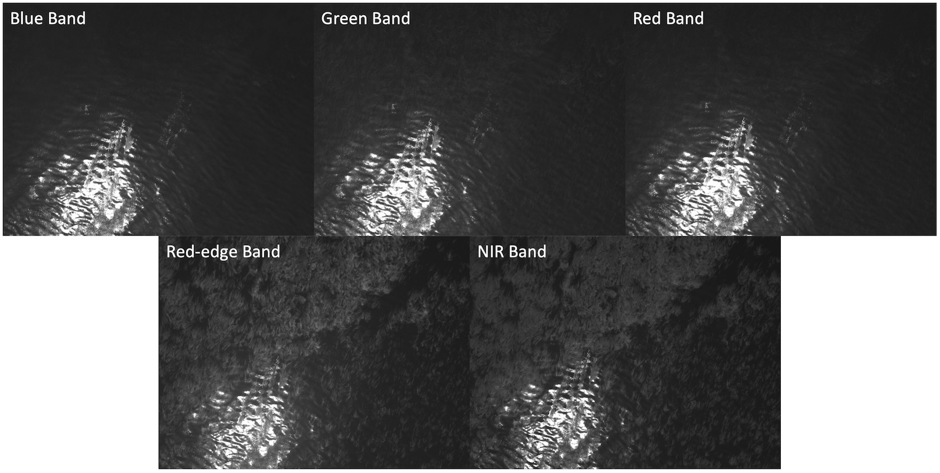
Supplementary Figure 1. Example of a blue, green, red, red-edge, and NIR band for a single UAV image. Kelp is least prominent in the blue band, allowing for more accurate isolation of glint pixels and less potential for the inclusion of undistorted kelp pixels within glint masks.
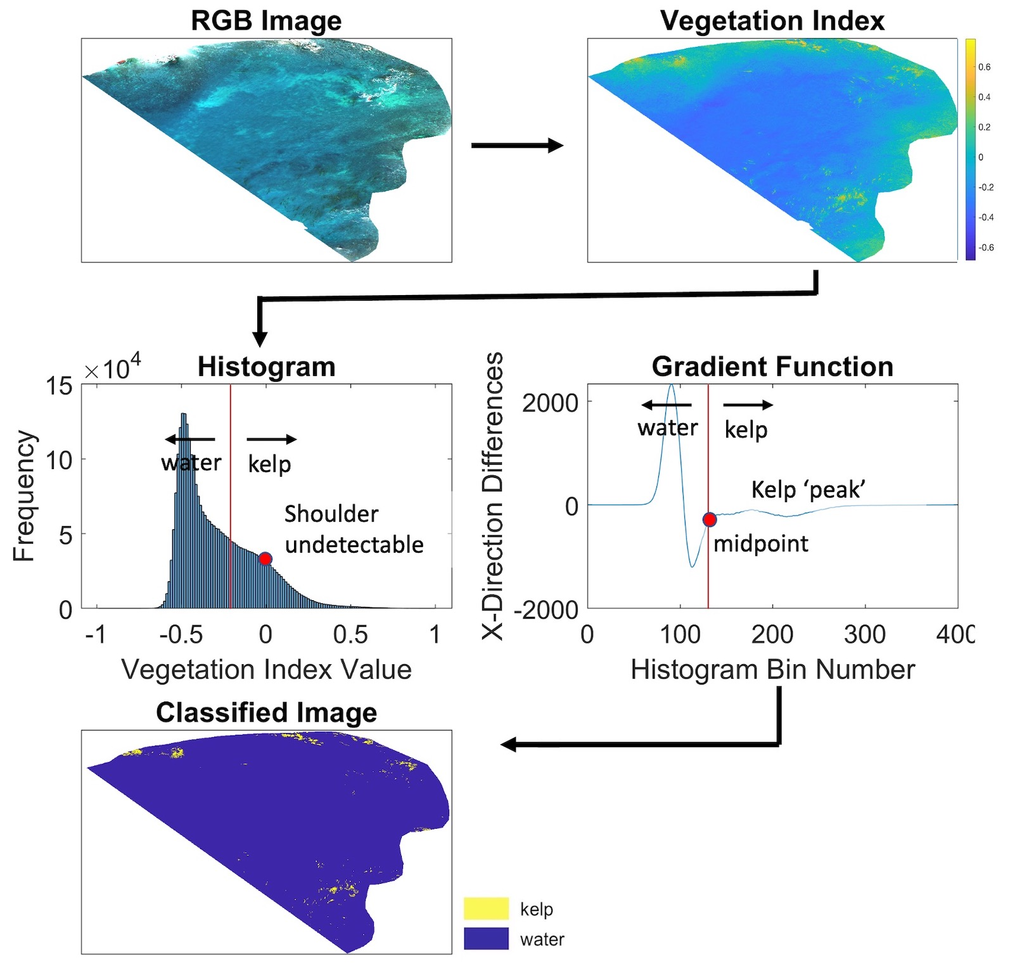
Supplementary Figure 2. Methodology used in the detection of the presence or absence of kelp in each pixel when only one histogram peak was identified. The function gradient is applied to the histogram to search for slight differences between neighboring histogram bins. The midpoint between the identified peaks from the gradient function is used as the vegetation threshold for kelp classification.

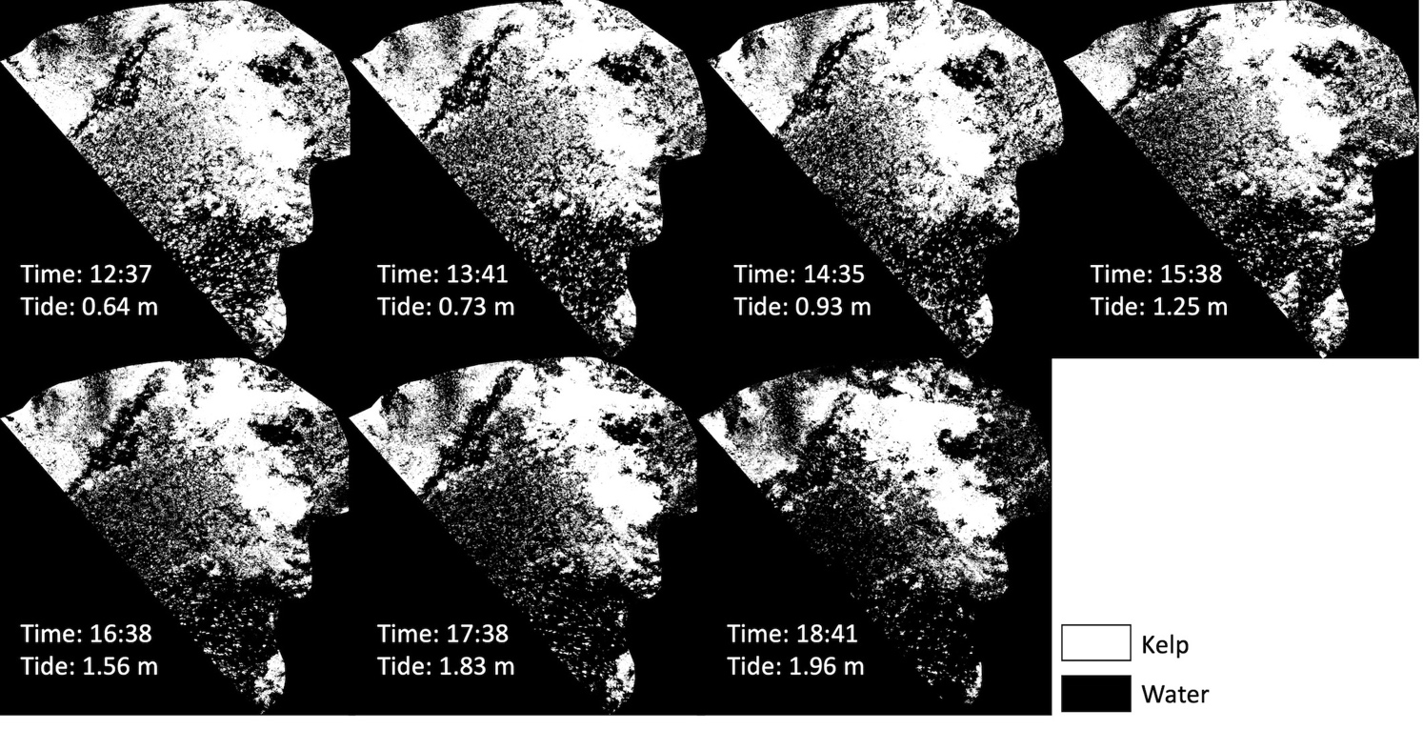
Supplementary Figure 3. Binary maps from the first tidal survey performed at Honeymoon Cove on 9 July 2018.
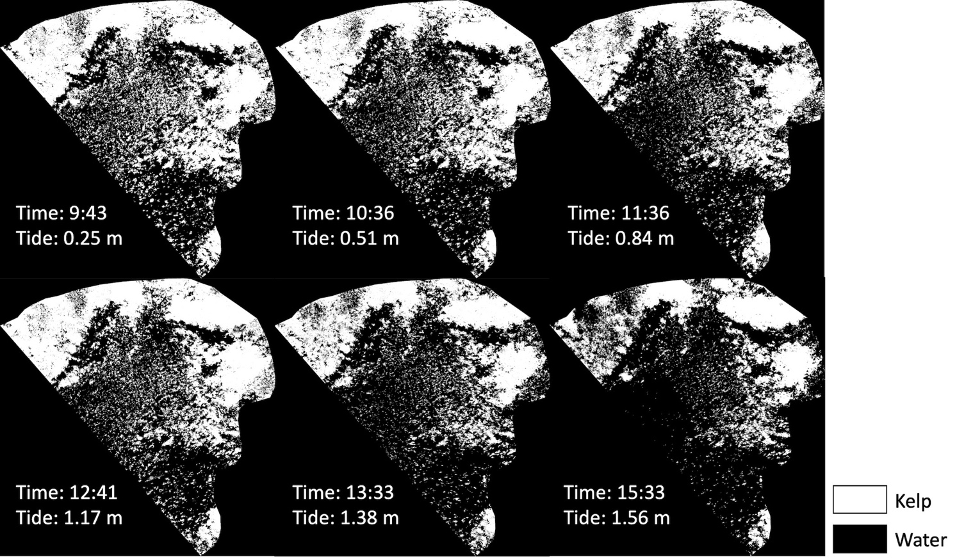
Supplementary Figure 4. Binary maps from the second tidal survey performed at Honeymoon Cove on 18 July 2018.
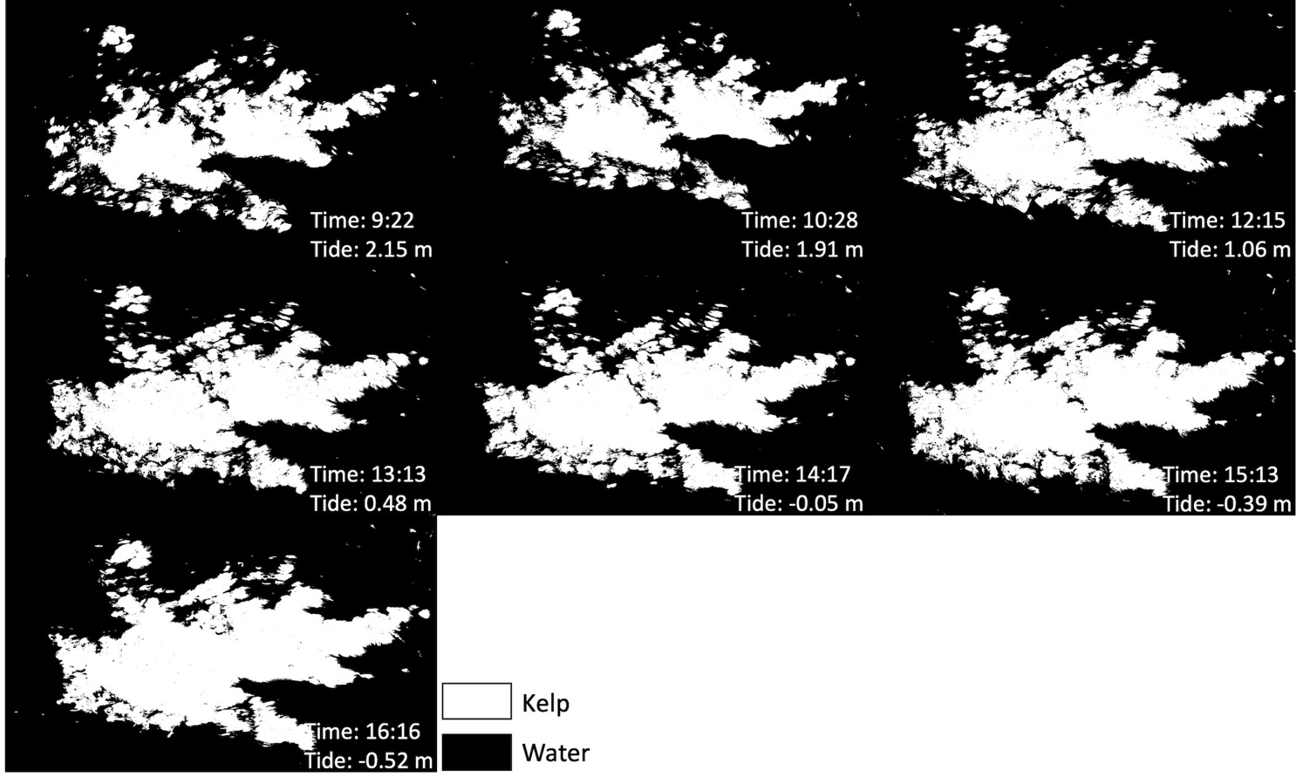
Supplementary Figure 5. Binary maps from the tidal survey performed at Arroyo Quemado on 2 January 2018.
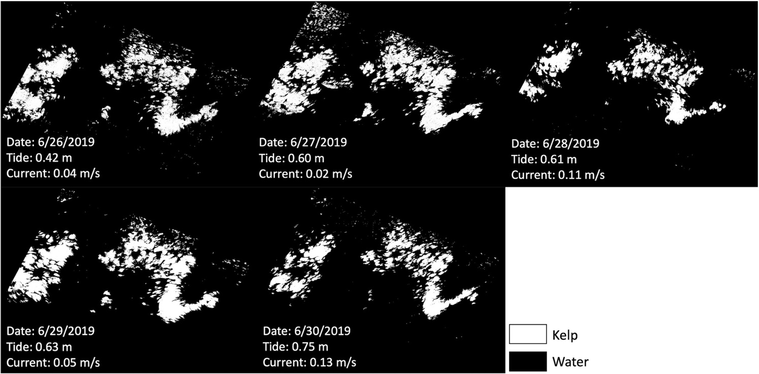
Supplementary Figure 6. Binary maps from the multi-day current surveys performed at Arroyo Quemado between 26 June 2019 and 30 June 2019.

Supplementary Tables
Supplementary Table 1. Tide, current, time of acquisition (represented by midpoint between flight launch and flight landing), sun azimuth, sun elevation, and sun zenith. Current data were available from the SBC-LTER ADCP located at the Arroyo Quemado (AQUE) kelp forest; no current data were available at Honeymoon Cove (HC). Solar azimuth was measured in degrees clockwise from north, and elevation in degrees up from the horizon (calculated from the NOAA Solar Position Calculator; https://www.esrl.noaa.gov/gmd/grad/solcalc/azel.html).
UAV Survey | date | Flight  Time | Tidal  Height  (m) | Current  Speed  (m/s) | Sun  Azimuth | Sun  Elevation | Cosine of  Solar Zenith
AQUE Current | 6/26/19 | 11:36 | 0.42 | 0.04 | 99.19 | 56.11 | 0.83
AQUE Current | 6/27/19 | 13:15 | 0.60 | 0.02 | 133.28 | 74.61 | 0.96
AQUE Current | 6/28/19 | 13:24 | 0.61 | 0.11 | 139.62 | 75.82 | 0.97
AQUE Current | 6/29/19 | 14:12 | 0.63 | 0.05 | 189.35 | 78.60 | 0.98
AQUE Current | 6/30/19 | 15:18 | 0.75 | 0.13 | 239.76 | 70.32 | 0.94
AQUE Tidal | 1/2/18 | 9:22 | 2.15 | 0.07 | 128.94 | 12.11 | 0.21
AQUE Tidal | 1/2/18 | 10:28 | 1.91 | 0.07 | 141.24 | 21.70 | 0.37
AQUE Tidal | 1/2/18 | 12:15 | 1.06 | 0.09 | 166.57 | 31.49 | 0.52
AQUE Tidal | 1/2/18 | 13:13 | 0.48 | 0.12 | 182.27 | 32.66 | 0.54
AQUE Tidal | 1/2/18 | 14:17 | -0.05 | 0.09 | 199.31 | 30.18 | 0.50
AQUE Tidal | 1/2/18 | 15:13 | -0.39 | 0.12 | 212.70 | 25.12 | 0.42
AQUE Tidal | 1/2/18 | 16:16 | -0.52 | 0.14 | 225.53 | 16.93 | 0.29
HC Tidal 1 | 7/9/18 | 12:37 | 0.64 | No Data | 117.18 | 68.64 | 0.93
HC Tidal 1 | 7/9/18 | 13:41 | 0.73 | No Data | 159.82 | 77.86 | 0.98
HC Tidal 1 | 7/9/18 | 14:35 | 0.93 | No Data | 216.91 | 76.05 | 0.97
HC Tidal 1 | 7/9/18 | 15:38 | 1.25 | No Data | 248.58 | 65.41 | 0.91
HC Tidal 1 | 7/9/18 | 16:38 | 1.56 | No Data | 262.26 | 53.34 | 0.80
HC Tidal 1 | 7/9/18 | 17:38 | 1.83 | No Data | 271.37 | 40.90 | 0.65
HC Tidal 1 | 7/9/18 | 18:41 | 1.96 | No Data | 279.32 | 27.89 | 0.47
HC Tidal 2 | 7/18/18 | 9:43 | 0.25 | No Data | 85.13 | 32.44 | 0.54
HC Tidal 2 | 7/18/18 | 10:36 | 0.51 | No Data | 92.33 | 43.43 | 0.69
HC Tidal 2 | 7/18/18 | 11:36 | 0.84 | No Data | 102.62 | 55.78 | 0.83
HC Tidal 2 | 7/18/18 | 12:41 | 1.17 | No Data | 121.28 | 68.34 | 0.93
HC Tidal 2 | 7/18/18 | 13:33 | 1.38 | No Data | 153.37 | 75.84 | 0.97
HC Tidal 2 | 7/18/18 | 15:33 | 1.56 | No Data | 243.94 | 65.76 | 0.91

