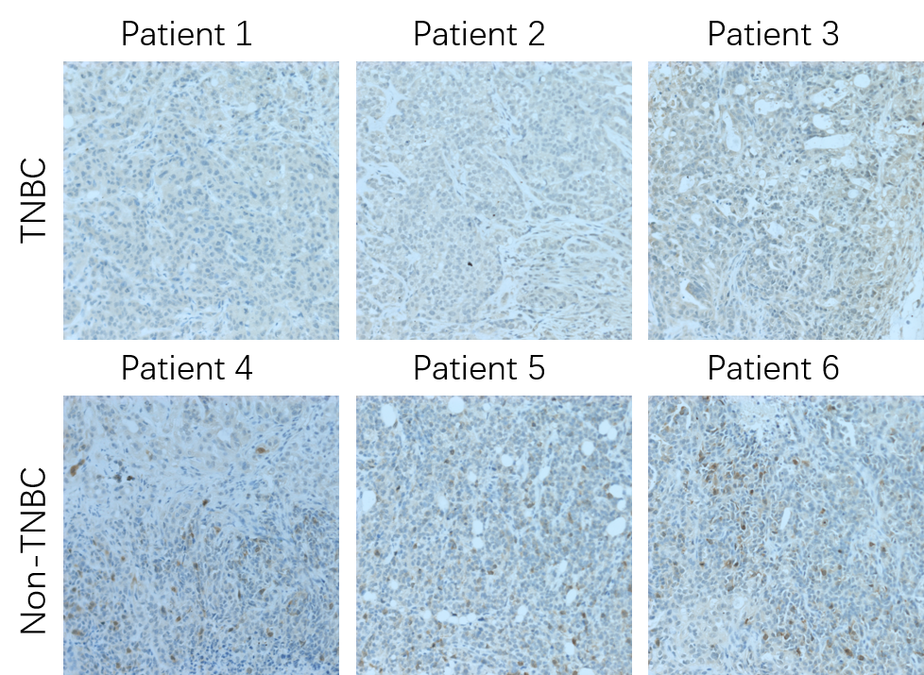
Figure S1 Immunohistochemistry staining assay of GPRC5A on non-TNBC and TNBC breast cancer tissues.
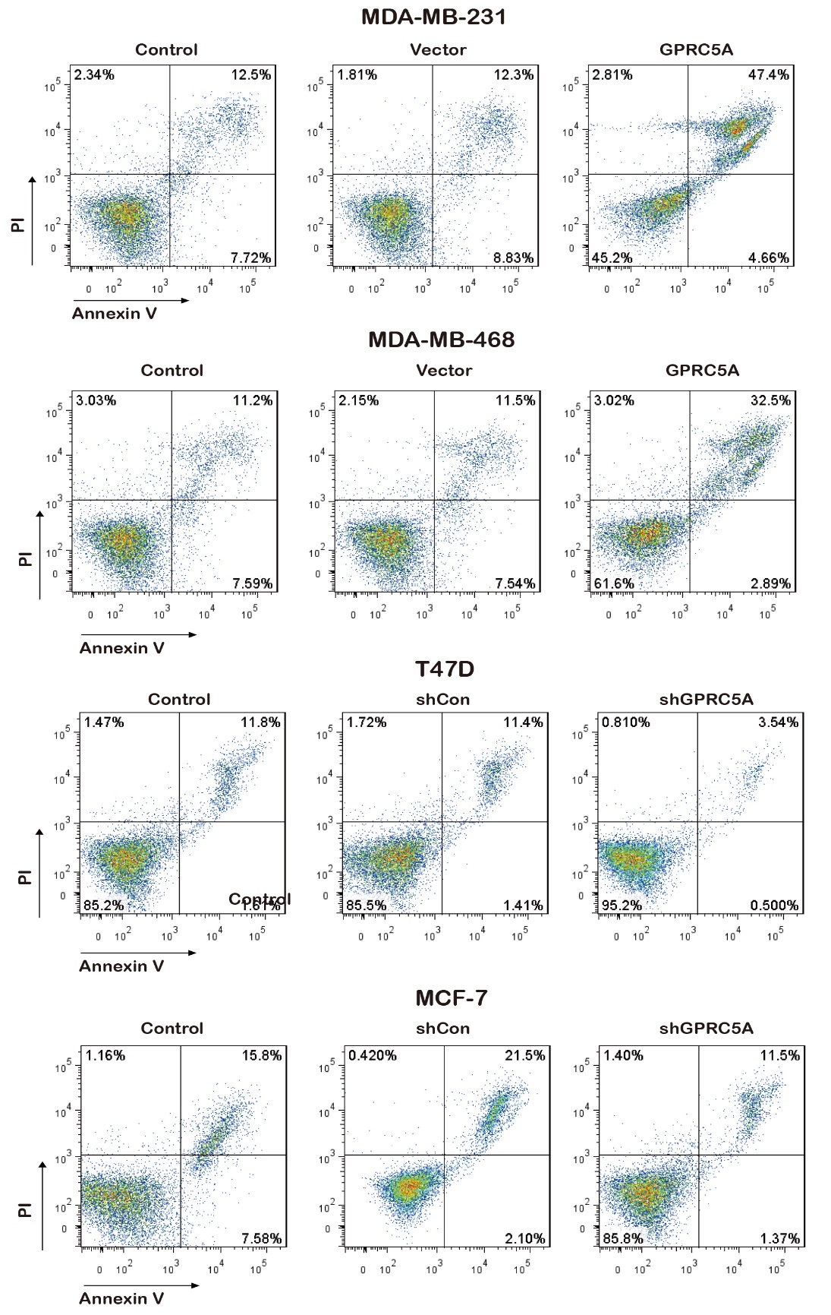
Figure S2 Flow cytometric analysis of cell apoptosis in MDA-MB-231/ MDA-MB-468/ T47D/ MCF-7 transfected with vector control (Vector/ shCon), GPRC5A or shGPRC5A. The control group is wildtype cells.
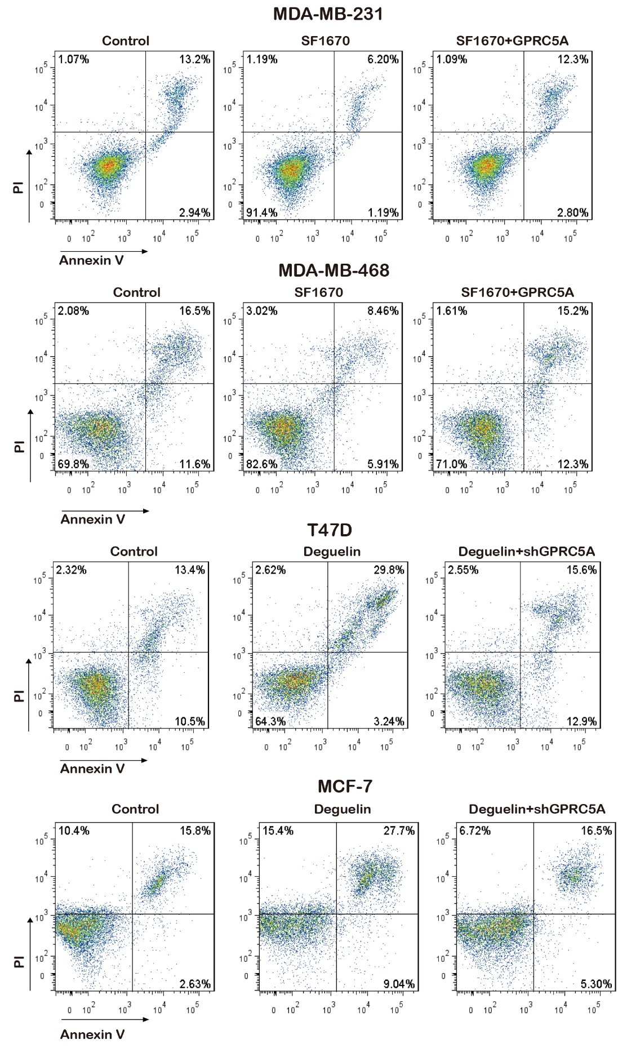
Figure S3 Flow cytometric analysis of cell apoptosis in MDA-MB-231/ MDA-MB-468/ T47D/ MCF-7 transfected with vector control (Vector/ shCon), GPRC5A or shGPRC5A following treatment with SF1670 or Degurlin. The control group is wildtype cells.

