Supplementary material

Endogenous 2μ plasmid editing for pathway engineering in Saccharomyces cerevisiae.
Bo-Xuan Zeng^{1, 2}, Ming-Dong Yao^{1, 2}, Wen-Hai Xiao^{1, 2}, Yun-Zi Luo^{1,3}, Ying Wang^{1, 2}*, Ying-Jin Yuan^{1, 2}
¹ Frontier Science Center for Synthetic Biology and Key Laboratory of Systems Bioengineering (Ministry of Education), School of Chemical Engineering and Technology, Tianjin University, Tianjin 300072, China
² Collaborative Innovation Center of Chemical Science and Engineering (Tianjin), Tianjin University, Tianjin 300072, China
³ Department of Gastroenterology, State Key Laboratory of Biotherapy, West China Hospital, Sichuan University, Chengdu, 610041, China.

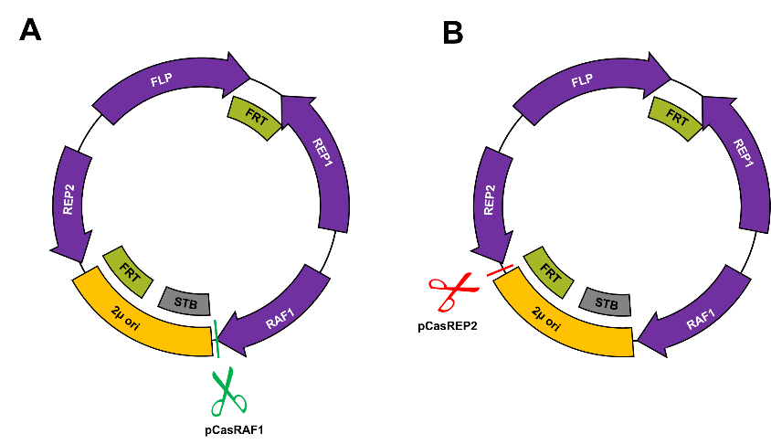

Figure S1. Structure of wild type endogenous 2μ plasmid (pE2μ), two sites were chosen for editing to insert target DNA element.

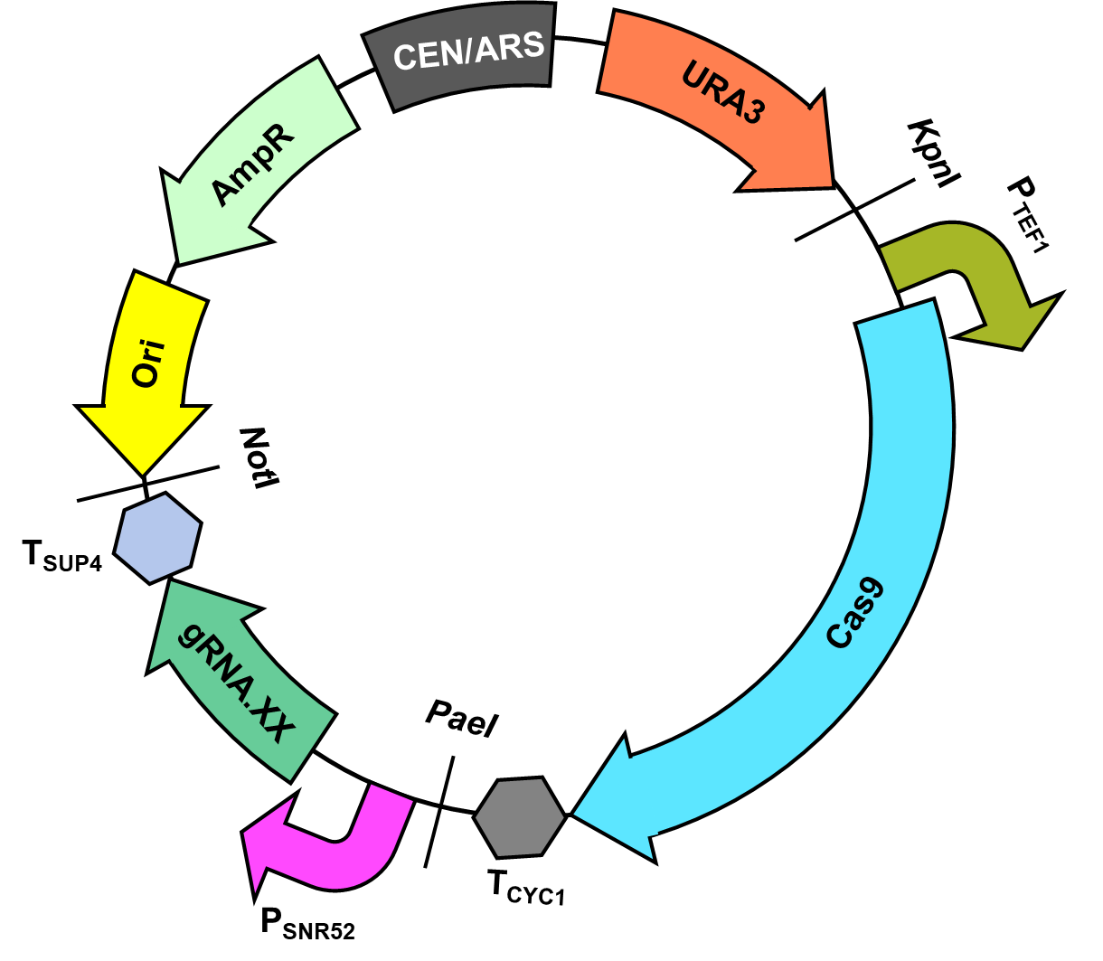
Figure S2 Structure of CRISPR/cas9 plasmid.

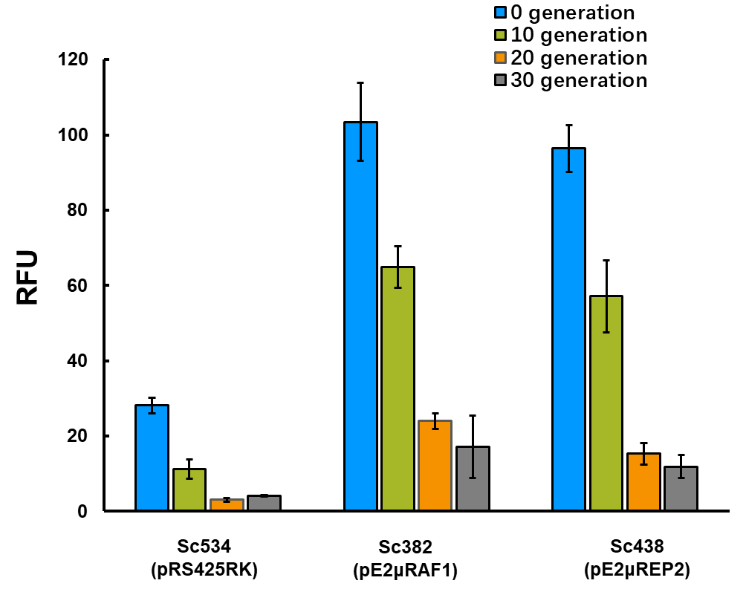

Figure S3. Fluorescence for strain harboring different plasmid in cultivation of 30 generation.

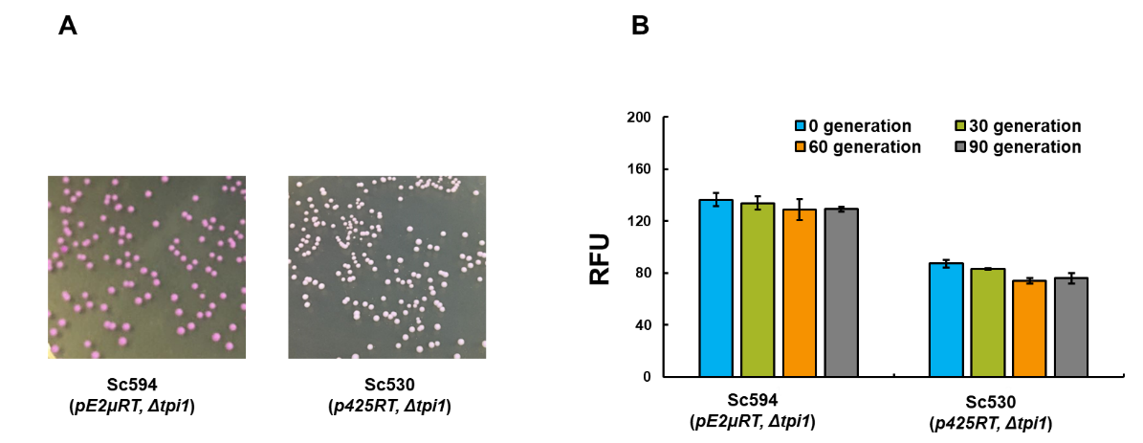
Figure S4. Comparation of Sc594 and Sc530. (A) Diluted culture of Sc530 and Sc594 were plated on YPD plate at 90th generation. (B) Fluorescence for Sc530 and Sc594 in cultivation of 90 generation.

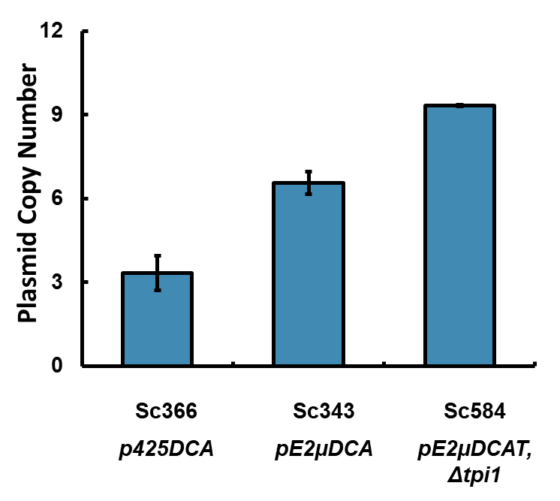
Figure S5. Average PCN of Sc366, Sc343, Sc584 after 120h fermentation.

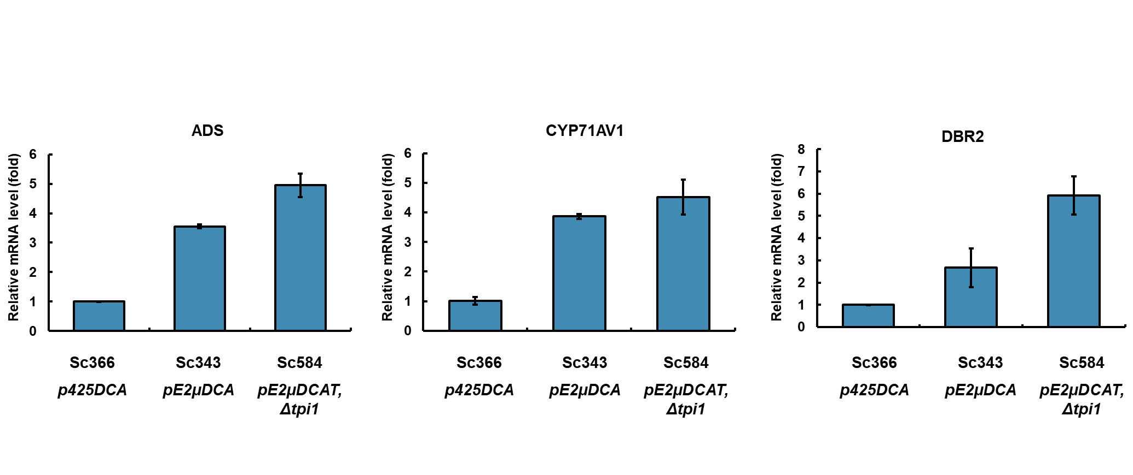
Figure S6. Comparation of relative mRNA level of Sc343 and Sc584 to strain Sc366 for gene ADS, CYP71AV1, DBR2

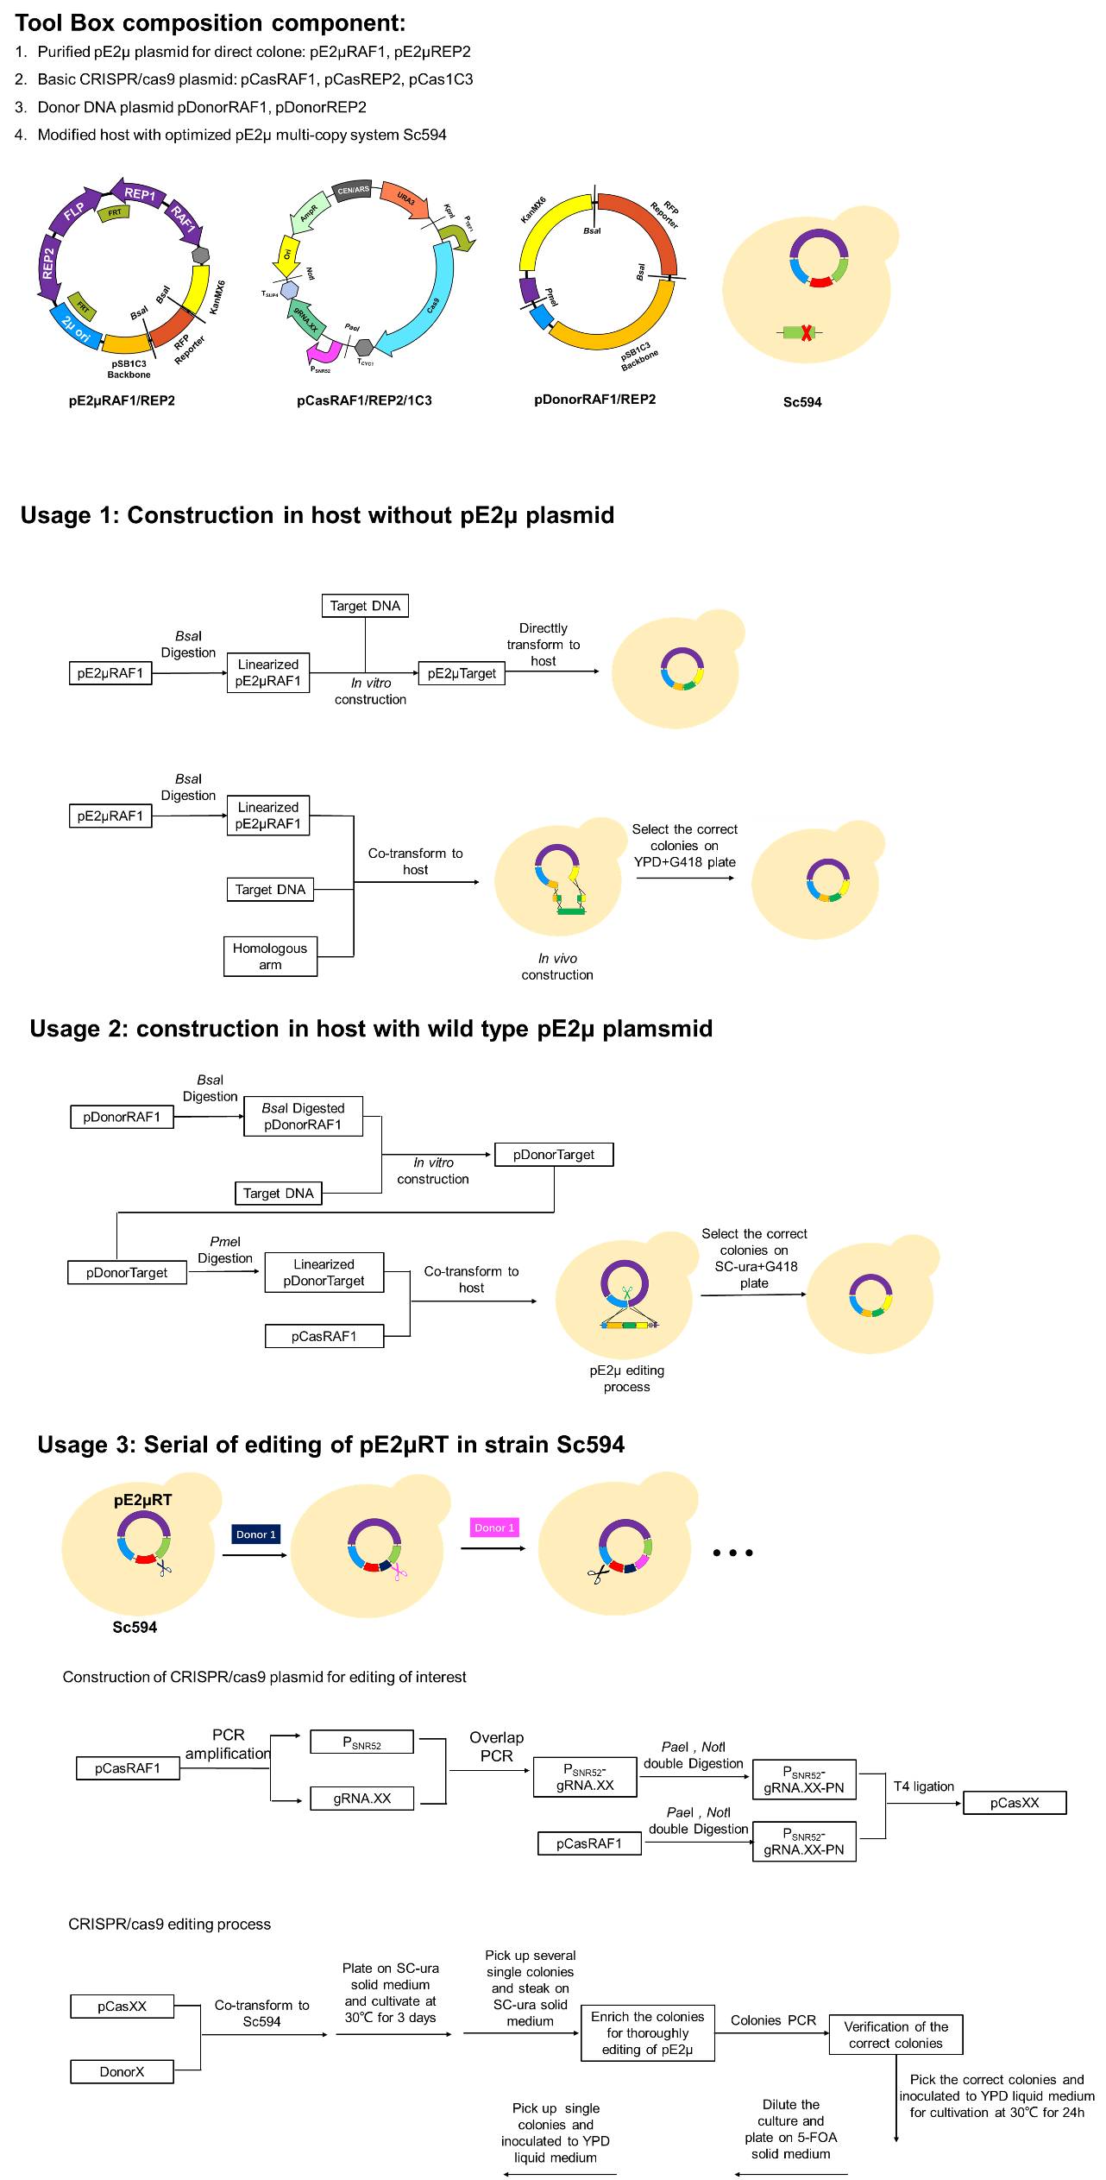

Figure S7. Tool box of the pE2μ multi-copy system for increasing the copy number of the target DNA element in different host.

Table S1. Primer used in this study
Primer | Sequence
18Q2a-pgi1t-R | GTTCGGATGTGATGTGAGAACTGgtagtttagtgtttttcttccagtgcgag
18Q2a-pgi1t-F | aaacgcggatcCAAATCGCTCTTAAATATATACCTAAAGAAC
18Q2a-homodown-F | ttacgcggatccttattatacaggttcaaatatactatctgtttcagggaaaac
18Q2a-homodown-R | atctgtgcttcattttgtaggtttaaactagctagaccgagaaagagactagaaatg
18Q2a-homoup-F | ttctcggtctagctagtttaaacctacaaaatgaagcacagatgcttcgttaacaaag
18Q2a-homoup-R | tttaggactagtcctggagaaactattgcatctattgcatag
18Q4-pTDH3-F | ttaccggaattcggatccgagaccAGTTTATCATTATCAATACTGCCATTTCAAAGAAT
18Q4-adh1t-R | acatacgtctcagtagctcgaggagaccggtagaggtgtggtcaataagag
2μori-test-F | gcgttgcatttttgttctacaaaatg
biobrick-R | attaccgcctttgagtgagc
18Q-test-5 | atgccttataaaacagctatagattgc
18Q-test-15 | GATTGCGCCTGAGCGAGACGAAATAC
18Q3a-cas9-F | taacgcggtaccAGCTCATAGCTTCAAAATGTTTCTACTCCTTTTTTACTC
18Q3-cas9-R | gagctcgcatgcCCGCAAATTAAAGCCTTCGAGCGTCCCAAAAC
18Q3-pSNR52-F | taatcgggcatgcgagctcTCTTTGAAAAGATAATGTATGATTATGCTTTC
18Q0b-pSNR52-R | aaacaaatacatacattgtcttccGATCATTTATCTTTCACTGCGGAGAAGTTTCG
18Q0b-gRNA-F | Cggaagacaatgtatgtatttgttttagagctagaaatagcaagttaaaataaggc
18Q3-cyc1t-R | ggataagaatgcggccgcaaagccttcgagcgtcccaaaac
20dTPI-leu2-F1 | CCTTTTCTGGCATCCAGTTTTgattcaagaaatatcttgaccgcag
20dTPI1-leu2-F2 | CAGCTTCCTCTATTGATGTTACACCTGGACACCCCTTTTCTGGCATCCAGTTTTga
20TPI1-leu2-F3 | TTGGTGGAAGATTACCCGTTCTAAGACTTTTCAGCTTCCTCTATTGATGTTACACC
20dTPI1-leu2-R1 | AAAAAGCGCCTTGCTTTTTGTTtgcaccatatcgactacgtcgtaag
20dTPI1-leu2-R2 | tTCAATTGTTAAATGCTTTTCTTCTTTTTATTAGAAAAAGCGCCTTGCTTTTTGTTtg
20dTPI1-leu2-R3 | GTTGATATAGAGGTGTTCAATTGTTAAATGCTTTTCTTCTTTTTATTAGAAAAAGC
20QRcT-F1 | acgtgcccgatcaactcgagtgccacctATCTTCAGTGGCATGTGAGATTCTCC
20QRcT-F2 | cattatggtgaaagttggaacctcttacgtgcccgatcaactcgagtgcc
20QRcT-F3 | caaaaaatacgcccggtagtgatcttatttcattatggtgaaagttggaacctc
20QRcT-R1 | ttaatgtcatgataataatggtttcttGTAAATCTACCGTCCCTTACAAGAAC
20QRcT-R2 | gatacgcctatttttataggttaatgtcatgataataatggtttcttGTAAATCtac
20QRcF-R3 | ttttatctgaaattctgcctcgtgatacgcctatttttataggttaatgtcatg
18Q0d-gRNA-F | GATCgaaaatcacgtaatacttctgttttagagctagaaatagcaagttaaaataaggc
18Q0d-pSNR52-R | gctctaaaacagaagtattacgtgattttcGATCATTTATCTTTCACTGCGGAGAAG
18Q4f0-D-R | CAGATCTCTAGACCATTTGACACTTGATTTGACACTTCTTTTTTTTTTTATTTATG
18Q4f0-D-F | TCAATAGGATCCGTTTAAACGGAAGAAGATGTTATGAAGCTCG
18Q4f0b-2μ-F | GTTTAAACGGATCCCGGATGAAAGGTAGTCTAGTACCTCCTGTG
18Q4f0b-2μ-R | TTATAGCGGCCGCACTAGTTATGATCCAATATCAAAGGAAATGATAGCA
qALG9-F | CCAATTGTTTAATCCGGGCTG
qALG9-R | CAGTGGACAGATAGCGTAGAG
qRFP-F | GTTCATATGGAAGGTTCAGTTAATGGTC
qRFP-R | CAAGCAAATGGTAATGGACCACCT
qADS-F | GCAATCTTTGGCTAACGACGTTG
qADS-R | CAAAGCTGGGTTAGTAGAGAAAGCG
qCYP71AV1-F | AATTGCCACTATACTATCCCGTGC
qCYP71AV1-R | AGTGATGCAAGAACTTTTTAGATGGG
qDBR2-F | TGTGGTGGTTACACCAGAGAATTGG
qDBR2-R | GTGGGTGTAGAAGGTAGCTCTGTC
18Q0l-gRNA-F | TCataatggtttcttagacgtcgttttagagctagaaatagcaagttaaaataagg
18Q0l-pSNR52-R | gctctaaaacgacgtctaagaaaccattatGATCATTTATCTTTCACTGCGGAGAAG

