Supplementary Material

Supplementary Data on Lithofacies
Upper Abrahamskraal Formation.--- In the SW-MKB, the gravel facies are confined to small to elongated lenticular ribbon-like beds that are 0.4 to 1 m thick and 1 m to ~15 m in wide, usually at the base of upward-fining successions (see below) that rest on irregular lower scour surfaces. Poorly-sorted, massive and matrix-supported breccias (Gmm1 and Gmm2) are more common than clast-supported, horizontally bedded facies (Gch, Table 1, Fig. 4). Compositionally, the poorly-sorted clasts are mudstones, sandstones, and fossilised wood, small bones and carbonate nodules. Clast-size ranges from 2 to 20 cm (av. ~5 cm). The matrix is mainly made up of fine sand and very fine dark grey, clayey sediment. The sandstone facies are 1 m thick and 6-15 m wide ribbons with lenticular or wedge-shaped cross-sections. They comprise a large range of facies from the most common trough cross-bedded sandstones (St) to horizontally and ripple cross-laminated sandstones, as well as massive and low-angle cross bedded sandstones (Sh, Sr1, Sm, Sl - Table 1, Fig. 4) and from classical upward-fining successions. These have gravels facies (e.g., Gmm1) and/or coarse-grained, cross-bedded St, Sl) sandstones in their lower parts. Their middle portion is dominated by cross-bedded (St, Sp), laminated (Sh) and massive (Sm) sandstones, that are invariably capped by ripple cross-laminated sandstones (Sr). This vertical suit of facies is also coupled with an upward decrease in grain-size. The fine-grained facies are mainly massive (occasionally laminated) olive green grey siltstones (and less commonly, red purple, massive and horizontally laminated mudstones (Fl1; Fl2; Fsm2; Table 1, Fig. 4). In situ carbonate nodules are locally abundant, and occur as dark grey or dark brown nodules that range in size from 2 to 60 cm in diameter. Occasionally, the in situ carbonate nodules are found concentrated in layers, and together with desiccation cracks (Fmd) and therapsid fossils form part of paleosol (Table 1, Fig. 4). Rare fossilised wood fragments and trace fossils are also present. The ichnofossils are exclusive to the upper bedding planes of thin, fine-grained sandstone interbeds, and are simple, unlined, unbranched, gently curving, cylindrical (diameters ~0.5 cm) infilled invertebrate burrows. The lithology of their massive fill is in essence identical to the fine-grained sandstone host rock.
In the S-MKB (Fig. 1), the gravel facies in the upper Abrahamskraal Formation are confined to beds that are broad ribbons and narrow sheets, which are on average 0.5 m thick and 10 m wide. Resting on erosive and irregular lower contacts, they are found at the base of channel deposits and grade into the overlying sandstones forming classical upward-fining successions (described above). The coarse-grained lithofacies vary from clast-supported conglomerates and breccias (Gcm, Gch) to matrix-supported breccias with intraformational rip-up clasts (Gmm2 - Table 1; Fig. 4). Well-sorted, clast-supported and massive conglomerates (Gcm) are more common than horizontally bedded gravels (Gch). Intraformational clasts are also common within sandstone beds, where they either form small, 1 m thick and 4 m wide lenses or single clast stingers that are <10 cm thick. Sandstones bodies vary from single storey to multi-storey deposits that are on average ~4 m thick and 120 m wide. Individual beds tend to form vertically stacked lenses, and occasionally laterally accreted sheets. Grain sizes range from fine- to coarse-grained with medium-grained sandstones dominating the outcrops. Horizontal lamination (Sh) and planar cross-bedding (Sp) are common; however ripple cross-laminations (Sr) are the dominant sedimentary structure in the eastern Abrahamskraal Formation. Well-defined by mud drapes, Sr facies vary from climbing ripples (Sr1) to trough-shaped flaser ripples (Sr2). The mudstones, which are slightly coarser than in the SW-MKB, form lateral extensive sheet-like deposits that are up to 20 m thick and extend for 100s of metres. The mudstones form alternating successions of laminated, purple-red mudrocks (Fl1) and olive green-grey, massive siltstones (Fsm2 - Table 1, Fig. 4). A mottling texture is very common in all mudrocks (Fr). In situ carbonate nodule horizons (facies P) and laminated tuffs (T) are common.
Lower Teekloof Formation.--- In the SW-MKB, the gravel facies is rare and confined to narrow to broad ribbons (~50 cm thick, 5-8 m wide) at the base of the upward-fining successions. Matrix-supported breccias (Gmm2) dominate and compromise very angular mudstone clasts, sub-rounded to sub-angular sandstone pebbles and many carbonate nodules set in a sandy matrix (Table 1). Confined to laterally accreted wedges, the sandstone facies in the western lower Teekloof Formation are highly diverse and cover the entire lithofacies spectrum of sandstone facies, with the exception of facies Sr2 (Table 1). From most to least abundant, these lithofacies are: St, Sl, Sm, Sp, Sh, Sr1 and Sb; they occur in classical upward-fining successions described above. The fine-grained facies alternate between the massive and/or laminated red-maroon claystones (Fl1; Fsm1) and the more common massive olive green grey claystones/siltstones (Fsm2). In situ carbonate nodules (P) of a few cm in diametre are very common in the fine-grained facies. In the S-MKB, the lithofacies abundances in the lower Teekloof Formation are identical to the underlying Abrahamskraal Formation of the S-MKB (Table 1), with the exception of the gravel facies and the ripple cross-laminations with mud drapes (Sr2), the former being more common (but still rare – see next section) and the latter absent in the lower Teekloof Formation of the S-MKB.

Supplementary Figure 1 —Example of a channel belt exposure used in facies quantification from the Abrahamskraal Formation at location M in southwestern main Karoo Basin (study area W2). Lithofacies maps of the outcrops in (A) and (B) show that downward accretion architectural elements (DAs) dominate at this location. A and B show perpendicular sections of the same channel belt as well as the overall vertical stacking of the elongated, ribbon-like DAs. Note that the palaeocurrent direction (PC) is perpendicular to the outcrop in A and parallel to the outcrop in B. Light yellow = channel elements, light grey = floodplain elements (FF); bounding surfaces are numbered. (C) Sedimentary log at location M showing the vertical distribution of the lithofacies and architectural elements (e.g., GB, CR, CS, which are not indicated in A and B for simplicity). Relative proportions of architectural elements derived from C are incorporated into the facies quantification analysis.
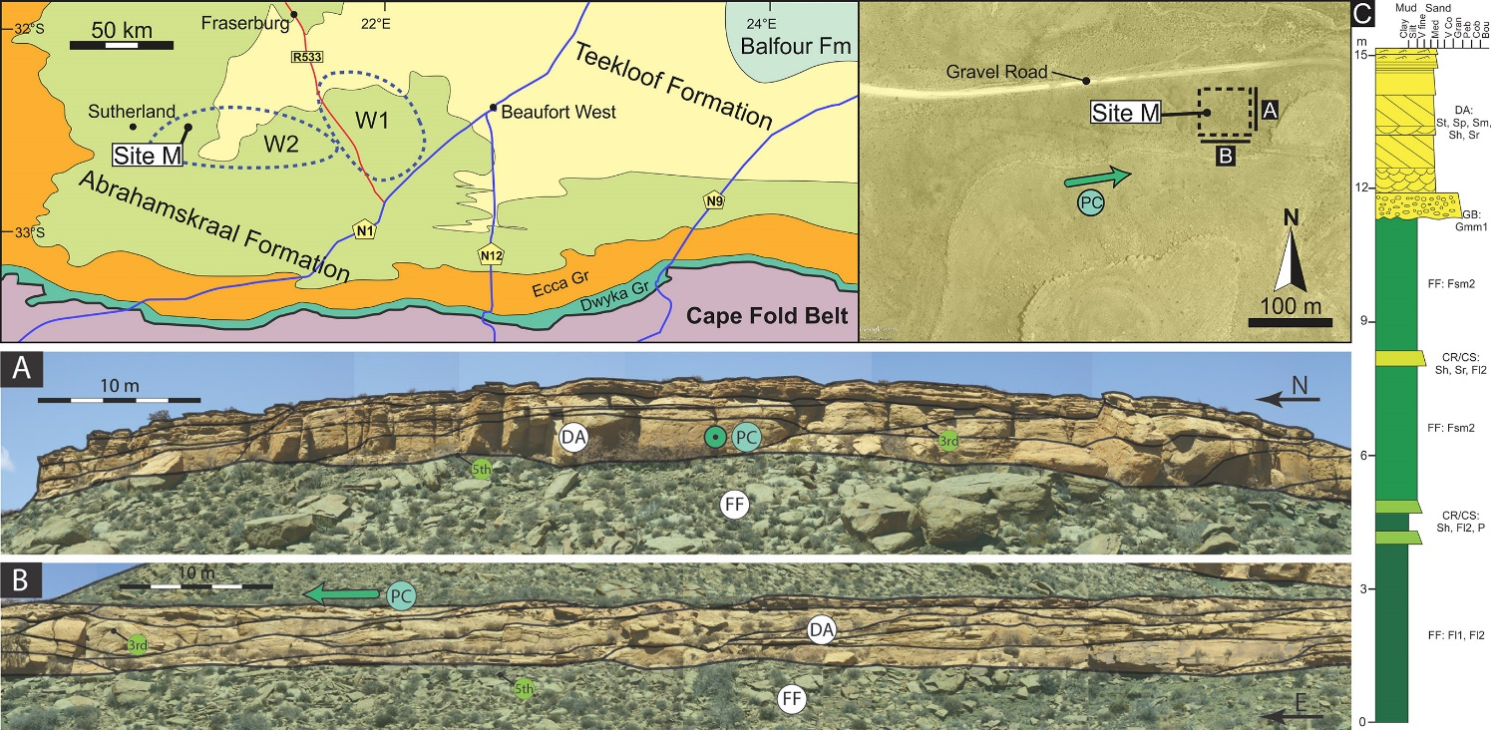

Supplementary data on channel belt dimensions
To quantify the dimensions of the sandstone bodies confined to channel belts in the Abrahamskraal and Teekloof Formations, width and thickness measurements were taken and the calculated width-thickness ratios, after being corrected for obliquity to palaeoflow, were compared to a global dataset presented in Gibling (2006). Although the outcrops are often well over 100 m wide and several 10s’ of metres high, occasionally, where the channel belt is wider than the outcrop, the width measurements are partial, and thus the width-thickness ratios cannot be accurately constrained. In this study, no qualitative distinction was made between the single storey, isolated and multi-storey, amalgamated sandstone bodies, and thus the measurements refer to the maximum lateral and vertical dimensions of a given sandstone-dominated channel belt (see Fig. 2), irrespective of how many or what type of lithofacies or lithofacies associations are stacked in it laterally or vertically. In other words, data on width-thickness ratios are thus representative of fluvial hierarchies at the level of Channel Belts, irrespective of what their architectural types are.
The width (W) and thickness (T) measurements of the sandstone bodies in the study area and the derived W/T ratios are shown in Supplementary Figure 2. The maximum width values of the sandstone bodies in the upper Abrahamskraal Formation are ~3.5 and ~2 times smaller than in the lower Teekloof Formation, which are ~773 m and 230 m in the SW-MKB and S-MKB, respectively. Similarly, the mean widths in the lower Teekloof Formation (~130 m and ~91 m in the SW-MKB and S-MKB, respectively) are greater than in the upper Abrahamskraal Formation (S Fig. 2D). Thicknesses trends seem to be more variable, with the Teekloof Formation being thicker in the S-MKB with a maximum of 30 m (mean ~5.8 m) versus a maximum of 5.6 m (mean ~3.8 m) for the upper Abrahamskraal Formation. In contrast, the SW-MKB shows the opposite thickness trend (Fig. 10D). In brief, the maximum and mean values indicate that in both formations the sandstone bodies are wider in the SW-MKB, and, especially in the lower Teekloof Formation, thicker in the S-MKB. Moreover, Supplementary Figure 2 also shows a positive correlation between width and thickness values and that most of the data plot between the W/T = 10 and W/T = 100 lines, indicating that the sandstone bodies in the study area tend to be narrow sheets, and occasionally broad ribbons. Furthermore, most measurements plot in a region where many river style envelopes of Gibling (2006) overlap, and therefore inferences connecting W/T values to a specific river style are difficult to be made. However, most of the data points (S Fig. 2A) are concentrated in the population envelope that is for “crevasse channels and avulsion deposits” of Gibling (2006). The few outliers (nine in total – S Fig. 2B, C) are mainly from the lower Teekloof Formation in the SW-MKB.
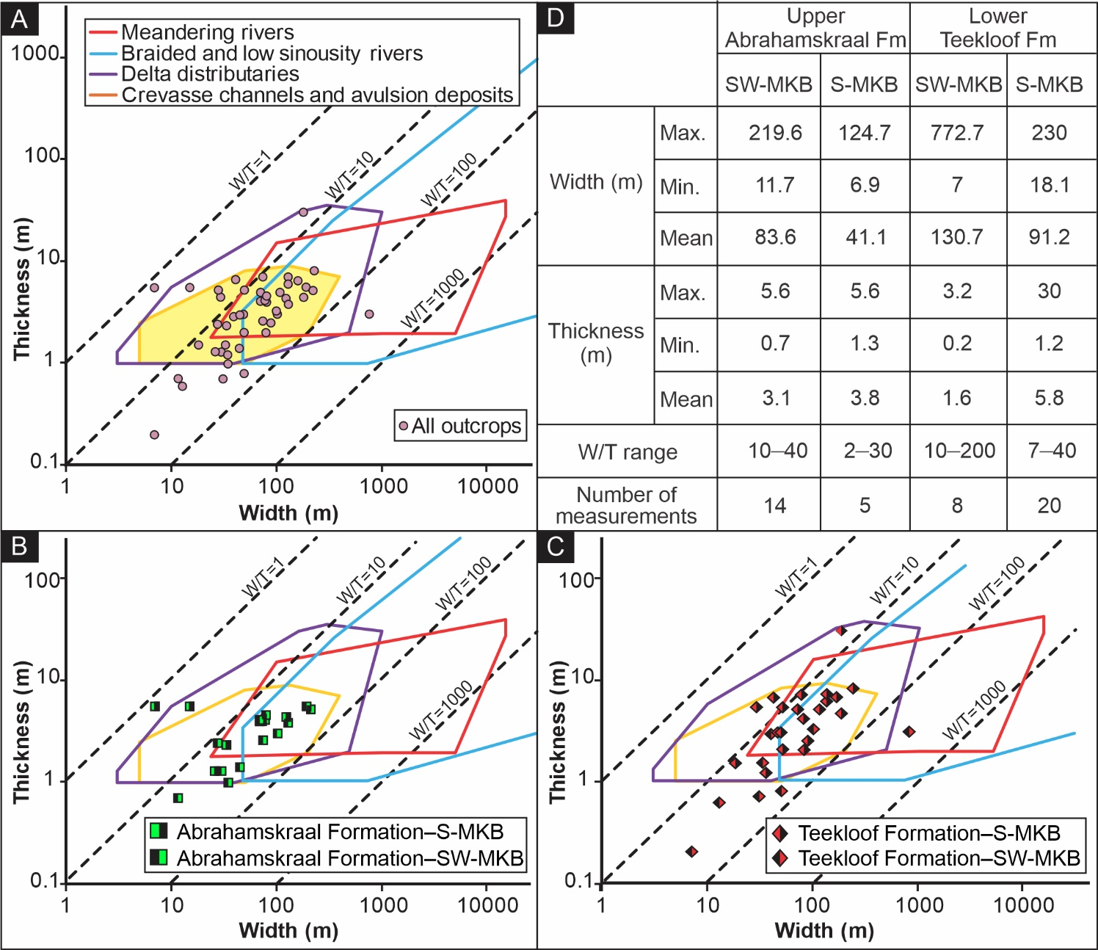Supplementary Figure 2 — Width (W) vs. thickness (T) plot for sandstone body measurements for all outcrops (A); in upper Abrahamskraal (B) and lower Teekloof (C) formations. Note the positive correlation between W and T. Most measurements plot in the area demarcated by 10 < W/T < 100, indicating that sandstone bodies tend to be narrow sheets and broad ribbons. Envelope polygons corresponding to different river styles are taken from Gibling (2006). Note the logarithmic scale. (D) Summary of the W and T values of the sandstone bodies in the studied stratigraphic interval. No qualitative distinction was made between the single vs multistorey sandstone bodies. W/T range was obtained from data used in A–C. Abbreviations: SW-MKB - southwestern main Karoo Basin; S-MKB - southern main Karoo Basin; Fm - formation.

Supplementary Tables
Supplementary Table 1. GPS coordinates of the sampling sites in the main Karoo Basin of South Africa. For map view distribution of the sites, see Bordy (2018).
Supplementary Table 2. Summary of the quantitative facies analysis results for the architectural elements in the studied stratigraphic interval. First six AEs are channel related; the rest are floodplain related (see Fig. 2). For pie charts, see Figure 4. See text, Table 2, 3 and Figures 6–8 for details. All values are in %-es. Abbreviations: AEs – architectural elements; W1 – eastern sector and W2 – western sector in the southwestern main Karoo Basin; E – southern main Karoo Basin. See Figure 1 for the relative positions of W1, W2 and E.
 | Abrahamskraal Formation |  |  |  | Teekloof Formation
AEs | W1 | W2 | E1 | Average | W1 | W2 | E1 | Average
CH | 0.4 | 4.3 | 0 | 1.6 | 0 | 0 | 0 | 0
LA | 8.1 | 0 | 17.4 | 8.5 | 27.3 | 7.9 | 16.9 | 17.4
DA | 25.6 | 24.9 | 2 | 17.5 | 0 | 14.2 | 6.3 | 6.8
DLA | 18.3 | 0 | 0 | 6.1 | 0 | 0 | 0.8 | 0.3
GB | 1.1 | 1 | 0.4 | 0.8 | 0.6 | 1.1 | 0 | 0.6
SG | 0 | 0 | 0 | 0 | 0.8 | 0 | 0 | 0.3
AC | 0.2 | 0 | 0 | 0.1 | 1.4 | 0 | 0 | 0.5
LV | 4.8 | 7.2 | 0 | 4 | 2.2 | 0 | 0.2 | 0.8
CR | 2.9 | 0 | 0.1 | 1 | 0.1 | 0 | 0.1 | 0.1
CS | 12.8 | 6.3 | 18.5 | 12.5 | 17.2 | 9.2 | 4.6 | 10.3
SF | 4.1 | 0 | 19.6 | 7.9 | 0 | 18.9 | 19.9 | 12.9
FF | 21.7 | 56.4 | 41.9 | 40 | 50.3 | 48.7 | 51.3 | 50.1
Total | 100 | 100 | 100 | 100 | 100 | 100 | 100 | 100

Supplementary Table 3. Thickness and width data of the outcrops used in the quantitative analysis of the architectural elements shown in Figures 4 and 5. Abbreviations: W1 – eastern sector and W2 – western sector in the southwestern main Karoo Basin; E – southern main Karoo Basin. See Figure 1 for the relative positions of W1, W2 and E. See Supplementary Table 1 for the GPS coordinates of the outcrop sites.
Formation | Study area | Site | Thickness | Width | Total Logged Thickness (m) | Average Logged Thickness (m) | Total Logged Width (m) | Average Logged Width (m)
Teekloof | W1 | P2 | 5.2 | 62.0 | 14.8 | 3.7 | 244.9 | 61.2
 |  | P3 | 1.5 | 32.9
 |  | P5 | 4.5 | 50.0
 |  | P6 | 3.6 | 100.0
 | W2 | SU-TEE4 | 15.0 | 772.7 | 27.0 | 13.5 | 812.1 | 406.0
 |  | SU-TEE7 | 12.0 | 39.4
 | E | KM4 | 6.5 | 130.0 | 116.2 | 19.4 | 965.0 | 160.8
 |  | OT1 | 12.0 | 45.0
 |  | OT2 | 24.5 | 180.0
 |  | OT3 | 16.2 | 230.0
 |  | OT4 | 7.0 | 130.0
 |  | KM7 | 50.0 | 250.0
Abrahamskraal | W1 | A1 | 2.4 | 28.0 | 26.8 | 3.8 | 589.8 | 84.3
 |  | A2 | 5.2 | 219.6
 |  | A4 | 4.1 | 78.0
 |  | A5 | 4.1 | 69.7
 |  | A6 | 4.6 | 79.7
 |  | A7 | 2.4 | 45.0
 |  | A8 | 4.0 | 69.7
 | W2 | SU-ABR1 | 5.6 | 195.3 | 12.4 | 4.1 | 429.0 | 143.0
 |  | SU-ABR3 | 3.0 | 103.7
 |  | SU-ABR4 | 3.8 | 130.0
 | E | KM3 | 2.3 | 33.2 | 43.6 | 8.7 | 398.8 | 79.8
 |  | KM5 | 4.4 | 124.7
 |  | KM5_2 | 1.3 | 25.9
 |  | KM8 | 5.6 | 15.0
 |  | KM7 | 30.0 | 200.0

Supplementary Table 4. Mineral modal composition of twenty-three fine-grained sandstone samples derived from identifying three hundred sediment grains per slide. Results are shown in percentages. Qm - Monocrystalline quartz; Qp - Polycrystalline quartz; Fp - Plagioclase feldspar; Fk - Alkali feldspar; Lv - Volcanic lithic grain; Lm - Metamorphic lithic grain; Lp Plutonic lithic grain; Ls - Sedimentary lithic grain; Accs - Accessory mineral (mica, pyroxenes, amphiboles); Un - Unidentified minerals; Av. – Average; SD - Standard deviation. See Supplementary Table 1 for the GPS coordinates of the sampling sites.

