Supplementary Figure 1. Photos of the three studied habitat types. Photos by Balázs Deák.
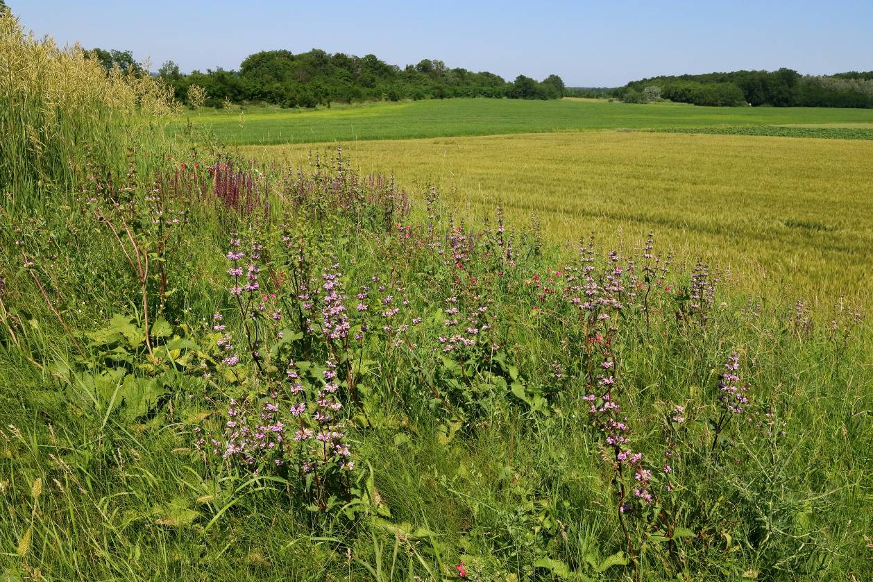
Kurgan
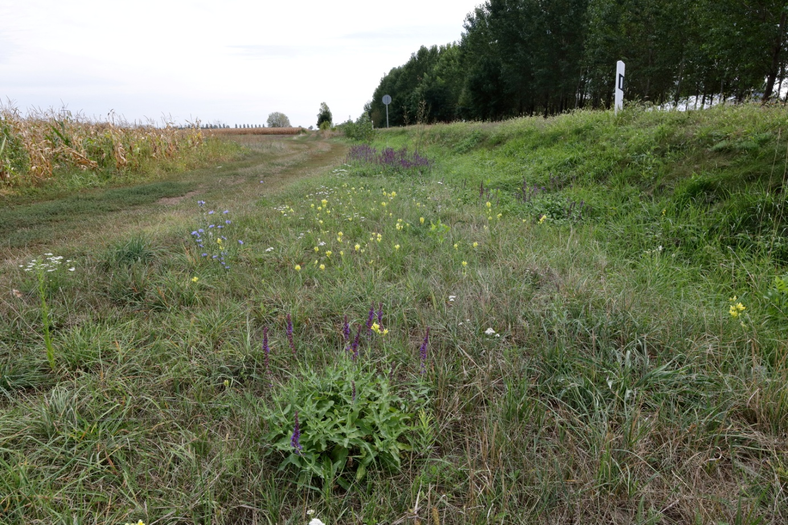
Verge
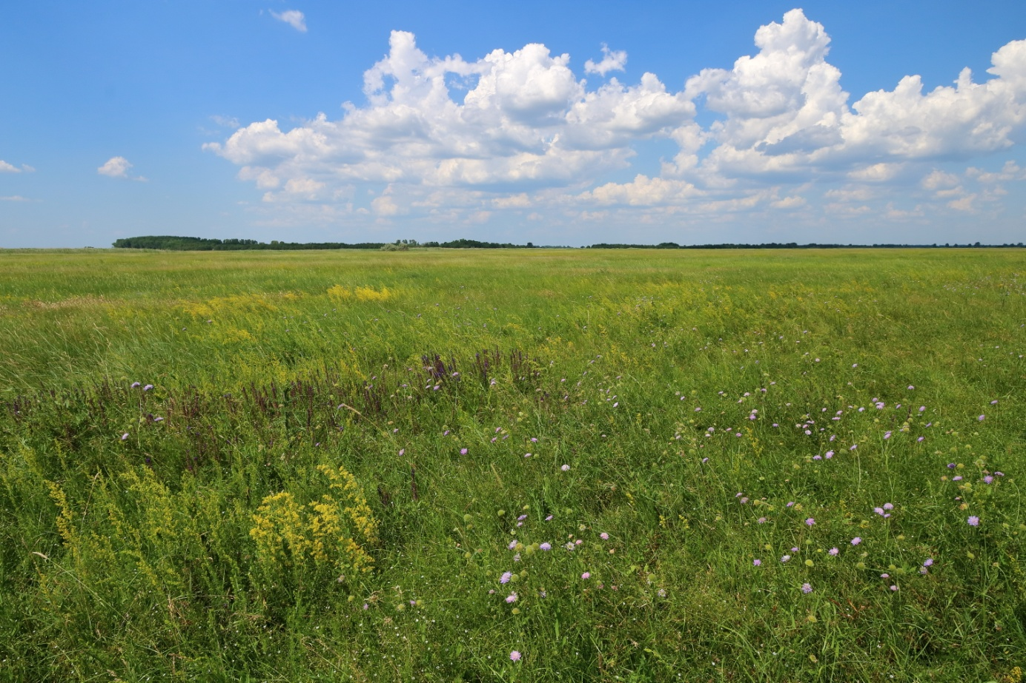
Extensive loess grassland

